Novel aminopyridazine derivative of minaprine modified by radiolysis presents potent anti-inflammatory effects in LPS-stimulated RAW 264.7 and DH82 macrophage cells

Gyeong Han Jeong ^{a,b,#}, Hanui Lee ^{a,b,#}, So-Yeun Woo ª, Hong-Ki Lee ^{b}, Byung Yeoup Chung ª, Hyoung-Woo Bai ^{a,b,c,*}

ª Research division for Biotechnology, Advanced Radiation Technology Institute (ARTI), Korea Atomic Energy Research Institute (KAERI), Jeongeup 56212, Republic of Korea
^{b} Center for companion animal new drug development, Korea Institute of Toxicology (KIT), Jeongeup 56212, Republic of Korea
^{c} Radiation Biotechnology and Applied Radioisotope Science, University of Science and Technology (UST), Daejeon 34113, Republic of Korea.

* Corresponding Author. E-mail address: hbai@kaeri.re.kr (H.W.Bai)
# These authors contributed equally to this work.

Contents

Figure S1. HPLC chromatograms of irradiated mianprine and the isolated compound 2.
Figure S2. ¹H NMR spectrum of compound 2 in CD₃OD.
Figure S3. ¹³C NMR spectrum of compound 2 in CD₃OD.
Figure S4. ¹H-¹H COSY spectrum of compound 2 in CD₃OD.
Figure S5. HSQC spectrum of compound 2 in CD₃OD.
Figure S6. HMBC spectrum of compound 2 in CD₃OD.
Figure S7. NOESY spectrum of compound 2 in CD₃OD.
Figure S8. HRESIMS spectrum of compound 2.
Figure S9. Chemical structures of minaprine and isolated compound 2.

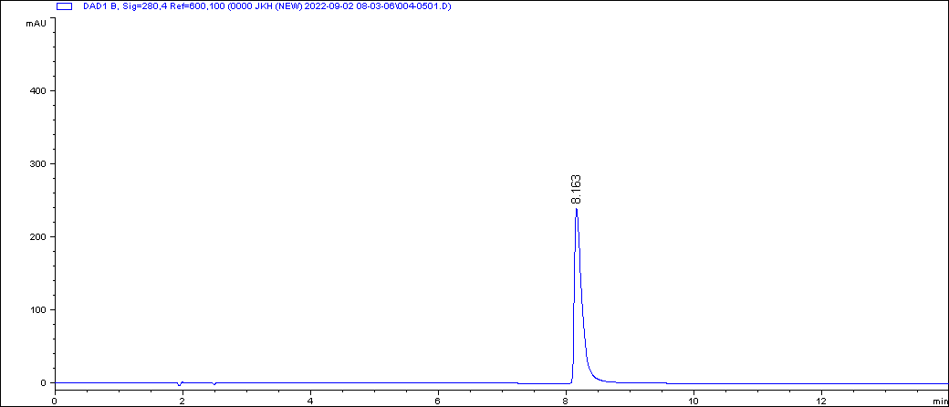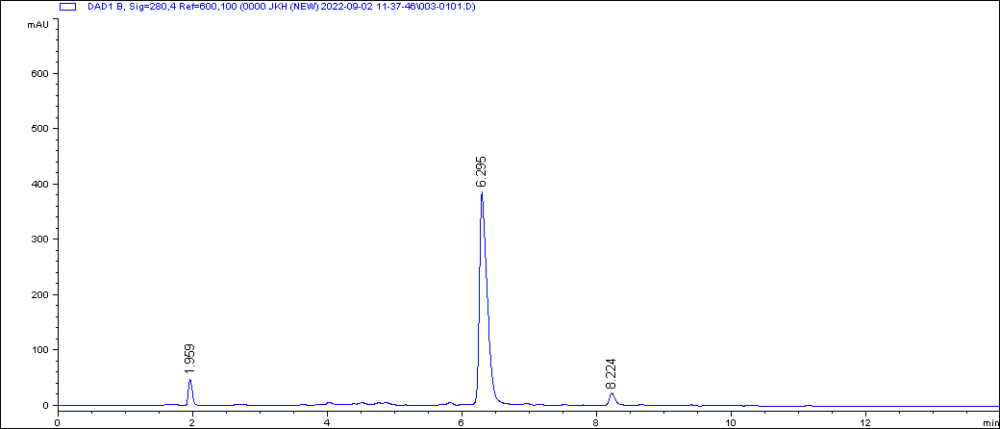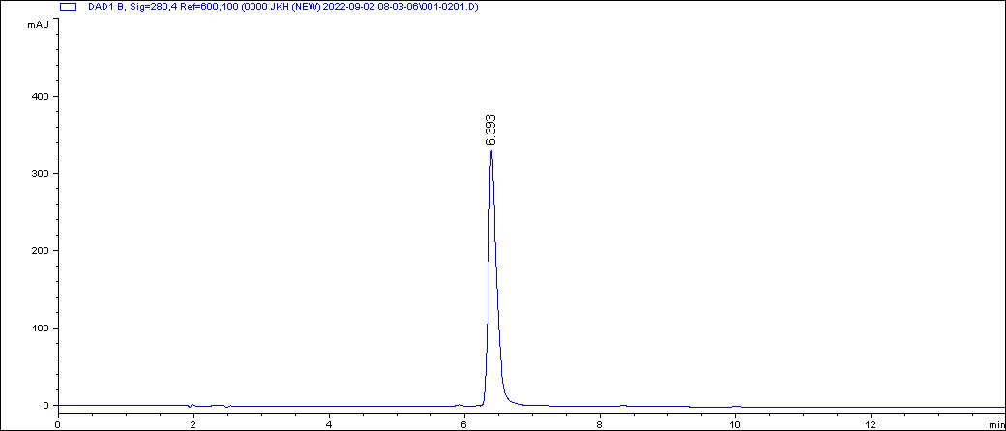
Compound 2
Irradiated reactant at 30 kGy
Minaprine (1)
Figure S1. HPLC chromatograms of irradiated mianprine and the isolated compound 2.

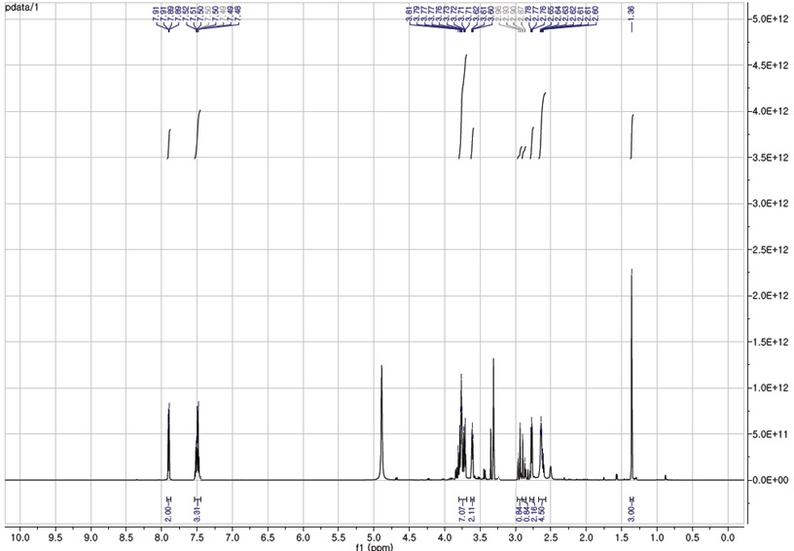
Figure S2. ¹H NMR spectrum of compound 2 in CD₃OD.

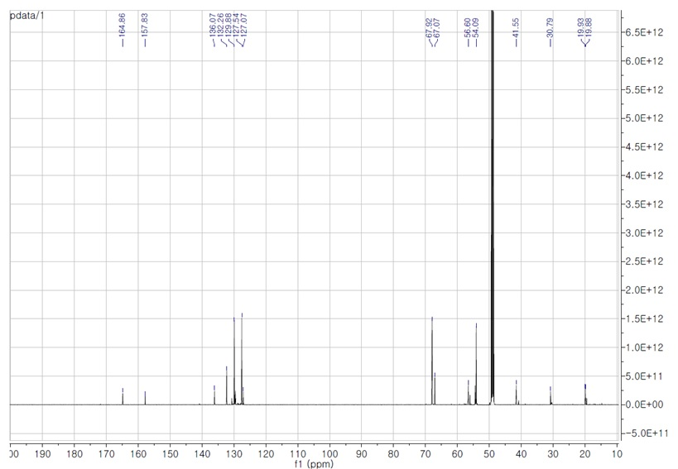
Figure S3. ¹³C NMR spectrum of compound 2 in CD₃OD.

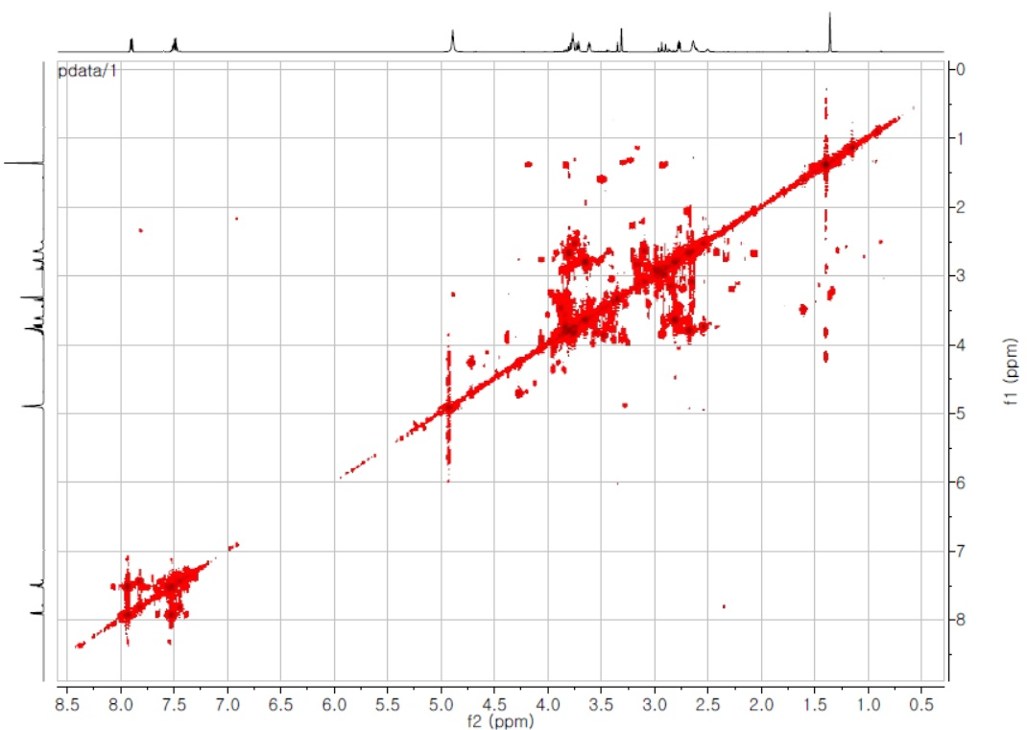
Figure S4. ¹H-¹H COSY spectrum of compound 2 in CD₃OD.

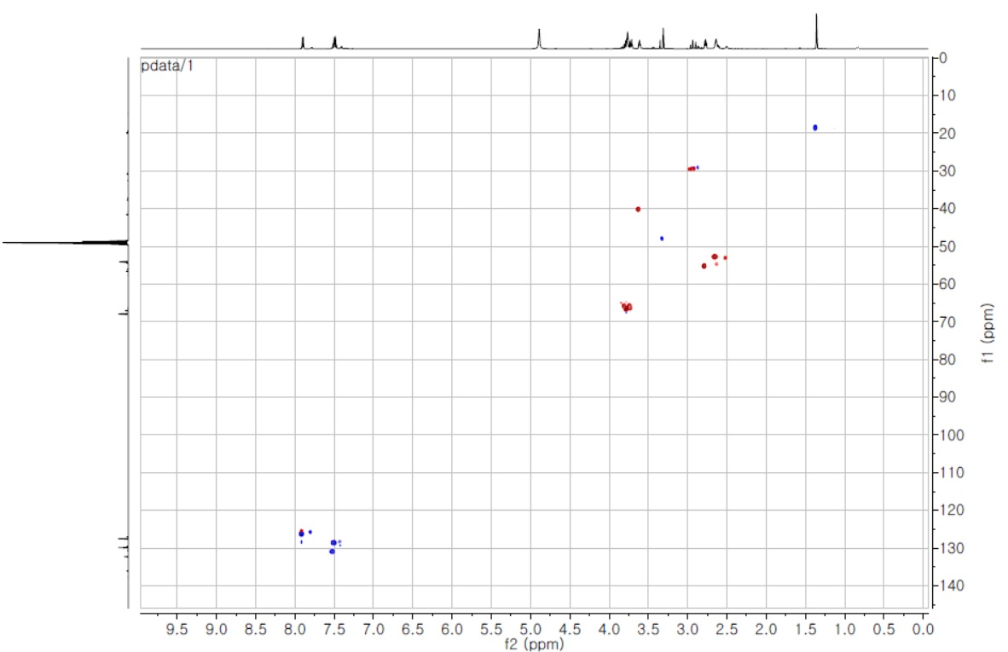
Figure S5. HSQC spectrum of compound 2 in CD₃OD.

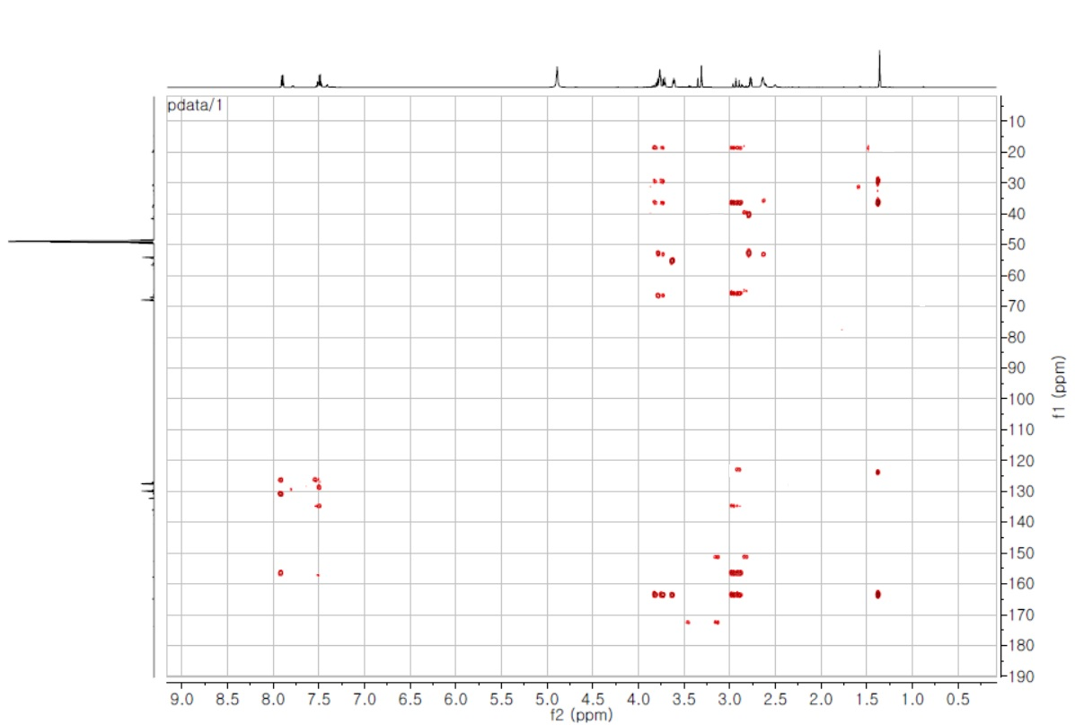
Figure S6. HMBC spectrum of compound 2 in CD₃OD.

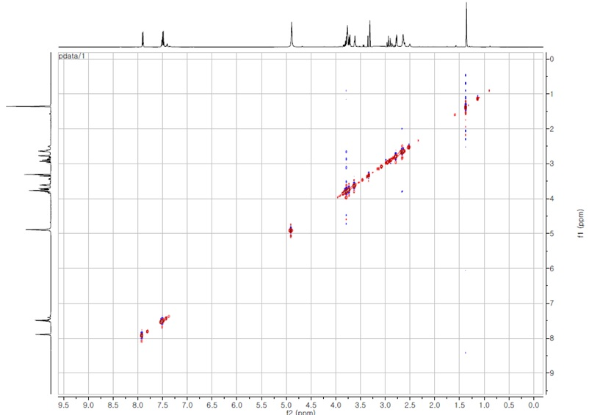
Figure S7. NOESY spectrum of compound 2 in CD₃OD.

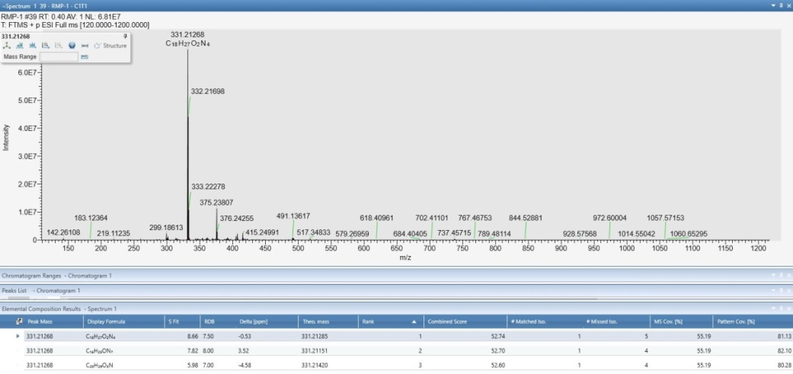
Figure S8. HRESIMS spectrum of compound 2.

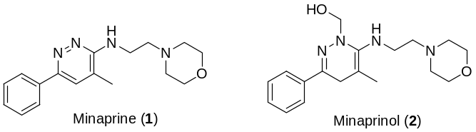
Figure S9. Chemical structures of minaprine and isolated compound 2.

