Table.1 Summary of six potentially natural medicines
Herb ID | Pinyin name | Latin name | English name | Class in English | Appearance
SMHB00072 | Chuanlianzi | Toosendan Fructus | Szechwan Chiberry Fruit | Qi Regulating Drugs | 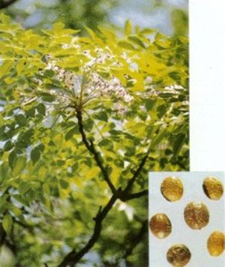
SMHB00090 | Dazao | Jujubae Fructus | Jujube Chinese date | Qi Reinforcing Drugs | 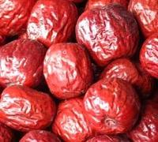
SMHB00139 | Gehua | Flos Puerariae Lobatae | flower bud of lobed kudzuvine | Pungent Cool Diaphoretics | 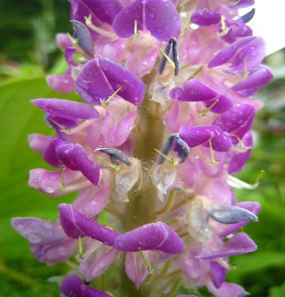
SMHB00319 | Qianhu | Peucedani Radix | root of Grand Hogfennel | Phlegresolving Medicine | 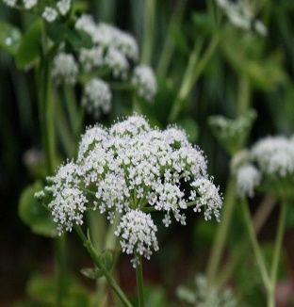
SMHB00360 | Shanzhaye | Crataegi Folium | Crataegi Folium | Blood Activating Stasis Removing Drugs | 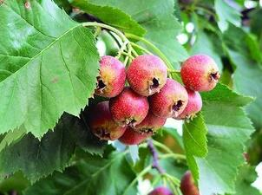
SMHB00412 | Weilingcai | Potentiliae Chinensis Herba | Chinese Cinquefoil | Antipyretic Detoxicate Drugs | 