Table.2 Chemical information for potentially active compounds
Mol ID | Molecule name | MW | AlogP | OB (%) | Caco-2 | BBB | DL | Molecular Formula | CAS.no | Structure
MOL008583 | beta-Sitosterol | 414.79 | 8.08 | 36.91 | 1.32 | 0.99 | 0.75 | C₂₉H₅₀O | 83-46-5 | 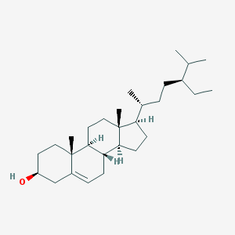
MOL000422 | Kaempferol | 286.25 | 1.77 | 41.88 | 0.26 | -0.55 | 0.24 | C₁₅H₁₀O₆ | 520-18-3 | 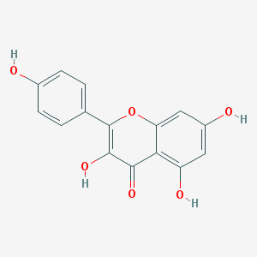
MOL000098 | Quercetin | 302.25 | 1.50 | 46.43 | 0.05 | -0.77 | 0.28 | C₁₅H₁₀O₇ | 73123-10-1;  74893-81-5;  117-39-5 | 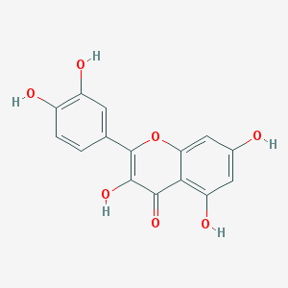
MOL000359 | Sitosterol | 414.79 | 8.08 | 36.91 | 1.32 | 0.87 | 0.75 | C₂₉H₅₀O | 83-46-5; 149-91-7; 474-58-8; 915-05-9; 5779-62-4; 64997-52-0 | 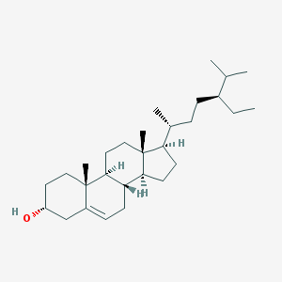
MOL000449 | Stigmasterol | 412.77 | 7.64 | 43.83 | 1.44 | 1.00 | 0.76 | C₂₉H₄₈O | 83-48-7 | 