Steric blockage of lysenin toxin by crowding
Ignacio L.B. Munguira¹ & Alfonso Barbas²
¹ U1006 INSERM, Université Aix-Marseille, Parc Scientifique et Technologique de Luminy, 163 avenue de Luminy, 13009 Marseille, France
²Instituto de Fusión Nucelar, José Gutiérrez Abascal 2, 28006 Madrid, Spain

Supplementary Movie 1:
Oligomerization process of lysenin at a concentration of monomers of lysenin in a solution of 5.6µM on an SLB composed of SM/Chol 1:1.
Movie parameters: full movie length 92568 ms; frame rate 456 ms; full image size 525nm x 619nm. Full color scale 16 nm; full frame size 300x465 pixels; color depth 8bit (256 values).
Left, topography image. Right, assignment of pixels and populations by the height value of the pixel as follows: (i) If $h∈[0,1]$nm, the pixel was assigned to free membrane; (ii) if $h∈[7,8]$nm to a pore; (iii) if $h∈[13,14]$nm to a prepore; and (iv) if $h∈[13,14]$ nm to a non-bound monomer.

Supplementary Movie 2:
Prepore-to-pore transition induce by acidification of the bathing solution on membrane patch fully imaged with individual lysenin oligomer resolution sheds light on the differences of area of occupancy of the prepore state and at the pore state of the oligomers.
SLB composed of SM/Chol 1:1. pH decrease from 7.5 to 5.2. Movie parameters: full movie length 24min; frame rate 720ms; full image size 460nm x 460nm. Full-color scale 16 nm; full frame size 287x265 pixels; color depth 8bit (256 values).

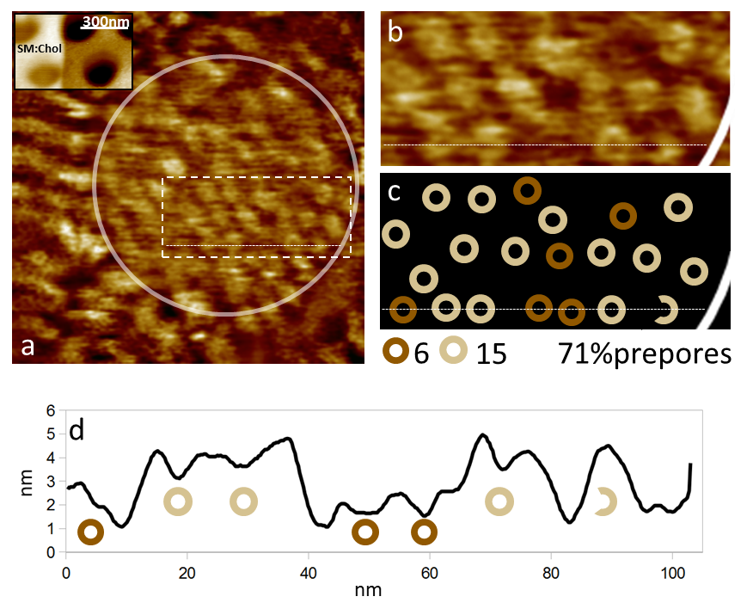
Supplementary Figure S1. Final state of the lysenin oligomerization on non-supported SLBs of SM/Chol 1:1 over 300nm nanowells. a) An SM/Chol 1:1 membrane after 5.6 µM lysenin incubation. The zone of the membranes spanned over the nanowell is the zone inside the white circle. The inset is an image of the SM/Chol 1:1 membrane spanning over the nanowells before incubation. b) Close-up of the spanned membrane on an area where the lysenin oligomers are visible. c) Oligomers representation with the count of prepores and pores, and the percentage of prepores. d) Profile along the slashed line showing the identification of the oligomer prepore or pore state according to its height. Please note that the oligomer most to the right would be incomplete in its oligomerization, i.e., formed by less than nine monomers, even if it presents a height signature of prepore and we represent this circumstance by an incomplete circle.

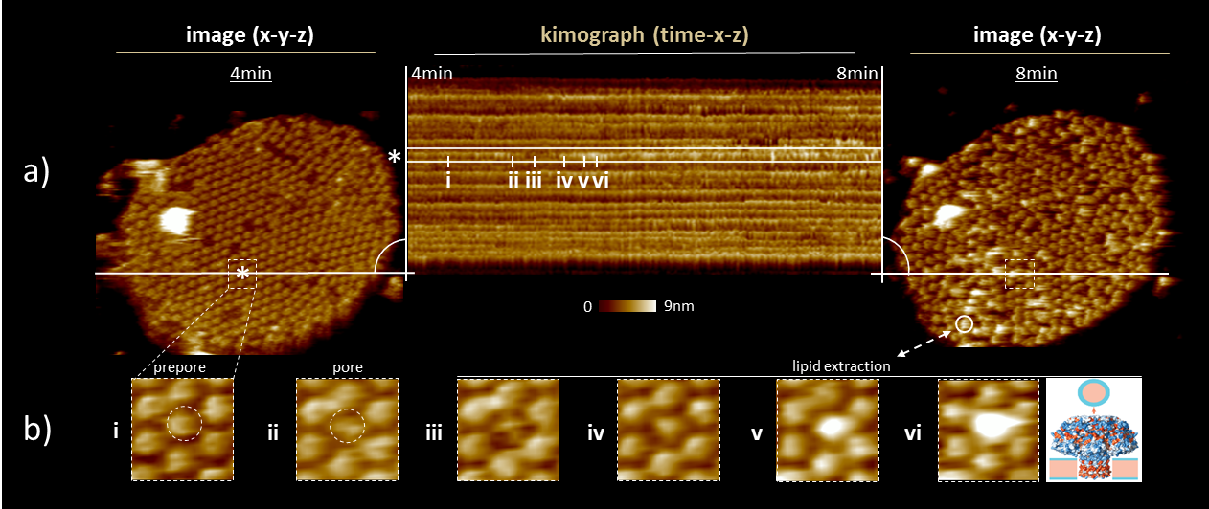
Supplementary Figure S2) Lipid extraction at the prepore-to-pore transition. a left, image of the SM/Chol 1:1 membrane patch from Fig. 2, the patch covered with Lysenin oligomers, out of which 5% are in the pore structural state. The frame correspond to minute 4 of the time reference of Fig. 2 and supplementary movie 2. The asterisk indicates the lysenin oligomer highlighted in the figure. a central, kymograph from the minute 4 to the minute 8 of the time reference of Fig. 2 of the profile-lines indicated. Six instants from lysenin nonamer highlighted are signalled in roman numbers. a right, image of the SM/Chol 1:1 membrane patch covered with Lysenin nonamers at minute 8. 11% of nonamers are in the pore structural state. The white circle signals one of the events of lipid extraction visible in the image. b, Images of the six instants from a lysenin oligomer highlighted in the figure. i, the nonamer in prepore structural state. ii, the nonamer in pore structural state. iii, iv, v and vi, lipid extraction; sequence of events. An illustrative cartoon is shown on vi.

Origin of hydrophobic negative mismatch in lysenin pores

Cryogenic Electron Microscopy (Cryo-EM) studies- of Lysenin pore is 32 Å in height¹. Sphingomyelin/Cholesterol (SM/Chol) 1:1 bilayers are about 4.5 nm height.58 This difference in height of Lysenin pore in SM/Chol 1:1 membranes implies a bent of membrane in the region surrounding the pore, call negative mismatch^{2,3,4}. This membrane bending results in a net attraction-to decrease the amount of bent membrane- between pores that induce aggregation.59,60

1. Bokori-Brown, M., Martin, T.G., Naylor, C.E., Basak, A.K., Titball, R.W. & Savva, C.G. Cryo-EM structure of lysenin pore elucidates membrane insertion by an aerolysin family protein. Nat Commun 7, 11293 (2016).
2. Ros, U. & Garcia-Saez, A.J. More Than a Pore: The Interplay of Pore-Forming and Lipid Membranes. J Membr Biol 248, 545 (2015).
3. Quinn, P.J. Structure of Sphingomyelin Bilayers and Complexes with Cholesterol Forming Membrane Rafts. Langmuir, 10 (2013).
4. Guigas, G. & Weiss, M. Effects of protein crowding on membrane systems. Biochim Biophys Acta 1858, 2441 (2016).
60. Phillips, R., Ursell, T., Wiggins, P. & Sens, P. Emerging roles for lipids in shaping membrane-protein function. Nature 459, 379 (2009).

