Supplementary Figures

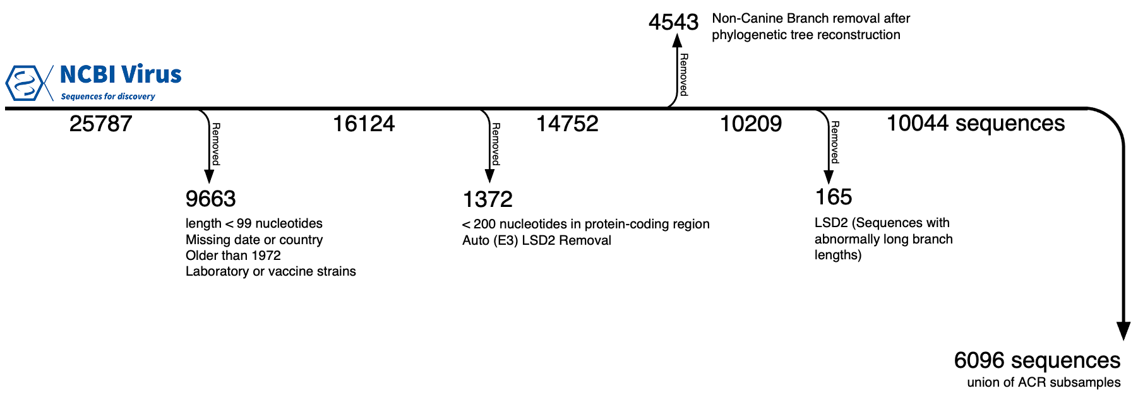

Supplementary Figure 1. Flowchart of inclusion and exclusion of RABV sequences downloaded from the NCBI Virus database. The number of sequences excluded and the reason for their removal is shown. The number of sequences present at each step is visible under the horizontal line.

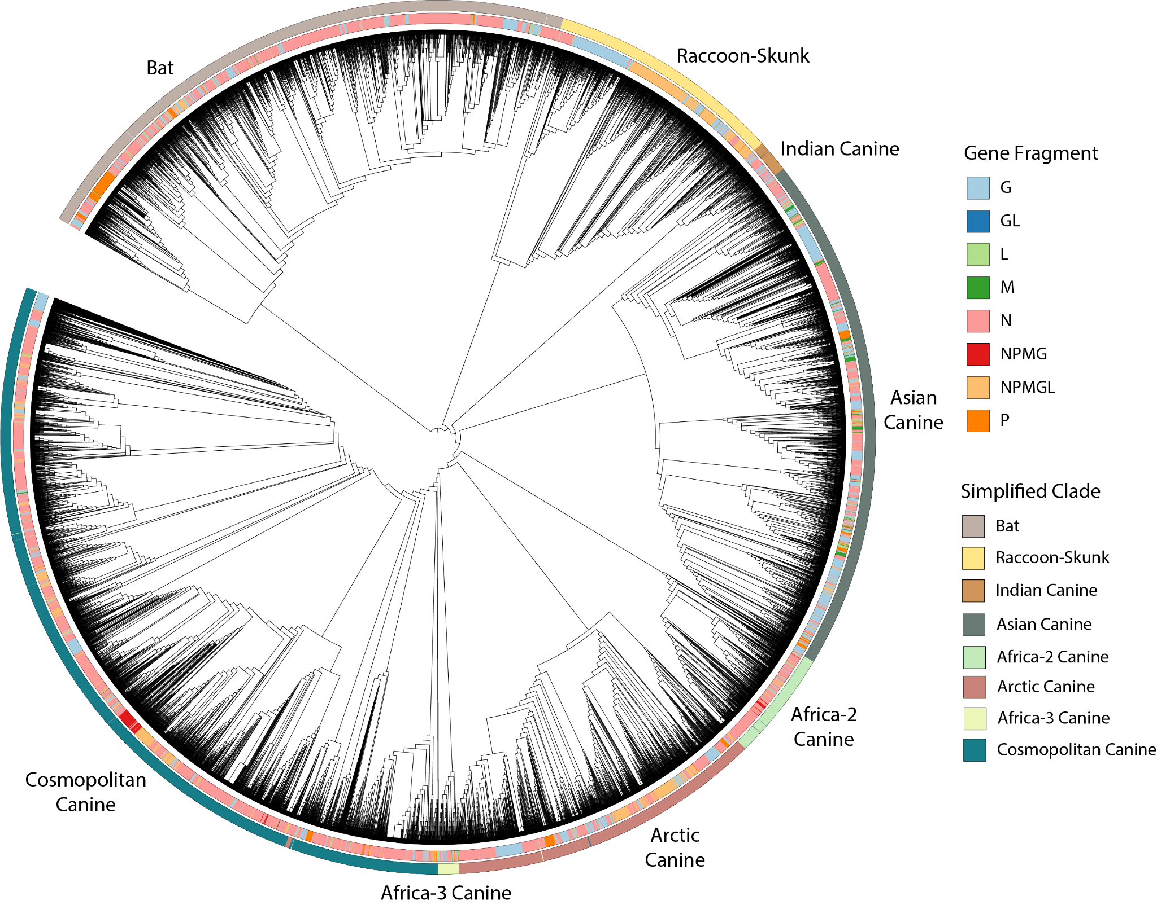

Supplementary Figure 2. Phylogenetic analysis of 14,752 RABV sequences. Sequences are labeled by simplified major clades (outer circle) and gene fragment (inner circle). Phylogenetic grouping by clade is clear, while there is a scattered distribution by gene fragment.

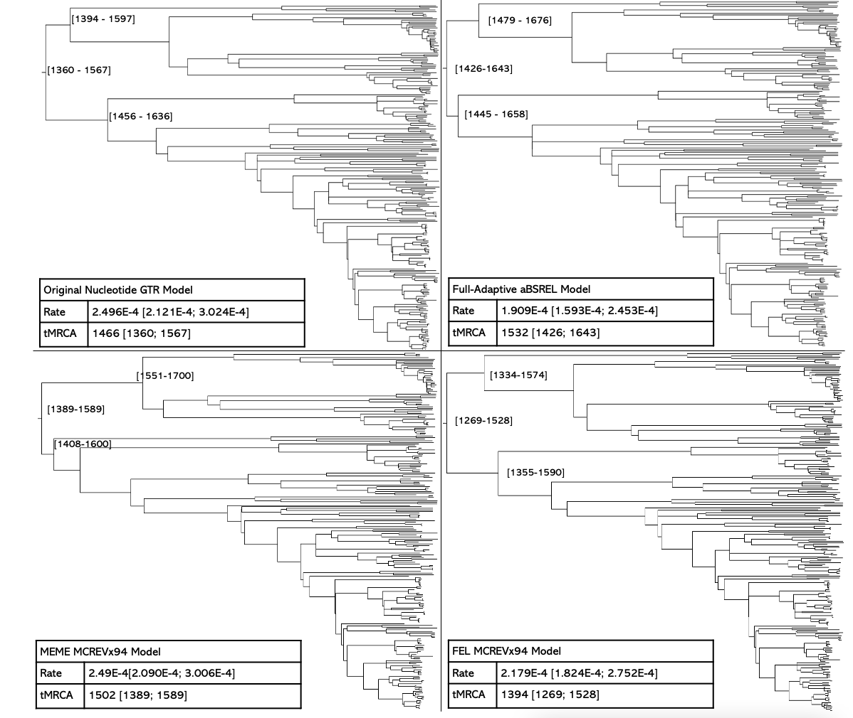

Supplementary Figure 3. Time-calibrated phylogenetic tree after branch-length optimization. Branch lengths were re-estimated by positive and purifying selection models in HyPhy by aBSREL, FEL, and MEME.

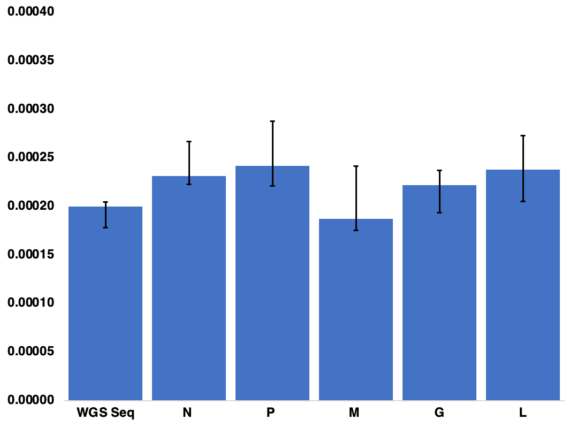

Supplementary Figure 4. Evolutionary rate of RABV genes in the canine-maintained cluster. Evolutionary rates were estimated by LSD2 from gene-specific MSAs with noncoding regions removed. Noncoding regions were not removed from WGS sequences. Regions tested include whole-genome sequences (WGS), nucleoprotein (N), phosphoprotein (P), matrix (M), glycoprotein (G) and polymerase (L). Error bars present 95% confidence intervals from 1000 replicates.

Supplementary Tables

Supplementary Table 1. Full RABV Metadata with added columns and exclusion reason
https://github.com/amholtz/GlobalRabies/blob/main/data/metadata_edited_exclusion.tab
https://amholtz.github.io/GlobalRabies/

Supplementary Table 2. Subgenomic fragments by sequence and country. Number of sequences and countries represented by each sequence fragment.

Fragment | Sequences | Countries
N | 8136 | 120
G | 3649 | 85
L | 254 | 77
P | 572 | 78
M | 196 | 77
WGS | 1972 | 75
Total | 14779 | 121

Supplementary Table 3. Full Canine RABV tree compared to subsampled trees. Subsamples are the result of a subsampling protocol which produces a unique set of sequences for a more equal representation of countries. Internal nodes and their geographic estimates were compared to the full-tree. Nodes with estimated character state probabilities greater than 50% were considered resolved. Internal nodes of two trees are compatible if their subtrees have the same tips. Of the compatible nodes in a subsample and the full tree, the estimated character (if resolved in both) was compared. ‘Agg’ column presents the full tree that has been pruned by the aggregation of sequences represented by subsamples 1-5. Triplet distance represents the fraction of triplets that differ across the trees normalized with all triplet possibilities in the compared trees.

 | Full Tree | Sub 1 | Sub 2 | Sub 3 | Sub 4 | Sub 5 | Agg
tMRCA | 1356  [1301-1403] | 1375  [1310- 1429] | 1375  [1327-1416] | 1369  [1310-1416] | 1374  [1317-1423] | 1368  [1311-1417] | 1356  [1301-1403]
num. tips | 10044 | 5371 | 5367 | 5367 | 5372 | 5371 | 6096
num. internal nodes | 4779 | 2729 | 2724 | 2751 | 2713 | 2715 | 3114
normalized triplet distance to Full Tree | - | 0.0062 | 0.0064 | 0.0062 | 0.0063 | 0.0060 | -
# reso. internal nodes (%) | 4706 (98.5%) | 2673 (97.9%) | 2665 (97.8%) | 2687 (97.7%) | 2646 (97.5%) | 2656 (97.8%) | -
inter. nodes Full Tree compatible (%) | - | 60.16% | 60.84% | 59.03% | 59.94% | 59.65% | -
Full Tree shared ACR (of compatible) | - | 1770  (94.40%) | 1741  (94.47%) | 1817 (94.24%) | 1778 (94.32%) | 1787  (94.10%) | 2169 (93.61%)

Supplementary Table 4. Ancestral character reconstruction (ACR) by region and country of both parental and child node for 44 canine subclades. 95% confidence intervals are provided for the tMRCA for each clade. tMRCA of previous Troupin et al. ²⁶ are displayed. Rows with more than one country show the conflict between the confidence analysis between the full tree ACR result and the subsamples (Full Tree | Subsampled aggregation).

Clade Definition | Regional Origin | Country Origin | TMCRA | Troupin et al. ²⁶  TMRCA | Parent Region | Parent Country | Parent - TMRCA
Africa-2 | Western Africa |  | 1799 ( 1761 - 1832 ) | 1802 ( 1750 - 1852 ) |  |  | 1578 (1522 - 163 )
Africa-3 | Southern Africa | South Africa | 1723 ( 1691 - 1752 ) | 1756 ( 1710 - 1815 ) |  |  | 1564 (1526 - 159 )
Arctic_A | Northern America | Canada | 1929 ( 1918 - 1939 ) | 1942 ( 1929 - 1954 ) |  |  | 1796 (1766 - 1824)
Arctic_AL1a | Southern Asia |  | 1920 ( 1905 - 1931 ) | 1940 ( 1927 - 1953 ) | Southern Asia |  | 1879 (1859 - 1898)
Arctic_AL1b | Southern Asia |  | 1948 ( 1940 - 1954 ) | 1936 ( 1919 - 1953 ) | Southern Asia |  | 1938 (1931 - 1945)
Arctic_AL2 | Eastern Asia | China | 1866 ( 1843 - 1885 ) | 1886 ( 1852 - 1921 ) |  |  | 1743 (1709 - 1777 )
Arctic_AL3 | Southern Asia | Nepal | 1977 ( 1973 - 1981 ) | 1881 ( 1856 - 1906 ) | Southern Asia |  | 1907 (1892 - 1921)
Asian_SEA1a | Eastern Asia | China | 1904 ( 1880 - 1926 ) | 1973 ( 1967 - 1978 ) | Eastern Asia |  | 1711 (1675 - 1747)
Asian_SEA1b | Eastern Asia |  | 1768 ( 1737 - 1797 ) | 1830 ( 1789 - 1873 ) | Eastern Asia |  | 1711 (1675 - 1747)
Asian_SEA2a | Eastern Asia | China | 1826 ( 1799 - 1850 ) | 1956 ( 1945 - 1967 ) | Eastern Asia |  | 1740 (1701 - 1773)
Asian_SEA2b | Eastern Asia | China | 1975 ( 1966 - 1982 ) | 1951 ( 1937 - 1968 ) | Eastern Asia | China | 1857 (1831 - 1881)
Asian_SEA3 | South-Eastern Asia | Thailand | 1853 ( 1827 - 1876 ) | 1898 ( 1876 - 1920 ) | Eastern Asia |  | 1589 (1553 - 1623)
Asian_SEA4 | South-Eastern Asia | Philippines | 1898 ( 1885 - 1910 ) | 1925 ( 1904 - 1946 ) | Eastern Asia |  | 1671 (1635 - 1701)
Asian_SEA5 | Eastern Asia | Taiwan | 1791 ( 1762 - 1819 ) | 1957 ( 1939 - 1973 ) | Eastern Asia |  | 1651 (1616 - 1680)
Cosmopolitan | Northern America |  | 1656 ( 1627 - 1683 ) | 1730 ( 1687 - 1773 ) |  |  | 1564 1526 - 1598)
Cosmo_AF1a | Northern Africa |  | 1876 ( 1862 - 1889 ) | 1872 ( 1851 - 1895 ) | Northern Africa |  | 1854 (1842 - 1866)
Cosmo_AF1b | Eastern Africa | Zambia | 1878 ( 1863 - 1891 ) | 1907 ( 1890 - 1925 ) | Eastern Africa |  | 1826 (1813 - 1838)
Cosmo_AF1c | Eastern Africa | Madagascar | 1983 ( 1980 - 1985 ) | 1983 ( 1980 - 1985 ) | Eastern Africa |  | 1826 (1813 - 1838)
Cosmo_AF4 | Northern Africa | Egypt | 1910 ( 1894 - 1927 ) | 1932 ( 1923 - 1940 ) | Northern America | USA | 1679 (1656 - 1701)
Cosmo_AM1 | Northern America | USA | 1867 ( 1850 - 1883 ) | 1908 ( 1886 - 1928 ) | Northern America | USA | 1810 (1794 - 1825)
Cosmo_AM2a | Central America | Mexico | 1851 ( 1836 - 1864 ) | 1890 ( 1861 - 1920 ) | Northern America | USA | 1772 (1750 - 1791)
Cosmo_AM2b | Northern America | USA | 1939 ( 1928 - 1949 ) | 1830 ( 1781 - 1852 ) | Northern America | USA | 1791 (1768 - 1811)
Cosmo_AM3a | South America | Brazil | 1897 ( 1880 - 1912 ) | 1912 ( 1890 - 1936 ) | South America | Brazil | 1808 (1785 - 1827)
Cosmo_AM3b | South America | Brazil | 1861 ( 1847 - 1872 ) | 1890 ( 1863 - 1916 ) | South America | Brazil | 1808 (1785 - 1827)
Cosmo_AM4 | Northern America | USA | 1821 ( 1800 - 1840 ) | 1846 ( 1811 - 1883 ) | Northern America | USA | 1710 (1688 - 1732)
Cosmo_CA1 | Eastern Europe | Russia | 1924 ( 1913 - 1935 ) | 1946 ( 1936 - 1957 ) | Eastern Europe |  | 1898 (1889 - 1908)
Cosmo_CA2 | Western Asia | Iraq | 1981 ( 1977 - 1985 ) | 1944 ( 1927 - 1960 ) | Western Asia |  | 1817 (1798 - 1833)
Cosmo_CA3 | Eastern Europe | Romania|  Russia | 1936 ( 1925 - 1946 ) | 1942 ( 1926 - 1956 ) | Eastern Europe |  | 1880 (1870 - 1889)
Cosmo_CE | Eastern Europe | Germany|  Poland | 1968 ( 1962 - 1973 ) | 1967 ( 1961 - 1974 ) | Eastern Europe | Germany|  Poland | 1931 (1921 - 1938)
Cosmo_EE | Southern Europe | Serbia | 1944 ( 1936 - 1950 ) | 1943 ( 1934 - 1954 ) | Eastern Europe | Poland|Serbia | 1907 (1897 - 1916)
Cosmo_ME1a | Western Asia |  | 1922 ( 1911 - 1933 ) | 1938 ( 1927 - 1948 ) | Western Asia |  | 1861 (1850 - 1872 )
Cosmo_ME1b | Western Asia | Israel | 1990 ( 1987 - 1991 ) | 1987 ( 1984 - 1990 ) | Western Asia |  | 1922 (1911 - 1933 )
Cosmo_ME2 | Western Asia | Turkey | 1960 ( 1952 - 1968 ) | 1986 ( 1984 - 1989 ) | Western Asia |  | 1859 (1847 - 1870 )
Cosmo_NEE | Eastern Europe |  | 1887 ( 1873 - 1899 ) | 1954 ( 1926 - 1964 ) | Eastern Europe | Poland|Serbia | 1882 (1870 - 1892 )
Cosmo_Vac | Western Europe | France | 1959 ( 1950 - 1967 ) | not in study | Northern America | USA | 1788 (1771 - 1805 )
Cosmo_Vac2 | Central America | Mexico | 1942 ( 1926 - 1954 ) | not in study | Northern America | USA | 1864 (1845 - 1880 )
Cosmo_WE | Western Europe | Germany | 1948 ( 1940 - 1954 ) | 1949 ( 1942 - 1958 ) | Eastern Europe | Germany|  Poland | 1931 (1921 - 1938 )
Cosmo_YUGCOW | Southern Europe | Montenegro | 1977 ( 1977 - 1979 ) | not in study | Western Asia |  | 1819 (1804 - 1833)
Cosmo_YUGFOX | Southern Europe | Serbia | 1967 ( 1954 - 1977 ) | not in study | Southern Europe | Serbia | 1909 (1894 - 1923)
Indian-Sub | Southern Asia |  | 1760 ( 1716 - 1799 ) | 1785 ( 1733 - 1840 ) |  |  | 1397 (1341 - 1443)

Supplementary Table 5. Inferred human-mediated introductions identified on the phylogenetic tree. Using the full-canine tree consisting of 10,044 sequences, 14,640 transmissions were identified, 232 of which were to non-neighboring countries, and 43 of which fit the criteria as a human-mediated introduction. Human-mediated introductions are defined as transmissions that occurred within 16 years and between two countries that are more than 2000 km apart or separated by a body of water.

Parent Country | Child Country | Parent Date | Child Date | Branch Length (years) | Subtree Size (num. of tips) | Distance (km) | (km/year)
Cameroon | Tanzania | 1992.8 | 1993.0 | 0.2 | 73.0 | 3308.4 | 19477.4
China | Chile | 1996.4 | 1998.0 | 1.6 | 1.0 | 19079.9 | 11754.8
Bangladesh | France | 2014.6 | 2016.5 | 1.9 | 1.0 | 7916.8 | 4131.3
India | Oman | 2008.5 | 2009.0 | 0.5 | 1.0 | 1936.2 | 3556.2
India | Oman | 2007.9 | 2008.7 | 0.8 | 13.0 | 1936.2 | 2442.4
Philippines | Japan | 2004.5 | 2006.0 | 1.5 | 1.0 | 2999.5 | 2003.3
Philippines | Japan | 2004.5 | 2006.0 | 1.5 | 1.0 | 2999.5 | 2003.3
Philippines | Japan | 2004.1 | 2006.0 | 1.9 | 1.0 | 2999.5 | 1605.9
India | Nigeria | 2002.0 | 2007.7 | 5.7 | 3.0 | 8088.0 | 1430.3
France | India | 1994.0 | 1999.0 | 5.0 | 5.0 | 6594.2 | 1318.8
India | France | 2009.0 | 2014.0 | 5.0 | 1.0 | 6594.2 | 1316.7
France | Mexico | 1994.0 | 2002.5 | 8.5 | 3.0 | 9206.8 | 1079.8
Nigeria | Iran | 2007.7 | 2013.2 | 5.5 | 1.0 | 5865.2 | 1065.1
Nepal | Italy | 1990.0 | 1997.0 | 7.0 | 1.0 | 6640.5 | 948.6
France | Oman | 1992.0 | 1998.0 | 6.0 | 1.0 | 5620.0 | 936.2
India | Italy | 2004.7 | 2011.9 | 7.1 | 1.0 | 5922.2 | 831.8
Mali | France | 2009.0 | 2014.2 | 5.3 | 1.0 | 4139.8 | 785.9
Thailand | Philippines | 2001.0 | 2004.0 | 3.0 | 1.0 | 2210.0 | 736.0
India | Ethiopia | 2000.9 | 2008.0 | 7.1 | 1.0 | 4561.5 | 644.2
Thailand | Philippines | 2001.0 | 2005.0 | 4.0 | 1.0 | 2210.0 | 552.5
China | Thailand | 2005.0 | 2012.0 | 7.0 | 1.0 | 3303.9 | 471.8
Nepal | Italy | 1981.3 | 1996.0 | 14.7 | 1.0 | 6640.5 | 452.2
Namibia | Tanzania | 2004.0 | 2011.0 | 7.0 | 1.0 | 2953.5 | 421.9
China | Thailand | 2005.0 | 2013.0 | 8.0 | 1.0 | 3303.9 | 412.8
China | Thailand | 2005.0 | 2013.0 | 8.0 | 1.0 | 3303.9 | 412.8
China | Thailand | 2005.0 | 2013.0 | 8.0 | 1.0 | 3303.9 | 412.8
China | Thailand | 2005.0 | 2013.0 | 8.0 | 1.0 | 3303.9 | 412.8
China | Thailand | 2005.0 | 2013.0 | 8.0 | 1.0 | 3303.9 | 412.8
China | Thailand | 2005.0 | 2013.0 | 8.0 | 1.0 | 3303.9 | 412.8
China | Thailand | 2005.0 | 2013.0 | 8.0 | 1.0 | 3303.9 | 412.8
Tanzania | Cameroon | 1993.0 | 2001.5 | 8.5 | 24.0 | 3308.4 | 388.3
China | Thailand | 2005.0 | 2014.0 | 9.0 | 1.0 | 3303.9 | 367.0
China | Thailand | 2005.0 | 2014.0 | 9.0 | 1.0 | 3303.9 | 367.0
Tanzania | Ghana | 1995.9 | 2008.7 | 12.9 | 1.0 | 4604.6 | 357.4
India | Thailand | 2009.0 | 2017.9 | 8.9 | 1.0 | 2919.7 | 327.1
India | Iran | 1999.0 | 2007.5 | 8.5 | 2.0 | 2544.6 | 297.6
China | Thailand | 2002.5 | 2014.0 | 11.5 | 2.0 | 3303.9 | 286.3
Tanzania | Cameroon | 1993.0 | 2006.5 | 13.5 | 3.0 | 3308.4 | 244.5
Mauritania | Nigeria | 1981.5 | 1993.0 | 11.5 | 1.0 | 2478.3 | 216.1
Cuba | Colombia | 1905.6 | 1917.5 | 12.0 | 3.0 | 2203.7 | 184.4
Mexico | Cuba | 1894.2 | 1905.6 | 11.3 | 109.0 | 1784.2 | 157.7
Morocco | Spain | 1958.9 | 1973.4 | 14.5 | 9.0 | 762.7 | 52.8
Spain | Morocco | 1992.5 | 2008.0 | 15.5 | 1.0 | 762.7 | 49.3

Supplementary Methods

Supplementary Methods 1. Purifying Selection Models used from HyPhy
FEL identifies instances of purifying selection in codons and identifies the internal branches where this has occurred. MEME identifies instances of episodic and pervasive positive selection on internal branches of the tree. aBSREL uses an adaptive model to re-estimate dN/dS ratios for each branch of the tree, yielding a more specific branch-length estimation.

Supplementary Methods 2. ACR Comparison Between Full-Canine Tree and Subsamples
A custom script (https://github.com/amholtz/GlobalRabies/blob/main/R/ACR_Sub_comparison.R) was used to compare the ACR node estimations for each subsample and full-canine tree. We considered nodes with ACR marginal probability > 50% as “resolved” and the others as “unresolved”. 98% of the tree nodes were resolved in the full-canine tree and in the subsampled trees (see Supp. Table 3 for more details). The state estimates were aggregated across each subsample and compared to the full-canine tree PastML node estimates. Only state (country) estimates consistent between the aggregated subsample and full-canine tree were retained. Of 4706 nodes that had resolved ancestral state (country) estimates from the full-tree, 1103 were found across the 5 subsamples (23%) and could hence be compared. Most nodes that were not comparable were peripheral on the tree. A total of 90% of the comparable nodes share the same ancestral state estimates as the full-canine tree estimate. This result strongly validates the original ancestral character reconstruction (ACR) for the full-canine tree, indicating how only about 10% of the nodes alter after subsampling.

