Supplementary Materials for
Tissue-Specific Carbon Isotope Discrimination of Amino Acids in the Southern Sea Otter
Alana L. Robinson*, Emma A. Elliott Smith, Alexi C. Besser, Seth D. Newsome
*Corresponding author: alanalea@unm.edu

This PDF file includes:
Supplementary Text
SI-1 - Corrections to primary producer LDA dataset.
Additional Figures and Tables
Table S1 - Amino acid δ¹³C values for samples derivatized, analyzed, and corrected using both the older (AA-STD; Elliott Smith et al. 2022) and newer (AA-UNM) in-house reference materials.
Table S2 - Average offsets in amino acid δ¹³C values among samples derivatized, analyzed, and corrected using both the older (AA-STD; Elliott Smith et al. 2022) and newer (AA-UNM) in-house reference materials.

Table S3 - Amino acid δ¹³C values after applying the offsets from Table S2.
Table S4 - List of sea otter individuals, including stranding site, sex, and age.
Table S5 - Global amino acid δ¹³C means and variances of the in-house reference material.
Table S6 - LDA classifications of sea otter tissues using a training dataset of marine primary producer dataset for the North Pacific (Elliott Smith et al. 2022).
Table S7 - Linear discriminant analysis (LDA) classifications comparing results with and without lysine in a marine primary producer dataset from the North Pacific (Elliott Smith et al. 2022).
Figure S1 - Bulk tissue δ¹³C and δ¹⁵N whisker profiles for 10 sea otter individuals.
Figure S2 - Linear regressions of δ¹³C values of threonine in the liver and serine and glycine in liver, bone collagen, muscle, and whisker.
FigureS3 - Bulk tissue δ¹³C and δ¹⁵N values of southern sea otters reported in Elliott Smith et al. (2020).
Figure S4 - Essential amino acid δ¹³C “fingerprinting” results for samples from in-house reference material calibration test.
Figure S5 - Essential amino acid δ¹³C “fingerprinting” results for samples from in-house reference material calibration test after applying offsets.
Figure S6 - Relationships between δ¹³C values of precursor and product AA for different tissues.

SI-1. Corrections to primary producer LDA dataset.
The primary producer data published in Elliott Smith et al. 2022 and used in this study were generated on the same GC-C-IRMS system at UNM-CSI following the same derivatization procedure as described here for Monterey Bay Enhydra lutris specimens. Thus, no inter-laboratory calibrations were necessary. However, during this project, the supplier of the in-house reference material changed; the sea otter amino acid (AA) δ¹³C data we present here were analyzed with the newer reference material. This material contains powdered AAs of known isotopic composition and is derivatized along with each batch of samples to account for the carbon atoms added during derivatization (O'Brien et al. 2002). To calibrate between these two in-house reference materials and make our data directly comparable with previous works, we derivatized a subset of our sea otter samples (n=8; Table S1) with both the reference material used in Elliott Smith et al. (2022) and the new UNM-CSI reference material – henceforth termed “AA-STD”, and “AA-UNM”, respectively. This calibration dataset included samples of bone collagen, liver, muscle, and whisker from the female otter 7060-14, whisker, muscle, and bone collagen from male 4981-07, and muscle from male 3110-98 (Table S1).
We analyzed individual AA δ¹³C values for these samples following the procedures described in the Methods over the course of two consecutive nights; four to seven injections of each in-house reference material bracketed sample injections. We corrected the AA δ¹³C data as described in the Methods using the measured values for each in-house reference material, resulting in two sets of “corrected” AA δ¹³C values for each of our eight samples (Table S1). We then compared the AA δ¹³C values corrected using the AA-STD vs. AA-UNM standards for each sample. There were consistent, albeit variable, differences among AA δ¹³C values (Table S1). We also compared the positions of each sample in essential AA “fingerprinting” space (e.g., Larsen et al. 2013) between the two in-house reference material corrections (Figure S4) using linear discriminant analysis (LDA) on the aforementioned dataset of nearshore marine producers (Elliott Smith et al. 2022) as described in the Methods. Systematic differences were evident between AA-STD vs. AA-UNM corrected δ¹³C values and essential AA δ¹³C fingerprints. To account for this, we subtracted the average AA-STD – AA-UNM offset for each AA δ¹³C value (Table S2). This serves to calibrate AA-UNM-corrected sample δ¹³C values to AA-STD-corrected sample δ¹³C values (Table S3). Following this adjustment, sample AA δ¹³C values (Table S2) and positions in LDA space (Figure S5) were nearly indistinguishable for the eight samples ran with both in-house reference materials. We applied the calculated offsets in Table S2 to all our samples to make direct comparisons with the nearshore marine producer data from Elliott Smith et al. (2022).

Table S1. Amino acid δ¹³C values for samples derivatized, analyzed, and corrected using both the older (AA-STD; Elliott Smith et al. 2022) and newer (AA-UNM) in-house reference materials.
Reference Material | Sample ID | Ala13C | Gly13C | Thr13C | Ser13C | Val13C | Leu13C | Ile13C | Pro13C | Asp13C | Glu13C | Phe13C | Lys13C
AA-UNM | ALR-SO-3110-98-MUSCLE | -14.4 | -2 | -4.1 | 2.3 | -19.7 | -24.5 | -14 | -16.1 | -12.6 | -13.8 | -24.1 | -16
AA-STD | ALR-SO-3110-98-MUSCLE | -13.6 | -0.8 | -3.5 | 4.9 | -19.3 | -24.2 | -14.3 | -15.4 | -12.2 | -14.2 | -24.2 | -15.8
 | Offset | 0.8 | 1.2 | 0.6 | 2.6 | 0.4 | 0.3 | 0.3 | 0.7 | 0.4 | 0.4 | 0.1 | 0.2
AA-UNM | ALR-SO-4981-07-BONE | -14.3 | -5.2 | -6.5 | -1.7 | -20.8 | -24.7 | -17.3 | -19 | -15.6 | -14.4 | -24.5 | -19.7
AA-STD | ALR-SO-4981-07-BONE | -13.5 | -4.1 | -5.9 | 0.9 | -20.4 | -24.5 | -17.5 | -18.3 | -15.3 | -14.8 | -24.7 | -19.5
 | Offset | 0.8 | 1.1 | 0.6 | 2.6 | 0.4 | 0.2 | 0.2 | 0.7 | 0.3 | 0.4 | 0.2 | 0.2
AA-UNM | ALR-SO-4981-07-MUSCLE | -13.7 | -2.8 | -6.1 | 0.5 | -19.4 | -24.3 | -14.3 | -16.9 | -12.8 | -13.5 | -23.8 | -15.5
AA-STD | ALR-SO-4981-07-MUSCLE | -12.9 | -1.7 | -5.5 | 3.1 | -19 | -24.1 | -14.5 | -16.2 | -12.4 | -13.9 | -24 | -15.3
 | Offset | 0.8 | 1.1 | 0.6 | 2.6 | 0.4 | 0.2 | 0.2 | 0.7 | 0.4 | 0.4 | 0.2 | 0.2
AA-UNM | ALR-SO-4981-07-WHISKER | -14.7 | -4.9 | -6.2 | 0.2 | -20.4 | -24.1 | -14.3 | -14.4 | -12.7 | -12.2 | -24 | -16.3
AA-STD | ALR-SO-4981-07-WHISKER | -14 | -3.8 | -5.6 | 2.8 | -20 | -23.9 | -14.5 | -13.6 | -12.4 | -12.7 | -24.2 | -16.1
 | Offset | 0.7 | 1.1 | 0.6 | 2.6 | 0.4 | 0.2 | 0.2 | 0.8 | 0.3 | 0.5 | 0.2 | 0.2
AA-UNM | ALR-SO-7060-14-BONE | -13.5 | -3.1 | -4 | 3.1 | -18.8 | -23 | -14.9 | -18.4 | -13.7 | -12.2 | -23.3 | -14
AA-STD | ALR-SO-7060-14-BONE | -12.9 | -2 | -4.1 | 1.9 | -18.7 | -23.2 | -16.3 | -17.5 | -14.2 | -14 | -23.2 | -14.8
 | Offset | 0.6 | 1.1 | 0.1 | 1.2 | 0.1 | 0.2 | 1.4 | 0.9 | 0.5 | 1.8 | 0.1 | 0.8
AA-UNM | ALR-SO-7060-14-LIVER | -13.7 | -1.3 | -2.3 | 0 | -20 | -23.7 | -16.1 | -13.4 | -12.3 | -11.3 | -23.4 | -15
AA-STD | ALR-SO-7060-14-LIVER | -13.1 | -0.2 | -2.4 | -1.1 | -20 | -23.8 | -17.4 | -12.5 | -12.8 | -13.1 | -23.3 | -15.8
 | Offset | 0.6 | 1.1 | 0.1 | 1.1 | 0 | 0.1 | 1.3 | 0.9 | 0.5 | 1.8 | 0.1 | 0.8
AA-UNM | ALR-SO-7060-14-MUSCLE | -12.8 | -1.9 | -3.5 | 3.5 | -18.4 | -23.3 | -14.1 | -15.9 | -12.2 | -13.5 | -23.5 | -13.7
AA-STD | ALR-SO-7060-14-MUSCLE | -12.2 | -0.9 | -3.6 | 2.4 | -18.3 | -23.5 | -15.5 | -15 | -12.7 | -15.3 | -23.4 | -14.5
 | Offset | 0.6 | 1 | 0.1 | 1.1 | 0.1 | 0.2 | 1.4 | 0.9 | 0.5 | 1.8 | 0.1 | 0.8
AA-UNM | ALR-SO-7060-14-WHISKER | -14.5 | -2.3 | -4.3 | -1 | -19.3 | -23 | -15.1 | -14.5 | -12.2 | -12.1 | -23.6 | -17
AA-STD | ALR-SO-7060-14-WHISKER | -13.9 | -1.2 | -4.4 | -2.1 | -19.2 | -23.2 | -16.4 | -13.6 | -12.7 | -13.9 | -23.6 | -17.8
 | Offset | 0.6 | 1.1 | 0.1 | 1.1 | 0.1 | 0.2 | 1.3 | 0.9 | 0.5 | 1.8 | 0 | 0.8

Table S2. Average offsets in amino acid δ¹³C values among samples derivatized, analyzed, and corrected using both the older (AA-STD; Elliott Smith et al. 2022) and newer (AA-UNM) in-house reference materials.

Amino Acid | Mean Offset*
Alanine | -0.7 ± 0.1
Glycine | -1.1 ± 0.0
Threonine | -0.2 ± 0.4
Serine | -0.7 ± 2.0
Valine | -0.2 ± 0.2
Leucine | -0.03 ± 0.2
Isoleucine | 0.8 ± 0.6
Proline | -0.8 ± 0.1
Aspartic Acid | 0.1 ± 0.4
Glutamic Acid | 1.1 ± 0.8
Phenylalanine | 0.04 ± 0.1
Lysine | 0.3 ± 0.5

*The difference in corrected amino acid δ¹³C values using the older (AA-STD) vs. newer (AA-UNM) in-house reference materials. For example, Ala offset = Ala δ¹³C_{AA-UNM} – Ala δ¹³C_{AA-STD.}

Table S3. Amino acid δ¹³C values after applying the offsets from Table S2. Samples initially corrected to AA-UNM standard have been corrected to the AA-STD standard since this was used to correct the primary producer dataset (Elliott Smith et al. 2022).
Reference Material | Sample ID | Ala13C | Gly13C | Thr13C | Ser13C | Val13C | Leu13C | Ile13C | Pro13C | Asp13C | Glu13C | Phe13C | Lys13C
AA-STD | ALR-SO-3110-98-MUSCLE | -13.6 | -0.8 | -3.5 | 4.9 | -19.3 | -24.2 | -14.3 | -15.4 | -12.2 | -14.2 | -24.2 | -15.8
AA-UNM | ALR-SO-3110-98-MUSCLE | -13.7 | -0.9 | -3.9 | 3 | -19.5 | -24.5 | -14.8 | -15.3 | -12.7 | -14.9 | -24.1 | -16.3
 | Offset | 0.1 | 0.1 | 0.4 | 1.9 | 0.2 | 0.3 | 0.5 | 0.1 | 0.5 | 0.7 | 0.1 | 0.5
AA-STD | ALR-SO-4981-07-BONE | -13.5 | -4.1 | -5.9 | 0.9 | -20.4 | -24.5 | -17.5 | -18.3 | -15.3 | -14.8 | -24.7 | -19.5
AA-UNM | ALR-SO-4981-07-BONE | -13.6 | -4.1 | -6.3 | -1 | -20.6 | -24.7 | -18.1 | -18.2 | -15.7 | -15.5 | -24.5 | -20
 | Offset | 0.1 | 0 | 0.4 | 1.9 | 0.2 | 0.2 | 0.6 | 0.1 | 0.4 | 0.7 | 0.2 | 0.5
AA-STD | ALR-SO-4981-07-MUSCLE | -12.9 | -1.7 | -5.5 | 3.1 | -19 | -24.1 | -14.5 | -16.2 | -12.4 | -13.9 | -24 | -15.3
AA-UNM | ALR-SO-4981-07-MUSCLE | -13 | -1.7 | -5.9 | 1.2 | -19.2 | -24.3 | -15.1 | -16.1 | -12.9 | -14.6 | -23.8 | -15.8
 | Offset | 0.1 | 0 | 0.4 | 1.9 | 0.2 | 0.2 | 0.6 | 0.1 | 0.5 | 0.7 | 0.2 | 0.5
AA-STD | ALR-SO-4981-07-WHISKER | -14 | -3.8 | -5.6 | 2.8 | -20 | -23.9 | -14.5 | -13.6 | -12.4 | -12.7 | -24.2 | -16.1
AA-UNM | ALR-SO-4981-07-WHISKER | -14 | -3.8 | -6 | 0.9 | -20.2 | -24.1 | -15.1 | -13.6 | -12.8 | -13.3 | -24 | -16.6
 | Offset | 0 | 0 | 0.4 | 1.9 | 0.2 | 0.2 | 0.6 | 0 | 0.4 | 0.6 | 0.2 | 0.5
AA-STD | ALR-SO-7060-14-BONE | -12.9 | -2 | -4.1 | 1.9 | -18.7 | -23.2 | -16.3 | -17.5 | -14.2 | -14 | -23.2 | -14.8
AA-UNM | ALR-SO-7060-14-BONE | -12.8 | -2 | -3.8 | 3.8 | -18.6 | -23 | -15.7 | -17.6 | -13.8 | -13.3 | -23.3 | -14.3
 | Offset | 0.1 | 0 | 0.3 | 1.9 | 0.1 | 0.2 | 0.6 | 0.1 | 0.4 | 0.7 | 0.1 | 0.5
AA-STD | ALR-SO-7060-14-LIVER | -13.1 | -0.2 | -2.4 | -1.1 | -20 | -23.8 | -17.4 | -12.5 | -12.8 | -13.1 | -23.3 | -15.8
AA-UNM | ALR-SO-7060-14-LIVER | -13 | -0.2 | -2.1 | 0.7 | -19.8 | -23.7 | -16.9 | -12.6 | -12.4 | -12.4 | -23.4 | -15.3
 | Offset | 0.1 | 0 | 0.3 | 1.8 | 0.2 | 0.1 | 0.5 | 0.1 | 0.4 | 0.7 | 0.1 | 0.5
AA-STD | ALR-SO-7060-14-MUSCLE | -12.2 | -0.9 | -3.6 | 2.4 | -18.3 | -23.5 | -15.5 | -15 | -12.7 | -15.3 | -23.4 | -14.5
AA-UNM | ALR-SO-7060-14-MUSCLE | -12.1 | -0.8 | -3.3 | 4.2 | -18.2 | -23.3 | -14.9 | -15.1 | -12.3 | -14.6 | -23.5 | -14
 | Offset | 0.1 | 0.1 | 0.3 | 1.8 | 0.1 | 0.2 | 0.6 | 0.1 | 0.4 | 0.7 | 0.1 | 0.5
AA-STD | ALR-SO-7060-14-WHISKER | -13.9 | -1.2 | -4.4 | -2.1 | -19.2 | -23.2 | -16.4 | -13.6 | -12.7 | -13.9 | -23.6 | -17.8
AA-UNM | ALR-SO-7060-14-WHISKER | -13.8 | -1.2 | -4.1 | -0.3 | -19.1 | -23 | -15.9 | -13.7 | -12.3 | -13.2 | -23.6 | -17.3
 | Offset | 0.1 | 0 | 0.3 | 1.8 | 0.1 | 0.2 | 0.5 | 0.1 | 0.4 | 0.7 | 0 | 0.5

Table S4. List of sea otter individuals, including stranding site, sex, and age. Individuals are listed in order of date collected in Monterey Bay, CA by the California Sea Otter Stranding Network between 1998 and 2014.

Sample ID | Collection Year | Stranding Site | Sex | Age
SO 3110-98 | 1998 | Salinas River State Beach | M | Adult
SO 4923-07 | 2007 | Otter Point | M | Adult
SO 4981-07 | 2007 | Asilomar State Beach | M | Adult
SO 5774-10 | 2010 | Moss Landing | M | Adult
SO 7105-14 | 2014 | Moss Landing | M | Adult
SO 5818-10 | 2010 | Pebble Beach | F | Adult
SO 6234-11 | 2011 | Del Monte Beach | F | Adult
SO 6878-13 | 2013 | Hopkins Marine Station | F | Adult
SO 7060-13 | 2013 | Del Monte Beach | F | Adult
SO 7089-14 | 2014 | Del Monte Beach | F | Adult

Table S5. Global amino acid δ¹³C means and variances of the in-house reference material (AA-UNM). “δ¹³C_{std}” refers to the underivatized δ¹³C value of a given amino acid as measured via EA-IRMS, and “δ¹³C_{dst}” refers to the derivatized δ¹³C value of the same amino acid as measured via GC-C-IRMS. Global means and associated standard deviations (SDs) of the δ¹³C values for each amino acid were calculated across all injections of the in-house reference material across all runs and derivatization batches in this study. Amino acid δ¹³C data are corrected on a daily, or ‘per run’ basis, and thus the “Mean Within-Run SD of δ¹³C_{dst}” column is an estimate of the analytical precision of amino acid δ¹³C values. Asterisks (*) denote amino acids that are considered essential for most animals.
Amino Acid | δ¹³C_{std} | Global Mean (±SD) δ¹³C_{dst} | Mean Within-Run SD of δ¹³C_{dst}
Alanine | -18.1 | -26.3 ± 1.3 | 0.3
Aspartic Acid | -22.3 | -28.6 ± 0.4 | 0.2
Glutamic Acid | -11.1 | -23.5 ± 0.5 | 0.3
Glycine | -42.2 | -33.7 ± 1.3 | 0.2
Hydroxyproline/Proline | -10.4 | -20.7 ± 0.5 | 0.2
Serine | -30.1 | -33.5 ± 1.9 | 0.4
Tyrosine | -22.9 | -29.6± 1.0 | 0.5
Isoleucine* | -12.1 | -22.7 ± 0.7 | 0.2
Lysine* | -12.9 | -24.4 ± 2.1 | 0.4
Leucine* | -28.3 | -30.2 ± 0.6 | 0.2
Phenylalanine* | -13.1 | -21.0 ± 0.8 | 0.2
Threonine* | -10.7 | -26.8 ± 1.7 | 0.4
Valine* | -11.8 | -22.7 ± 0.7 | 0.2

Table S6. Linear discriminant analysis (LDA) classifications of sea otter tissues using a training dataset of marine primary producer dataset for the North Pacific (Elliott Smith et al. 2022). Classifications include Chlorophyta (Ulva sp.), POM/PHY (Particulate organic matter/phytoplankton), and Ochrophyta (Kelps). Chlorophyta and POM/PHY were pooled into one POM/Ulva class posthoc due to a high misclassification rate for these two sources (Table 2). Individual sea otters classifying as POM/Ulva can be considered as generally obtaining essential amino acids from ‘pelagic’ resources.

Individual | Sex | Tissue | Classification
3110 | male | Bone | Ochrophyta
3110 | male | Liver | Ochrophyta
3110 | male | Muscle | Ochrophyta
3110 | male | Whisker | Ochrophyta
4923 | male | Bone | Ochrophyta
4923 | male | Liver | Ochrophyta
4923 | male | Muscle | Ochrophyta
4923 | male | Whisker | Ochrophyta
4981 | male | Bone | Ochrophyta
4981 | male | Liver | Ochrophyta
4981 | male | Muscle | POM/Ulva
4981 | male | Whisker | POM/Ulva
5774 | male | Bone | POM/Ulva
5774 | male | Liver | Ochrophyta
5774 | male | Muscle | Ochrophyta
5774 | male | Whisker | Ochrophyta
5818 | female | Bone | POM/Ulva
5818 | female | Liver | POM/Ulva
5818 | female | Muscle | POM/Ulva
5818 | female | Whisker | Ochrophyta
6234 | female | Bone | POM/Ulva
6234 | female | Liver | POM/Ulva
6234 | female | Muscle | POM/Ulva
6234 | female | Whisker | Ochrophyta
6878 | female | Bone | POM/Ulva
6878 | female | Liver | Ochrophyta
6878 | female | Muscle | POM/Ulva
6878 | female | Whisker | Ochrophyta
7060 | female | Bone | Ochrophyta
7060 | female | Liver | Ochrophyta
7060 | female | Muscle | Ochrophyta
7060 | female | Whisker | Ochrophyta
7089 | female | Bone | Ochrophyta
7089 | female | Liver | Ochrophyta
7089 | female | Muscle | Ochrophyta
7089 | female | Whisker | Ochrophyta
7105 | male | Bone | POM/Ulva
7105 | male | Liver | Ochrophyta
7105 | male | Muscle | POM/Ulva
7105 | male | Whisker | Ochrophyta

Table S7. Linear discriminant analysis (LDA) classifications comparing results with and without lysine in a marine primary producer dataset from the North Pacific (Elliott Smith et al. 2022). Top panel of the table shows results with all six essential amino acids and bottom panel shows LDA results without lysine. Columns represent classification as given by LDA cross-validation and leave-one-out procedure; rows represent the group being classified. The cross diagonal (bold text) are correct reclassifications (82% for both models across all groups). Numbers falling off this diagonal indicate samples that were incorrectly reclassified by the model.
 | LDA Classification
 |  | Chlorophyta | Ochrophyta | POM | Rhodophyta | % Correct
LDA_{ALL EAA}:  True Producer Identity | Chlorophyta | 14 | 0 | 9 | 0 | 61
LDA_{ALL EAA}:  True Producer Identity | Ochrophyta | 2 | 54 | 0 | 0 | 96
LDA_{ALL EAA}:  True Producer Identity | POM | 9 | 1 | 17 | 2 | 59
LDA_{ALL EAA}:  True Producer Identity | Rhodophyta | 1 | 0 | 0 | 23 | 96
LDA_{NO LYS}:  True Producer Identity | Chlorophyta | 15 | 0 | 8 | 0 | 65
LDA_{NO LYS}:  True Producer Identity | Ochrophyta | 2 | 54 | 0 | 0 | 96
LDA_{NO LYS}:  True Producer Identity | POM | 9 | 1 | 18 | 1 | 62
LDA_{NO LYS}:  True Producer Identity | Rhodophyta | 3 | 0 | 0 | 21 | 88

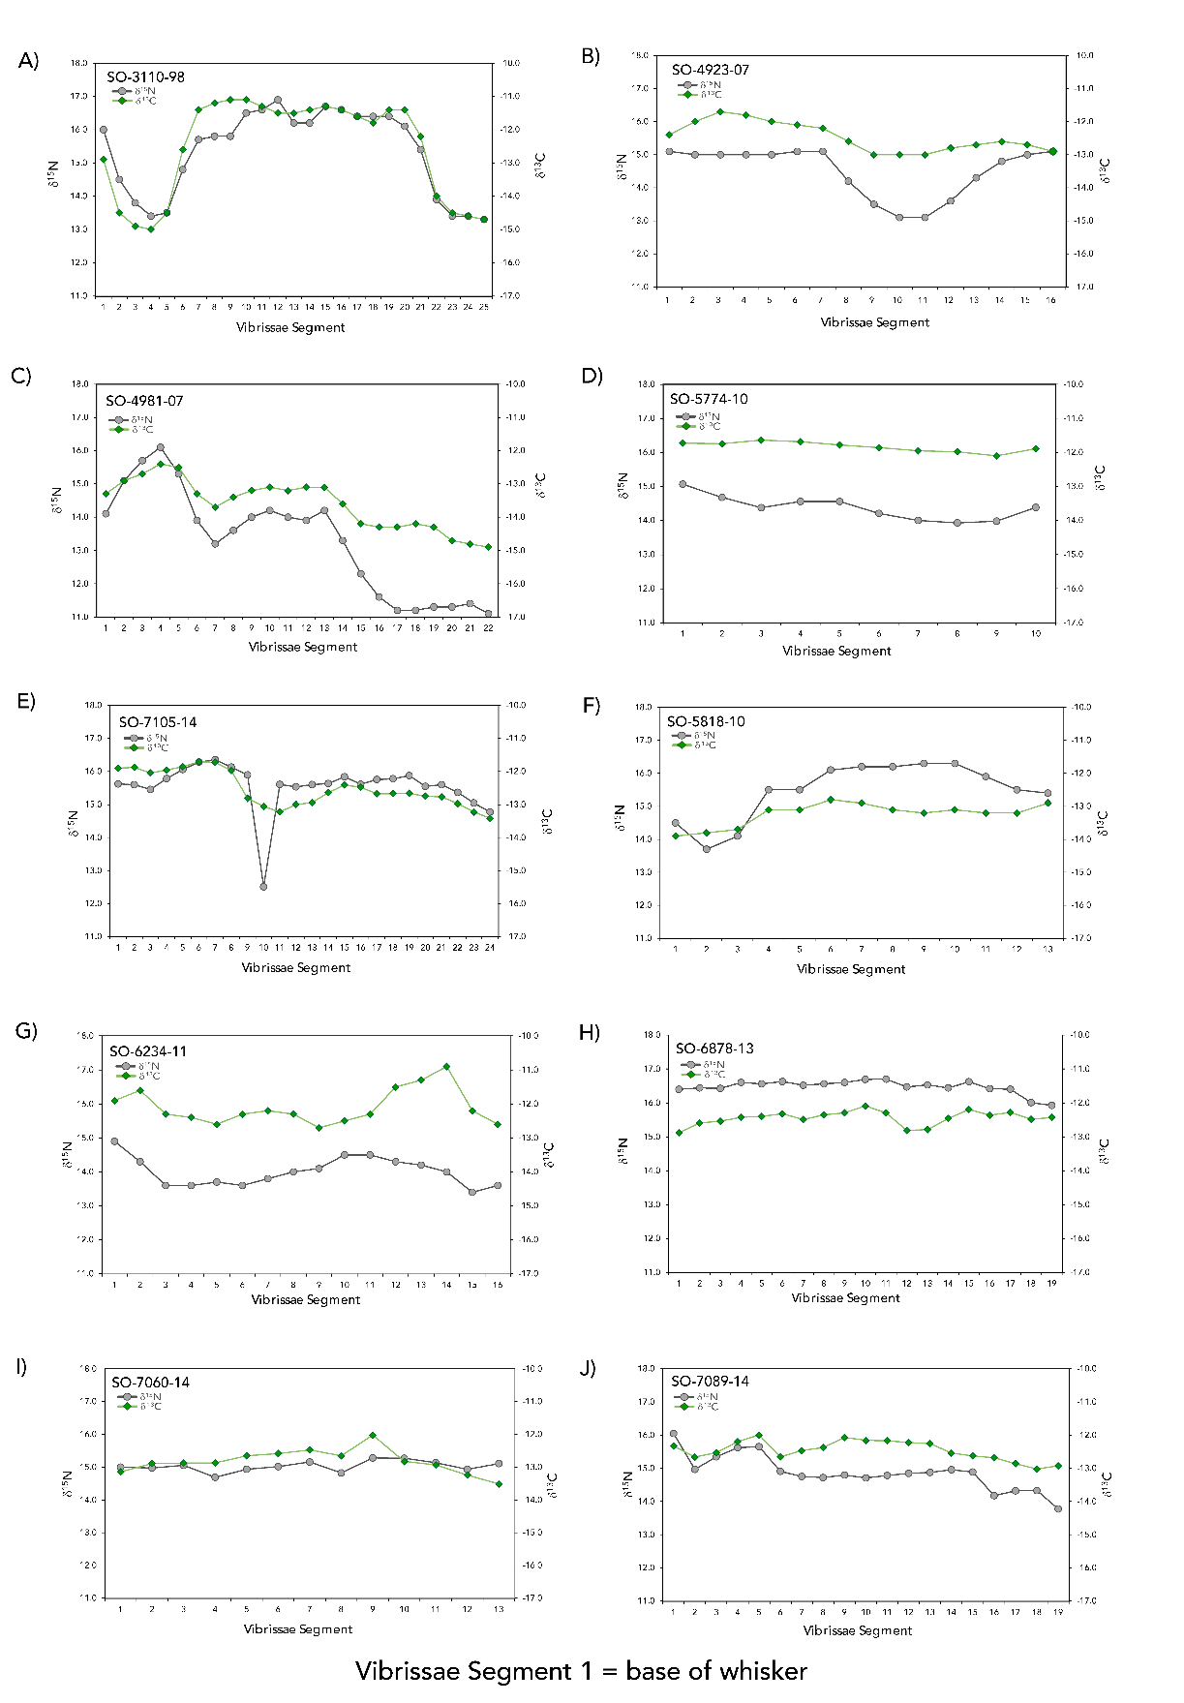
Figure S1. Bulk tissue δ¹³C and δ¹⁵N whisker profiles for 10 sea otter individuals. δ¹³C and δ¹⁵N values of segments of entire whiskers pulled from the 10 sea otter individuals analyzed in this study. The whiskers were sampled from base to tip, with the base of the whisker indicated by segment 1 in the figure. These represent ~8-12 months of an otter’s life (Tyrell et al. 2013).
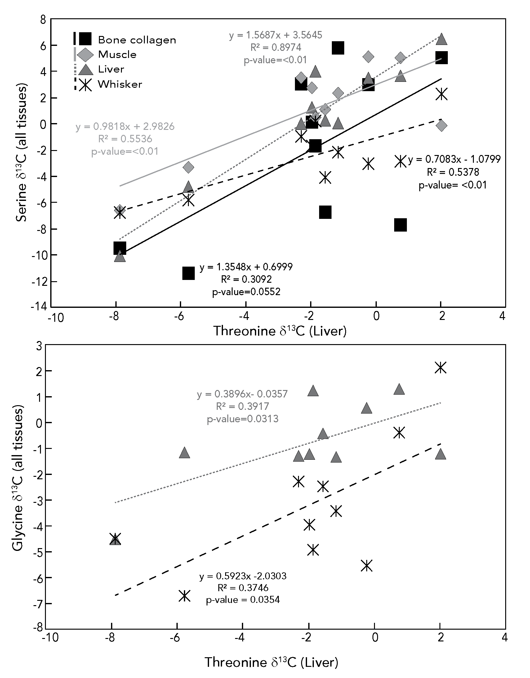
Figure S2. Linear regressions of δ¹³C values of threonine in the liver and serine and glycine in all liver, bone collagen, muscle, and whisker. The δ¹³C values of the precursor amino acid threonine on the x-axis are compared to those of its product amino acids glycine and serine on the y-axis across different tissue types. Threonine δ¹³C values are only included for liver because that is where enzymatic breakdown of dietary threonine is most likely to be taking place. Serine and glycine δ¹³C values are included for each tissue to examine possible transport of those amino acids from the liver to other tissues. Note that the catabolism of threonine into serine is indirect because there are multiple enzyme mediated reactions between the precursor (threonine) and the product (serine). A best fit line is assigned to each comparison with p-value < 0.05.

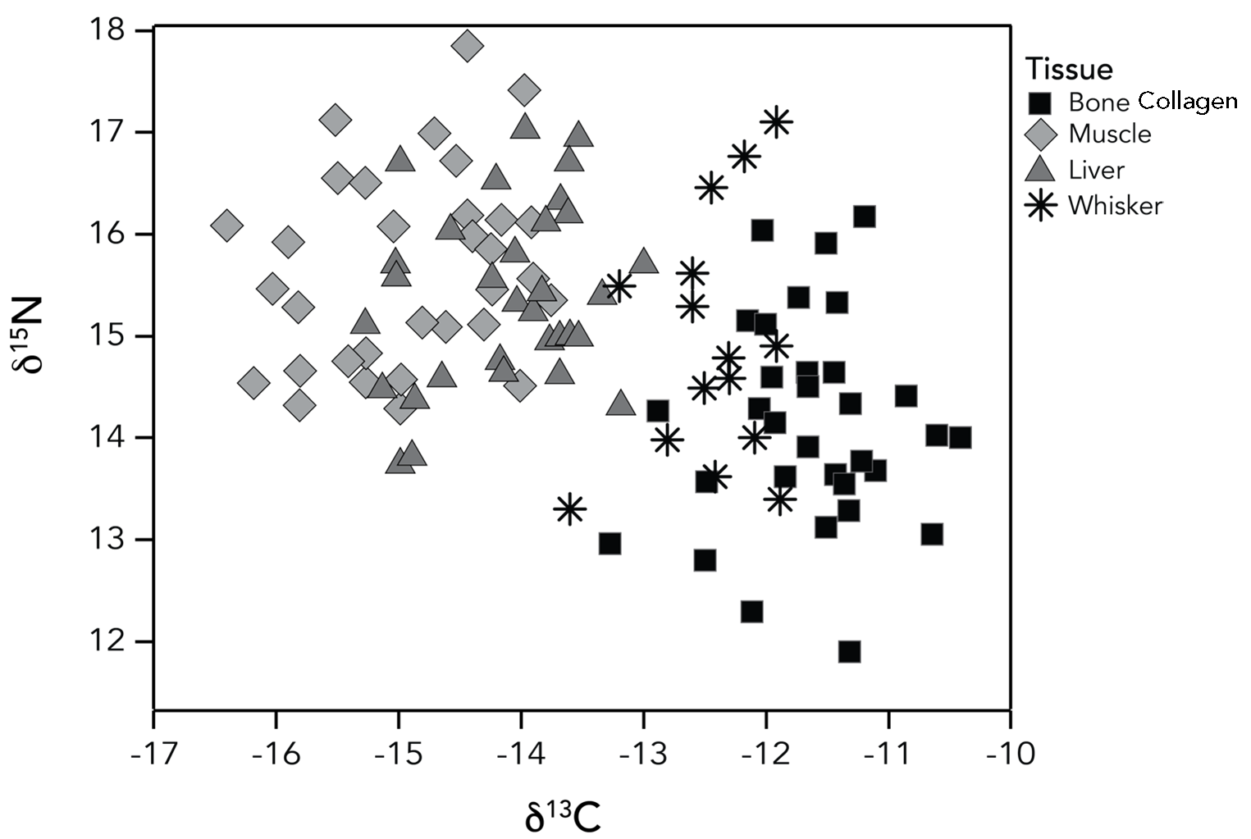
Figure S3. Bulk tissue δ¹³C and δ¹⁵N values of southern sea otters reported in Elliott Smith et al. (2020). Data include four paired tissue types for each individual (n=32).

Figure S4. Essential amino acid δ¹³C “fingerprinting” results for samples included in the in-house reference material calibration test. Blue boxes represent data corrected using the newer (AA-UNM) reference material and red boxes represent data corrected using the older (AA-STD) reference material; all sample injections were the same, and in-house reference materials bracketed sample injections in the same runs. The library dataset (e.g., black, blue, green, and grey points) were corrected using only the AA-STD reference material (Elliott Smith et al. 2022). Differences between AA-STD and AA-UNM corrections are evident.
Figure S5. Essential amino acid δ¹³C “fingerprinting” results for samples included in the in-house reference material calibration test after applying offsets. These data are identical to those presented in Figure S4, however the blue boxes now show data corrected using the newer (AA-UNM) reference material after applying the offsets described in SI-1 and reported in Table S2. Differences between AA-STD and AA-UNM corrections are negligible following the use of this offset.

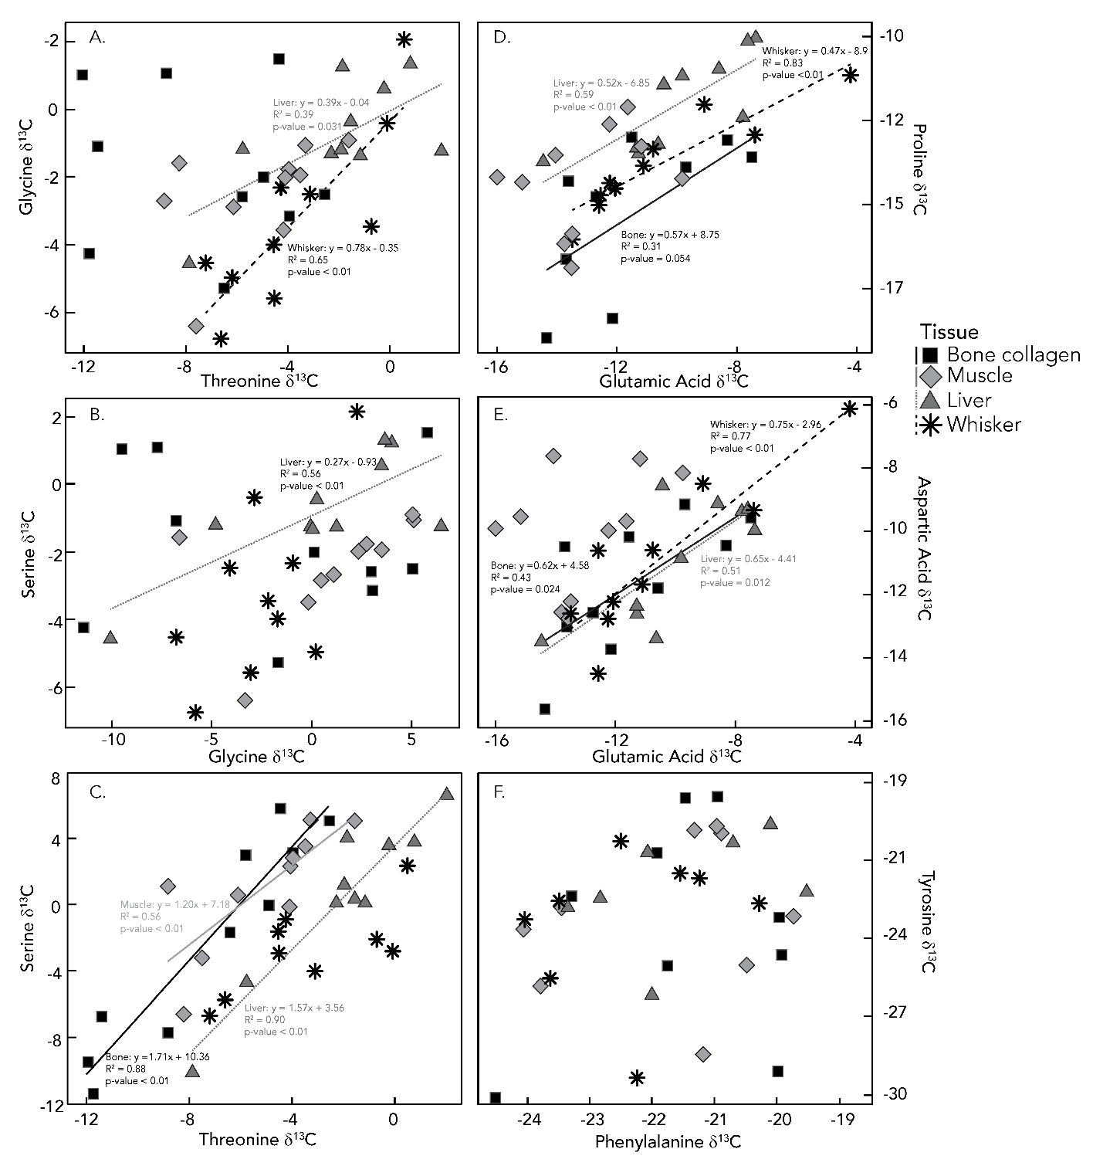Figure S6. Linear regressions between the δ¹³C values of precursor (x-axis) and product (y-axis) amino acids for different tissues, including threonine-glycine (A), serine-glycine (B), threonine-serine (C), glutamic acid-proline (D), glutamic acid-aspartic acid (E), and phenylalanine-tyrosine (F). Note that the relationships between threonine-serine and glutamic acid-aspartic acid are indirect, meaning there are multiple enzyme mediated reactions between the precursors and the products.

SI References.
Elliott Smith, E., M. Fox, M. Fogel, and S. Newsome. 2022. Amino acid δ13C fingerprints of nearshore marine autotrophs are consistent across broad spatiotemporal scales: an intercontinental isotopic dataset and likely biochemical drivers. Functional Ecology 36:1191-1203.
Larsen, T., M. Ventura, N. Andersen, D. M. O'Brien, U. Piatkowski, and M. D. McCarthy. 2013. Tracing carbon sources through aquatic and terrestrial food webs using amino acid stable isotope fingerprinting. PloS one 8:e73441.
O'Brien, D. M., M. L. Fogel, and C. L. Boggs. 2002. Renewable and nonrenewable resources: amino acid turnover and allocation to reproduction in Lepidoptera. Proceedings of the National Academy of Sciences 99:4413-4418.
Tyrrell LP, Newsome SD, Fogel ML, et al (2013) Vibrissae growth rates and trophic discrimination factors in captive southern sea otters ( Enhydra lutris nereis ). J Mammal 94:331–338. https://doi.org/10.1644/12-MAMM-A-035.1

