Agency | Cue-Sound Congruency | Sound Offset (ms) | Relative Sound Level | Percentage incl. 95% CI [LL, UL]
Active | Congruent | 50 | T < S | 0.44 [0.40, 0.48]
Passive | Congruent | 50 | T < S | 0.36 [0.33, 0.39]
Active | Congruent | 50 | T = S | 0.53 [0.51, 0.55]
Passive | Congruent | 50 | T = S | 0.48 [0.47, 0.49]
Active | Congruent | 50 | T > S | 0.63 [0.59, 0.67]
Passive | Congruent | 50 | T > S | 0.65 [0.62, 0.68]
Active | Incongruent | 50 | T < S | 0.44 [0.40, 0.48]
Passive | Incongruent | 50 | T < S | 0.38 [0.35, 0.41]
Active | Incongruent | 50 | T = S | 0.52 [0.50, 0.54]
Passive | Incongruent | 50 | T = S | 0.47 [0.45, 0.49]
Active | Incongruent | 50 | T > S | 0.63 [0. 59, 0.67]
Passive | Incongruent | 50 | T > S | 0.62 [0.59, 0.65]
Active | Congruent | 0 | T < S | 0.44 [0.41, 0.47]
Passive | Congruent | 0 | T < S | 0.40 [0.37, 0.43]
Active | Congruent | 0 | T = S | 0.54 [0.52, 0.56]
Passive | Congruent | 0 | T = S | 0.50 [0.49, 0.51]
Active | Congruent | 0 | T > S | 0.67 [0.64, 0.70]
Passive | Congruent | 0 | T > S | 0.63 [0.60, 0.66]
Active | Incongruent | 0 | T < S | 0.40 [0.37, 0.43]
Passive | Incongruent | 0 | T < S | 0.40 [0.37, 0.43]
Active | Incongruent | 0 | T = S | 0.52 [0.50, 0.54]
Passive | Incongruent | 0 | T = S | 0.51 [0.49, 0.53]
Active | Incongruent | 0 | T > S | 0.61 [0.57, 0.65]
Passive | Incongruent | 0 | T > S | 0.65 [0.62, 0.68]
Table S1. Results. Mean percentages of responses in which participants (N=224) judged the subjective loudness of the test tone as higher than the loudness of the standard tone, separately for all conditions: agency (active, passive), loudness differences between test- and standard tone (T < S, T = S, T > S), cue- sound congruency (congruent, incongruent) and sound offset (0ms, 50ms).

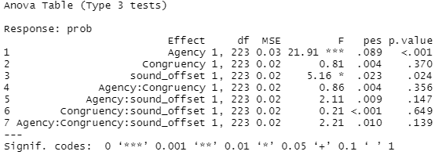
Table S2. ANOVA table. Results of the 2x2x2 repeated measures ANOVA (N=224) with factors “agency”, “congruency”, and “sound offset”. The effect size parameter “pes” denotes the partial eta squared (η_{p}²).

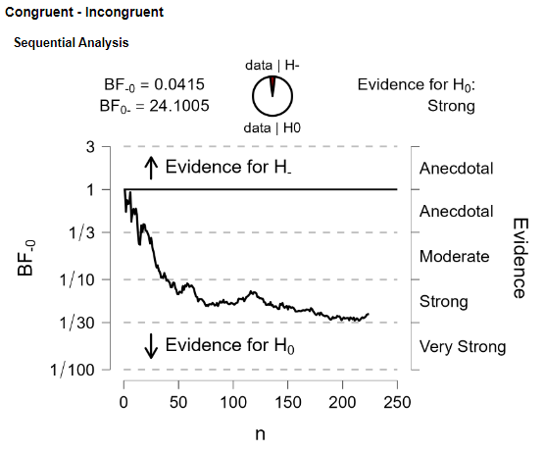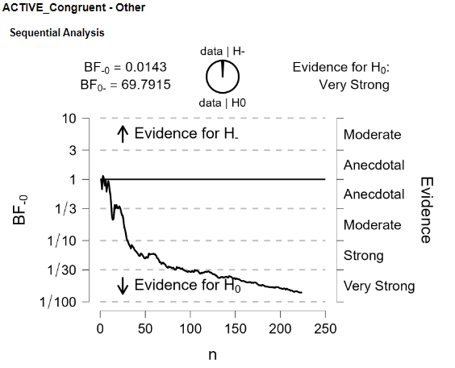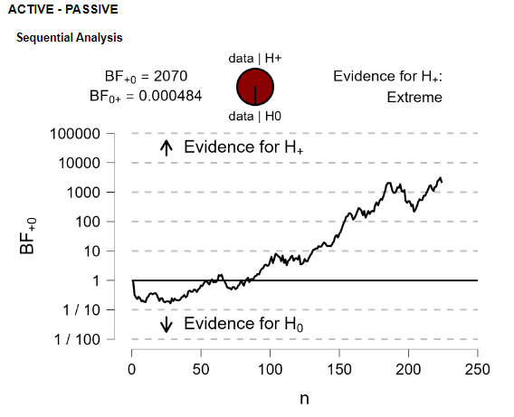
C
A
B

Fig. S1. Sequential BF analysis of A) the effect of self-initiation on auditory perception (H1: active > passive), B) the effect of cue-sound congruency on auditory perception (H1: congruent < incongruent), and C) the effect of self-initiation and cue-sound congruency in a two-alternative forced choice loudness comparison task (H1: active-congruent < active-incongruent, passive-congruent & passive-incongruent). Evolution of sequentially conducted Bayes factors (BFs) is based on the complete sample (N=224). We compared percentages of “test > standard” reports for “T=S” trials (i.e., identical sound levels), using a two-sided Bayesian paired t-test in JASP 0.16.3 (prior: default Cauchy prior with the scale parameter r = .707).
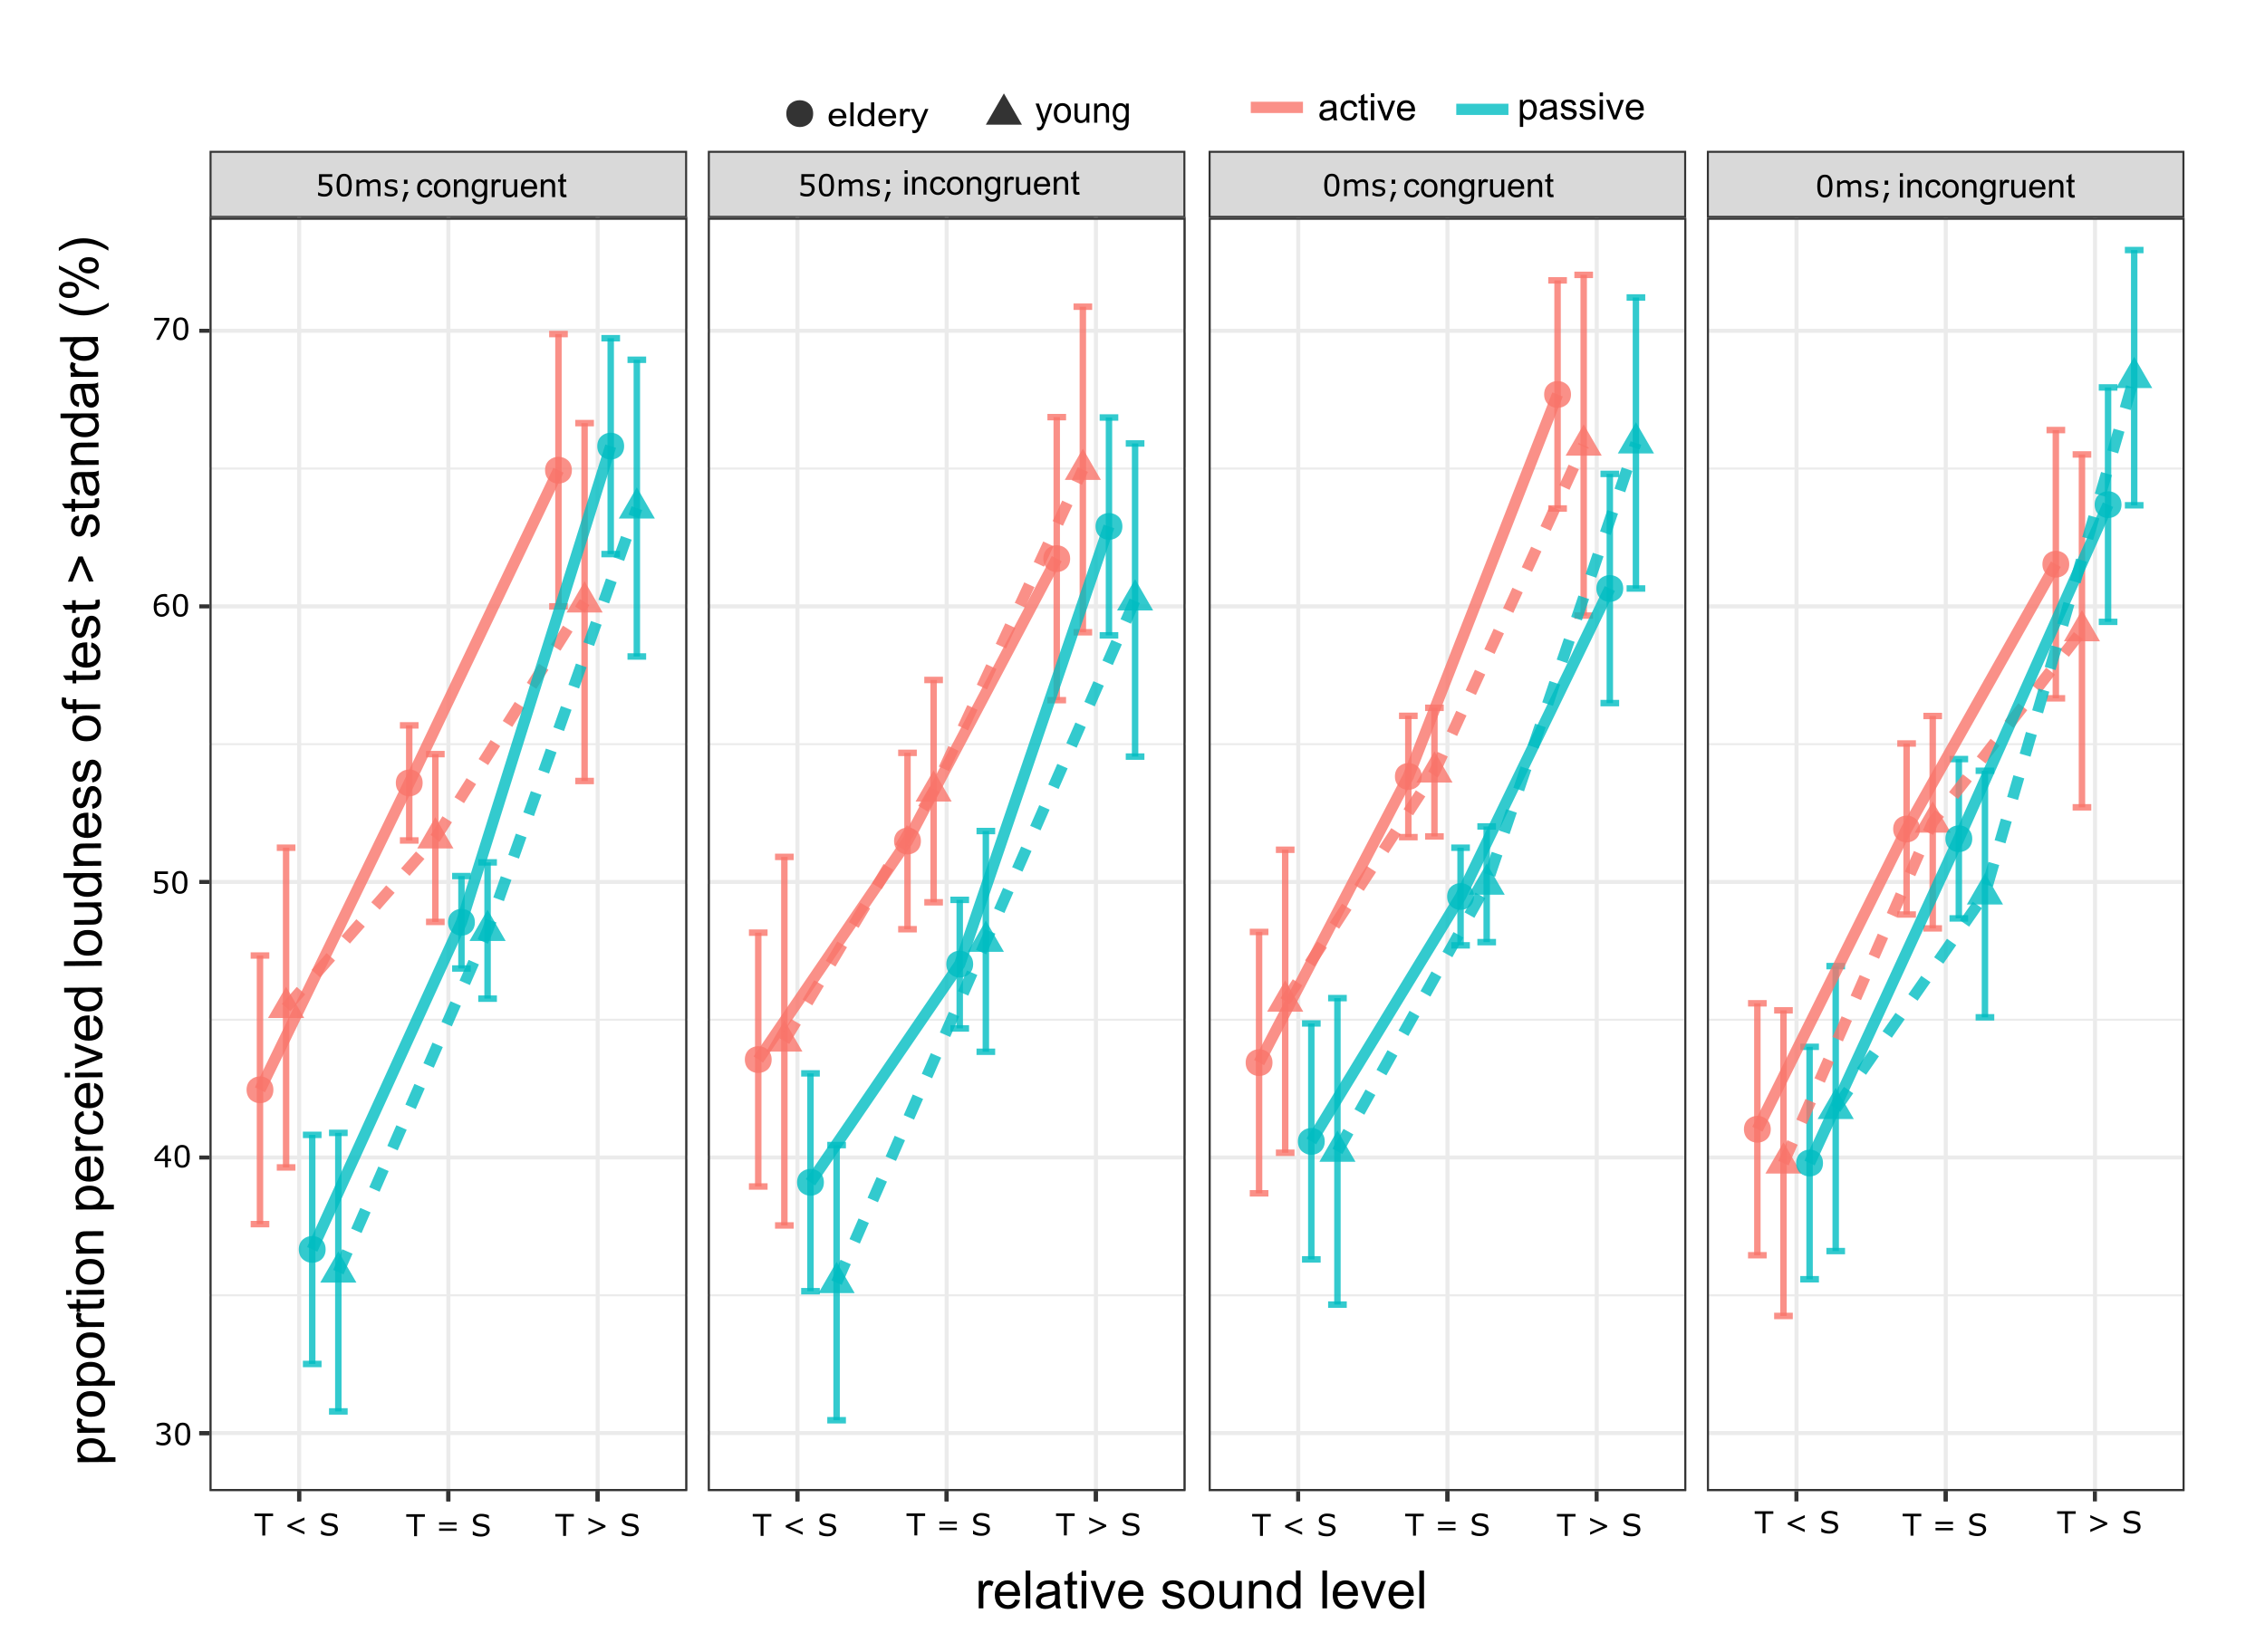

Fig. S2. Shown are the mean percentages of responses in which participants (N=224; young: N = 81, elderly: N = 143) judged the volume of the test stimulus as higher than the volume of the standard, comparing actively versus passively generated test tones, for different volume differences between test- and standard tone (T < S, T = S, T > S), separated by the factors “cue- sound congruency” (congruent, incongruent) and “sound offset” (0 ms, 50 ms), and divided by age groups (young < 40 years, elderly > 40 years). Error bars indicate 95% confidence intervals calculated for within-subject data using the summarySEwithin function from the Rmisc package (version 1.5.1).
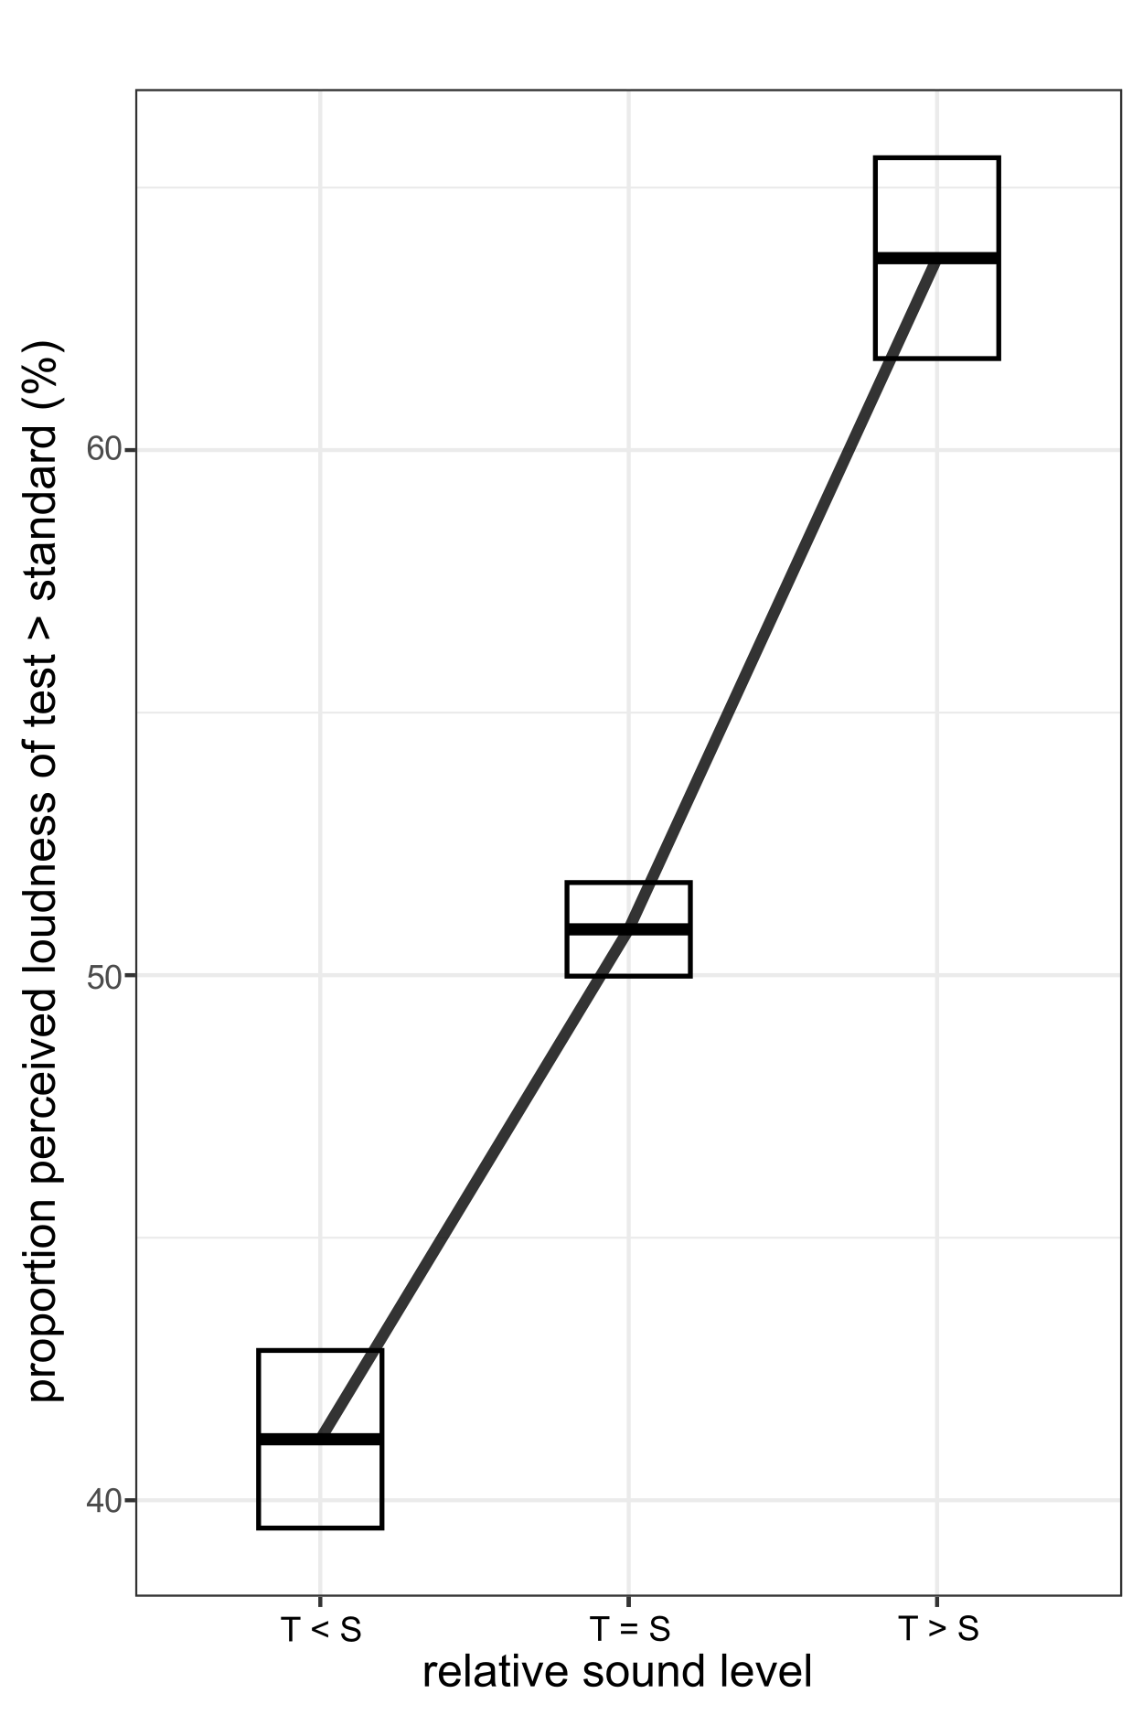
Fig. S3. Average in mean percentages of responses in which participants (N=224) judged the volume of the test stimulus as higher than the volume of the standard, for different volume differences between test (1st)- and standard (2nd) tone (T < S, T = S, T > S). Error bars indicate 95% confidence intervals calculated for within-subject data using the summarySEwithin function from the Rmisc package (version 1.5.1).

