Supplemental Information

Unveil the role of structural vacancy in Mn-based Prussian blue for energy storage application

Chongwei Gao¹, Ming Chen², Xunan Wang¹, Guobing Zhang¹, Xi Tan², Shuhua Zhang¹, Jiantao Li^{3*}, Guang Feng^{2*}, Dengyun Zhai^{1*} and Feiyu Kang^{1*}

¹Shenzhen Geim Graphene Center, Institute of Materials Research, Tsinghua Shenzhen International Graduate School, Tsinghua University, Shenzhen 518055, China.
²State Key Laboratory of Coal Combustion and School of Energy and Power Engineering, Huazhong University of Science and Technology, Wuhan 430070, China.
³State Key Laboratory of Advanced Technology for Materials Synthesis and Processing, Wuhan University of Technology, Wuhan 430070, China.

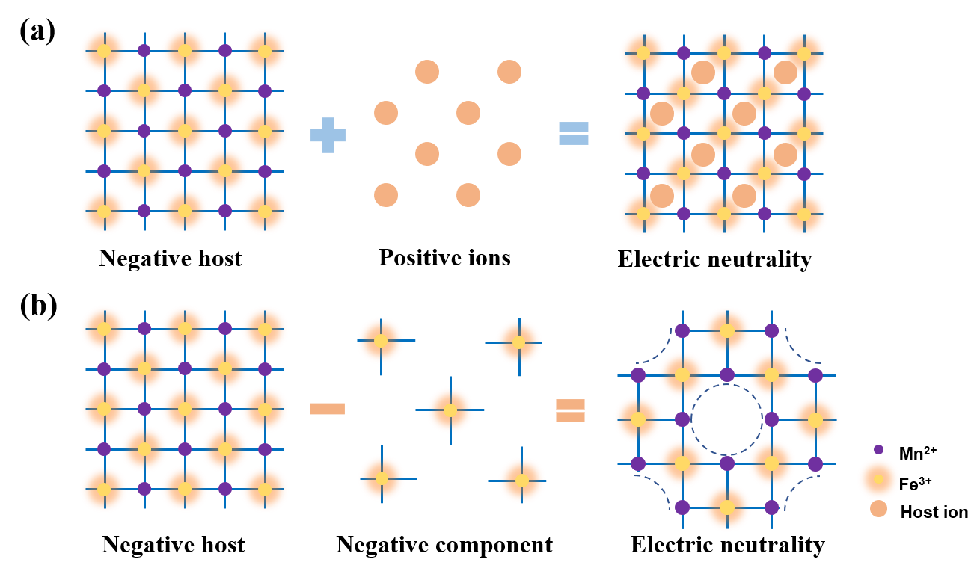
Figure S1. Two different charge-compensation modes. (a) The cation-compensation. (b) The vacancy-compensation.

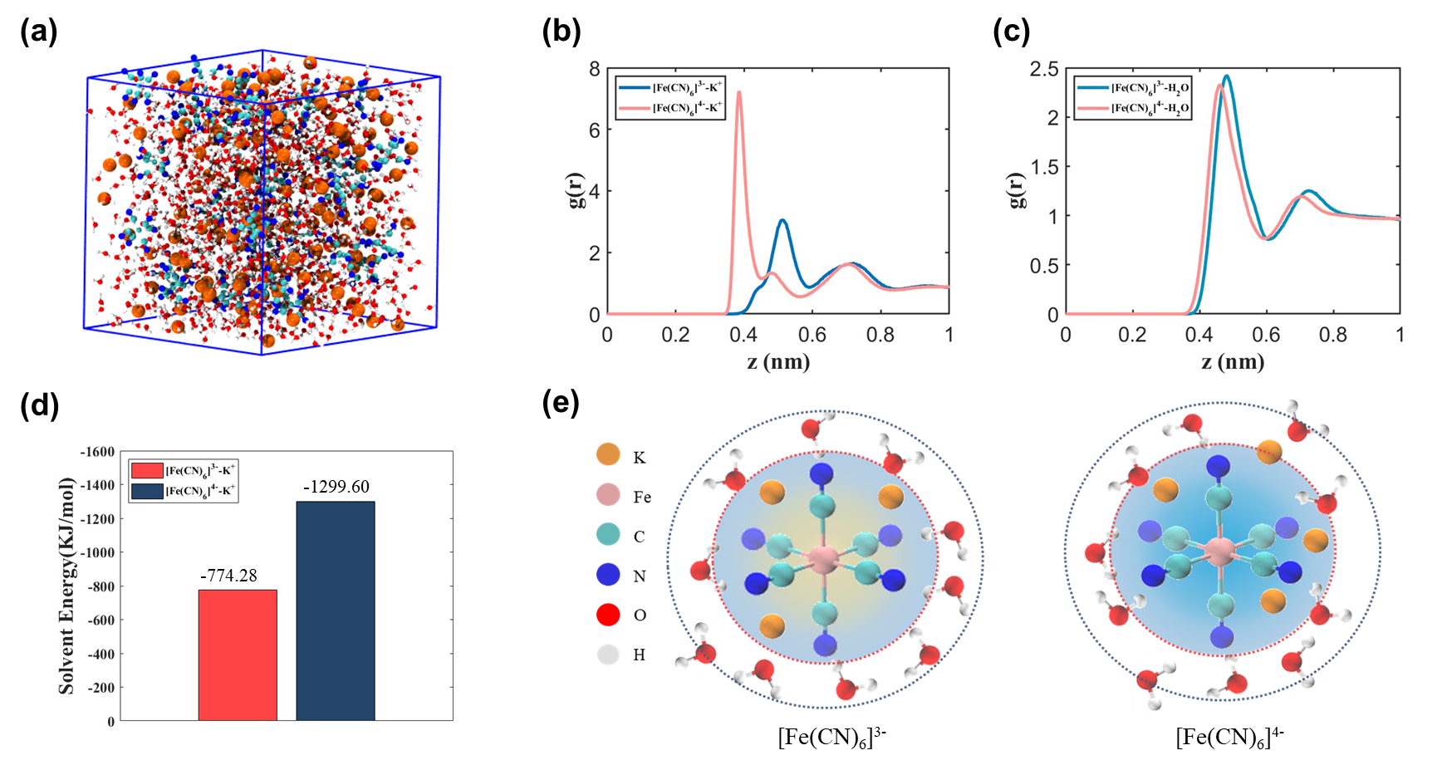
Figure S2. Molecular dynamics simulation. (a) Snapshots of the molecular dynamic simulation. (b-c) Radial distribution function (g(r)) for Fe(CN)₆³⁻/Fe(CN)₆^{4—}K⁺ (b), and for Fe(CN)₆³⁻/Fe(CN)₆^{4—}H₂O. (d) The interaction energy between Fe(CN)₆³⁻ and K⁺, and between Fe(CN)₆⁴⁻ and K⁺ (e) Schematic of the solvation formation of Fe(CN)₆³⁻ and Fe(CN)₆⁴⁻ in aqueous solution.

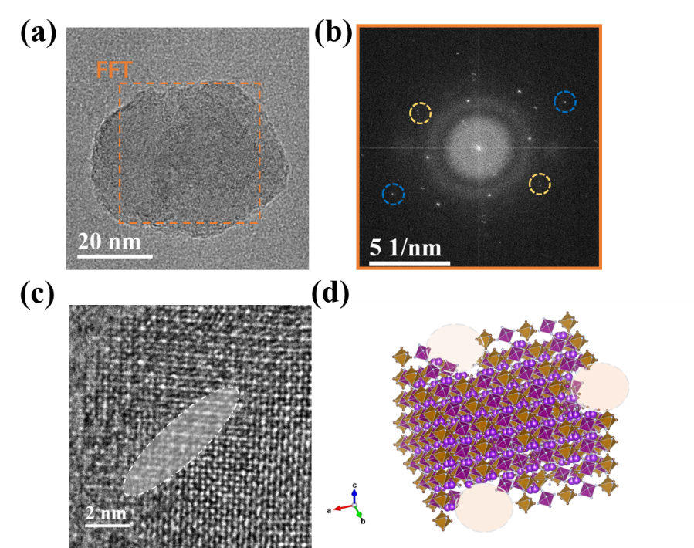
Figure S3. Investigation of the vacancies distribution in K-rich MnHCF. (a) The TEM image of MnHCF-DV and the corresponding FFT (b). (c) HRTEM image of MnHCF-DV. (d) Schematic of vacancies distribution after the fusion growth.

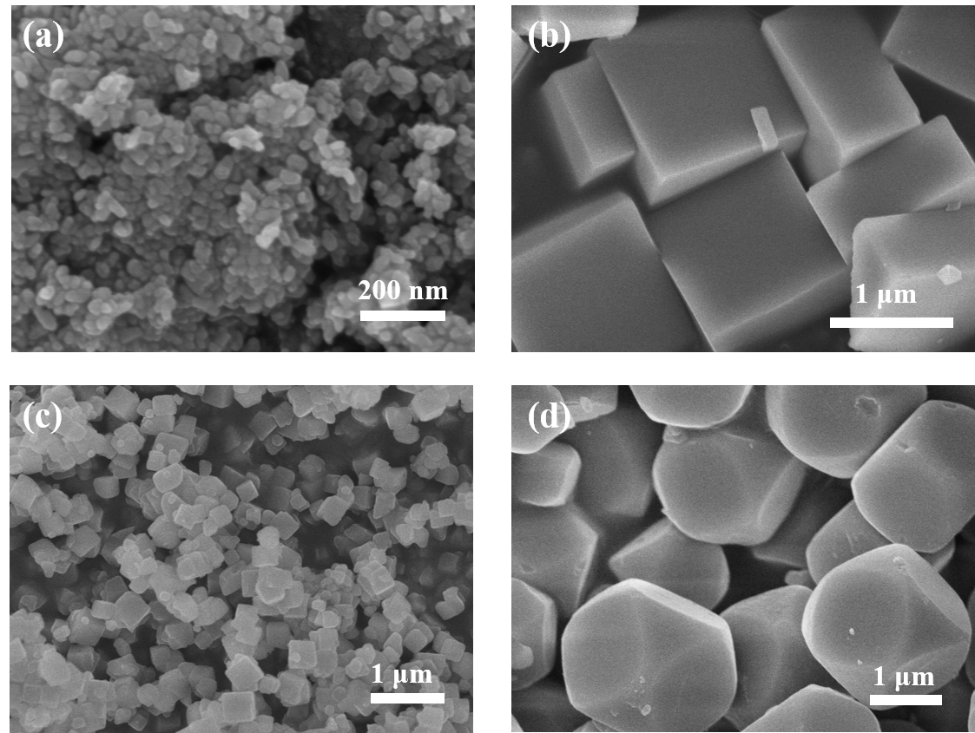
Figure S4. The SEM Images of (a) MnHCF-DV, (b)MnHCF, (c) MnHCF-SV-MnCl₂, and (d) MnHCF-SV-MnNO₃

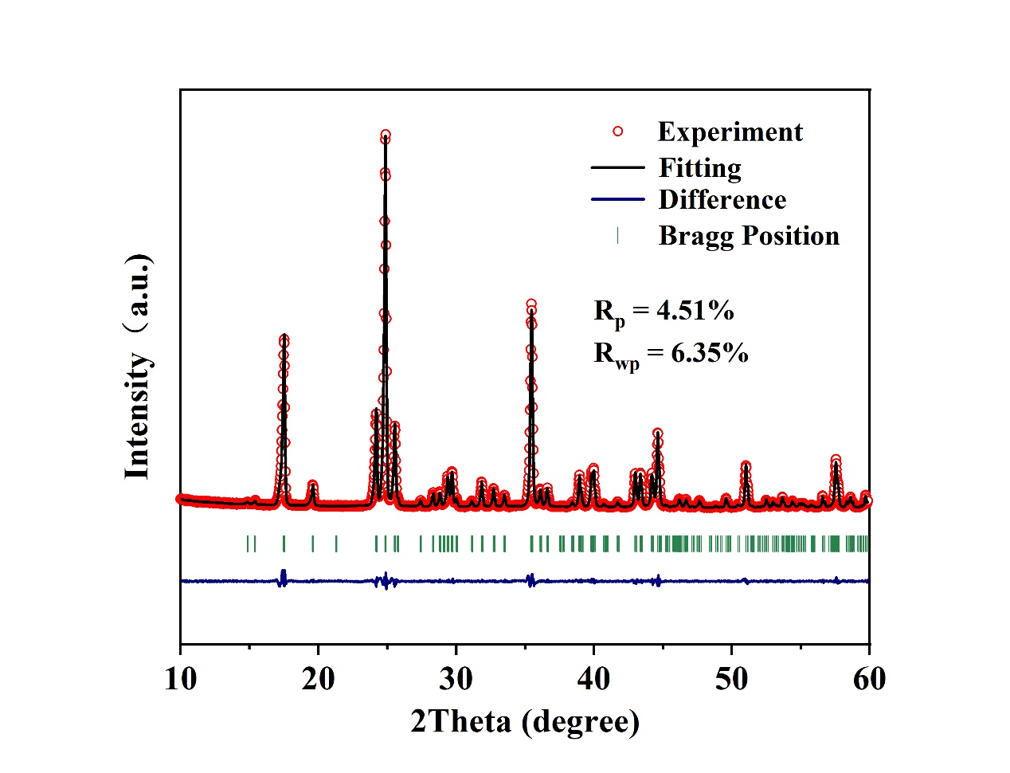
Figure S5. XRD Rietveld refinement result of MnHCF.

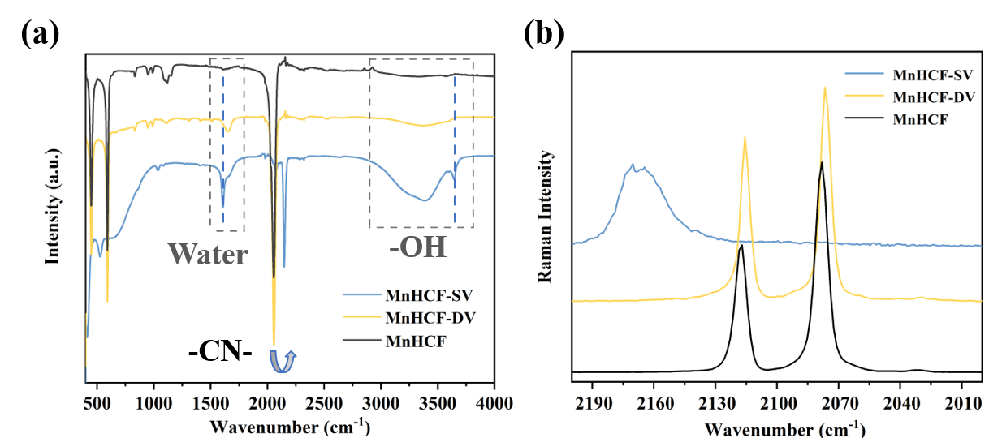
Figure S6. The characterization of the chemical environment (a) the FT-IR spectra and (b) the Raman spectra of MnHCF-SV, MnHCF-DV, and MnHCF.

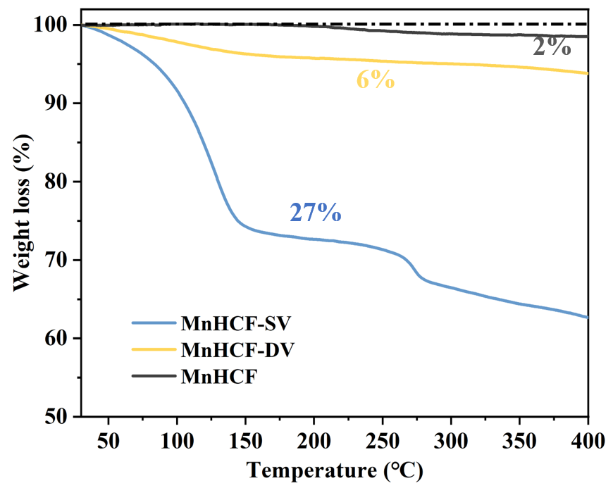
Figure S7. The TGA curves of MnHCF-SV, MnHCF-DV, and MnHCF. The water content is 27%, 6%, and 2%, respectively.

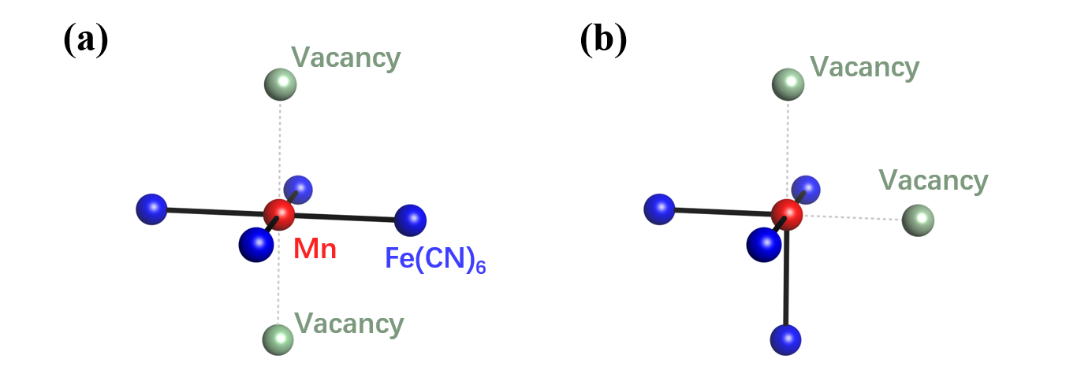
Figure S8. Schematic structure of (a) symmetric and (b) asymmetric vacancies distribution around the Mn site.

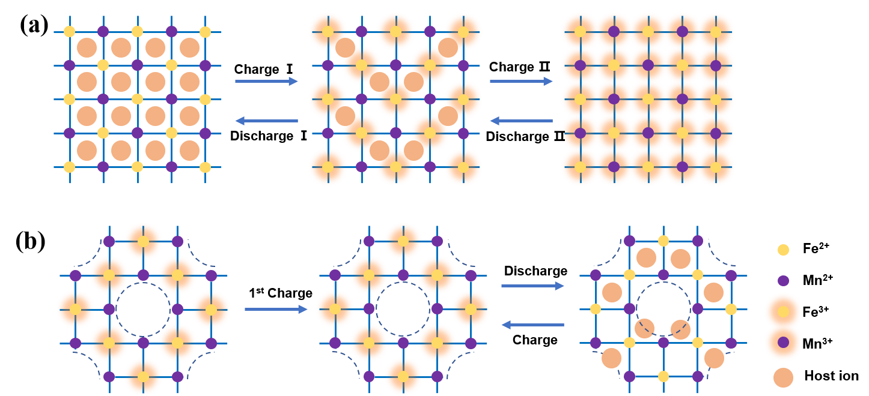
Figure S9. The electrochemical activity analysis. (a) The typical electrochemical process during charging and discharging with two redox reactions of Fe²⁺/Fe³⁺ and Mn²⁺/Mn³⁺. (b) The assumption of the electrochemical process for MnHCF-SV.

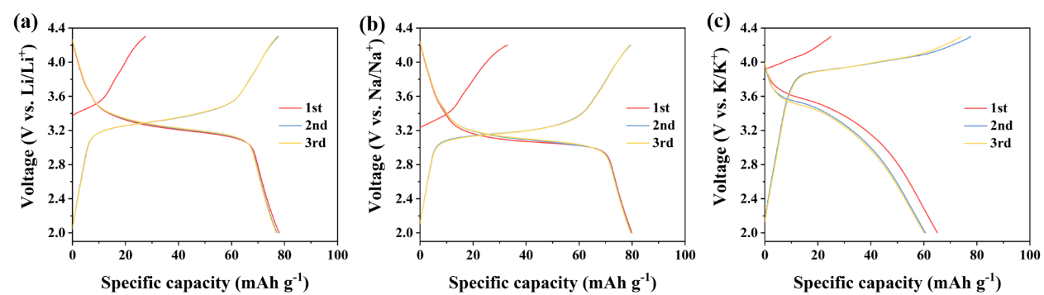
Figure S10. The charge-discharge curves of MnHCF-SV in different electrolytes. (a) 1.0 M LiPF₆ in EC/DEC (1:1 by volume). (b) 1.0 M NaPF₆ in EC/DEC (1:1 by volume). (c) 0.8 M KPF₆ in EC/DEC (1:1 by volume).

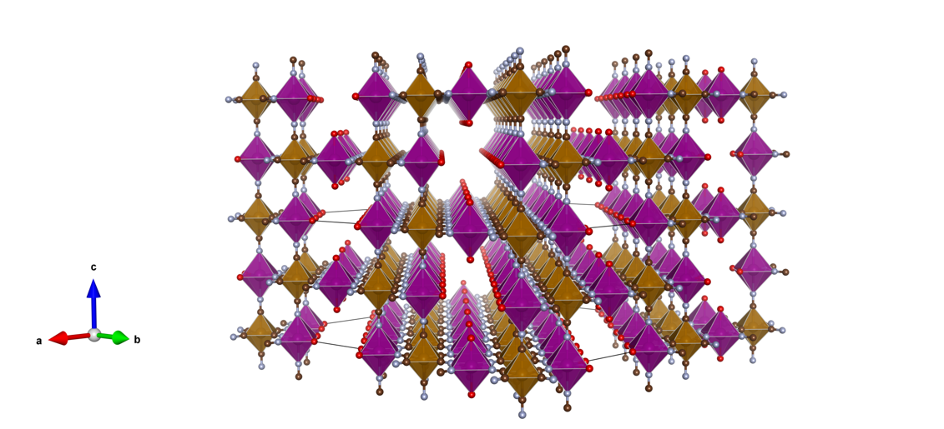
Figure S11. The schematic structure of MnHCF-SV with long channels formed by neighbouring vacancies.

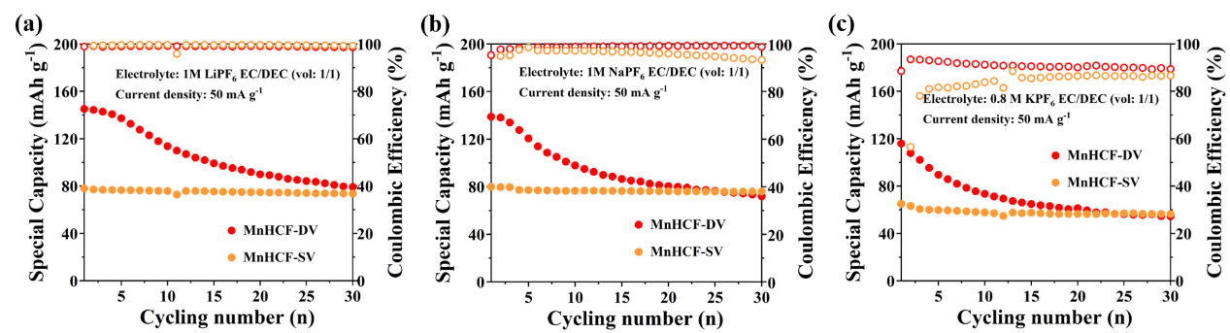
Figure S12. The cycle performance of MnHCF-SV and MnHCF-DV in different electrolytes. (a) 1.0 M LiPF₆ in EC/DEC (1:1 by volume). (b) 1.0 M NaPF₆ in EC/DEC (1:1 by volume). (c) 0.8 M KPF₆ in EC/DEC (1:1 by volume).

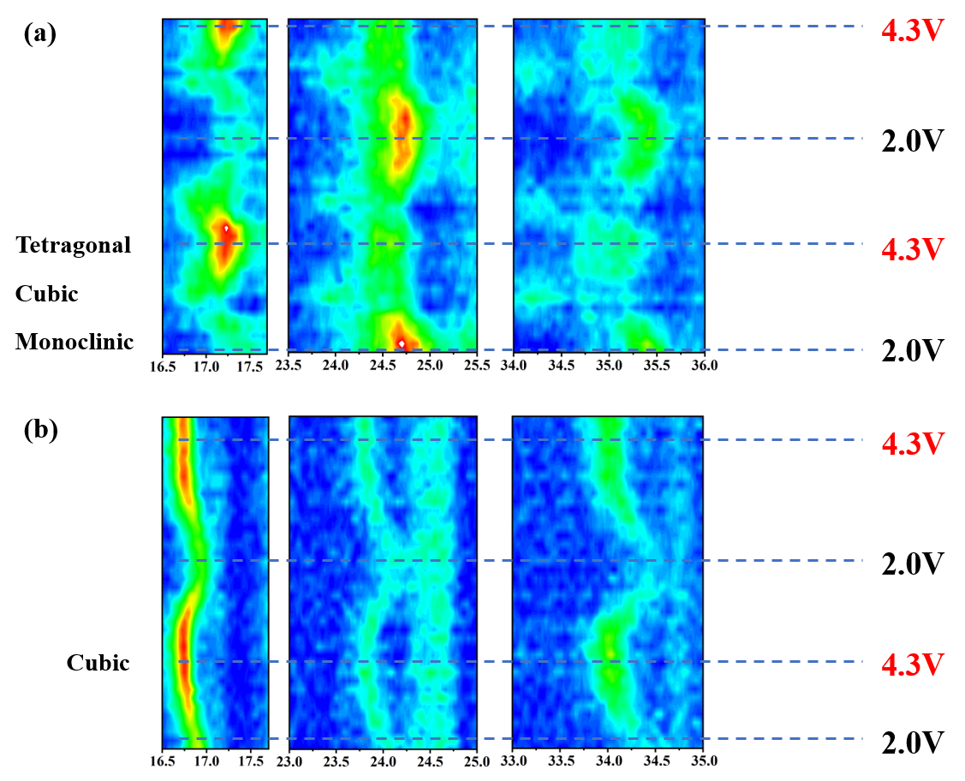
Figure S13. Structure evolution during the cycles. Intensity contour maps of (a) MnHCF-DV and (b) MnHCF-SV collected by in-situ XRD.

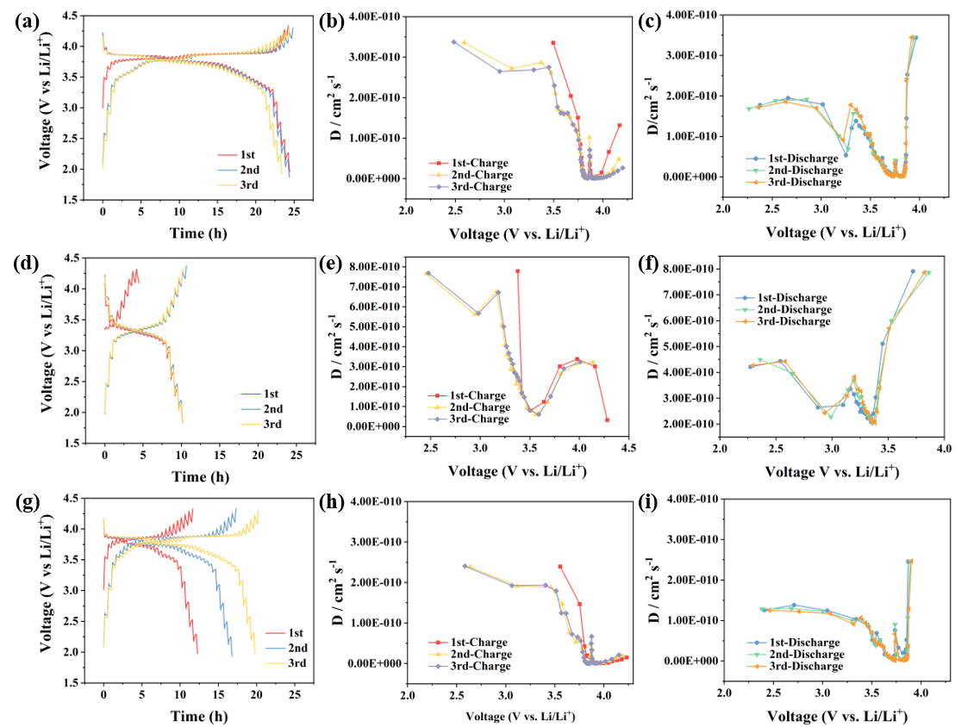
Figure S14. GITT curves and calculated Li⁺ diffusion coefficient of MnHCF-DV (a-c), MnHCF-SV (d-f), and MnHCF (g-i) for the first three cycles.

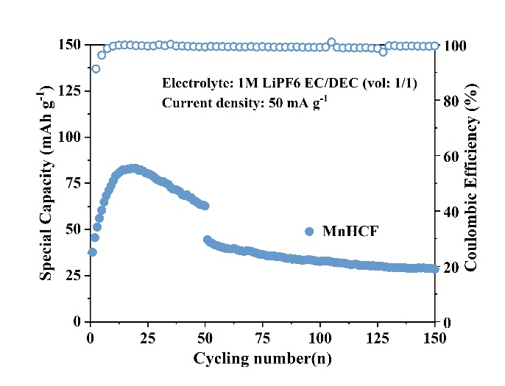
Figure S15. The cycle performance of MnHCF at the current density of 30 mA g⁻¹ and 100 mA g⁻¹ in 1 M LiPF6 EC/DEC (1:1 by volume).

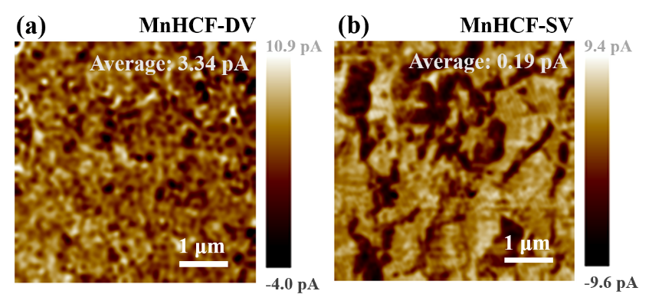
Figure S16. Conductive images of MnHCF-DV and MnHCF-SV obtained by C-AFM.

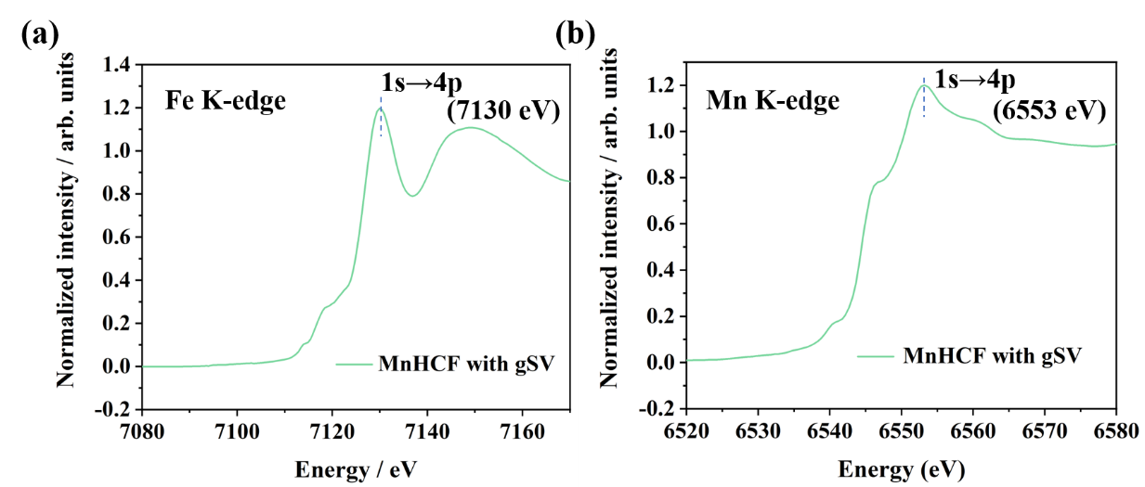
Figure S17. The Normalized XANES spectra at (a) Fe K-edge and (b) Mn K-edge of MnHCF with gSV.

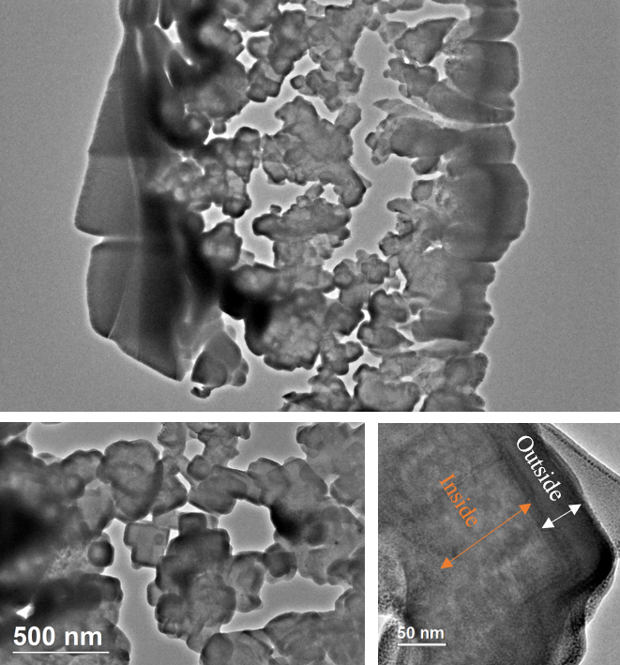
Figure S18. The TEM images of the FIB-prepared cross-section of MnHCF with gSV.

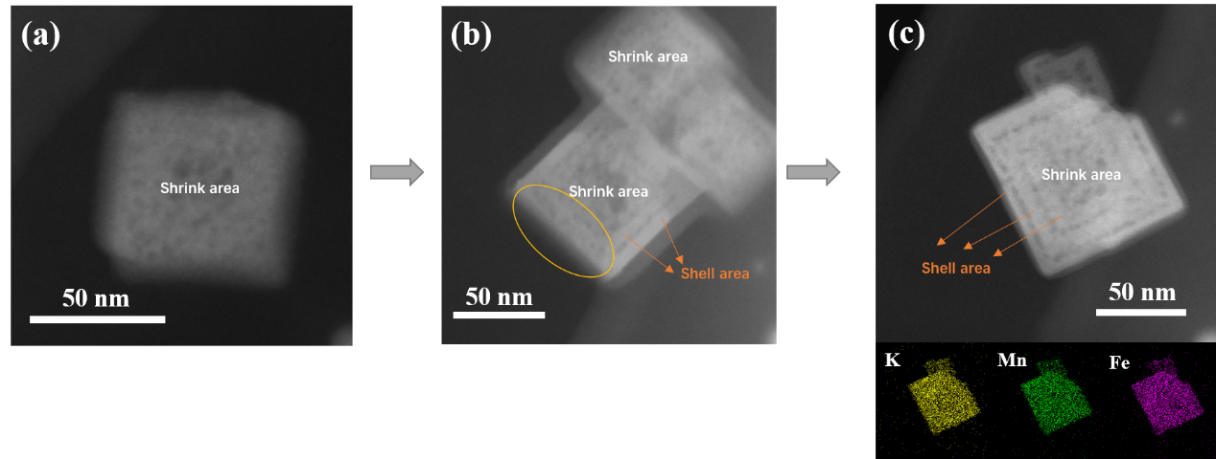
Figure S19. The HADDF images of MnHCF with gSV during different synthesis stages.

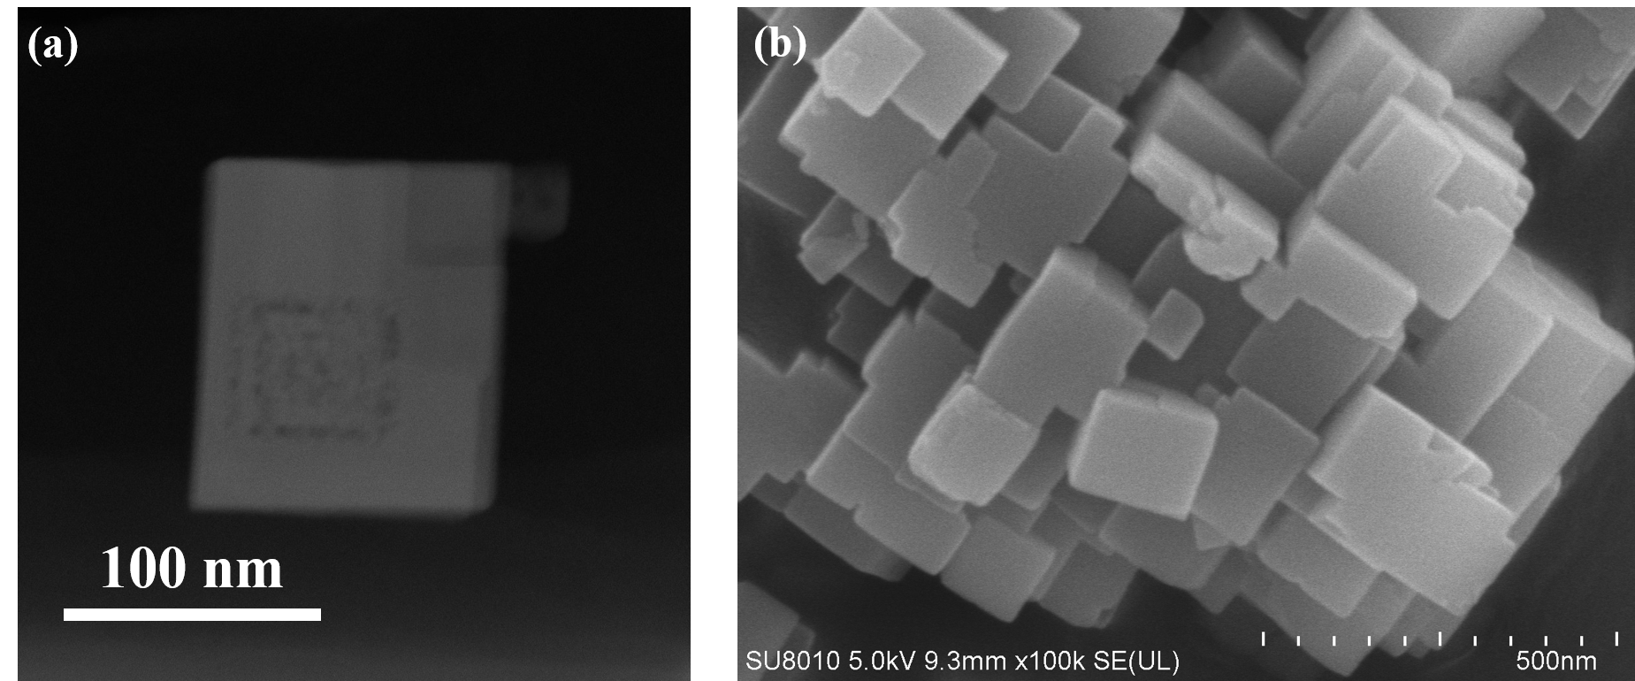
Figure S20. The HAADF image (a) and SEM image (b) of MnHCF with gSV (Fe(CN)₆³⁻/ Fe(CN)₆⁴⁻ = 2/1).

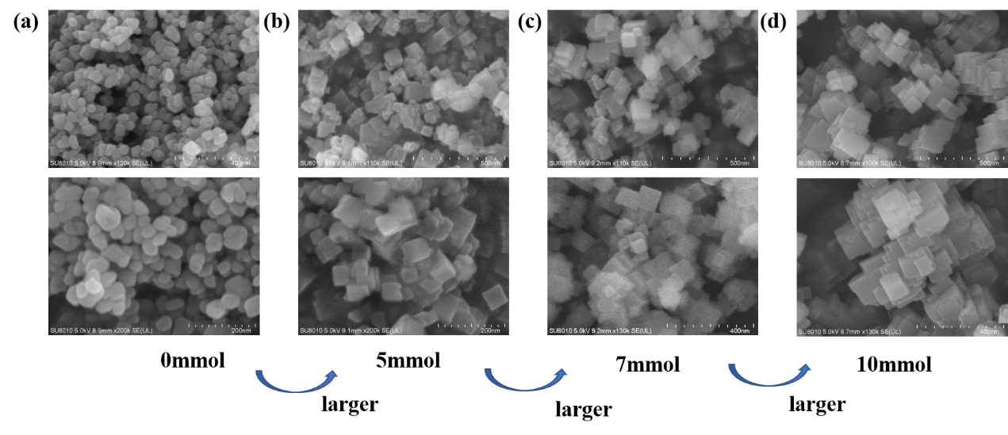
Figure S21. The SEM images of MnHCF with gSV prepared with different content of potassium citrate. (a) 0mmol, (b) 5mmol, (c) 7mmol and (d) 10mmol.

In order to obtain a more distinct image inside of the particles, Focused ion beam (FIB) was used to cut off the particles. As shown in Figure S18, the inner is not porous. The contrast ratio inside and outside of the particles is obviously different. More HADDF images at different synthesis stages were obtained to identify the formation process. As shown in Figure S19, when the particle size is around 50 nm, the outer layer doesn’t appear. At this stage, we think Fe(CN)₆⁴⁻ is the primary reactant to realize the K-rich structure. Due to the crystal shrink induced by K⁺, which can be proved by XRD results, the structure becomes more localization and eventually forms a ‘chaotic’ morphology. When the particle size is over 50 nm, the shell appears (as shown in Figure S19b). Fe(CN)₆³⁻ as the reactant co-participates the particle growth along with Fe(CN)₆⁴⁻, and structural vacancies are successfully introduced into the outer layer. With the insertion of K⁺, the partial shell turns to a shrink area, as marked by the yellow circle in Figure S9b. This process happens over and over again. As shown in Figure S9c, some shell was preserved and eventually realized hierarchical nanoarchitecture. Energy-dispersive spectroscope (EDX) mapping results suggest a homogenous distribution of K, Mn, and Fe. Meanwhile, the reactant ratios of Fe(CN)₆³⁻/ Fe(CN)₆⁴⁻ will significantly affect the morphology and structure of the final product. As shown in Figure S20, when changing the molar ratio of Fe(CN)₆³⁻/ Fe(CN)₆⁴⁻ from 1/2 to 2/1, the outer shell thickens with a larger particle size. In addition, potassium citrate also plays a key role in particle growth. As shown in Figure S21, the growth of particles is rather limited without enough potassium citrate.

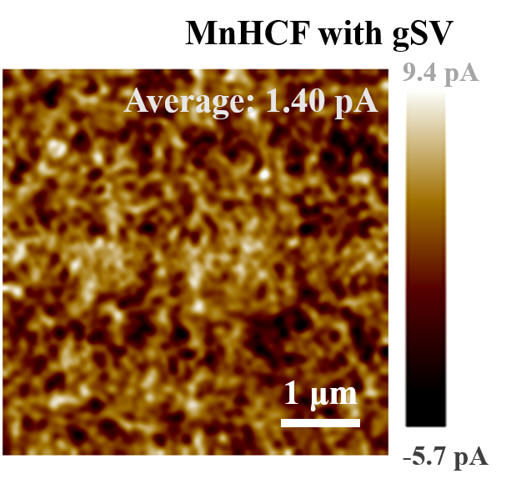
Figure S22. Conductive images of MnHCF-DV and MnHCF-SV obtained by C-AFM.

As shown in FigureS22, compared to MnHCF-DV (3.34 pA), the average electrical currents through the surface of MnHCF with gSV is only 1.40 pA, demonstrating that structural vacancies near the surface successfully decrease the interface electric conductivity of K-rich MnHCF.

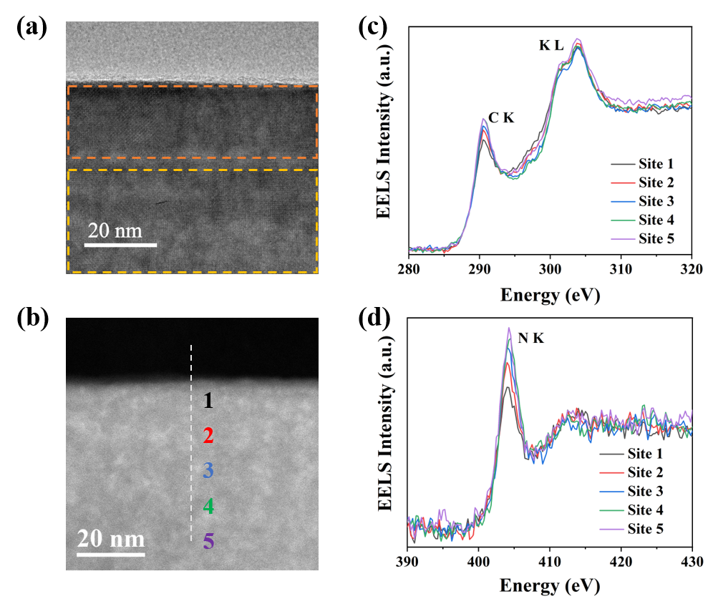
Figure S23. Electron energy loss spectroscopy of MnHCF with gSV. (a) The HRTEM image of the selected cross-sectional area and corresponding STEM image (b). The EEL spectra of (c) C K-edge, K L-edge, and (d) N K-edge are recorded respectively from site 1 to site 5.

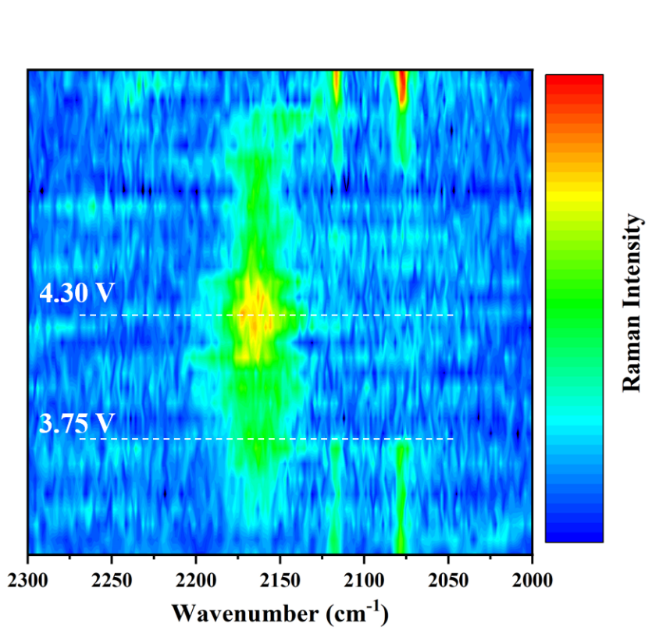
Figure S24. The in-situ Raman spectra of MnHCF with gSV during the cycle.

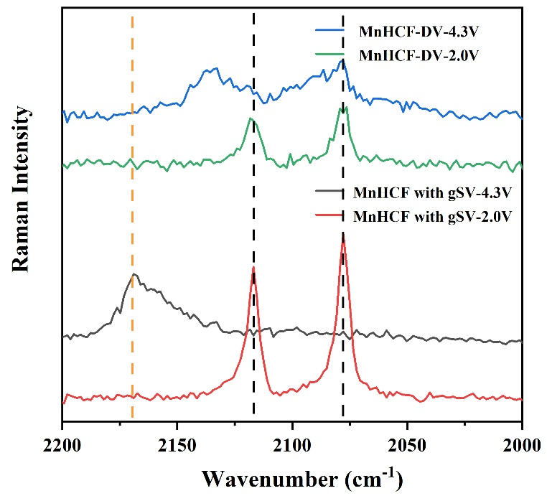
Figure S25. The ex-situ Raman spectra of MnHCF-DV and MnHCF with gSV at different voltages (2.0V and 4.3V).

In-situ Raman measurement is used to detect the change of the C≡N chemical environment for MnHCF with gSV during the cycle. The peak of C≡N is highly sensitive to the connected atoms with different valance. When the voltage reaches 3.75 V upon charging, two peaks at 2079 cm⁻¹ and 2118 cm⁻¹ disappear completely, indicating that Fe²⁺ is completely oxidized to Fe³⁺. And the new peak at 2165 cm⁻¹ increases gradually when charging from 3.75 to 4.3 V, corresponding to the oxidation of Mn²⁺ to Mn³⁺. The evolution is highly reversible upon discharging. However, the Ex-situ Raman of MnHCF-DV only shows peak broadening from 2.0 to 4.3 V, indicating a low electrochemical activity.

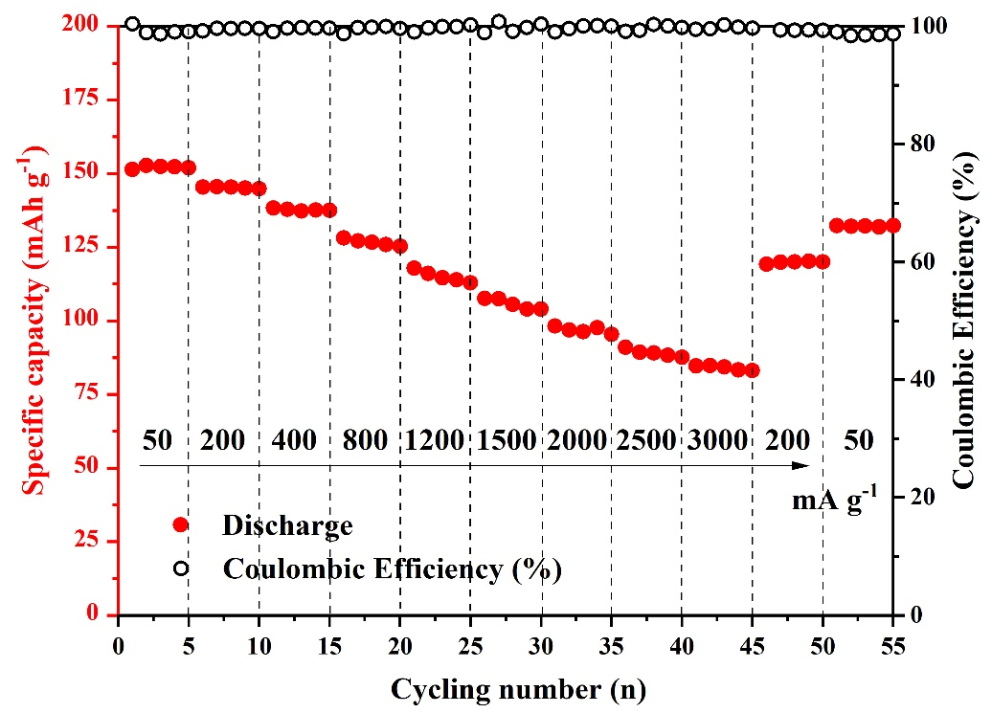
Figure S26. The rate performance of MnHCF with gSV.

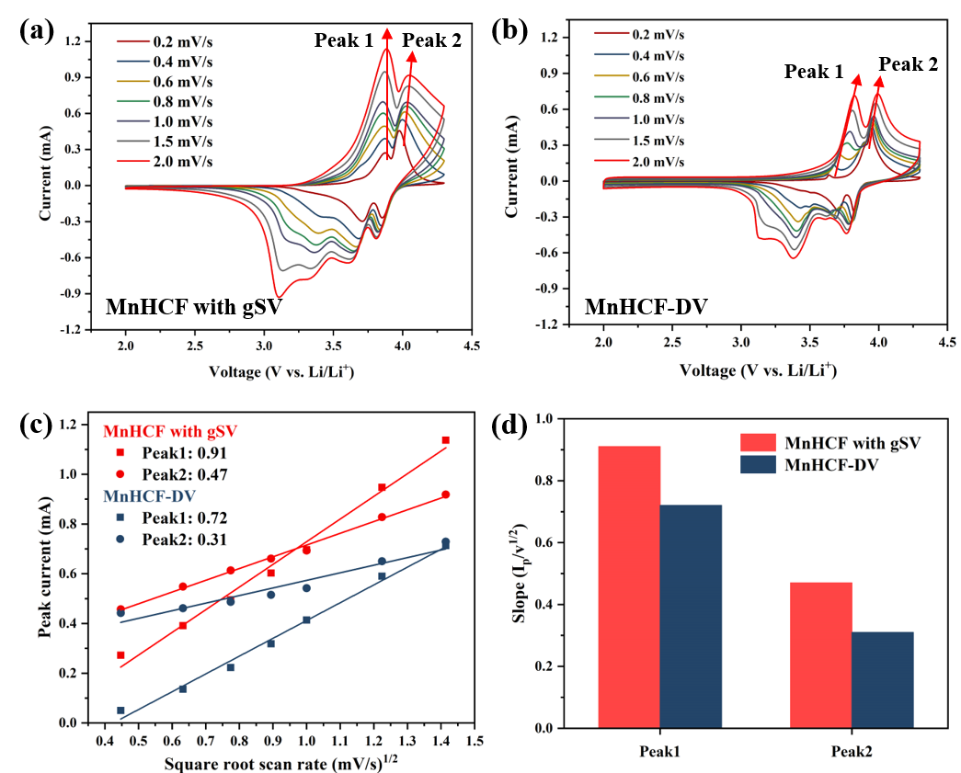
Figure S27. Kinetic properties comparison. CV curves at different scanning rates of (a) MnHCF with gSV and (b) MnHCF-DV. (c) The linear relationship between peak current and square scan rate of Peak1 and Peak2. (d) The calculated slope of Peak1 and Peak2 for MnHCF and MnHCF with gSV.

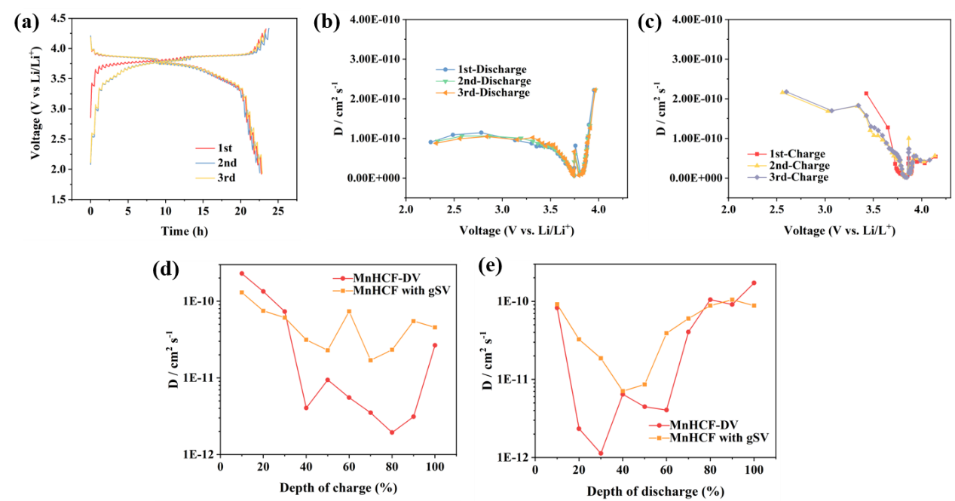
Figure S28. (a-c) GITT curves and calculated Li⁺ diffusion coefficient of MnHCF with gSV for the first three cycles. The comparison of Li⁺ diffusion coefficient between MnHCF-DV and MnHCF with gSV at different depth of charge (d) and discharge (e).

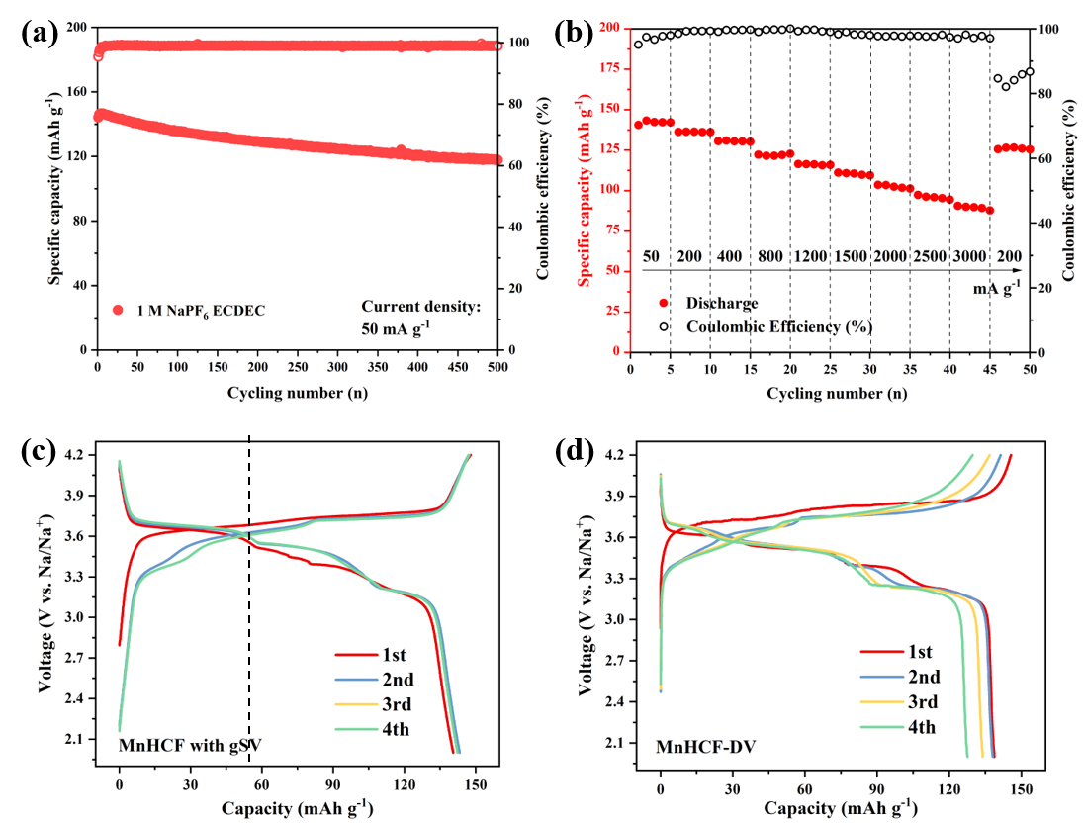
Figure S29. The electrochemical tests for Na⁺ storage in 1 M NaPF6 EC/DEC (1:1 by volume). (a) The cycle performance of MnHCF with gSV at 50 mA g⁻¹. (b) The rate performance of MnHCF with gSV. The charge-discharge curves of (c) MnHCF with gSV and (d) MnHCF-DV for the first four cycles.

The electrochemical performance of MnHCF with gSV in 1 M NaPF₆ EC DEC are shown in Figure S29. The cyclic stability is observably improved compared to MnHCF-DV. Figure S29a shows the long-term cyclic performance at the current density of 50 mA g⁻¹. The capacity retention reaches 81.9% after 500 cycles. Meanwhile, the rate performance was tested from 50 mA g⁻¹ to 3000 mA g⁻¹, as shown in Figure S29b. The capacity is still 89.8 mAh g⁻¹ at the density of 3000 mA g⁻¹. Significantly, MnHCF with gSV exhibits a longer discharge platform above 3.5 V, corresponding to the redox of Mn²⁺/Mn³⁺, although the total initial capacity is similar with MnHCF-DV (Figure S29c and d). In addition, the reversibility of charge-discharge curves has an obvious difference. For MnHCF-DV, the charging capacity at high voltage is not reversible, caused by polarization and side reaction with electrolyte at high voltage. For MnHCF with gSV, the charge/discharge process is highly reversible, and the charge/discharge curves are symmetrical, indicating lower polarization and a more stable interface with electrolyte at high voltage.

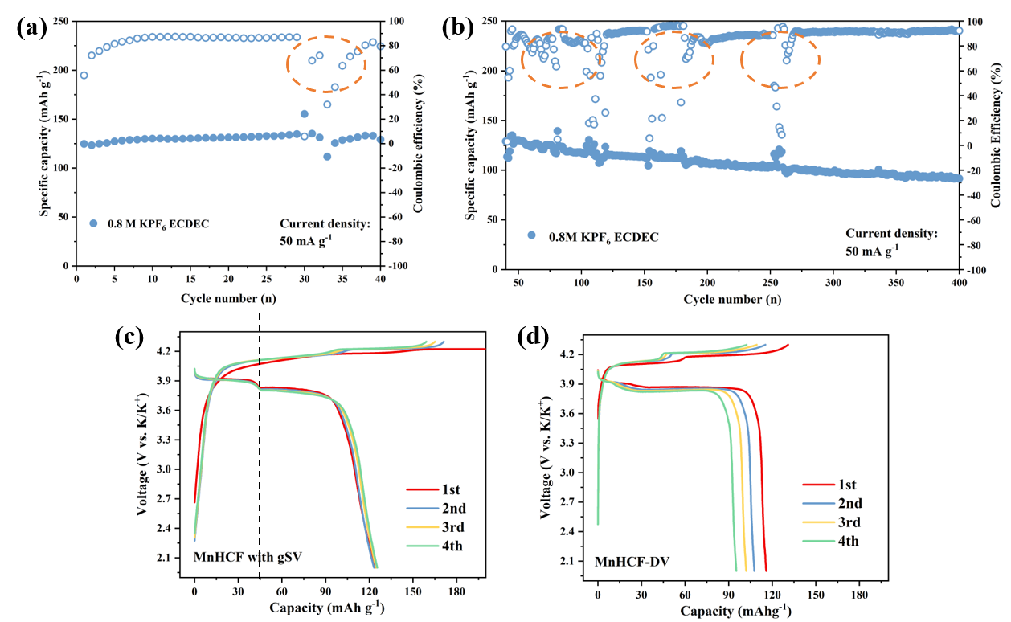
Figure S30. The electrochemical tests for K⁺ storage in 0.8 M KPF6 EC/DEC (1:1 by volume). (a) and (b) The cycle performance of MnHCF with gSV at 50 mA g⁻¹. The charge-discharge curves of (c) MnHCF with gSV and (d) MnHCF-DV for the first four cycles at 50 mA g⁻¹.

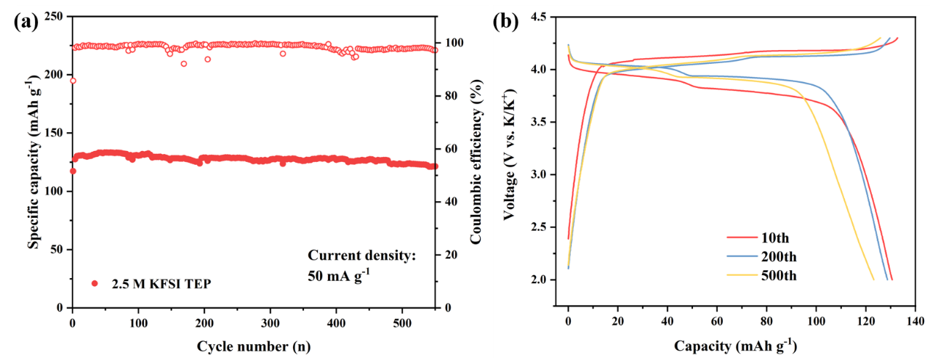
Figure S31. The electrochemical tests for K⁺ storage in 2.5 M KFSI TEP. (a) The cycle performance of MnHCF with gSV and (b) the corresponding charge-discharge curves at 50 mA g⁻¹.

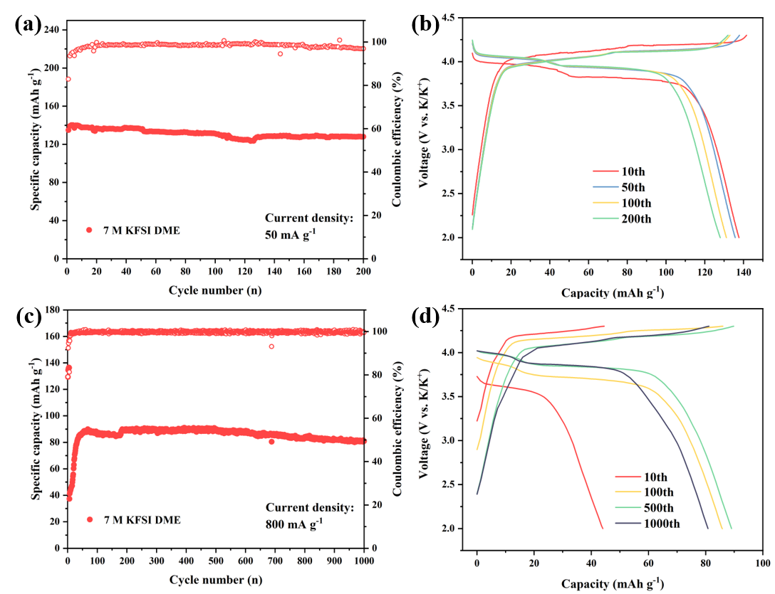
Figure S32. The electrochemical tests for K⁺ storage in 7 M KFSI DME. (a) The cycle performance of MnHCF with gSV and (b) the corresponding charge-discharge curves at 50 mA g⁻¹. (c) The cycle performance of MnHCF with gSV and (d) the corresponding charge-discharge curves at 800 mA g⁻¹.

The electrochemical behavior of MnHCF with gSV for K⁺ storage is shown in Figure S30-32. Firstly, 0.8 M KPF₆ EC/DEC was used as an electrolyte for the cyclic test. As shown in Figure S30a, this material shows excellent cyclic stability without any capacity fading after 30 cycles, which is superior to MnHCF-DV. However, serious side reactions and terrible K metal deposition behavior on the anode lead to unstable coulombic efficiency (as marked by yellow circles), making the electrochemical performance unpredictable.¹ Even in this case, the capacity retention can still reach 81.4% after 400 cycles. The discharge capacity of Mn²⁺/Mn³⁺ at high voltage is also obviously improved, as shown in Figure S30c and d. In order to further investigate the K⁺ storage properties of MnHCF with gSV, 2.5 M KFSI TEP and 7M KFSI DME were used as electrolytes.²⁻⁴ As shown in Figure S31, this material shows excellent cyclic stability in 2.5 M KFSI TEP at 50mA g⁻¹. The specific capacity remains 123 mAh g^{–1} after 500 cycles with almost no capacity fading. The charge/discharge curves are almost the same at the 10th, 200th, and 500th cycles without polarization increasing, indicating excellent structural stability. Meanwhile, this material shows similar electrochemical performance in 7M KFSI DME (Figure S32). The initial capacity can reach 138 mAh g⁻¹ at a density of 50 mA g⁻¹, and the capacity retention can remain 93.5% after 200 cycles. When cycling at a high current density of 800 mA g⁻¹, the capacity remains 89 mAh g⁻¹ after 1000 cycles with an average CE of nearly 100% (Figure S32c and d). The above electrochemical performances demonstrate the importance of gradient structure vacancy during Na⁺ and K⁺ storage.

Table S1. ICP results of the MnHCF-SV, MnHCF-DV, MnHCF, and MnHCF with gSV samples.

Sample | K: Mn: Fe | Molecular formula
MnHCF-SV | 0.053: 1: 0.676 | Mn[Fe(CN)₆]_{0.68}□_{0.32}
MnHCF-DV | 1.610: 1: 0.869 | K_{1.61}Mn[Fe(CN)₆]_{0.87}□_{0.13}
MnHCF | 1.968: 1: 0.976 | K_{1.97}Mn[Fe(CN)₆]_{0.98}□_{0.02}
MnHCF with gSV | 1.64: 1: 0.89 | K_{1.64}Mn[Fe(CN)₆]_{0.89}□_{0.11}

Table S2. Structural parameters of MnHCF-DV according to Rietveld analysis.
S. G. P21/n a=10.099349 Å, b=7.289271 Å, c=6.976348 Å, β=90.2154°
Rp=4.55%, wRp=6.03%,
Atom | x | y | z | Occ. | Wyckoff.
Fe | 0.000000 | 0.000000 | 0.000000 | 0.8690 | 2a
Mn | 0.000000 | 0.500000 | 0.500000 | 1.0000 | 2d
C1 | 0.566824 | 0.619580 | 0.265579 | 0.8690 | 4e
C2 | 0.928109 | 0.770560 | 0.122849 | 0.8690 | 4e
C3 | 0.712358 | 0.499002 | 0.581535 | 0.8690 | 4e
N1 | 0.460669 | 0.231806 | 0.834373 | 0.8690 | 4e
N2 | 0.012442 | 0.339651 | 0.743756 | 0.8690 | 4e
N3 | 0.204549 | 0.475331 | 0.394866 | 0.8690 | 4e
K | 0.758021 | 0.939705 | 0.476820 | 0.8050 | 4e
O | 0.333452 | 0.351223 | 0.288687 | 0.2353 | 4e

Table S3. Structural parameters of MnHCF according to Rietveld analysis.
S. G. P21/n a=10.117098 Å, b=7.343159 Å, c=6.961758 Å, β=89.99°
Rp=4.56%, wRp=6.38%,
Atom | x | y | z | Occ. | Wyckoff.
Fe | 0.000000 | 0.000000 | 0.000000 | 0.976000 | 2a
Mn | 0.000000 | 0.500000 | 0.500000 | 1.000000 | 2d
C1 | 0.566197 | 0.633797 | 0.215309 | 0.976000 | 4e
C2 | 0.929013 | 0.760931 | 0.152053 | 0.976000 | 4e
C3 | 0.683181 | 0.550444 | 0.581177 | 0.976000 | 4e
N1 | 0.483912 | 0.243723 | 0.856687 | 0.976000 | 4e
N2 | 0.011772 | 0.353561 | 0.738884 | 0.976000 | 4e
N3 | 0.214955 | 0.484055 | 0.419589 | 0.976000 | 4e
K | 0.761448 | 0.934352 | 0.481625 | 0.984000 | 4e

Table S4. Structural parameters of MnHCF-SV according to Rietveld analysis.
S. G. Fm-3m a=b=c= 10.524525 Å
Rp=4.88%, wRp=6.36%,
Atom | x | y | z | Occ. | Wyckoff.
Fe | 0.000000 | 0.000000 | 0.000000 | 0.6760 | 4a
Mn | 0.000000 | 0.000000 | 0.500000 | 1.0000 | 4b
C | 0.000000 | 0.000000 | 0.181527 | 0.6760 | 24e
N | 0.000000 | 0.000000 | 0.290743 | 0.6760 | 24e
O1 | 0.000000 | 0.000000 | 0.290743 | 0.3240 | 24e
O2 | 0.236123 | 0.263877 | 0.263877 | 0.233451 | 32f

Table S5. Structural parameters of MnHCF with gSV according to Rietveld analysis.
S. G. P21/n a=10.168829 Å, b=7.330147 Å, c=7.021809 Å, β=90.3088°
Rp=5.64%, wRp=7.59%,
Atom | x | y | z | Occ. | Wyckoff.
Fe | 0.000000 | 0.000000 | 0.000000 | 0.8900 | 2a
Mn | 0.000000 | 0.500000 | 0.500000 | 1.0000 | 2d
C1 | 0.563544 | 0.626281 | 0.257152 | 0.8900 | 4e
C2 | 0.933441 | 0.762927 | 0.126217 | 0.8900 | 4e
C3 | 0.688937 | 0.503402 | 0.613116 | 0.8900 | 4e
N1 | 0.458743 | 0.247068 | 0.835847 | 0.8900 | 4e
N2 | 0.019806 | 0.339656 | 0.741473 | 0.8900 | 4e
N3 | 0.200482 | 0.477359 | 0.386113 | 0.8900 | 4e
K | 0.759360 | 0.939250 | 0.478071 | 0.8175 | 4e
O | 0.382934 | 0.053829 | 0.377182 | 0.1825 | 4e

1 Gao, C. W. et al. Coexistence of two coordinated states contributing to high-voltage and long-life Prussian blue cathode for potassium ion battery. Chem. Eng. J. 431, 133926 (2022).
2 Liu, S. et al. An intrinsically non-flammable electrolyte for high-performance potassium batteries. Angew. Chem. Int. Ed. 59, 3638-3644 (2020).
3 Deng, L. et al. Defect-free potassium manganese hexacyanoferrate cathode material for high-performance potassium-ion batteries. Nat. Commun. 12, 2167 (2021).
4 Xiao, N., McCulloch, W. D. & Wu, Y. Reversible Dendrite-Free Potassium Plating and Stripping Electrochemistry for Potassium Secondary Batteries. J. Am. Chem. Soc. 139, 9475-9478 (2017).

