SPIRIT Checklist for Trials
Complete this checklist by entering the page and line numbers where each of the items listed below can be found in your manuscript.
Your manuscript may not currently address all the items on the checklist. Please modify your text to include the missing information. If you are certain that an item does not apply, please state "n/a" and provide a short explanation. Leaving an item blank or stating “n/a” without an explanation will lead to your manuscript being returned before review.
Upload your completed checklist as an additional file when you submit to Trials. You must reference this additional file in the main text of your protocol submission. The completed SPIRIT figure must be included within the main body of the protocol text and can be downloaded here: http://www.spirit-statement.org/schedule-of-enrolment-interventions-and-assessments/
In your methods section, please state that you used the SPIRIT reporting guidelines, and cite them as:
Chan A-W, Tetzlaff JM, Gøtzsche PC, Altman DG, Mann H, Berlin J, Dickersin K, Hróbjartsson A, Schulz KF, Parulekar WR, Krleža-Jerić K, Laupacis A, Moher D. SPIRIT 2013 Explanation and Elaboration: Guidance for protocols of clinical trials. BMJ. 2013;346:e7586
 |  | Reporting Item | Page and Line Number | Reason if not applicable
Administrative information
Title | #1 | Descriptive title identifying the study design, population, interventions, and, if applicable, trial acronym | P1, line1-4
Trial registration | #2a | Trial identifier and registry name. If not yet registered, name of intended registry | P2, line 63-64
Trial registration: data set | #2b | All items from the World Health Organization Trial Registration Data Set | P2, line 63-64
Protocol version | #3 | Date and version identifier | P2, line 63-64
Funding | #4 | Sources and types of financial, material, and other support | P16, line 482-487
Roles and responsibilities: contributorship | #5a | Names, affiliations, and roles of protocol contributors | P1, line6-30/P16, line 494-501
Roles and responsibilities: sponsor contact information | #5b | Name and contact information for the trial sponsor | N/A | Investigator-initiated study, with funding provided by the Health Department of the Basque Government. The funders had no role in the design of this study and will not have any role during its execution, analyses, interpretation of data, or submission of outcomes.
Roles and responsibilities: sponsor and funder | #5c | Role of study sponsor and funders, if any, in study design; collection, management, analysis, and interpretation of data; writing of the report; and the decision to submit the report for publication, including whether they will have ultimate authority over any of these activities | N/A | Investigator-initiated study, with funding provided by the Health Department of the Basque Government. The funders had no role in the design of this study and will not have any role during its execution, analyses, interpretation of data, or submission of outcomes.
Roles and responsibilities: committees | #5d | Composition, roles, and responsibilities of the coordinating centre, steering committee, endpoint adjudication committee, data management team, and other individuals or groups overseeing the trial, if applicable (see Item 21a for data monitoring committee) | P16, line 494-501
Introduction
Background and rationale | #6a | Description of research question and justification for undertaking the trial, including summary of relevant studies (published and unpublished) examining benefits and harms for each intervention | P3-5, line 67-157
Background and rationale: choice of comparators | #6b | Explanation for choice of comparators | P5,line146-153
Objectives | #7 | Specific objectives or hypotheses | P5,line154-157
Trial design | #8 | Description of trial design including type of trial (eg, parallel group, crossover, factorial, single group), allocation ratio, and framework (eg, superiority, equivalence, non-inferiority, exploratory) | P5-6, line160-166
Methods: Participants, interventions, and outcomes
Study setting | #9 | Description of study settings (eg, community clinic, academic hospital) and list of countries where data will be collected. Reference to where list of study sites can be obtained | P5-6, line160-183
Eligibility criteria | #10 | Inclusion and exclusion criteria for participants. If applicable, eligibility criteria for study centres and individuals who will perform the interventions (eg, surgeons, psychotherapists) | P6,line185-203
Interventions: description | #11a | Interventions for each group with sufficient detail to allow replication, including how and when they will be administered | P7, line206-221
Interventions: modifications | #11b | Criteria for discontinuing or modifying allocated interventions for a given trial participant (eg, drug dose change in response to harms, participant request, or improving / worsening disease) | P7, line 221-223
Interventions: adherance | #11c | Strategies to improve adherence to intervention protocols, and any procedures for monitoring adherence (eg, drug tablet return; laboratory tests) | P7, line 225-227 | Monitoring by physicians responsible for each patient, geriatrician monitoring progress
Interventions: concomitant care | #11d | Relevant concomitant care and interventions that are permitted or prohibited during the trial | P7, line 225-227 | All participants will receive care or interventions as usual
Outcomes | #12 | Primary, secondary, and other outcomes, including the specific measurement variable (eg, systolic blood pressure), analysis metric (eg, change from baseline, final value, time to event), method of aggregation (eg, median, proportion), and time point for each outcome. Explanation of the clinical relevance of chosen efficacy and harm outcomes is strongly recommended | P8-12, line253-352
Participant timeline | #13 | Time schedule of enrolment, interventions (including any run-ins and washouts), assessments, and visits for participants. A schematic diagram is highly recommended (see Figure) | P5-6, line 166-183 | Figure 1
Sample size | #14 | Estimated number of participants needed to achieve study objectives and how it was determined, including clinical and statistical assumptions supporting any sample size calculations | P8,line239-251
Recruitment | #15 | Strategies for achieving adequate participant enrolment to reach target sample size | P6,line168-183
Methods: Assignment of interventions (for controlled trials)
Allocation: sequence generation | #16a | Method of generating the allocation sequence (eg, computer-generated random numbers), and list of any factors for stratification. To reduce predictability of a random sequence, details of any planned restriction (eg, blocking) should be provided in a separate document that is unavailable to those who enrol participants or assign interventions | P7, line 230-238/ P12, line 357-376/P5, line 167-183
Allocation concealment mechanism | #16b | Mechanism of implementing the allocation sequence (eg, central telephone; sequentially numbered, opaque, sealed envelopes), describing any steps to conceal the sequence until interventions are assigned | P5, line 167-183 | Out of the three sites, one will have intervention, the other two not. Subjects are randomly recruited from the patient list in each clinic according to inclusion and exclusion criteria.
Allocation: implementation | #16c | Who will generate the allocation sequence, who will enrol participants, and who will assign participants to interventions | P7, line 225-228
Blinding (masking) | #17a | Who will be blinded after assignment to interventions (eg, trial participants, care providers, outcome assessors, data analysts), and how | P7,line229-237
Blinding (masking): emergency unblinding | #17b | If blinded, circumstances under which unblinding is permissible, and procedure for revealing a participant’s allocated intervention during the trial | N/A | The design is open label so unblinding will not occur.
Methods: Data collection, management, and analysis
Data collection plan | #18a | Plans for assessment and collection of outcome, baseline, and other trial data, including any related processes to promote data quality (eg, duplicate measurements, training of assessors) and a description of study instruments (eg, questionnaires, laboratory tests) along with their reliability and validity, if known. Reference to where data collection forms can be found, if not in the protocol | P9-12, line280-353
Data collection plan: retention | #18b | Plans to promote participant retention and complete follow-up, including list of any outcome data to be collected for participants who discontinue or deviate from intervention protocols | P7-8, line 240-254. P6-7, line 206-223 | patients will be recommended for additional measures aimed at preventing weakness and risk of falls, and discontinued when medical care interferes with correct conduct of the study
Data management | #19 | Plans for data entry, coding, security, and storage, including any related processes to promote data quality (eg, double data entry; range checks for data values). Reference to where details of data management procedures can be found, if not in the protocol | P11,line331-336 | Biological samples will be stored in the Basque Biomarker Center (Biobanco). The serum sample will be centrifuged and stored in four aliquots. One of the EDTA samples will be immediately frozen and stored at -80ºC, and the other one will be centrifuged for plasma and buffy coat extraction. Samples will be stored at -80ºC at the clinical sites, before transportation with dry ice to the Blood-Essay Evaluation Center for subsequent processing and storage. For the management, monitoring and security in the quality of the ultrasound data, the commercial platform clarius (brand of ultrasound scanners used in the project) will be used.
Statistics: outcomes | #20a | Statistical methods for analysing primary and secondary outcomes. Reference to where other details of the statistical analysis plan can be found, if not in the protocol | P12-13,line354-369
Statistics: additional analyses | #20b | Methods for any additional analyses (eg, subgroup and adjusted analyses) | N/A | The data in this study does not require subgroup analysis
Statistics: analysis population and missing data | #20c | Definition of analysis population relating to protocol non-adherence (eg, as randomised analysis), and any statistical methods to handle missing data (eg, multiple imputation) | P8, line 248-254. P12-13, line 357-375 | 10% drop-outs are foreseen and accounted for in the sample size calculation. data from patients with missing follow-up data will be included for randomised analysis of the primary outcomes (page 8).  Random sample imputation will be used for missing data in training, and missing reference variables will be excluded from validation and testing. (see Statistical analysis page 13-14).
Methods: Monitoring
Data monitoring: formal committee | #21a | Composition of data monitoring committee (DMC); summary of its role and reporting structure; statement of whether it is independent from the sponsor and competing interests; and reference to where further details about its charter can be found, if not in the protocol. Alternatively, an explanation of why a DMC is not needed | P7, line 225-228. P7, line 230-238. | Safety aspects will be monitoring by the principal investigator of each clinical site (see safety monitoring page 7). Data allocation in training and validation sets will be blinded to data evaluation centers (see randomization and blinding Page 6).
Data monitoring: interim analysis | #21b | Description of any interim analyses and stopping guidelines, including who will have access to these interim results and make the final decision to terminate the trial | P7, line 225-228.
Harms | #22 | Plans for collecting, assessing, reporting, and managing solicited and spontaneously reported adverse events and other unintended effects of trial interventions or trial conduct | P6-7, line 206-223/ P7, line 225-228. | See Interventions "Patients which need medical medical care that interferes with the correct conduct of the study, they will be treated according to the clinical routine and will be excluded from the study."
Auditing | #23 | Frequency and procedures for auditing trial conduct, if any, and whether the process will be independent from investigators and the sponsor | N/A | As part of grant specifications, yearly reports are submitted to the funding institution. As part of IRB specifications, auditing may be performed from the ethics committee during the study.
Ethics and dissemination
Research ethics approval | #24 | Plans for seeking research ethics committee / institutional review board (REC / IRB) approval | P15,line452-458
Protocol amendments | #25 | Plans for communicating important protocol modifications (eg, changes to eligibility criteria, outcomes, analyses) to relevant parties (eg, investigators, REC / IRBs, trial participants, trial registries, journals, regulators) |  | If it is necessary to modify this protocol during clinical research, it will be reviewed by the hospital ethics committee and implemented after approval. The investigators will communicate the trial results to participants via email.
Consent or assent | #26a | Who will obtain informed consent or assent from potential trial participants or authorised surrogates, and how (see Item 32) | P15,line456-458 | Written informed consent will be obtained from each subject. The objectives and methods, benefits, possible risks and solutions will be clarified clearly for all subjects by the authors. Appendix 1.
Consent or assent: ancillary studies | #26b | Additional consent provisions for collection and use of participant data and biological specimens in ancillary studies, if applicable | N/A | Applicable in appendix 1. All the consent needed are applicable in one consent.
Confidentiality | #27 | How personal information about potential and enrolled participants will be collected, shared, and maintained in order to protect confidentiality before, during, and after the trial | P15,line456-458/ 461-465/ 474-469/ | All documents communicating with the ethics committee will be kept in the researcher’s folder.
Declaration of interests | #28 | Financial and other competing interests for principal investigators for the overall trial and each study site | P16,line480
Data access | #29 | Statement of who will have access to the final trial dataset, and disclosure of contractual agreements that limit such access for investigators | P15,line460-466
Ancillary and post trial care | #30 | Provisions, if any, for ancillary and post-trial care, and for compensation to those who suffer harm from trial participation | N/A | there will be no compensation
Dissemination policy: trial results | #31a | Plans for investigators and sponsor to communicate trial results to participants, healthcare professionals, the public, and other relevant groups (eg, via publication, reporting in results databases, or other data sharing arrangements), including any publication restrictions | P16,line 470-477
Dissemination policy: authorship | #31b | Authorship eligibility guidelines and any intended use of professional writers |  | Authorship will be decided before publications depending on the researchers´ contributions to the specific manuscripts.
Dissemination policy: reproducible research | #31c | Plans, if any, for granting public access to the full protocol, participant-level dataset, and statistical code | P16, line 475-477 | Free access to the journal will be paid for and all data codes and databases will be made available. Software models derived from the ultrasound raw data will be made available in open-source software repositories (e.g., GitLab).
Appendices
Informed consent materials | #32 | Model consent form and other related documentation given to participants and authorised surrogates | Appendix 1 | Appendix 1. Appendix 1:  Translated to English from original protocol.  INFORMED CONSENT   Title of the study: "Development of continuous assessment of muscle fragility and quality in older subjects using multiparametric omics based on ultrasound and blood analysis". ECOFRAIL study.  Date: Signature of the person explaining the informed consen  Patient Information Sheet Version 3, May 31, 2022. 2
  TO BE FILLED IN ONLY BY THE PATIENT (in his/her own handwriting):
  I (name and surname) ___________________________________________
  I have read and understood the information sheet given to me.
  I have been able to ask questions about the study and they have been answered.
  I have received sufficient information about the study.
  Destination of the leftover sample after use in this research project
  ⃣ Destruction
  ⃣ Donate the surplus sample to the Basque Biobank for Research of the Basque Foundation for Health Innovation and Research (BIOEF) to be kept and used for future research.
  ⃣ Coded (to know the results of the research carried out).
  ⃣ Anonymised (nobody can ever recover the link between your samples and you).
  I have spoken to: ___________________________________________________
  (Name of Researcher or person designated to provide the information)
  I understand that my participation is voluntary.
  I understand that I can withdraw from the study:
  - Whenever I want.
  - Without having to explain myself.
  - Without affecting my medical care.
  I freely agree to participate in the study.
  Date: Signature of Participant
  (To be completed by the patient)
Biological specimens | #33 | Plans for collection, laboratory evaluation, and storage of biological specimens for genetic or molecular analysis in the current trial and for future use in ancillary studies, if applicable | Appendix 2 | Appendix 2:  Ultrasound data flow and management from clinical acquisition centres to ultrasound data evaluation centre.  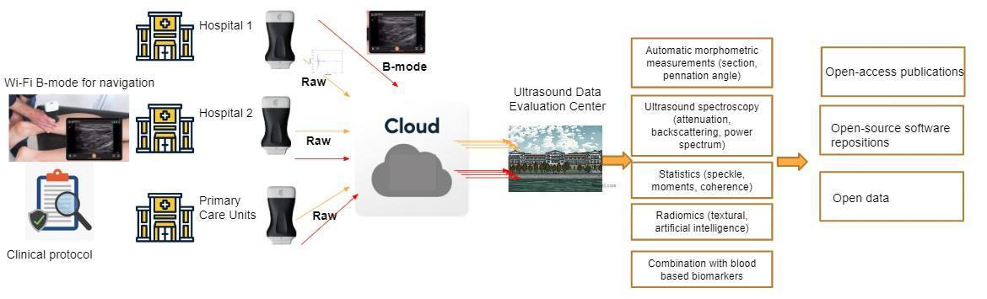  Biomarkers data flow and management from clinical centres to blood-essay evaluation centre.  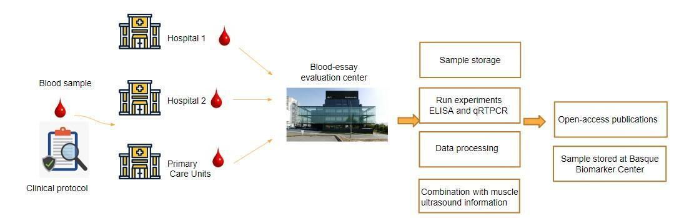
It is strongly recommended that this checklist be read in conjunction with the SPIRIT 2013 Explanation & Elaboration for important clarification on the items. Amendments to the protocol should be tracked and dated. The SPIRIT checklist is copyrighted by the SPIRIT Group under the Creative Commons “Attribution-NonCommercial-NoDerivs 3.0 Unported” license. This checklist can be completed online using https://www.goodreports.org/, a tool made by the EQUATOR Network in collaboration with Penelope.ai

