Supplementary material

Table S1. Results of test of significance of factors and interaction for the model (⊍ = 0.05)
 |  | Total carbohydrates model |  | Phenolic compounds model
Factor (coded) | Factors | p - value |  | p - value
A | Time | 0.1742 | not significant | < 0.0001 | significant
B | Sulfuric acid | < 0.0001 | significant | < 0.0001 | significant
C | Temperature | < 0.0001 | significant | < 0.0001 | significant
AB | _ | 0.6453 | not significant | < 0.0001 | significant
AC | _ | 0.0366 | not significant | < 0.0001 | significant
BC | _ | < 0.0001 | significant | < 0.0001 | significant
A2 | _ | < 0.0001 | significant | 0.0128 | significant
B2 | _ | < 0.0001 | significant | < 0.0001 | significant
C2 | _ | < 0.0001 | significant | < 0.0001 | not significant
ABC | _ | _ | _ | 0.0749 | significant
Model | _ | < 0.0001 | significant | < 0.0001 | significant
Lack of fit | _ | 0.3542 | Not significant | 0.4745 | not significant
R² | _ | 0.9849 |  | 0.9754
Adjusted R² | _ | 0.9814 |  | 0.9688

S1. Confocal analysis methodology
Structural changes between untreated and hydrolyzed GP were appraised by a confocal laser scanning microscopy (CLSM). For CLSM, representative samples of untreated and hydrolyzed GP for all conditions were taken respectively. Particularly, for CLSM the samples were incubated with 2 markers in the dark for 30 minutes at room temperature. The markers used were safranin O at 1% w/v for lignin staining (green) ʎ emission/excitation 546/ 590 nm and Congo red for holocellulose. Then, the samples were centrifuged and washed with PBS 1X, and mounted for visualization on a fluorodish plate. The samples were visualized in three fluorescence channels using the FV1000 confocal laser microscope (Olympus, Japan), and then the images were analyzed (including the relative fluorescence unit (RFU) quantification) using the FV10 Olympus var 0.2c software.

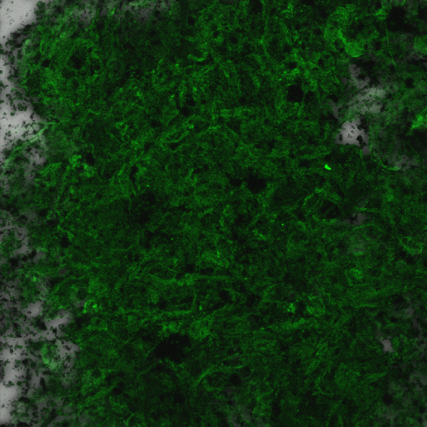
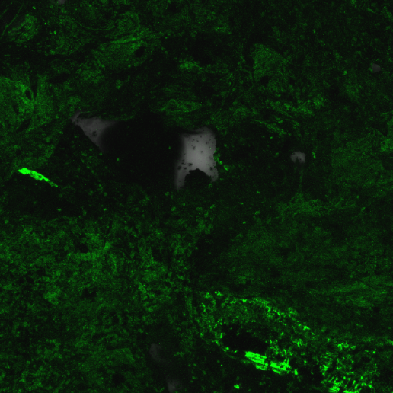
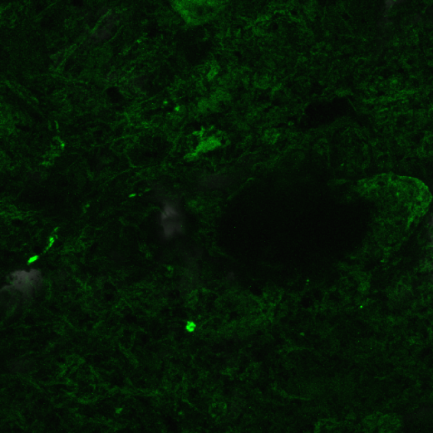
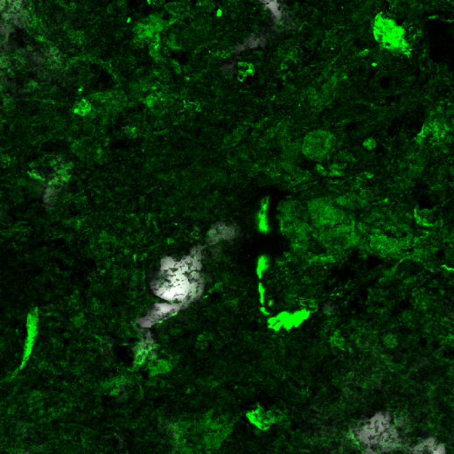
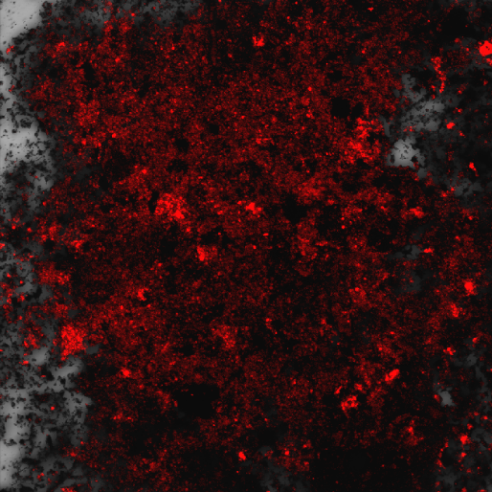
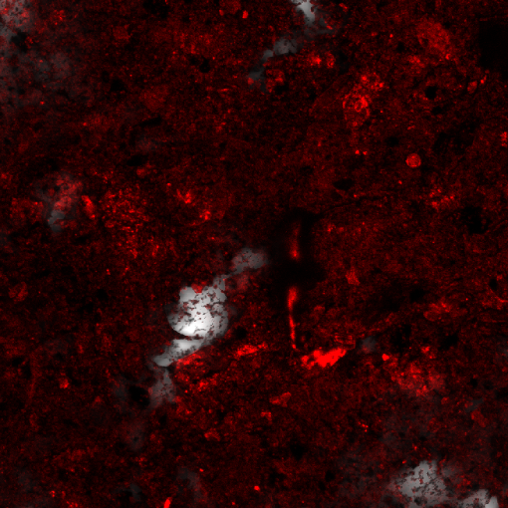
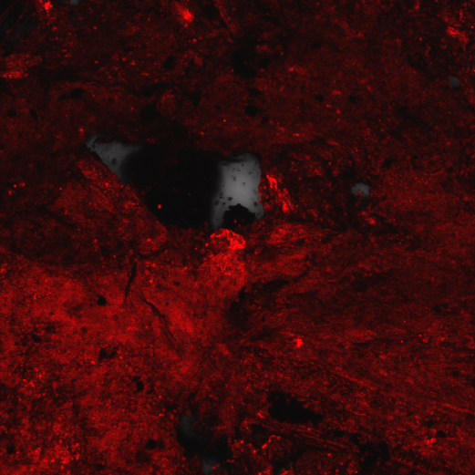
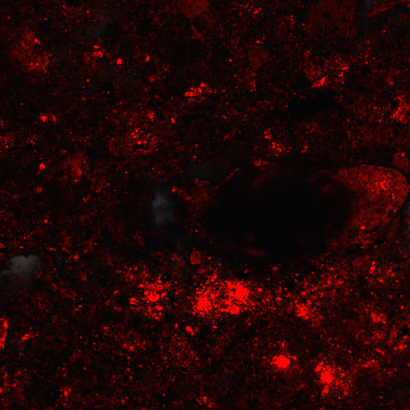
Treatment 7
(120 min,15 %v/v H₂SO₄, 95°C)
Untreated Grape Pomace
1410±341 UFR
Treatment 8
(240 min,15 %v/v H₂SO₄, 95°C)
1359±161 UFR
Treatment 1
(120 min, 5 %v/v H₂SO₄, 65°C)
1894±144 UFR
1315±376 UFR
2044±178 UFR
1619±387 UFR
1416±57 UFR
1451±113 UFR
H
E
B
A
F
G
C
D

D
c

Figure S1. Confocal images for untreated grape pomace and treated grape pomace for treatment number 1,7 y 8. a-d) lignin (green colour) and e-h) cellulose (red colour)

