Supplementary Table 1 Subgroups survival analysis of CHL patients according to EBV status by Cox regression modeling
Variables |  | OS  HR [95%CI] | p-value
Age <45 | LMP1+ vs. LMP1 - | 3.26 (0.85-12.40) | 0.0275*
Age ≥45 | LMP1+ vs. LMP1 - | 1.29 (0.29-5.69) | 0.728
Women | LMP1+ vs. LMP1- | 1.98 (0.38-10.21) | 0.34
Men | LMP1+ vs. LMP1- | 3.68 (1.039-13.04) | 0.0219*
Limited-stage (I-IIA) | LMP1+ vs. LMP1 - | 0.67 (0.17-2.66) | 0.507
Advanced-stage (IIB-IV) | LMP1+ vs. LMP1 - | 1.36 (0.39-4.719) | 0.599
Non-Nodular Sclerosis | LMP1+ vs. LMP1 - | 2.3 (0.4-7.8) | 0.045*
Abbreviations: CHL, classical Hodgkin lymphoma; EBV, Epstein-Barr virus; OS, overall survival; CHL; LMP1, latent membrane protein 1. *Statistically significant p-value <0.05.

Supplementary Fig.1 ROC curves for infiltrating immune cells and ratios of 102 CHL samples with the cutoffs and Area Under the curves (AUC) were indicated

Supplementary Fig. 2 Subgroups Survival analysis of classical Hodgkin lymphoma patients according to EBV-LMP1 status. Kaplan-Meier curves showing the impact of LMP1 on the overall survival and event-free survival in subgroups of patients according to age (A, B, C), sex (D), stage (E, F), mediastinal mass (G, H), ABVD treatment regimen (I, J), Log-rank, p < 0.05 statistically significant

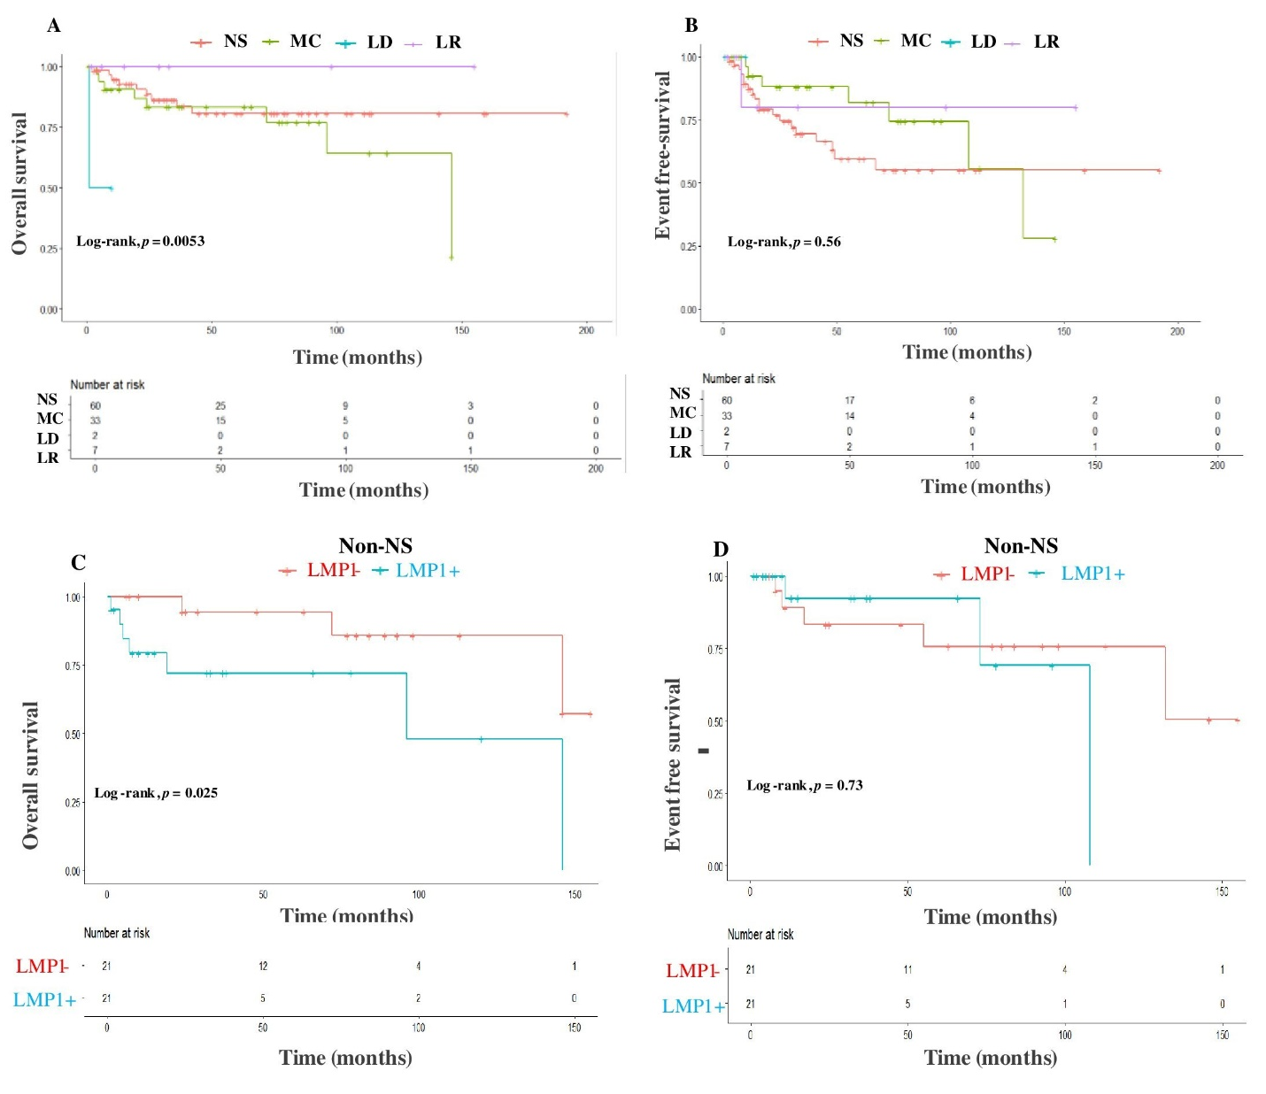
Supplementary Fig. 3 Survival analysis of classical Hodgkin lymphoma according to histological subtypes and the impact of LMP1. Kaplan-Meier curves showing the overall survival (OS) and event-free survival (EFS) of CHL according to four subtypes (A, B), the impact of LMP1 on the survival of non- nodular sclerosis (non-NS) group (C, D), Log-rank p < 0.05 statistically significant

