Supplementary Materials

1. Kinetic Monte Carlo (KMC) based Potts Model:

The Kinetic Monte Carlo Potts model [1] works on a computational domain consisting of a continuum of lattice sites. A cluster of lattice sites composes a grain, and each lattice site is assigned a spin value. The KMC Potts model is based on an on-lattice technique where the lattice sites are assumed to be static, and the melt pool moves over the stationary lattice sites. The curvature-driven grain growth is approximated by minimizing the grain boundary energy or curvature of the boundaries of the grains. Lattice sites having similar spin values composes an entire grain. The grain boundaries have dissimilar spin values. A lattice site’s spin is compared with the neighboring lattice sites to determine the configurational energy of a particular lattice site. The expression for total energy calculated by comparing the spins of the lattice sites is:

$E=\frac{1}{2}\sum_{i=1}^{N}{\sum_{j=1}^{L}{\left(1-{δ(q}_{i},q_{j})\right)}}$ (1)

Here, $N$ is the number of lattice sites and $L$ is the number of neighbors. Here, $q$ designates a particular spin value of a lattice site ($q_{i}$) and its neighboring lattice site ($q_{i}$). $δ$ is the Kronecker’s delta function and energy is zero when the spin values of the lattice sites are equal ($q_{i}=q_{j}).$
The evolution of grains occurs by comparing spins of the lattice sites at the grain boundaries and simultaneous calculation of local configurational energies. After comparing a spin value with the spin value of its neighboring site, the move is accepted or rejected is based on the acceptance relative probability $P$ and comparing it with the random number ($R$) generated computationally by using the Metropolis function. The value of relative probability ($P$) depends on the change in energy ($∆E)$, whether it’s positive or negative. The expression for the acceptance probability is given by:

$P= \left\{\begin{aligned}exp\left(-\frac{∆E}{k_{B}T_{s}}\right) if ∆E>0 \\ 1 if ∆E ≤0\end{aligned}\right.$ (2)
Here, $k_{B}$ is the Boltzmann constant and $T_{s}$ is the simulation temperature. Now, after comparison of the spins, if the change in the system energy is negative then the change of spin is accepted. If the system energy increases after the comparison between spins, still there is a chance for acceptance of the spin change if the random number $R$ is less than $P$. Simulation time is given in terms of Monte Carlo Steps ($MCS$), where each timestep signifies spin update after comparing two neighboring lattice sites.
As the molten pool traverses along the powder bed, microstructure starts evolving within and just outside of the molten zone. During the movement of the melt-pool along the powder bed, a steep thermal gradient occurs within a region also known as Heat Affected Zone ($HAZ$). The on-lattice KMC Potts model approximates the movement of molten zone estimating the number of spin assignments along the boundary. Now the grain boundary mobility is given by the following equation which follows an Arrhenius relationship with the local or the physical temperature ($T$):

$M\left(T\right)= M_{o}exp\left(\frac{-Q}{RT}\right)$ (3)
Here, $Q$ is the activation energy for grain boundary mobility and $T$controls the local grain boundary mobility. $R$ is the gas constant and $M_{o}$ is the mobility pre-factor, is a material-specific parameter. The probability for assigning a spin value for grain evolution is given by:

$P= \left\{\begin{aligned}M(T)exp\left(-\frac{∆E}{k_{B}T_{s}}\right) if ∆E>0 \\ M(T) if ∆E ≤0\end{aligned}\right.$ (4)

As the molten pool moves the trailing region of the molten pool solidifies due the thermal gradient between the melt-pool and peripheral powder region. Due to this, spin re-assignment happens between the lattice sites along the boundaries of the melt-pool and with the previously solidified grains.

2. Featurization of microstructural images:

As mentioned earlier in Section 3 of the paper, for the featurization of the microstructural images we use some custom pre-processing steps and an off-the-shelf image analysis toolkit, watershed algorithm [2]. ﻿The main goal of the watershed algorithm is to visualize the topography of the two-dimensional microstructural image in three-dimensions [3]. The term ‘topography’ considers three different regions for each of the grains in the microstructure image, i) a local minimum, or a shallow region which is like a hole punched inside from a significant area (here we call it the grain area itself); ii) the edges bounding the shallow region; iii) the region in between the edges and the shallow region, with a distinct slope. The algorithm aims to find the boundaries of the grains, which is the watershed line or boundary, divides two shallow regions. Now, as we consider our grain boundary regions as the watershed lines and the grains themselves as the shallow regions or valleys, thus watershed algorithm for grain segmentation can be implemented. The watershed algorithm requires two arguments as inputs: the original image and markers. Here, markers are the objects in the image, the sure foreground region, or the region which we know exactly are the grains, the background of the image, and the grain boundaries. Now, to label the markers some pre-processing steps for the image need to be followed.
The input greyscale image was a bright image with most of the image pixels populated within a range of high values. For that, locally, the image contrast will vary a lot. A good image should have an equalized contrast within a particular range of pixel values. The histogram equalization [4] technique evenly distributes the pixel intensities within the input grey image. Histogram equalization performs this by efficiently spreading out the highly populated intensity values used to debase the image contrast. However, there are some consequences of using histogram equalization. This technique sometimes decreases the depth of colors in the image. Also, sometimes it fails to identify the inherent noise present in an image. A remedy to this is adaptive histogram equalization which locally emphasizes the contrast present in the image. In this technique, the entire image is divided into several tiles or blocks (default is 8x8 in OpenCV), and for each block, histogram equalization is applied. Now, there is a chance of background noise in the image, as a solution to that, contrast limiting is applied [5]. If any histogram bin is above the default limit of contrast (default is 40 in OpenCV), those pixels will be clipped and evenly distributed to other bins before the application of histogram equalization. After that, the edges of the grains were detected using the canny edge detection method [6], and the resulting image was thresholded using Otsu’s binarization method [7]. To remove the small noise present in the image, a morphological operation [8, 9], ‘opening’ was performed. The opening operation [9] helps to recognize that the region near the center of the object is for sure grains and the background region. Then, distance transform [10] was performed with proper thresholding to get the regions for which are grains or the sure foreground area. For determining the background region, another operation, dilation was performed. Dilation [9] helps to make sure whatever region in the background in the result is really a background since the grain boundary region is removed. Moreover, to ensure the grain boundaries from the image, which can be obtained by subtracting the background region from the foreground. Thereafter, the markers or the foreground, background, and grain boundary regions were labeled by using the ‘connectedComponents’ function of the OpenCV library. Finally, the ‘watershed’ function was applied using the original image and labeled markers as inputs.
As we fairly segment each grain with the watershed algorithm, the ‘regionprops’ function underneath the ‘measure’ module of the Scikit-Image library [11] was used for extracting the microstructural features as distributions. The angle of inclination of each grain was measured with the build direction (here, uni-directional, or bi-directional cases). A grain tilted in the clockwise direction is considered to have a positive angle and a grain tilted in the counterclockwise direction is considered to have a negative angle with respect to the normal taken as reference. The ‘regionprops’ function fits each labeled grain to an ellipse to determine the major and minor axis lengths of the grains. Utilizing the ratio of minor to major axis length, the aspect ratio of grains was calculated. Grains having an aspect ratio near zero are considered to have a columnar or needle-shaped geometry and an aspect ratio nearing a value of one is considered to have an equiaxed or circular geometry. The area and perimeter of each grain were calculated, and the perimeter-to-area ratio can be used as an indicator of both area and shape of the grains. Also, the diameter of the grains, equivalent to the grain area was calculated which gave the size of each grain from the microstructure images.

3. Benchmarking with previous literature:

As discussed earlier in section 2 of the manuscript, the simulation results from the present work were compared with the experimental EBSD results of Parimi et al. [12]. Simultaneously, the results were also compared with the KMC simulation results of Rodgers et al. [13]. Fig. S1 and Fig. S2 represent the comparison of additive patterns from the present simulation with the previously published additive patterns [12, 13].

Using the images obtained from replicating the KMC simulations performed by Rodgers et al. [13], we used our featurization algorithm for extracting the microstructural features and compared the distributions of the orientation of grains and aspect ratio with the previously published experimental and simulation results [12, 13]. The comparisons are represented in Fig. S3, and S4.

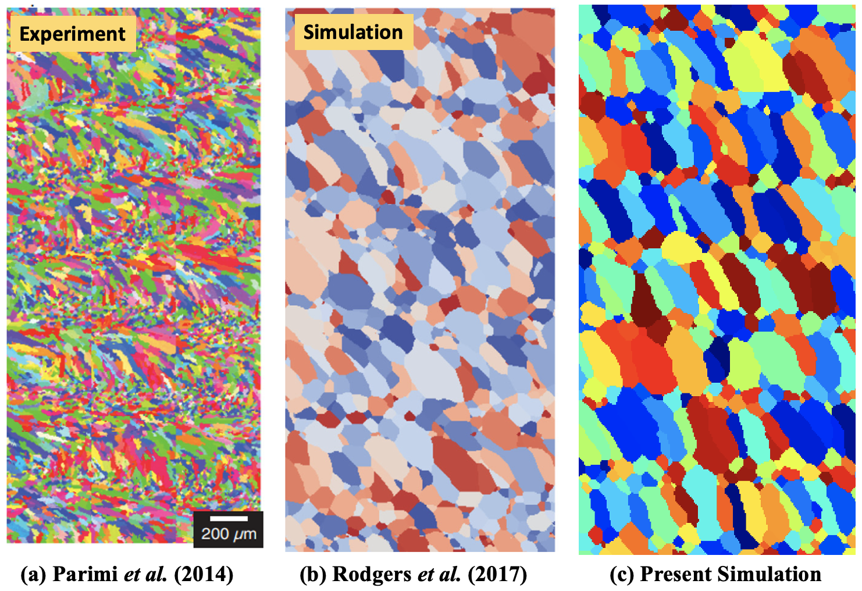

Fig. S1: Comparison of uni-directional additive patterns obtained from the present simulation with (a) Parimi et al. [12] and KMC simulation of (b) Rodgers et al. [13]

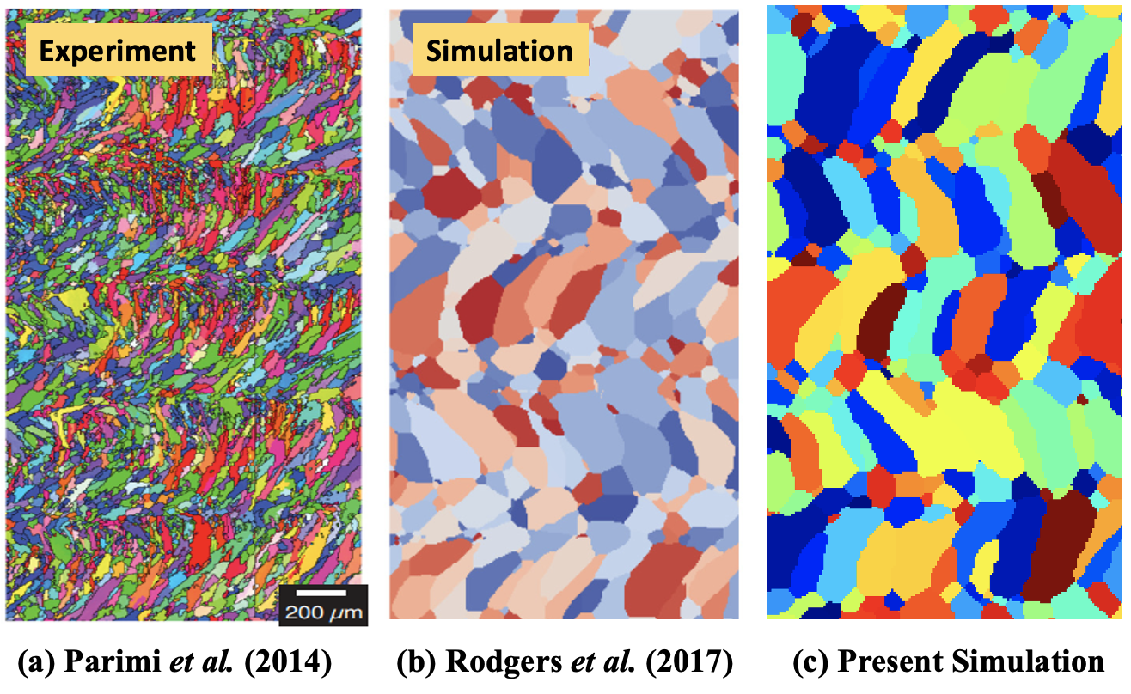

Fig. S2: Comparison of bi-directional additive patterns obtained from the present simulation with (a) Parimi et al. [12] and KMC simulation of (b) Rodgers et al. [13]

(b)
(a)
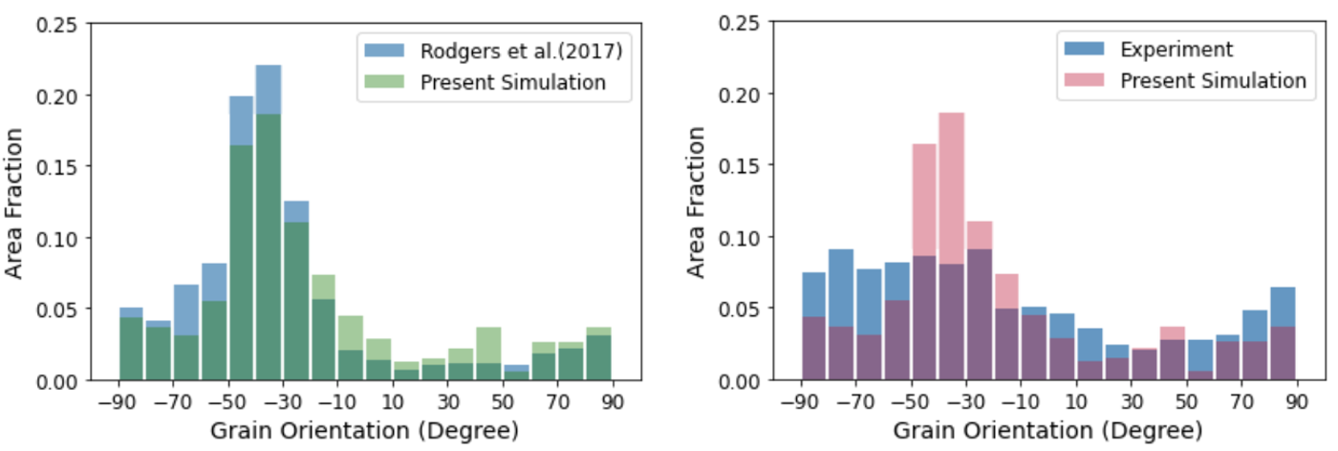

Fig. S3: Comparison for distributions of angular orientation of grains in between (a) present and KMC simulation of Rodgers et al. [13], (b) experiment (Parimi et al. [12]) and present simulation for uni-directional additive patterns conditions from Fig. S1

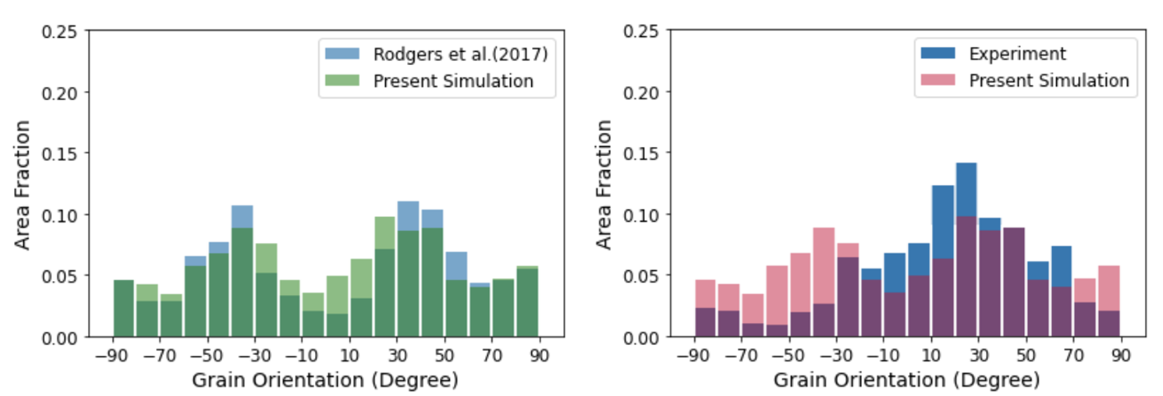

(b)
(a)

Fig. S4: Comparison for distributions of angular orientation of grains in between (a) present and KMC simulation of Rodgers et al. [13], (b) experiment (Parimi et al. [12]) and present simulation for bi-directional additive patterns from Fig. S2.

4. Kernel Density Estimation (KDE) of microstructural features:

One of the most intuitive ways to plot a distribution is a histogram. For benchmarking purposes, histograms have been used to compare datasets [13, 14, 15]. The datasets were binned into equal widths and the number of bins was equal. However, there are some artefacts when using histograms:

- With the variation in the AM process parameters; velocity, hatch spacing, melt pool width and length, the grains resulting in the microstructural image varies. That means, the number of observations or labeled grains by the watershed algorithm varies in the dataset.

- Moreover, the binning strategy is ambiguous for different datasets, and the shape of the histogram changes with changing bin widths of the histogram.

To solve this uncertainty, a remedial approach is to use a kernel density function that approximates the histogram with a continuous function, using kernel density estimation (KDE) [16]. The kernel density estimation is a non-parametric way of calculating the probability density function. If an independent, uniformly distributed distribution ($x_{1}, { x}_{2}, …, { x}_{n}$) is given, then the probability density function of the distribution is given as $p\left(x\right)$ in the equation,
$p\left(x\right) = \frac{1}{nh} \sum_{j=1}^{n}{K\left(\frac{x-x_{j}}{h}\right)}$ (5)

Where, $K\left(x, h\right)$ is the kernel function and $h$ is the bandwidth parameter, which determines the smoothness of the density curve. $n$ is the number of sample points in the distribution.
SciPy [17] was used to calculate the bandwidth factor and the ‘Gaussian’ kernel function was used in this work. Bandwidth selection can be done using two principal methods, the first one is the ‘rule of thumb’ from SciPy, and the second one is the ‘cross-validation method’, that comes from the Scikit-Learn [18] library. We chose Scott's rule of thumb [19] for the calculation of suitable bandwidth for the density distributions, as the ‘cross-validation method’ incurred high computational cost. First, the raw data was fitted to a Gaussian kernel, and then the covariance factor of the fitted data was determined. As a next step, the covariance factor was multiplied by the standard deviation of the fitted data to determine the bandwidth factor. The bandwidth determined using this method seemed to fit the data very smoothly and the yield a density curve having negligible noise or jitteriness.

5. t-SNE representation of process parameters:

As explained in the introductory part of the section 4, in Fig. 3 of the main paper, we represented the parametric variations using t-SNE (t-distributed stochastic neighbor embedding) [20]. The t-SNE technique has some unique hyperparameters which affects the clustering of the process parameter data points. Those unique hyperparameters are perplexity, learning rate, and the number of iterations used for the convergence of the optimization process. In Fig. 3 of the main paper, we have chosen the following values of hyperparameters: perplexity = 10, learning rate = 0.01, and number of iterations = 20000. However, we have tested different hyperparameters and mainly focused on different perplexity values. The plots for t-SNE clustering at different perplexity values are shown in Figure S5.
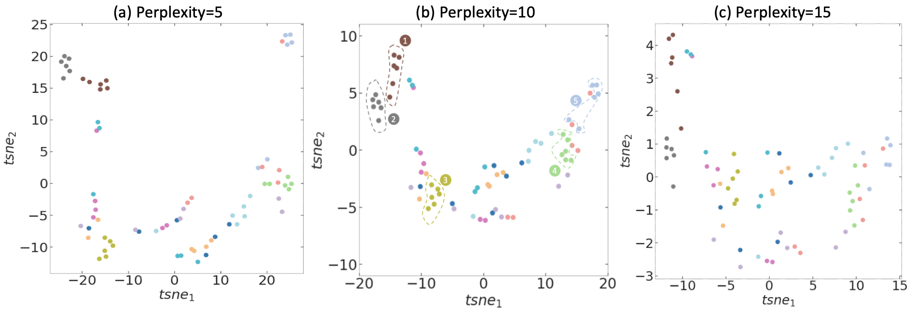

Fig. S5: t-SNE representations of corresponding simulations for different process parameters at (a) perplexity=5,
(b) perplexity=10, (c) perplexity=15. For t-SNE representation of the AM process parameters we have considered Fig. S5(b) in comparison with the other two figures, a perplexity value of 10 seems to cluster the parametric variations more efficiently.

6. Effect of stochasticity in KMC simulations:

As discussed previously and portrayed in Fig. 3 of the manuscript, microstructural images obtained from KMC simulations exhibit variability even for the same input processing conditions. Therefore, while analyzing the effect of input parameters we average over six independent simulations to preclude stochastic effects. Features obtained from different stochastic realizations of one input condition are shown in Figure S6. Except the orientational distributions, all other features exhibit minor variability across different seed values. The density distributions, averaged over six independent simulations, are plotted with error bands to illustrate the margin of error associated with the curve. The margin of error was calculated based on a pre-defined confidence level, standard deviation of the dataset and number of observations in the dataset. 95% confidence level was used for calculation of error margins.
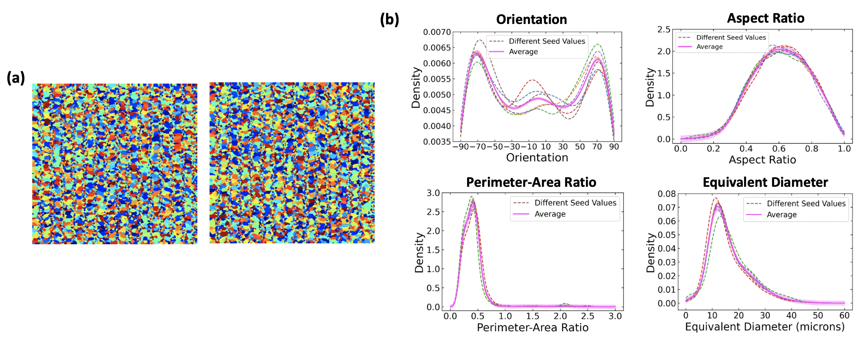

Fig. S6: (a) Similar microstructural images at different seed values for similar input condition ($v$=30, h=30, w=45, l=60) (b) Variations in distributions of descriptors at different seed values for similar input condition, with an average distribution curve for each descriptor averaged over six independent simulations.

7. Parametric variations:

As discussed earlier in the previous sections 4.1 and 4.2, more parametric variations for finely sampled velocities, hatch spacings, pool widths, and pool lengths are shown in Fig. S7, S8, S9, and S10 respectively.
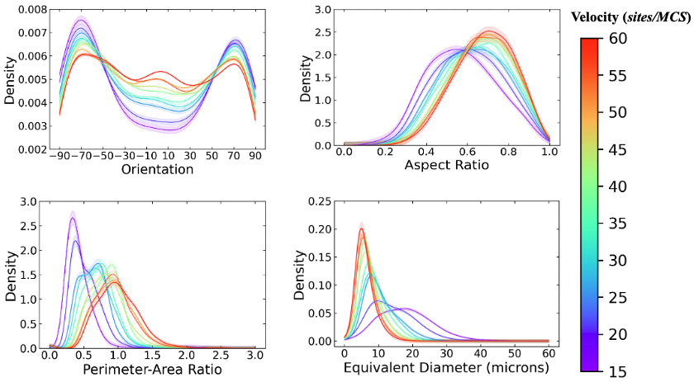

Fig. S7: (a) Variations in descriptors at different velocities gradually increasing from 15 sites/MCS to 60 sites/MCS, at an interval of 5 sites/MCS. Other input parameters are constant: $h=30,l=60, w=45$.

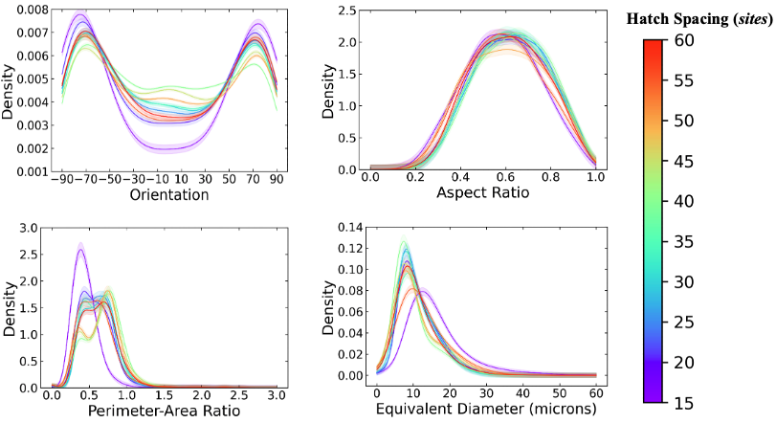

Fig. S8: (a) Variations in descriptors at different hatch spacings gradually increasing from 15 sites to 60 sites, at an interval of 5 sites. Other input parameters are constant: $v=25,l=60, w=45$.

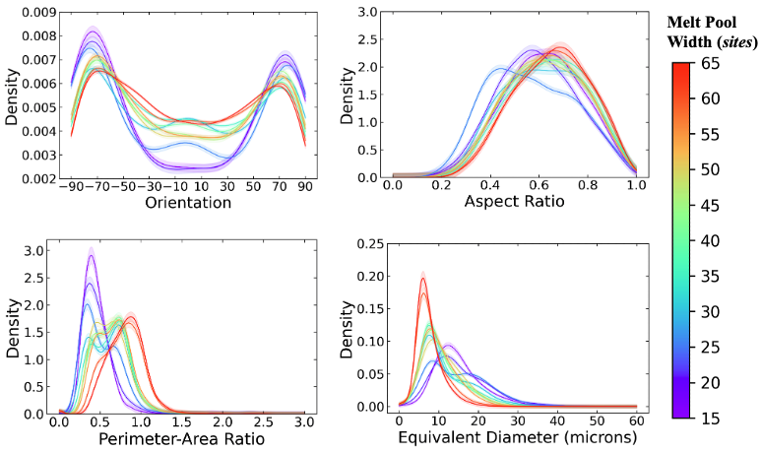

Fig. S9: (a) Variations in descriptors at different melt pool widths gradually increasing from 15 sites to 65 sites, at an interval of 5 sites. Other input parameters are constant: $v=25,h=30, l=60$.
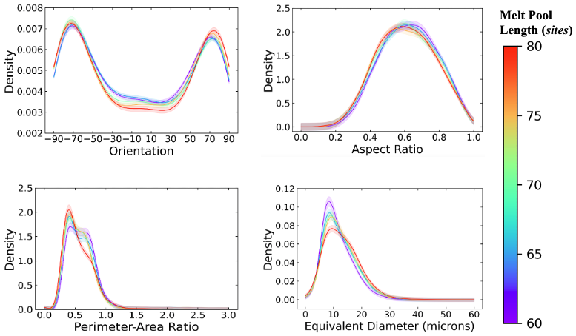
Fig. S10: (a) Variations in descriptors at different melt pool lengths gradually increasing from 60 sites to 80 sites. Other input parameters are constant: $v=25,h=30, l=60$.

References

[1] Holm, E.A. and Battaile, C.C., 2001. The computer simulation of microstructural evolution. Jom, 53(9), pp.20-23.

[2] ﻿Haris, K., Efstratiadis, S. N., Maglaveras, N., Katsaggelos, A. K. Hybrid image segmentation using watersheds and fast region merging. IEEE Trans. Image Process, 7, 1684–1699 (1998).

[3] Guo, Q., Wang, Y., Yang, S. and Xiang, Z., 2022. A method of blasted rock image segmentation based on improved watershed algorithm. Scientific Reports, 12(1), pp.1-21.
[4] Pizer, S.M., Amburn, E.P., Austin, J.D., Cromartie, R., Geselowitz, A., Greer, T., ter Haar Romeny, B., Zimmerman, J.B. and Zuiderveld, K., 1987. Adaptive histogram equalization and its variations. Computer vision, graphics, and image processing, 39(3), pp.355-368.
[5] Pisano, E.D., Zong, S., Hemminger, B.M., DeLuca, M., Johnston, R.E., Muller, K., Braeuning, M.P. and Pizer, S.M., 1998. Contrast limited adaptive histogram equalization image processing to improve the detection of simulated spiculations in dense mammograms. Journal of Digital imaging, 11(4), pp.193-200.
[6] Ding, L., Goshtasby, A., 2001. On the Canny edge detector. Pattern recognition, 34(3), pp.721-725.
[7] ﻿Xue, J. H., Zhang, Y. J. Ridler, Calvard’s, Kittler and Illingworth’s and Otsu’s methods for image thresholding. Pattern Recognition Letters, 33, 793–797 (2012).
[8] Comer, M.L., Delp III, E.J., 1999. Morphological operations for color image processing. Journal of electronic imaging, 8(3), pp.279-289.
[9] Haralick, R.M., Sternberg, S.R. and Zhuang, X., 1987. Image analysis using mathematical morphology. IEEE transactions on pattern analysis and machine intelligence, (4), pp.532-550.
[10] ﻿Cuisenaire, O. Locally adaptable mathematical morphology using distance transformations. Pattern Recognition, 39, 405–416 (2006).
[11] Van der Walt, S., Schönberger, J.L., Nunez-Iglesias, J., Boulogne, F., Warner, J.D., Yager, N., Gouillart, E. and Yu, T., 2014. scikit-image: image processing in Python. PeerJ, 2, p.e453.
[12] ﻿L.L. Parimi, G.A. Ravi, D. Clark, M.M. Attallah, Microstructural and texture development in direct laser fabricated IN718, Mater. Charact. 89 (2014) 102–111.

[13] Rodgers, T.M., Madison, J.D. and Tikare, V., 2017. Simulation of metal additive manufacturing microstructures using kinetic Monte Carlo. Computational Materials Science, 135, pp.78-89.

[14] Li, W. and Soshi, M., 2019. Modeling analysis of grain morphologies in Directed energy deposition (DED) coating with different laser scanning patterns. Materials Letters, 251, pp.8-12.
[15] Li, W. and Soshi, M., 2019. Modeling analysis of the effect of laser transverse speed on grain morphology during directed energy deposition process. The International Journal of Advanced Manufacturing Technology, 103(9), pp.3279-3291.

[16] Chen, Y.C., 2017. A tutorial on kernel density estimation and recent advances. Biostatistics & Epidemiology, 1(1), pp.161-187.
[17] Virtanen, P., Gommers, R., Oliphant, T.E., Haberland, M., Reddy, T., Cournapeau, D., Burovski, E., Peterson, P., Weckesser, W., Bright, J. and Van Der Walt, S.J., 2020. SciPy 1.0: fundamental algorithms for scientific computing in Python. Nature methods, 17(3), pp.261-272.
[18] Pedregosa, F., Varoquaux, G., Gramfort, A., Michel, V., Thirion, B., Grisel, O., Blondel, M., Prettenhofer, P., Weiss, R., Dubourg, V. and Vanderplas, J., 2011. Scikit-learn: Machine learning in Python. the Journal of machine Learning research, 12, pp.2825-2830.
[19] Scott, D.W., 2015. Multivariate density estimation: theory, practice, and visualization. John Wiley & Sons.
[20] L. van der Maaten, G. Hinton, Visualizing high-dimensional data using t-SNE, J. Mach. Learn. Res. 9 (2008) 2579–2605.

