Online Data Supplement

Manuscript Title: The diagnostic accuracy of lung ultrasound to determine PiCCO-derived extravascular lung water in invasively ventilated patients with COVID-19 ARDS

Table of contents

Online Supplement A: Exclusion criteria INVENT COVID trial 1
Online Supplement B: Standard operating procedure for PiCCO measurement 2
Table S1: The 4-region B-line count score 4

Online Supplement A: Exclusion criteria INVENT COVID trial

- Persistent septic shock (> 24 h) with a mean arterial pressure ≤ 65 mmHg and serum lactate level > 4 mmol/L (36 mg/dL) despite adequate volume resuscitation and vasopressor use (norepinephrine > 0·2 μg/kg/min) for > 6 h;
- Pre-existing chronic pulmonary disease, including known diagnosis of interstitial lung disease; known diagnosis of chronic obstructive pulmonary disease GOLD Stage IV or forced expiratory volume in 1 s < 30% predicted; diffusing capacity for carbon monoxide < 45% (if test results are available); total lung capacity < 60% of predicted (if test results are available);
- Chronic home oxygen treatment;
- Pre-existing heart failure with known left ventricular ejection fraction < 40%;
- Active treatment of hematological or non-hematological cancer with targeted immuno- or chemotherapy, or thoracic radiotherapy in the last year;
- Currently receiving extracorporeal life support;
- Severe chronic liver disease with Child-Pugh score > 12;
- Subjects in whom a decision to withdraw medical care is made (e.g., palliative setting);
- Inability of the ICU staff to initiate investigational medicinal product administration within 48 h of intubation;
- Known to be pregnant or breast-feeding;
- Enrolled in a concomitant clinical trial of an investigational medicinal product;
- White blood cell count < 2·5 × 10⁹/l; hemoglobin < 4·0 mmol/l or thrombocytes < 50 × 10⁹/l;
- The use of strong CYP3A4 inducers, including the following drugs: Carbamazepine, efavirenz, enzalutamide, phenobarbital, phenytoin, hypericum (St. John’s wort), mitotane, nevirapine, primidone, rifabutin, rifampicin;
- The presence of an intra-aortic balloon pump (IABP);
- Known medical history of aortic aneurysm in the trajectory of the PiCCO measurement between central venous line and arterial detector;
- Known medical history of an intracardiac shunt.

Online Supplement B: Standard operating procedure for PiCCO measurement

Background
PICCO stands for Pulse Contour Cardiac Output monitoring. It involves the principle of thermodilution. A sensor cable (see figure, 1) is attached to the central venous catheter (CVC), with its tip in the superior vena cava. The PICCO thermodilution catheter is placed in the femoral artery. An injection of 20 ml of cold (<8 degrees Celsius) NaCl is injected via the central venous catheter. Subsequently, the change in temperature is detected via the PICCO catheter.

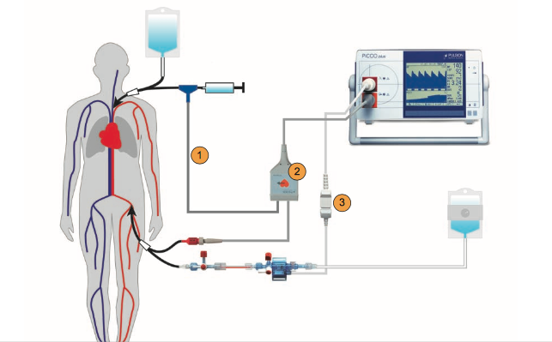
1: Injectate sensor cable; 2: Arterial connection cable; 3: Pressure connection cable

Several parameters can be obtained by transpulmonary dilution, including:
- Extravascular lung water (EVLW) and pulmonary vascular permeability (PVP)
- Measures of cardiac contractility: global ejection fraction, GEF), cardiac output (CO), filling volume (global end-diastolic volume, GEDV) and stroke volume variation (SVV).
These parameters are indexed against body surface area (BSA).

Insertion of the PICCO catheter

Under sterile circumstances, an intensive care physician will insert the PICCO catheter using the standard ultrasound-guided procedure for arterial catheter insertion. The preferred location for the PICCO catheter is the femoral artery.

Monitor set-up
- Register length and weight of the patient on the monitor.
- On the monitor, chose Ventilated + PICCO.
- Insert the PICCO module into the module rack next to the monitor and attach the PICCO cable to the module.
- Connect the long PICCO cable with the blue temperature sensor that is attached proximally at the CVC.
- Connect the short PICCO cable with the red transducer of the PiCCO catheter.
- Click CO to start calibrating the cardiac output.
Calibration:
Once per shift the cardiac output measurement is calibrated using thermodilution. Three measurements are obtained and the averaged result is saved. The PICCO can be attached to the monitor, where it displays cardiac output continuously. Other measurements, such as the GEF and EVLW, are only determined during thermodilution, not continuously.
Thermodilution measurement
- Make sure the injectate cable is connected to the central venous catheter as proximally as possible. The PICCO is connected to the CVC directly (see second image below) to ensure that the entire injection is given, minimizing loss of the cold injectate in the line.

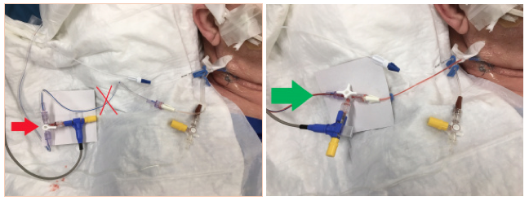
Red cross and arrow: incorrect connection. Green arrow: correct connection.
- Prepare three syringes containing 20ml NaCl 0.9% (minimum 8 degrees Celsius)
- Ensure an optimal arterial curve. If necessary, flush the arterial catheter before calibration.
- Check the settings of the PICCO module (injectate volume 20ml, injectate temperature, length and weight of the patient).
- Administer the injectate (20ml) within 7 seconds, paying attention that you notice a temperature decrease of at least 0.2 degrees Celsius.
- Conduct at least three measurements that do not differ >10%. In case of a larger deviation, tap on the measurement to annul it, then re-do the measurement.

Table S1: The 4-region B-line count score

Ultrasound finding | Score
No B-line/ICSª | 0
One B-line/ICS | 1
Two B-lines/ICS | 2
Three B-lines/ICS | 3
Four B-lines/ICS | 4
Five B-lines/ICS | 5
Confluent B lines >50% ICS | 6
Confluent B lines >75% ICS | 7
Confluent B lines 100% ICS | 8
ªICS = intercostal space
Table summarizing the 4-region B-line count score proposed by Enghard et al.

