Supplementary material for “North Atlantic chlorophyll blooming enhances terrestrial primary over Europe”

Young-Min Yang^{1,2*}, Jae-Heung Park³, Jong-Yeon Park⁴, Soon-Il An⁵,Sang-Wook Yeh⁶, Eun-Young Kwon^{7,8}, June-Yi Lee^{7,8} and Tim Li^{1,2}
¹Key Laboratory of Meteorological Disaster, Ministry of Education (KLME)/Joint International Research Laboratory of Climate and Environment Change (ILCEC)/Collaborative Innovation Center on Forecast and Evaluation of Meteorological Disasters (CIC-FEMD), Nanjing University of Information Science and Technology, Nanjing, 210044, China. ²Department of Atmospheric Sciences and International Pacific Research Center, University of Hawaii, Honolulu HI 96822, USA. ³Division of Environmental Science and Engineering, Pohang University of Science and Technology, Pohang 37673, Korea. ⁴ School of Earth and Environmental Science, Chun-Nam National University, Korea. ⁵Department of Atmospheric Sciences and Irreversible Climate Change Research Center, Yonsei University, Seoul 03722, Korea. ⁶Department Marine Sciences and Convergent Technology, Hanyang University, ERICA, South Korea. ⁷Research Center for Climate Sciences, Pusan National University, Busan, South Korea. ⁸Center for Climate Physics, Institute for Basic Science, Busan, South Korea.. * indicates a corresponding author; e-mail: ymyang@hawaii.edu

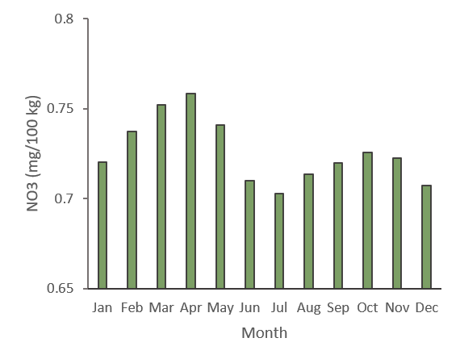

Supplementary Figure S1. Climatology of monthly chlorophyll. Climatological monthly NO3 nutrients in latitude of North Atlantic ocean (50°W-30°W, 55°N-65°N) (mg m⁻³).

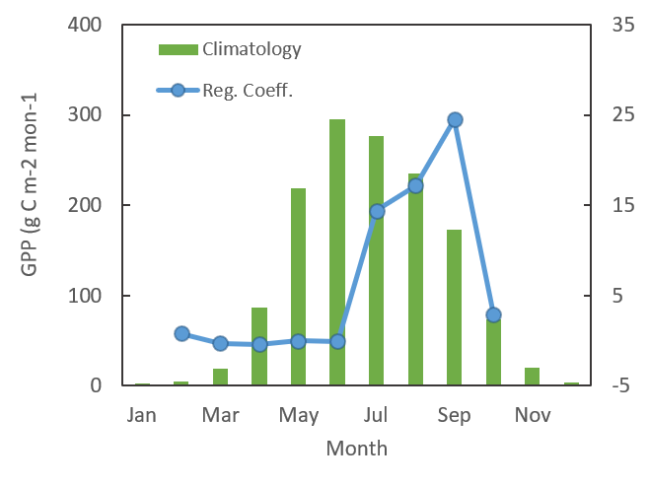

Supplementary figure S2. Seasonal cycle of GPP anomalies relaed to North Atlantic Chlorophyll. The regression coefficient of the monthly GPP from LUEM over Europe (5°–30°E, 45°–55°N) with respect to the North Atlantic chlorophyll (50°W-30°W, 55°N-65°N) index (blue line) and climatological monthly GPP over Europe (green bars) based on LUE (g C m⁻² month⁻¹ ).

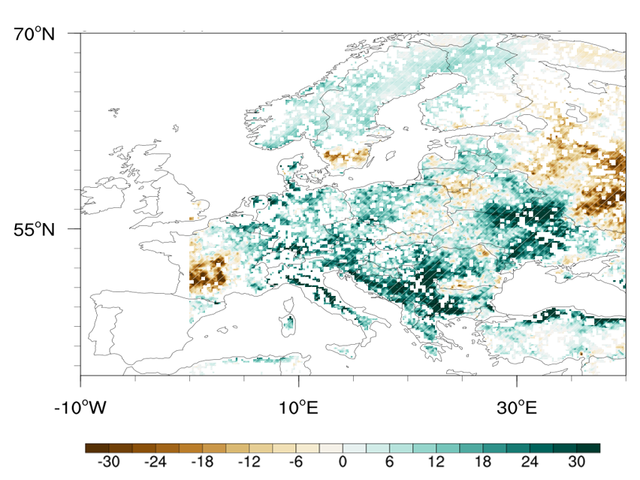

Supplementary figure S3. Impact of North Atlantic chlorophyll on Europe's ecosystem. a Regression coefficient of September GPP from LUEM (g C m⁻² month⁻¹ ) onto September North Atlantic chlorophyll (50°W-30°W, 55°N-65°N) from observation. Hatching and scale bars represent a range of 95% confidence level based on a Student’s t-test.

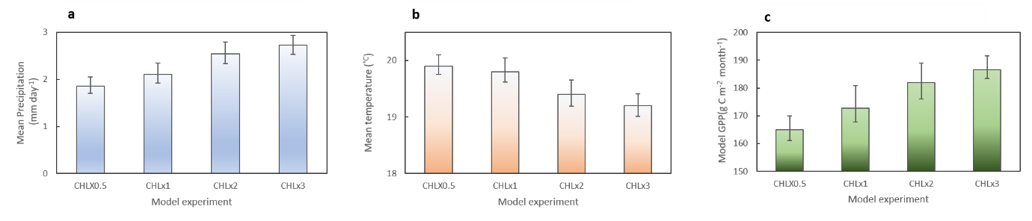

Supplementary Figure S4 | Impact of North Atlantic chlorophyll on Europe's climate. a-c Sensitivity of Europe climate (5°E-25°E, 45°N-55°N) to the high-latitude chlorophyll (50°W-30°W, 55°N-65°N) from NUIST earth system model simulations with prescribed chlorophyll concentrations (50%, 100%, 200%, and 300% of climatology). a mean precipitation (mm day⁻¹), b near-surface (2m) temperature anomalies (C°) ), and c near-surface (2m) temperature anomalies (C°) during September. The black line represents the ensemble spread. 50yr simulation data are used for analysis.

