Appendix

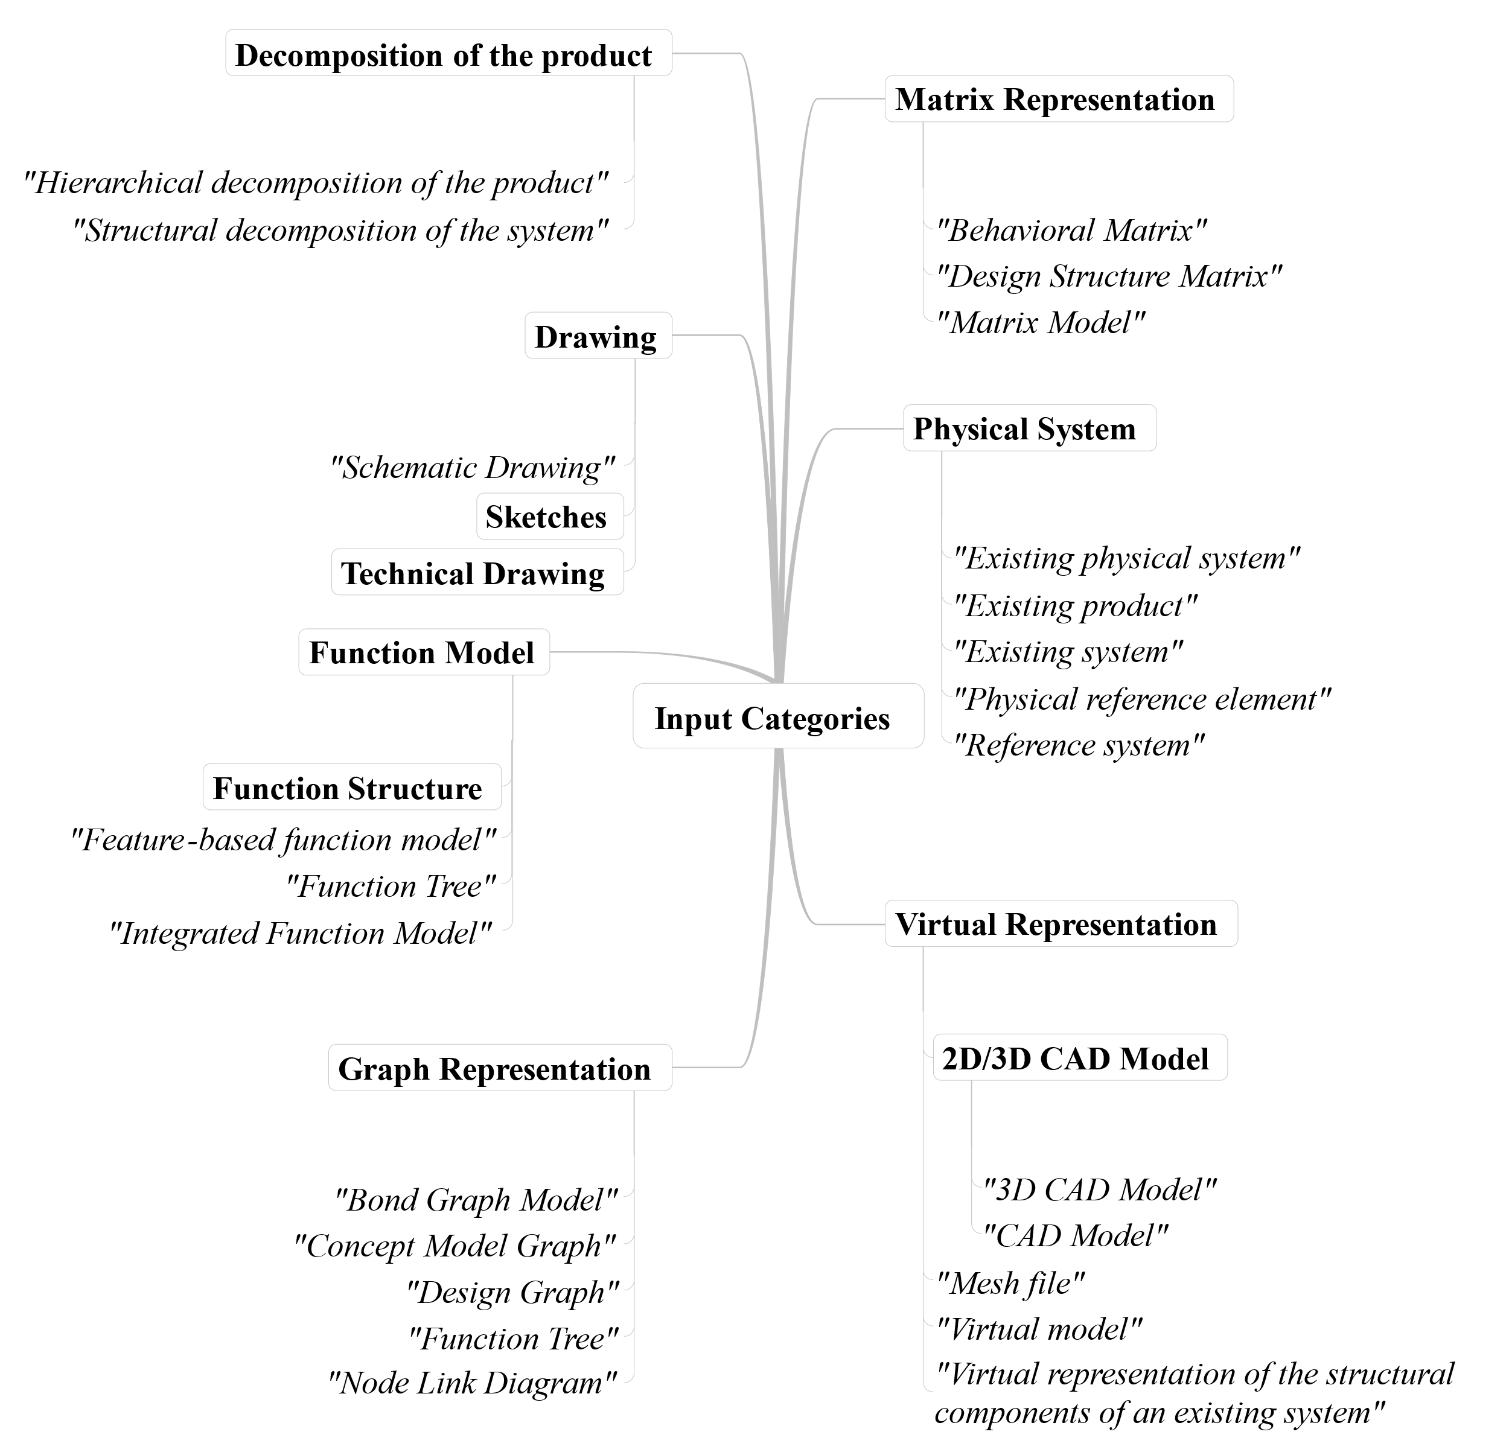
Figure 5. Categories of the inputs of the product models. The categories are illustrated in boxes and underneath are grouped descriptions without a box in italics.

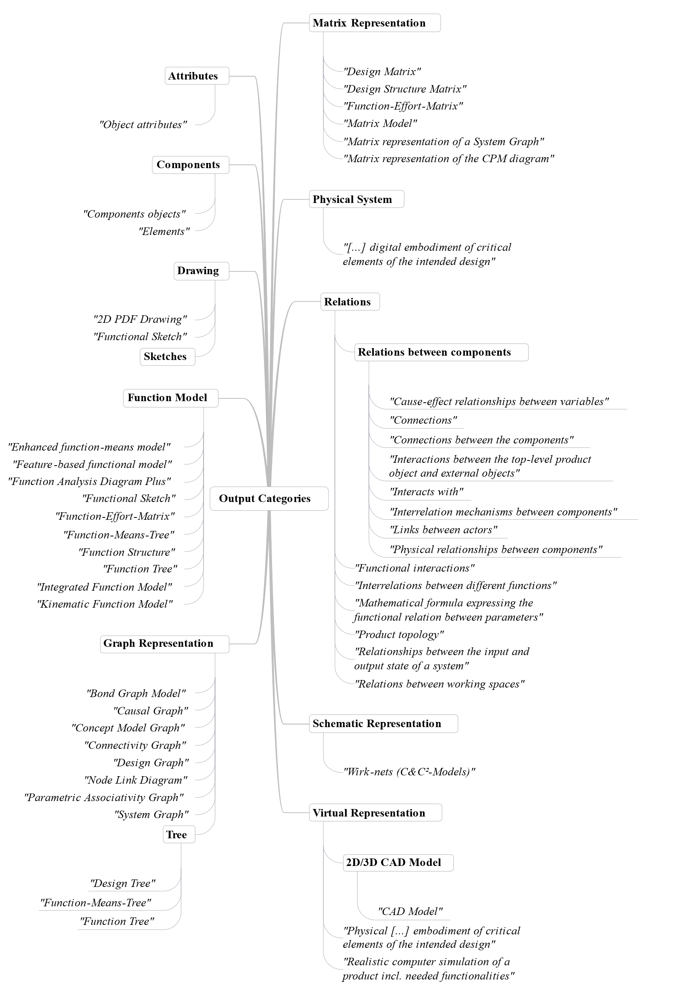
Figure 6. Categories of the outputs of the product models. The categories are illustrated in boxes and underneath are grouped descriptions without a box in italics.

