Supplementary Materials

PBP-A, a cyanobacterial DD-peptidase with high specificity for amidated muropeptides, imposes a pH-dependent fitness cost in Escherichia coli as a consequence of promiscuous activity
Gol Mohammad Dorrazehi, Matthias Winkle, Vincent Stroobant, Hervé Degand, Damien Evrard, Pierre Morsomme, Jacob Biboy, Joe Gray, Waldemar Vollmer and Patrice Soumillion

For characterization of activity and fitness cost of PBP-A, we run all the experiments in parallel for PBP-A-wt and the variant PBP-A-Leu158Glu (L158E) endowed with increased hydrolytic activity on penicillin (Urbach et al., 2008). Therefore, the data for both PBP-A-wt and PBP-A-L158E are available in supplementary materials.
Tables S1. Relative abundance of muropeptides detected by HPLC in assays with PBP-A-wt and PBP-A-L158E and purified PG from E. coli BW25113∆6LDT.
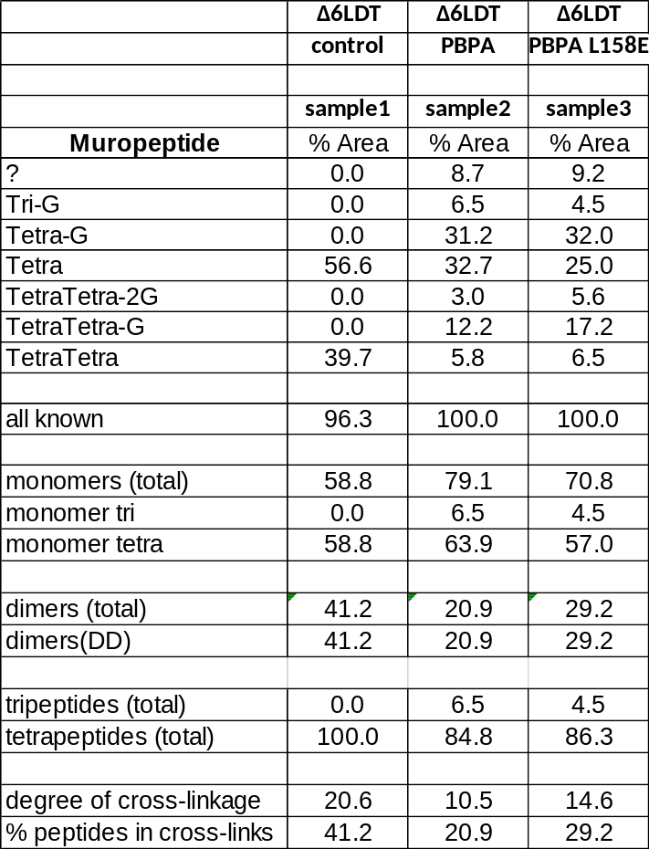

Table S2. Relative abundance of muropeptides detected in assay of PBP-A on PG extracts of E. coli CS703-1 at pH 7.5 and 5.0.
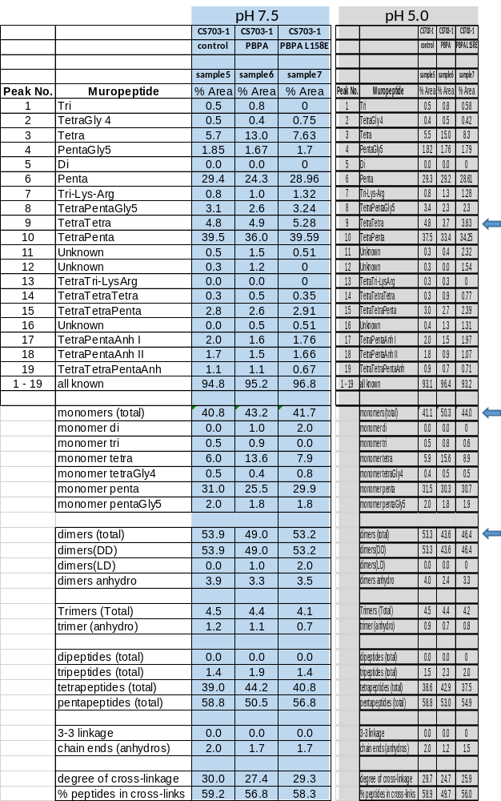

Table S3. Relative abundance of muropeptides detected in assay of PBP-A on PG extracts of E. coli TOP10 at pH 7.5 and 5.0.
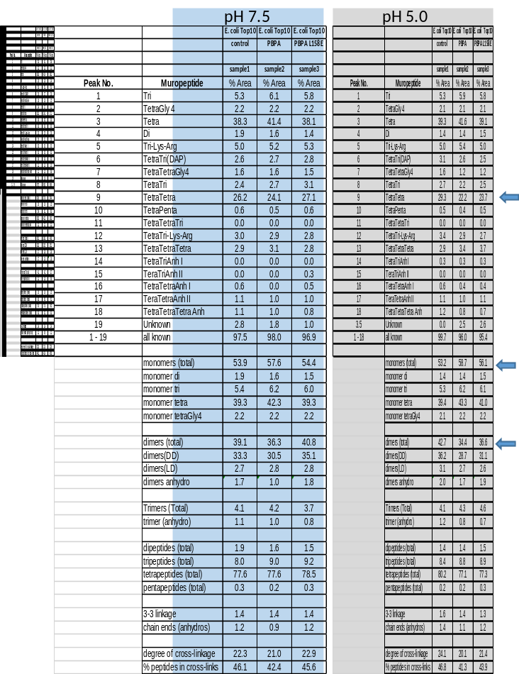

Table S4. Relative abundance (%) of muropeptides detected in PG isolated from E. coli TOP10 (control), E. coli TOP10/rhaA::PBP-A-wt, E. coli TOP10/pBAD43_PBP-A-wt, E. coli TOP10/rhaA::PBP-A-L158E and E. coli TOP10/pBAD43_PBP-A-L158E.
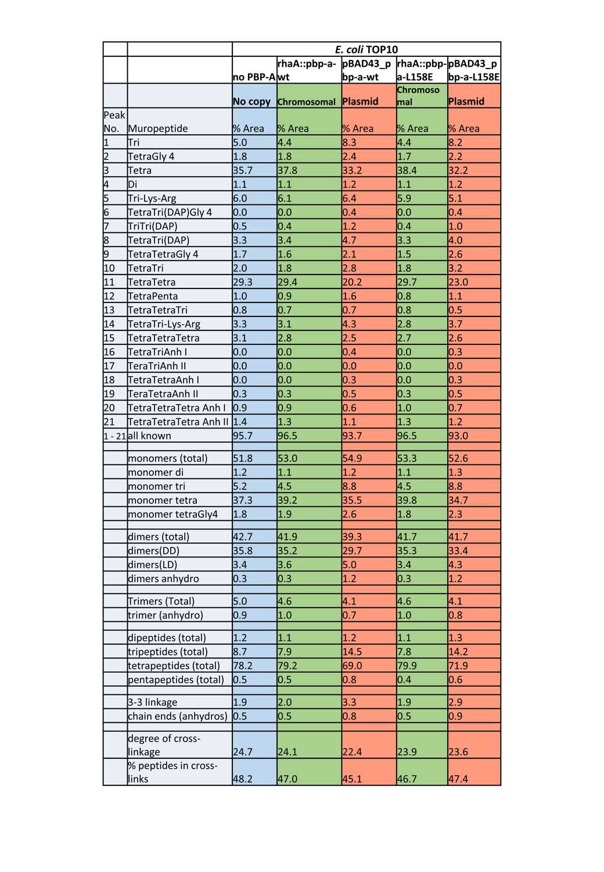
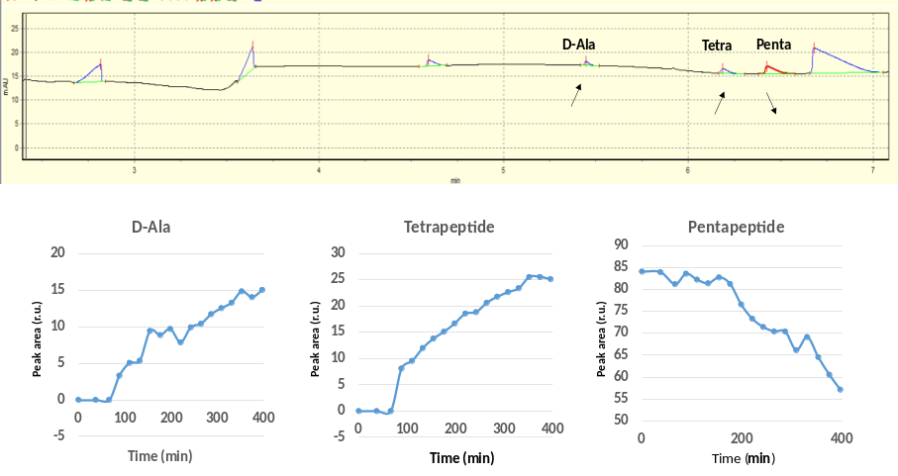

Fig S1. Capillary electrophoresis analysis of PBP-A assay with amidated pentapeptide. During time-dependent capillary electrophoresis, 2 peaks were showing increase in peak area and 1 peak was showing decrease, while other peaks remained constant. Among the increasing peaks, peak of D-alanine (D-Ala) was verified by adding D-Ala in a positive control assay, hence the other increasing peak would be the Tetrapeptide (Tetra) product.
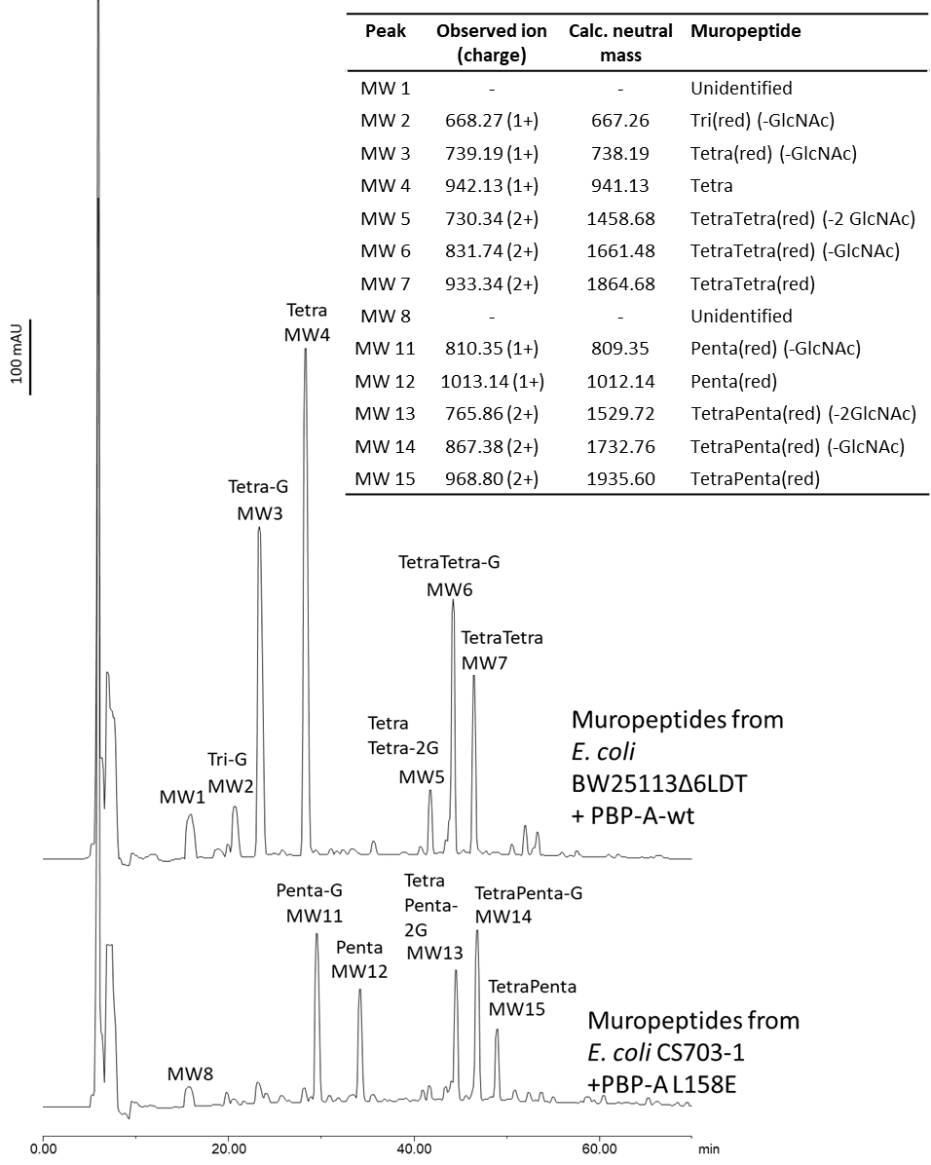
Fig S2-a. HPLC peak detection in assay of PBP-As with purified PG. The table on the right represent MS analysis for molecular weight (MW) of labelled peaks obtained in HPLC. MS spectra for all the peaks are available in Fig S1-b to Fig S1-o.

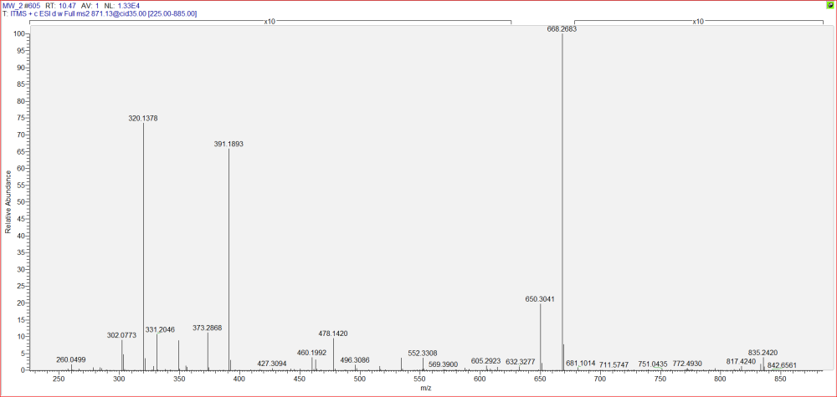
Fig S2-b. MS/MS spectra of peak MW2 in Fig S2-a.

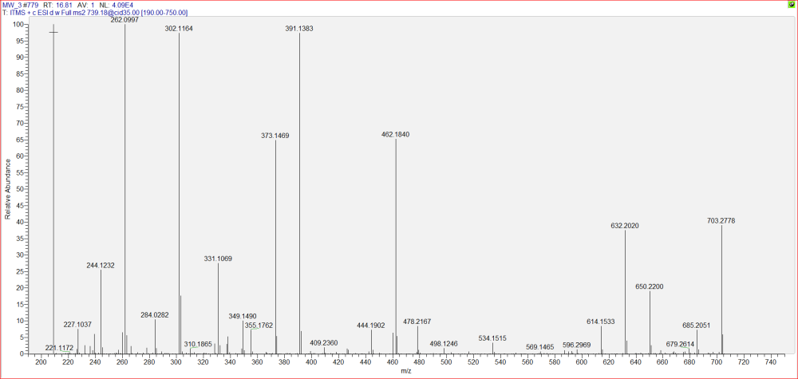
Fig S2-c. MS/MS spectra of peak MW3 in Fig S2-a.
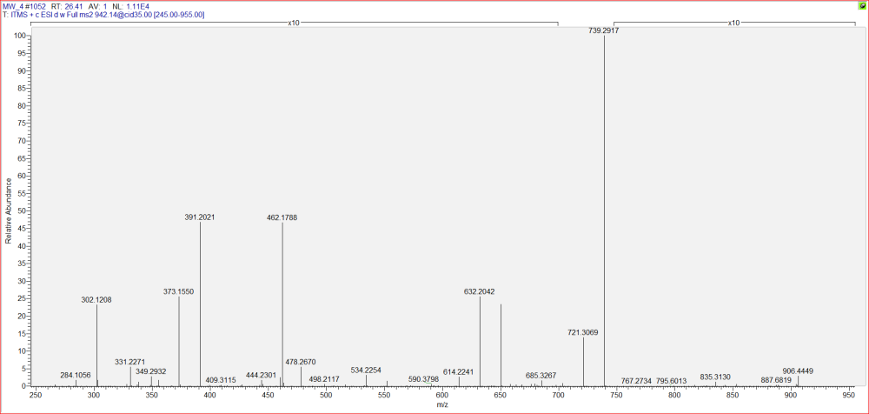
Fig S2-d. MS/MS spectra of peak MW4 in Fig S2-a.

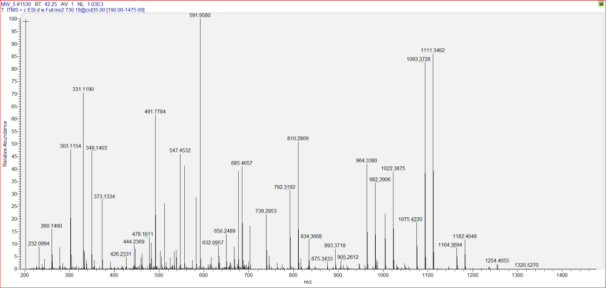
Fig S2-e. MS/MS spectra of peak MW5 in Fig S2-a.

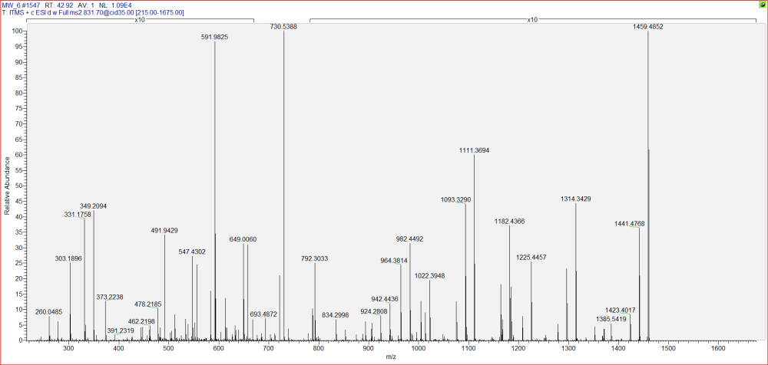
Fig S2-f. MS/MS spectra of peak MW6 in Fig S2-a.

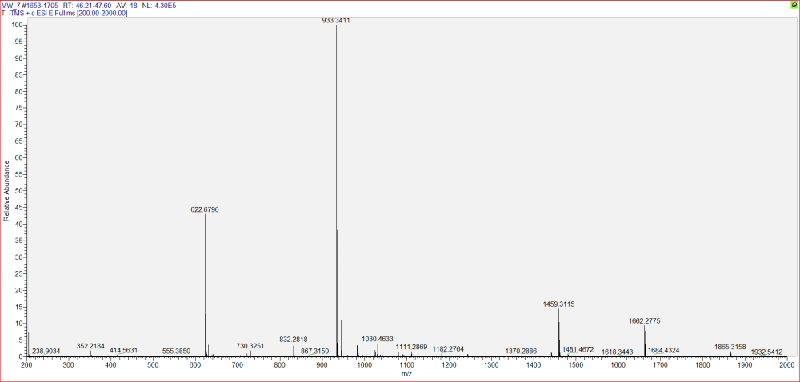
Fig S2-g. MS/MS spectra of peak MW7 in Fig S2-a.
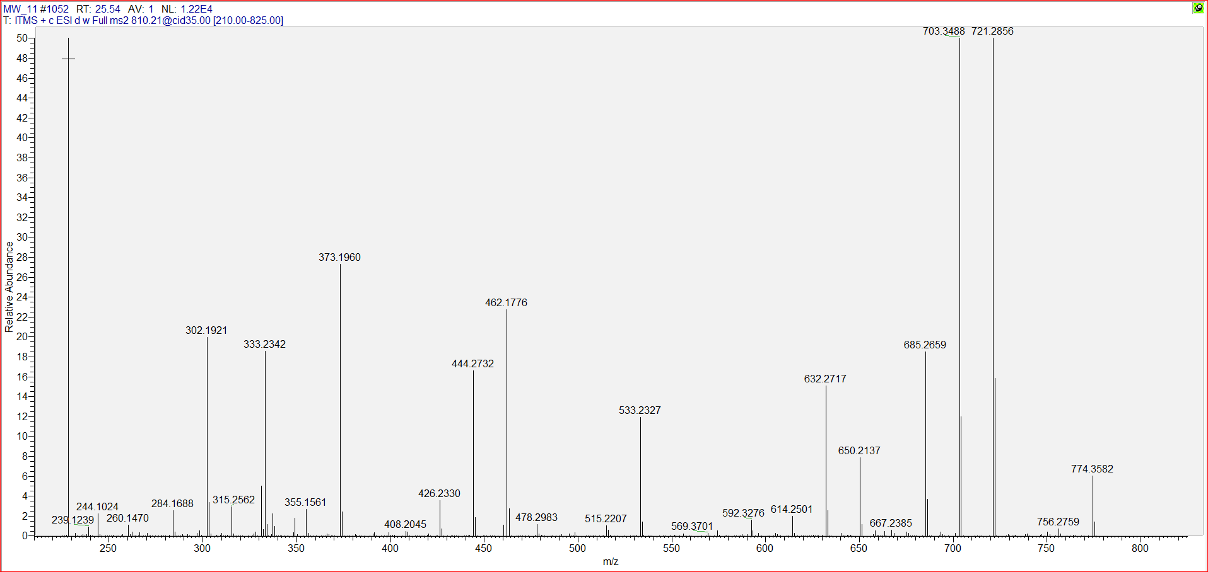
Fig S2-h. MS/MS spectra of peak MW9 in Fig S2-a.

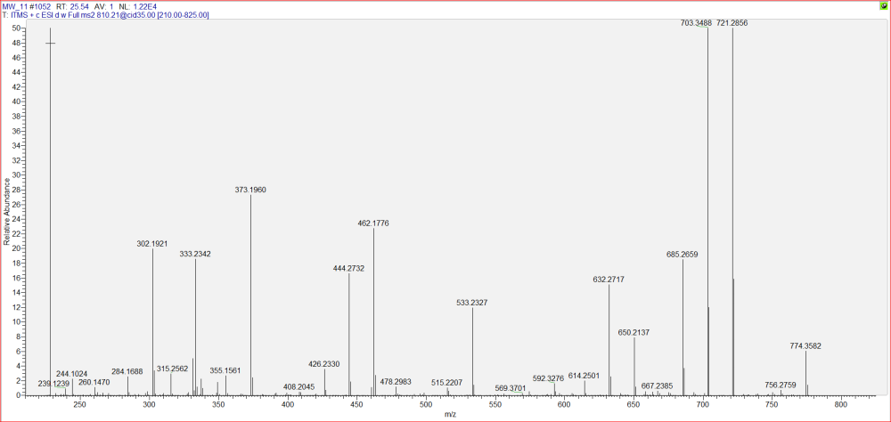
Fig S2-i. MS/MS spectra of peak MW11 in Fig S2-a.
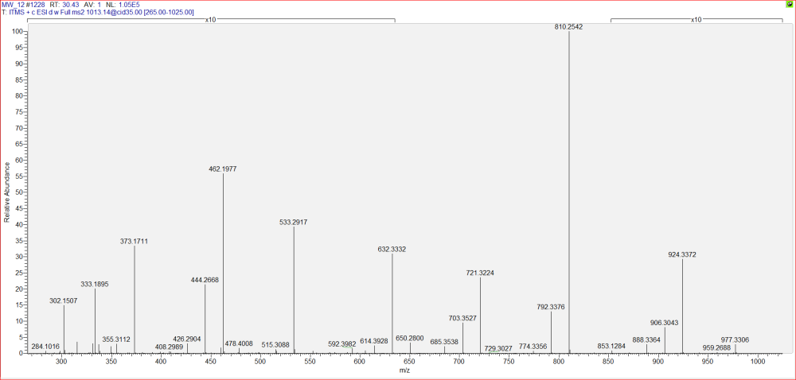
Fig S2-j. MS/MS spectra of peak MW12 in Fig S2-a.

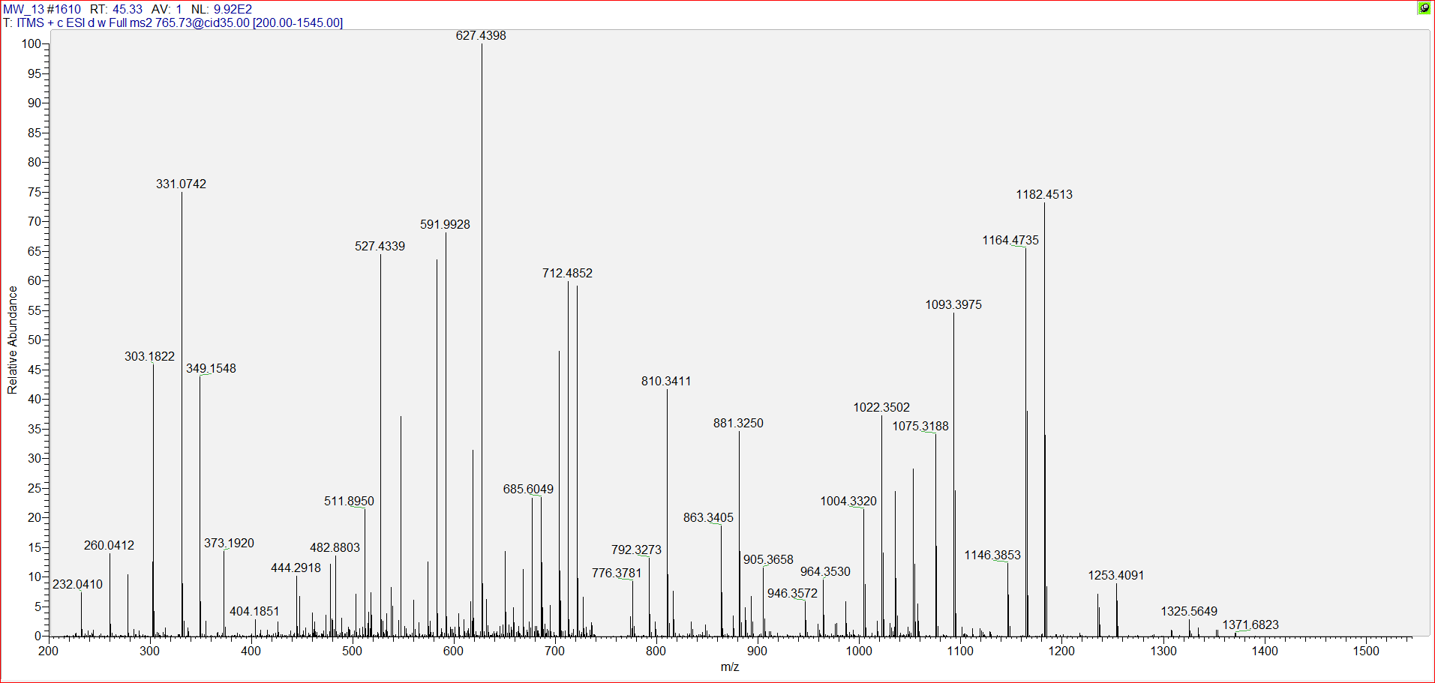
Fig S2-k. MS/MS spectra of peak MW13 in Fig S2-a.

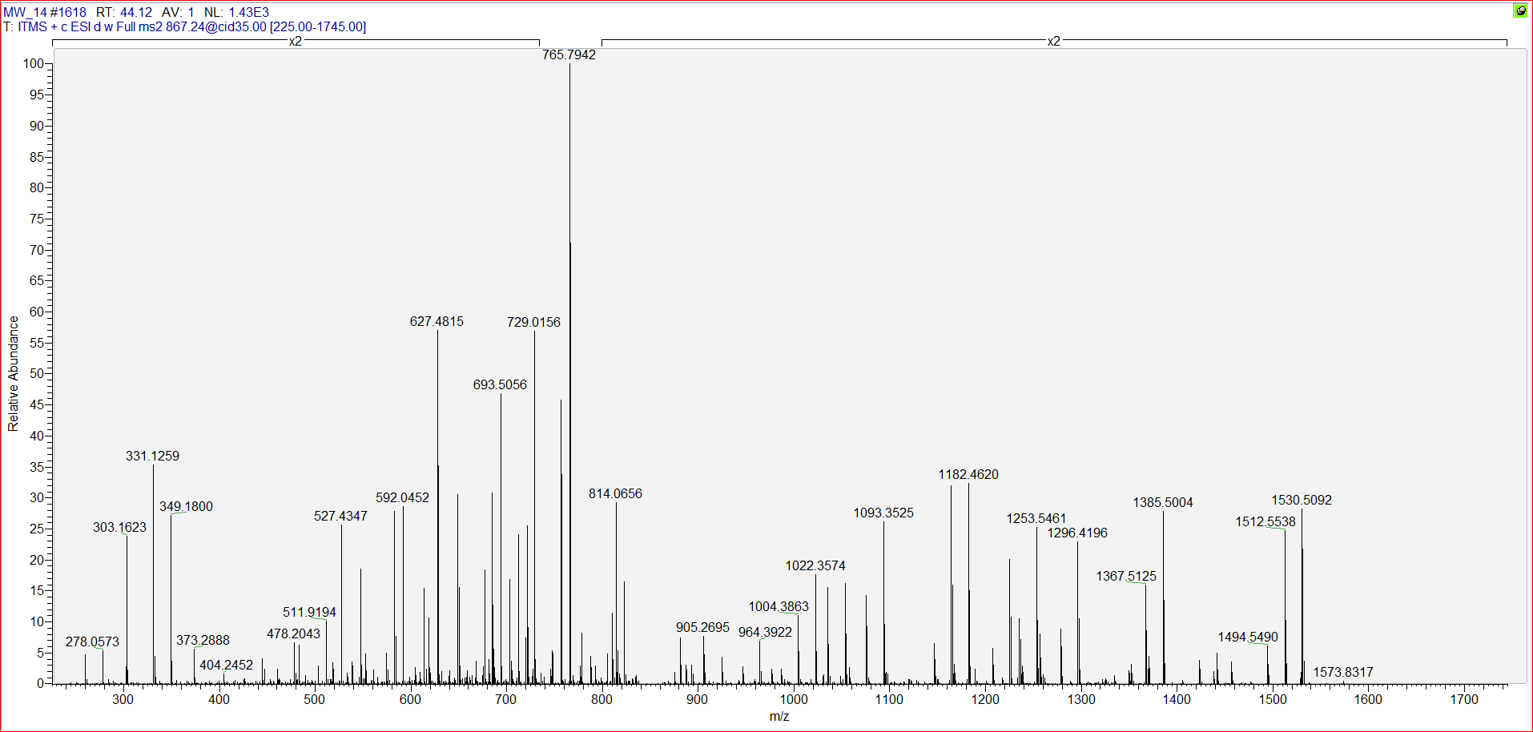
Fig S2-l. MS/MS spectra of peak MW14 in Fig S2-a.

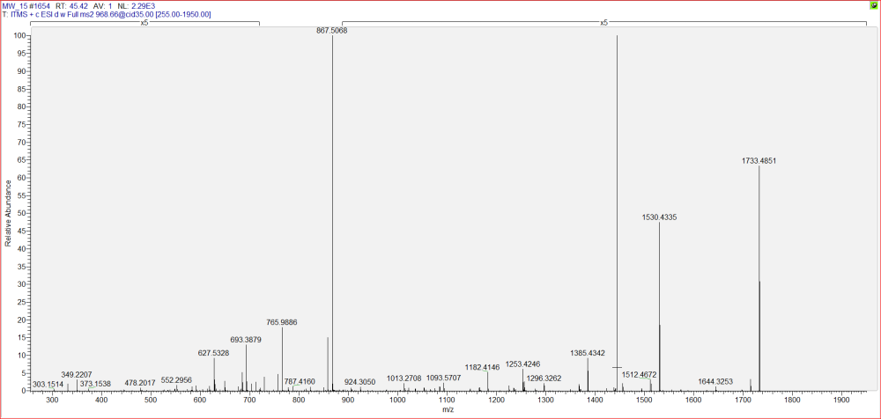
Fig S2-m. MS/MS spectra of peak MW15 in Fig S2-a.
.

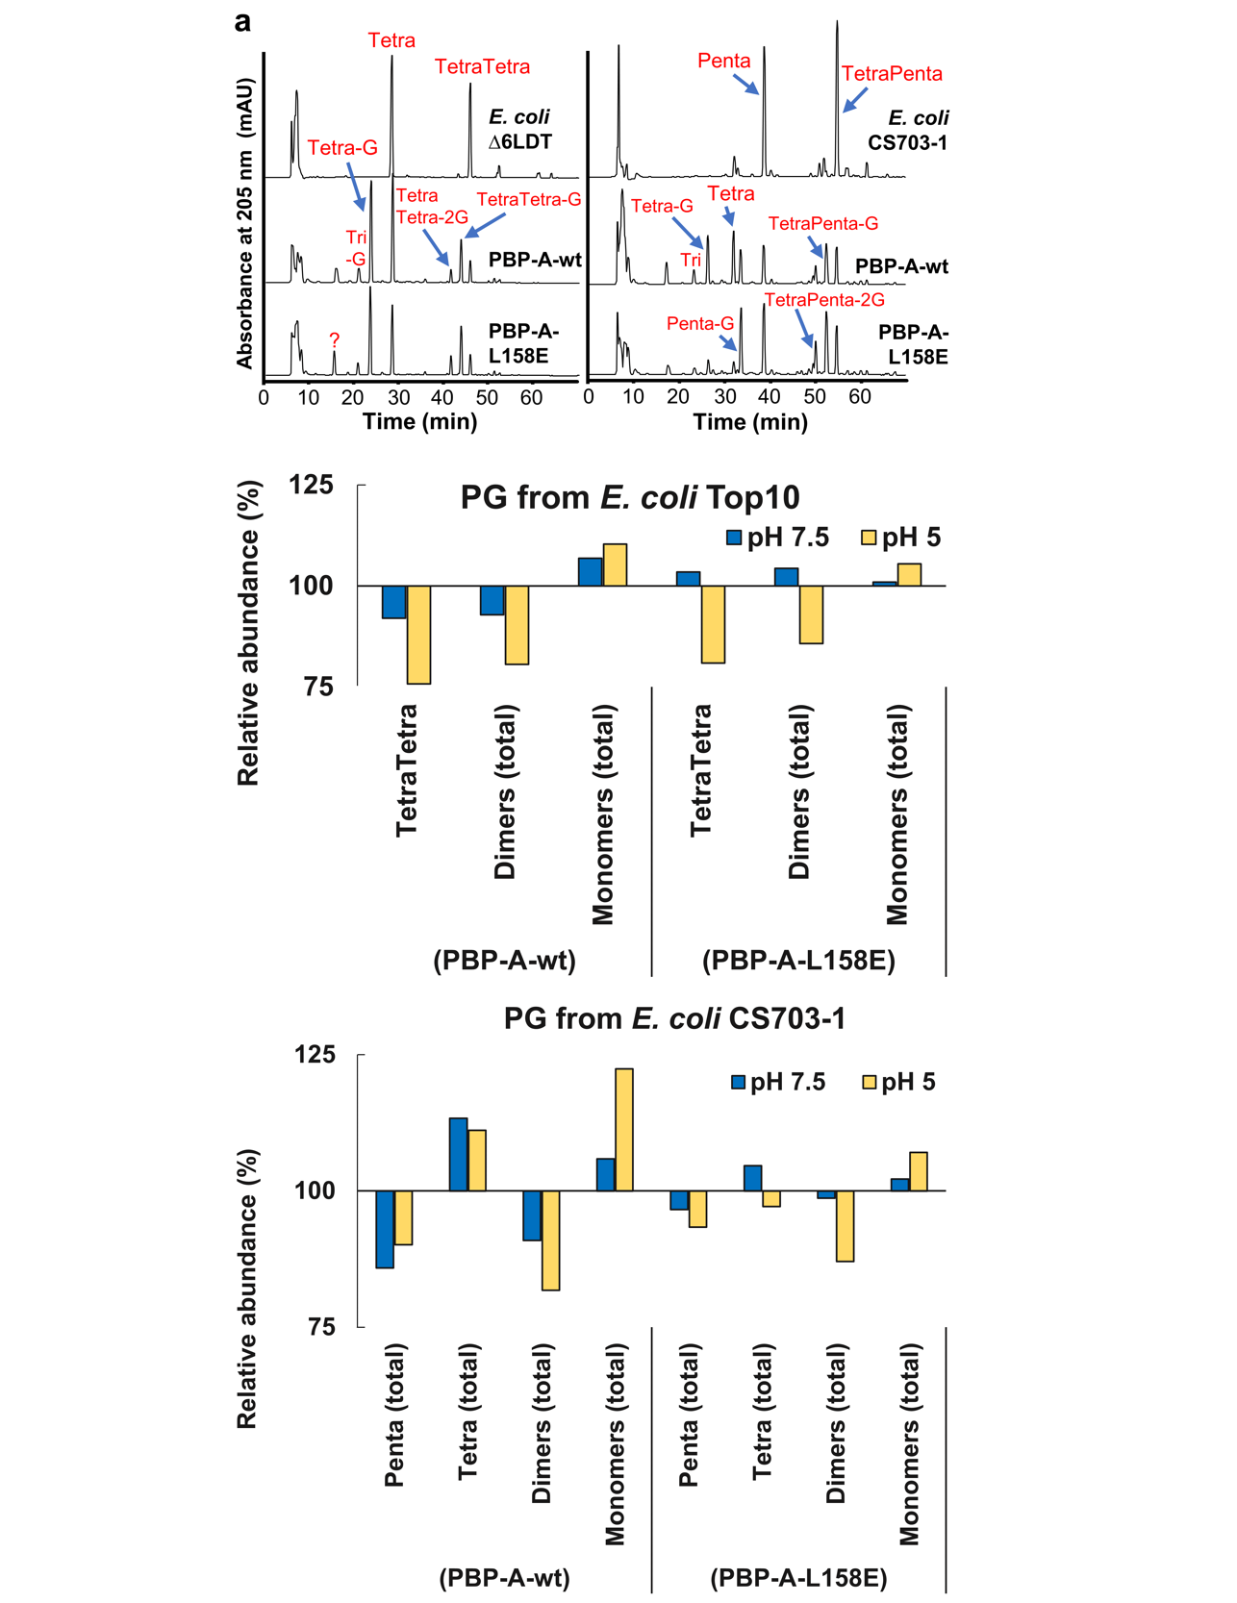
Fig S3. Activities of PBP-A-L158E vs PBP-A-wt on purified peptidoglycan (PG) from E. coli.

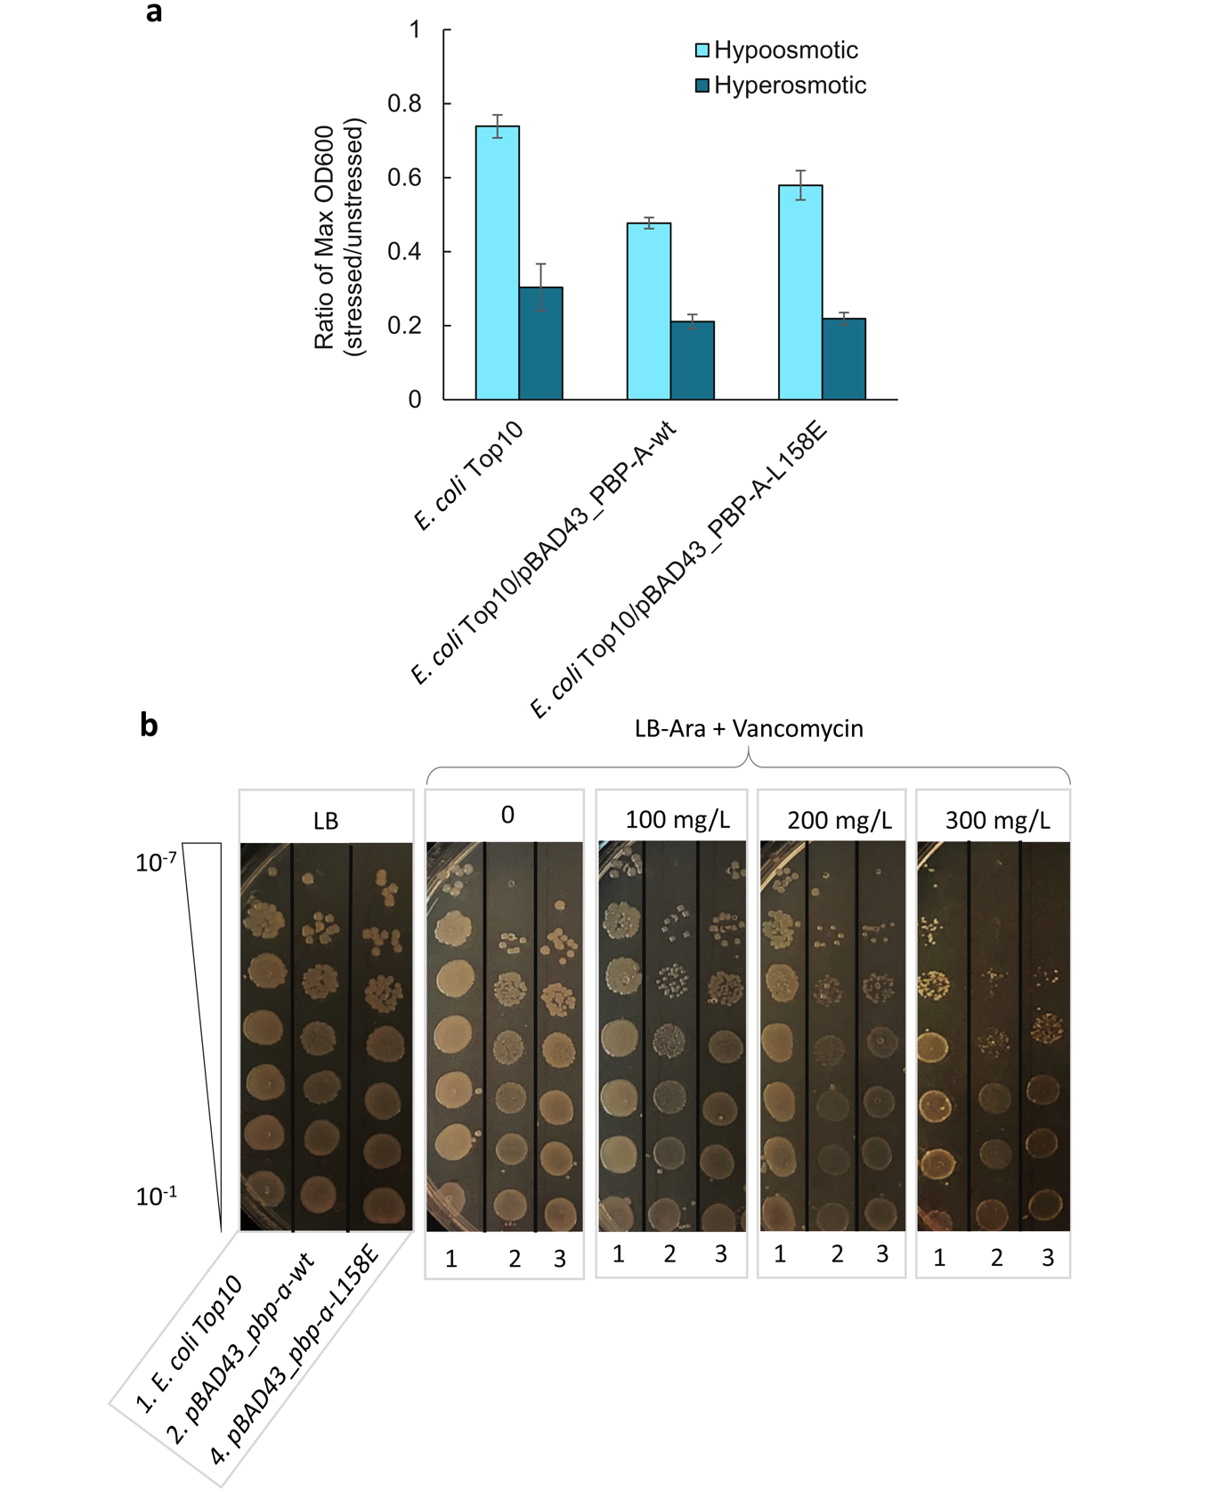
Fig S4. Phenotypic characterization of the fitness cost of PBP-A-L158E vs PBP-A-wt in E. coli. a) Osmosensitivity of E. coli cells expressing PBP-A. b) Vancomycin susceptibility spotting assay.

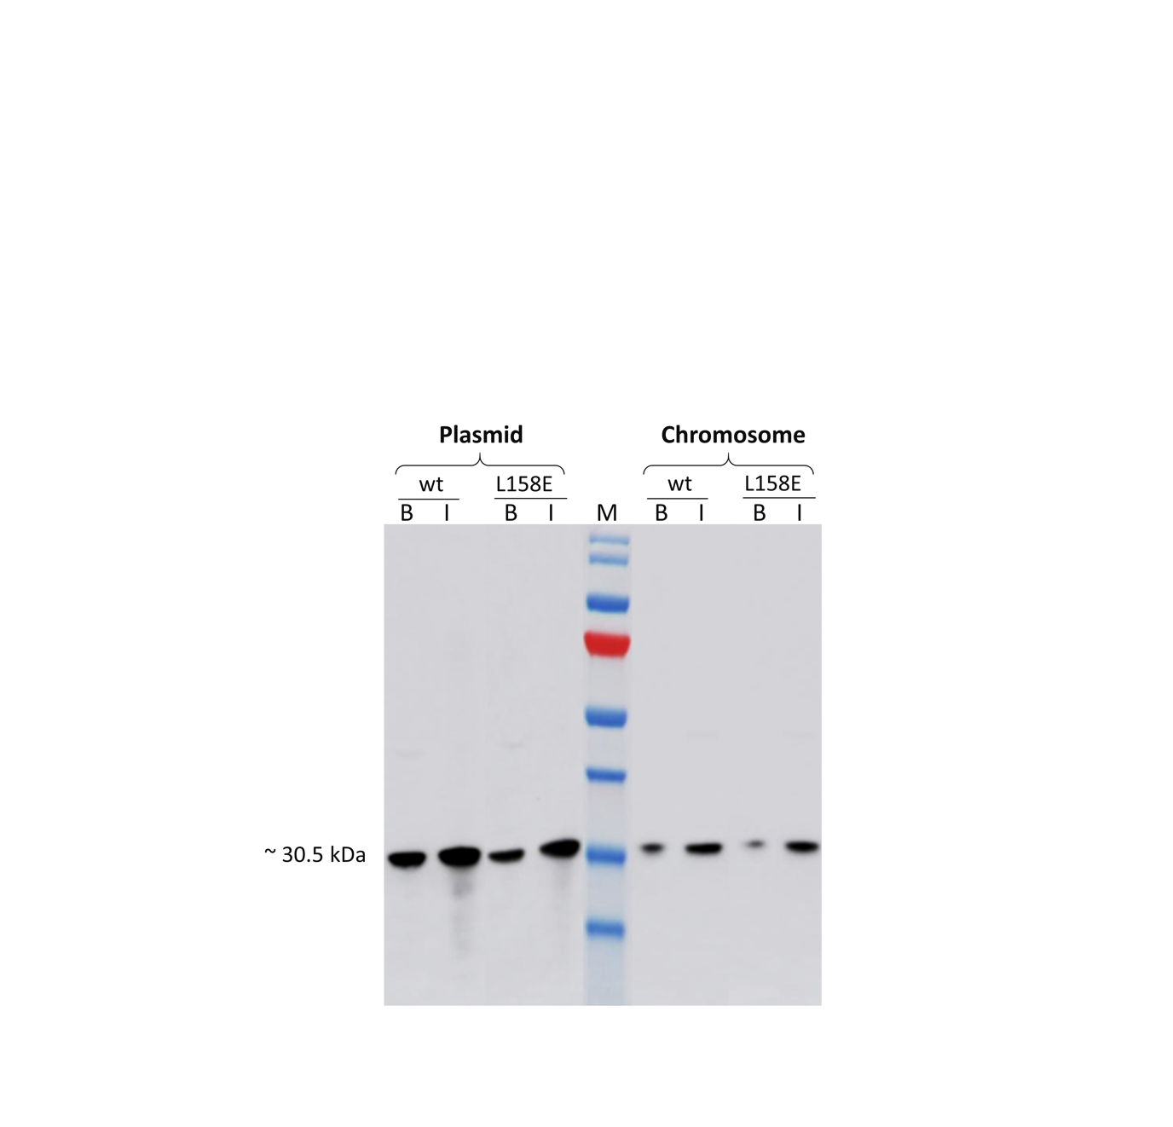
Fig S5. Effect of copy number on expression level of PBP-A. Part B represent the western blot analysis of PBP-A expression in periplasm of E. coli under low-copy plasmid (pBAD43) and chromosomal context, where we subjected equal amount of cells to periplasmic extraction. wt, PBP-A-wt; L158E, PBP-A-L158E; B, basal (non-induced) expression; I, induced expression; M, pre-stained protein marker. wt, PBP-A-wt; L158E, PBP-A-L158E; B, basal (non-induced) expression; I, induced expression; M, pre-stained protein marker.

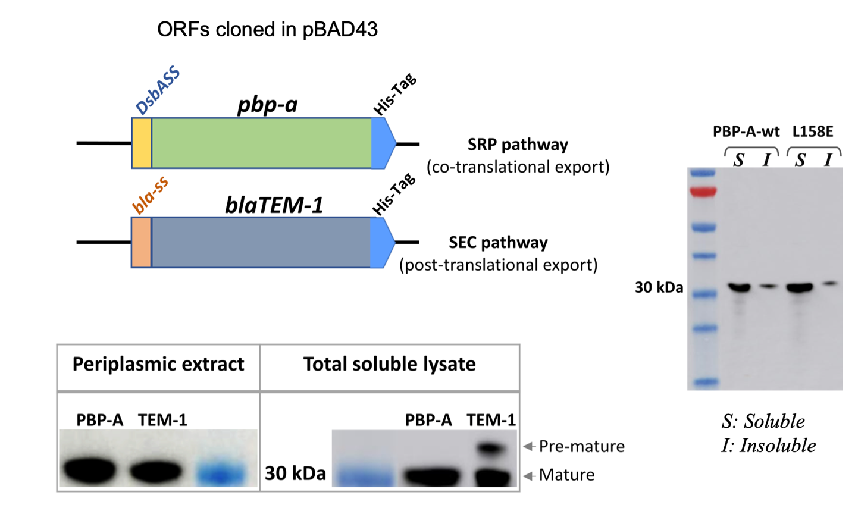
Fig S6. Translocation of proteins into periplasm of E. coli. Upper left: the genetic constructs of pbp-A and bla genes are shown in schematic, where a DsbA signal sequence (DsbAss) is fused to N-termini of pbp-A gene to facilitate a co-translational export while the TEM-1 gene is fused to its native β-lactamase signal sequence (bla-ss). Lower left: western blot of soluble fractions from periplasmic and total cell lysate of E. coli confirms the co-translational expression of mature PBP-A proteins without any pre-mature intermediates, while for a post-translationally mediated TEM-1 protein shows presence of both mature (30.5 kDa) and pre-mature or un-exported (33.0 kDa) proteins. Right: Western blotting of total soluble and insoluble fractions from total cell lysate of E. coli/pBAD43_DsbAss-PBP-As confirms that PBP-A almost entirely exist in soluble form.

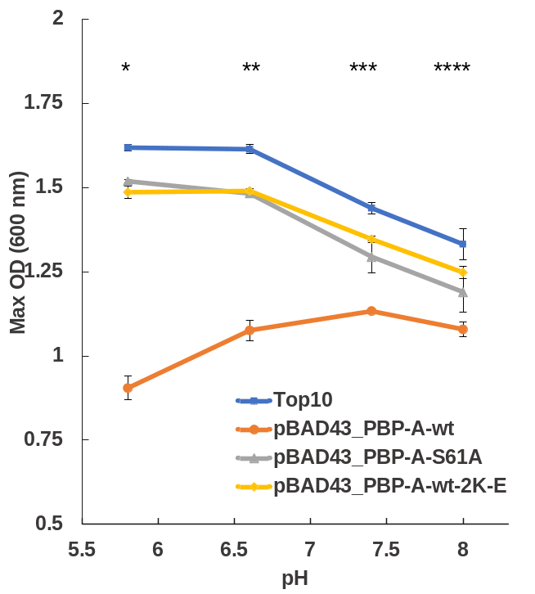
Fig S7. Maximum population density (max OD₆₀₀) of E. coli cultures at different pH. Comparison of pH profiles between E. coli TOP10 wild-type cells and cells expression different PBP-A mutants: PBP-A-wt and PBP-A-wt-S61A (pI 7.56), and PBP-A-wt harboring two substitutions of surface lysines (Lys, K) into glutamic acid (Glu, E), named PBP-A-wt-2K-E (pI 5.99). The maximum fitness cost due to PBP-A expression is detectable at acidic pH and the shift in optimum pH towards basic pH upon expression of PBP-A-wt is significantly detectable. For PBP-A-wt-S61A and PBP-A-wt-2K-E, the pH profile is similar to the wild-type E. coli cells. The data represent average of three replicates. Similar results were observed for E. coli/pBAD43_PBP-A-L158E (data not shown). Isoelectric point (pI) of PBP-A proteins was reduced by introducing two nonsynonymous substitution of lysine (K) to glutamic acid (E) at positions K104 and K212 located on surface of PBP-A protein. These substitutions would decrease the pI of PBP-A by 1.5 units. Theoretical isoelectric point of proteins were calculated using ExPASy Server (https://web.expasy.org/compute_pi/).

References:
Urbach, C., Fastrez, J., & Soumillion, P. (2008). A new family of cyanobacterial penicillin-binding proteins. A missing link in the evolution of class A beta-lactamases. The Journal of Biological Chemistry, 283(47), 32516–32526. https://doi.org/10.1074/jbc.M805375200

