From molecule to device: DFT and SCAPS-1D simulations on the effect of aromaticity of π-linkers on enhancing the performance of anthanthrene-based dyes with D-π-A configuration in dye‐sensitized solar cells

Nuha Wazzan^{a‡}, Kamal A. Soliman^{b}, Prafulla K. Jha^{c‡‡}
ª King Abdulaziz University, Chemistry Department, Faculty of Science, P.O Box 42805 Jeddah 21589, Saudi Arabia
^{b} Department of Chemistry, Faculty of Science, Benha University, P.O. Box 13518, Benha, Egypt
^{c} Department of Physics, Faculty of Science, The M. S. University of Baroda, Vadodara, Gujarat, 390002, India
‡ Corresponding author: E-Mail: nwazzan@kau.edu.sa (Nuha Wazzan)
‡‡ Corresponding author: E-Mail: Prafullaj@yahoo.com (Prafulla Jha)

Supplementary Data
Table of Contents
1. Computational details 3
1.1. Open-Circuit Voltage 3
1.2. Light Harvesting Efficiency 3
1.3. Reorganization Energy 3
1.4. Absolute Hardness 4
1.5. Free energies of electron injection and dye regeneration 4
1.6. Excited state lifetimes 4
1.7. Noncovalent interactions (NCIs) 5
1.8. Le Bahers’s parameters 5
1.9. Transfer integrals, and intrinsic mobility 5
2. Supplementary figures 7
Figure SD 1: Energy levels of FMOs of the π-cores of D2, and D5 to D11 dyes. 7
Figure SD 2: The optimized π-stacking arrangement of two adjacent dye molecules of the investigated dyes calculated at the CPCM/M06-2x/6-31+G(d,p) in THF. Note: arrow between the two sulfur atoms (yellow) of thiophene units as considered to represent the space distance between two interacting dye molecules. 7
Figure SD 3: Left: NCI-RDG 2D scatter maps, and right: 3D colour-filled RDG isosurfaces of investigated dye dimers at CPCM/M06-2x/6-31+G(d,p) in THF. 10
Figure SD 4: Total density of states (TDOS) plots of the adsorbed systems of dye@TiO₂. 10
Figure SD 5: Simulated absorption spectra of dye@TiO2 systems in THF. 10
Figure SD 6: MESPs of the eight investigated dyes in their isolated and adsorbed (on TiO2) forms at iso-value 0.1 au. 11
Figure SD 7: ELFs of dye molecules before and after adsorption on TiO₂. 12
Figure SD 8: Dipole moments ($μGS$, $μES$ and $∆μ$) (in Debye) of D2, and D5 to D11 dyes. 13
Figure SD 9: LHE and $η$ relationship of D2, and D5 to D11 dyes. 13
3. Supplementary tables 14
Table SD 1: Hole, electron, hole-electron, and total reorganization energies ($λhole$, $λelec$, $∆λ$ and $λtot$, respectively. 14
Table SD 2: Le Bahers’s CT indices included the charge transfer distance $D$, $H$ , $t$ (in Å), and the amount of charge transferred $q$ (in e) of the seven designed dyes along with those of D2 dye calculated at the CPCM/TDCAM-B3LYP/6-31+G(d,p) in THF. Note: data for D10 dye not converged and not included. 14
Table SD 3: GSEO, ESOPs, $EDye$ and $EDye*$ , excitation energy $Eex$, and free energies of charge injection and dye regeneration, $∆Ginj$, $∆Greg$, respectively, (in eV) of the isolated dyes calculated at CPCM/TDCAM-B3LYP/6-31G(d,p) in THF. 14
Table SD 4: Adsorption energies (in kJ/mol) and their energy components (in Hartree) of the eight dye@TiO2 adsorbed systems. Note: data of D2 dye are collected from ref. [15]. 15
Table SD 5: Ti–O bond lengths of the dye@TiO2 adsorbed systems calculated at CPCM/M06-2x with 6-31+G(d,p) and LANL2DZ in THF. 15
Table SD 6: Energies of HOMOs, LUMOs of isolated and adsorbed dyes, CB, and VB of TiO2, and their dipole moments (in Debye) calculated at CPCM/M06-2x with 6-31+G(d,p) and LANL2DZ in THF. 16
Table SD 7: Ground state, excited state, and change dipole moments ($μGS$, $μES$, and $∆μ$, respectively) in Debye. 16
Table SD 8: Computed molecular parameters of the eight investigated dyes. 16
4. Additional results and discussion 17
4.1 FMOs of π-aromatic cores 17
4.2 Molecular electrostatic potential maps 17
4.2 Solubility 18
4.3 Molecular description parameters 19

- Computational details

  - Open-Circuit Voltage
A series of organic solar cell devices employing 26 polymer donor moieties having a common acceptor and different HOMO levels have been investigated [1]. Based on [1], An empirical equation to obtain the theoretical value of open−circuit voltage ($V_{oc}$) has been proposed. It is to be noted that the $V_{oc}$ loss of 0.3 V indicated is empirical and the actual loss could be greater or smaller than 0.3 V. In this study, the 0.3 V is chosen to predict the trend in the $V_{oc}$ variation among the four dyes studied and the emphasis is not on finding the exact $V_{oc}$ values:
$$V_{oc}= \left|E_{HOMO}^{Donor(Dye)}-E_{LUMO}^{acceptor(TiO_{2})}\right|-0.3$$ | Equation 1
$E_{LUMO}^{acceptor(TiO_{2})}$is the energy condition band at $-4.0$ eV.

  - Light Harvesting Efficiency
To quantify the light harvesting efficiency ($LHE$), Lambert–Beer's law is used [2]:
$$LHE=1-{10}^{-f_{max}^{abs}}$$ | Equation 2
Where $f_{max}^{abs}$ is the oscillator strength at the maximum absorption band.

  - Reorganization Energy
The total electronic energies of neutral, cationic, and anionic forms of these compounds were used to compute the reorganization energy ($λ_{\text{hole/electron}}$), according to the following equations: [3, 4]
$$λ_{\text{hole/electron}}=λ^{±}+λ^{o}=[E^{±}(M)-E^{±}(M^{±})]+[E(M^{±})-E(M)]$$ | Equation 3
Where, $E^{±}(M)$is the energy of cation/anion with neutral structure, $E^{±}(M^{±})$ is the energy of cation/anion with cationic/anionic structure, $E\left(M^{±}\right)$is the energy of neutral structure at cationic/anionic state, $E\left(M\right)$is the energy of neutral structure.
The adiabatic ionization potential/electron affinity ($AIP$, $AEA$), and vertical ionization potential/electron affinity ($VIP$, $VEA$) were calculated as:
$$A_{IP/EA}=E^{±}\left(M^{±}\right)-E(M)$$ | Equation 4
$$V_{IP/EA}=E\left(M^{±}\right)-E(M)$$ | Equation 5

  - Absolute Hardness
Based on the molecular orbital theory, the absolute hardness ($h$) was calculated using equation [5]:
$$h=\frac{1}{2}\left(\frac{∂μ}{∂N}\right)=\frac{1}{2}\left(\frac{∂^{2}E}{∂N^{2}}\right)=\left(\frac{AIP-AEA}{2}\right)$$ | Equation 6
  - Free energies of electron injection and dye regeneration
An excited photosensitizer will inject electrons from the LUMO level to the CB of the TiO2 semiconductor, with the free energy of electron injection (${∆G}_{inj}$) being used to calculate the electron injection rate according to the following equation:
${∆G}_{inj}=E^{{Dye}^{*}}-$ $E_{CB}$ | Equation 7
Where $E^{{Dye}^{*}}$is the excited state oxidation potential (ESOP), and $E_{CB}$ is the reduction potential of the conduction band of TiO₂ semiconductor ($-4.0$ eV [6-8]). The oxidation potential energy is given by:
$E^{{Dye}^{*}}=E^{Dye}-E_{ex}=-E_{HOMO}^{Dye}-E_{ex}$ | Equation 8
Where $E^{Dye}$ is the ground state oxidation potential (GSOP) (i.e., $-E_{HOMO}^{Dye}$ by Koopman’s theory) and $E_{ex}$ is electronic vertical transition energy (excitation energy). Also, the free energy of dye regeneration (${∆G}_{reg}$) can be calculated as:
$${∆G}_{reg}=E_{\left(I_{3}^{-}/I^{-}\right)}-E^{Dye}=E_{\left(I_{3}^{-}/I^{-}\right)}+E_{HOMO}^{Dye}$$ | Equation 9
Where $E_{\left(I_{3}^{-}/I^{-}\right)}$ is redox potential energy of $I_{3}^{-}/I^{-}$ redox electrolyte ($-4.8$eV) [9].
  - Excited state lifetimes
The excited state lifetimes have been computed using the Einstein transition probabilities [10]:
$$τ=\frac{c^{3}}{2{\left(E_{flu}\right)}^{2}f}$$ | Equation 10
Where $c$is the speed of light (in a.u., c = 137.036), $E_{flu}$is the fluorescent energy and $f$is the oscillator strength (in a.u. unit). Note that, 1 a.u. of time = $2.419×{10}^{-17}$sec.

  - Noncovalent interactions (NCIs)
Johnson et al. [11] suggested the Noncovalent interaction (NCI) approach. An analysis based on electron density and its derivatives, we can determine the types and regions of weak interactions in molecular systems. It depends on the electron density ($ρ(r)$) and 2-dimentional (2D) plot of the reduced density gradient (RDG), according to the following equation:
$$RDG=\frac{1}{2{\left(2π^{2}\right)}^{1/3}}\frac{\left|ρ\left(r\right)\right|}{ρ{\left(r\right)}^{4/3}}$$ | Equation 11
Where $\left|ρ\left(r\right)\right|$ is the electron density gradient.

  - Le Bahers’s parameters
The important Le Bahers’s parameters are [12]:
- The charge transfer distance ($D$): is the spatial distance between the two regions where the electron densities incremented and depleted during the electronic excitation.
- The amount of charge transferred ($q$): computed by integrating electron density increments or depletions over the entire surface.
- $H$ index: using the electron transfer line as a guide, the half of the sum of two centroid axes (D→A) direction, mostly the $x$-axis. If$H≫D$, the overlap between the centroids along the axis of charge transfer is thus expected.
- $t$ index: $t=D-H$, to quantify through-space excitations in ICTs.
  - Transfer integrals, and intrinsic mobility
Based on the semi-classical model of Marcus charge transfer [13, 14], and by taking into account the π- π stacking configuration between two neighboring dye molecules (dimer), see Figure SD2, one can calculate a key parameter which is the charge transfer rate (denoted by $k_{CT}^{+/-}$ ). Reorganization energy ($λ_{hole/elec}=λ_{+/-}$) can play a role in determination of $k_{CT}^{+/-}$ according to the following equation:
$$k_{CT}^{+/-}=\left(\frac{4π^{2}}{h}\right)V_{+/-}^{2}{\left(4λ_{+/-}k_{B}T\right)}^{-0.5}exp\left[\frac{-λ_{+/-}}{4k_{B}T}\right]$$ | Equation 12
where $T$ is the absolute temperature (298.0 K), $k_{B}$ is Boltzmann constant ($8.617 x {10}^{-5}$eV/K), $h$ is Planck’s constant ($4.135 x {10}^{-15}$ eV.s), and $V_{+/-}$ is the electronic coupling matrix element between two neighboring dye molecules (in eV). For electrons, the values of the electronic coupling matrix element ($V_{-}$) and holes ($V_{+}$) between two dye molecules are calculated according to the following two equations:
$$V_{+/-}=\frac{E_{H/L+1}-E_{H-1/L}}{2}$$ | Equation 13
where $E_{H}$, $E_{H-1}$, $E_{L}$ and $E_{L+1}$represent the energies (in eV) of the HOMO, HOMO-1, LUMO and LUMO+1, respectively, since during neutralization, dyes assume a closed-shell configuration. A key parameter is the hopping mobility ($μ_{hop}^{+/-}$) which helps in calculating the electron or hole transport character of the dye. We can evaluate the $μ_{hop}^{+/-}$ values (in cm²V⁻¹s⁻¹) using the following equation:
$$μ_{hop}^{+/-}=\frac{eD^{+/-}}{k_{B}T}$$ | Equation 14
where $e$ denotes the electronic charge ($1.60 x {10}^{-19}$ C), and $D$ is the diffusion coefficient. The value of $D$ can be computed in a one-dimensional charge transfer process using the following equation:
$$D^{+/-}=\frac{k_{CT}^{+/-}l^{2}}{2}$$ | Equation 15
where $l$ represents the space distance between two neighboring dye molecules.

Supplementary figures

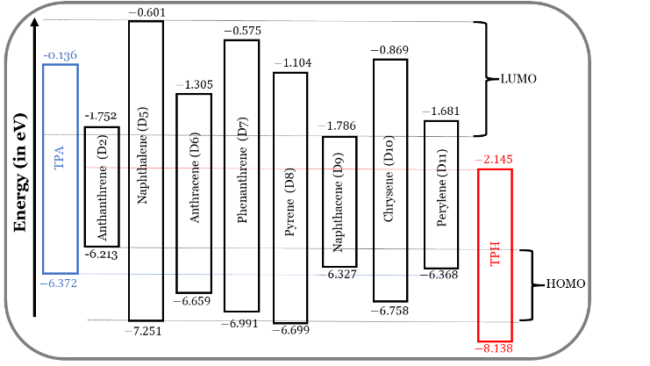

Figure SD 1: Energy levels of FMOs of the π-cores of D2, and D5 to D11 dyes.

Figure SD 2: The optimized π-stacking arrangement of two adjacent dye molecules of the investigated dyes calculated at the CPCM/M06-2x/6-31+G(d,p) in THF. Note: arrow between the two sulfur atoms (yellow) of thiophene units as considered to represent the space distance between two interacting dye molecules.

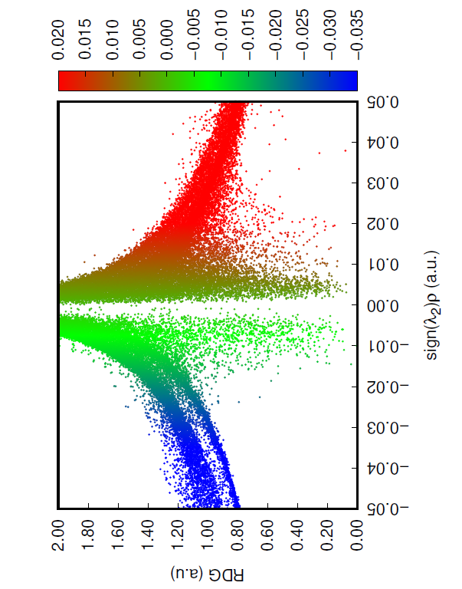 | 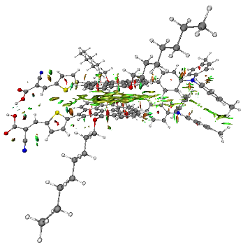
D2-D2
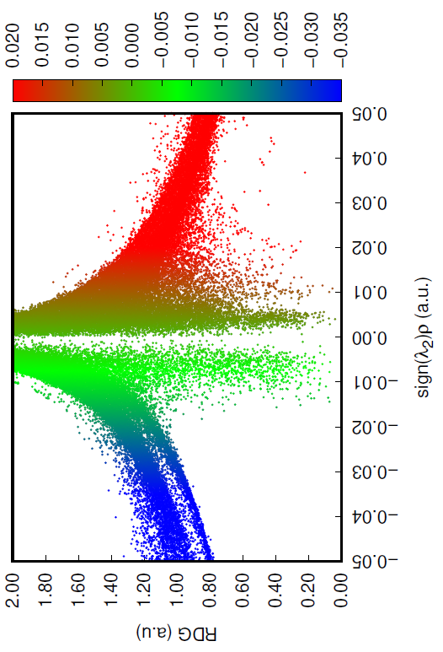 | 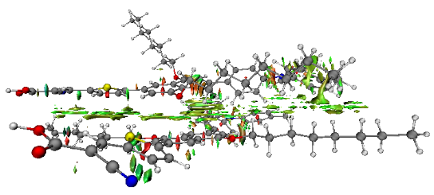
D5-D5
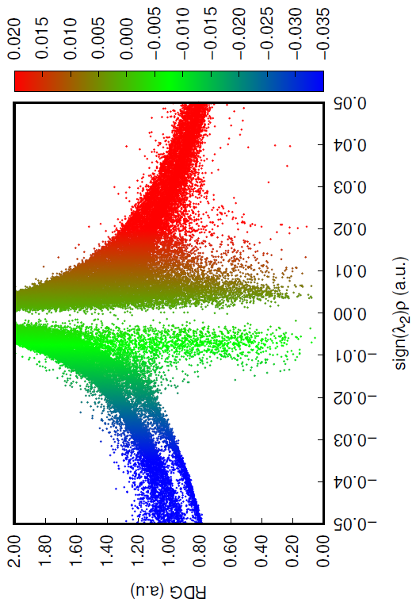 | 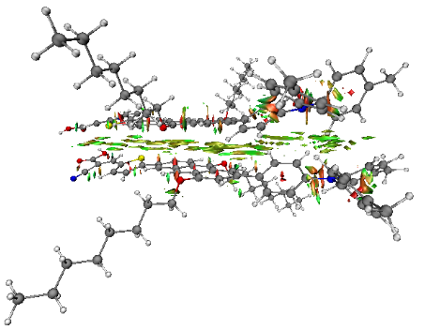
D6-D6
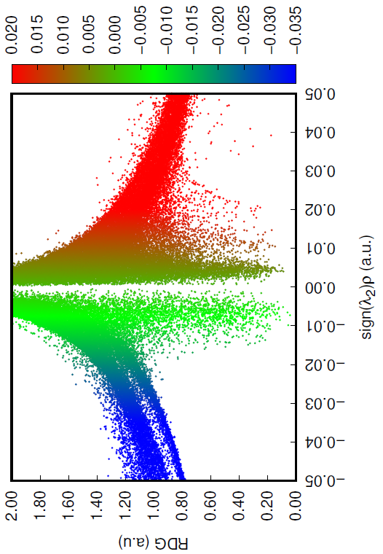 | 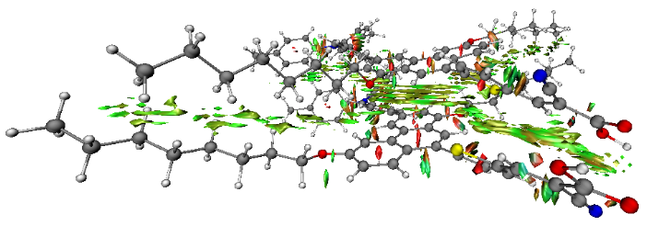
D7-D7
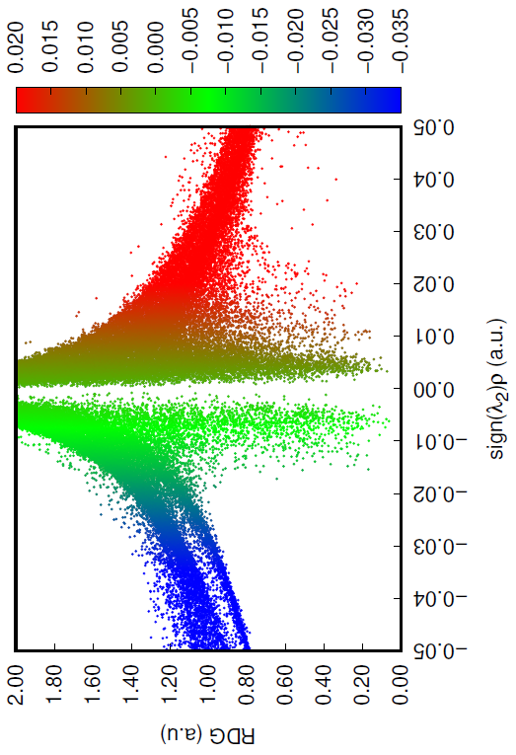 | 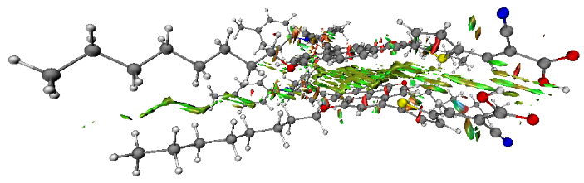
D8-D8
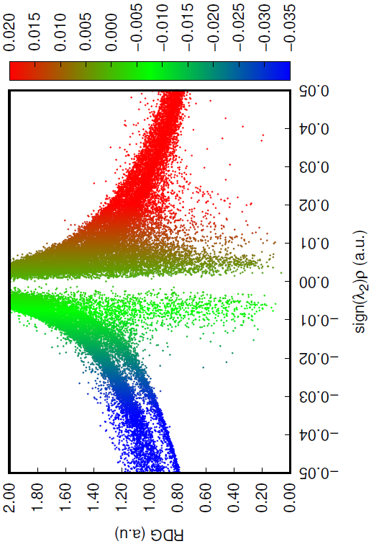 | 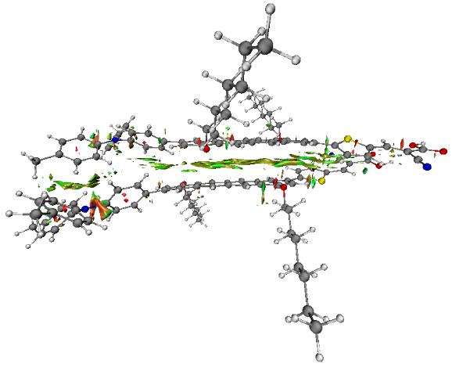
D9-D9
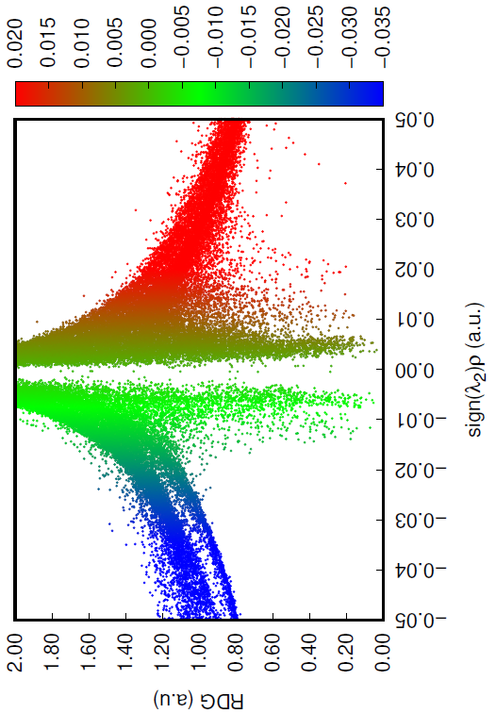 | 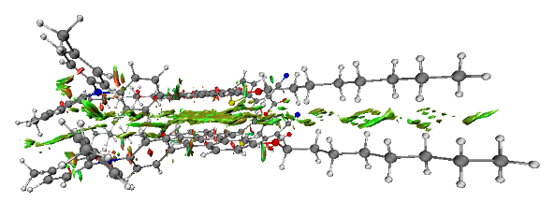
D10-D10
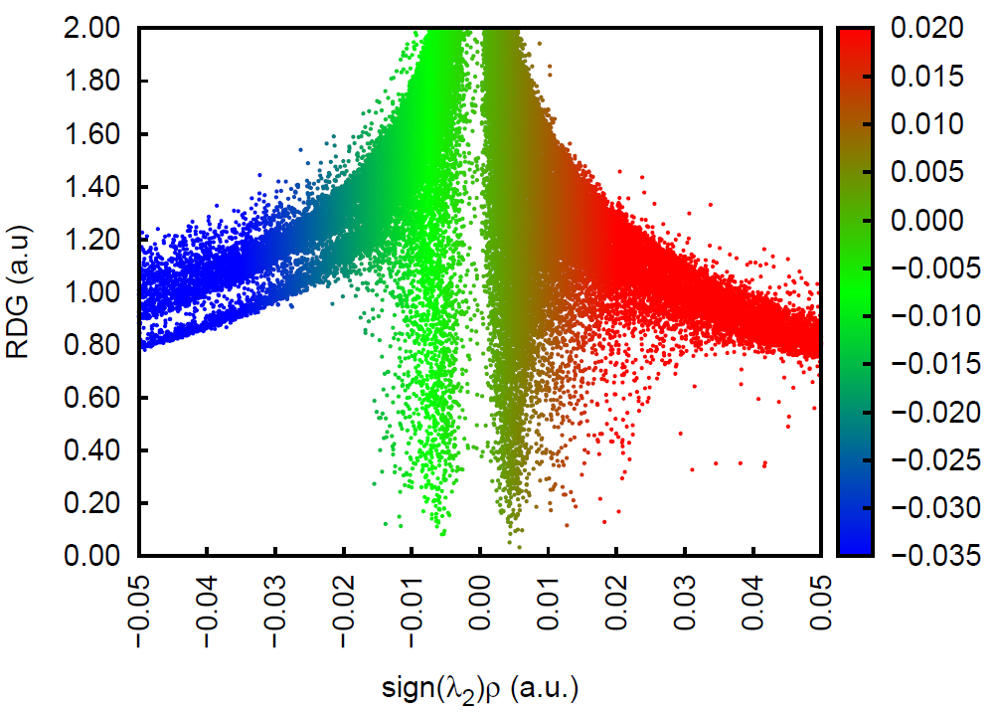 | 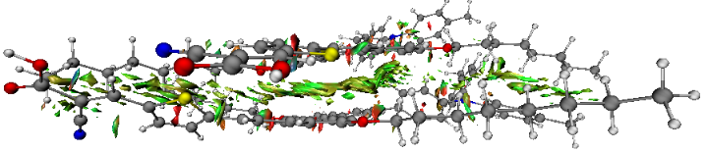
D11-D11

Figure SD 3: Left: NCI-RDG 2D scatter maps, and right: 3D colour-filled RDG isosurfaces of investigated dye dimers at CPCM/M06-2x/6-31+G(d,p) in THF.

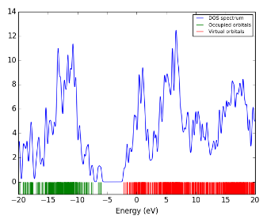 | 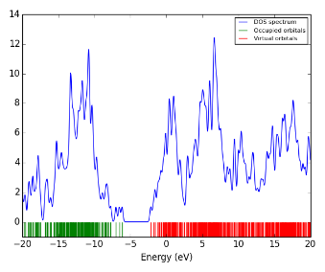 | 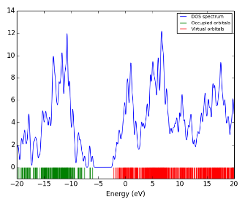 | 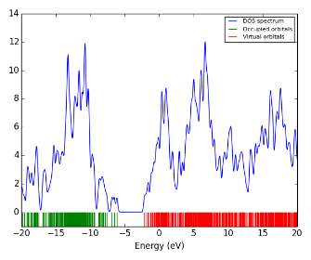
D2@TiO2 | D5@TiO₂ | D6@TiO₂ | D7@TiO₂
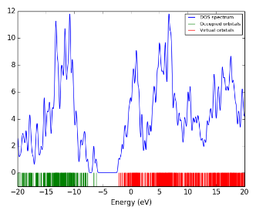 | 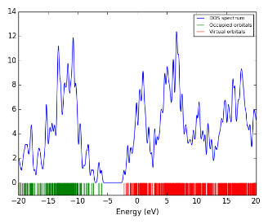 | 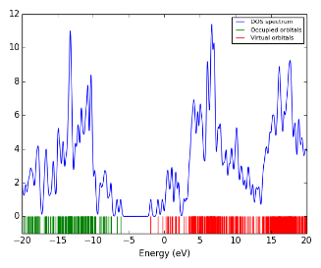 | 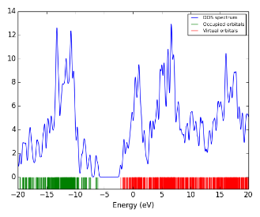
D8@TiO₂ | D9@TiO₂ | D10@TiO₂ | D11@TiO₂

Figure SD 4: Total density of states (TDOS) plots of the adsorbed systems of dye@TiO₂.

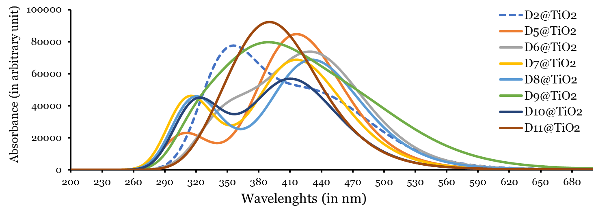

Figure SD 5: Simulated absorption spectra of dye@TiO2 systems in THF.

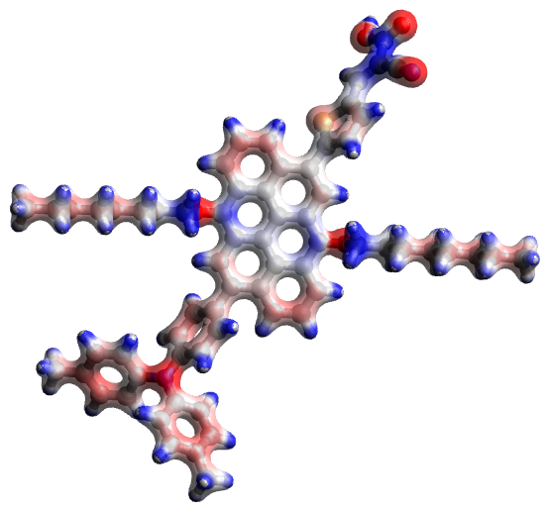 | 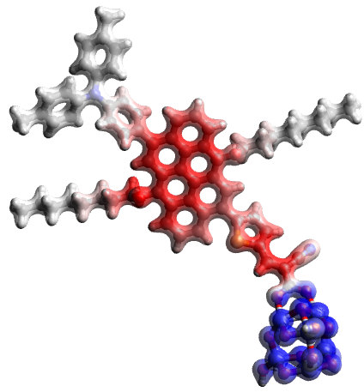 | 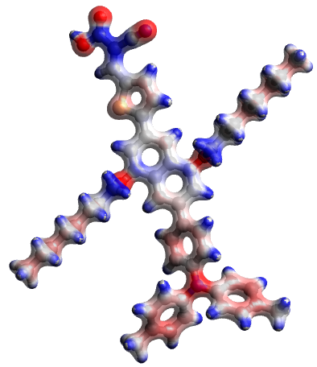 | 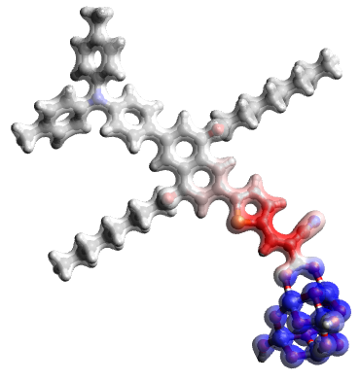
D2 | D2@TiO2 | D5 | D5@TiO2
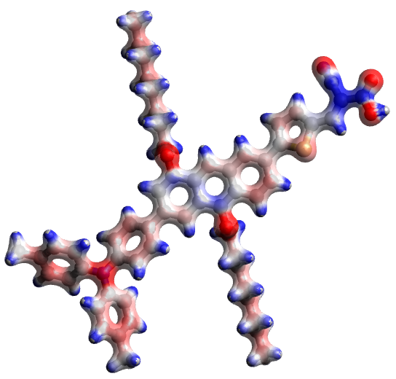 | 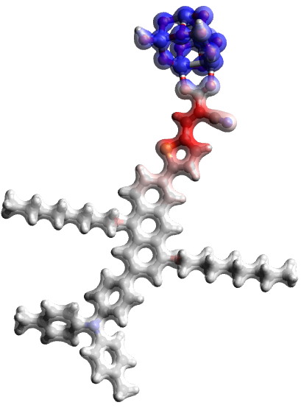 | 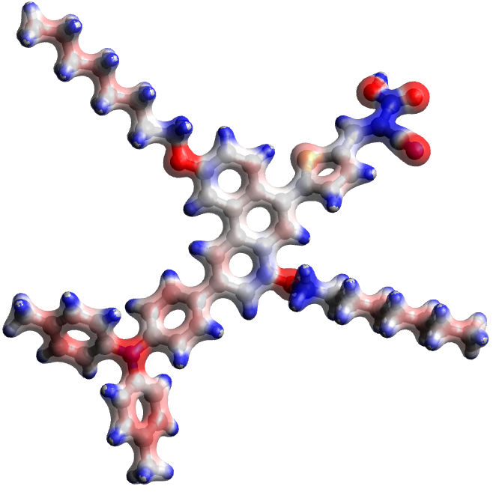 | 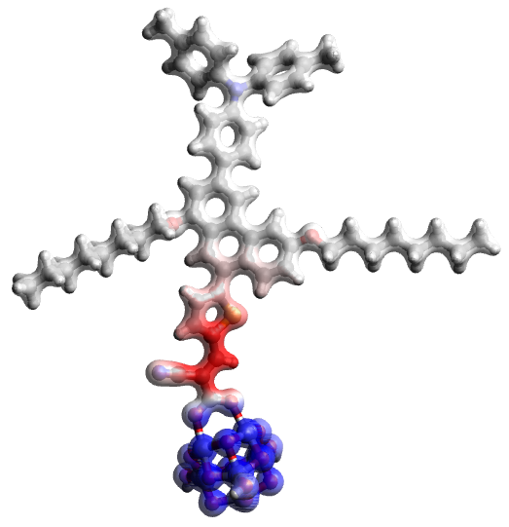
D6 | D6@TiO2 | D7 | D7@TiO2
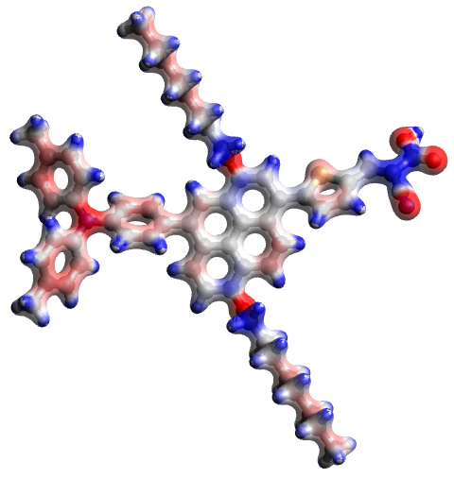 | 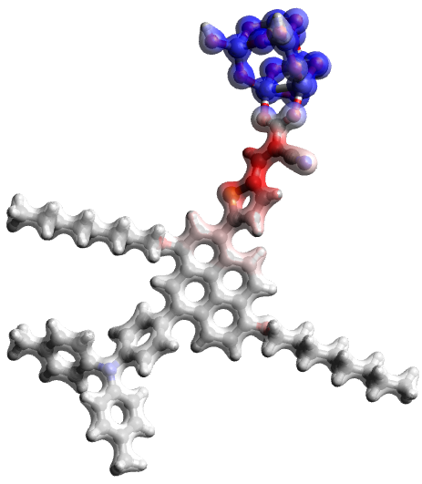 | 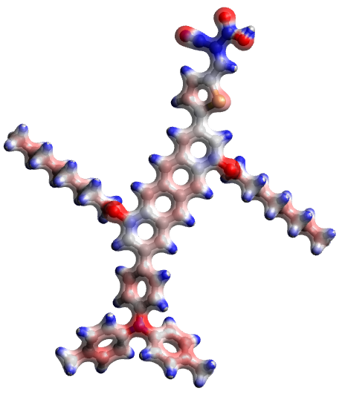 | 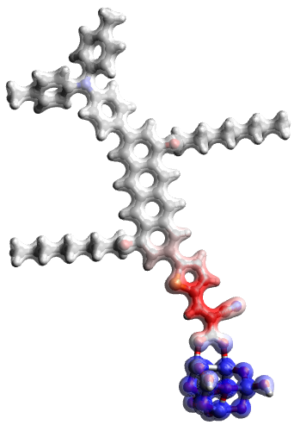
D8 | D8@TiO2 | D9 | D9@TiO2
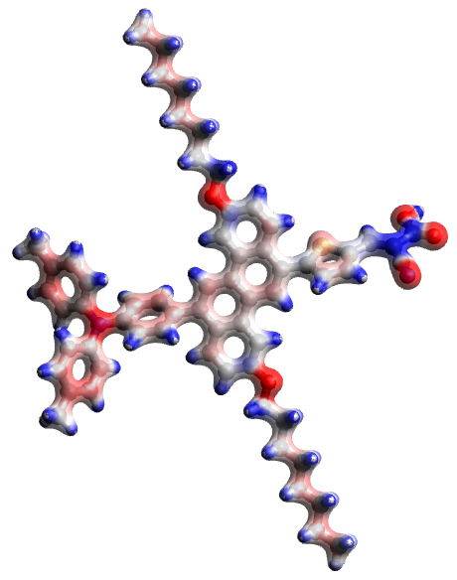 | 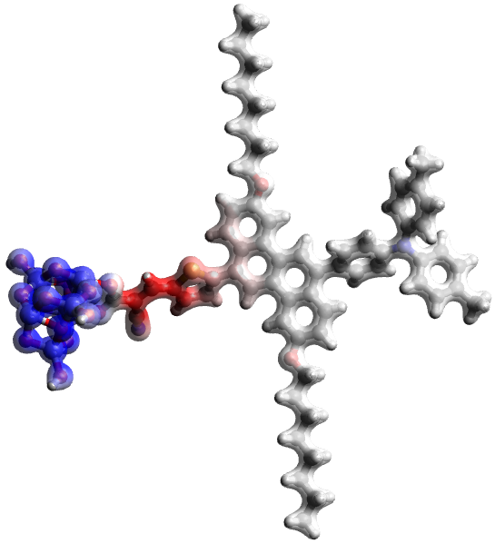 | 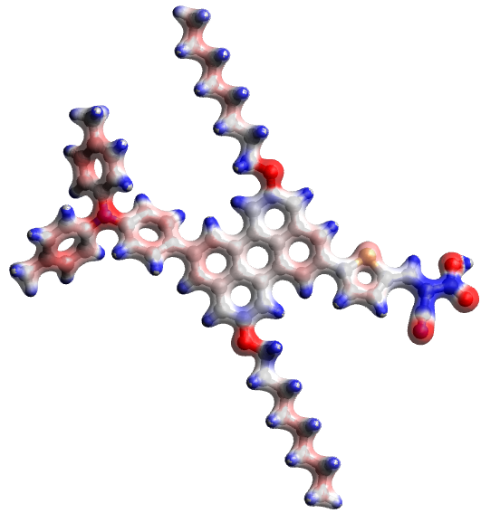 | 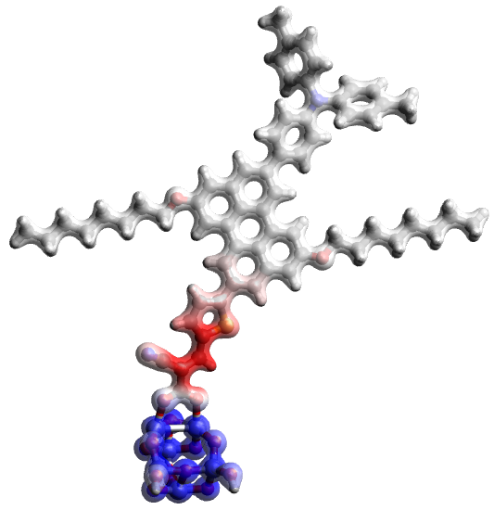
D10 | D10@TiO2 | D11 | D11@TiO2

Figure SD 6: MESPs of the eight investigated dyes in their isolated and adsorbed (on TiO2) forms at iso-value 0.1 au.

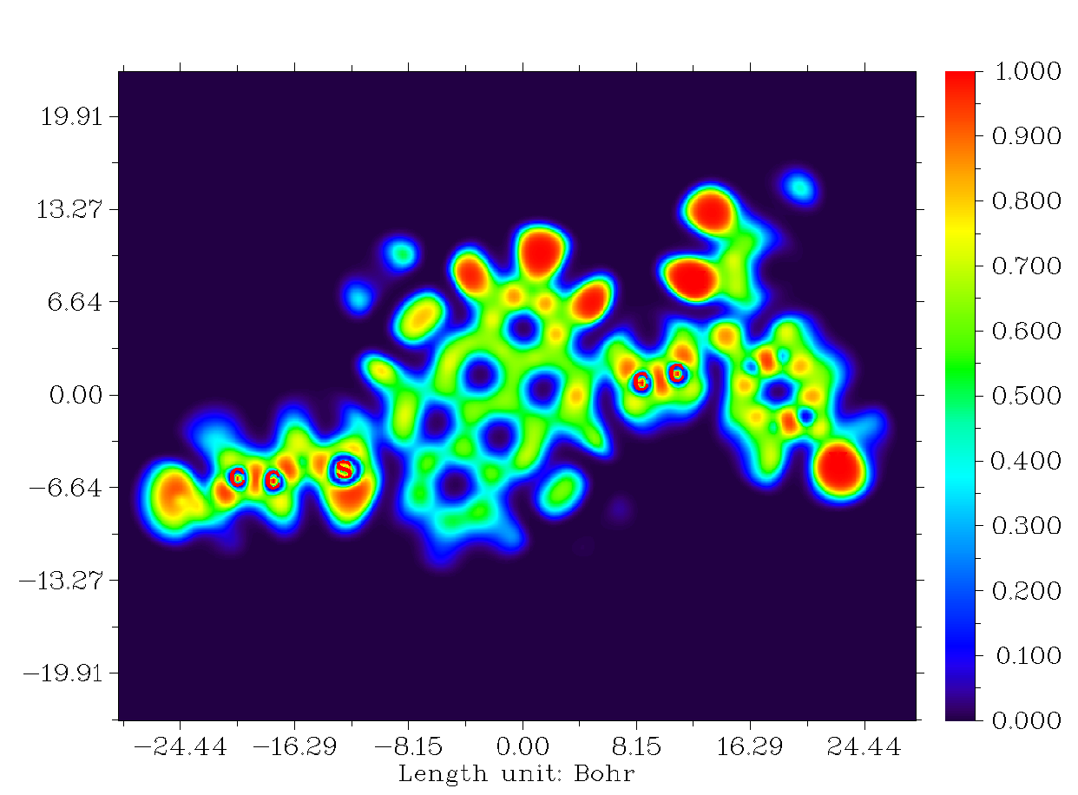 | 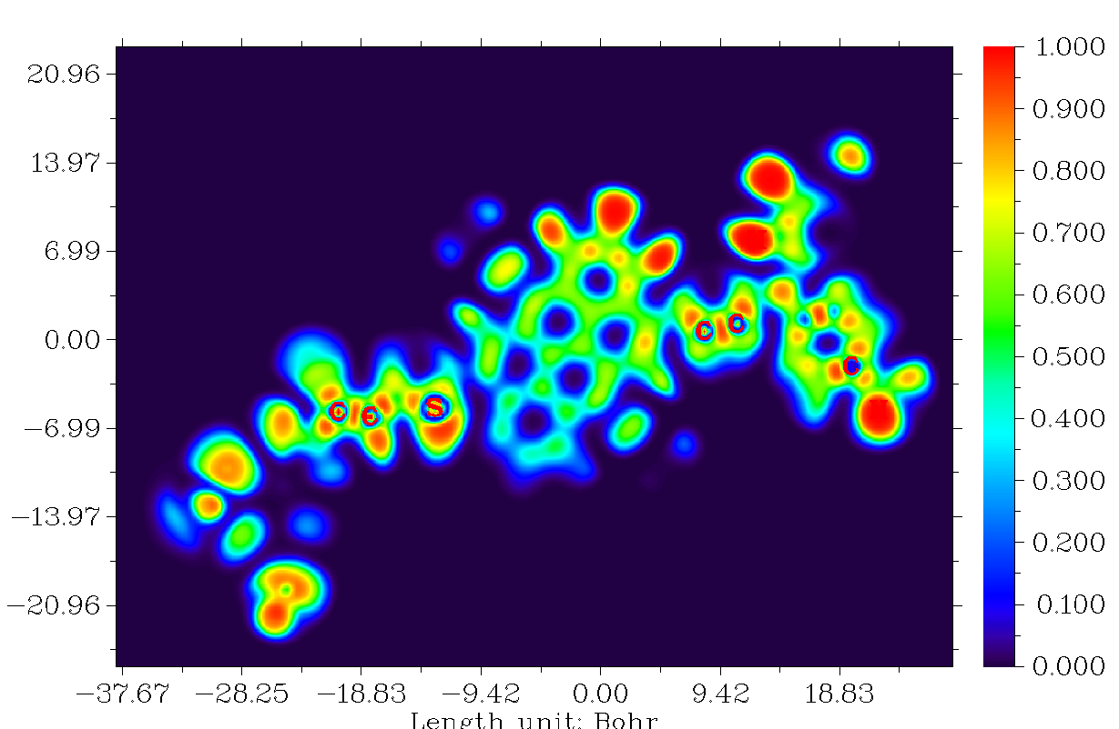 | 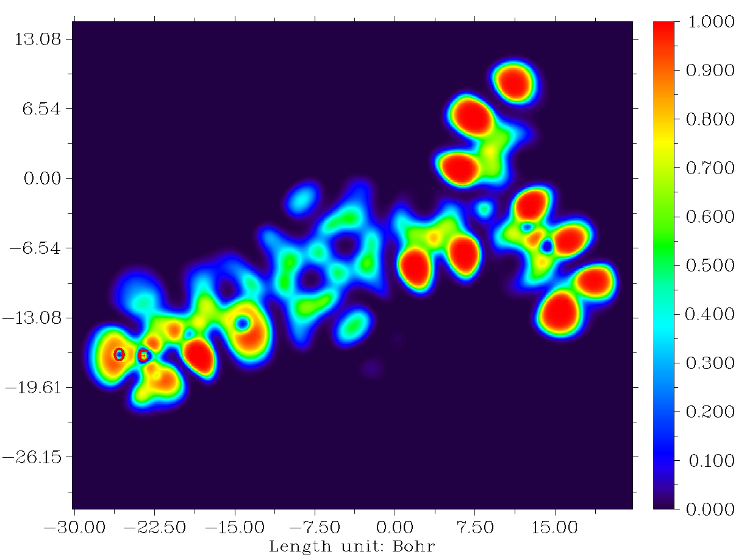 | 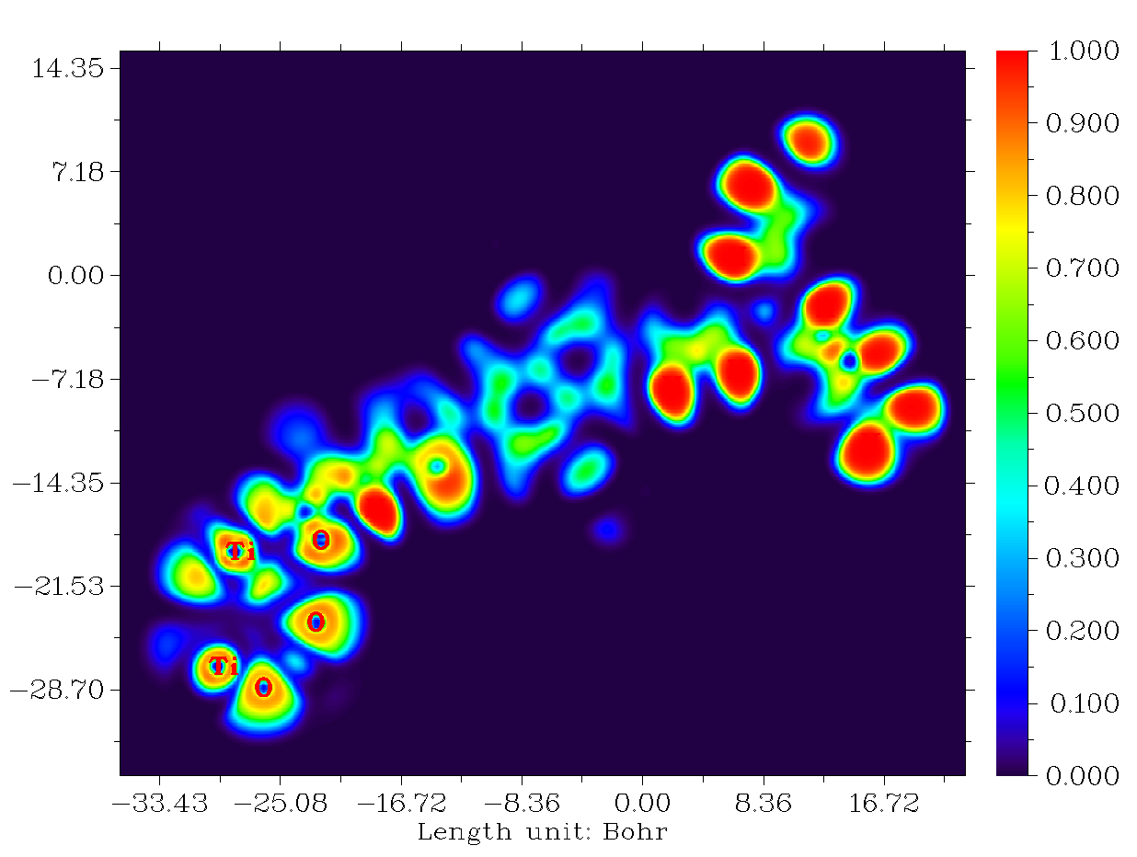
D2 | D2@TiO₂ | D5 | D5@TiO₂
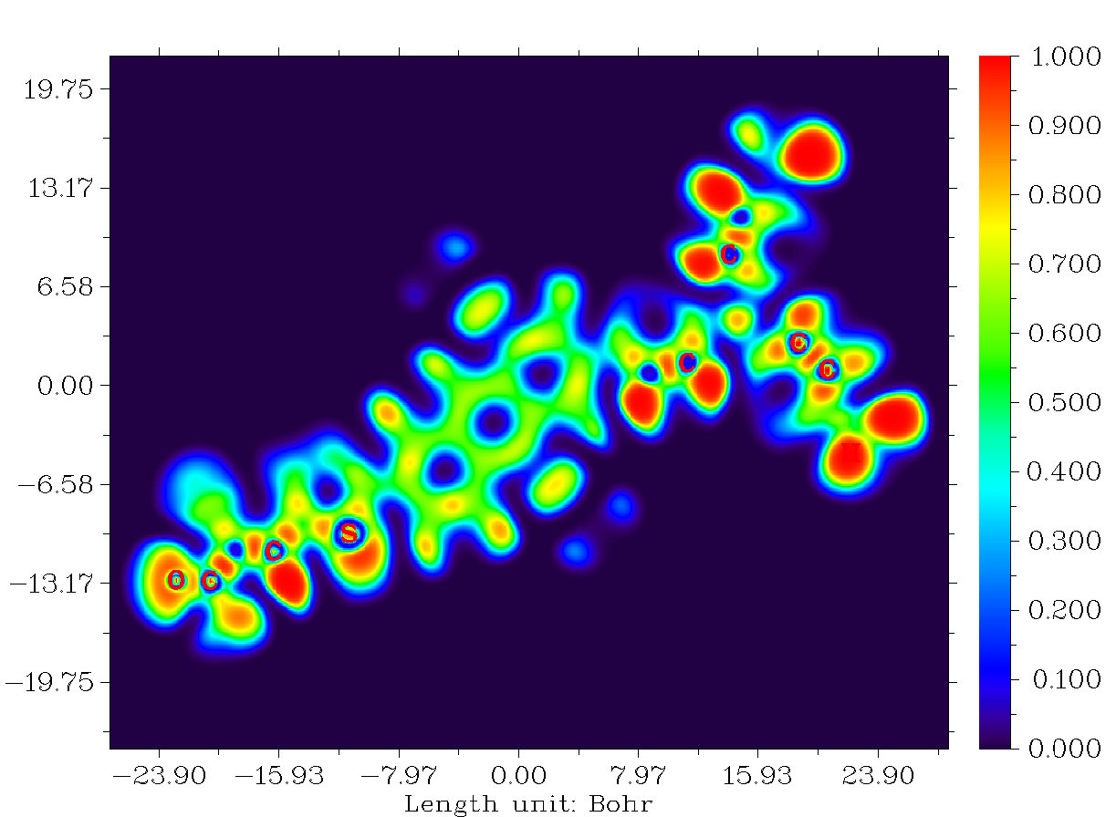 | 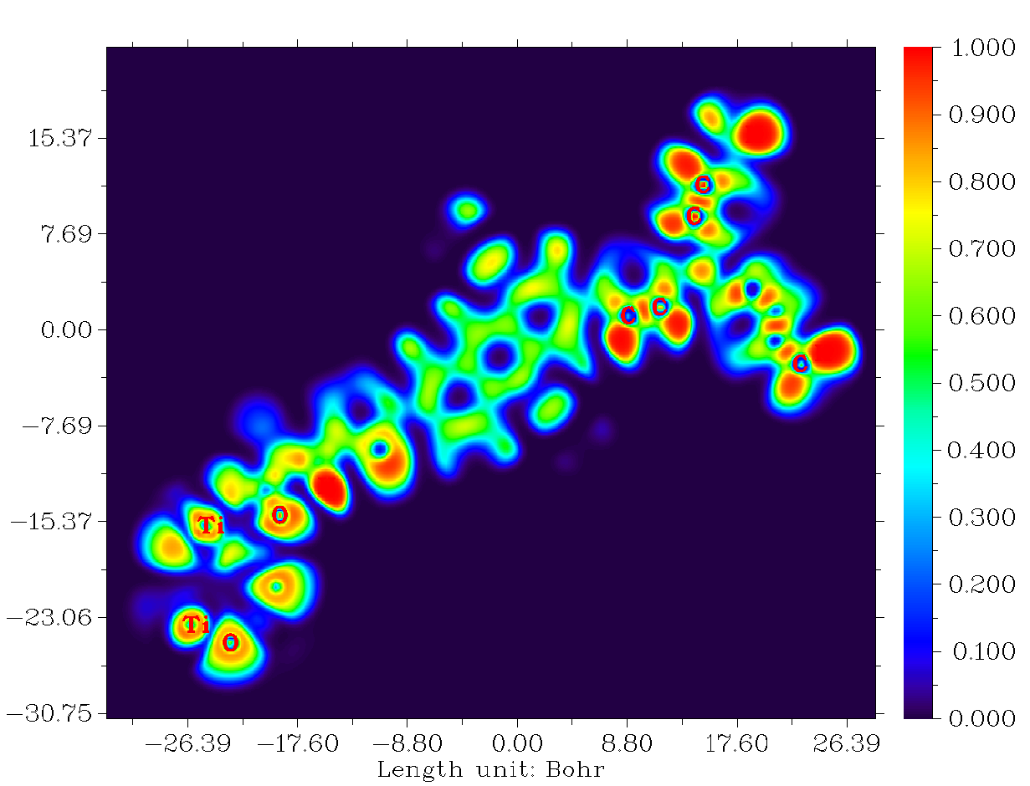 | 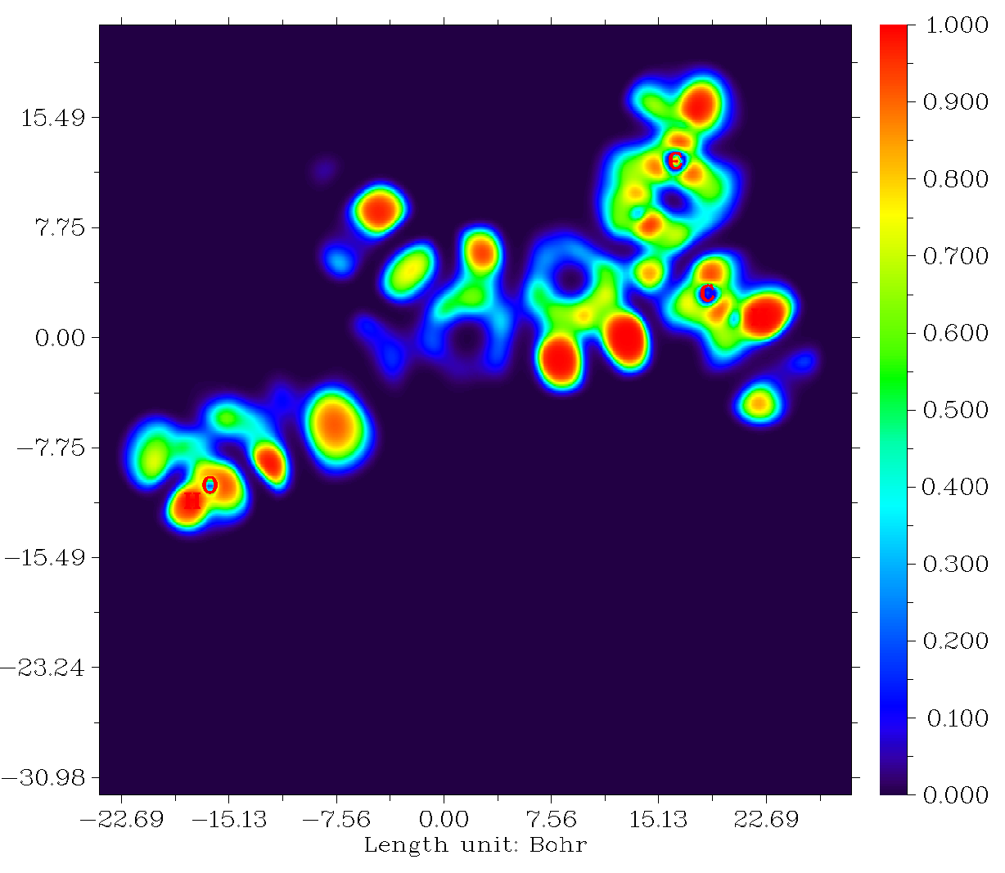 | 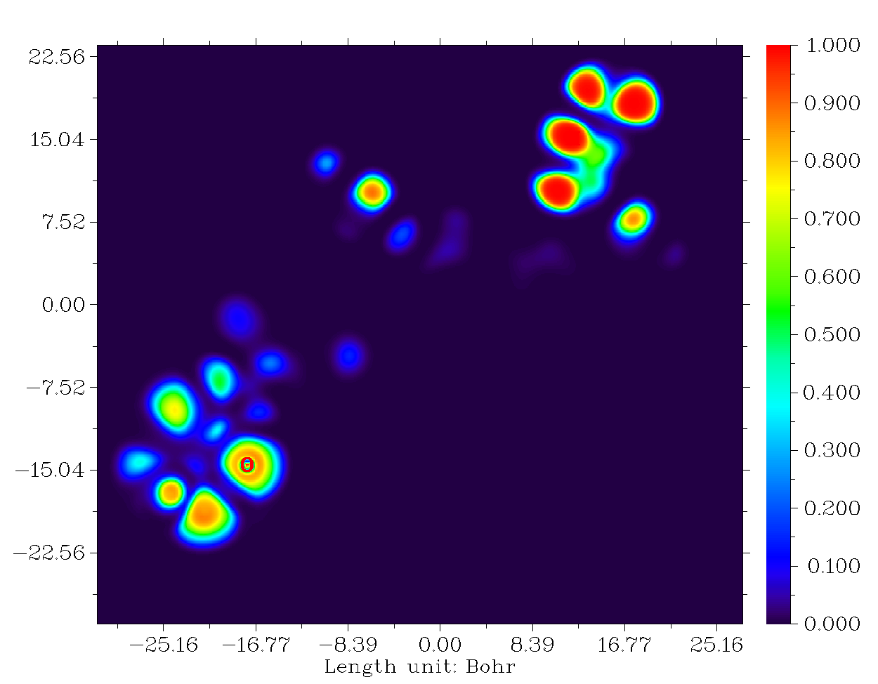
D6 | D6@TiO₂ | D7 | D7@TiO₂
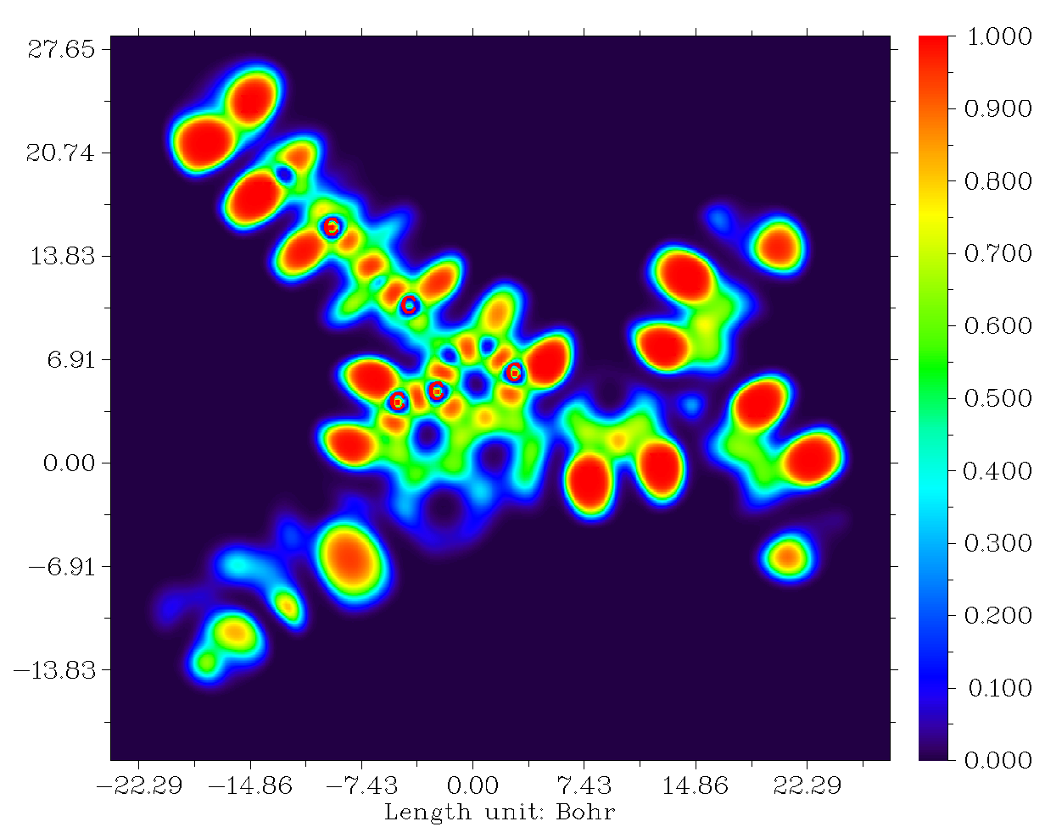 | 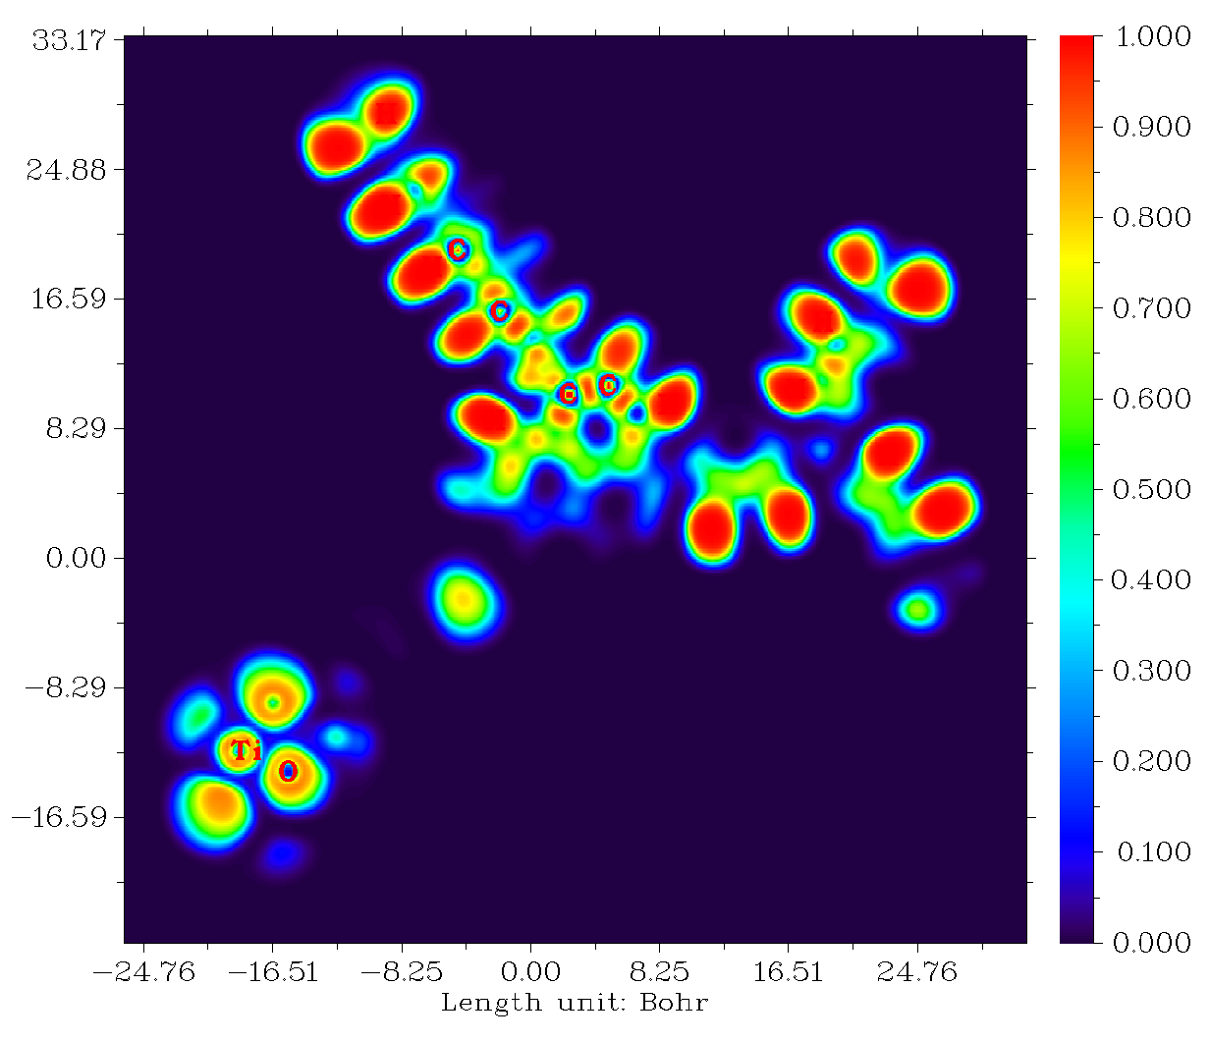 | 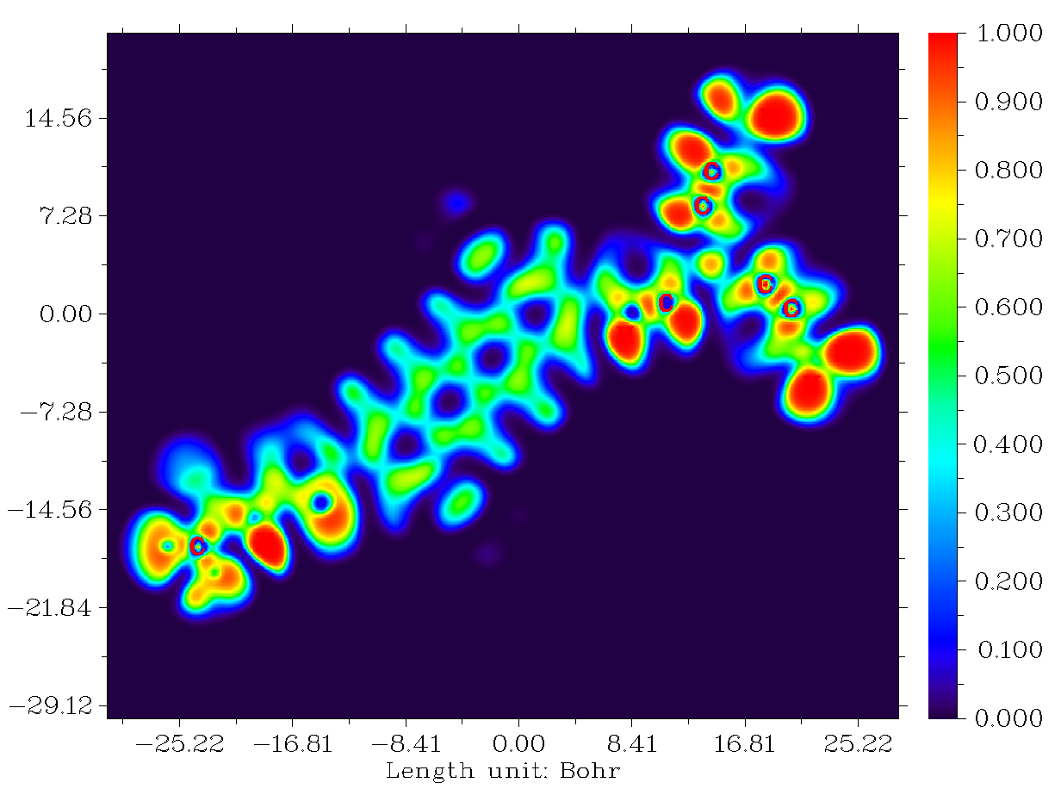 | 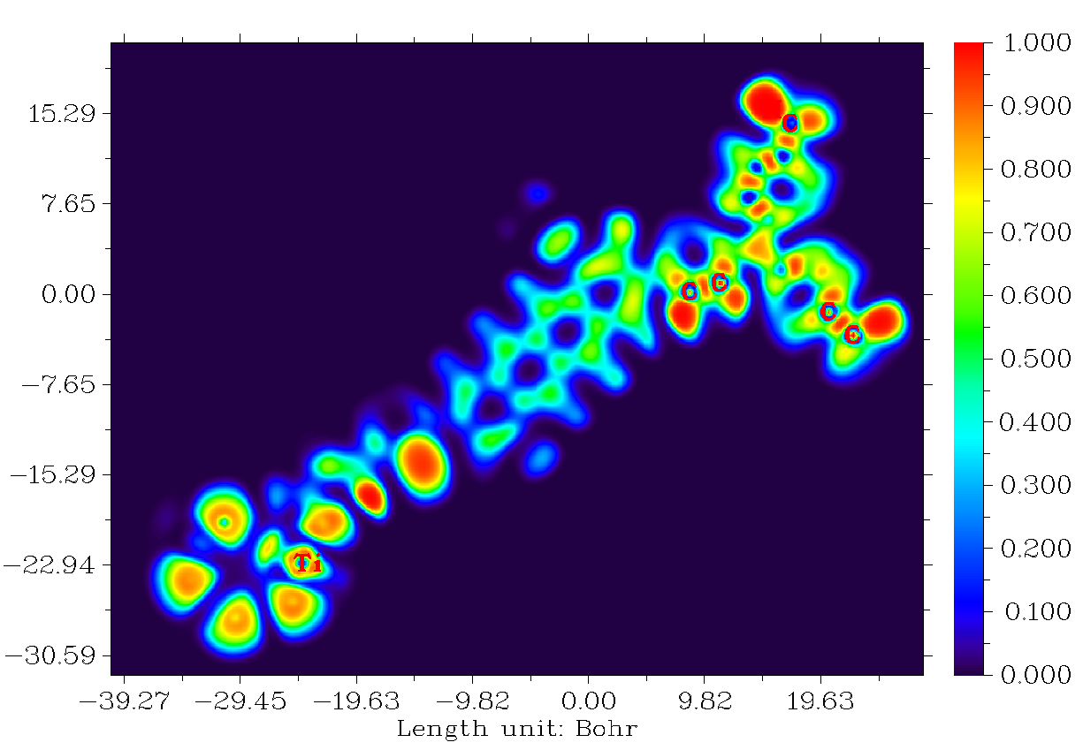
D8 | D8@TiO₂ | D9 | D9@TiO₂
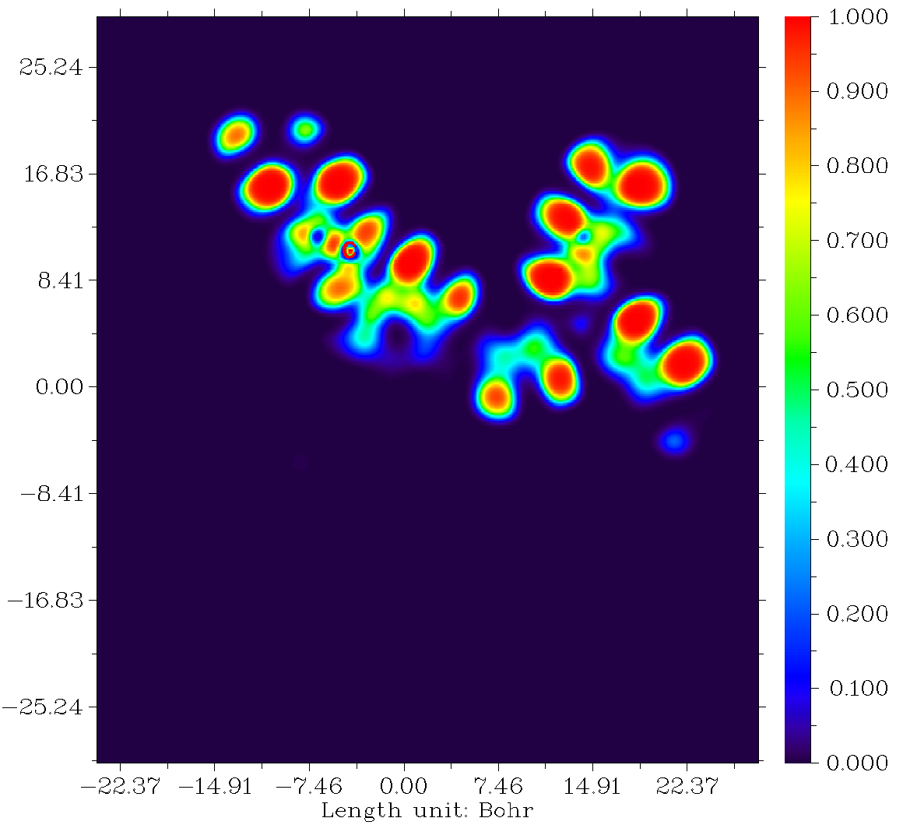 | 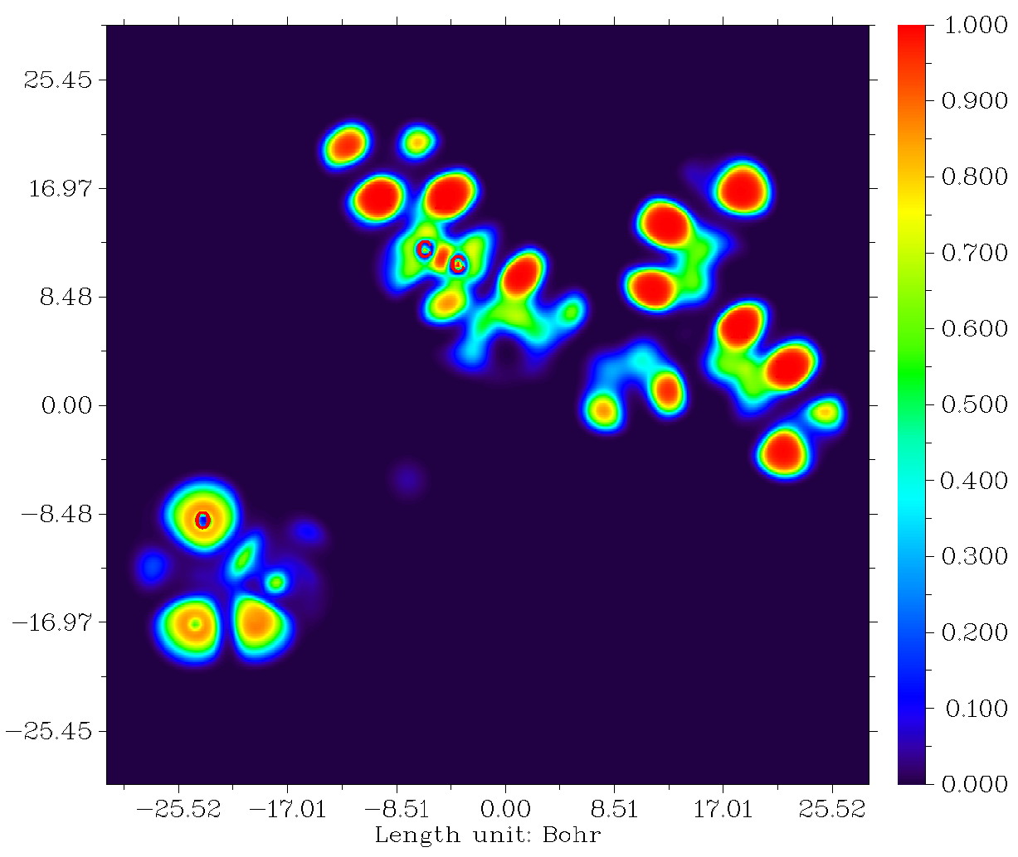 | 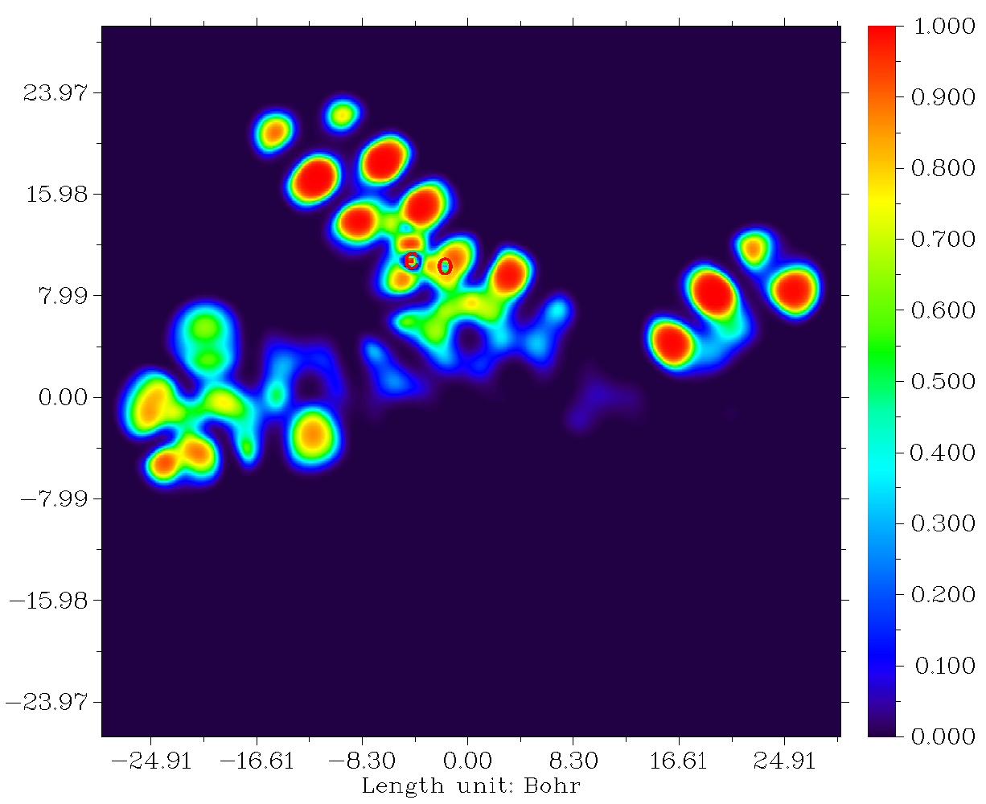 | 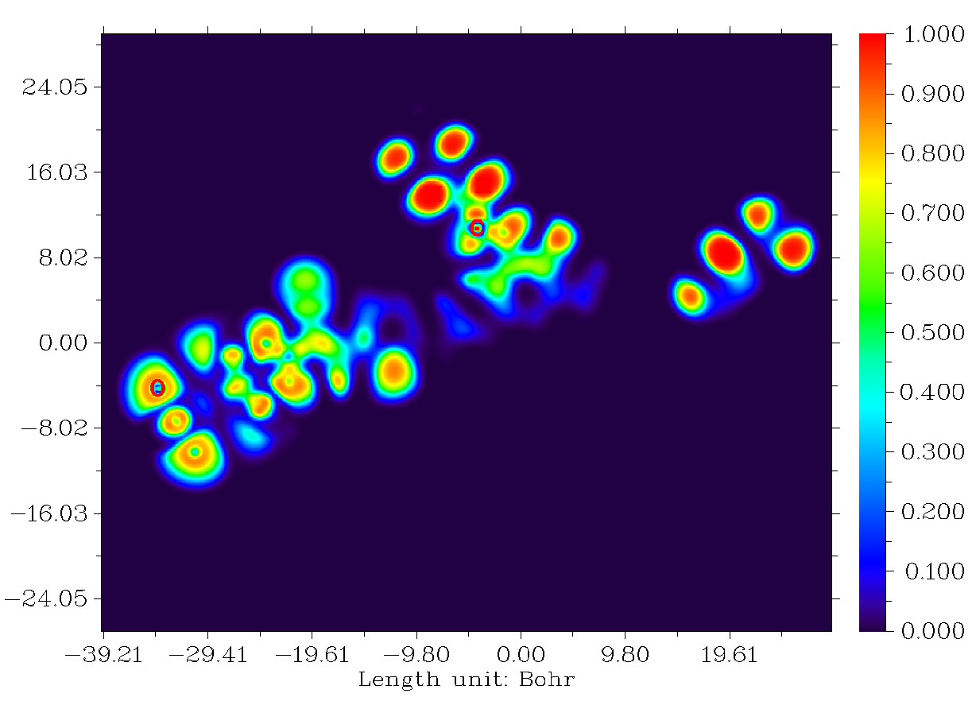
D10 | D10@TiO₂ | D11 | D11@TiO₂

Figure SD 7: ELFs of dye molecules before and after adsorption on TiO₂.

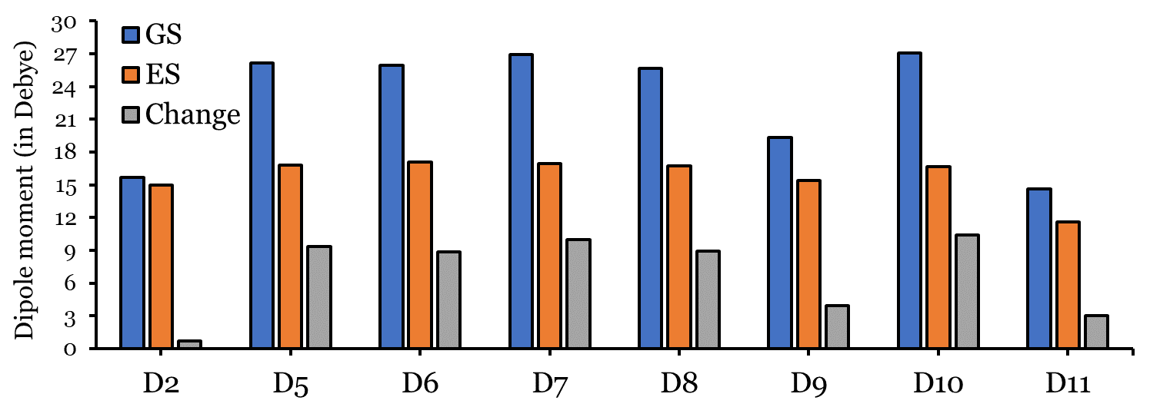

Figure SD 8: Dipole moments ($μ_{GS}$, $μ_{ES}$ and $∆μ$) (in Debye) of D2, and D5 to D11 dyes.

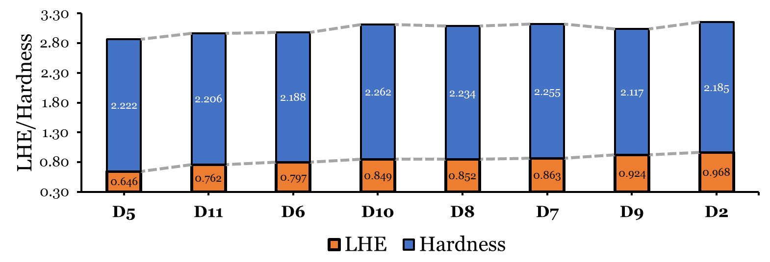

Figure SD 9: LHE and $η$ relationship of D2, and D5 to D11 dyes.

Supplementary tables

Table SD 1: Hole, electron, hole-electron, and total reorganization energies ($λ_{hole}$, $λ_{elec}$, $∆λ$ and $λ_{tot}$, respectively.
Dye | $$λ_{hole}$$ | $$λ_{elec}$$ | $$∆λ$$ | $$λ_{tot}$$
D2 | 0.156 | 0.452 | 0.296 | 0.607
D5 | 0.147 | 0.435 | 0.288 | 0.582
D6 | 0.145 | 0.431 | 0.286 | 0.576
D7 | 0.144 | 0.447 | 0.303 | 0.590
D8 | 0.155 | 0.440 | 0.286 | 0.595
D9 | 0.146 | 0.433 | 0.286 | 0.579
D10 | 0.151 | 0.442 | 0.291 | 0.592
D11 | 0.143 | 0.453 | 0.310 | 0.596

Table SD 2: Le Bahers’s CT indices included the charge transfer distance $D$, $H$ , $t$ (in Å), and the amount of charge transferred $q$ (in e) of the seven designed dyes along with those of D2 dye calculated at the CPCM/TDCAM-B3LYP/6-31+G(d,p) in THF. Note: data for D10 dye not converged and not included.
Dye | $$D$$ | $$q$$ | $$H$$ | $$t$$
D2 | 1.071 | 0.987 | 7.787 | -6.716
D5 | 0.764 | 0.804 | 6.102 | -5.338
D6 | 1.956 | 0.754 | 6.491 | -4.535
D7 | 3.308 | 0.719 | 6.431 | -3.123
D8 | 1.305 | 0.780 | 6.182 | -4.877
D9 | 1.107 | 0.774 | 7.741 | -6.634
D11 | 2.930 | 0.897 | 7.270 | -4.340

Table SD 3: GSEO, ESOPs, $E^{Dye}$ and $E^{{Dye}^{*}}$ , excitation energy $E_{ex}$, and free energies of charge injection and dye regeneration, ${∆G}_{inj}$, ${∆G}_{reg}$, respectively, (in eV) of the isolated dyes calculated at CPCM/TDCAM-B3LYP/6-31G(d,p) in THF.
Dye | $$E^{Dye}$$ | $$E^{{Dye}^{*}}$$ | $$E_{ex}$$ | $${-∆G}_{inj}$$ | $$-{∆G}_{reg}$$
D2 | 6.246 | 3.496 | 2.75 | 0.504 | 1.446
D5 | 6.378 | 3.418 | 2.96 | 0.582 | 1.578
D6 | 6.324 | 3.484 | 2.84 | 0.516 | 1.524
D7 | 6.359 | 3.209 | 3.15 | 0.791 | 1.559
D8 | 6.382 | 3.482 | 2.90 | 0.518 | 1.582
D9 | 6.236 | 3.236 | 3.00 | 0.764 | 1.436
D10 | 6.366 | 3.276 | 3.09 | 0.724 | 1.566
D11 | 6.350 | 3.250 | 3.10 | 0.750 | 1.550

Table SD 4: Adsorption energies (in kJ/mol) and their energy components (in Hartree) of the eight dye@TiO2 adsorbed systems. Note: data of D2 dye are collected from ref. [15].
Adsorbed systems | Energy of dye | Energy of TiO₂ cluster | Energy of adsorbed system | Energy of Hydrogen | Absolute adsorption energies | Relative adsorption energies
D2@TiO₂ | -3361.058 | -1252.903 | -4613.709 | -0.497 | -645.083 | 15.1
D5@TiO₂ | -2901.476 | -1252.903 | -4154.134 | -0.497 | -660.164 | 0.0
D6@TiO₂ | -3055.057 | -1252.903 | -4307.712 | -0.497 | -655.582 | 4.6
D7@TiO₂ | -3055.065 | -1252.903 | -4307.720 | -0.497 | -653.671 | 6.5
D8@TiO₂ | -3131.268 | -1252.903 | -4383.923 | -0.497 | -653.469 | 6.7
D9@TiO₂ | -3208.632 | -1252.903 | -4461.286 | -0.497 | -650.400 | 9.8
D10@TiO₂ | -3208.651 | -1252.903 | -4461.305 | -0.497 | -650.565 | 9.6
D11@TiO₂ | -3284.856 | -1252.903 | -4537.509 | -0.497 | -647.627 | 12.5

Table SD 5: Ti–O bond lengths of the dye@TiO2 adsorbed systems calculated at CPCM/M06-2x with 6-31+G(d,p) and LANL2DZ in THF.
Adsorbed systems | (Ti─O)1 | (Ti─O)2 | Adsorbed systems | (Ti─O)₁ | (Ti─O)₂
D2@TiO₂ | 2.0585 | 2.0440 | D8@TiO₂ | 2.0629 | 2.0375
D5@TiO₂ | 2.0626 | 2.0377 | D9@TiO₂ | 2.0382 | 2.0616
D6@TiO₂ | 2.0624 | 2.0379 | D10@TiO₂ | 2.0401 | 2.0652
D7@TiO₂ | 2.0414 | 2.0544 | D11@TiO₂ | 2.0451 | 2.0573

Table SD 6: Energies of HOMOs, LUMOs of isolated and adsorbed dyes, CB, and VB of TiO2, and their dipole moments (in Debye) calculated at CPCM/M06-2x with 6-31+G(d,p) and LANL2DZ in THF.
System | $$E_{HOMO/VB}$$ | $$E_{LUMO/CB}$$ | $$∆_{(L/CB)-(H/VB)}$$ | $${∆E}_{LUMO-CB}$$ | $$μ_{normal}$$
TiO₂ | -6.560 | -1.999 | 4.561 | ‒ | 1.941
D2 | -6.229 | -2.194 | 4.035 | 0.195 | 9.963
D2@TiO₂ | -6.024 | -2.142 | 3.883 | 0.143 | 9.341
D5 | -6.338 | -2.239 | 4.099 | 0.240 | 10.121
D5@TiO₂ | -6.145 | -2.161 | 3.984 | 0.162 | 10.674
D6 | -6.281 | -2.269 | 4.012 | 0.270 | 10.249
D6@TiO₂ | -6.087 | -2.182 | 3.905 | 0.183 | 10.599
D7 | -6.321 | -2.160 | 4.161 | 0.161 | 9.391
D7@TiO₂ | -6.126 | -2.127 | 4.000 | 0.128 | 6.522
D8 | -6.344 | -2.228 | 4.115 | 0.229 | 9.355
D8@TiO₂ | -6.141 | -2.151 | 3.990 | 0.152 | 9.405
D9 | -6.197 | -2.334 | 3.863 | 0.335 | 10.474
D9@TiO₂ | -6.009 | -2.228 | 3.782 | 0.229 | 5.847
D10 | -6.328 | -2.154 | 4.174 | 0.155 | 9.528
D10@TiO₂ | -6.138 | -2.084 | 4.053 | 0.085 | 7.432
D11 | -6.314 | -2.265 | 4.048 | 0.266 | 9.696
D11@TiO₂ | -6.117 | -2.172 | 3.945 | 0.173 | 9.029

Table SD 7: Ground state, excited state, and change dipole moments ($μ_{GS}$, $μ_{ES}$, and $∆μ$, respectively) in Debye.
Dye | $$μ_{GS}$$ | $$μ_{ES}$$ | $$∆μ$$
D2 | 15.703 | 14.988 | 0.715
D5 | 26.178 | 16.828 | 9.350
D6 | 25.958 | 17.078 | 8.879
D7 | 26.921 | 16.911 | 10.010
D8 | 25.665 | 16.740 | 8.926
D9 | 19.312 | 15.406 | 3.906
D10 | 27.046 | 16.668 | 10.377
D11 | 14.603 | 11.559 | 3.044

Table SD 8: Computed molecular parameters of the eight investigated dyes.
Dye | $${IP}_{a}$$ | $${EA}_{a}$$ | $${IP}_{v}$$ | $${EA}_{v}$$ | $$η$$ | $$μ$$ | $$ω$$ | $$ω^{+}$$ | $$ω^{-}$$
D2 | 5.47 | 3.19 | 5.55 | 2.96 | 2.02 | -4.211 | 4.395 | 0.596 | 4.808
D5 | 5.47 | 3.22 | 5.54 | 3.00 | 2.05 | -4.289 | 4.487 | 0.612 | 4.900
D6 | 5.45 | 3.23 | 5.53 | 3.01 | 2.01 | -4.275 | 4.556 | 0.642 | 4.917
D7 | 5.46 | 3.17 | 5.54 | 2.95 | 2.08 | -4.289 | 4.322 | 0.561 | 4.802
D8 | 5.48 | 3.21 | 5.56 | 2.98 | 2.06 | -4.286 | 4.463 | 0.603 | 4.889
D9 | 5.44 | 3.25 | 5.52 | 3.03 | 1.93 | -4.266 | 4.711 | 0.705 | 4.971
D10 | 5.47 | 3.16 | 5.54 | 2.94 | 2.09 | -4.241 | 4.309 | 0.556 | 4.797
D11 | 5.46 | 3.24 | 5.54 | 3.01 | 2.02 | -4.289 | 4.545 | 0.634 | 4.923

Additional results and discussion

4.1 FMOs of π-aromatic cores
The dye with D‒π‒A configuration would expected to have a flow of electrons within the its framework, since the electrons will move from the electron-donor site through the π-bridge unit to reach the electron-acceptor site [16]. Therefore, this ICT process required proper alignments of the energy levels of HOMOs and LUMOs of these units toward one another. Alignment of HOMO and LUMO energy levels of the TPA (triphenylamine), TPH (thiophene), and different π-bridge cores of the eight investigated dyes are displayed in Figure SD 1. From Figure SD 1, the HOMO energy level of TPA unit is higher than the HOMOs of aromatic cores, except those of D2, D9, and D11 dyes, i.e., Anthanthrene, Naphthacene, and Perylene cores, respectively. All dyes have lower LUMOs than TPH units. Since for TPA unit, the $E_{HOMO}=-6.372$ eV and for D3 to D8 the corresponding values are in the range −6.659 to −7.251 eV, and for TPH unit, the $E_{LUMO}=-2.145$ eV and for aromatic cores the values range from −1.786 to −0.601 eV. Hence, the aromatic cores motivate the ICT within the dye’s framework. Additionally, the energy gaps of the TPA and TPH units are larger than those of aromatic cores, i.e., the aromatic cores reduce the$E_{g}$values. Since $E_{g}=5.994$ and $6.236$eV for TPH, and TPA, respectively, but for the aromatic cores the energy gaps range from 4.461 to 5.890 eV. The exceptions are D5 ($E_{g}=6.650$eV), and D7 ($E_{g}=6.416$ eV), the introduction of these two cores (Naphthalene, and Phenanthrene, respectively) increases the energy gaps of dyes.

4.2 Molecular electrostatic potential maps
Calculating the molecular electrostatic potential (MESP) can provide insight into the dye's photovoltaic performance. In spite of the fact that the molecular charge distribution is not perturbed (as no polarization occurs), the electrostatic potential of a molecule serves as a good guide in simulating the reactivity of the molecule towards positively or negatively charged reactants. The MESP creates the potential experience by a positive charge near a molecule when the electron density is distributed around the molecule [17]. In MESP, chemical reactivity is shown as a positive potential, which can be used for electrophilic attack, whereas nucleophilic attack can be achieved through a negative potential. Figure SD 6 shows the MESPs of the eight investigated isolated dyes. There is a map of the MESP on the surface of 0.1 au electron density. The negative electrostatic potential is represented by red color while the positive electrostatic potential is represented by blue color. In addition, the white color shows region with zero potential. As expected, the negative electrostatic potentials (red color) are found on region/atom with high electron density such as the Oxygen, Nitrogen atoms and the part of π-linker cores. While the positive electrostatic potentials are mainly on Hydrogen, and Carbon atoms and part of π-linker cores. Other regions are white colored with almost zero potentials. The most distinguish combination between red and blue colored regions is on the anchoring (carboxylic groups) and the donor (TPA) unit. As a general note, the MESP of the designed dyes are very similar to that of the experimentally tested dye (D2). We can claim here that the based on the similarity of MESPs of D2 dye and the other designed dyes, the designed dyes are excellent candidates in DSSC devices.

4.2 Solubility
By increasing the dipole moment, the molecule will self-assemble, disorder between donor and acceptor will decrease, and charge recombination will be reduced, thereby increasing the fill factor [18]. The dipole moments of D2, and D5 to D11 dyes are calculated in THF at CPCM/CAM-B3LYP and /TDCAM-B3LYP/6-31+G(d,p) level for the ground state’s dipole moment ($μ_{GS}$) and first excited’s dipole moment ($μ_{ES}$) states, respectively, Figure SD 8 and Table SD 7. In contrary to the trend observed in the four tested dyes (except D2 dye), for all designed dyes, the $μ_{GS}$ are higher than $μ_{GS}$, values. Moreover, the seven designed dyes have higher dipole moments for the ground and excited states compared to those of the experimentally tested one D2 dye, therefore, the designed dyes are more soluble in in THF compared to D2 dye. Hence they can give better morphology of the film [18]. The exception are the dipole moments of D11 dye, since they are smaller than those of D2 dye. In contrast, the lower dipole moment allows higher stability in organic solar cells [19].
The $μ_{GS}$ values increased as follows: D11 (14.60 Debye) < D2 (15.70 Debye) < D9 (19.31 Debye) < D8 (25.67 Debye) < D6 ( 25.96 Debye) < D5 (26.18 Debye) < D7 (26.92 Debye) < D10 (27.05 Debye). The $μ_{ES}$ values increased in nearly the same order as the $μ_{GS}$ values and follows the order: D11 (11.56 Debye) < D2 (14.99 Debye) < D9 (15.41 Debye) < D10 (16.67 Debye) < D8 ( 16.74 Debye) < D5 (16.83 Debye) < D7 (16.91 Debye) < D6 (17.08 Debye). In contrast, the change in dipole moments ($∆μ$($=\left|μ_{GS}-μ_{ES}\right|$) for the eight investigated dyes is closely related to the change of $μ_{GS}$ and $μ_{ES}$ values, and it is: D2 (0.72 Debye) < D11 (3.04 Debye) < D9 (3.91 Debye) < D6 (8.88 Debye) < D8 ( 8.93 Debye) < D5 (9.35 Debye) < D7 (10.01 Debye) < D10 (10.38 Debye).

4.3 Molecular description parameters
The lower adiabatic/vertical ionization potential (${IP}_{a/v}$) and higher adiabatic/vertical electron affinity (${EA}_{a/v}$) values stimulate holes and electrons injection, respectively. As can be seen clearly from Table SD 8, the ionization energies and electron affinities (adiabatic and vertical) do not vary noticeably between the investigated dyes. However, these values for the designed dyes are generally identical, in few cases they are smaller and larger compared to the values of D2 dye, see Table SD 8. Therefore, the designed dyes have comparable electron donating and electron accepting power to that of D2 molecule. The electrophilicity index ($ω$), and electron-accepting power ($ω^{+}$) were calculated. The order of increasing $ω$ and $\left(ω^{+}\right)$ is: D10 < D7 < D2 < D8 < D5 < D11 < D6 < D9. Therefore, four designed dyes (D5, D6, D9, and D11) showed better electron-accepting ability than D2 dye, and only D10 and D7 showed a less electron-accepting ability than D2 dye. Since smaller hardness ($η$) value is a good indicator as it lowers the resistance to ICT, among the designed dyes, only D6, and D9 dyes showed a softer character (smaller $η$ value) compared to that of D2 dye, other designed dyes are harder molecules (larger $η$ value), Table SD 8. An analysis of the relationship between LHE and $η$values is showed in Figure SD 9. Usually in literature the this relationship was represented by a funnel-like shape [18], in this study, this shape is not hold in all cases. Generally, as the dye molecule becomes harder as its LHE value becomes larger.

References
1. Scharber, M.C., et al., Design Rules for Donors in Bulk-Heterojunction Solar Cells—Towards 10 % Energy-Conversion Efficiency. Advanced Materials, 2006. 18(6): p. 789-794.
2. Fan, W., D. Tan, and W.Q. Deng, Acene‐Modified Triphenylamine Dyes for Dye‐Sensitized Solar Cells: A Computational Study. ChemPhysChem, 2012. 13(8): p. 2051-2060.
3. Chi, W.-J. and Z.-S. Li, The theoretical investigation on the 4-(4-phenyl-4-[small alpha]-naphthylbutadieny)-triphenylamine derivatives as hole transporting materials for perovskite-type solar cells. Physical Chemistry Chemical Physics, 2015. 17(8): p. 5991-5998.
4. Chitpakdee, C., et al., Theoretical studies on electronic structures and photophysical properties of anthracene derivatives as hole-transporting materials for OLEDs. Spectrochimica Acta Part A: Molecular and Biomolecular Spectroscopy, 2014. 125: p. 36-45.
5. Pearson, R.G., Chemical hardness and density functional theory. Journal of Chemical Sciences, 2005. 117(5): p. 369-377.
6. Fujisawa, J.-i., T. Eda, and M. Hanaya, Comparative study of conduction-band and valence-band edges of TiO2, SrTiO3, and BaTiO3 by ionization potential measurements. Chemical Physics Letters, 2017. 685: p. 23-26.
7. Cahen, D., et al., Nature of Photovoltaic Action in Dye-Sensitized Solar Cells. The Journal of Physical Chemistry B, 2000. 104(9): p. 2053-2059.
8. Som, N.N., et al., Strain and layer modulated electronic and optical properties of low dimensional perovskite methylammonium lead iodide: Implications to solar cells. Solar Energy, 2018. 173: p. 1315-1322.
9. Zhang, G., et al., Employ a bisthienothiophene linker to construct an organic chromophore for efficient and stable dye-sensitized solar cells. Energy & Environmental Science, 2009. 2(1): p. 92-95.
10. Hilborn, R.C., Einstein coefficients, cross sections, f values, dipole moments, and all that. American Journal of Physics, 1982. 50(11): p. 982-986.
11. Johnson, E.R., et al., Revealing Noncovalent Interactions. Journal of the American Chemical Society, 2010. 132(18): p. 6498-6506.
12. Le Bahers, T., C. Adamo, and I. Ciofini, A Qualitative Index of Spatial Extent in Charge-Transfer Excitations. Journal of Chemical Theory and Computation, 2011. 7(8): p. 2498-2506.
13. Marcus, R.A., Chemical and Electrochemical Electron-Transfer Theory. Annual Review of Physical Chemistry, 1964. 15(1): p. 155-196.
14. Marcus, R.A., Electron transfer reactions in chemistry. Theory and experiment. Reviews of Modern Physics, 1993. 65(3): p. 599-610.
15. Wazzan, N., Theoretical investigation of anthanthrene-based dyes in dye‐sensitized solar cell applications: Effect of nature of alkyl-substitutions and number of anchoring groups. Arabian Journal of Chemistry, 2022: p. 103969.
16. Lin, J.T., et al., Organic Dyes Containing Furan Moiety for High-Performance Dye-Sensitized Solar Cells. Organic Letters, 2009. 11(1): p. 97-100.
17. Sharma, V. and P.K. Jha, Enhancement in power conversion efficiency of edge-functionalized graphene quantum dot through adatoms for solar cell applications. Solar Energy Materials and Solar Cells, 2019. 200: p. 109908.
18. Ans, M., et al., Designing indacenodithiophene based non-fullerene acceptors with a donor–acceptor combined bridge for organic solar cells. RSC Advances, 2019. 9(7): p. 3605-3617.
19. Siddique, S.A., et al., Efficient tuning of zinc phthalocyanine-based dyes for dye-sensitized solar cells: a detailed DFT study. RSC Advances, 2021. 11(44): p. 27570-27582.

