Supplementary Information

Inverse Design of Enzymatic Reaction Network States

Bob van Sluijs¹, Tao Zhou¹*, Britta Helwig¹, Mathieu Baltussen¹, Frank H. T. Nelissen¹, Hans A. Heus¹, and Wilhelm T. S. Huck¹ *
¹ Institute for Molecules and Materials, Radboud University, 6525 AJ Nijmegen, The Netherlands.
Corresponding Author: tao.zhou@ru.nl; w.huck@science.ru.nl

Contents
1. Model, Software and Analysis 3
1.1 Software 3
1.2 Model and Optimal Experimental Design 4
1.3 Model Fit to OED Dataset 5
1.4 Flow Device and Control Parameter Inputs 7
1.5 Effect of Different Flow Rates on Product Formation 8
1.6 Predictive Power of Model 9
1.6.1 Effect of Dataset Size on Prediction Error and Prediction Variance 9
1.6.2 Further Coarse Graining Reduces Predictive Power. 9
2. Experimental Data 11
2.1 Ion Pair HPLC Data 11
2.2 Flow Experiment Data 12
3. Enzyme Purification and Validation of Enzyme Activity 16
3.1 Enzymes: Source and Availability 16
3.2 Cloning, expression and purification 17
3.2.1 UMPK 17
3.2.2 GMPK 17
3.3 Characterization of Enzyme-beads 19
3.3.1 PK beads preparation 19
3.3.2 AK bead preparation 21
3.3.3 APRT beads preparation 23
3.3.4 UPRT beads preparation 25
3.3.5 UMPK beads preparation 26
3.3.6 GMPK bead preparation 28
4. Reference 29

Model, Software and Analysis

1.1 Software
Fitting large models to multiple experiments simultaneously is computationally expensive, we opted to use –AMICI, a package developed by Fröhlich et al.¹ to compile the ODE’s to C++ (callable from python). This package utilizes the SBML format. To facilitated ease of use we mapped a string-based definition of the model² onto the SBML format so users can easily define their model.³ The models are defined by:
- The species (states)
- The observed species (observables)
- A lower and upper bound for each parameter
- A lower and upper bound for each control parameter
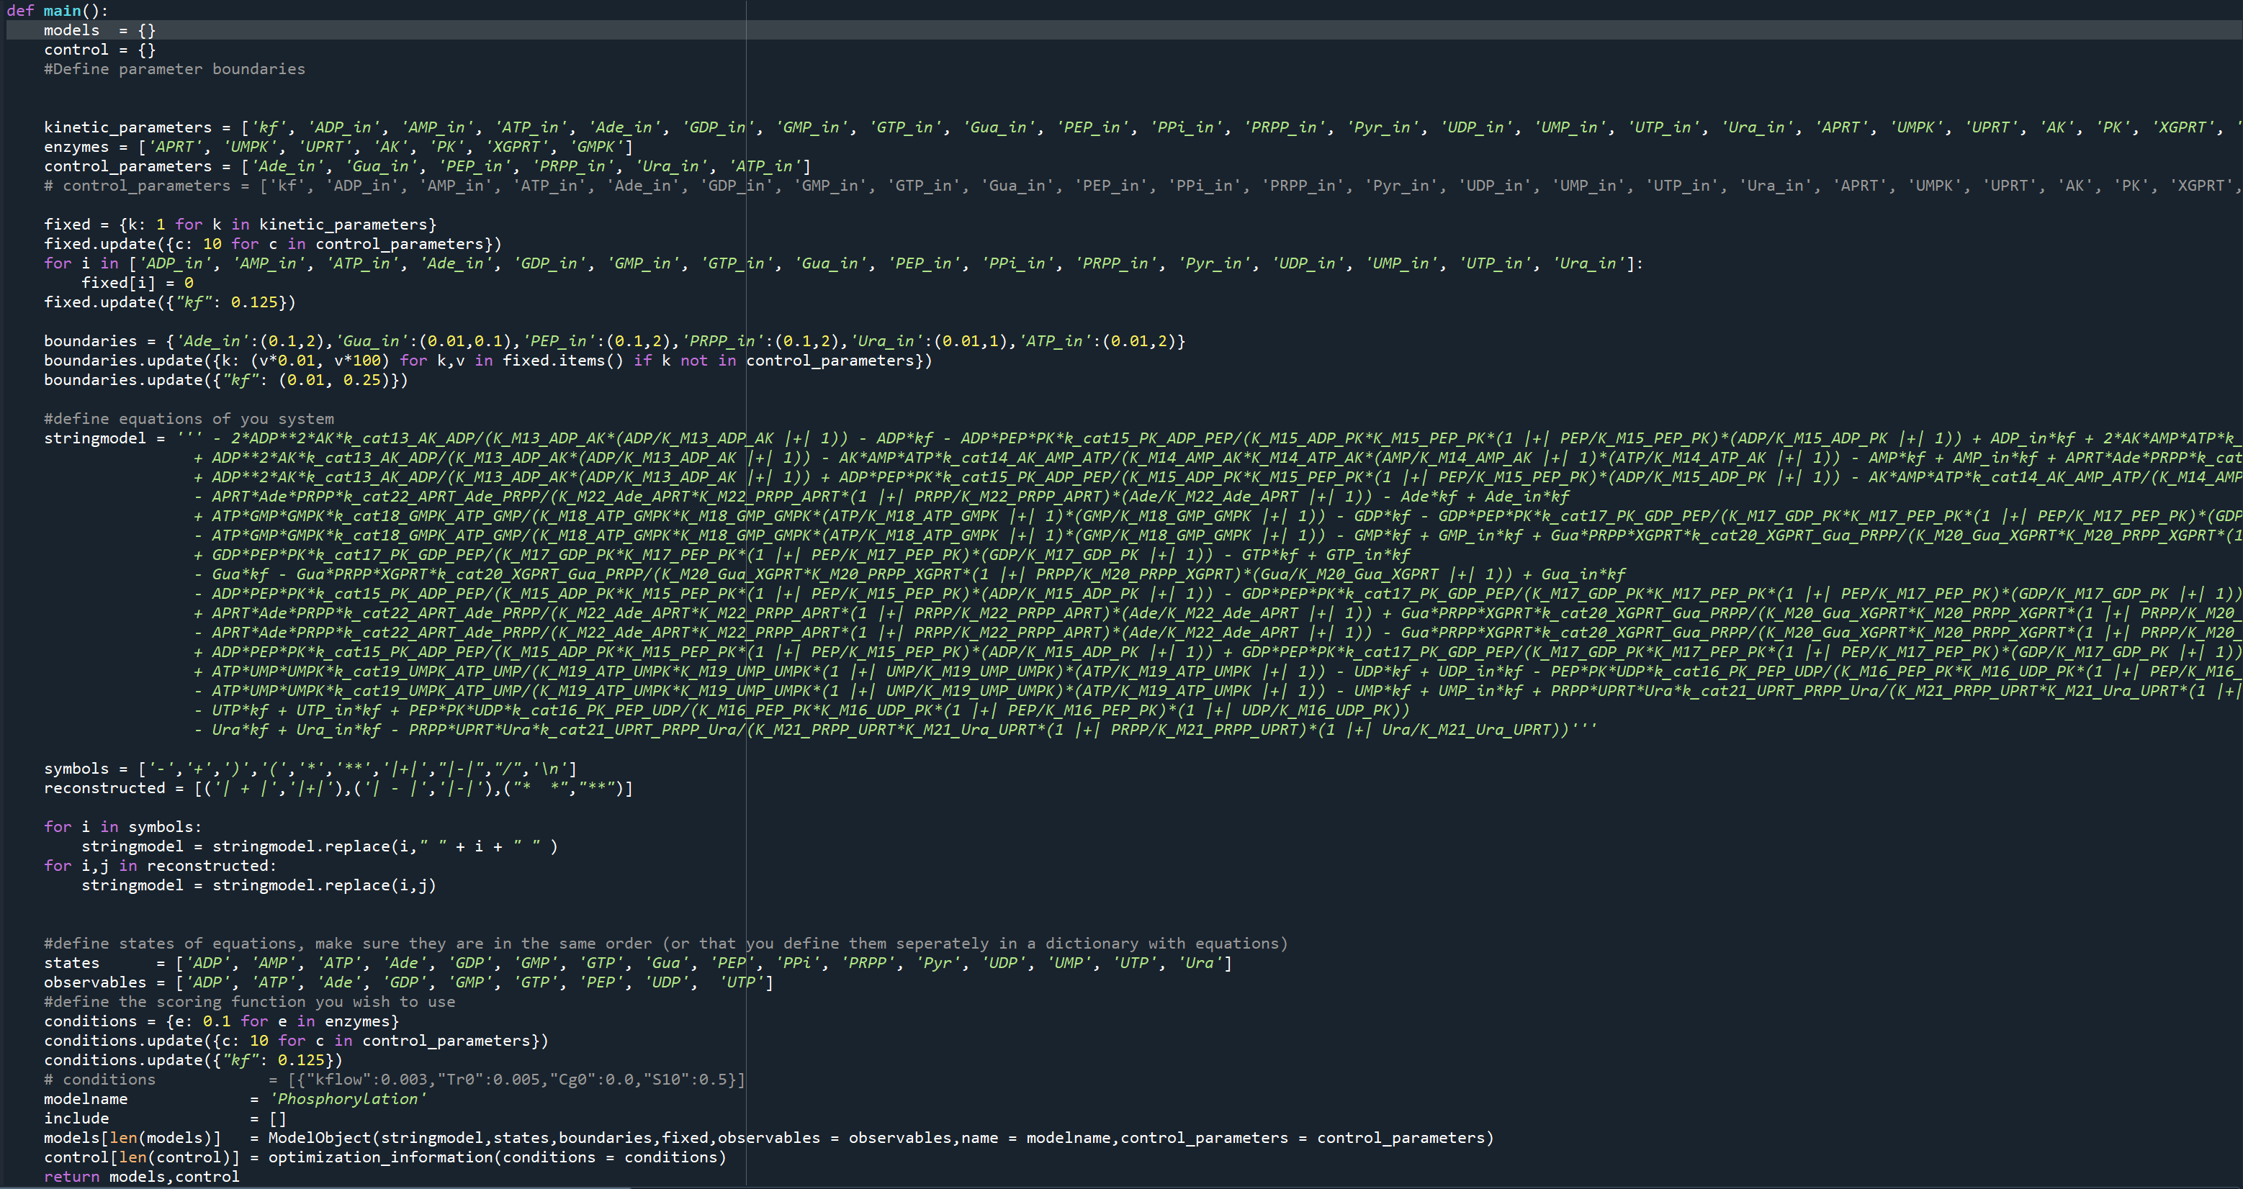
Fig. S1. The input file that the software uses.
There is a full description of the software available at github.com/huck/OED. We uploaded to command file needed to design experiments and the format for the model where it is possible to define a model, the parameters, the control parameters and the observables. The model text for the model itself was automatically generated to prevent typos using and can be found at github.com/huckgroup/OED. This SI tutorial was partially adapted from Sluijs et al. work.³

1.2 Model and Optimal Experimental Design
The model is parsed can be defined as a string and written out in full, after which it is converted into matrix format to obtain a stoichiometric matrix and a flux vector according to
$$\frac{dX}{dt}=Sv(X)$$ | (1)
Where $S ≜ (P-R)^{T}$ is the stoichiometry matrix of the system with products P and reactants R and $v(X)$ the kinetic equations in the flux vector. These vectors are subsequently used to create an Antimony file (human readable version of SBML). Antimony makes use of reaction equations and fluxes. The antimony file is converted to an SBML file using LibSBML which in turn is compiled to C++ using AMICI modified from ref 3. To model our reaction pathway, we utilize reversible bi-bi reaction which convert input substrate to a final product according to:
$$V=\frac{\left[S1\right]*\left[S2\right]*[Enzyme ]*k_{cat}}{Km_{1}*Km_{2}*(1+\frac{\left[S1\right]}{Km_{1}})*(1+\frac{[S2]}{Km_{2}})}$$ | (2)

Where [S1] and [S2] are the substrate concentrations, [enzyme] the concentration of beads multiplied by their activity (S3), $k_{cat}$ the catalysis rate of the enzymes. The full model can be found in the additional data 1. The ODE model can be extended to include the parameter sensitivities of the within the model with respect to the observables, these sensitivities map onto the contribution a specific parameter has to the observed rate of change in a species. This can be achieved by differentiating the ODE equations of the species that can be observed with respect to all the parameters according to

$$\frac{d}{dt}\frac{∂x}{∂p_{i}}= \frac{∂f\left(x,u,p\right) }{∂x}\frac{∂x}{∂p_{i}}+\frac{∂f\left(x,u,p\right) }{∂p_{i}} for i=1,…,N_{p}$$ | (3)

Where $\frac{∂f\left(x,u,p\right) }{∂x}$ is the Jacobian, $\frac{∂x}{∂p_{i}}$ the sensitivity coefficients and $\frac{∂f\left(x,u,p\right) }{∂p_{i}}$ the parameter sensitivities (don’t forget the chain rule). Thus, for each species we obtain $N_{p}$ additional ODE equations. The similarity of these sensitivities at specific times need to be quantified to that end we build the sensitivity matrix according to
$$S=\left[\begin{aligned}\begin{matrix}\frac{∂y_{j1}}{∂p_{1}}(t_{1}) & ⋯ & \frac{∂y_{j1}}{∂p_{N_{p}}}(t_{1}) \\ ⋮ & & ⋮ \\ \frac{∂y_{j1}}{∂p_{1}}(t_{N_{t}}) & ⋯ & \frac{∂y_{j1}}{∂p_{N_{p}}}(t_{N_{t}})\end{matrix} \\ \begin{matrix}\frac{∂y_{j2}}{∂p_{1}}\left(t_{1}\right) & ⋯ & \frac{∂y_{j2}}{∂p_{N_{p}}}\left(t_{1}\right) \\ ⋮ & & ⋮ \\ \frac{∂y_{j2}}{∂p_{1}}\left(t_{N_{t}}\right) & ⋯ & \frac{∂y_{j2}}{∂p_{N_{p}}}\left(t_{N_{t}}\right)\end{matrix}\end{aligned}\right]$$
Where $y$is are the subset of observable states x on the rows, $p$ the parameter along the columns and $t$the time point of the observation up to $t_{N_{t}}$ . Finally, $j$ Is the index corresponding to individual experiments (thus in each matrix columns we stack the sensitivities of a single parameter at specific times for different observables in different experiments, always in the same order). The Fisher matrix is subsequently computed according to
$$F= S^{T}S$$ | (4)
Most optimal design problems revolve the fisher information matrix (FIM). The data in the fisher information matrix maps onto the curvature of a parameter around its maximum likelihood.⁴ Noisy data, parameter insensitivities or covariance with other parameters equate to a flat curve (all values possible) representing less information. Since noisy data and parameter insensitivity are intrinsic to the experimental set-up and the observables are what they are, the only way to reduce the covariance between parameters is to optimize a sequence of control inputs and subsequently select the most informative input pattern. In this process we use the d-optimality criterion (determinant of F) taking the $max_{D}\left(F\right),$ or minimizing |F⁻¹|. A practical use case example of this is given in Sinkoe et al.⁴, or in here for a more general background information⁵.

1.3 Model Fit to OED Dataset
Fitting the model is a non-trivial problem since the experimental dataset is complex, consisting of multiple experiments where the state space is constantly perturbed by alternating values for the control parameters. Therefore we use our own flexible agent-based optimization algorithm modified from Sluijs et al³ and minimize the difference according to
$$S =\sum_{k=1}^{i}{\sum_{l=1}^{o}{\frac{\sum{( \left(N_{k,l}\right)-\left(M_{k,l}\right))^{2}}}{(\frac{\sum_{j=1}^{n}{M_{k,l}}}{n})}}*D}$$ | (5)

Where N is the experiment and M the corresponding simulation time course data vector, I the index of the experiment, o the observable and n the timepoint, D is the relative deviation (factor) between observed mean in the data and the simulated mean over time, Fig. S2 was modified from Sluijs et al ³. The fitting procedure consists of 2 steps:
- Monte Carlo Samling of Parameters (Latin hypercube, 500 initial samples), discard unfit ~80%
- Initial fit of OED experiments with MC samples as starting point (500 iterations)

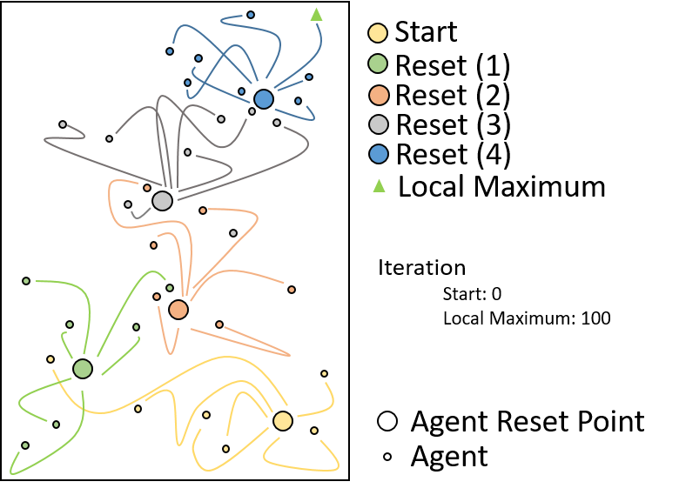
Fig. S2. Abstraction of the optimization algorithm (for OED and parameter fitting). Agents (representing parameter sets) are initialized and are mutated for 20 iterations, if a mutation is better the agent moves across the landscape (mutation can be recombination with another agent or modifying single parameter value a single index or multiple indices between its lower and upper bound), the fittest agent is subsequently selected and the other agents are re-initialized around that agent (called a reset). This mutation and reset process is repeated until the algorithm converges to a local maximum defined as the inverse of equation 5.
The parameter space for a single parameter is created by building a (uniform)logarithmically spaced vector $V$with $n$ the size of the vector (100). The individual parameters $V_{i}=$ $10^{θ_{i}}$where $θ_{i}$ is sampled from a uniformly distributed vector $θ$ defined by
$θ =\{r:r ∃i ϵ N such that r= log_{10}\left(α\right)+\frac{log_{10}\left(β\right)}{n}i, \& r ϵ \left[log_{10}\left(α\right),log_{10}\left(β\right)\right)\}\}$
where α and β, the respective upper and lower bound of a parameter. This means that agents move across the fitness landscape by mutating the index (up or down) within the parameter vector (agents communicate/recombine with each other by passing on these indices). The sensitivity of the parameters with respect to the likelihood can generally be given by
$$\frac{dL\left(Y:p\right)}{dp}= \sum_{i=1}^{n}{\left(y\left(t_{i}\right)-x\left(t_{i},p\right)\right) * x_{p}(}t_{i },p)$$ | (6)

Where y is the experimental data, x the simulated equivalent, and $x_{p}$ the vector with parameter sensitivities from equation (3). It can be used to calculate the gradient along which a parameter needs to be mutated to converge.
We plot the distributions in figure 4 as if we sample from the likelihood. We fit the parameters to the dataset >1000 times, not all of these optimizations converge to the same optimum (they can get stuck local optima). For the distribution plots we sample the fittest parameter set and all those whose fit score deveate 15% from that set assuming that they are ‘equally good’ as we have technical noise, Note, we ensure we have atleast 50 samples. This -roughly- maps onto the likelihood of the parameters, assuming that the additional constraints imposed on the parameters by the data that the upper and lower extremes of the potential parameter values shrinks and/or the potential combinations. In Fig. S3 the convergence score is ranked from best to worst.
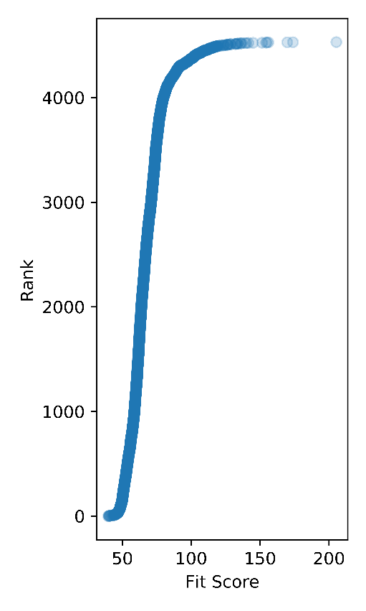
Fig. S3. the figure shows the scores of fits to the model, the parameter sets in figure 4 of the main text consists of those that deviate less than 15% from the best score.

1.4 Flow Device and Control Parameter Inputs
The inflow rate of controlled substrates is modelled by accounting for the inflow rate of a specific syringe into the CSTR reactor and the concentration of the input substrate in that syringe proportional to the volume of the reactor, according to:
$$\left[C_{ss}\right]= \left[S_{j}\right]*\frac{{Kf}_{in,I}}{kf}$$ | (7)

Where ${Kf}_{in,I}$is the flowrate of a specific syringe that flows into the reactor of a given species $\left[S_{j}\right]$ is the stock concentration of the substrate and F is the fraction ${Kf}_{in,I}$ contributes to the total flowrate $Kf$. The total flow rate (flow out of the reactor) that applies to all species is defined as: the sum of all ${Kf}_{in,I}$.
$kf=$ $\frac{\sum_{i=1}^{i}{{Kf}_{in,I}}}{volume}$ | (8)
To prevent backflow a minimal inflow of 6.75 uL/hour for an individual syringe, the volume of the reactor is 100 uL, and we have 6 input syringes. Thus, the minimal flow rate in the device is 40.5 uL/hour, for reference, a total flow rate of 100 uL/h translates to a $kf$parameter of 1/hour i.e. This flow rate is equivalent to the replacement of a single reactor volume. Assuming a maximum total flow rate of 10 reactor volumes per hour, the controlled concentration range which can flow into the reactor spans > 2 orders of magnitude.
For the optimal experimental design component of the optimization cycle described in the paper, convergence to a global optimum where the best $max_{D}\left(F\right)$cannot be guaranteed the fittest inflow pattern from an optimized set of input patterns (20) is chosen. This profile is translated to a command file including the length of the control input and the flow rate for the syringe and is automatically loaded into the pump profile program which controls the syringe pumps.

1.5 Effect of Different Flow Rates on Product Formation
By varying the total flow rate, we can control conversion, favouring monophosphates (fast flow rates), diphosphates (medium flow rates), triphosphates (low flow rates). We cannot alter these flowrates drastically within short time frames as this introduces additional extrinsic noise both within the reactor and when the samples are collected from the CSTR. Thus, we opted to introduce three total flowrates wherein we vary the substrate concentrations. The effect on the conversion of the input can be seen in figure S4. It shows the mean and distribution of the monophosphates and input bases, the diphosphates and triphosphates. This is a rough representation, but it shows that see a transition from monophosphates to triphosphates can be observed as the flow rate is decreased, this increases the information within the experiment as Baltussen et al.² has shown. Intuitively, knowing that there is a total flow rate wherein a substrate is not converted means there is a limit to the speed an enzyme can convert it e.g. between 150-300 ul/h all the nucleobases are converted, this means we do not know how fast enzymes have converted the substrates only that occurred faster than dilution. Conversely at 600 ul/h, nucleobases are still present, this means conversion is slower than dilution.
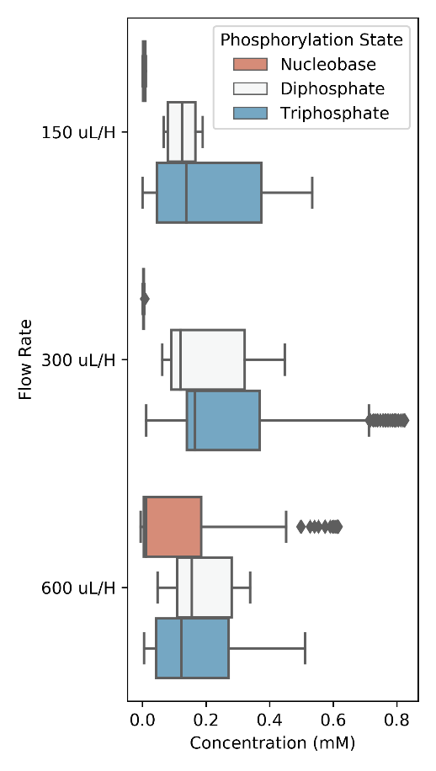
Fig. S4. shows the phosphorylation level of the nucleobases for different flow rates. The data is sampled by taking all datapoints across a 100-minute time window for each flow rate from the final iteration (shown in Fig. S11).

1.6 Predictive Power of Model
In this section we investigate the effect of different dataset compositions on the final prediction shown in Fig. 5 of the main text. We also investigate the effect of further coarse graining the model on the same.

1.6.1 Effect of Dataset Size on Prediction Error and Prediction Variance
Fig. S5 shows the effect of adding experiments to the dataset on the certainty of the prediction. For each addition to the dataset the predictions (shaded area) improve. Interestingly for conditions where ATP is in excess fewer iterations are needed for a model to predict accurately this indicates there are conditions on the kinetic landscape that can be mapped with more ease than others.
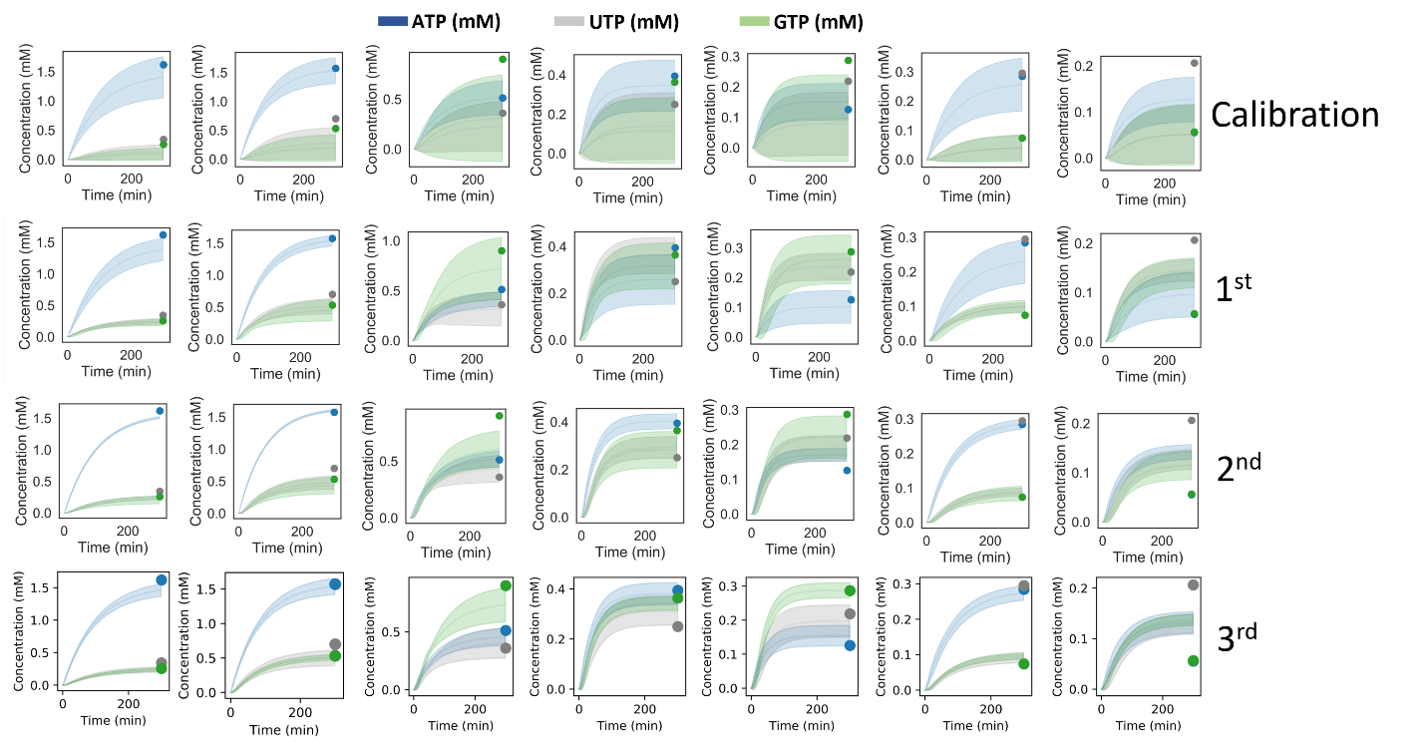
Fig. S5. shows the prediction of the final blends for each version of the dataset/iteration of the cycle from the calibration to the final experiment. As more data is added each iteration (number on the right) we reduce uncertainty around the predicted yield (shaded area). The y-axis shows the concentration in mM, the x-axis the time in minutes. The concentrations of ATP (blue), UTP (grey) and GTP (green) are shown.

1.6.2 Further Coarse Graining Reduces Predictive Power.
Fig. S6 is similar to Fig. S5, instead of different datasets however, the predictions are made using different models, all models are fit using the entire dataset (all iterations). On the first row the model assumes the conversion of diphosphates to triphosphates (PK) is an irreversible reaction. The model prediction on the second row assumes that the conversion of monophosphates to diphosphates is irreversible. It is known in literature that the pyrimidine salvage pathway can operate in the opposite direction in the right conditions (and can play a role in disease pathology).^{6,7} We did not know of the conditions in the reactor or the hybridization of enzymes to beads might interfere with the qualitative function of the pathway. The fact that neither models can predict new outcomes without a lot of uncertainty and we observe larger prediction errors especially when we assume PK is irreversible, (Fig. S6) even though it is trained on the same data indicates that reverse reactions are indeed, occurring. It shows why it is important to strike a balance between assumed mechanistic detail, identifiability and predictive power.
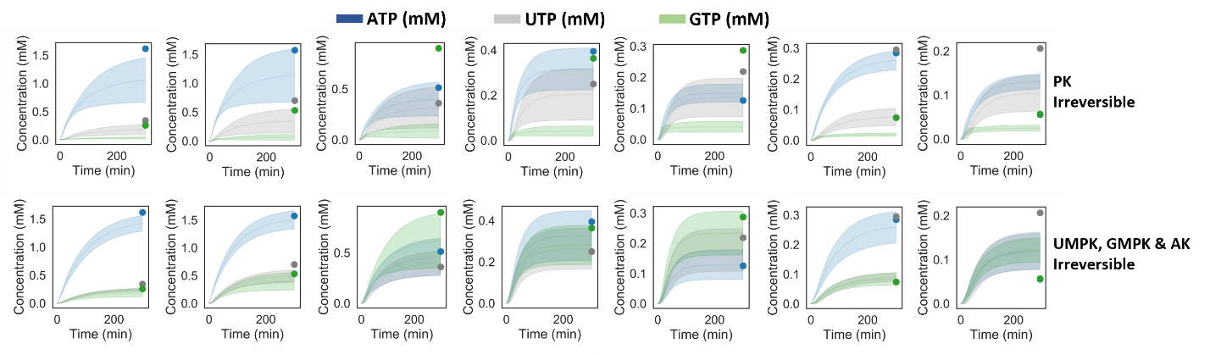
Fig. S6 shows the prediction of the final different model trained on the full dataset. None of these models appear to have any predictive power (even though they fit the data) indicating that they are biased towards the data and do not map onto actual processes well. The y-axis shows the concentration in mM, the x-axis the time in minutes. The concentrations of ATP (blue), UTP (grey) and GTP (are shown).
Fig. S7 summarized these and previous data, it shows the improvement of the final prediction versus the amount of data added or using a different model with the full dataset (3rd). Each condition was simulated using the fittest parameter sets and the deviation from the observed experimental yield was averaged, this was done for 1st, 2nd and 3rd iteration of the model. Each cycle the error around the prediction decreased -on average- ~35%.
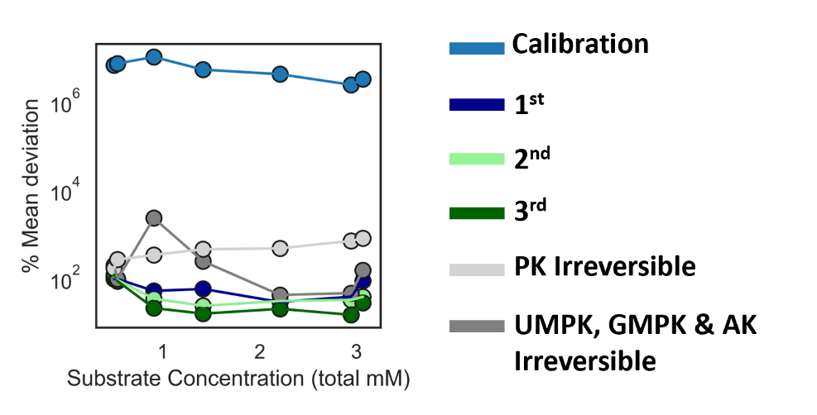
Fig. S7. The figure shows the mean deviation of the prediction from the mean for different version of the model (trained on different dataset). It includes the full model trained on just the calibration data and each subsequent iteration of the optimization cycle. It also includes (grey lines) predictions of 2 coarse grained models (PK or UMPK, GMPK and AK are deemed irreversible) trained on the full dataset.

Experimental Data

2.1 Ion Pair HPLC Data
A total of three iterations of the optimization cycle were performed, the enzymes are fixed to the microfluidic device, each experiment has a unique enzyme concentration, we quantify their relative units (i.e. how many beads are used). First, we needed to establish the compounds were detected by ion-pair reversed-phase HPLC. Fig. S7 shows 8 peaks were separated. We note that detecting phosphates is challenging and refer to the work from Nakajima et al., as we found this method worked best.⁸
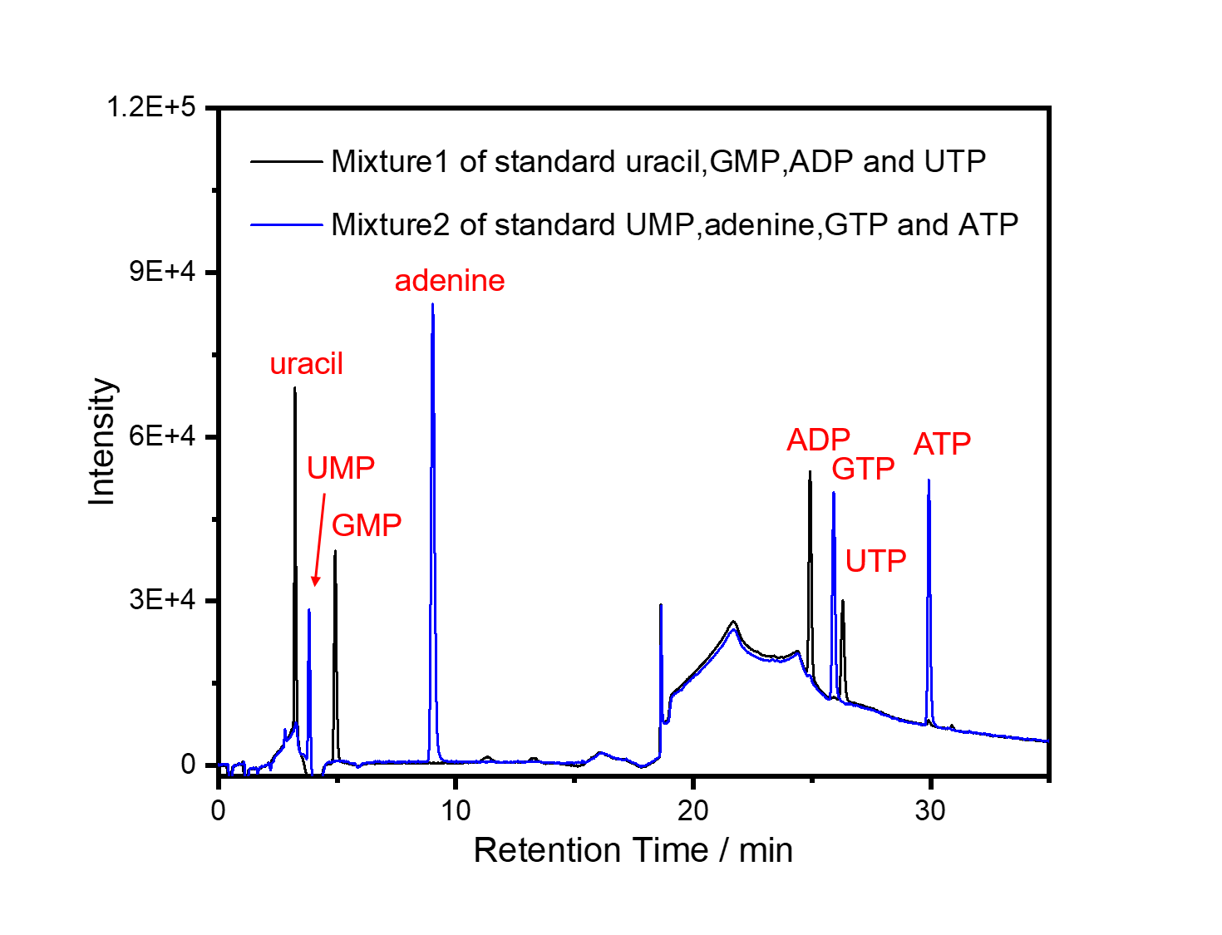
Fig. S8. Separation of eight standard nucleotides by ion-pair reversed-phase HPLC. Mixture1: 100 uM each of uracil, GMP, ADP and UTP; Mixture2: 100 uM each of UMP, adenine, GTP and ATP. Injection volume: 1 ul. Detection: 254 nm. See the detailed elution method in method part.

2.2 Flow Experiment Data
The first experiment was subsequently designed manually (calibration) and is largely utilized to probe the boundaries of the system specifically: for which range of input concentrations can conversion be observed and can differentiate between causes when nothing is observed i.e., determining whether this due to unfavourable kinetics or because the limits of detection reached (we know the enzymes work as for each we performed an activity assay in Section 3.3). The results are shown in Fig. S9. In the first iteration of the optimization cycle, we maintain a constant total flow, changing the individual flow rates of the input substrates within these bounds (Fig. S10), the latter 2 iterations in the cycle make use of a dynamic flow profile where the total flow transitions between 4 states (Fig. S11 and Fig. S12).
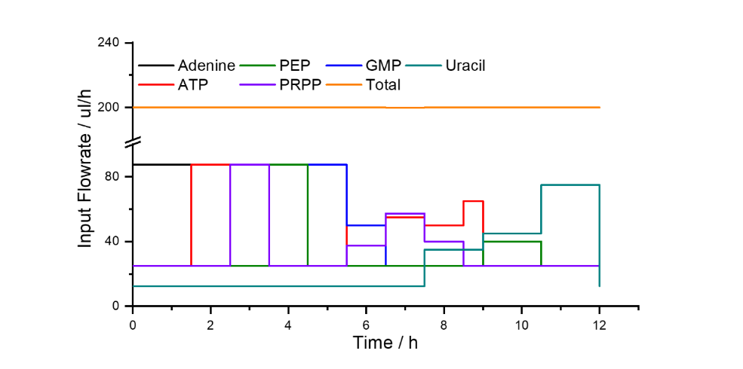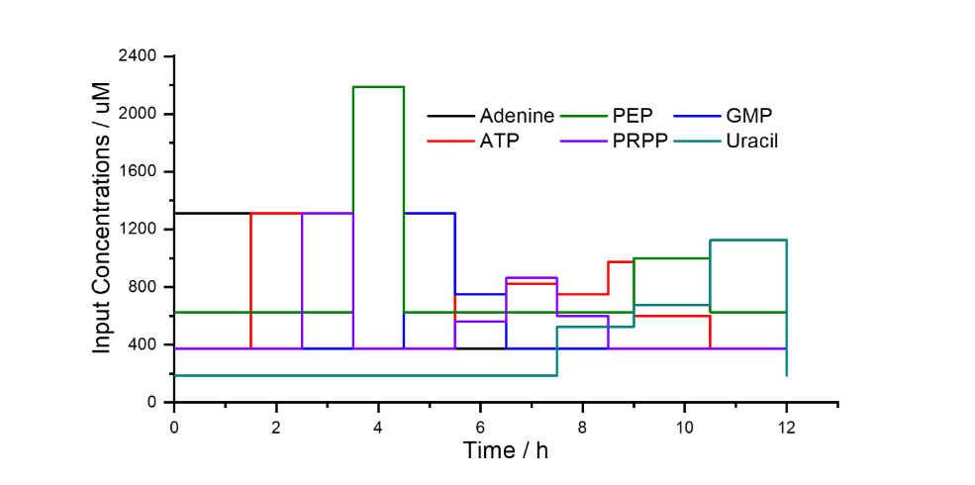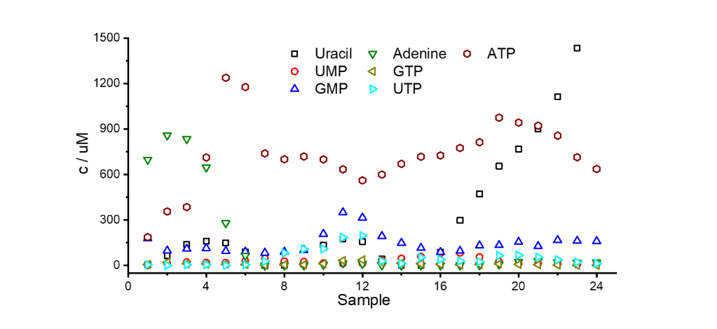
a
b
c
Fig. S9. a) shows input concentrations into the reactor over time for the calibration experiment, b) shows the inflow rate of each syringe over time (and the total flow rate), c) shows the concentrations as measured with the ion-pair HPLC in uM. The relative enzyme concentrations defined as ul of beads are AK: 2 ul, PK: 20 ul, UMPK: 15 ul, APRT: 2 ul, GMPK: 5 ul, UPRT: 15 ul.

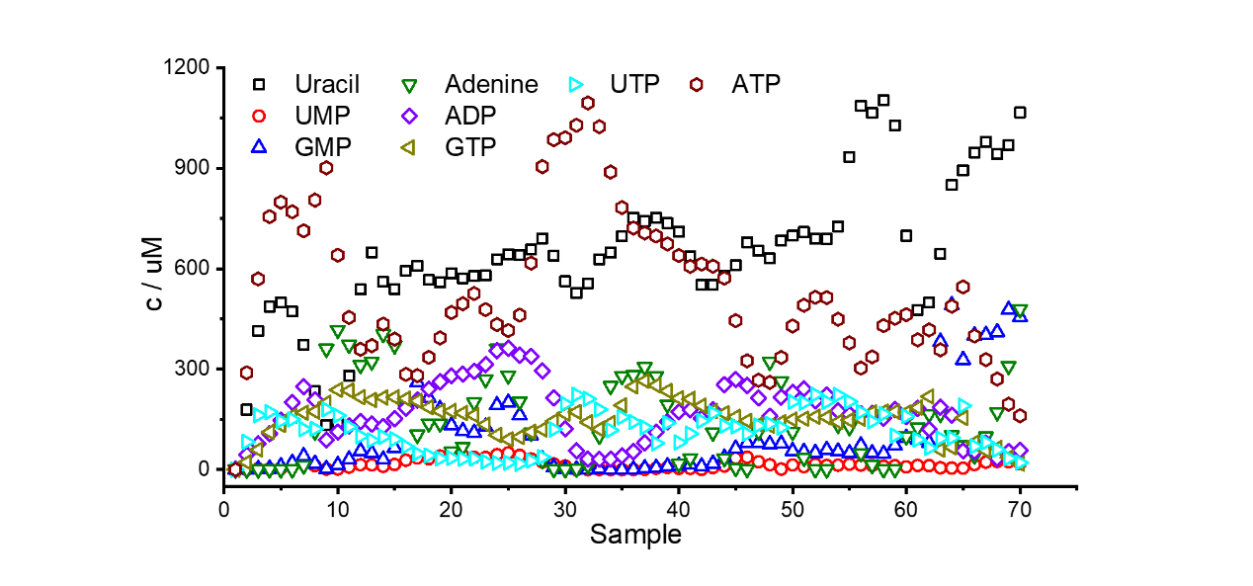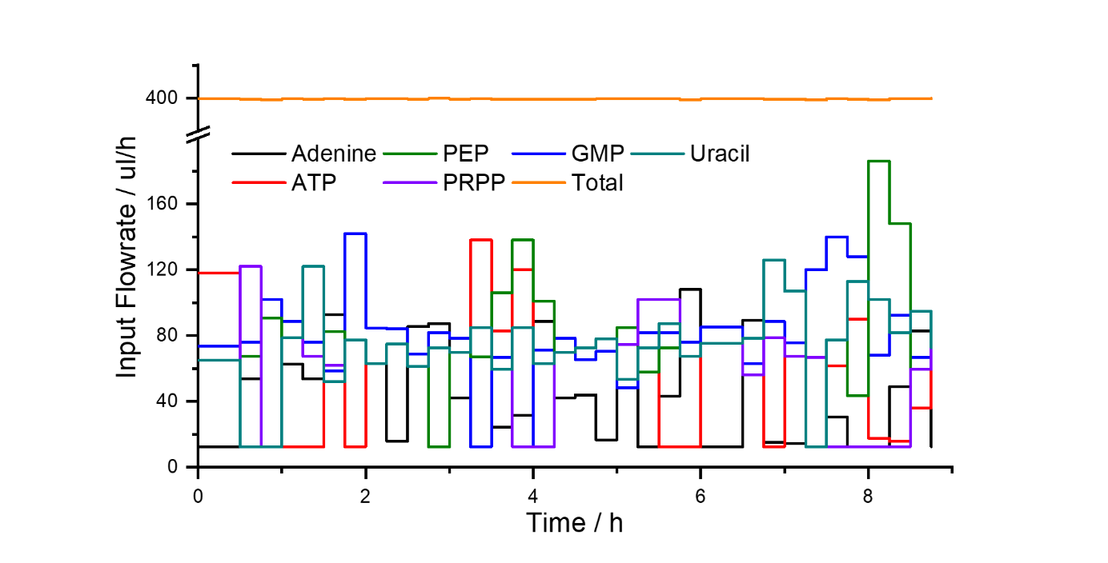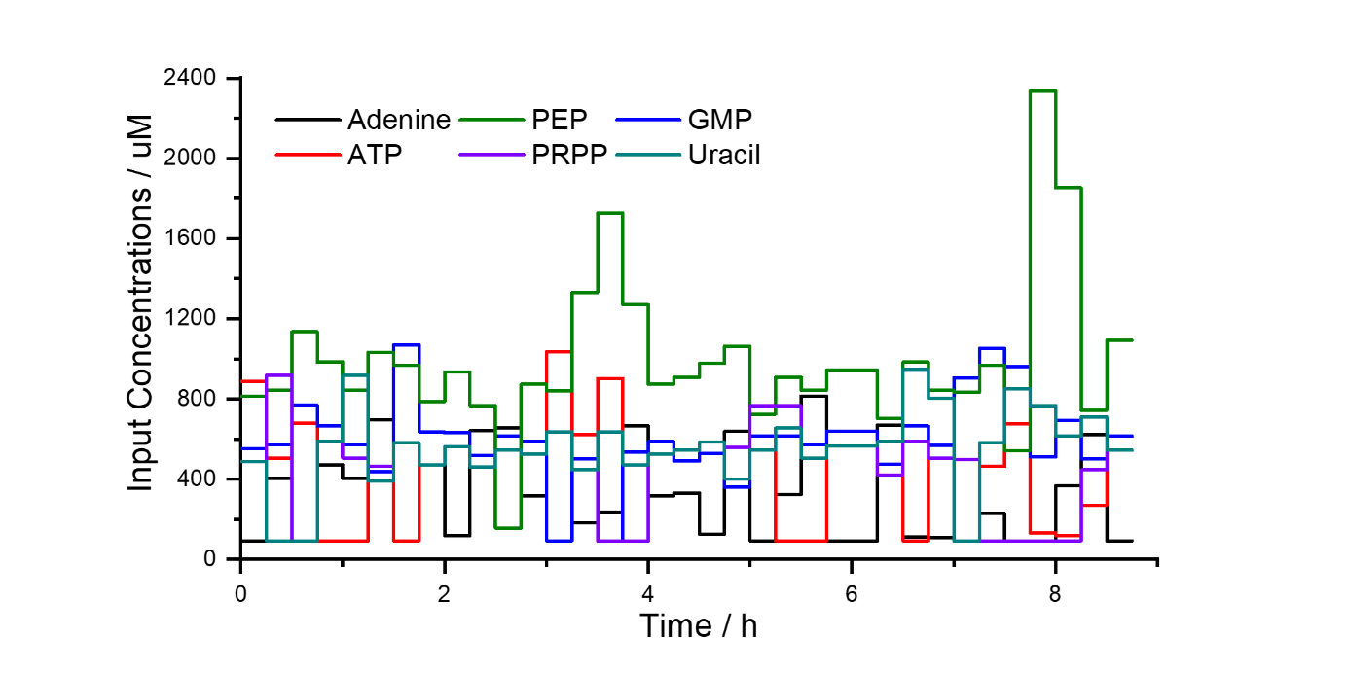
a
b
c
Fig. S10. a) shows input concentrations into the reactor over time for the first flow experiment, with constant flow, b) shows the inflow rate of each syringe over time (and the total flow rate), c) shows the concentrations as measured with the ion-pair HPLC in uM. The relative enzyme concentrations are AK: 2 ul, PK: 20 ul, UMPK: 15 ul, APRT: 2 ul, GMPK: 5 ul, UPRT: 15 ul.
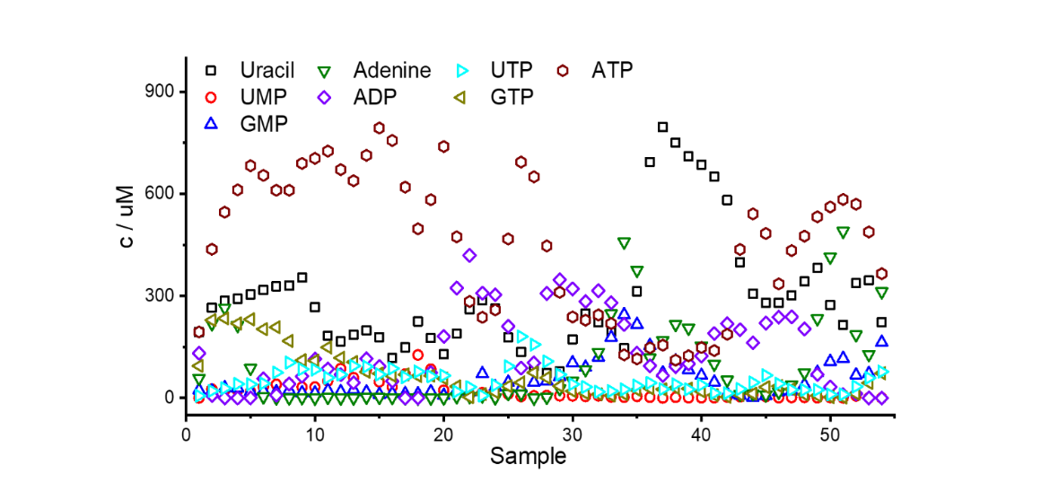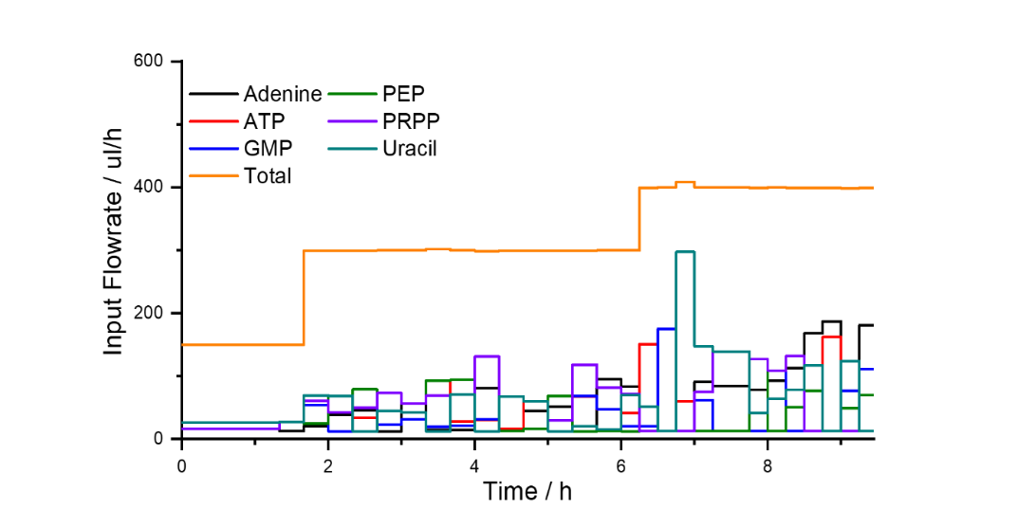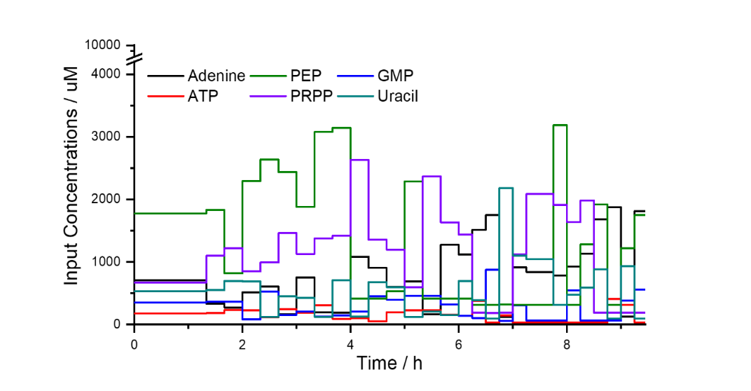
a
b
c
Fig. S11. a) shows input concentrations into the reactor over time for the second flow experiment with a dynamic 3 tier flow profile. b) shows the inflow rate of each syringe over time (and the total flow rate), c) shows the concentrations as measured with the ion-pair HPLC in uM. The relative enzyme concentrations are AK: 4 ul, PK: 38 ul, UMPK: 8 ul, APRT: 5ul, GMPK: 3 ul, UPRT: 13 ul.

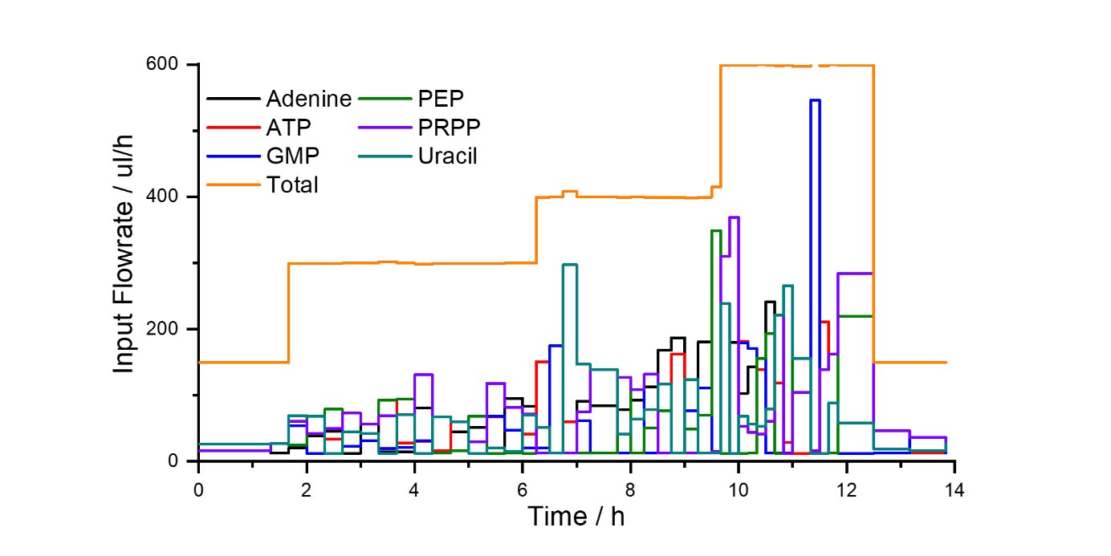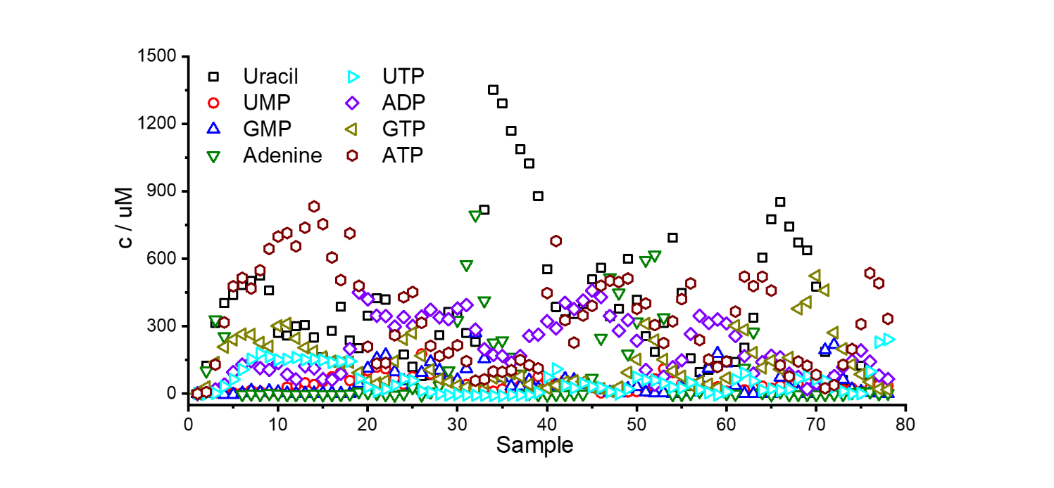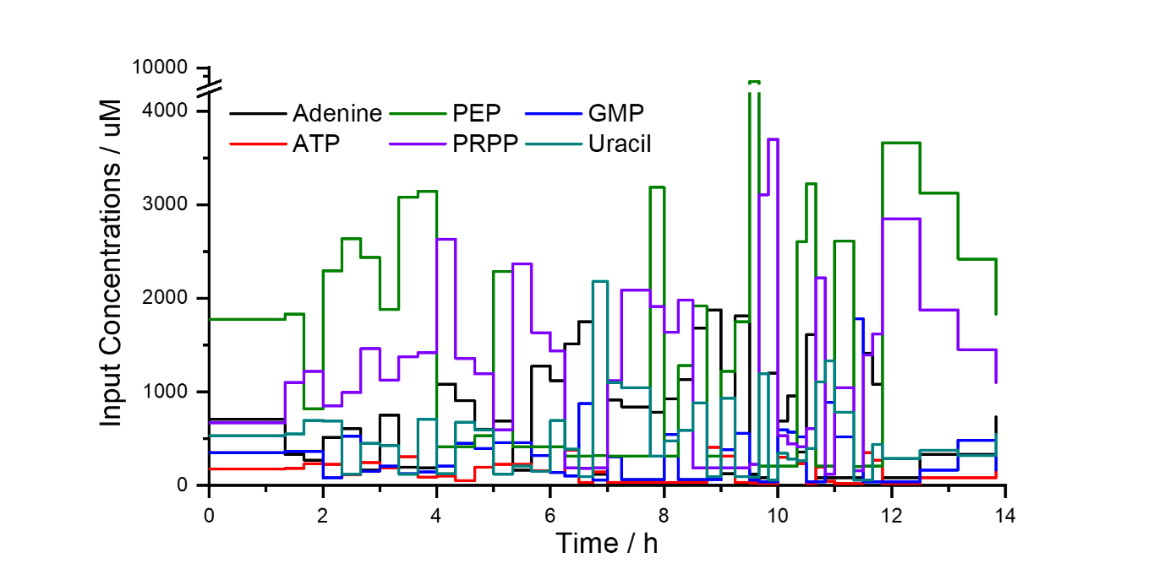
c
b
a
Fig. S12. a) shows input concentrations into the reactor over time for the first flow experiment, with a dynamic 4 tier flow profile. b) shows the inflow rate of each syringe over time (and the total flow rate), c) shows the concentrations as measured with the ion-pair HPLC in uM. The relative enzyme concentrations are AK: 1.5 ul, PK: 20 ul, UMPK: 40 ul, APRT: 2.5 ul, GMPK: 10 ul, UPRT: 6 ul.

Enzyme Purification and Validation of Enzyme Activity

3.1 Enzymes: Source and Availability
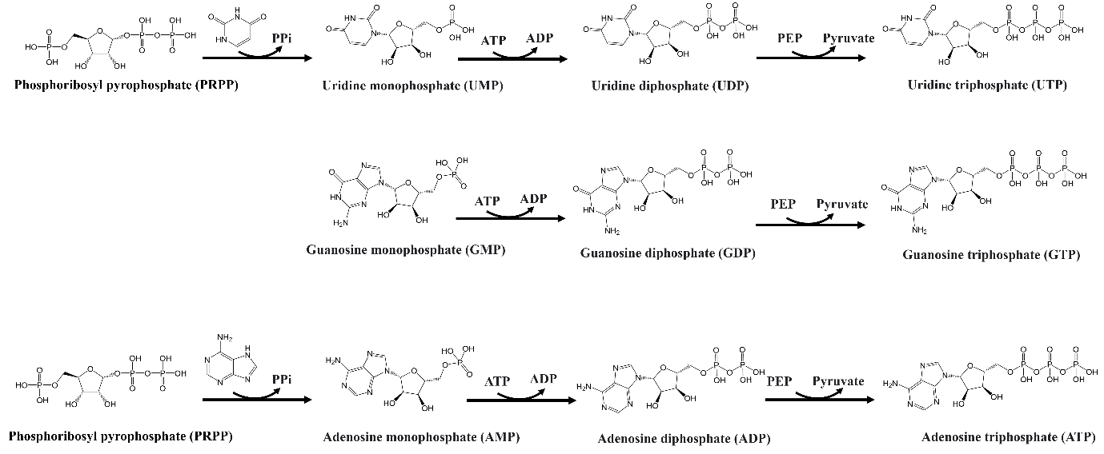
Fig. S13. Detailed overview of the nucleotide salvage module with the molecular structures of the substrates and reaction products; PEP, phosphoenolpyruvic acid.
Some enzymes (figure S13) were cloned into and purified from e.coli, others were purchased from Sigma (Table S1). This part of the SI contains protocols for the purification process and the characterization of enzyme activity after coupling them to beads to assess if they still function. Note that we quantify the activity of the beads and can account for their concentration, not individual enzymes. Thus, in the model we use relative concentrations, choosing to set the calibration experiment as a reference.

Table S1. Overview of the enzymes used in the pyrimidine salvage pathway
Enzyme | Availability | EC | Source | Abbreviation | Reaction
Adenine phosphoribosyl transferase | Purified | 2.4.2.7 | E. coli | APRT | PRPP + adenine = AMP + PPi
Adenylate kinase | Sigma | 2.7.4.3 | Rabbit muscle | AK | AMP + ATP = ADP + ADP
Guanylate kinase | Purified | 2.7.4.8 | E. coli | GMPK | GMP + ATP = ADP + GDP
Uridylate kinase | Purified | 2.7.4.22 | E. coli | UMPK | UMP + ATP = ADP + UDP
Uridine phosphoribosyl transferase | Purified | 2.4.2.9 | E. coli | UPRT | PRPP + uracil = UMP + PPi
Pyruvate kinase | Sigma | 2.7.1.40 | Rabbit muscle | PK | ADP + PEP = ATP + Pyruvate  GDP + PEP = GTP + Pyruvate  UDP + PEP = UTP + Pyruvate

3.2 Cloning, expression and purification

3.2.1 UMPK
The gene for UMPK was amplified from Escherichia coli K12 derived XL-1 blue competent cells using primers:
UMPK-Fw 5’GCATGACGTAGTACATATGGCTACCAATGCAAAACCCGTCTATAAACGC3’ UMPK-Rv 5’ACTGGTACGCCTCGAGTTATTCCGTGATTAAAGTCCCTTCTTTTTCACCC3’.
Sequences in bold and underlined indicate the restriction sites for subsequent cloning into a pET15b expression vector. The PCR mixture contained 1 µM of each primer, 0.2 mM dNTPs, 0.25 ul of competent E. coli cells and 2 U of Pfu DNA polymerase in its standard reaction buffer. Mixture was cycled for 25 times between 95°C (30s), 58°C (30s) and 72°C (2min). Agarose gel analysis of the reaction product showed a single band around 725 bp as expected. DNA was digested with NdeI and XhoI, purified over agarose gel using a Qiaquick gel extraction kit (Qiagen) and subsequently ligated into a dephosphorylated NdeI + XhoI digested pET15b vector introducing an N-terminal hexahistidine tag. Recombinant plasmids were checked on insert and subsequently transformed into E. coli BL21(DE3) for protein expression. Bacteria were cultivated in 1 liter of LB media at 30°C to OD600nm ~0.6 upon which protein expression was induced by adding IPTG to 0.5 mM. Cells were further cultivated overnight at 18°C and then harvested by centrifugation for 10 minutes at 5000 rpm in a Beckman JA-10 rotor. All subsequent steps were at 4°C unless otherwise noted. The pellet was resuspended in 40 mL buffer A (50 mM Na2B4O7.10H2O, 500 mM NaCl, 0.5 mM Na2-EDTA, 5 mM β-mercaptoethanol at pH 8.5) containing 20 mM imidazole, 20 µg/mL PMSF and 1 mg/mL lysozyme. The cell suspension was sonicated for 30 seconds at 17 micron amplitude for 6 times with pause intervals of 1 minute on ice. Lysate was centrifuged for 30 minutes at 17000 rpm in a Beckman JA25.50 rotor. Cleared supernatant was loaded onto a 5 mL Ni2+-sepharose HP column (GE Healthcare) that was pre-equilibrated in buffer A containing 20 mM imidazole. The column was washed with 25 ml of buffer A containing 50 mM imidazole and bound proteins were eluted with buffer A containing 500 mM imidazole and collected in fractions of ~1 mL. Fractions were analysed on SDS-PAGE and fractions containing solely UMPK (8 in total) were pooled and dialyzed in a 3.5 kDa MWCO dialysis tubing against 1 liter of 20 mM potassium phosphate buffer, pH 7.2, refreshing the dialysis buffer once. Enzyme isolate became opaque and was centrifuged for 1 minute at 14000 rpm in a table top centrifuge to remove any formed precipitate. Opaque supernatant was pipetted into a fresh tube and stored at 4°C.

3.2.2 GMPK
The gene for GMPK was amplified from Escherichia coli K12 derived XL-1 blue competent cells using primers:
GMPK-Fw 5’GCATGACGTAGTACATATGGCTCAAGGCACGCTTTATATTGTTTCTGCCC3’ GMPK-Rv 5’ACTGGTACGCCTCGAGTCAGTCTGCCAACAATTTGCTGATTAAAGCGTC3’.
Sequences in bold and underlined indicate the restriction sites for subsequent cloning into a pET15b expression vector. The PCR mixture contained 1 µM of each primer, 0.2 mM dNTPs, 0.25 ul of competent E. coli cells and 2 U of Pfu DNA polymerase in its standard reaction buffer. Mixture was cycled for 25 times between 95°C (30s), 60°C (30s) and 72°C (2min). Agarose gel analysis of the reaction product showed a single band around 725 bp as expected. DNA was digested with NdeI and XhoI, purified over agarose gel using a Qiaquick gel extraction kit (Qiagen) and subsequently ligated into a dephosphorylated NdeI + XhoI digested pET15b vector introducing an N-terminal hexahistidine tag. Recombinant plasmids were checked on insert and subsequently transformed into E. coli BL21(DE3) for protein expression. Bacteria were cultivated in 0.5 liter of LB media at 30°C to OD_{600nm} ~0.6 upon which protein expression was induced by adding IPTG to 0.5 mM. Cells were further cultivated overnight and then harvested by centrifugation for 10 minutes at 5000 rpm in a Beckman JA-10 rotor. All subsequent steps were at 4°C unless otherwise noted. The pellet was resuspended in 40 mL buffer A (100 mM potassium phosphate buffer at pH7.5, 300 mM NaCl, 1 mM Na₂-EDTA and 5 mM β-mercaptoethanol) containing 20 mM imidazole, 20 µg/mL PMSF and 1 mg/mL lysozyme. The cell suspension was sonicated for 30 seconds at 17 micron amplitude for 5 times with pause intervals of 1 minute on ice. Lysate was centrifuged for 45 minutes at 16000 rpm in a Beckman JA25.50 rotor. Cleared supernatant was loaded onto a 5 mL Ni²⁺-sepharose HP column (GE Healthcare) that was pre-equilibrated in buffer A containing 20 mM imidazole. The column was washed with 25 ml of buffer A containing 50 mM imidazole and bound proteins were eluted with buffer A containing 300 mM imidazole and collected in fractions of ~1.5 mL. Fractions were analysed on SDS-PAGE and fractions containing solely GMPK (5 in total) were pooled and dialyzed in a 3.5 kDa MWCO dialysis tubing against 1 liter of 20 mM potassium phosphate buffer, pH 7.2, refreshing the dialysis buffer once. Enzyme isolate was centrifuged for 1 minute at 14000 rpm in a table top centrifuge to remove any formed precipitate. Supernatant was pipetted into a fresh tube and stored at 4°C.

3.3 Characterization of Enzyme-beads

3.3.1 PK beads preparation
1 ml of assay mixture contains:
- IVTT Buffer - 0.2 mM NADH (prepare stock freshly)
- 1.5 mM PEP - 1.5 mM ADP - 2 U lactate dehydrogenase
- PK_beads: 6 ul

Calculate the activity of the PK_beads solution according to:
$$U=\frac{\left({OD}_{t2}-{OD}_{t1}\right)*1000*V_{reaction}}{\left(t2-t1\right)*6220*V_{enzyme}}$$
Where t is elapsed time in minutes, OD is the linear absorbance change over t2 - t1, $V_{enzyme}$ is the volume of enzyme solution added in μl and $V_{reaction}$is the reaction volume in ml, 6220 is the molar extinction coefficient of NADH in mol.l⁻¹cm⁻¹ at 340 nm and U is the number of units denoted as μmol ADP converted to ATP per minute per μl of enzyme solution (μmol.min⁻¹μl⁻¹). Figure S14 and S15 show the activity calculation and characterization respectively.

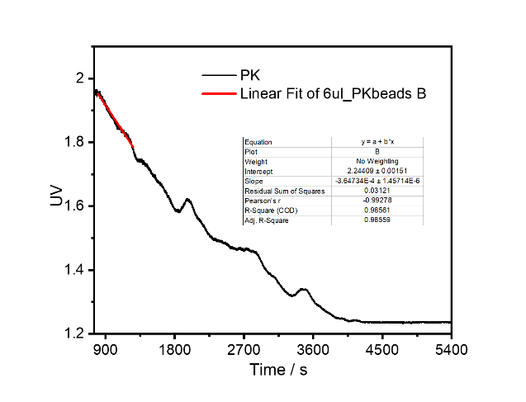
Fig. S14. progress curve of PK beads assay; The unit is calculated as 0.018 μmol per min per mg enzyme beads.

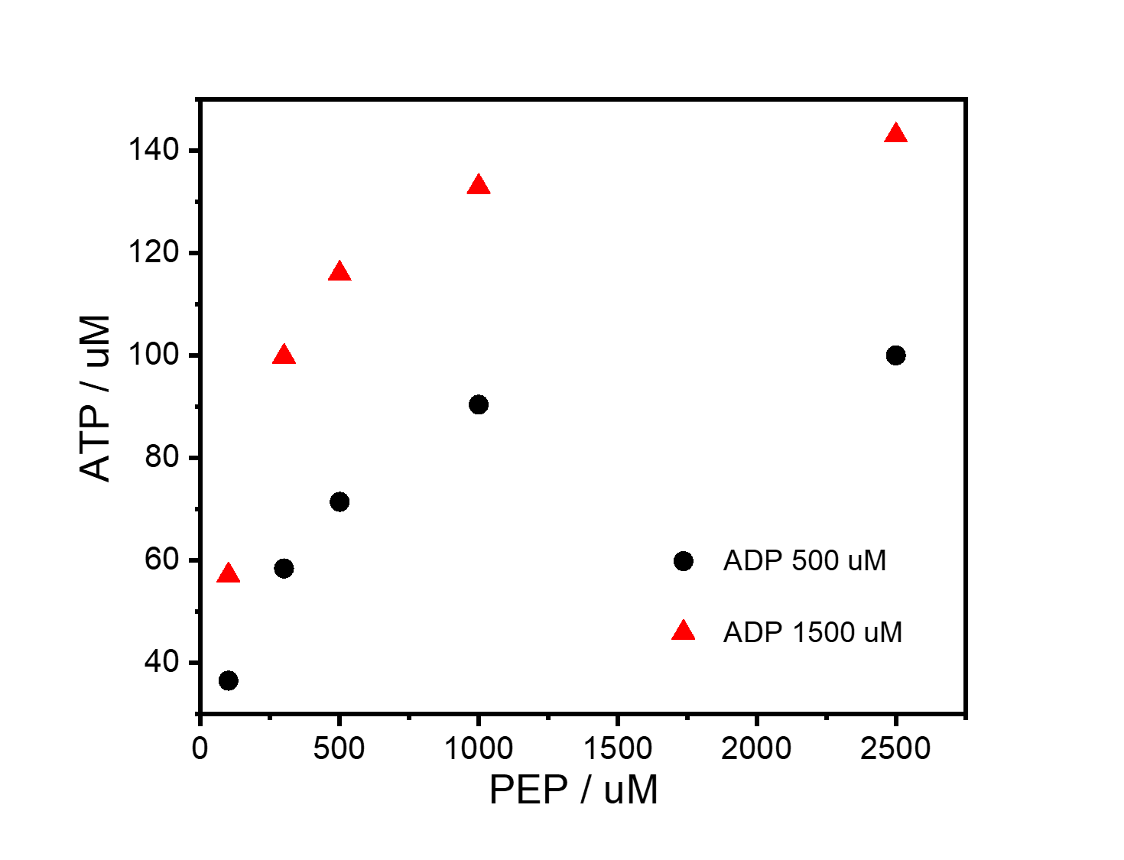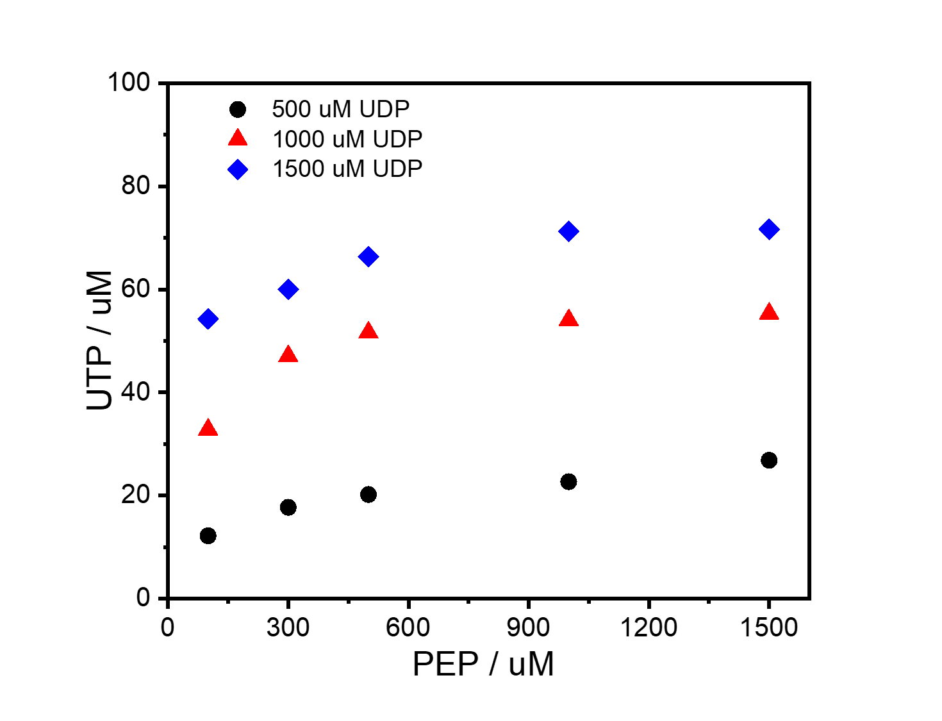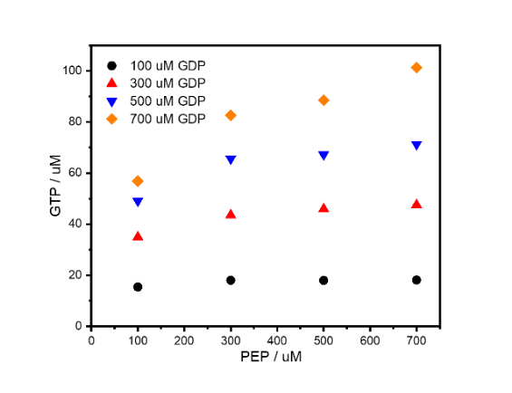
PK_beads: 2 ul Flowrate: 750 ul/h
ADP: 500, 1500 uM
PEP: 100, 300, 500, 1000, 2500 uM
PK_beads: 6 ul Flowrate: 750 ul/h
GDP: 100, 300, 500, 700 uM
PEP: 100, 300, 500, 700 uM
PK_beads: 6 ul Flowrate: 750 ul/h
UDP: 500, 1000, 1500 uM
PEP: 100, 300, 500, 1000, 1500 uM
Fig. S15. Activity Characterization of PK beads in flow at steady state. Enzyme PK remain active after immobilization.

3.3.2 AK bead preparation
1 ml of assay mixture contains:
IVTT Buffer
0.2 mM NADH (prepare stock freshly)
1.5 mM Phosphoenolpyruvate
1.5 mM AMP
3 mM ATP
2 U pyruvate kinase
2 U lactate dehydrogenase
6 ul AK_Beads

Calculate the activity of the AK beads solution according to:

$$U=\frac{\left({OD}_{t2}-{OD}_{t1}\right)*1000*{0.5*V}_{reaction}}{\left(t2-t1\right)*6220*V_{enzyme}}$$

Like to PK, t is elapsed time in minutes, OD is the linear absorbance change over t2 - t1, $V_{enzyme}$ is the volume of enzyme solution added in μl and $V_{reaction}$is the reaction volume in ml. Figure S16 and S17 show the activity calculation and characterization respectively.
.
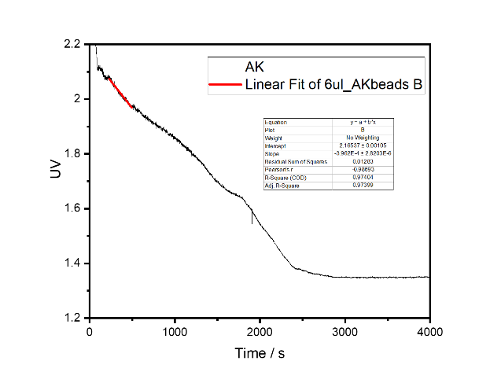
Fig. S16. progress curve of AK beads assay; The unit is calculated as 0.01 μmol per min per mg enzyme beads.

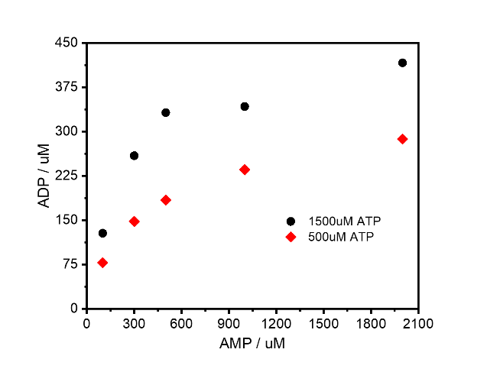
AK_beads: 4 ul Flowrate: 750 ul/h
ATP: 500, 1500 uM
PEP: 100, 300, 500, 1000, 2000 uM
Fig. S17. Activity characterization of AK beads in flow at steady state. Enzyme AK remain active after immobilization.

3.3.3 APRT beads preparation
1 ml of assay mixture contains:

- IVTT Buffer
- 0,2 mM NADH (prepare stock freshly)
- 1 mM Phosphoenolpyruvate
- 1,5 mM PRPP
- 1,5 mM Adenine hydrochloride
- 3 mM ATP
- 2 U lactate dehydrogenase
- 2 U pyruvate kinase
- 2 U adenylate kinase
- 8 ul APRT_beads

Calculate the activity of the APRT beads solution according to:

$$U=\frac{\left({OD}_{t2}-{OD}_{t1}\right)*1000*{0.5*V}_{reaction}}{\left(t2-t1\right)*6220*V_{enzyme}}$$

Like PK, t is elapsed time in minutes, OD is the linear absorbance change over t2 - t1, $V_{enzyme}$ is the volume of enzyme solution added in μl and $V_{reaction}$is the reaction volume in ml. Figure S18 and S19 show the activity calculation and characterization respectively.
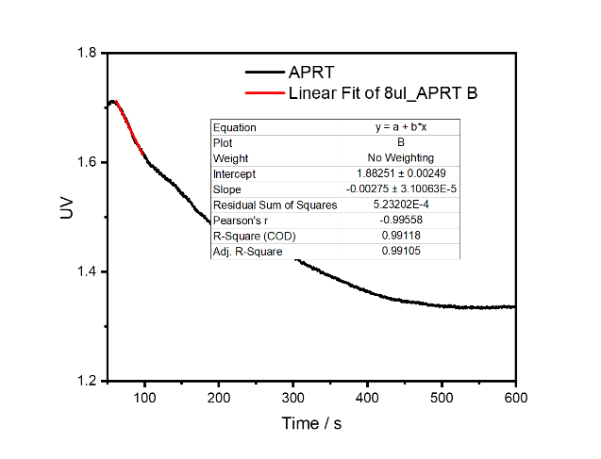

Fig. 18. progress curve of APRT beads assay; The unit is calculated as 0.051 μmol per min per mg enzyme beads.

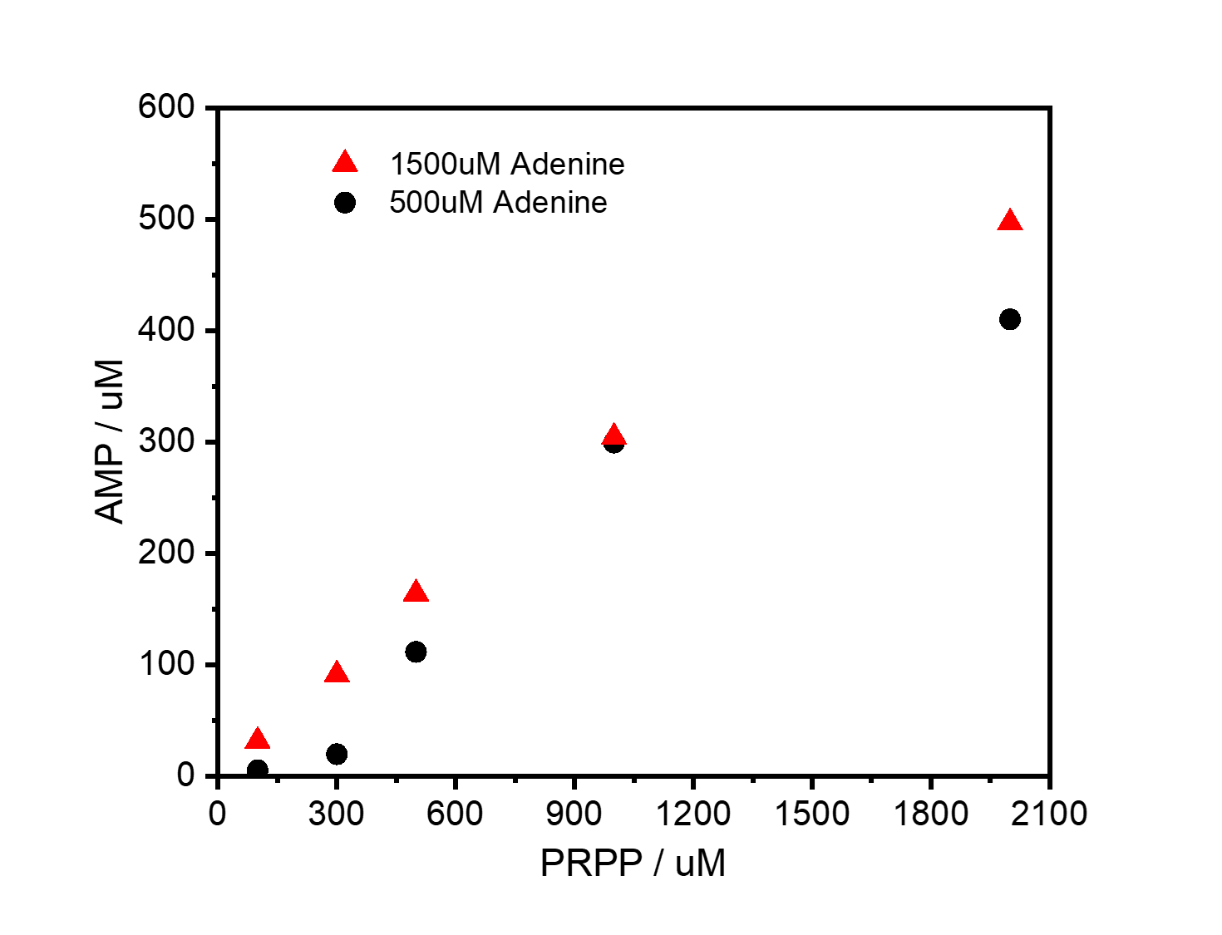
APRT_beads: 8 ul Flowrate: 750 ul/h
Adenine: 500, 1500 uM
PRPP: 100, 300, 500, 1000, 2000 uM
Fig. S19. Activity characterization of APRT beads in flow at steady state. Enzyme APRT remains active after immobilization.

3.3.4 UPRT beads preparation
IVTT buffer
1.5 mM PRPP
0.1 mM uracil
6 ul UPRT beads
Calculate the activity of the UPRT beads according to:
$$U=\frac{\left({OD}_{t2}-{OD}_{t1}\right)*1000*V_{reaction}}{\left(t2-t1\right)*2763*V_{enzyme}}$$
Where t = elapsed time in minutes, OD is the linear absorbance change over t₂ - t₁, V_{enzyme} is the volume of enzyme solution added in μl and V_{reaction} is the reaction volume in ml, ε is the molar extinction coefficient in mol⁻¹.l.cm⁻¹ 271 nm and U is the number of units denoted as μmol uracil coupled to PRPP per minute per μl of enzyme solution (μmol.min⁻¹μl⁻¹). The absorbance is 2763 instead of 6220. Figure S20 and S21 show the activity calculation and characterization respectively.
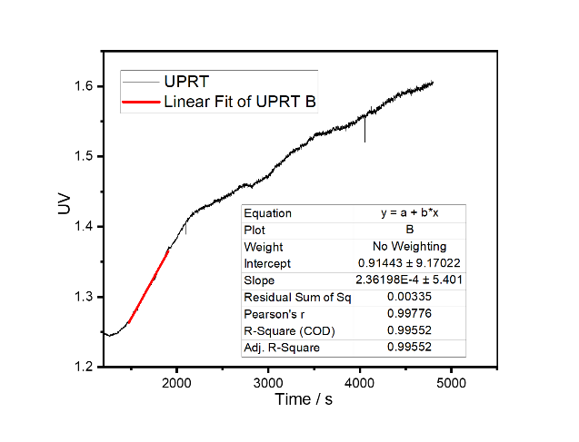
Fig. S20. progress curve of UPRT beads assay; The unit is calculated as 0.027 μmol per min per mg enzyme beads.

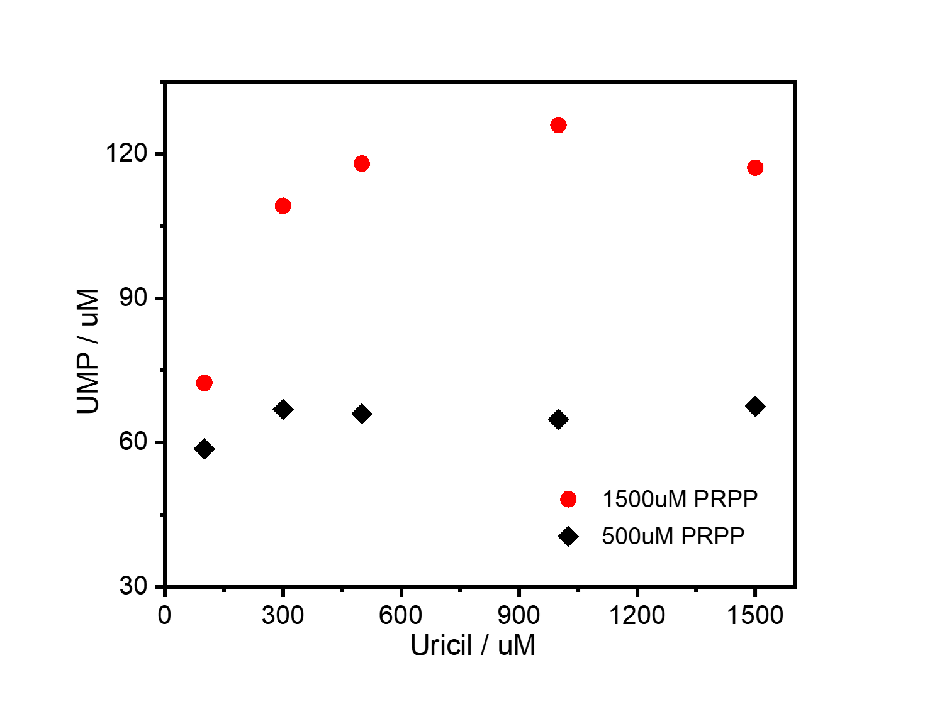
UPRT_beads: 8 ul Flowrate: 750 ul/h
PRPP: 500, 1500 uM
Uracil: 100, 300, 500, 1000, 1500 uM
Fig. S21. Activity characterization of UPRT beads in flow at steady state. Enzyme UPRT remains active after immobilization.

3.3.5 UMPK beads preparation
1 ml of assay mixture contains:

- IVTT Buffer
- 0,2 mM NADH (prepare stock freshly)
- 1.5 mM Phosphoenolpyruvate
- 1.5 mM UMP
- 3 mM ATP
- 2 U pyruvate kinase
- 2 U lactate dehydrogenase
5 ul UMPK_beads

Calculate the activity of the UMPK beads solution according to:

$$U=\frac{\left({OD}_{t2}-{OD}_{t1}\right)*1000*{0.5*V}_{reaction}}{\left(t2-t1\right)*6220*V_{enzyme}}$$
Where t = elapsed time in minutes, OD is the linear absorbance change over t₂ - t₁, V_{enzyme} is the volume of enzyme solution added in μl and V_{reaction} is the reaction volume in ml. Figure S22 and S23 show the activity calculation and characterization respectively.
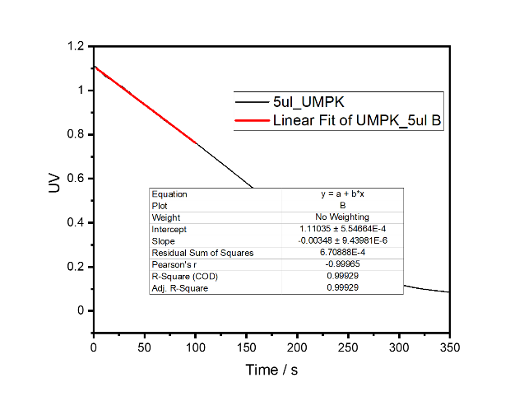.
Fig. S22. Progress curve of UMPK beads assay; The unit is calculated as 0.1 μmol per min per mg enzyme beads.

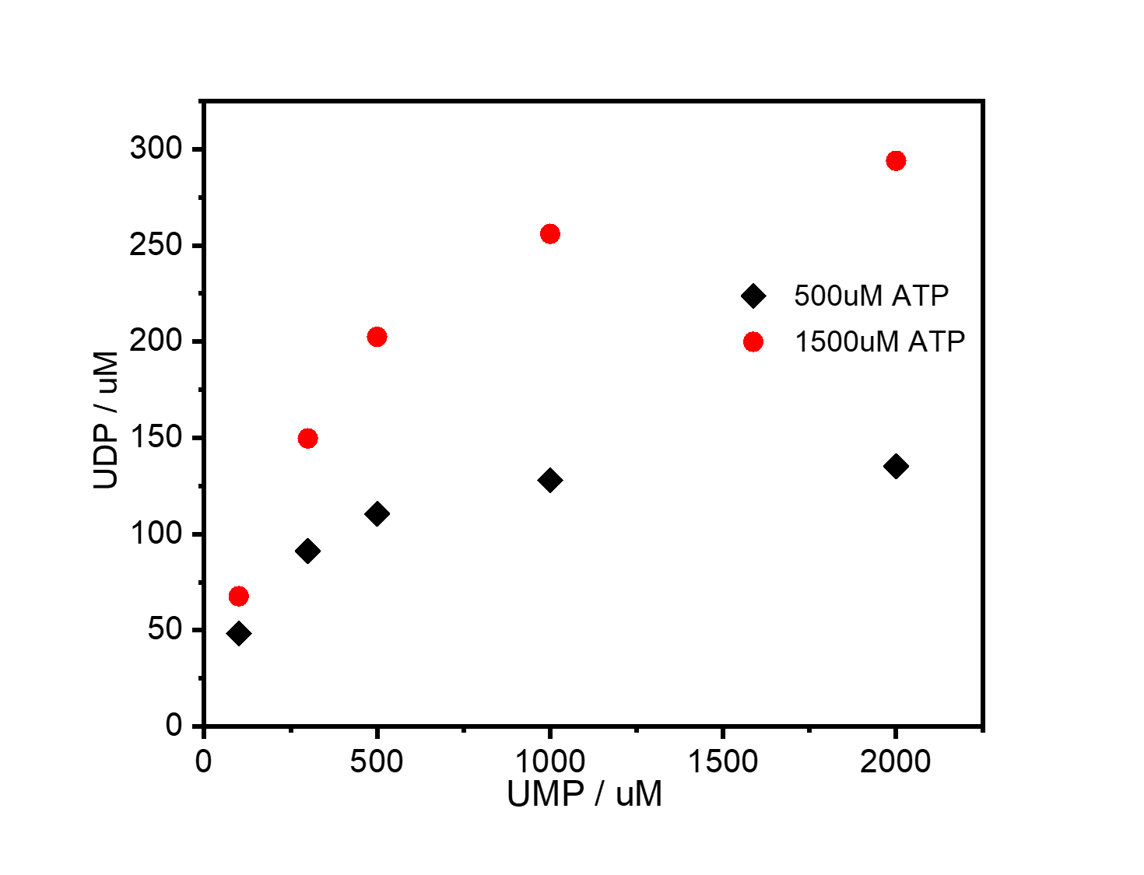
UMPK_beads: 4 ul Flowrate: 750 ul/h
ATP: 500, 1500 uM
UMP: 100, 300, 500, 1000, 2000 uM

Fig. S23. Activity characterization of UMPK beads in flow at steady state. Enzyme UMPK remains active after immobilization.

3.3.6 GMPK bead preparation
1 ml of assay mixture contains:

- IVTT Buffer
- 0,2 mM NADH (prepare stock freshly)
- 1.5 mM Phosphoenolpyruvate
- 1.5 mM GMP
- 3 mM ATP
- 2 U pyruvate kinase
- 2 U lactate dehydrogenase
6 ul GMPK beads

Calculate the activity of the GMPK beads solution according to:

$$U=\frac{\left({OD}_{t2}-{OD}_{t1}\right)*1000*{0.5*V}_{reaction}}{\left(t2-t1\right)*6220*V_{enzyme}}$$
Where t = elapsed time in minutes, OD is the linear absorbance change over t₂ - t₁, V_{enzyme} is the volume of enzyme solution added in μl and V_{reaction} is the reaction volume in ml. Figure S24 and S25 show the activity calculation and characterization respectively.
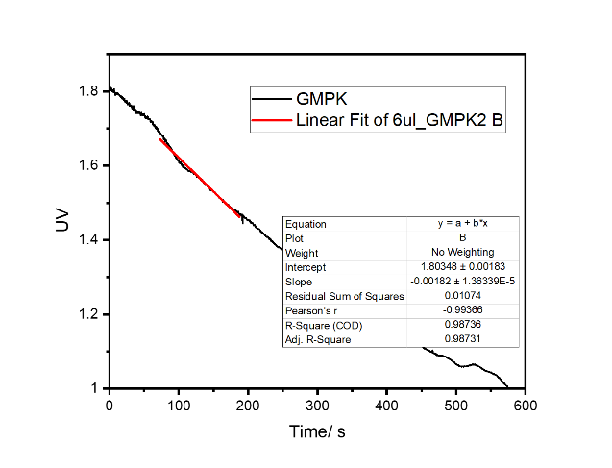
Fig. S24. progress curve of GMPK beads assay; The unit is calculated as 0.045 μmol per min per mg enzyme beads.

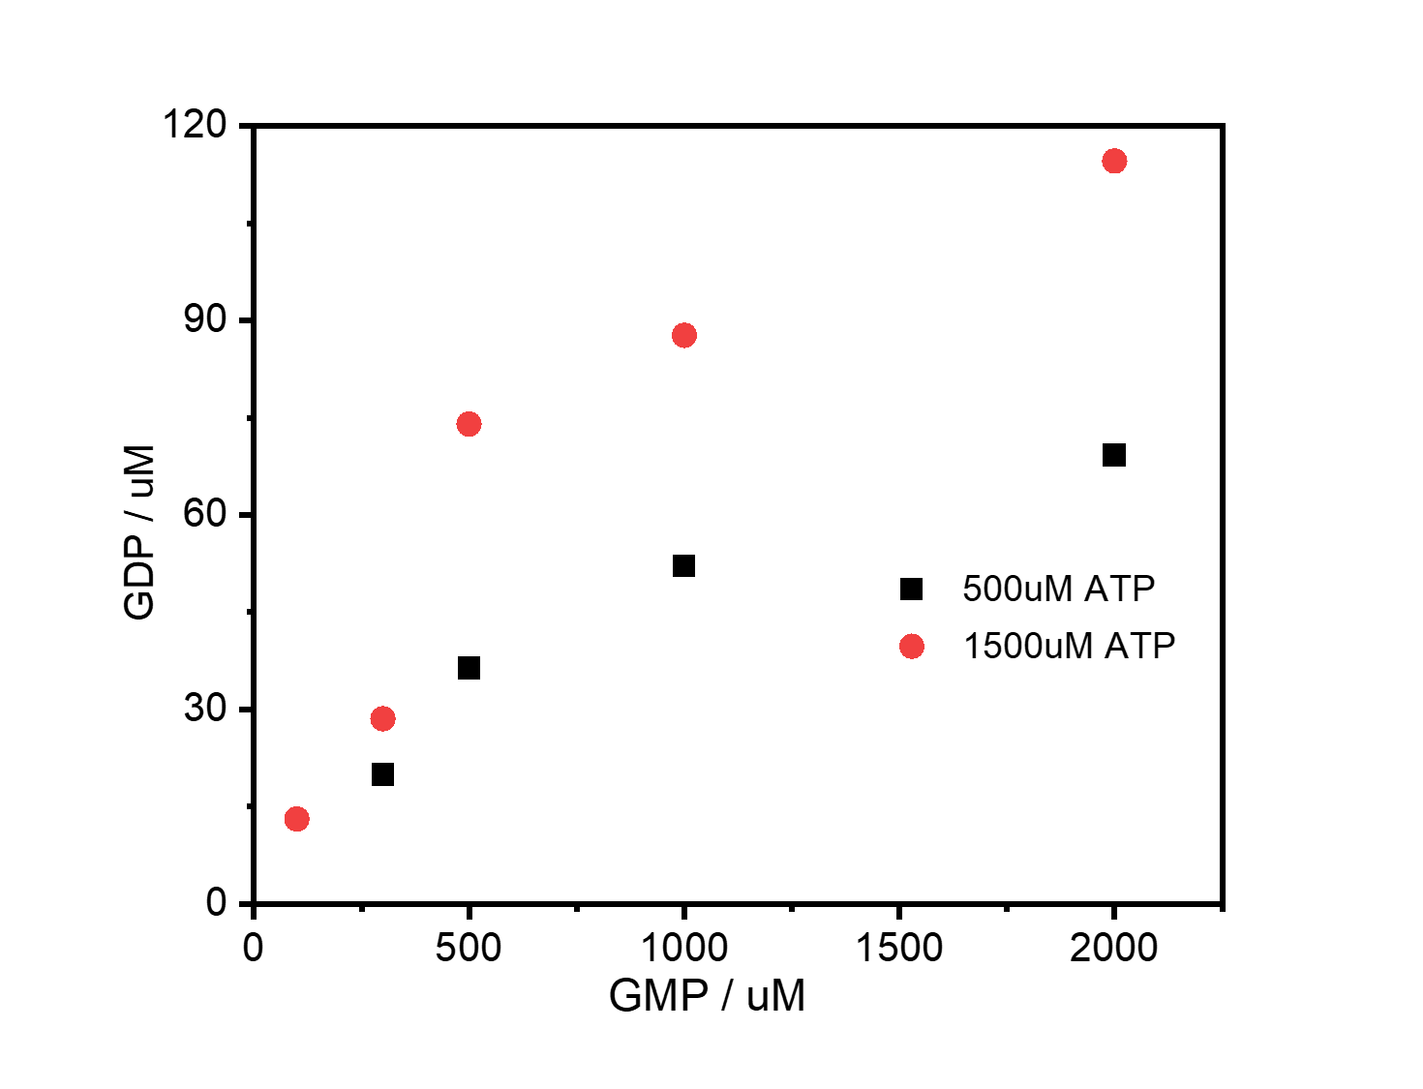
GMPK_beads: 6 ul Flowrate: 750 ul/h
ATP: 500, 1500 uM
GMP: 100, 300, 500, 1000, 2000 uM
Fig. S25. Activity characterization of GMPK beads in flow at steady state. Enzyme GMPK remains active after immobilization.

Reference
1. Fröhlich, F., Weindl, D., Schalte, Y., Pathirana, D. et al. AMICI: high-performance sensitivity analysis for large ordinary differential equation models. Bioinformatics 37, 3676-3677 (2021).
2. Baltussen, M., Wiel, J., Regueiro, C., Jakštaitė M., & Huck, W. T. S., A Bayesian approach to extracting kinetic information from artificial enzymatic networks, Anal. Chem. 94, 7311 (2022).
3. Sluijs, B., Maas, R. J. M., Linden, A. J., Greef, T. F. A., & Huck, W. T. S., A microfluidic optimal experimental design platform for forward design of cell-free genetic networks, Nat Commun 13, 3626, (2022).
4. Sinkoe, A., & Hahn, J., Optimal experimental design for parameter estimation of an IL-6 signaling model, Processes 5, 49 (2017).
5. Aguiar, P. F., Bourguignon, B., Khots, M. S., Massart, D. L., & Phan-Than-Luu, R., D-optimal designs. Chemometr Intell Lab Syst 30, 199-210 (1995).
6. Dobson, G. P., Hitchins, S., & Teague, W. E., Thermodynamics of the pyruvate kinase reaction and the reversal of glycolysis in heart and skeletal muscle. J. Biol. Chem. 277, 27176-27182 (2002).
7. Israelsen, W. J., & Heiden, M. G. V., Pyruvate kinase: Function, regulation and role in cancer. Semin Cell Dev Biol. 43, 43-51 (2005).
8. Nakajima, K., Kitazume, S., Angata, T., Fujinawa, R. et al. Simultaneous determination of nucleotide sugars with ion-pair reversed-phase HPLC, Glycobiology 20, 865-871 (2010).

