Supplement materials

Religiosity of Poles before and during the pandemic
As we begin to analyze the impact of Poles' religiosity on their well-being during the pandemic period, it is worth first tracing contextual variables over time.
Looking at the distributions of the level of SDR in the study population before the pandemic (2020), one year (2021) and two years (2022) after its outbreak there are significant differences between each pair of variables (see figure 9). Leaving the fact that the median SDRs before the pandemic (Me before COVID-19 pandemic (March 2020) =5.00) and after the pandemic year (Me during COVID-19 pandemic (March 2021)=5.00) remain the same, there is a significant difference in the distribution of the variable's values in the compared years (p <0.001). Small effect size but significant (WKendall=0.03) is noticeable. This is better illustrated by differences in averages. After the outbreak of the pandemic there is a decrease in religiosity among Poles in each subsequent year $\underline{X}$before COVID-19 pandemic (March 2020) = 4.75, $\underline{X}$during COVID-19 pandemic (March 2021)=4.56, $\underline{X}$during COVID-19 pandemic (April 2022) =4.21) (see table 6).

Table 6. Descriptive statistics of the SDR variable at three time points: before COVID-19 pandemic (March 2020), during COVID-19 pandemic (March 2021), during COVID-19 pandemic (April 2022)
Self-declared religiosity (SDR) | N | Median  (Me) | Mean ($\underline{X})$ | IQR
Before COVID-19 pandemic (March 2020) | 622 | 5 | 4.74 | 5
During COVID-19 pandemic (March 2021) | 622 | 5 | 4.56 | 6
During COVID-19 pandemic (April 2022) | 622 | 4.5 | 4.21 | 5

Figure 9. Comparison of the distribution of the Self-declared Religiosity variable at three time points: before COVID-19 pandemic (March 2020), during COVID-19 pandemic (March 2021), during COVID-19 pandemic (April 2022)
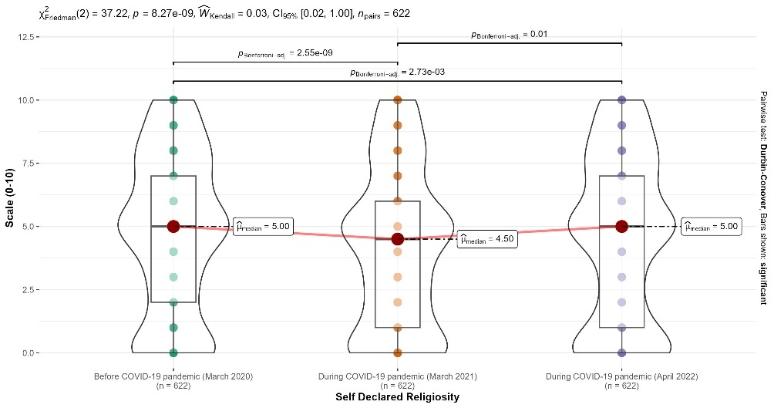

Figure 10. Flows for ‘attendance’ in the religious and fuzzy categories
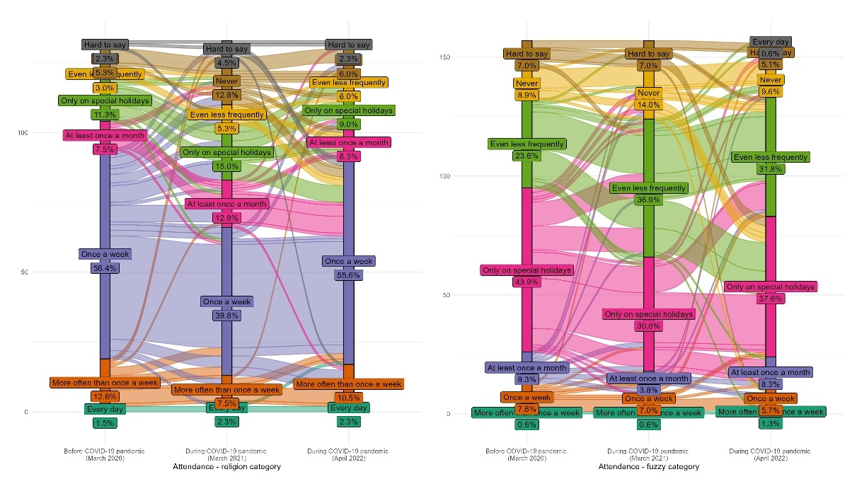

Figure 11. Flows for ‘pray’ in the religious and fuzzy categories
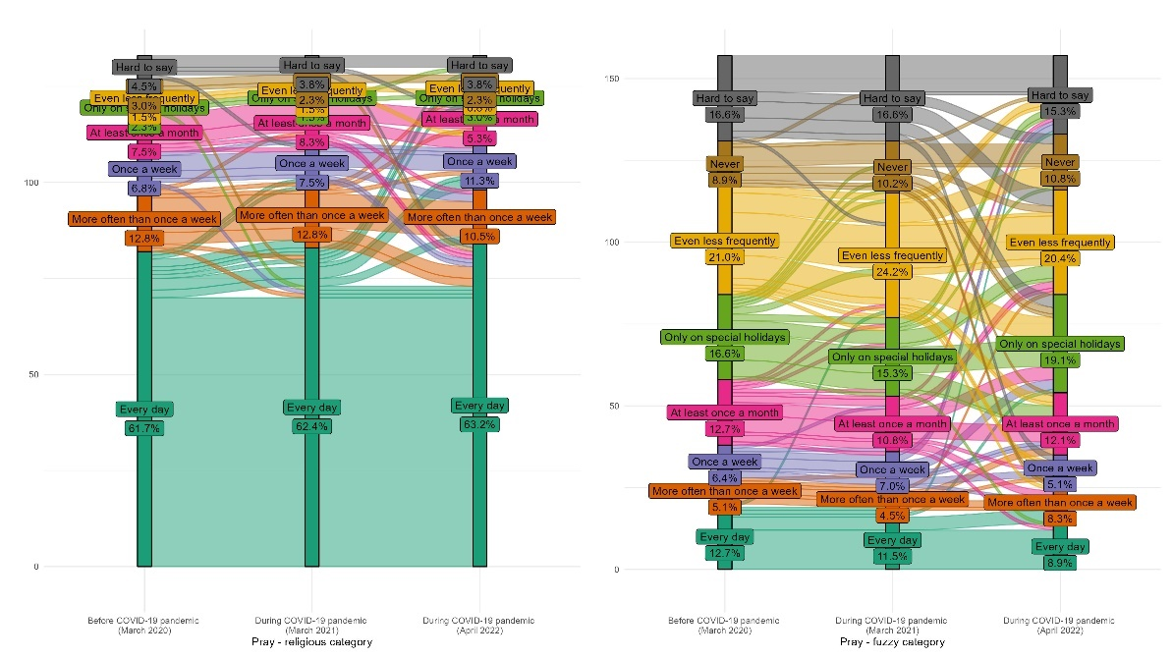

Characteristics of the differences between the categories: religious, fuzzy, secular

In order to identify significant differences between categories of religiosity, it was checked whether they differed significantly in terms of socio-demographic and worldview characteristics. Only significant differences will be synthetically indicated. In the case of age, the fuzzy category (Me=47) differed significantly from secular (Me=63, p< 0.001) and religious (Me=58, p<0.005). In addition, secular individuals were more likely to come from large cities (43%) relative to the fuzzy (33%) and religious groups (22%), while the religious (47%) and fuzzy (38%) were more likely than secular (23%) to report living in rural areas. Secular individuals were furthermore better educated than fuzzy and religious. 42% of them possessed higher education to respectively 21% of fuzzy and 27% of religious.
With regard to worldview issues, religious people are significantly more concerned about the COVID-19 vaccines than secular, although the percentage vaccinated in each group is insignificant. In addition, the loneliness index was significantly lower in the religious category than the secular. Trust in the government was also higher when comparing the results with the secular category. Scientists were significantly less trusted in the fuzzy group.

 |  | Secular (S) |  | Fuzzy (F) |  | Religious (R) |  | Pearson's Chi-squared test; Kruskal-Wallis rank sum test | Pairwise comparison between group levels with correction for multiple testing
 |  | N | % / Median (IQR) | N | % / Median (IQR) | N | % / Median (IQR) | Pearson's Chi-squared test; Kruskal-Wallis rank sum test
Gender | Female | 56 | 46% | 76 | 48% | 64 | 48% | >0.9
Gender | Male | 65 | 54% | 81 | 52% | 69 | 52% | >0.9
Locality | < 100 | 52 | 43% | 52 | 33% | 29 | 22% | <0.001 | S>F (p< 0.037); S>R (p< 0,000)
Locality | > 100 | 41 | 34% | 45 | 29% | 41 | 31% | <0.001
Locality | countryside | 28 | 23% | 60 | 38% | 63 | 47% | <0.001 | F>S (p<0.037); R>S (p<0,000)
Education | basic vocational or lower | 25 | 21% | 73 | 46% | 48 | 36% | <0.001 | F>S (p<0.000); R>S (p<0,007)
Education | secondary or post-secondary | 45 | 37% | 51 | 32% | 49 | 37% | <0.001
Education | bachelor's degree or higher | 51 | 42% | 33 | 21% | 36 | 27% | <0.001 | S>F (p<0,000); S>R (p<0,007)
Age |  | 63 |  | 47 |  | 58 |  | <0.001 | S>F (p< 0.000); R>F (p< 0,017)
Trust | Government | 0.00 (0.00, 1.00) |  | 3.00 (0.00, 5.00) |  | 5.00 (1.00, 8.00) |  | <0.001 | F>S (p<0,000); R>S (p<0,000)
Trust | Scientists | 7.0 (5.0, 9.0) |  | 5.0 (3.0, 7.0) |  | 7.0 (5.0, 8.0) |  | <0.001 | S>F (p<0,001); R>F (p<0,001)
Difficulty paying bills during the past 12 months | yes | 22 | 18% | 49 | 31% | 26 | 20% | <0.016 | F>S (p<0.041); F>R (p<0.048)
Difficulty paying bills during the past 12 months | no | 99 | 82% | 108 | 69% | 107 | 80% | <0.016 | S>F (p<0.041); R>F (p<0.048)
Vaccine hesitancy | lack of concern | 46 | 38% | 32 | 20% | 32 | 24% | <0.003 | S>F (p<0,003); S>R (p<0,034)
Vaccine hesitancy | concern | 75 | 62% | 125 | 80% | 101 | 76% | <0.003 | F>S (p<0,003); R>S (p<0,034)
Table 7. Differences between the categories: religious, fuzzy, secular for socio-demographic variables

