Supplementary information for “Engineering siRNA-loaded and RGDfC-targeted selenium nanoparticles for highly efficient silencing of DCBLD2 gene for colorectal cancer treatment”
Hongli Huang^{1,2,#}, Hanqing Chen ^{1, 2,#}, Diwen Shou^{1, 2}, Ying Quan^{1, 2}, Jiemin Cheng^{1, 2}, Huiting Chen^{1, 2}, Gang Ning^{1, 2}, Yongqiang Li^{1, 2}, Yu Xia ^{1, 2,}*, Yongjian Zhou ^{1, 2,}*
¹Department of Gastroenterology and Hepatology, Guangzhou First People’s Hospital, School of Medicine, South China University of Technology, Guangzhou,510180, China
²Guangzhou Key Laboratory of digestive diseases,Guangzhou Digestive Disease Center, Guangzhou First People’s Hospital,Guangzhou 510180, China
#These authors contributed equally to this work.
* Corresponding authors: eyyuxia@scut.edu.cn (Yu Xia); eyzhouyongjian@scut.edu.cn (Yongjian Zhou)

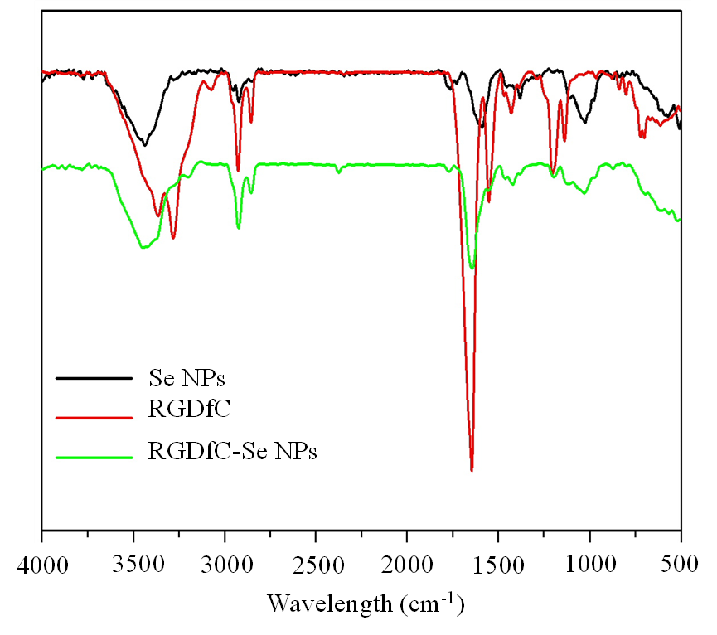

Fig. S1 Fourier transform infrared spectra of SeNPs, RGDfC and RGDfC-SeNPs.

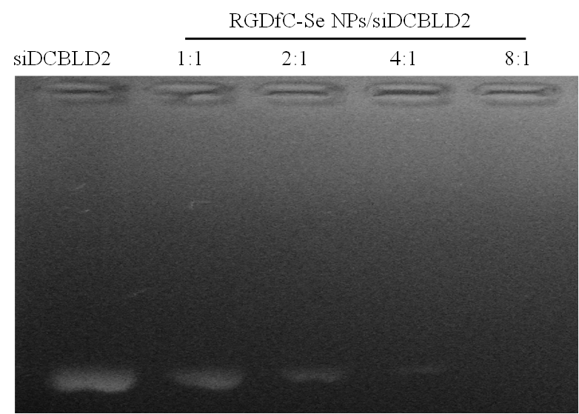
Fig. S2 The stability of siDCBLD2 loaded onto RGDfC-SeNPs was investigated by agarose gel electrophoresis, and the weight ratio of RGDfC-SeNPs/siDCBLD2 was from 1/1 to 8/1.

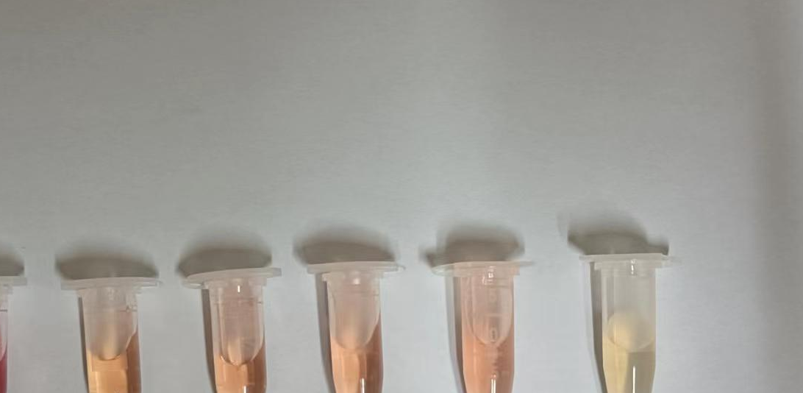

Fig. S3 The siRNA stability analysis using serum protein containing media. 1 indicates media; 2 indicates serum protein containing media; 3 indicates the mixed solutions including the serum protein containing media and RGDfC-Se@DCBLD2 (50 nM); 4 indicates the mixed solutions including the serum protein containing media and RGDfC-Se@DCBLD2 (100 nM); 5 indicates the mixed solutions including the serum protein containing media and RGDfC-Se@DCBLD2 (200 nM); 6 indicates the RGDfC-Se@DCBLD2 solution (200 nM).

Fig. S4 The protein expressions of DCBLD2 in the tumors treated with saline, RGDfC-Se@siNC and RGDfC-Se@siDCBLD2, respectively.

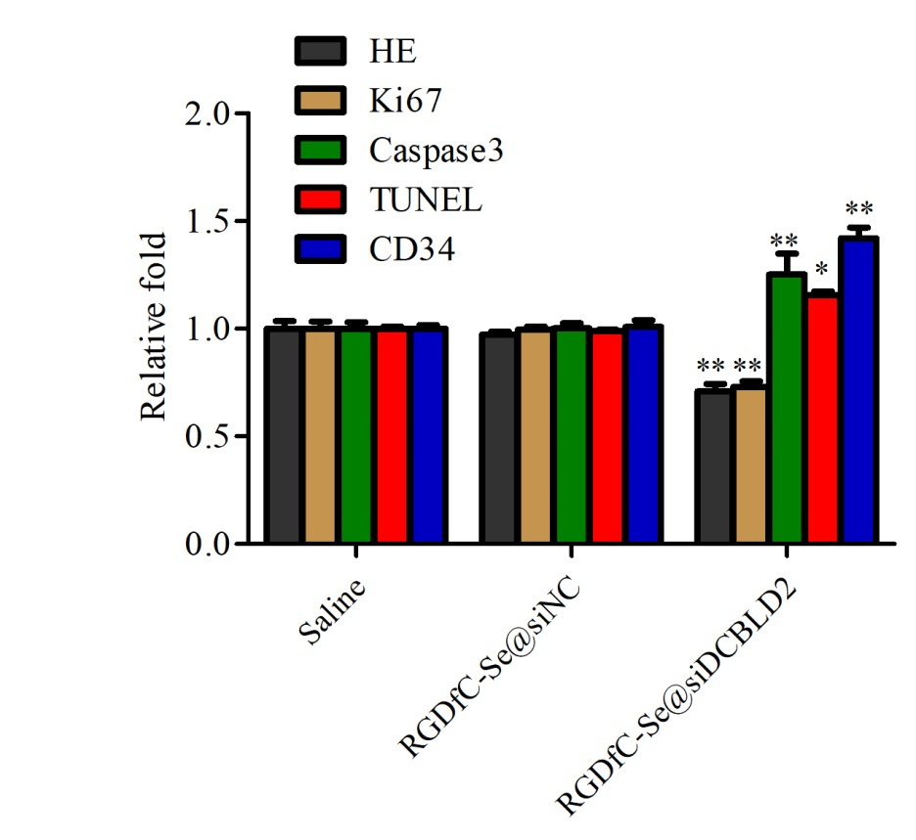

Fig. S5 The quantitative analysis of immunohistochemical assays from Fig. 7A. *p<0.05, **p<0.01 vs saline group.

