[Supplementary Information]

A new trypan blue agar plate assay for in vivo evaluation of gut damage in Folsomia candida springtail

Jin Il Kwak, Lia Kim, Youn-Joo An *,

Department of Environmental Health Science, Konkuk University, Seoul 05029, South Korea

* Corresponding author
Youn-Joo An
Tel: +82 2 2049 6090
Fax: +82 2 2201 6295
E-mail: anyjoo@konkuk.ac.kr

Table S1. Test design for optimizing ingredients and conditions for staining and depuration of plates.

Classification for comparison |  | Label | Ingredients for staining or depuration plate
 |  | Label | Agar (0.8%) | Sugar (5%) | Sugar (10%) | Blue dye (0.1%) | Blue dye (1%) | Trypan blue (0.1%) | Trypan blue (1%)
Staining plate | Media | with agar | O | - | - | O | - | - | -
Staining plate | Media | without agar | - | - | - | O | - | - | -
Staining plate | Media | with sugar | O | O | - | O | - | - | -
Staining plate | Media | without sugar | O | - | - | O | - | - | -
Staining plate | Dye concentration | 0.1% Trypan blue | O | O | - | - | - | O | -
Staining plate | Dye concentration | 1% Trypan blue | O | O | - | - | - | - | O
Staining plate | Dye concentration | 0.1% Blue dye | O | O | - | O | - | - | -
Staining plate | Dye concentration | 1% Blue dye | O | O | - | - | O | - | -
Staining plate | Staining period | 0.1% Trypan blue | O | O | - | - | - | O | -
Staining plate | Staining period | 0.1% Blue dye | O | O | - | O | - | - | -
Depuration plate | Media | agar plate with sugar | O | - | O | - | - | - | -
Depuration plate | Media | plaster plate with yeast | - | - | - | - | - | - | -
Depuration plate | Depuration period | agar plate with sugar | O | - | O | - | - | - | -
Depuration plate | Depuration period | plaster plate with yeast | - | - | - | - | - | - | -

Figure S1. (A) Timeframe and (B) design of applicability test using two model chemicals (Cu and Cr), blank (DW), and negative control (Ca).

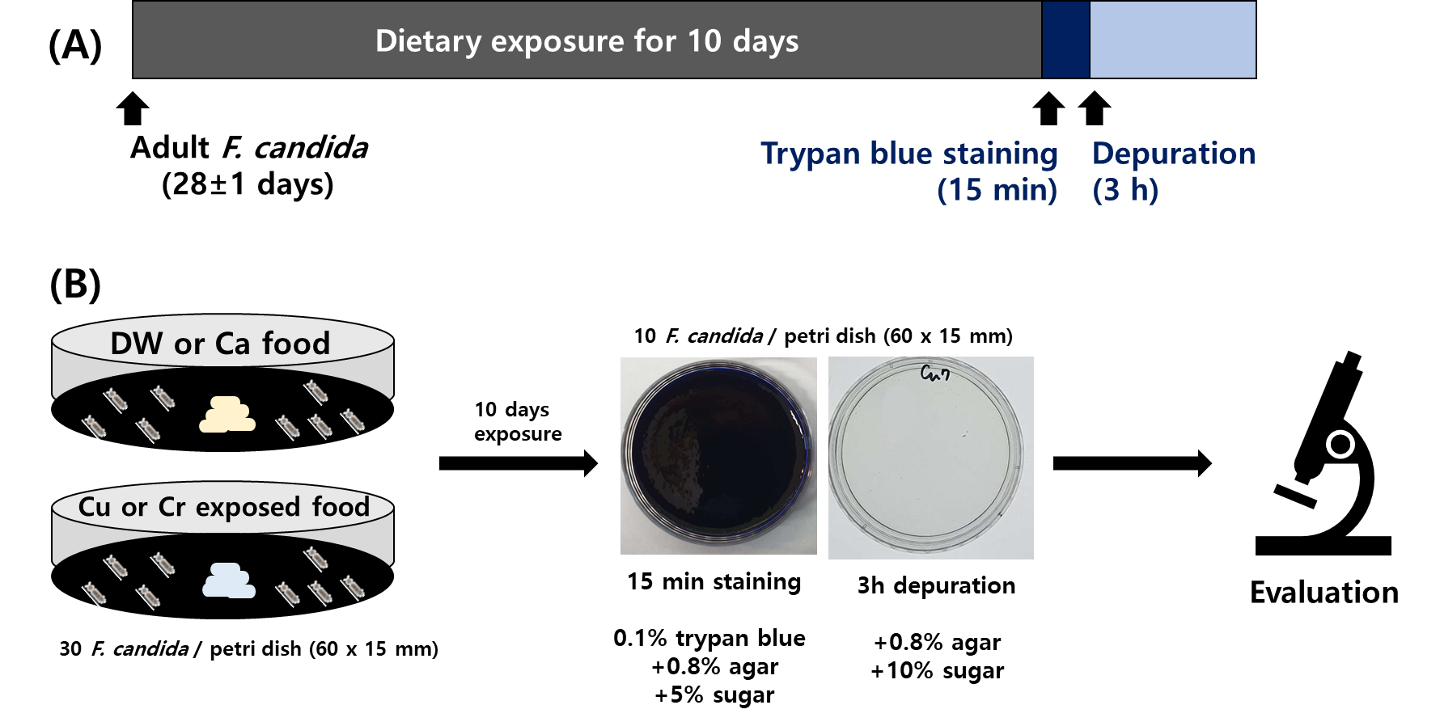
Figure S2. Time-dependent uptake of blue dye (dye control, 0.1%, and 1%) to establish optimum dye concentration. Blue dye uptake was quicker and more efficient at 0.1% concentration than at 1%.

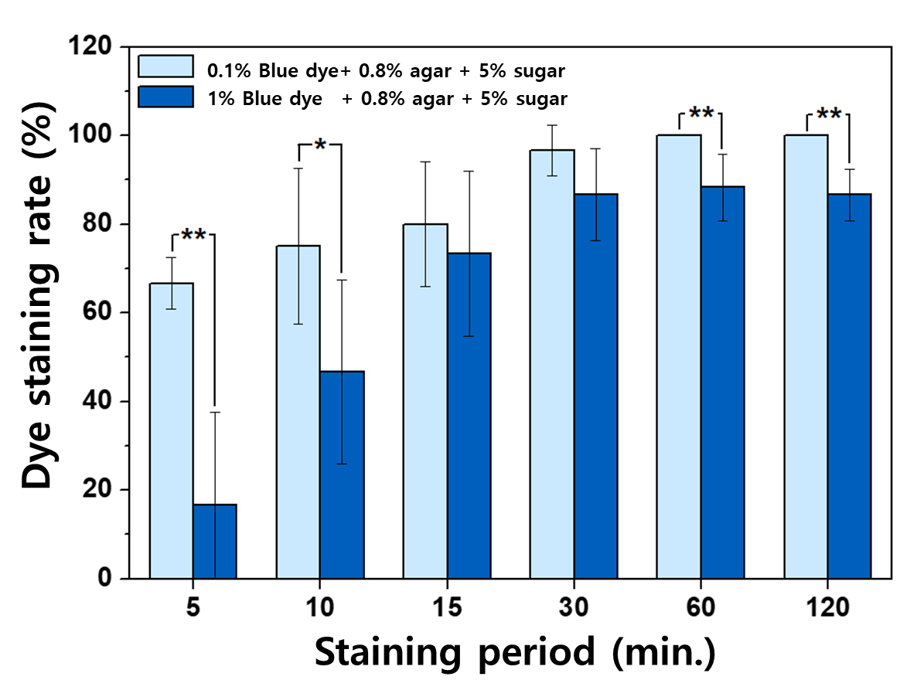

Figure S3. Test design for investigating optimum conditions (shown in red). Detailed ingredients for staining of the depuration plates are described in Table S1.

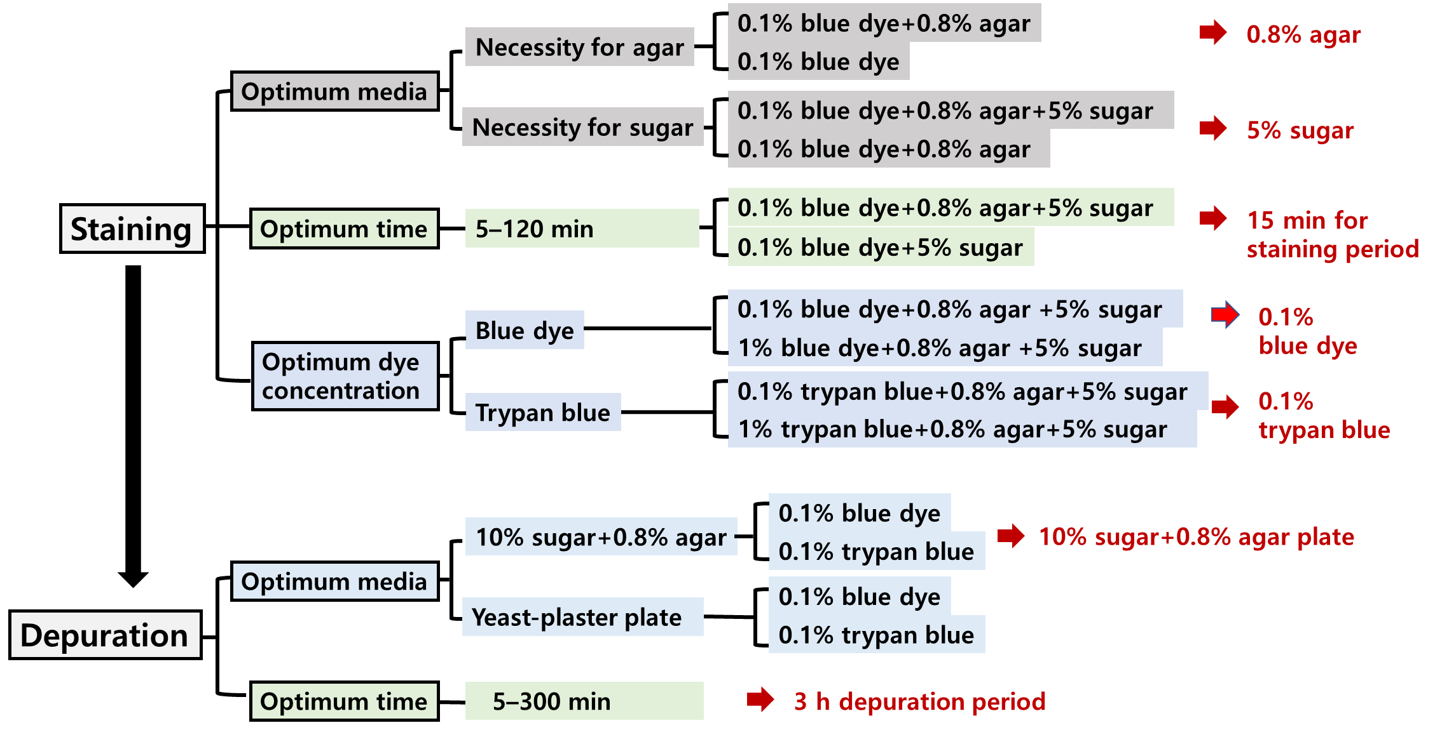
Figure S4. Time-dependent depuration of trypan blue on a depuration plate containing 10% sugar + 0.8% agar. Blue arrowheads indicate gut barriers stained by trypan blue. Healthy F. candida was lightly stained by trypan blue (blank), and trypan blue residues were excreted after 2 to 3 hours of depuration. However, the gut of F. candida exposed to Cu or Cr was notably stained by trypan blue and maintained until 3 hours of depuration.

