Electrochemical property based on the structural control of pitch-based carbon anode
Jin Ung Hwang^{1,2}, Jong Hoon Cho¹, Ji Sun Im^{1,3,*}, Jong Dae Lee^{2,*}

Table of contents
Figure S1. HR-TEM and FFT images (right, inset) of pitch-based carbon material (a)P4401-1000, (b) P4401-1300, (c) P4401-2400.
Figure S2. XPS survey scan of pitch-based carbon material.
Figure S3. Nitrogen adsorption-desorption isotherm of pitch-based carbon material.

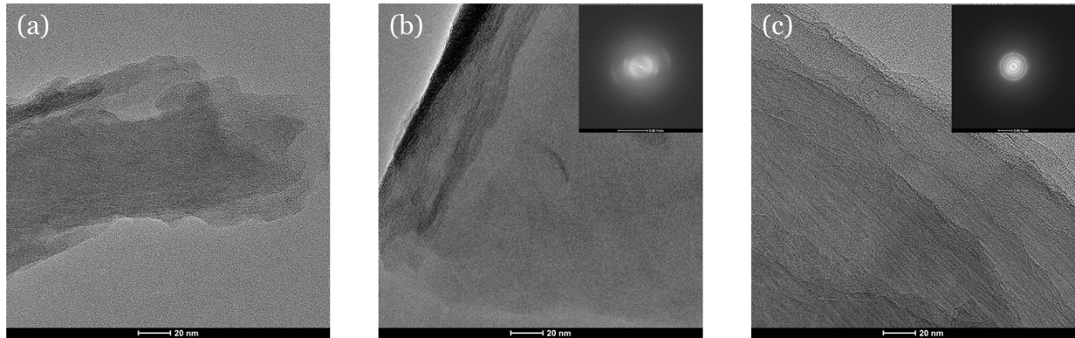
Figure S1. HR-TEM and FFT images (right, inset) of pitch-based carbon material (a) P4401-1000, (b) P4401-1300, (c) P4401-2400.

Figure S2. XPS survey scan of pitch-based carbon material.

Figure S3. Nitrogen adsorption-desorption isotherm of pitch-based carbon material.

