A dispersion-corrected DFT calculations on encapsulation of Favipiravir drug used as antiviral against COVID-19 into carbon-, boron-, and aluminum-nitride nanotubes for optimal drug delivery systems combined with molecular docking simulations
Roqaya Albarakati¹, Ohoud Al-Qurashi², Zaki Safi³, Nuha Wazzan^{1‡}
¹King Abdulaziz University, Chemistry Department, Faculty of Science, P.O. Box 4280, Jeddah 21589, Saudi Arabia.
²Department of Chemistry, Faculty of Science, University of Jeddah, Jeddah, Saudi Arabia
³Department of Chemistry, Faculty of Science, Al Azhar University-Gaza, P.O. Box 1277, Gaza, Palestine.
‡Corresponding author: nwazzan@kau.edu.sa (Nuha Wazzan)
Supplementary Data (SD)
Contents
Supplementary tables 2
Table SD 1: Comparison between some important geometrical parameters of the optimized FAV forms calculated at CPCM/B3LYP/6-31G(d,p( in water medium. Note: for more clarifications bond lengths and angles are represented in molecular structures. 2
Table SD 2: Relative total energies $∆E$ (in kJ/mol), electronic parameters (in eV), and dipole moments $DM$ (in Debye) of FAV forms in gas and water at B3LYP-D with 6-31G(d,p) level of theory. 3
Table SD 3: BSSE energies, binding energies corrected/uncorrected with BSSE, and relative binding energies corrected with BSSE (in kJ/mol), difference ($∆$) and recovery time ($τ$) at 298.15 K (in sec) computed at the B3LYP-D with 6-31G(d,p) level of theory. 3
Table SD 4: Thermodynamic parameters (in kJ/mol) of ES at CPCM/B3LYP-D/6-31G(d,p). 4
Supplementary figures 5
Figure SD 1: The linear relationship between the energy gaps and global hardness values as calculated at the CPCM/B3LYP-D/6-31G(d,p) level of theory. 5
Cartesian coordinates of optimized geometries of FAV forms at CPCM/B3LYP/6-31G(d,p) level of theory. 5
K2 5
E3 5
E1 6
E2 6
K1 7

Supplementary tables

Table SD 1: Comparison between some important geometrical parameters of the optimized FAV forms calculated at CPCM/B3LYP/6-31G(d,p( in water medium. Note: for more clarifications bond lengths and angles are represented on molecular structures.
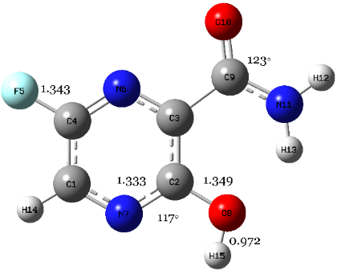 |  | 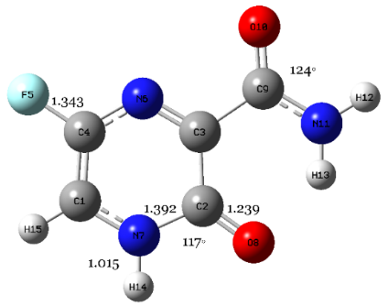 |  | 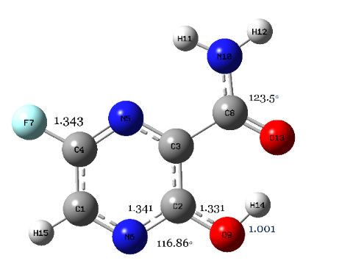
E2 |  | K2 |  | E3
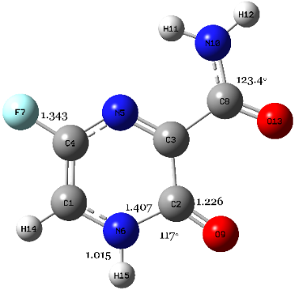 |  |  | 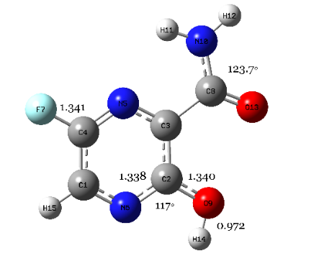
K1 |  |  | E1
Bond length/angle | E1 | E2 | E3 | K1 | K2
O9−H14 | 0.972 | 0.972 | 1.001 | − | −
N6−H14 | − | − | − | 1.015 | 1.015
N6-C2 | 1.338 | 1.333 | 1.341 | 1.407 | 1.392
C=O | 1.340 | 1.349 | 1.331 | 1.226 | 1.239
C-F | 1.341 | 1.343 | 1.343 | 1.342 | 1.343
N5-C2-O9 | 117◦ | 117◦ | 116.86◦ | 117◦ | 117◦
N10-C8-O13 | 123.7◦ | 123◦ | 123.5◦ | 123.4 | 124
A close look at the structures, both E1 and E3 are the same structure in which E1 form has the O-H cis to the N atom of pyrazine ring, while it is a trans for E3 form with a distance of 0.972 and 1.001 Å, respectively. However, the five forms of FAV are different in the terminal amine (NH₂) and carbonyl (C=O) groups, in which the structure of K1 and E3 (E1) are tautomers to each other, and they have the C=O at the right side with a value of N-C-O angle about 124$°$. Whereas the two other forms K2 and E2 are tautomers to each other and have the NH₂ in the right side with a value of N-C-O angle of 124$°$ and 123$°$ , respectively. Moreover, the movement of the H atom between the N and O atomic sites through the keto-enol tautomerism could result in significant changes. For instance, the O-H bond length of E2 form is 0.971 Å while it increases to 1.001 Å for E3 form. Whereas the N-H which are fixed at 1.015 Å. Besides, the bond lengths in E3 form, N-C and C=O are 1.341 and 1.331 Å, while those of K1 form are 1.407 and 1.226 Å, respectively. Likewise, the bond lengths of C=O and N-C in E2 form are 1.349 and 1.333 Å, but those for the K2 form become shorter for C=O by 0.11 (1.239 Å) and longer for N-C (1.392 Å). Also, the angle of N-C-O of K1/K2 (120$°$) is greater than E3/E2 (116.8$°$). Furthermore, for all tautomers the C-F length is fixed at 1.343 Å.

Table SD 2: Relative total energies $∆E$ (in kJ/mol), electronic parameters (in eV), and dipole moments $D_{M}$ (in Debye) of FAV forms in gas and water at B3LYP-D with 6-31G(d,p) level of theory.
Medium | form | $$∆E$$ | $$E_{HOMO}$$ | $$E_{LUMO}$$ | $$E_{g}$$ | $$D_{M}$$ | $$η$$
Gas | E3 | 0.000 (0.000)^{[1]} | −6.792 | −2.317 | 4.475 | 4.545 | 2.238
Gas | E1 | 40.987 | −6.818 | −2.220 | 4.597 | 2.447 | 2.281
Gas | K2 | 50.417 | −6.719 | −2.669 | 4.050 | 5.909 | 2.009
Gas | E2 | 50.739 | −6.888 | −2.176 | 4.713 | 5.581 | 2.338
Gas | K1 | 66.422 | −6.463 | −2.639 | 3.824 | 5.320 | 1.897
Water | E3 | 0.000 (0.000)^{[1]} | −6.778 | −2.261 | 4.517 | 4.545 | 2.259
Water | K2 | 23.955 | −6.506 | −2.531 | 3.975 | 8.070 | 1.987
Water | E1 | 33.924 | −6.861 | −2.166 | 4.696 | 3.454 | 2.348
Water | E2 | 36.510 | −7.009 | −2.151 | 4.858 | 7.476 | 2.410
Water | K1 | 36.930 | −6.416 | −2.544 | 3.872 | 7.649 | 1.921

Table SD 3: BSSE energies, binding energies corrected/uncorrected with BSSE, and relative binding energies corrected with BSSE (in kJ/mol), difference ($∆$) and recovery time ($τ$) at 298.15 K (in sec) computed at the B3LYP-D with 6-31G(d,p) level of theory.
 | System | $$E_{BSSE}$$ | Binding energy |  | ¹$∆$ | Corrected relative binding energy with BSSE  (${∆E}_{bind}^{BSSE}$)
 | System | $$E_{BSSE}$$ | Uncorrected  with BSSE  $(E_{bind}$) | Corrected with BSSE  ($E_{bind}^{BSSE}$) | ¹$∆$
Gas | K2/AlNNT | 0.03393 | −273.801 | −184.724 | 89.077 | 0.000
Gas | E3/AlNNT | 0.03028 | −230.999 | −151.503 | 79.496 | 33.221
Gas | K2/BNNT | 0.03841 | −224.890 | −124.014 | 100.876 | 60.710
Gas | E3/BNNT | 0.03762 | −197.108 | −98.324 | 98.784 | 86.400
Gas | K2/CNT | 0.03086 | −176.900 | −95.855 | 81.044 | 88.868
Gas | E3/CNT | 0.02876 | −143.888 | −68.367 | 75.521 | 116.357
Aqueous | K2/AlNNT | 0.036 | −402.292 | −308.821 | 93.471 | 0.000
Aqueous | E3/AlNNT | 0.0310 | −249.157 | −167.611 | 81.546 | 141.210
Aqueous | K2/BNNT | 0.0385 | −221.878 | −120.750 | 101.128 | 188.071
Aqueous | E3/BNNT | 0.038 | −195.351 | −96.316 | 99.035 | 212.505
Aqueous | K2/CNT | 0.0313 | −175.268 | −93.094 | 82.174 | 215.727
Aqueous | E3/CNT | 0.0287 | −143.009 | −67.572 | 75.44 | 241.249
¹$∆=E_{bind}^{BSSE}-E_{bind}$

Table SD 4: Thermodynamic parameters (in kJ/mol) of ES at CPCM/B3LYP-D/6-31G(d,p).
System | $${∆H}_{bind}$$ | $${∆G}_{bind}$$ | $${∆S}_{bind}$$
K2/AlNNT | −903.311 | −834.757 | −0.230
E3/AlNNT | −849.764 | −790.604 | −0.198
K2/BNNT | −797.848 | −733.654 | −0.215
E3/BNNT | −782.895 | −716.649 | −0.222
K2/CNT | −840.567 | −770.217 | −0.236
E3/CNT | −821.141 | −752.999 | −0.229

Supplementary figures

Figure SD 1: The linear relationship between the energy gaps and global hardness values as calculated at the CPCM/B3LYP-D/6-31G(d,p) level of theory.

Cartesian coordinates of optimized geometries of FAV forms at CPCM/B3LYP/6-31G(d,p) level of theory.

K2 form
Atom | X | Y | Z
C | -2.144904 | 0.785396 | 0.000011
C | 0.242361 | 1.277484 | 0.000024
C | 0.426593 | -0.180897 | -0.000027
C | 1.803859 | -0.823563 | -0.000038
C | -1.836925 | -0.548198 | -0.000045
F | -2.823784 | -1.459154 | -0.000074
N | -0.591908 | -1.014683 | -0.000057
N | -1.099646 | 1.648523 | 0.000051
N | 2.839614 | 0.041684 | -0.000040
O | 1.124932 | 2.147623 | 0.000095
O | 0 1.927277 | -2.047870 | 0.000062
H | 3.777075 | -0.332102 | 0.000060
H | 2.663253 | 1.042283 | -0.000011
H | -1.276804 | 2.648356 | 0.000102
H | -3.149469 | 1.185830 | 0.000034

E3 form
Atom | X | Y | Z
C | 2.092683 | 0.874117 | 0.000051
C | -0.156089 | 1.258295 | 0.000077
C | -0.389206 | -0.138489 | -0.000048
C | 1.839333 | -0.503516 | -0.000036
C | -1.785970 | -0.662119 | -0.000266
F | 2.870497 | -1.361567 | -0.000075
N | -1.922433 | -1.993436 | 0.000301
N | 0.631641 | -1.008986 | -0.000072
N | 1.092307 | 1.748462 | 0.000072
O | -1.150376 | 2.144107 | 0.000099
O | -2.752159 | 0.130950 | -0.000229
H | -1.105190 | -2.586464 | 0.000420
H | -2.844819 | -2.402532 | 0.000344
H | -1.990873 | 1.600185 | 0.000128
H | 3.111575 | 1.250454 | 0.000060

E1 form
Atom | X | Y | Z
C | 2.120916 | 0.792749 | -0.000345
C | -0.120602 | 1.279848 | -0.000008
C | -0.436895 | -0.099193 | 0.000301
C | -1.846261 | -0.640520 | 0.000740
C | 1.795056 | -0.563824 | -0.000034
F | 2.773358 | -1.481301 | -0.000066
N | 0.559800 | -0.998871 | 0.000259
N | 1.149705 | 1.700826 | -0.000321
N | -1.911881 | -1.991402 | 0.000200
O | -1.073122 | 2.222967 | 0.000067
O | -2.835372 | 0.091736 | -0.000368
H | -1.071636 | -2.549419 | -0.000224
H | -2.817088 | -2.435220 | -0.000894
H | -0.612769 | 3.080119 | -0.000139
H | 3.152569 | 1.130372 | -0.000627

E2 form
Atom | X | Y | Z
C | 2.105686 | 0.870063 | -0.000046
C | -0.152068 | 1.209282 | 0.000052
C | -0.396216 | -0.183763 | 0.000025
C | 1.855898 | -0.502678 | -0.000077
C | -1.753832 | -0.868078 | 0.000060
F | 2.891362 | -1.357471 | -0.000135
N | 0.653187 | -1.018889 | -0.000040
N | 1.080408 | 1.718041 | 0.000017
N | -2.841454 | -0.065477 | -0.000175
O | -1.175676 | 2.088583 | 0.000094
O | -1.826318 | -2.095673 | 0.000287
H | -3.749070 | -0.506613 | -0.000174
H | -2.772563 | 0.941351 | -0.000332
H | 3.115011 | 1.268949 | -0.000076
H | -0.801479 | 2.985578 | 0.000060

K1 form
Atom | X | Y | Z
C | 2.178707 | 0.668307 | -0.000070
C | -0.175428 | 1.378590 | 0.000057
C | -0.472467 | -0.064664 | 0.000036
C | 1.759699 | -0.634592 | -0.000069
C | -1.900472 | -0.562702 | 0.000034
F | 2.658116 | -1.632616 | -0.000131
N | 0.475429 | -0.980602 | -0.000016
N | 1.212392 | 1.616076 | -0.000010
N | -2.008540 | -1.912262 | 0.000493
O | -0.953929 | 2.326731 | 0.000071
O | -2.870286 | 0.194412 | -0.000325
H | -1.187745 | -2.497931 | 0.000199
H | -2.928125 | -2.325090 | -0.000059
H | 3.215135 | 0.978842 | -0.000113
H | 1.476207 | 2.596456 | -0.000007

References
1. Antonov, L., Favipiravir tautomerism: a theoretical insight. Theoretical Chemistry Accounts, 2020. 139(8): p. 1-7.

