Machine learning spots the time to treat Huntington disease
Igor Koval, Thomas Dighiero-Brecht, Allan J. Tobin, Sarah J Tabrizi, Rachael I Scahill, Stanley Durrleman, and Alexandra Durr
Supplementary Materials

Figure S1: Progression of 15 imaging and clinical biomarkers in HD. For the sake of clarity, only one half of the confidence intervals are shown in the left panel. The other half is shown in the right panel. The progression is estimated from all 299 participants in the TRACK-HD and TRACK-ON studies.

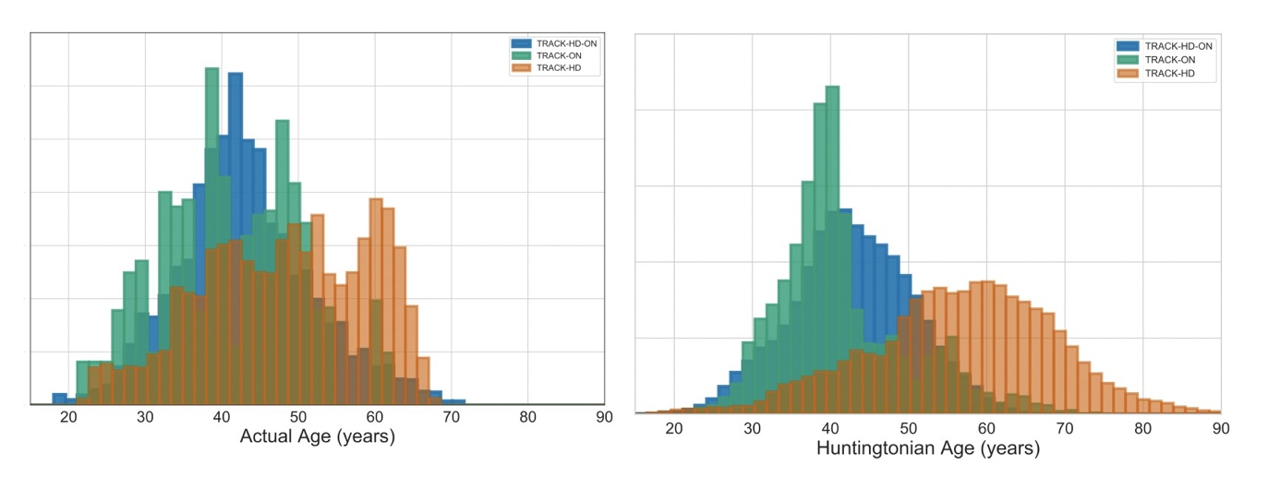
Figure S2: Comparison of actual age of the participants at baseline (left) and their Huntingtonian age at baseline (right). In orange are the participants in the initial TRACK-HD cohort who were not followed in TRACK-ON. Their Huntingtonian Age at baseline was higher showing that they were included at later disease stages. In green are the participants from the initial TRACK-HD study who were followed-over in TRACK-ON. They were initially included at the earliest disease stage. In blue are the new participants included in TRACK-ON. This stratification of participants according to their disease stage is not apparent in their age distribution.

Figure S3 Estimation of the temporal ordering of biomarker changes. A) A marker is said to diverge from control values at the point where it exceeded the 95th percentile of the control distribution B) HA at which each biomarker diverges from its control value in HD COURSE MAP produces a timeline of biomarker changes. Boxplot provides an easier visualization with confidence intervals.
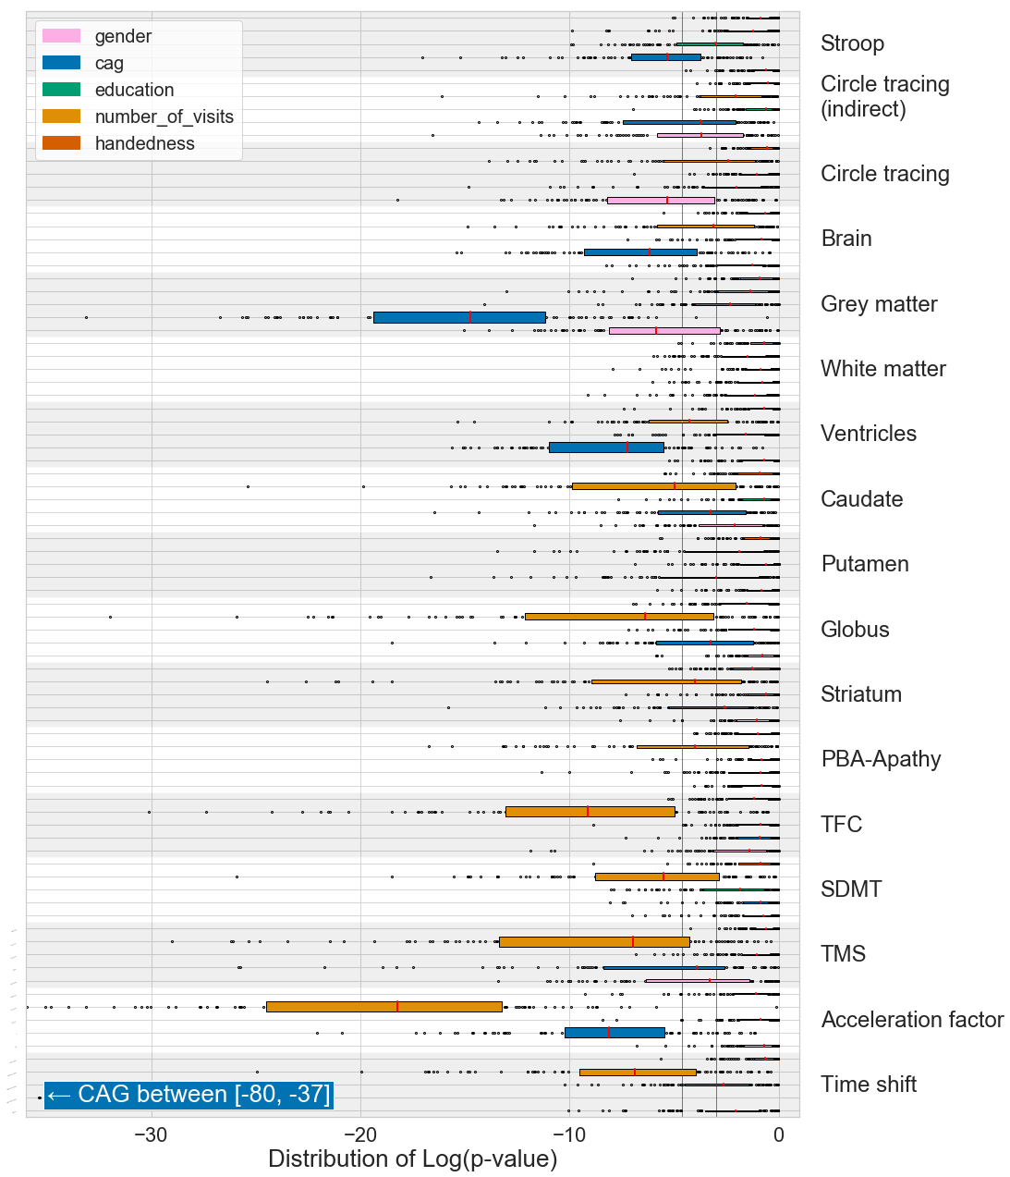
Figure S4: Multivariate regression of each model parameter (right) against five cofactors: sex, number of CAG repeats, level of education, number of visits and handedness. To estimate confidence intervals on the p-values, we bootstrapped the model 100 times and ran 100 multivariate analyses. The reported p-values correspond to the median over the runs. The two black vertical bars correspond to the 0.05 and 0.01 p-values thresholds. We note that the number of visits as a cofactor reflects a bias in cohort selection: subjects with more visits are those that can be followed during years, which is usually related to a slow disease progression - fast progressors are less likely to be evaluated for long periods of time because of death, physical or mental disabilities. Neither education level nor sex influences the speed of progression or the age at onset. Increased CAG repeats advance Stroop abnormality (p=0.0055) and delays grey-matter changes (p = 5.4 10⁻⁸ ), brain atrophy (p = 0.00049 ) and ventricles volumes (p = 0.00051 ) compared to the average progression. Sex influences on circle tracing and grey matter needs further investigation. The number of visits influenced every clinical variable but the Stroop test, as well as all the volumes of basal ganglia structures, but it had no influence on grey and white matter volume or on ventricular volume.

