Supplementary Information

Manuscript title: A Practical Approach to Assess the Wildfire Ignition and Spreading Capacities of Vegetated Surfaces in Romania

S1. Vegetation Structure of Romania and Wildfire Regimes
The forests on the Romanian Carpathian Mountains consist of 2.13 million hectares of Pannonian mixed deciduous and coniferous forests, 0.87 million hectares of central European mixed forest, 0.53 million hectares of Balkan mixed forest coniferous forests, 3,31 million hectares with species such as Abies alba, Picea abies, Pinus sylvestris, Pinus nigra); the plains area represents the forest-steppe floor in which predominates Quercus petraea, Quercus cerris, Quercus frainetto, Quercus pedunculiferra; along the large watercourses (i.e., such as Crisuri and Mureș Rivers in western Romania, Olt, Jiu, Buzău Rivers in the south and Siret, Prut Rivers in the east of the country) hydrophytic vegetation develops, as well as mixed riparian forests (Quercus robur, Ulmus laevis, Fraxinus excelsior, Fraxinus angustifolia, Salix alba, Populus alba).
Analyzing Romania's central relief units, the distribution of forested areas by categories of consistency highlights the Eastern Carpathians region, which covers an area of 4128 km² (representing 14.6% of their territory). It has a full consistency of forests and extended areas of 12664 km² (44.8% of the surface) with almost full consistency (Table S1).
Large areas of the arboretum with full consistency are also present in the significant relief units such as the Curvature Carpathians, the Apuseni Mountains, followed by the Southern Carpathians, were due to higher altitudes and their massiveness, arboretum develops on larger areas compared to the rest of the relief units with alpine vegetation area. At the opposite pole, there are relief units such as the Danube Delta, the Western Plain, the Romanian Plain, which have 90% of the area occupied by forest vegetation included in trees with degraded consistency. These are most often part of the category of forest vegetation outside the national forest fund, consisting of alignments of trees located along the transport and communication routes, along watercourses, forest vegetation developed on pastures with small consistency, forest plateaus, and trees located within the areas of protection of hydraulic works and land improvements.
Table S1. Distribution of forests in Romania by consistency categories at the level of significant relief units.
Major Relief Unit | Consistency categories
Major Relief Unit | Arboretum with full consistency (C=100) |  | Arboretum with almost full consistency (C = 70-90) |  | Arboretum with sparse, lighted, or braced consistency (C = 40-60) |  |  | Arboretum with degraded consistency  (C = 10-30)
 | Km² | % | Km² | % | Km² | % | Km² | %
Romanian Plain | 45459.89 | 92.9 | 881.28 | 1.8 | 1874.65 | 3.8 | 703.66 | 1.4
Getic Plateau | 8358.95 | 60.5 | 1647.01 | 11.9 | 3580.86 | 25.9 | 234.7 | 1.7
Western Hills south of Mures | 2458.28 | 54.3 | 394.81 | 8.7 | 1559.46 | 34.4 | 115.32 | 2.5
Banat Mountains | 1429.78 | 20.4 | 612.92 | 8.7 | 4568.48 | 65.2 | 399.24 | 5.7
Transylvanian Depression | 18164.37 | 71.8 | 1970.75 | 7.8 | 4593.99 | 18.2 | 568.38 | 2.2
Apuseni Mountains | 2319.16 | 21.7 | 1102.65 | 10.3 | 5275.04 | 49.4 | 1973.78 | 18.5
Moldavian Plateau | 19059.32 | 83.1 | 802.81 | 3.5 | 2766.84 | 12.1 | 300.88 | 1.3
Subcarpathian | 8206.62 | 49.5 | 1941.2 | 11.7 | 4867.73 | 29.3 | 1574.77 | 9.5
Dobrogea Plateau | 9136.14 | 60.5 | 160.5 | 11.9 | 765.5 | 25.9 | 90.79 | 1.7
Danube Delta | 4289.01 |  | 72.52 |  | 87.99 |  | 10.18
Mehedinti Plateau | 333.11 | 41.6 | 112.58 | 14.1 | 350.02 | 43.7 | 5.46 | 0.7
Western Plain | 15337.49 | 97.8 | 236.43 | 1.5 | 504.67 | 3.1 | 99.38 | 0.6
Eastern Carpathians | 8753.47 | 30.9 | 2738.64 | 9.7 | 12664.1 | 44.8 | 4128.64 | 14.6
Curvature Carpathians | 954.29 | 15.6 | 429.88 | 7.0 | 2605.22 | 42.5 | 2141.88 | 34.9
Southern Carpathians | 3852.61 | 27.2 | 1092.47 | 7.7 | 7488.87 | 52.8 | 1741.48 | 12.3
Western hills north of Mures | 5258.13 | 63.3 | 649.76 | 7.8 | 2090.52 | 25.2 | 305.84 | 3.7
Total (km²) | 153370.62 |  | 14846.21 |  | 55643.94 |  | 14394.38

Forest fires mostly represent vegetation fires in Romania. These are part of the category of hazards that cause economic damage and losses in vegetation. In case of forest fires that the Inspectorates of Emergency Situations report at each county's level, the intervention to extinguish them is made by firefighters, gendarmerie service, managers, and staff of each forest district. The leading cause of vegetation fires is due to the negligence of the population, combined with unfavorable weather conditions (successive days with temperatures over 30 ºC), fires left unattended by tourists, and even rudimentary agricultural practice involving the burning of vegetation on land they own, the so-called prescribed burns of pastures 1. Our study has counted all anthropogenic, hydro-meteorological, geophysical, and fuel factors that significantly correlate with Romania's fire regimes.

S2. Data sources and their acquisition
Table S2. The open-source raw data utilized in this study.
 | Data | Type | MMU | Utility within the method | Source
1 | CORINE land cover | Vector | 25ha | Vegetated surfaces; Settlements (S2); Fuel type (F1); Distance to agriculture (S5) | Copernicus/ EEA
2 | DEM | Raster | 25m | Slope (P1); Aspect (P2); Altitude (P3) | Copernicus/ EEA
3 | NDVI | Raster | 250m | NDVI (F3) | Earth data/ NASA
4 | TCD | Raster |  | TCD (F2) | Copernicus/ EEA
5 | Weather data | Raster | 30s | Solar radiation (E1); Precipitation (E2); Maximum Temperature (E3); Wind speed (E4) | Worldclim 2.0
6 | Burned area fraction | Raster |  | ROC/ AUC analysis | Climate Change Service
7 | Burned areas | Vector |  | ROC/ AUC analysis | EFFIS/ JRC
8 | OSM | Vector |  | Distance to water (P4); Distance to any road (S3); Distance to the main road (S4); Exposure analysis | OSM Geofabrik
9 | Population Density | Raster |  | Population density (S1); Exposure analysis | National Institute of Statistics (RO)
10 | Administrative/ NUTS | Vector |  | Exposure analysis | EUROSTAT
11 | Protected areas | Vector |  | Vulnerability analysis | Eionet/ EEA
.
The population density information is produced based on population records at the smallest local administrative unit level, as shown in Fig. S1 based on the data provided by the National Institute of Statistics of Romania. Initially, the map consisted of a polygon layer showing each local administration subdivisions, i.e., 3181 units in total within Romania. The capital city, Bucharest, has the highest mean population density of 8975 inh/km². Each polygon's centroid points generate the heatmap (i.e., kernel density estimation) of density distribution in a 50m pixel raster. The searching radius is set as 20km considering the upper bound of the Euclidean distance between centroids of adjacent local administrative units.
Another crucial piece of data used in this study is the Burned Area (BA) products acquired from Copernicus Climate Change Service (2019). They provide information about the total BA at the pixel level (250 m). The results are prepared via reflectance change analysis of medium resolution sensors like Terra MODIS, Sentinel-3 OLCI combined with the thermal data by MODIS. These products are vital raw data for research that focuses on themes like climate change, land use and land cover dynamics, wildfire risk assessment, among others 2. MODIS products are the most widely used global dataset by the scientific community 3-5. According to Fig. S2, 70410 reference points overlap with the vegetated surfaces.
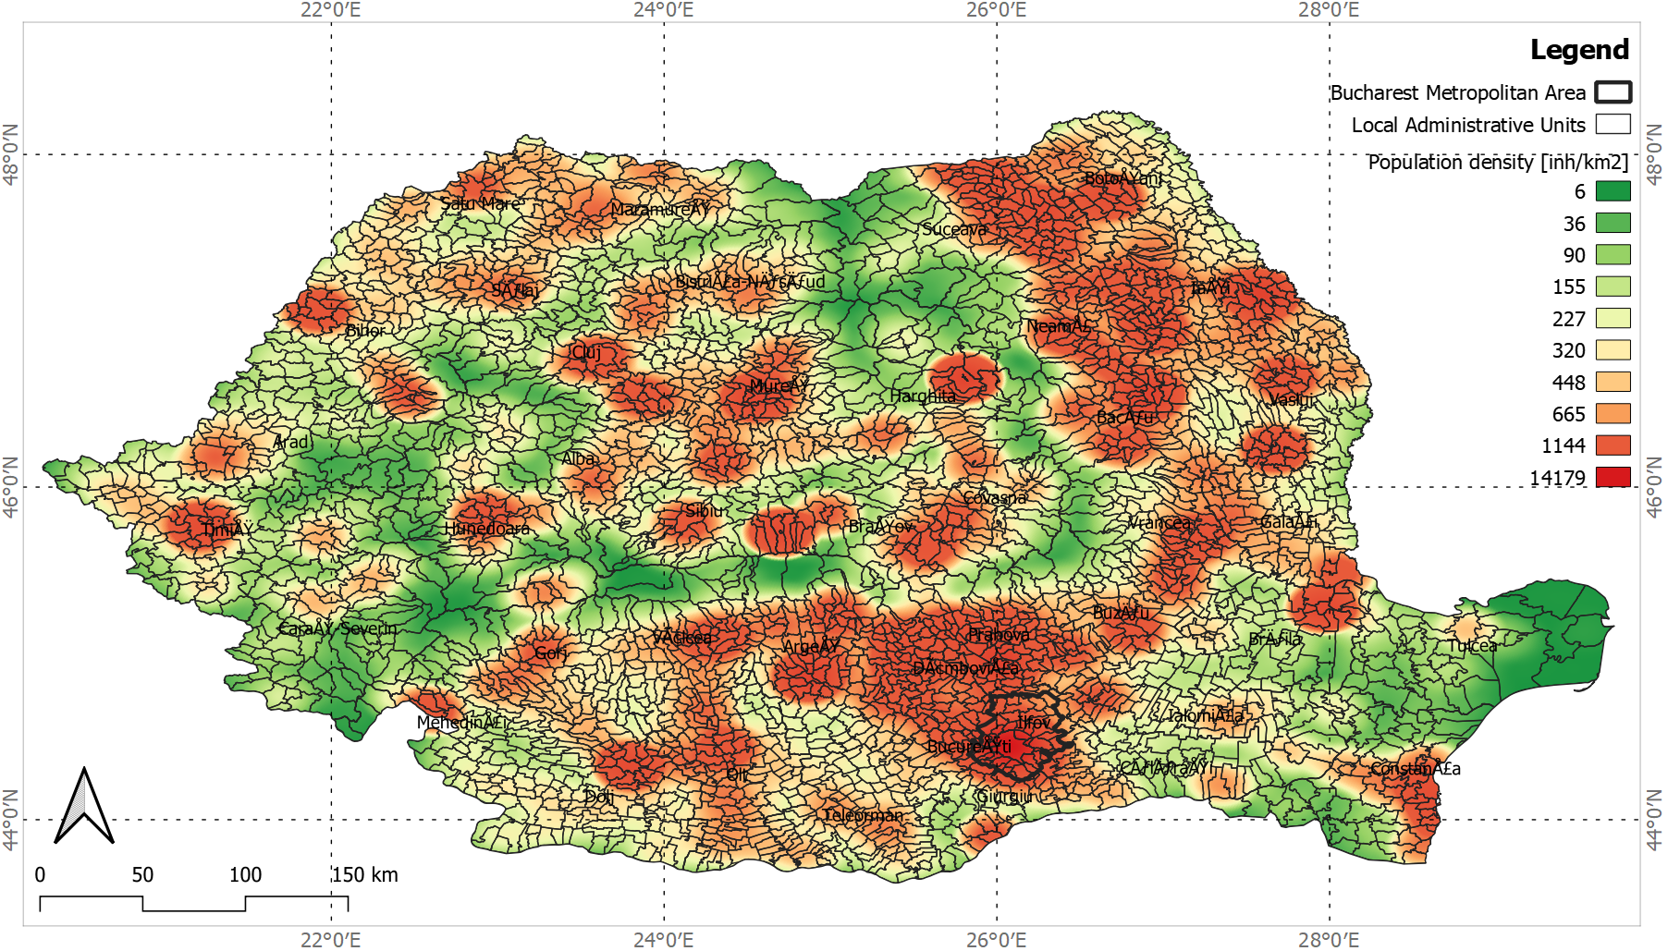
Figure S1. Heatmap of population density (inh/km2) distribution among administrative units (RO).
According to the wildfire regimes reported by Copernicus Climate Change Service during the fire season between 2015 and 2019, 1980 points overlap with surfaces marking a cumulative Burned Area Fraction (BAF) above 100. This threshold is assigned considering that a BAF value above 100 is considered a high probability that a particular location experienced a fire. Apart from burned area fraction, we utilized the fire regimes as derived from the EFFIS database. The wildfire occurrence and size are recorded based on the MODIS burned area product (MCD64A1) following the Globfire method 6. MCD64A1 products make use of Terra and Aqua satellite imagery. They are accepted as reliable for large fires (>50ha) 7.
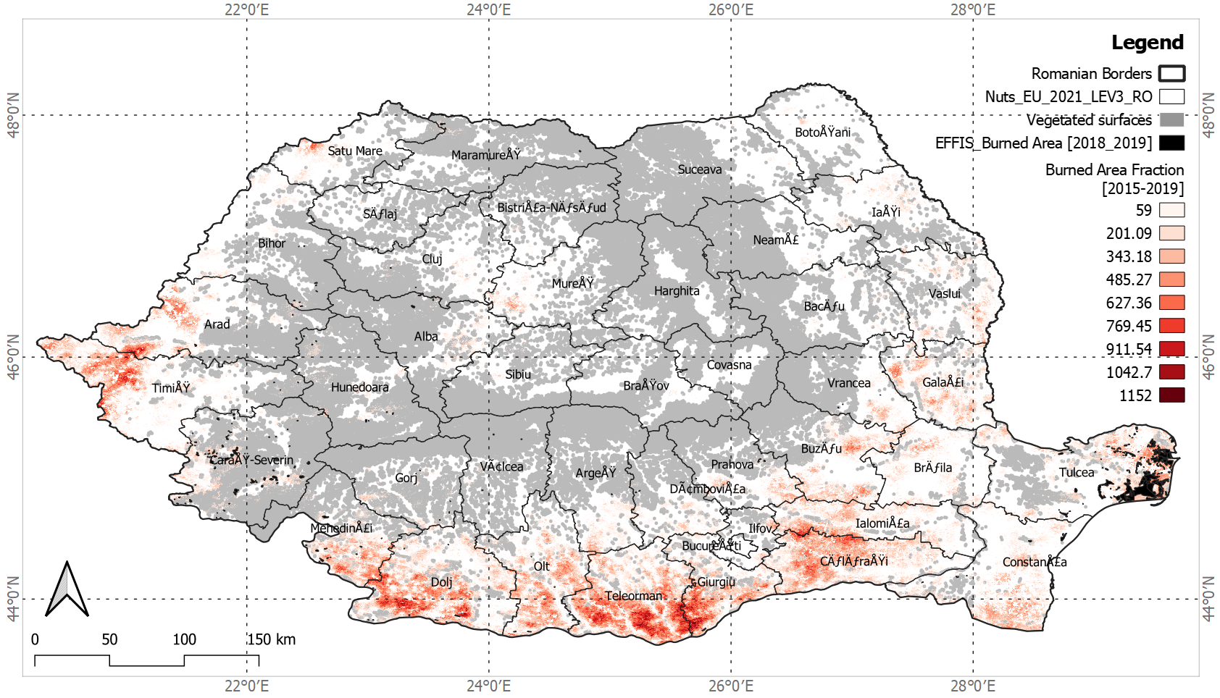
Figure S2. The burned surfaces in Romania (EFFIS, 2018-2019) and the burned area fraction. (Copernicus Climate Change Service, 2015-2019).

S3. WSCI_ROC values distribution per municipality

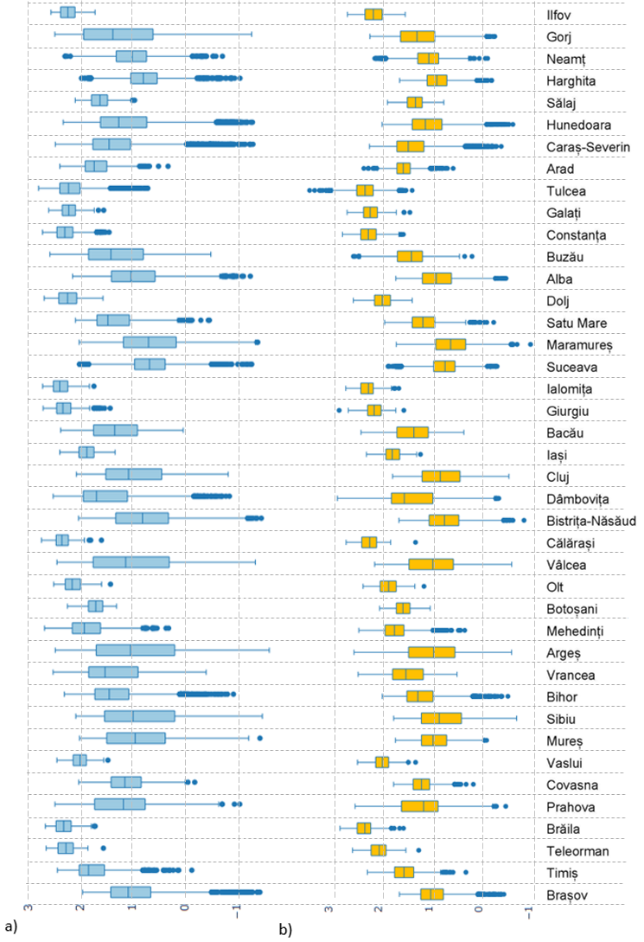
Figure S3. Box plot of (a) WIPI_ROC and (b) WSCI_ROC distribution per each administrative unit in Romania (Min, 25%, Median, 75%, Max, Outliers).
References

1 Barbu, I. Riscul la incendii în pădurile din România: cartare și metode de evaluare. Bucovina Forestieră 18, 155-163, doi:10.4316/bf.2018.015 (2018).
2 Buontempo, C. et al. Fostering the development of climate services through Copernicus Climate Change Service (C3S) for agriculture applications. Weather and Climate Extremes 27, 100226, doi:https://doi.org/10.1016/j.wace.2019.100226 (2020).
3 Loepfe, L., Lloret, F. & Román-Cuesta, R. M. Comparison of burnt area estimates derived from satellite products and national statistics in Europe. International Journal of Remote Sensing 33, 3653-3671, doi:10.1080/01431161.2011.631950 (2012).
4 Giglio, L., van der Werf, G. R., Randerson, J. T., Collatz, G. J. & Kasibhatla, P. Global estimation of burned area using MODIS active fire observations. Atmos. Chem. Phys. 6, 957-974, doi:10.5194/acp-6-957-2006 (2006).
5 Mouillot, F. et al. Ten years of global burned area products from spaceborne remote sensing—A review: Analysis of user needs and recommendations for future developments. International Journal of Applied Earth Observation and Geoinformation 26, 64-79, doi:https://doi.org/10.1016/j.jag.2013.05.014 (2014).
6 Artés, T. et al. A global wildfire dataset for the analysis of fire regimes and fire behaviour. Scientific Data 6, 296, doi:10.1038/s41597-019-0312-2 (2019).
7 Fornacca, D., Ren, G. & Xiao, W. Performance of Three MODIS Fire Products (MCD45A1, MCD64A1, MCD14ML), and ESA Fire_CCI in a Mountainous Area of Northwest Yunnan, China, Characterized by Frequent Small Fires. Remote Sensing 9, 1131 (2017).

