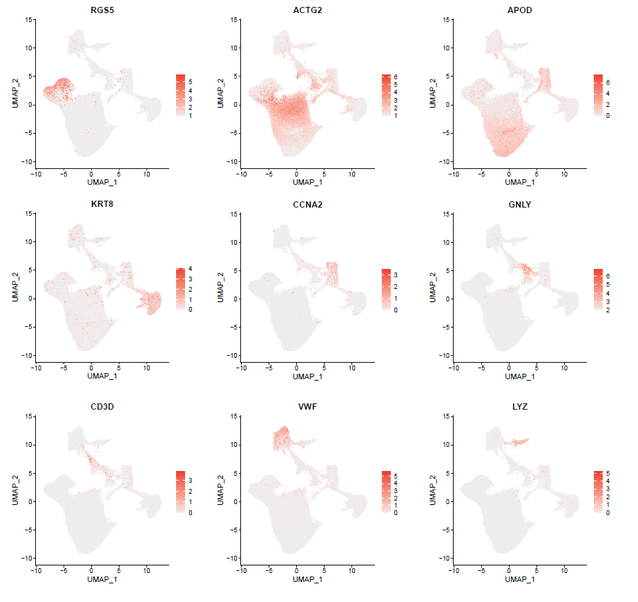
Fig. S1. UMAP plot, color-coded for relative expression (lowest expression to highest expression, white to red) of marker genes.

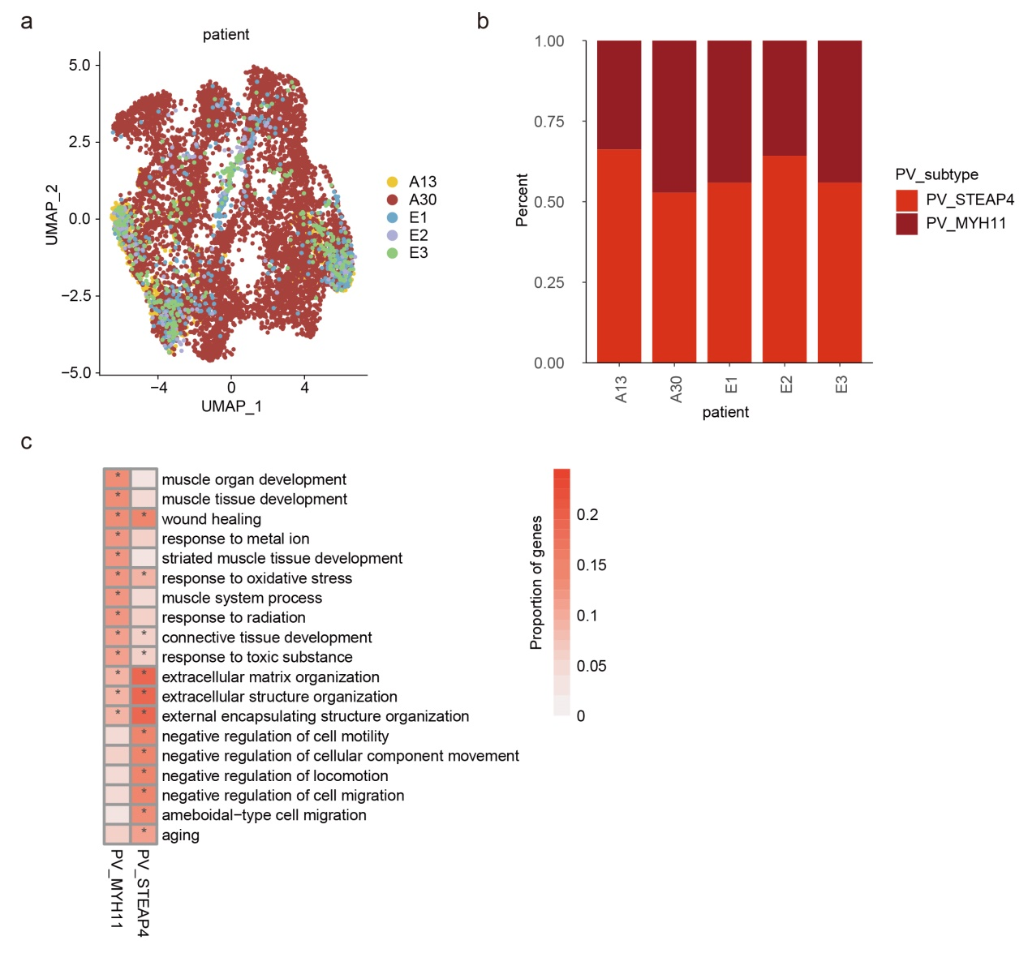
Fig. S2. PV cell clusters in human endometrium. a, UMAP plot of PV cells color-coded according to patients. b, The cell fractions of different PV cell types originating from different patients. c, Heat map showing the proportion of genes annotated in each function. *p<0.05.

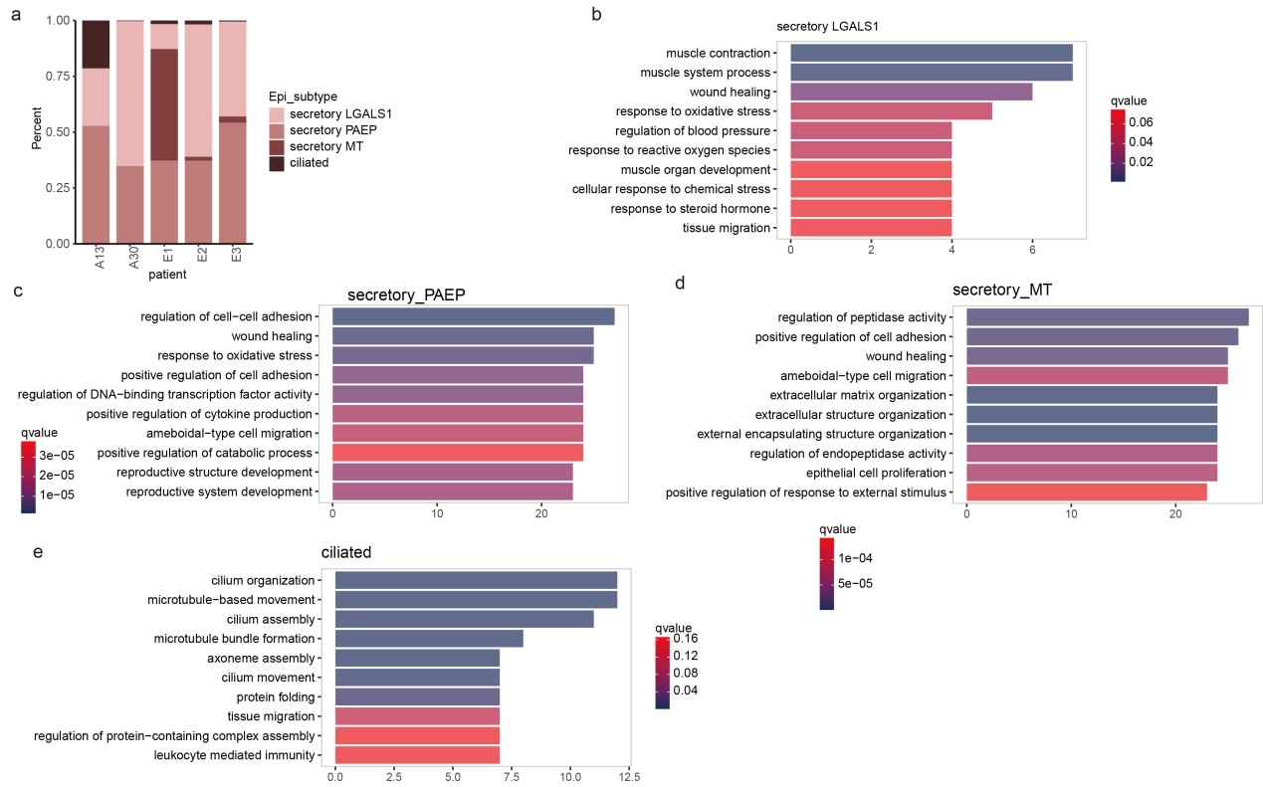
Fig. S3. Epithelial cell clusters in human endometrium. a, The cell fractions of different epithelial cell types originating from different patients. b-e, Bar plots showing the enriched functions of genes highly expressed in different epithelial cell clusters.

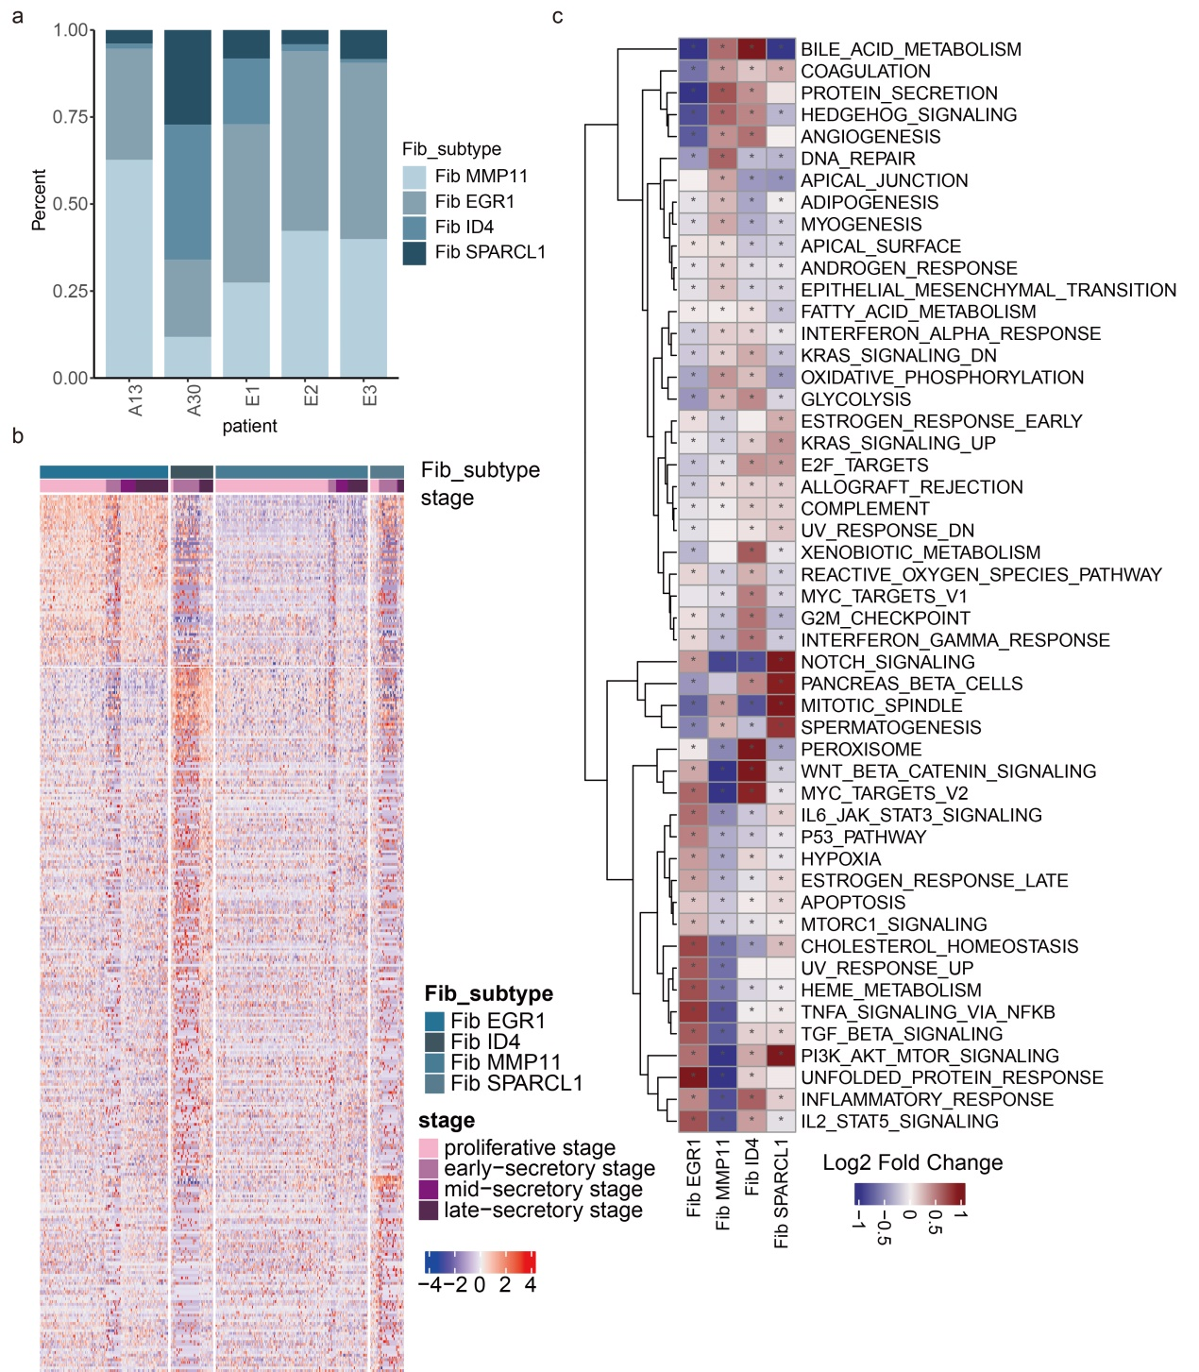
Fig. S4. Fibroblast cell clusters in human endometrium. a, The cell fractions of different fibroblast cell types originating from different patients. b, Heat map showing the expression levels of genes highly expressed in corresponding fibroblast subtypes. c, Heat map showing the differences of pathway activities among fibroblast subtypes.

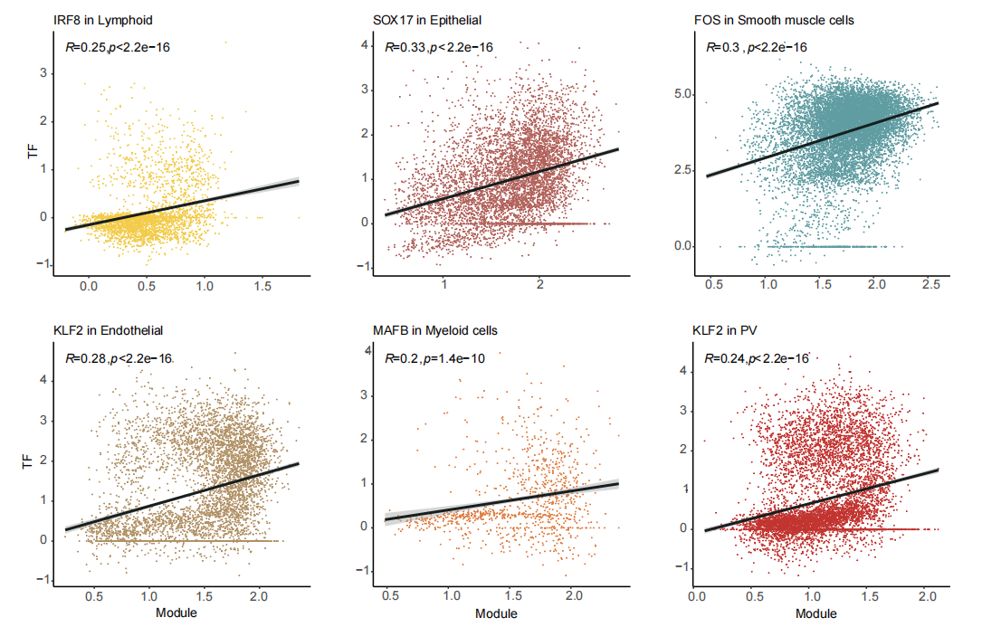
Fig. S5. Scatter plots showing the correlations between the expressions of TFs and the activities of modules.
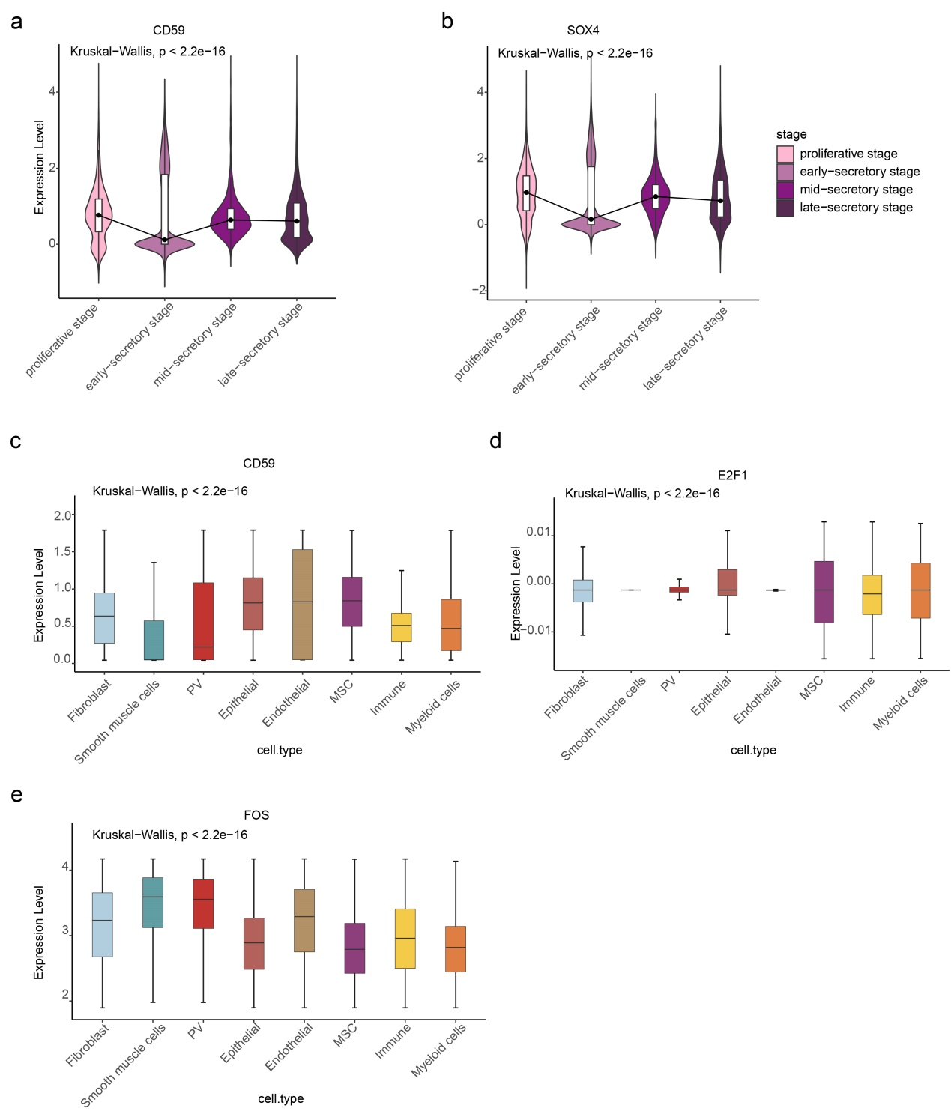
Fig. S6. Expression of marker genes across cell types.
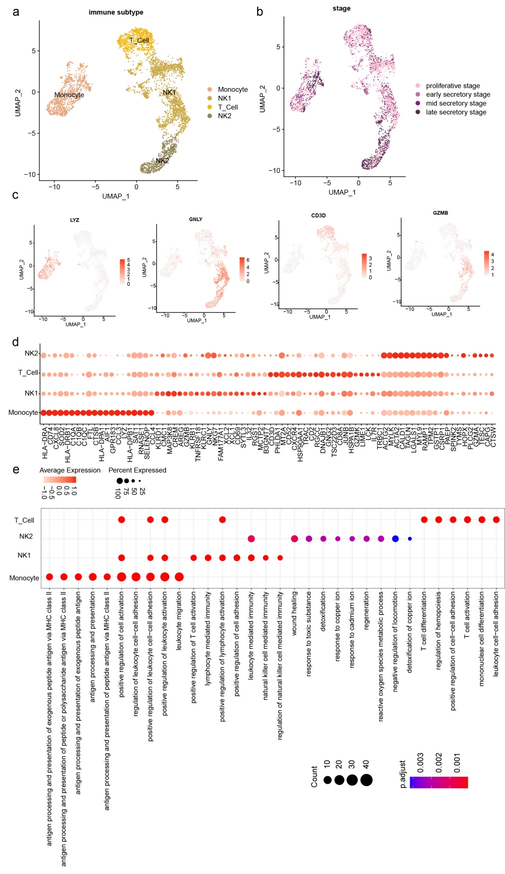
Fig. S7. Immune cell clusters in human endometrium. a, UMAP plot of immune cells color-coded according to cell types. b, UMAP plot of immune cells color-coded according to different phases. c, UMAP plots showing the expression of marker genes. d, Dot plots showing the expression levels of genes highly expressed in corresponding immune subtypes. e, Dot plots showing the enrichments of pathways among immune subtypes.

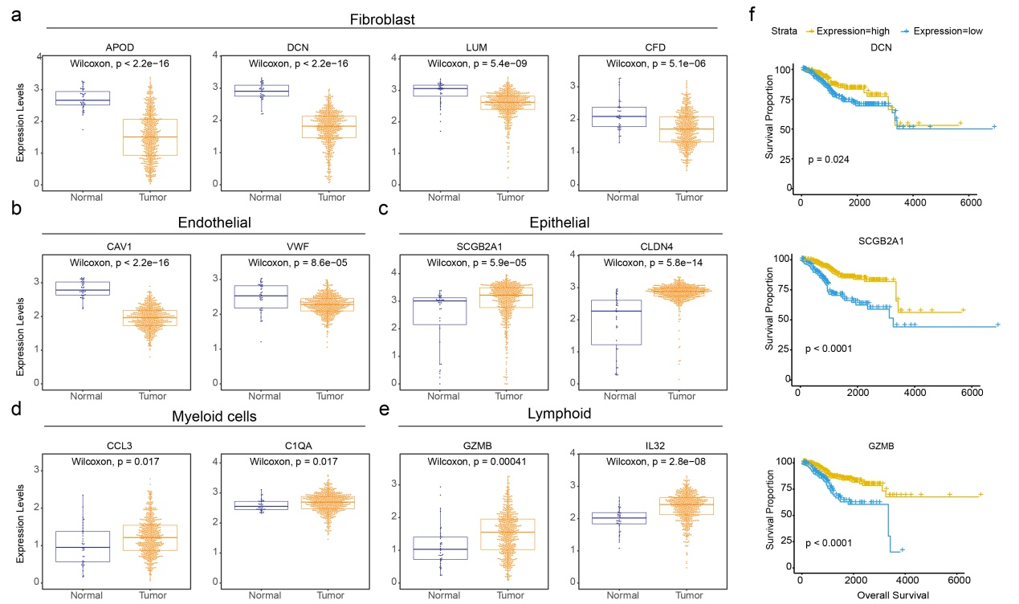
Fig. S8. The expressions and clinical relevance of genes highly expressed in cell types. A-E, Expression of genes in normal and cancer. F, The overall survival curves based on EC patients data, stratified by the expression patterns of genes.

