Supplementary Information (Materials and Methods and Suppl. Figs.)
Materials and Methods
Experimental subjects
Male and female Sprague-Dawley rats (200-250g, aged 7-9 weeks at arrival; Charles River Laboratories, strain code #400) were used for IVSA, occupancy, and autoradiography experiments. These rats were maintained under a reverse 12-h light/dark cycle with ad libitum access to food and water unless otherwise specified. Rats were housed two rats per cage before surgery and individually after surgery. Experiments were performed during dark cycle. Male Sprague-Dawley rats (300–400 g), purchased from Envigo (Frederick, MD, U.S.) were used for catalepsy, analgesia, and body temperature experiments. Male Sprague-Dawley rats (3 months-old; Charles River Laboratories) were used for the microdialysis experiments. These rats were maintained under a normal 12-h light/dark cycle with ad libitum access to food and water. Experiments were performed during the light cycle. Male and female C57BL/6J mice, ordered from the Jackson Laboratory, weighing 20–25 g, were used for psychomotor sensitization experiments. Male C57BL/6 mice (Charles River Laboratories, Wilmington, MA), experimentally naïve at the start of the study and weighing 20-25 g, were used for the locomotor activity experiments. Mice were maintained under a normal 12-h light/dark cycle with ad libitum access food and water, and experiments were performed during the light cycle. All experimental procedures were carried out in accordance with the National Institutes of Health Guide for the Care and Use of Laboratory Animals and were approved by the Animal Care and Use Committee of NIDA.

Drugs
(R,S)-methadone HCl (Cat. N. 9250-003), (R)-methadone HCl (Cat. N. 9250-005), and (S)-methadone HCl (Cat. N. 9250-004) were obtained from NIDA Drug Supply Program. All drugs were dissolved in 0.9% saline and given as a bolus of 1 ml/kg for rats (except for 100 mg/kg of S-MTD which was given at 2 ml/kg) and 10 ml/kg for mice. For IVSA experiments, (R,S)-methadone HCl was dissolved to 10 mg/ml, (R)-methadone HCl was dissolved to 5 mg/ml before dilution, and (S)-methadone HCl was dissolved to 50 mg/ml before final dilution.

Binding and enzyme target profile screen
These experiments were performed by an outside vendor (Eurofins, France). Briefly, membrane homogenates from stable cell lines or rat tissues expressing each receptor/enzyme were incubated with the respective radioligand in the absence or presence of (S)- and (R)-methadone (100 nM and 10 μM). In each experiment, the respective reference compound was tested concurrently with the test compound to assess the assay reliability. Nonspecific binding was determined in the presence of a specific agonist or antagonist at the target. Following incubation, the samples were filtered rapidly under vacuum through glass fiber filters presoaked in buffer and rinsed several times with an ice-cold buffer using a 48-sample or 96-sample cell harvester. The filters were counted for radioactivity in a scintillation counter using a scintillation cocktail.

Efflux transporter panel
These experiments were performed by an outside vendor (Eurofins, France). Briefly, membrane homogenates from stable cell lines were pre-incubated with (S)- and (R)-methadone at 10 µM followed by incubation with appropriate substrate and the presence or absence of an appropriate reference inhibitor. Efflux ratios (E) were calculated based on the apparent B–A and A–B permeability with and without verapamil. In each experiment, the respective reference compound was tested concurrently with the test compound to assess the assay reliability. Fluorescein was used as the cell monolayer integrity marker. Fluorescein permeability assessment (in the A–B direction at pH 7.4 on both sides) was performed after the permeability assay for the test compound. The cell monolayer that had a fluorescein permeability of less than 1.5 × 10−6 cm s − 1 for CaCo-2 was considered intact, and the permeability result of the test compound from intact cell monolayer was reported.

[³H]DAMGO experiments in rat brain membrane preparations
[³H]DAMGO Opioid receptor-binding assays were carried out as described previously¹. Briefly, whole rat brains minus cerebellum (BioIVT, Westbury, NY, U.S.) were thawed on ice, homogenized in 50 mM Tris HCl at pH 7.5 using a Kinematica Polytron (setting 6 for 20 s), and centrifuged at 30,000 g for 15 min at 4 °C. The supernatant was discarded, and the pellet was resuspended in fresh buffer and spun again at 30,000 g for 15 min. The pellet was resuspended to yield 100 mg/ml wet weight. Ligand binding experiments were conducted in polypropylene tubes containing 300 μl Tris buffer and 100 μl of tissue suspension for 1 h at room temperature. [³H]DAMGO (Perkin Elmer Life Sciences, Waltham, MA, U.S.) was used at 1 nM final concentration. Non-specific binding was determined in the presence of 10 μM naloxone. (R,S)-methadone, (R)-methadone and (S)-methadone stock solutions were diluted in 50 mM Tris buffer to yield the appropriate concentrations for binding assays. Incubations were terminated by rapid vacuum filtration over Whatman GF/B filters using a cell harvester (Brandel Instruments, Gaithersburg, MD, U.S.). Filters were washed three times with ice cold buffer, transferred to 24-well plates, and Cytoscint (MP Biomedicals, Irvine, CA, U.S.) was added. Radioactivity was counted the following day using a Perkin Elmer MicroBeta2 liquid scintillation counter. Raw cpm data were normalized to percent of radioligand bound, and Ki values were determined using nonlinear regression analysis (GraphPad Prism, San Diego, CA, U.S.).

Liver Microsomal Stability
Metabolic stability experiment for (R)-, (S)- and (R,S)-methadone were conducted in rat and human liver microsomes as we have previously described², with minor modification. For phase I metabolism, the reactions were carried out with 200 mM potassium phosphate buffer, pH 7.4, in the presence of NADPH regenerating system (1.3 mM NADPH, 3.3 mM glucose 6-phosphate, 3.3 mM MgCl₂, 0.4 U/mL glucose-6-phosphate dehydrogenase, 50 µM sodium citrate). Reactions in triplicate were initiated by addition of the liver microsomes to the incubation mixture (compound final concentration was 10 µM; 0.5 mg/mL microsomes). Compound disappearance over time was monitored via LC/MS. Chromatographic analysis was performed on a Dionex ultra high-performance LC system coupled with Q Exactive Focus orbitrap mass spectrometer (Thermo Fisher Scientific Inc., Waltham MA). Separation was achieved using Agilent Eclipse Plus column (100 × 2.1mm i.d; maintained at 35ºC) packed with a 1.8 µm C18 stationary phase. The mobile phase used was composed of 0.1% Formic Acid in Acetonitrile and 0.1% Formic Acid in water with gradient elution, starting with 2.5% organic phase (from 0 to 0.25 min) linearly increasing to 99% (from 0.25 to 1.25 min), and re-equilibrating to 2.5% by 4 min. The total run time for each analyte was 5 min. Pumps were operated at a flow rate of 0.4 mL/min. The mass spectrometer controlled by Xcalibur software 4.0.27.13 (Thermo Scientific) was operated with a HESI ion source in positive ionization mode for all TCK compounds. Data acquisition was performed in full-scan mode and analyzed using the extracted area ratios of the analyte (methadone = 310.2165 m/z) to the internal standard (losartan= 423.1695 m/z). Percent remaining was calculated by comparing t = 0 samples 30 and 60 min samples.

Analytical Measures

Chemicals and reagents
Optima LC-MS-grade acetonitrile was acquired from Fisher Scientific (Fair Lawn, NJ). Ammonium acetate 5M solution was obtained from obtained from ThermoFisher (Waltham, MA). HPLC-grade water was obtained from Avantor (Allentown, PA). A master stock of 3.2 mmol/L (±)-methadone was prepared in water and stored at ≤-20°C. Working stocks were prepared from the master stock and used to spike blank plasma or tissue homogenate at calibration levels of 32, 81, 162, 323, 808, and 1,616 nmol/L for plasma and at 0.06, 0.16, 0.32, 0.65, 1.62, and 3.23 pmol/mg for tissue.
Tissue and Plasma Extraction
Frozen brain tissue was thawed from ≤-70°C and weighed. Tissue was transferred to a homogenizing tube containing ceramic beads and 2 mL of water was added per 1 g of tissue. Each tissue sample was homogenized using a Bead Ruptor 12 homogenizer (Omni International, Kennesaw, GA) for 3 cycles of 30 seconds each on high. 100 μL of tissue homogenate was protein precipitated with 500 µL acetonitrile. Plasma extraction was performed by protein precipitation with 400 µL acetonitrile to 100 µL plasma thawed from ≤-70°C. The samples were shaken for 10 minutes at 2,000 rpm with a ThermoMixer C (Eppendorf, Enfield, CT) and centrifuged at 14,000 g for 10 minutes at 4°C in a Sorvall ST 40R centrifuge (ThermoFisher, Waltham, MA). 250 μL of the supernatant was collected and evaporated to dryness at 40°C under a stream of nitrogen gas in a Microvap Nitrogen Evaporator (Organomation, Berlin, MA). The residue was reconstituted with 125 µL of 85:15 10 mM ammonium acetate, pH 7.0/acetonitrile, shaken for 3 min at 2,000 rpm, and centrifuged at 14,000 g for 10 min. 60 μL of the supernatant were transferred to the autosampler where 10 µL was injected into the UHPLC-MS system. Samples exceeding the upper limit of quantification were further diluted to fall within the analytical measuring range.

UHPLC-MS conditions
Separation analysis was performed using a Vanquish UHPLC system (ThermoFisher, Waltham, MA) with tandem Orbitrap Exploris 120 mass spectrometer (ThermoFisher, Waltham, MA). Reverse phase chromatography was performed using a ChiralPak AGP 4 x 100 mm, 5 µm particle size column (Daicel, West Chester, PA) with an isocratic flow of 0.7 mL/min at 85:15 10 mM ammonium acetate ph 7.0/ acetonitrile for 30 minutes. Analysis was performed in positive ion mode with a full scan mass range of 265 – 370 m/z and a mass accuracy of 5 ppm. Ionization was conducted using a heated electron spray ionization (HESI) source. XCalibur v 4.4.16.14 (ThermoFisher, Waltham, MA) software was used to integrate and report peak area for the M+H ion (310.2163 m/z) at a retention time of 16.0 minutes ((R)-methadone) and 21.1 minutes ((S)-methadone). GraphPad Prism v 9.3.1 (GraphPad, San Diego, CA) was used to plot and fit a standard curve and to interpolate unknown values.

Autoradiography

Ex vivo [³H]DAMGO or [³H]MK-801 occupancy
Male and female rats were treated with saline, (R,S)-methadone (4 mg/kg sc), (R)-methadone (2 mg/kg sc), or (S)-methadone (30 mg/kg sc) 30 minutes before decapitation and tissue extraction. Brains were flash frozen and stored at -80°C until processed. Flash-frozen brains were separated by hemisphere and sectioned (20 µm) on a cryostat (Leica) and thaw mounted on ethanol cleaned glass slides. For [³H]DAMGO, 50mM Tris-HCl buffer containing 5 nM [³H]DAMGO (46 Ci/mmol, NIDA Drug Supply) was pipetted onto slides and allowed to incubate for 10 minutes at room temperature. For [³H]MK-801, 5mM Tris-HCl buffer, containing 100µM glutamate, 100µM glycine and 5 nM [³H]MK-801 (30 Ci/mmol, Novandi) was pipetted onto slides and allowed to incubate for 10 minutes at room temperature. For non-specific binding cold DAMGO (10µM) or cold MK-801 (1mM) was also added. The sections were then washed by 2x 30 second washes in their respective Tris buffers. Finally, slides were dipped in ice cold distilled water to remove salts. Sections were allowed to dry and slides were placed into a Hypercassette™ covered by a BAS-TR2025 phosphor screen (FujiFilm; GE Healthcare). The slides were exposed to the phosphor screen for 10 days and then imaged using a phosphor imager (Typhoon FLA 7000; GE Healthcare). The digitized images were calibrated using ¹⁴C standard slides (American Radiolabeled Chemicals). Regions of interest (ROIs) were hand-drawn based on anatomical landmarks and radioactivity was quantified using Multigauge software (GE Healthcare). The activity in 6–10 different sections was averaged per animal and brain region. MOR activity was normalized to brain concentration. Percent occupancy was computed as $100-(\frac{sample {nCi}/g}{average saline {nCi}/g}×100)$. One statistical outlier was excluded from (R,S)-methadone group.

[³H]DAMGO or [³H]MK-801 Autoradiography
Male and female rats were treated with saline, (R,S)-methadone (4 mg/kg sc), (R)-methadone (2 mg/kg sc), or (S)-methadone (30 mg/kg sc) once a day for eight days. Twenty-four hours after the last treatment, rats were decapitated, and brains extracted and flash frozen. Brains were stored at -80°C until processed. Brains were sectioned (20 µm) on a cryostat (Leica) and thaw mounted on ethanol cleaned glass slides. For [³H]DAMGO, slides were pre-incubated in 50mM Tris-HCl buffer for 10 minutes at room temperature. For [³H]MK-801, slides were pre-incubated in 5mM Tris-HCl buffer, containing 100µM glutamate and 100µM glycine for 30 minutes at room temperature. The pre-incubation buffer was removed and the slides were placed in the respective incubation buffers containing 5 nM [³H]DAMGO (46 Ci/mmol, NIDA Drug Supply) for 45 minutes or 5 nM [³H]MK-801 (30 Ci/mmol, Novandi) for 60 minutes at room temperature (total binding). For non-specific binding cold DAMGO (10µM) or cold MK-801 (1mM) was also added. The sections were then washed by two 30 second – 2 minute washes in the Tris buffer. Finally, slides were dipped in ice cold distilled water to remove salts. Sections were allowed to dry and slides were placed into a Hypercassette™ covered by a BAS-TR2025 phosphor screen (FujiFilm; GE Healthcare). The slides were exposed to the phosphor screen for 7 days and then imaged using a phosphor imager (Typhoon FLA 7000; GE Healthcare). The digitized images were calibrated using ¹⁴C standard slides (American Radiolabeled Chemicals). Regions of interest (ROIs) were hand-drawn based on anatomical landmarks and radioactivity was quantified using Multigauge software (GE Healthcare). The activity in 6–10 different sections was averaged per animal and brain region.

Ex vivo [³⁵S]GTPγS autoradiography
Flash-frozen brains were sectioned (20 µm) on a cryostat (Leica) and thaw mounted on ethanol cleaned glass slides. Preincubation buffer (50mM Tris-HCl, 1 mM EDTA, 5 mM MgCl2, and 100mM NaCl) was pipetted onto each slide and allowed to incubate for 20 min. The preincubation buffer was removed via aspiration and each slide was loaded with GDP in the presence of DPCPX and allowed to incubate for 60 min (Preincubation buffer, 2mM GDP, 1 μM DPCPX, Millipore water). GDP buffer was removed via aspiration and [³⁵S]GTPγS cocktail (GDP buffer, 1.3mM DTT, 2.7mM GDP, 1.3 μM DPCPX, 83 pM [³⁵S]GTPγS) with the indicated drugs (DAMGO 10 μM or methadone enantiomers 1 μM or 0.1 μM), without drugs (basal condition), or with a saturated concentration of nonradioactive GTP (for nonspecific binding) was pipetted onto each slide and allowed to incubate for 90 min. In case of antagonist pre-treatment, naloxone (10 μM) or (S)-methadone (10 μM) was added to the GDP buffer, and the [³⁵S]GTPγS cocktail contained the indicated drug plus naloxone (10 μM) or (S)-methadone (10 μM). The [³⁵S]GTPγS cocktail was removed via aspiration and slides were washed in ice-cold washing buffer (50mM Tris-HCl, 5 mM MgCl2, pH 7.4) for 5 min (2×) followed by a 30 s dip in ice-cold deionized water. Slides were allowed to dry and placed into a Hypercassette™ covered by a BAS-SR2040 phosphor screen (FujiFilm; GE Healthcare). The slides were exposed to the phosphor screen for 3 days and imaged using a phosphor imager (Typhoon FLA 7000; GE Healthcare). Regions of interest (ROIs) were hand-drawn based on anatomical landmarks and radioactivity was quantified using Multigauge software (GE Healthcare). The activity in 6–10 different sections was averaged per animal and brain region.

Intravenous drug self-administration

Intravenous surgery
The procedure is based on our previous study³. Rats were anesthetized with isoflurane (5% induction; 2–3% maintenance). Catheters were made from Silastic tubing attached to a modified 22-gauge cannula (Plastics One, Cat# C313G5up) and cemented to polypropylene mesh (Elko Filtering Co., Cat# 05-1000/45). The catheter was inserted into the jugular vein, and the mesh was fixed to the mid-scapular region of the rat. Rats were injected with carprofen (2.5 mg/kg, SC, Norbrook) after surgery and on the following day to relieve pain and decrease inflammation. Rats recovered for 5–8 days before drug self-administration training. During all experimental phases, catheters were flushed daily with gentamicin (4.25 mg/ml, Fresenius Kabi, Cat# 1002) dissolved in sterile saline. If we suspected catheter failure and at the end of the experiment, we tested patency with a short-acting barbiturate anesthetic Brevital (methohexital sodium, 10 mg/ml in buffered saline, 0.2 ml injection volume, IV).

Apparatus
All rats were trained and tested in standard Med Associates self-administration chambers. Each chamber had either one or two retractable levers located 7.5–8 cm above the grid floor. Lever presses on the active lever activated the infusion pump, whereas lever presses on the inactive lever had no consequences. Each session began with the illumination of a house light that remained on for the entire session. The active and inactive lever was inserted into the chamber 10 s after the house light was illuminated. Each infusion was paired with a 20-s white-light cue and there was a 20-s timeout before responses resulted in another infusion. At the end of the session, the house light was turned off and levers were retracted.

Behavioral procedure
For (R)-methadone and (S)-methadone pilot IVSA: Rats were restricted to 18-20 g of chow per day and trained to self-administer either (R)-methadone (female n = 4; male n = 2) or (S)-methadone (female n = 1; male n = 4) on an FR1 schedule (3 h/day). Methadone was infused over 3.5 s at a dose of 50 µg/kg/infusion. Responses on the active lever during the timeout period were recorded but did not result in methadone infusions. Responses on the inactive were recorded but had no consequences. After 16 sessions, the dose of (S)-methadone was increased to 100 µg/kg/infusion, then to 200 µg/kg/infusion after another 6 sessions, and finally to 500 µg/kg/infusion after 4 sessions. Dose Response: After this training period, rats trained on (R)-methadone were placed on a multiple-dose schedule to observe dose-dependent (R)-methadone self-administration (3.125, 6.25, 12.5, 25, 50, or 100 μg/kg/infusion) for 3 h/day for 6 consecutive days. (R)-methadone rats were then retrained on the 50 µg/kg/infusion dose until stable. (R)-methadone rats were then switched to (S)-methadone (500 µg/kg/infusion; rats trained on (S)-methadone were maintained on this dose) until stable. All rats were then placed on a multiple-dose schedule to observe dose-dependent (S)-methadone self-administration 62.5, 125, 250, 500, or 1000 μg/kg/infusion) for 3 h/day for 5 consecutive days. For methadone enantiomers IVSA: Rats were restricted to 18-20 g of chow per day and trained to self-administer either (R,S)-methadone (female n = 4; male n = 4; 100 µg/kg/infusion), (R)-methadone (female n = 2; male n = 3; 50 µg/kg/infusion), or (S)-methadone (female n = 4; male n = 4; 500 µg/kg/infusion) for 3 h/day. For the first 10 training sessions, infusions were on an FR1 schedule; however, for session 11-15, the schedule was increased to FR5. Dose response: After 15 days of training, rats were placed on a multiple-dose schedule to observe dose-dependent methadone self-administration ((R,S)- methadone doses 6.25, 12.5, 25, 50, 100, or 200 μg/kg/infusion; (R)-methadone doses 3.125, 6.25, 12.5, 25, 50, or 100 μg/kg/infusion; (S)-methadone doses 25, 50, 100, 200, 500, or 1000 μg/kg/infusion for 3 h/day for 6 consecutive days. Four of the (S)-methadone trained rats (female n = 2, male n = 2) were then placed on (R)-methadone until stable (2 days of FR1, followed by 5 days of FR5) and put through the same dose response.

Analgesia, catalepsy and hypothermia in rats

On the day of an experiment, rats were brought into the laboratory in their home cages and allowed 1 h to acclimate. Groups of rats (n = 5 per dose group) received s.c. injections of vehicle (1 ml/kg saline), (R,S)-methadone (0.3, 1, 3 or 10 mg/kg), (R)-methadone (0.1, 0.3, 1 or 3 mg/kg) or (S)-methadone (3, 10, 30 or 100 mg/kg) on the lower back between the hips and were returned to their home cages. Each rat was tested twice in separate experimental sessions, with at least 3 days of washout between experiments, and doses were randomly assigned. Pharmacodynamic endpoints including catalepsy score, body temperature, and hot plate latency, were determined prior to injection and at 15, 30, 60, 120, and 240 min post-injection⁴. At each timepoint, behavior was observed for 1 min by an experienced rater, and catalepsy was scored based on three overt symptoms: immobility, flattened body posture, and splayed limbs. Each symptom was scored as either 1 = absent or 2 = present, and catalepsy scores at each time point were summed, yielding a minimum score of 3 and a maximum score of 6. Next, body temperature was measured using a hand-held reader sensitive to signals emitted by the surgically implanted transponder. We chose to examine hypothermia as a representative adverse effect of opioid treatment, since body temperature is a physiological measure that decreases in parallel with opioid-induced bradycardia and respiratory depression⁵. Finally, rats were placed on a hot plate analgesia meter (IITC Life Sciences, Woodland Hills, CA, U.S.) set at 52 °C. Rats remained on the hot plate until they exhibited hind paw licking in response to the heat stimulus and were then returned to their home cages. Time spent on the hot plate was recorded using a timer triggered by a foot pedal. A 45 s cut-off was employed to prevent tissue damage. Pharmacodynamic findings were analyzed using GraphPad Prism 9. Raw time-course data for hot plate latency and catalepsy score were normalized to percent maximum possible effect (%MPE), using the following equation: (experimental measure − baseline measure)/(maximum possible response − baseline measure) X 100. The maximum possible response for hot plate latency was 45 s, whereas the maximal response for catalepsy score was 6. Raw time-course data for body temperature were normalized to change from baseline, Δ temperature in °C, for each rat. Normalized time-course data were analyzed by two-factor (dose x time) ANOVA followed by Tukey’s post hoc test to determine effects of drug doses at each time point. Mean hot plate latency and catalepsy score over the first 60 min were used to construct dose–response relationships, which were analyzed by nonlinear regression (response stimulation, normalized response) to determine ED50 (potency) values
Locomotor activity in mice

Locomotor activity was recorded immediately after the animals were introduced in the activity chambers with 42.0 x 42.0 cm open fields (Coulbourn Instruments). After 60 min of habituation, they were systemically administered (R,S)-methadone (3, 10 or 30 mg/kg, s.c.), (R)-methadone (1, 3, 10, or 30 mg/kg, s.c.) or (S)-methadone (10, 30 or 100 mg/kg, s.c.) and locomotor activity was recorded for an additional 60 min-period. In another group of experiments, (S)-methadone (10 or 30 mg/kg, s.c.) was administered 15 min before (R)-methadone (10 mg/kg, s.c.). All values registered per 10 min were transformed (square root) to reduce the asymmetric statistical distribution of the recorded raw data (skewness to the right) and decrease significant differences in the variances between differently treated groups⁶. The average of the results obtained from the 10 min-periods recorded for 1 h was used for calculations. One-way ANOVA followed by Tukey’s post hoc comparisons was used to compare the results of different groups (n = 7-12 per group) see figure legends for statistical results). Statistical analysis was performed with GraphPad Prism 9 software. Mice were euthanized using CO2 followed by decapitation at the end of the locomotor activity recording.

Psychomotor sensitization in mice

Wild-type mice (C57BL/6J, 20–25 g, N= 96, female n = 48, male n= 48) were tested for methadone-induced locomotor sensitization. The locomotor sensitization experiment was divided into two phases: habituation, and induction. During habituation, mice were injected with saline (0.9% NaCl) for two consecutive days. For the induction phase, mice were injected with (R,S)-methadone (4, 10, or 20 mg/kg; female n = 4, male n= 4 for each dose), (R)-methadone (2, 5, or 10 mg/kg; female n = 4, male n= 4 for each dose), or (S)-methadone (20, 30, or 40 mg/kg; female n = 4, male n= 4 for each dose), for three consecutive days. In the experiment to see if (S)-methadone antagonized (R)-methadone, mice were injected with saline (0.9% NaCl) twice 15 minutes apart for two consecutive days during the habituation phase. For the induction phase, mice were injected with saline, or (S)-methadone (10 or 30 mg/kg) and 15 minutes later all mice were injected with (R)-methadone (10 mg/kg; female n = 4, male n = 4 for each group) for three consecutive days. All drugs were administered IP and mice were placed in an open field arena (Opto-varimex ATM3, Columbus Instruments) five minutes after injection. Locomotor activity was tracked for 30 min as infrared beam crossing and traveled distance were converted to cm. Two-way ANOVA followed by Holm-Sidak post hoc comparisons was used to compare the results of different groups. Statistical analysis was performed with GraphPad Prism 9 (San Diego, CA).

In vivo microdialysis in rats

Rats were anesthetized with a mixture of ketamine/xylazine (80 and 10 mg/kg, respectively; NIDA Pharmacy) and implanted unilaterally in the ventral tegmental area (coordinates in millimeters from bregma with a 10° angle in the coronal plane: anterior, -5.6; lateral, 2.4; vertical, -9) with a microdialysis probe. After surgery, rats were allowed to recover in hemispherical CMA-120 cages (CMA Microdialysis) equipped with two-channel overhead fluid swivels (Instech) connected to a sample collector (CMA 470, CMA). Twenty-four hours after implanting the probes, experiments were performed on freely moving rats in the same hemispherical home cages in which they recovered overnight from surgery. An artificial cerebrospinal solution (CSS) containing (in mM) 144 NaCl, 4.8 KCl, 1.7 CaCl2, and 1.2 MgCl2 was pumped through the probe at a constant rate of 1 µl/min. After a washout period of 90 min, dialysate samples were collected at 20 min intervals. After two hours of analyzing basal levels of dopamine, (R)-methadone (3 or 10 µM) or (S)-methadone (10 or 100 µM) were dissolved in the CSS, were intracerebrally perfused, in the VTA, by reverse dialysis for 60 min and then switched back to CSS alone for an additional 60 min-period. In another experiment, (S)-methadone (100 µM) was perfused alone for 20 min and followed by a combined perfusion of (S)-methadone (100 µM) and (R)-methadone (10 µM). At the end of the experiment, rats were euthanized by a pentobarbital sodium overdose, as supplied in pentobarbital sodium-based veterinary euthanasia solution (NIDA Pharmacy; 10 ml/kg, i.p.) Brains were then removed and kept in a 4% formalin solution for one week before they were cut in serial coronal slices to identify probe placement using cresyl violet staining. Dopamine dialysate content was measured by HPLC coupled with a coulometric detector (5200a Coulochem III; ESA). The effect of (R)-MTD, (S)-MTD or their combined application on the extracellular dopamine concentration in the VTA was analyzed by comparing the average of the values of the three samples obtained during the perfusion of the drugs (alone in n or combined in o) versus the average of the five previous values, using Wilcoxon test. * and **: P < 0.05 and P < 0.01 (7–9 animals/group). Statistical analysis was performed with GraphPad Prism 9 software.

BRET and CODA-RET assays and radioligand binding experiments in mammalian transfected cells

Expression vectors and fusion proteins
Sequences encoding amino acids residues 1-229 and 230-311 of Renilla Luciferase (RLuc8 variant) and amino acid residues 1-155 and 156-238 of the monomeric Venus variant (mVenus) of the yellow fluorescence protein (YFP) were subcloned in pcDNA3.1 vector to obtain complementary RLuc hemi-truncated proteins (nRLuc, cRLuc). To obtain receptors fused to the full RLuc or to the different hemi-truncated proteins, human cDNAs for MOR and Gal₁R cloned into pcDNA3.1 were amplified without their stop codons using sense and antisense primers harboring EcoRV and KpnI to clone MOR and EcoRI and KpnI to clone Gal₁R. The amplified fragments were subcloned to be in-frame with restriction sites of pcRLuc-N1 vector (pRLuc-N1 PerkinElmer, Wellesley, MA, USA), pcDNA3.1-nRLuc or pcDNA3.1-cRLuc, to provide plasmids that express the receptor fused to RLuc, nRLuc or cRLuc on the C-terminal end of the receptor. In addition, we used the human G protein constructs Gαi1-YFP (with YFP, mVenus variant, inserted at position 91), untagged Gβ1 and untagged Gγ2. Several constructs were genereously shared by C. Gales at INSERM (Toulouse, France; Gαi1 construct) and N. Lambert (Georgia Regents University, Augusta, GA; Gαs). All constructs were confirmed by sequencing analysis, and their expression was tested by confocal microscopy, and the receptor-fusion protein functionality by ERK1/2 phosphorylation.

Cell cultures and transient transfection
Human embryonic kidney (HEK) cells stably expressing MORs (MU cells) or both MORs and Gal1Rs (MU-GAL cells) were generated as described before (Cai et al., 2019). MU and MU-Gal cells and transiently transfected HEK-2937 (obtained from ATCC) were maintained in culture with Dulbecco’s modified Eagle’s medium (DMEM) (Gibco, ThermoFisher Scientific, MA, USA), supplemented with 2 mM L-glutamine, 100 U/ml penicillin/streptomycin, MEM Non-Essential Amino Acid Solution (1/100), and 5% (v/v) heat-inactivated fetal bovine serum 5% fetal bovine serum (all supplements were from Gibco) and kept in an incubator at 37 ◦C and 5% CO₂ with selection antibiotics. MU cells were maintained with hygromycin B (50 μg/ml; Invitrogen, ThermoFisher Scientific) and MU-GAL cells with hygromycin B (50 μg/ml) and Geneticin (400 μg/ml; Gibco, ThermoFisher Scientific). Cells were kept below passage 20. For transient transfection, HEK-293T cells growing in 10-cm or 6-well dishes were transfected with the corresponding cDNAs by the polyethylenimine (PEI, Sigma) method. Cells were incubated (4 h) with the corresponding cDNA together with PEI (5.47 mM in nitrogen residues) and 150 mM NaCl in a serum-starved medium. After 4 h, the medium was changed to a fresh complete culture medium. Forty-eight hours after transfection, cells were washed twice in quick succession in Hank’s balanced salts solution [containing the following (in mM): 137 NaCl, 5 KCl, 0.34 Na₂HPO₄ x12 H₂O, 0.44 KH₂PO₄, 1.26 CaCl₂ x2H₂O, 0.4 MgSO₄ x7H₂O, 0.5 MgCl₂, 10 HEPES, pH 7.4], supplemented with 0.1% glucose (w/v) and detached and resuspended in the same buffer. Cell number was controlled by determining sample protein concentration using a Bradford assay kit (Bio-Rad, Munich, Germany) with bovine serum albumin (BSA) dilutions as standards.

[³H]Naloxone competitive-inhibition experiments
MU and MU-GAL cell suspensions were disrupted with a Polytron homogenizer (PTA 7 rotor, setting 3; Kinematica, Basel, Switzerland) for two 5 s-periods in 10 volumes of 50 mM Tris-HCl buffer, pH 7.4, containing a protease inhibitor cocktail (Sigma-Aldrich, St. Louis, MO, USA). Membranes were obtained by centrifugation twice at 105.000 g for 45 min at 4ºC. The pellet was stored at -80ºC, washed once more as described above and resuspended in 50 mM Tris-HCl buffer for immediate use. Membrane protein was quantified by the bicinchoninic acid method (Pierce Chemical Co., Rockford, IL, USA) using bovine serum albumin dilutions as standard. Binding experiments were performed with membrane suspensions (0.2 mg of protein/ml) at room temperature in 50 mM Tris-HCl buffer, pH 7.4, containing 5 mM MgCl₂. For competition-binding experiments, membrane suspensions were incubated for 2 h with a constant free concentration of 1.7 nM of [³H]naloxone (PerkinElmer, Boston, MA, USA) and free increasing concentrations of (R,S)-methadone (British Pharmacopoeia Comm. Lab., Teddington, UK), (R)-methadone (Toronto Research Chemicals, Toronto, Canada) or (S)-methadone (Toronto Research Chemicals). Free and membrane-bound ligands were separated by rapid filtration of 400 μl aliquots in a cell harvester (Brandel, Gaithersburg, MD, USA) through Whatman GF/C filters embedded in 0.3% polyethylenimine that were subsequently washed for 5 s with 5 ml of ice-cold 50 mM Tri(S)-HCl buffer. The filters were incubated with 10 ml of Ultima Gold MV scintillation cocktail (PerkinElmer, Waltham, MA, USA) overnight at room temperature and radioactivity counts were determined using a Tri-Carb 2900TR scintillation counter (Packard, Meriden, CT, USA) with an efficiency of 45%. Data were analyzed according to the ‘dimer receptor model’⁷. In competition experiments, the model analyzes the interactions of the radioligand with a competing ligand and it provides the affinity of the competing ligand for the first protomer in the unoccupied dimer (K_{DB1}), the affinity of the competing ligand for the second protomer when the first protomer is already occupied by the competing ligand (K_{DB2}) or the radioligand (K_{DAB}), and an index of cooperativity of the competing ligand (D_{CB}). A positive or negative value of D_{CB} implies either an increase or a decrease in affinity of K_{DB2} versus K_{DB1} and its absolute value provides a measure of the degree of ligand cooperativity. Radioligand binding curves were analyzed by nonlinear regression using the commercial Grafit curve-fitting software (Erithacus Software, Surrey, UK), by fitting the binding data to the mechanistic dimer receptor model, as described in detail elsewhere⁷.

Bioluminescence resonance energy transfer (BRET)
HEK-293T cells were co-transfected with MOR-RLuc (0.25 μg), as well as with Gαi1-YFP (5 μg) and untagged Gβ1 (4.5 μg) and Gγ2 (5 μg) subunits. Experiments were performed approximately 48 hours after transfection. The transient transfected cells were collected, washed, and resuspended in Dulbecco’s PBS (DPBS) with 0.1% glucose and 200 μM sodium bisulfite. Approximately 200,000 cells/well were distributed in 96-well plates, and 5 μM coelenterazine H (NanoLight Technology) was added. Fluorescence of the acceptor was quantified (excitation at 500 nm and emission at 540 nm for 1-s recording) to confirm the constant expression level across experiments. Two minutes after the addition of coelenterazine, increasing concentrations of (R,S)-methadone, (R)-methadone or (S)-methadone were added to different wells. The plate was read after agonist addition using a Mithras LB940 microplate reader (Berthold Technologies). BRET signal from cells was calculated as the ratio of the light emitted by Rluc8 at 485 nm to that emitted by YFP (mVenus variant) at 530 nm. A BRET change was defined as the BRET ratio for the corresponding drug minus the BRET ratio in the absence of the drug. E_{max} and EC₅₀ values are expressed as the basal subtracted BRET change in the concentration-response graphs.

Complemented donor-acceptor resonance energy transfer (CODA-RET)
HEK-293T cells co-transfected with MOR-cRLuc (3.3 μg) and Gal₁R-nRluc (1.6 μg), and co-transfected with Gαi1-YFP (5 μg) and untagged Gβ1 (4.5 μg) and Gγ2 (5 μg) subunits. 48 h after transfection the cells were harvested, washed, and resuspended in phosphate-buffered saline (PBS). About 200,000 cells/well were distributed in 96-well plates, and 5 μM coelenterazine H was added to each well. Two minutes after the addition of coelenterazine, increasing concentrations of (R,S)-methadone, (R)-methadone or (S)-methadone were added to different wells. Fluorescence of the acceptor was quantified (excitation at 500 nm and emission at 540 nm for 1-s recording) in the Mithras LB940 reader to confirm the constant expression level across experiments. In parallel, BRET signal from the same batch of cells was determined as the ratio of the light emitted by YFP (mVenus variant; 530 nm) over RLuc (485 nm). Results were calculated for the BRET change (BRET ratio for the corresponding drug minus BRET ratio in the absence of the drug) 5 min after addition of the agonists. Nonlinear fitting to obtain E_{max} and EC₅₀ values for all CODA-RET, BRET and statistical analysis was performed with GraphPad Prism 9 software. Differences in E_{max} and EC₅₀ values were analyzed by repeated measures ANOVA (with posthoc Dunnett’s test) and Friedman test (with posthoc Dunn’s test), respectively.

Computational methods

The active MOR-fentanyl-Gi cryo-EM structure (PDB id 8EF5) ⁸ was used in docking studies and molecular dynamics (MD) simulations. Ab initio conformational analysis and geometry optimization of (S)- and (R)-methadone were performed at the HF/6-31G* level of theory. Obtained energy minima were docked into the orthosteric binding cavity using the Molecular Operating Environment software (Chemical Computing Group Inc., Montreal, Quebec, Canada). Computational models of MOR-MOR homodimers were built via the TM 4/5 dimeric interface of the β₁-adrenergic receptor (4GPO) ⁹ or via the TM 5/6 interface of the MOR structure (4DKL) ¹⁰, as previously performed¹¹. These structures were embedded in a lipid bilayer box, constructed using PACKMOL-memgen¹², containing 1-palmitoyl-2-oleoyl-sn-glycero-3-phosphocholine, water molecules, and monoatomic Na+ and Cl- ions. MD simulation of these systems was performed with GROMACS 2019¹³ using the protocol previously reported ¹⁴. The analysis of the trajectories was performed with MDAnalysis¹⁵ and GetContacts (https://getcontacts.github.io/).

Data Availability Statement
The datasets generated during and/or analyzed during the current study are available from the corresponding author on reasonable request.
Methods References
1 Vandeputte, M. M. et al. Pharmacological evaluation and forensic case series of N-pyrrolidino etonitazene (etonitazepyne), a newly emerging 2-benzylbenzimidazole 'nitazene' synthetic opioid. Arch Toxicol 96, 1845-1863 (2022). https://doi.org:10.1007/s00204-022-03276-4
2 Berhane, I. et al. Thieno[2,3-d]pyrimidine-Based Positive Allosteric Modulators of Human Mas-Related G Protein-Coupled Receptor X1 (MRGPRX1). J Med Chem 65, 3218-3228 (2022). https://doi.org:10.1021/acs.jmedchem.1c01709
3 Bonaventura, J. et al. Pharmacological and behavioral divergence of ketamine enantiomers: implications for abuse liability. Molecular psychiatry 26, 6704-6722 (2021). https://doi.org:10.1038/s41380-021-01093-2
4 Bergh, M. S., Bogen, I. L., Garibay, N. & Baumann, M. H. Pharmacokinetics and pharmacodynamics of cyclopropylfentanyl in male rats. Psychopharmacology (Berl) 238, 3629-3641 (2021). https://doi.org:10.1007/s00213-021-05981-x
5 Wong, B. et al. Effects of inhaled aerosolized carfentanil on real-time physiological responses in mice: a preliminary evaluation of naloxone. Inhal Toxicol 29, 65-74 (2017). https://doi.org:10.1080/08958378.2017.1282065
6 Anden, N. E. & Grabowska-Anden, M. Stimulation of D1 dopamine receptors reveals direct effects of the preferential dopamine autoreceptor agonist B-HT 920 on postsynaptic dopamine receptors. Acta Physiol Scand 134, 285-290 (1988). https://doi.org:10.1111/j.1748-1716.1988.tb08490.x
7 Casado, V. et al. Useful pharmacological parameters for G-protein-coupled receptor homodimers obtained from competition experiments. Agonist-antagonist binding modulation. Biochem Pharmacol 78, 1456-1463 (2009). https://doi.org:10.1016/j.bcp.2009.07.012
8 Zhuang, Y. et al. Molecular recognition of morphine and fentanyl by the human mu-opioid receptor. Cell 185, 4361-4375 e4319 (2022). https://doi.org:10.1016/j.cell.2022.09.041
9 Huang, J., Chen, S., Zhang, J. J. & Huang, X. Y. Crystal structure of oligomeric beta1-adrenergic G protein-coupled receptors in ligand-free basal state. Nat Struct Mol Biol 20, 419-425 (2013). https://doi.org:10.1038/nsmb.2504
10 Manglik, A. et al. Crystal structure of the μ-opioid receptor bound to a morphinan antagonist. Nature 485, 321-326 (2012). https://doi.org:10.1038/nature10954
11 De Oliveira, P. A. et al. Preferential Gs protein coupling of the galanin Gal(1) receptor in the micro-opioid-Gal(1) receptor heterotetramer. Pharmacol Res 182, 106322 (2022). https://doi.org:10.1016/j.phrs.2022.106322
12 Schott-Verdugo, S. & Gohlke, H. PACKMOL-Memgen: A Simple-To-Use, Generalized Workflow for Membrane-Protein-Lipid-Bilayer System Building. J Chem Inf Model 59, 2522-2528 (2019). https://doi.org:10.1021/acs.jcim.9b00269
13 Abraham, M. J. et al. GROMACS: High performance molecular simulations through multi-level parallelism from laptops to supercomputers. SoftwareX 1-2, 19-25 (2015). https://doi.org:https://doi.org/10.1016/j.softx.2015.06.001
14 Navarro, G. et al. Experimental and computational analysis of biased agonism on full-length and a C-terminally truncated adenosine A(2A) receptor. Comput Struct Biotechnol J 18, 2723-2732 (2020). https://doi.org:10.1016/j.csbj.2020.09.028
15 Michaud-Agrawal, N., Denning, E. J., Woolf, T. B. & Beckstein, O. MDAnalysis: a toolkit for the analysis of molecular dynamics simulations. J Comput Chem 32, 2319-2327 (2011). https://doi.org:10.1002/jcc.21787
16 Lomize, M. A., Pogozheva, I. D., Joo, H., Mosberg, H. I. & Lomize, A. L. OPM database and PPM web server: resources for positioning of proteins in membranes. Nucleic Acids Res. 40, D370-376 (2012). https://doi.org:10.1093/nar/gkr703

Supplementary Table 1. Affinity values obtained by fitting data from competition experiments of the antagonist [³H]naloxone binding to MOR vs. MTD in MOR and MOR-Gal₁R cells
 |  | MOR |  |  |  |  |  |  | MOR-Gal₁R
Opioid |  | K_{DB1}ª | K_{DB2}ª |  | D_{CB} |  |  |  |  | K_{DB1}ª | K_{DB2}ª | D_{CB}
(R,S)-MTD |  | 3.2±0.4 | 65±9 | -0.7 |  |  |  |  |  | 2.3±0.6 | 105±25 | -1.1
(R)-MTD |  | 1.1±0.1 | 65±10 |  | -1.2 |  |  |  |  | 1.6±0.4 | 45±10 | -0.8
(S)-MTD |  | 16±3***,## | 1440±370**,## |  | -1.3 |  |  |  |  | 22±3***,### | 1500±300***,### | -1.2
ª in nM
Values are mean ± SEM, n=4-5
**p<0.01, ***p<0.001 vs (R)-MTD; ##p<0.01, ###p<0.001 vs (R,S)-MTD within MOR or MOR-Gal₁R cells; two-way ANOVA followed by Tukey’s post-hoc test

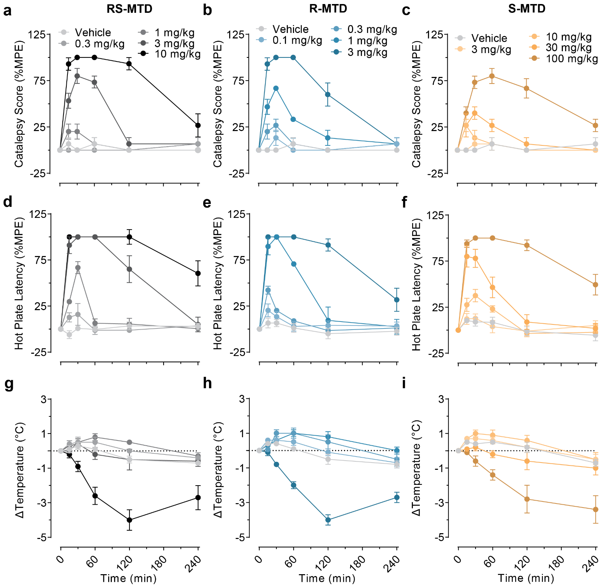Supplementary Fig. 1. Time course of effects of methadone and its enantiomers. a-c, Time course of the effects of (R,S)-MTD, (R)-MTD, or (S)-MTD on catalepsy. d-f, Time course of the effects of (R,S)-MTD, (R)-MTD, or (S)-MTD on hotplate latency. g-i, Time course of the effects of (R,S)-MTD, (R)-MTD, or (S)-MTD on body temperature. Values are shown as mean ± standard error of the mean. MTD = methadone.
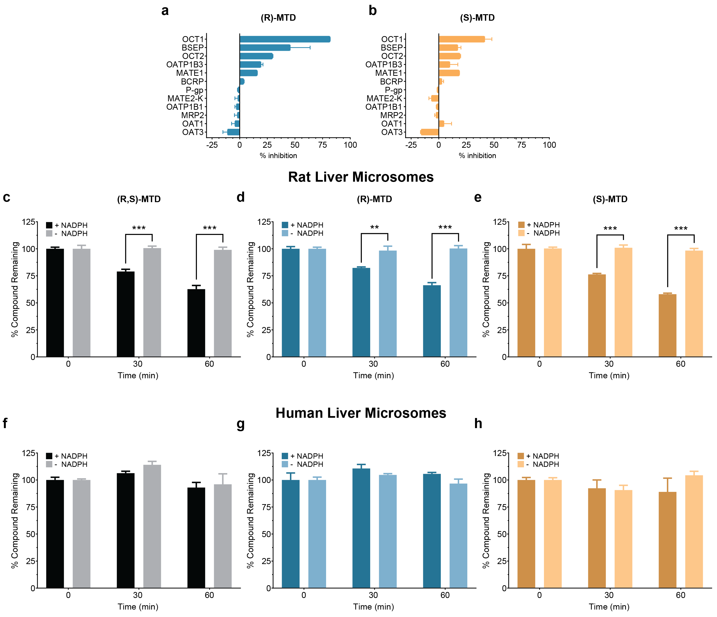Supplementary Fig. 2. Efflux panel and metabolic stability profile of (R)-MTD and (S)-MTD. a-b, Efflux pump competitive screen of (R)-MTD and (S)-MTD. c-e, metabolic stability of (R,S)-MTD, (R)-MTD, or (S)-MTD in liver microsomes from rats. f-h, metabolic stability of (R,S)-MTD, (R)-MTD, or (S)-MTD in liver microsomes from humans. Values are shown as mean ± standard error of the mean. BCRP = breast cancer resistance protein; BSEP = bile salt export pump; MATE1 = multidrug and toxin extrusion transporter 1; MATE2-K = multidrug and toxin extrusion transporter 2-K; MRP2 = multidrug resistance protein 2; MTD = methadone; NADPH = Nicotinamide Adenine Dinucleotide Phosphate; OAT1 = organic anion transporter 1; OATP1B1 = organic anion transporting polypeptides 1B1; OATP1B3 = organic anion transporting polypeptides 1B3; OAT3 = organic anion transporter 3; OCT1 = organic cation transporter 1; OCT2 = organic cation transporter 2; P-gp = P-glycoprotein. *P < 0.05, **P < 0.01, ***P < 0.001.

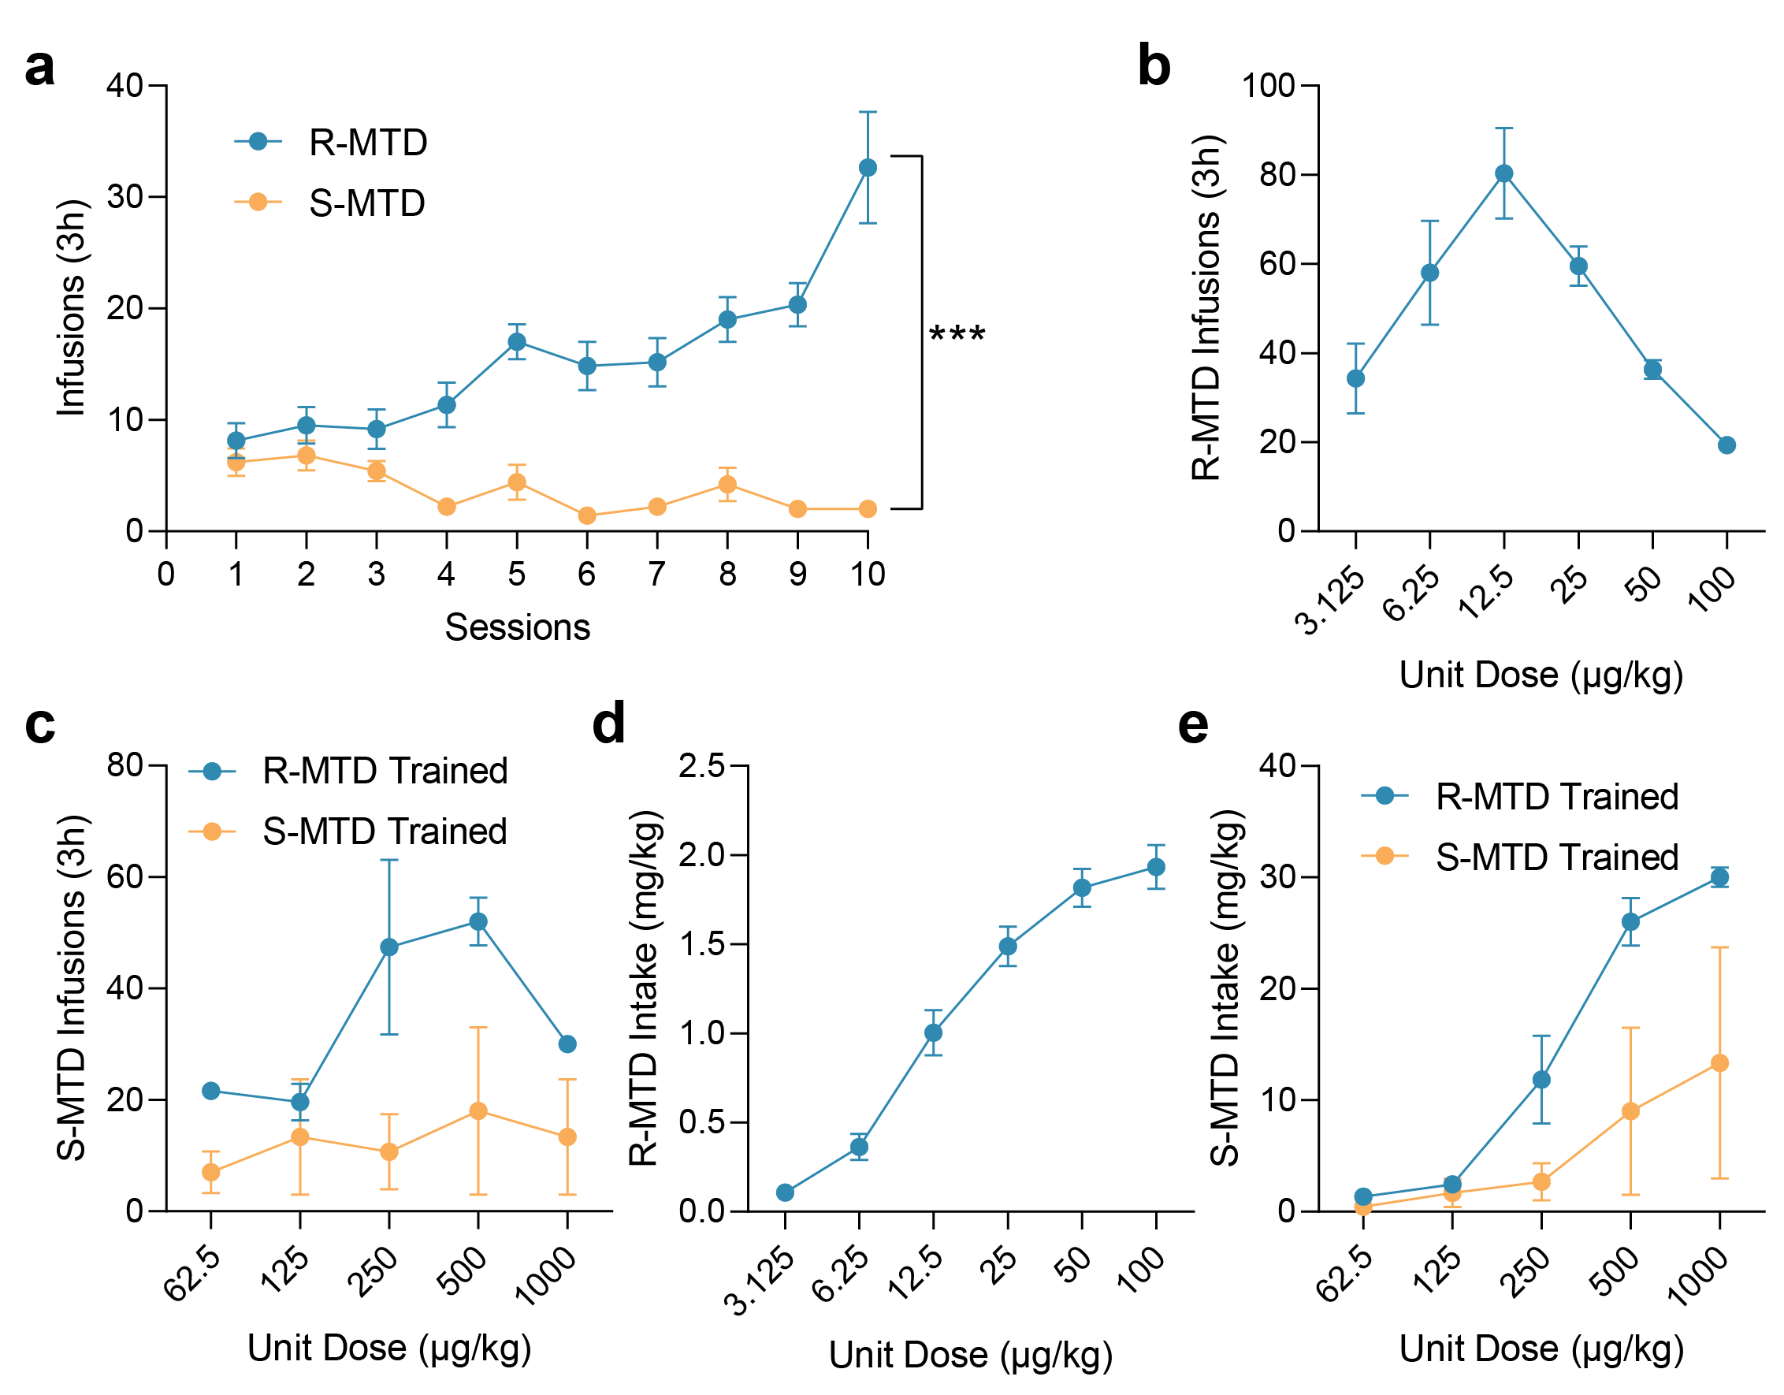Supplementary Fig. 3. IVSA Dose Optimization. a, IV infusions of (R)- or (S)-MTD during training at 50 μg/kg/infusion. b, Dose response of rats to (R)-MTD. c, Dose response to (S)-MTD from rats either trained to press for (R)-MTD or (S)-MTD. d, Cumulative dose of (R)-MTD during dose response. e, Cumulative dose of (S)-MTD during dose response from rats either trained to press for (R)-MTD or (S)-MTD. Values are shown as mean ± standard error of the mean. IVSA = intravenous self-administration, MTD = methadone. ***P < 0.001.

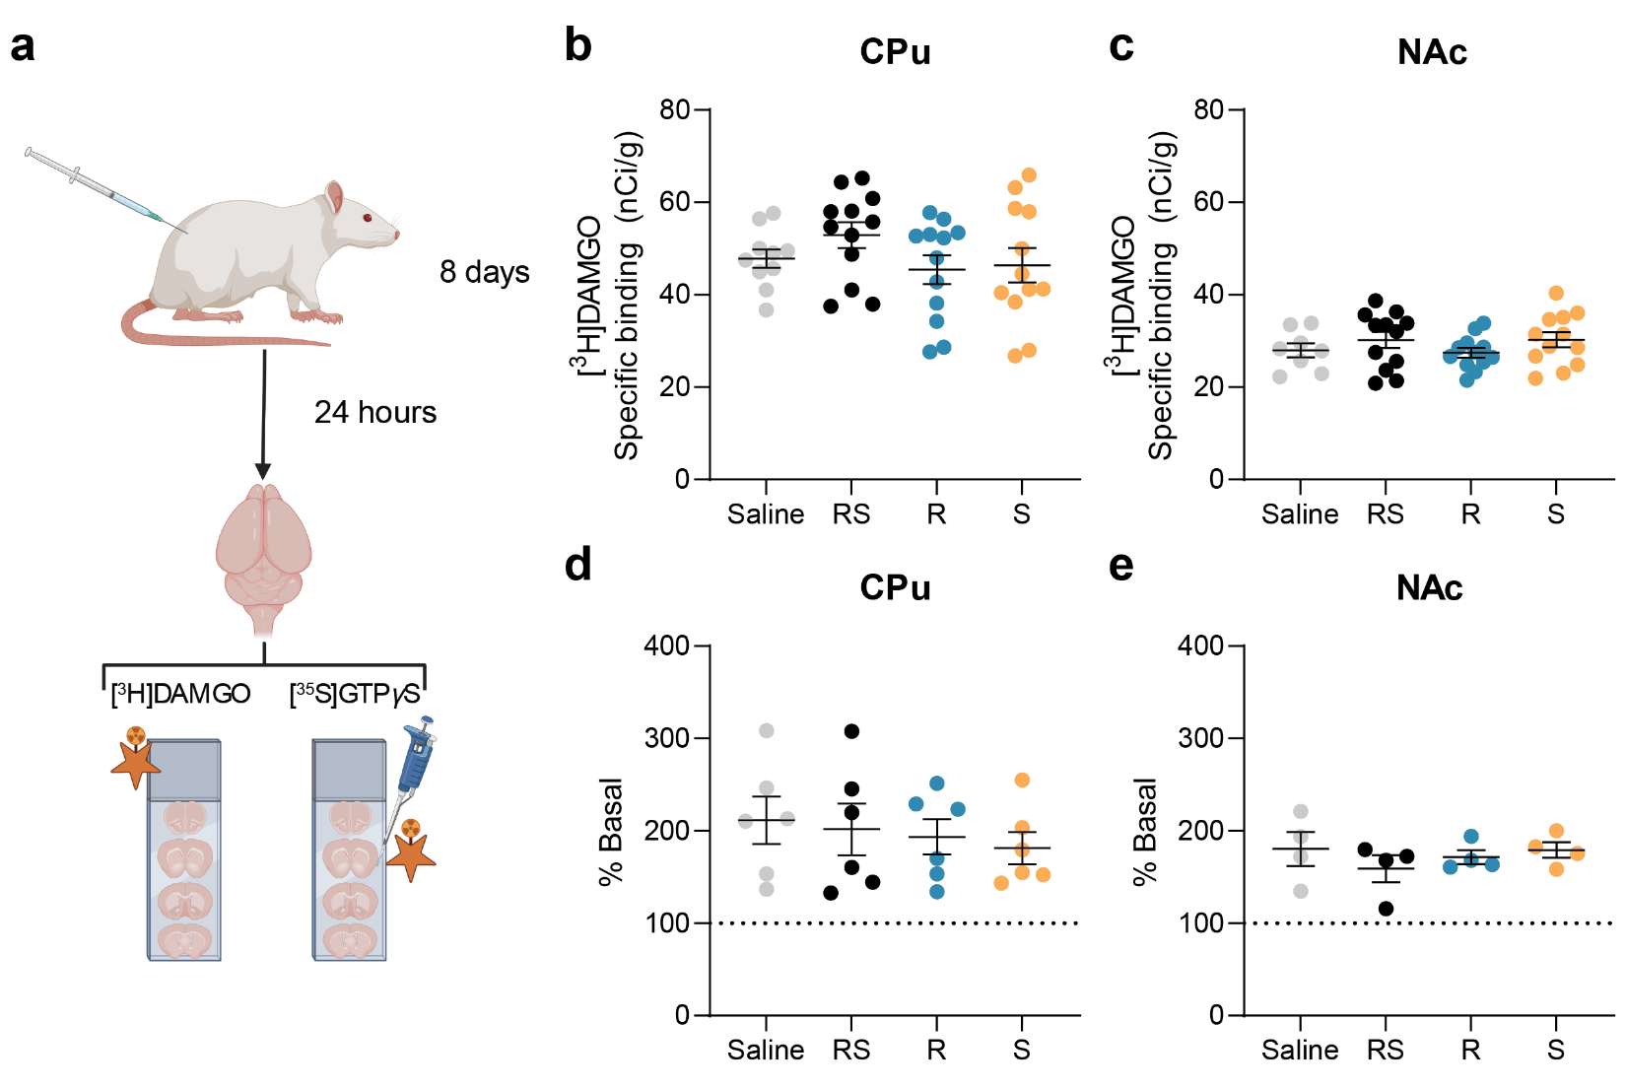Supplementary Fig. 4. Repeated administration of methadone does not affect MOR density or sensitivity. Created with BioRender.com. a, Schematic of repeated dosing experiment. b-c, analysis of [³H]DAMGO autoradiography in the CPu (b) and NAc (c) after repeated methadone administration. d-e, analysis of DAMGO-stimulated [³⁵S]GTPγS in the CPU (d) and NAc (e) after repeated methadone administration. Values are shown as mean ± standard error of the mean. CPu = Caudate putamen; MOR = μ opioid receptor; MTD = methadone; NAc = nucleus accumbens

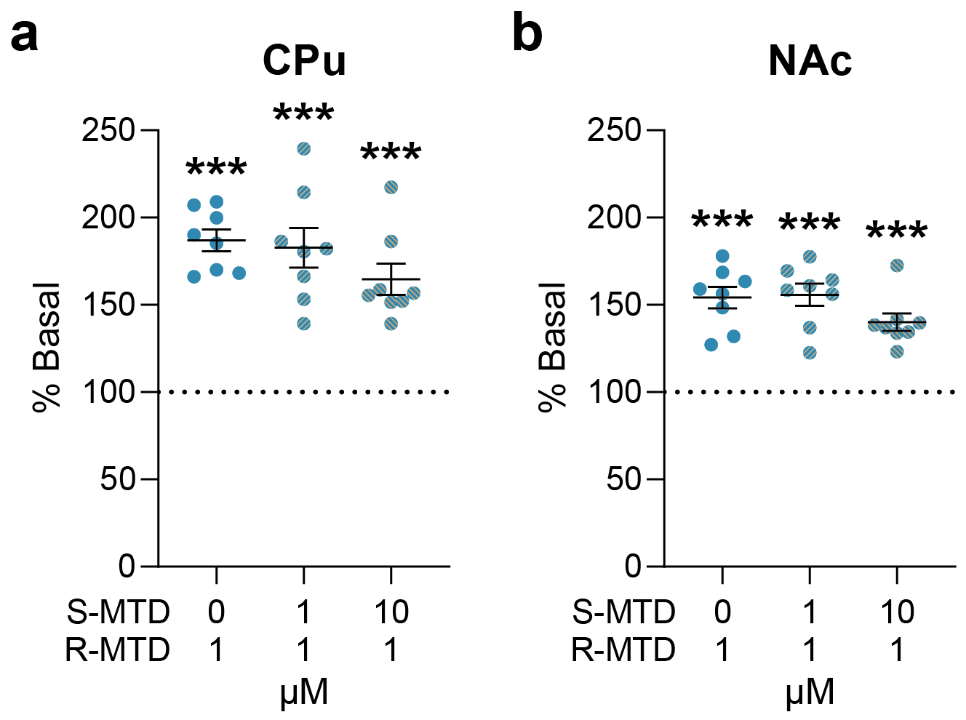
Supplementary Fig. 5. S-MTD does not antagonize R-MTD-induced MOR activation in CPu or NAc. Analysis of [³⁵S]GTPγS recruitment by R-MTD (1 μM) with or without preincubation of S-MTD (1 μM or 10 μM) in the CPu (a) or NAc (b). Values are shown as mean ± standard error of the mean. CPu = caudate putamen; MOR = μ opioid receptor; MTD = methadone; NAc = nucleus accumbens. ***P < 0.001 compared to basal (100%).

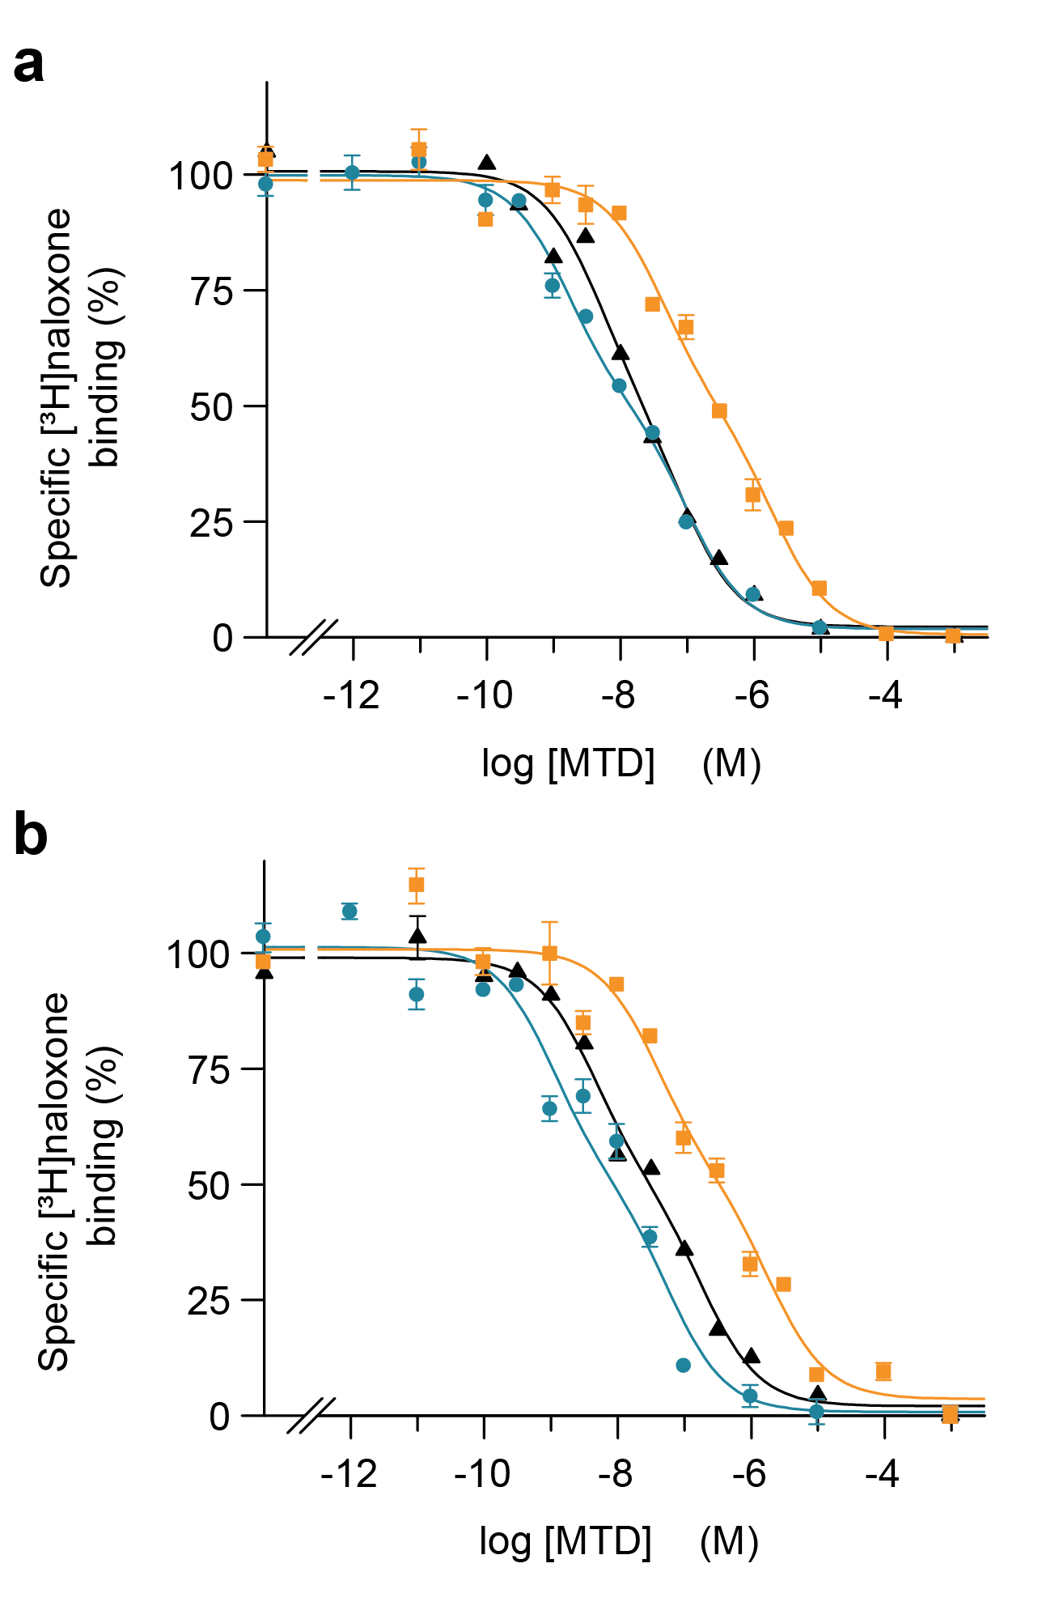

Supplementary Fig. 6. Radioligand binding to MOR in membranes from stably transfected HEK-293T cells. Representative competition curves of the MOR antagonist [³H]naloxone (1.7 nM) vs. increasing concentrations of three opioid agonists in MOR (a) or MOR-Gal₁R (b) cells. Experimental data were fitted to the “dimer receptor model” equations, as described in the Materials and Methods section. Values are expressed as a percentage of the specific binding without competitor (100% is 1.1 ± 0.2 pmol/mg protein in a and 0.12 ± 0.03 pmol/mg protein in b). (R,S)-MTD in black (triangle), (R)-MTD in blue (circle) and (S)-MTD in orange (square). Values are mean ± standard error of the mean from a representative experiment (n = 4-5) performed in triplicate. MOR = μ opioid receptor; MTD = methadone; Gal₁R = galanin1 receptor.

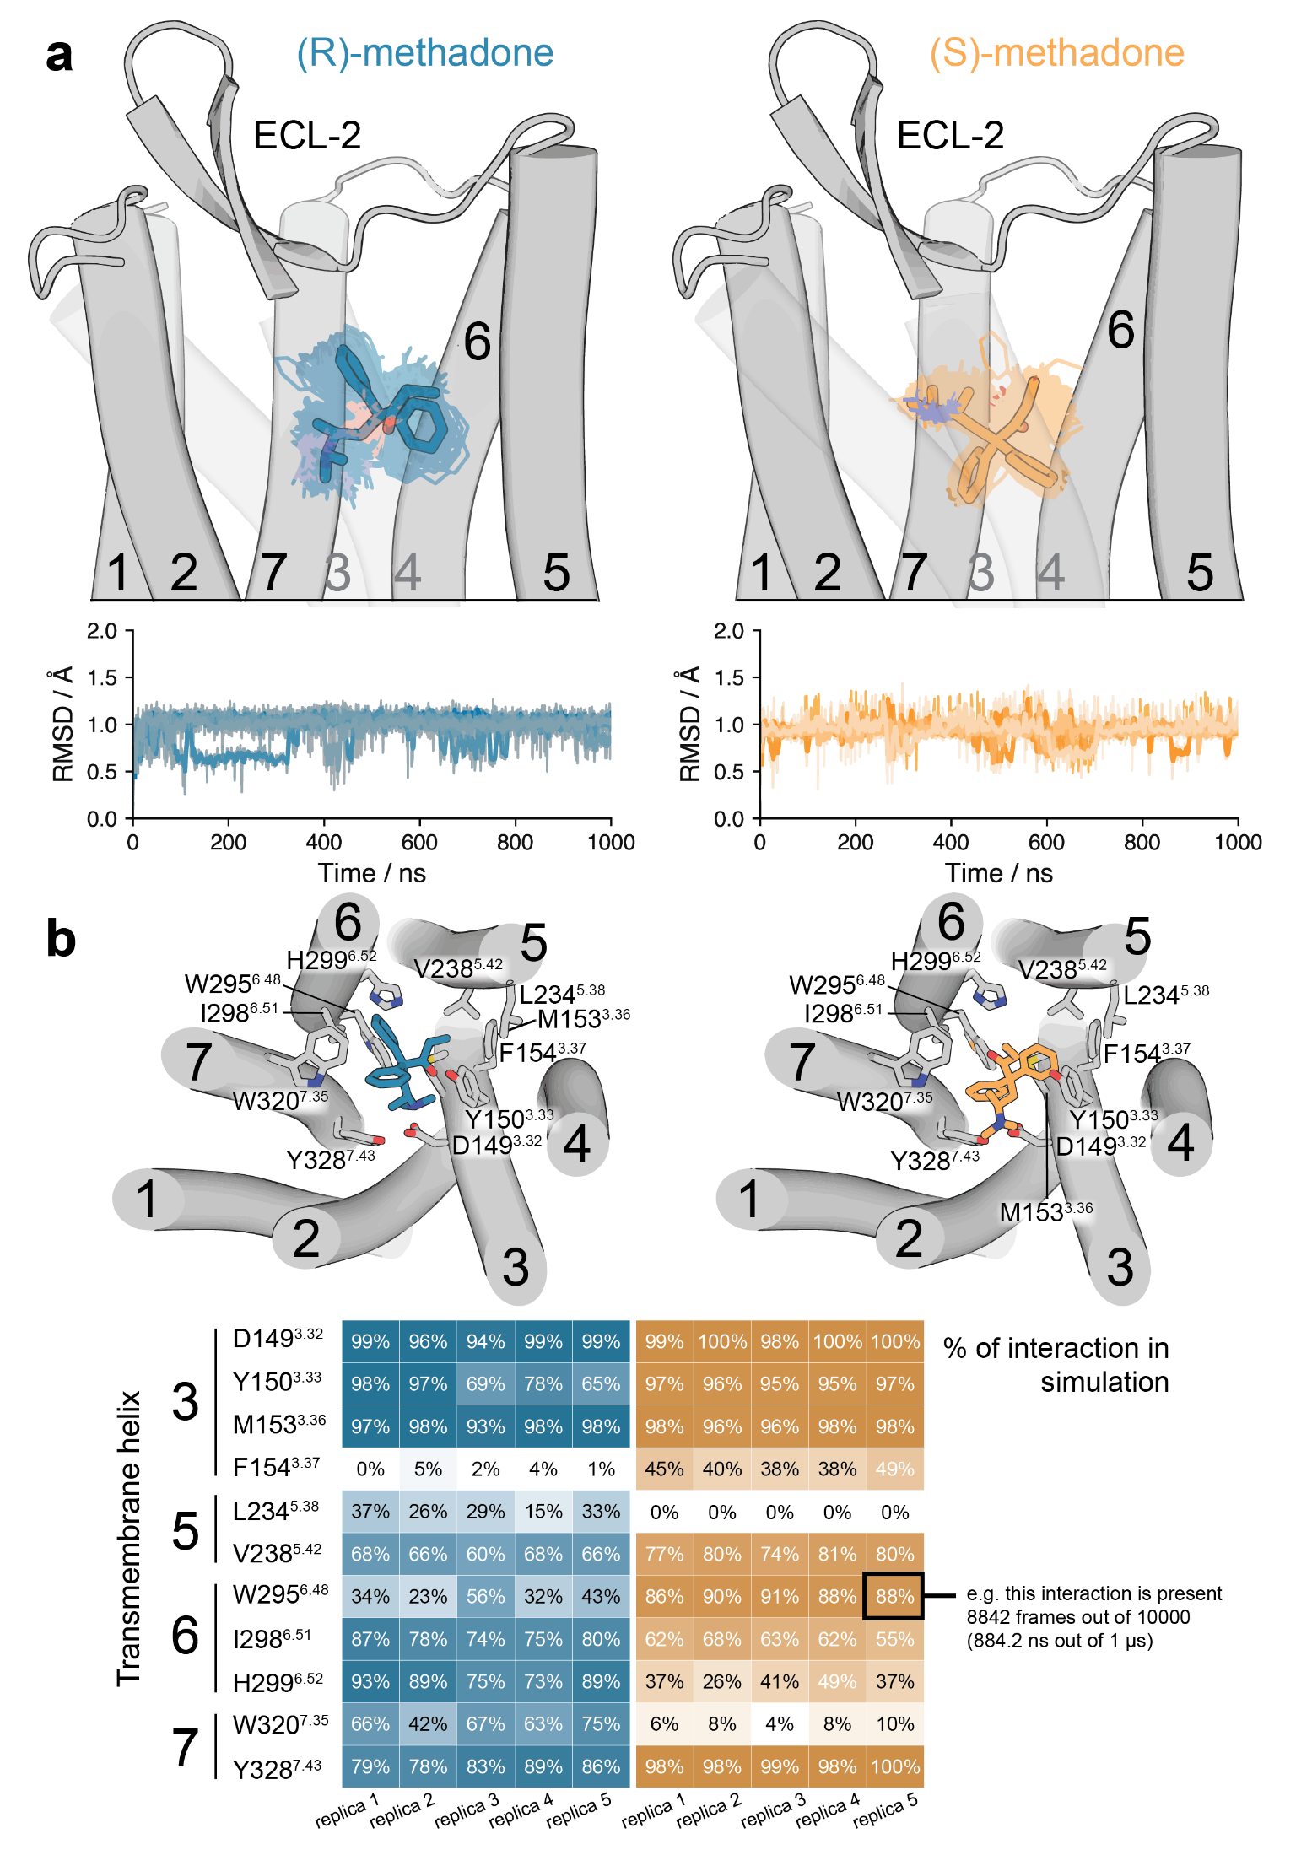
Supplementary Fig. 7. MD simulations of MOR bound to (R)-MTD and (S)-MTD. a, Representative structures (solid sticks) and evolution (lines) of (R)-MTD (in blue) and (S)-MTD (in orange) in complex with MOR (gray cylinders, only the initial structure is shown) as devised from five replicas of unbiased 1 μs MD simulations. The stability of the ligand-receptor complexes was analyzed via rmsd of the heavy atoms of (R)-MTD (blue lines) and (S)-MTD (orange lines). The low rmsd values indicate that both enantiomers remained highly stable at the orthosteric site. b, Detailed views of (R)-MTD and (S)-MTD and their receptor interacting side chains. Calculated frequency contacts (%) between side-chain residues of MOR involved in stable interactions with (R)-MTD or (S)-MTD during MD simulations, color-coded according to the frequency of contacts (https://getcontacts.github.io/). MD = molecular dynamics; MOR = μ opioid receptor; MTD = methadone; rmsd = root mean-square deviations
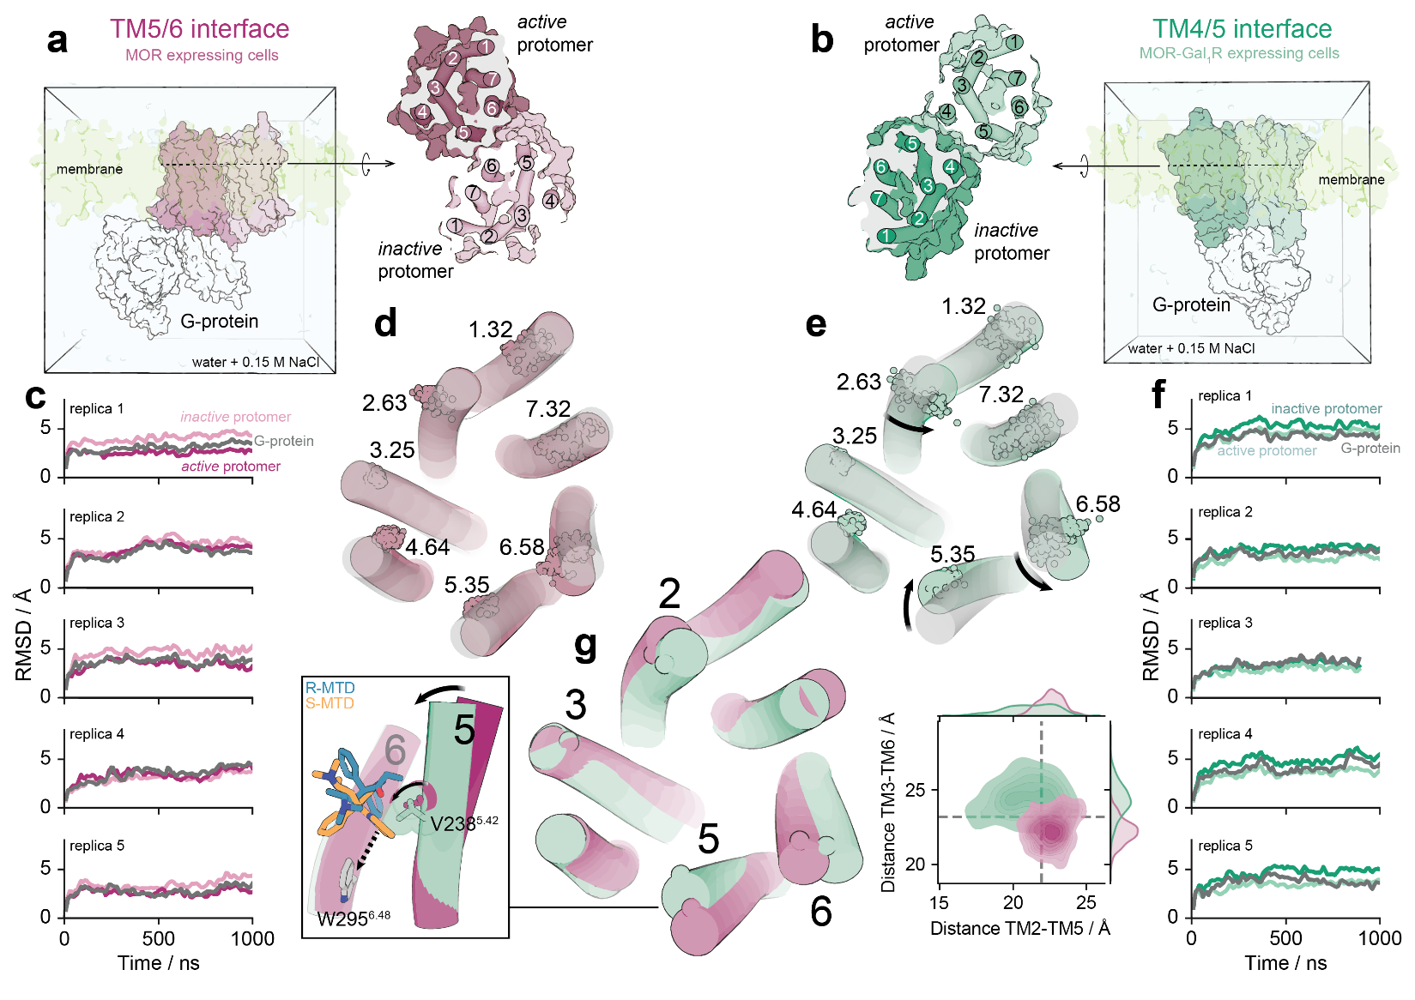
Supplementary Fig. 8 MD simulations of the MOR-MOR heteromer. a-b, Parallel to the membrane and extracellular views of the MOR-MOR heteromer, constructed via the TM 5/6 (a) or TM 4/5 (b) interface, as previously performed¹¹, in complex with G_{i}, embedded in a lipid bilayer box containing 1-palmitoyl-2-oleoyl-sn-glycero-3-phosphatidylcholine (POPC), water molecules and monoatomic Na+ and Cl- ions. c-f, Influence of the inactive MOR on the conformation of active MOR protomer in the TM 5/6 (c-d) and TM 4/5 (e-f) interfaces as devised by five replicas of unbiased 1 μs MD simulations. The stability of the complexes was analyzed via rmsd of inactive and active MOR protomers and the G protein (c, f). Superimposition of a representative TM bundle of active MOR, and the evolution of the C_{a} atoms (spheres) of the extracellular amino acids at position 1.32, 2.63, 3.25, 4.64, 5.35, 6.58, and 7.32, during the MD simulations of the MOR-MOR heteromer, modelled in the TM 5/6 (d) and TM 4/5 (e) interfaces, to the cryo-EM structure of MOR bound to fentanyl (8EF5, in light colour). Black arrows represent movements of the extracellular part of the helices relative to the fentanyl-bound structure. The xy plane is as defined by the Orientations of Proteins in Membranes (OPM) ¹⁶. g, Superimposition of representative TM bundles of active MOR in the TM 5/6 (purple) and TM 4/5 (green) interfaces. Contour plots of the distances between N129^{2.63} in TM 2 and E231^{5.35} in TM 5 (distance TM2-TM5) and between C142^{3.25} in TM 2 and K305^{6.58} in TM 6 (distance TM2-TM6) during the MD simulations. Distributions of these distances are shown in the axes. These results show that, in contrast to the TM 5/6 interface, TM 5 moved the extracellular part inward (black arrow) in the TM 4/5 interface. This movement relocated the position of the key V238^{5.42} (black arrow), and the phenyl ring of (S)-MTD toward W295^{6.48} (dashed arrow). MD = molecular dynamic; MOR = μ opioid receptor; MTD = methadone; rmsd = root-mean-square deviations; TM = transmembrane heli

