Supplemental Information

Supplementary Figures 1–3 describe the gating strategy used for FACS and for high-dimensional flow cytometry. Supplementary Figures 4–9 contain additional data. Supplementary Table 1 describes the datasets used for the training and test sets for model generation and validation. Supplementary Table 2 and 3 describe the antibody cocktail used for staining T cells and non-T cell PBMCs, respectively. Supplementary Table 4 describes the antibody cocktail utilized for high-parameter spectral flow cytometry.

Supplemental Figures
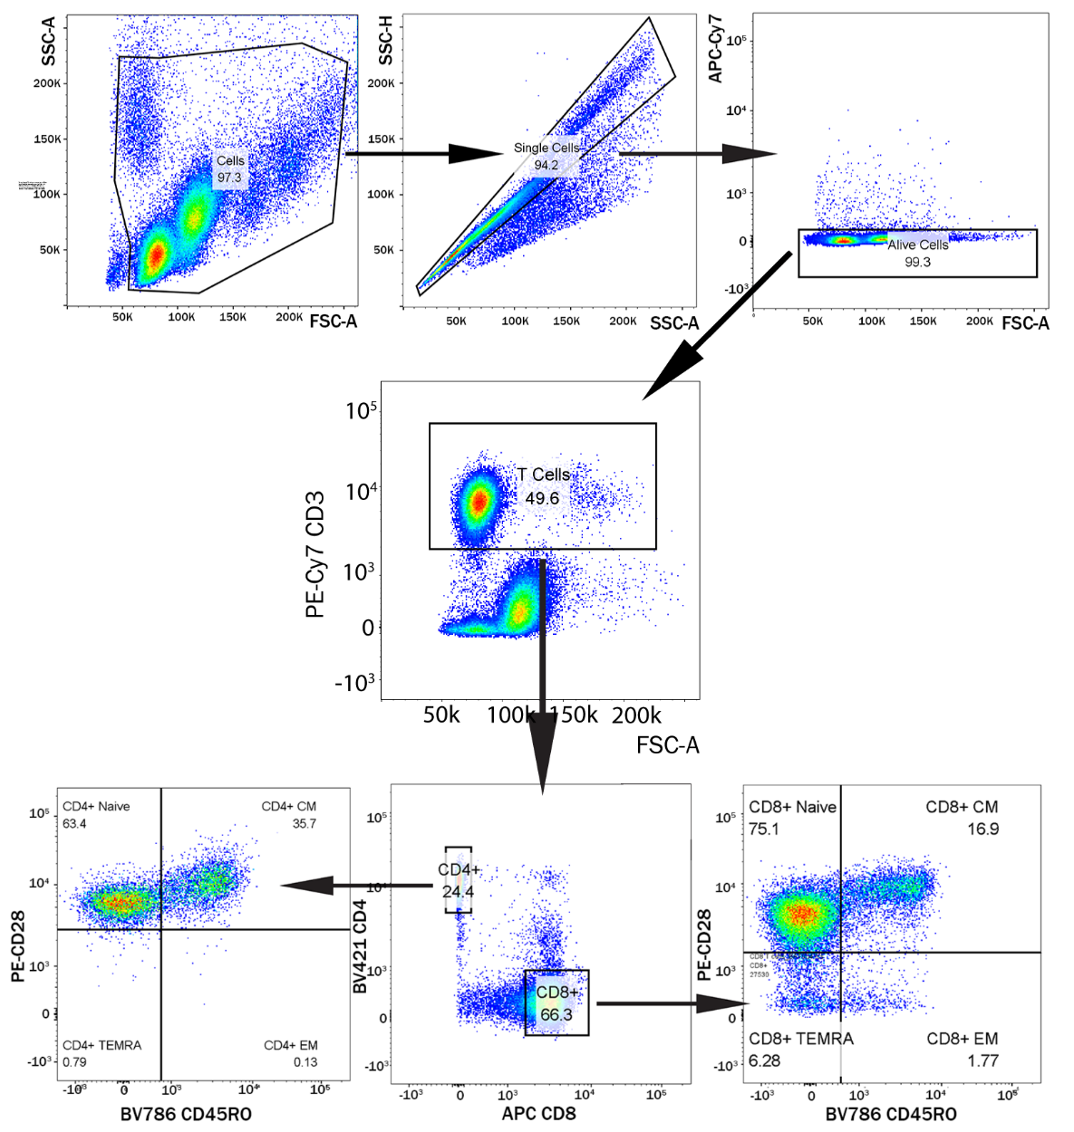
Supplementary Figure 1. Gating strategy for sorting of CD4⁺ subsets and CD8⁺ subsets.

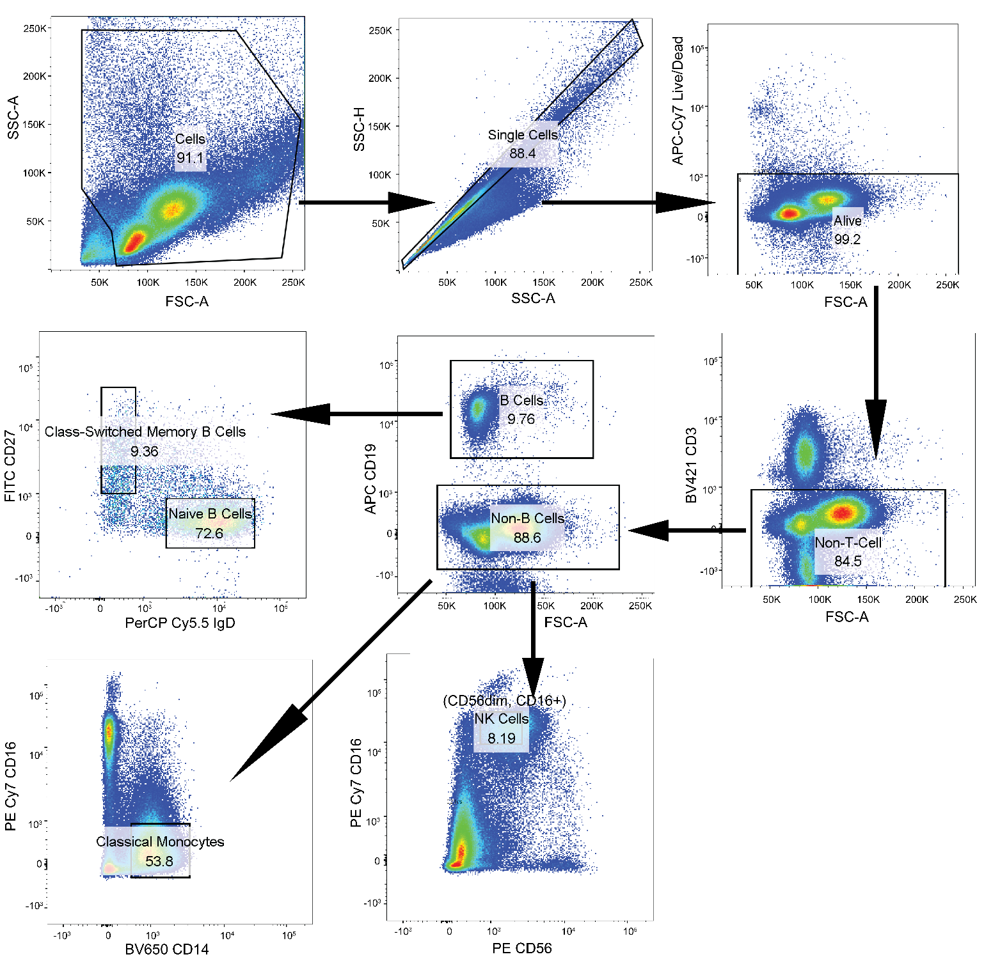
Supplementary Figure 2. Gating strategy for sorting of B-cell subsets, CD56_{dim} CD16⁺ NK cells, and classical monocytes.

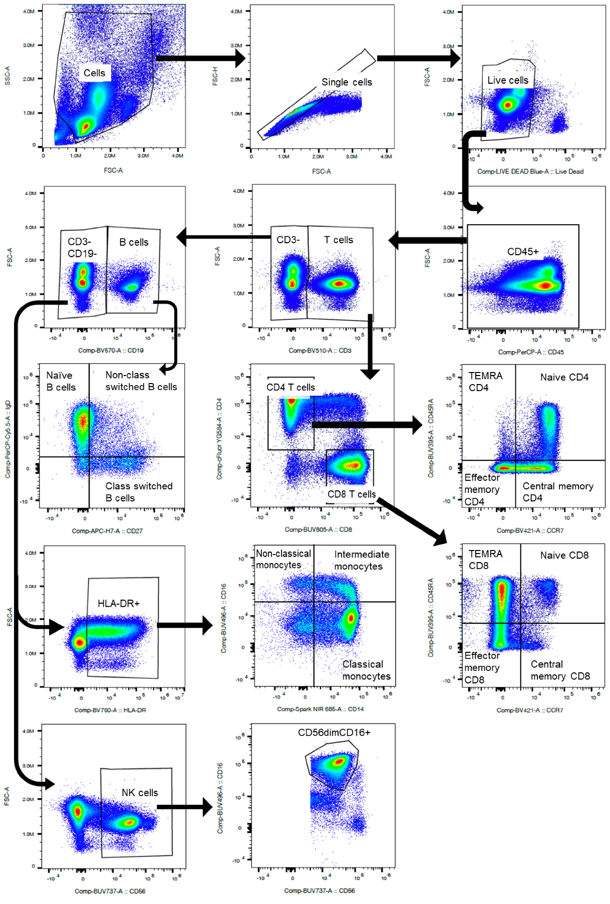
Supplementary Figure 3. Gating strategy for high-dimensional flow cytometry, for data shown in Figure 3e-3i.
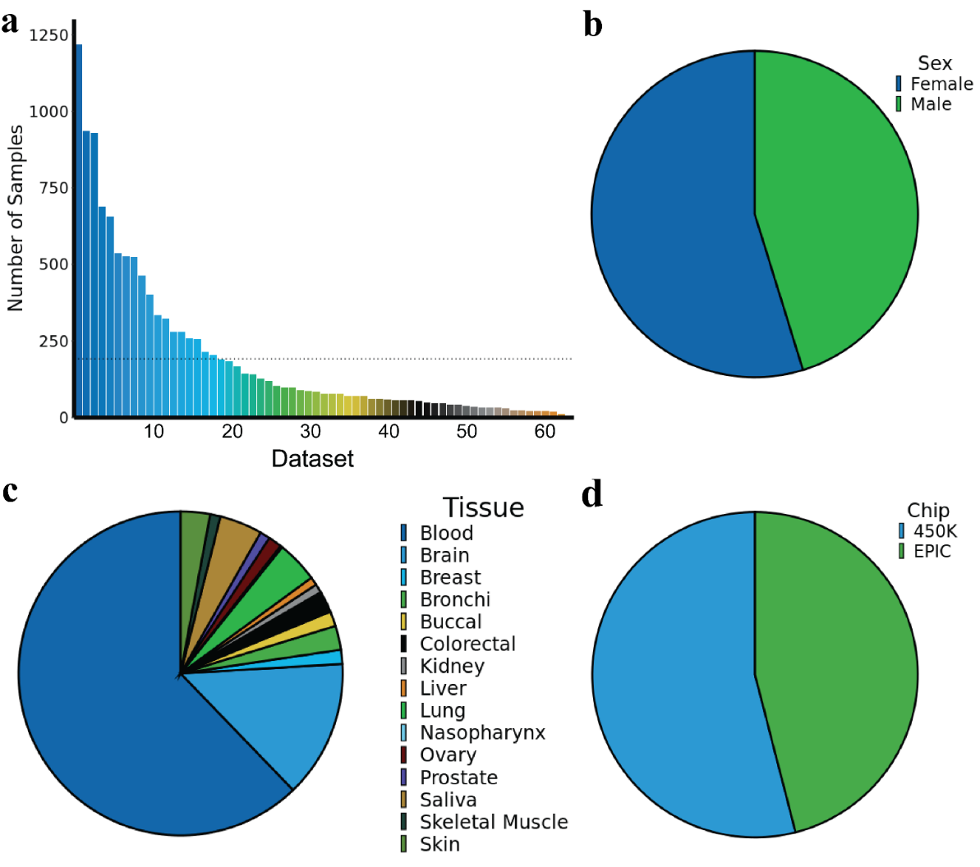
Supplementary Figure 4. IntrinClock training and validation. a, Number of samples used for IntrinClock training and validation per dataset. b, Sex distribution, c, tissue distribution, and d, Illumina chip distribution for samples used in IntrinClock training and validation.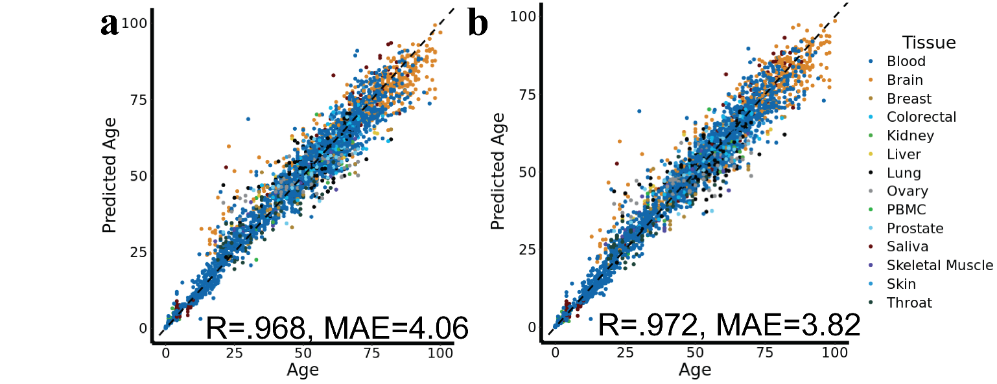
Supplementary Figure 5. Prediction and accuracy of test sets. a, Prediction accuracy and precision for the test set after training using one cycle of elastic net. b, Prediction accuracy and precision for the test set after training using once-repeated elastic net.
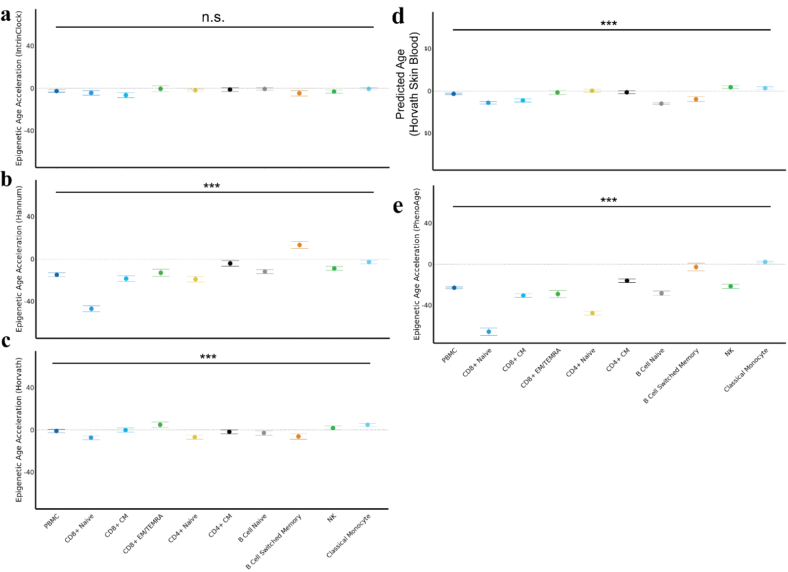
Supplementary Figure 6. Predicted epigenetic age acceleration of matched-donor PBMC, CD8⁺ naive, CD8⁺ CM, CD8⁺ EM/TEMRA, CD4⁺ naive, CD4⁺ CM, B-cell naive, B-cell switched memory, NK, and classical monocyte samples by the a, IntrinClock, b, Hannum, c, Horvath, d, Horvath Skin and Blood, and e, PhenoAge epigenetic clocks. *** ANOVA p-value less than .001. Error bars shown as mean ± standard error.

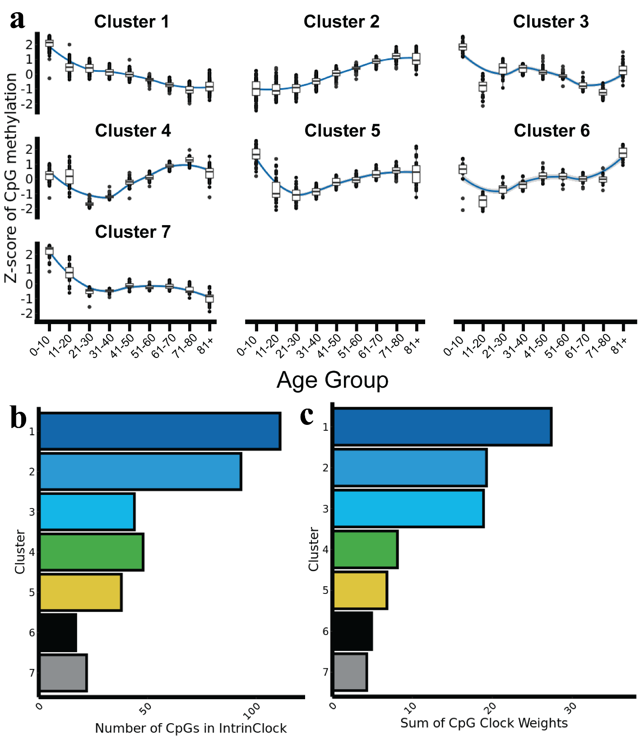
Supplementary Figure 7. IntrinClock and CpG methylation patterns and clusters. a, Analysis of IntrinClock CpG methylation patterns over five age groups in blood samples. b, Clusters by number of CpGs in the IntrinClock. c, Clusters weighed by the sum of absolute values of IntrinClock CpG coefficients.

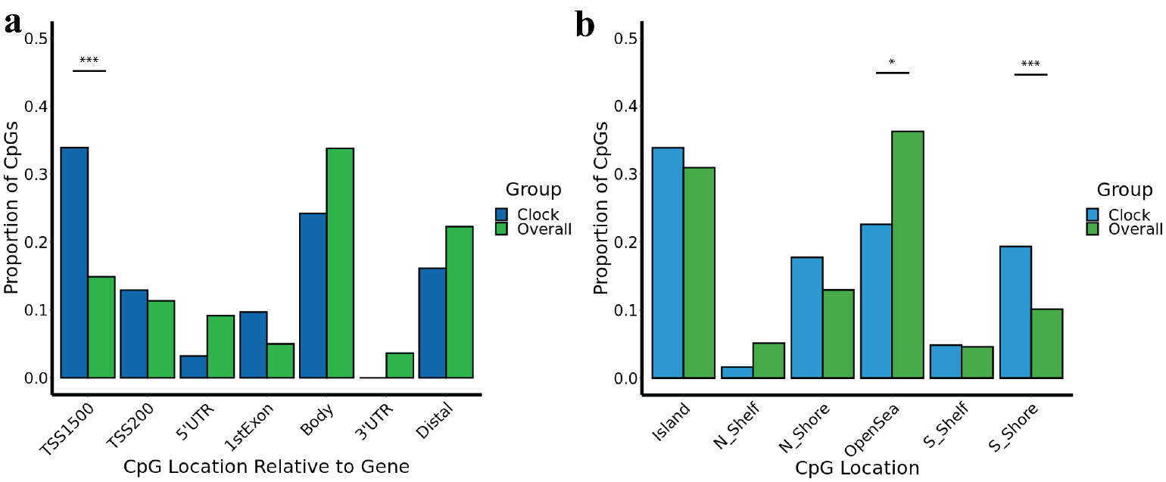
Supplementary Figure 8. Analysis of IntrinClock CpG methylation sites belonging to clusters 4, 5, and 6 (identified in Supplementary Figure 7). a, Distribution of clusters 4, 5, and 6 CpG sites relative to genes. b, Distribution of clusters 4, 5, and 6 CpG sites across the genome. *** One-sample proportion test p-value < .001; * one-sample proportion test p-value < .05.

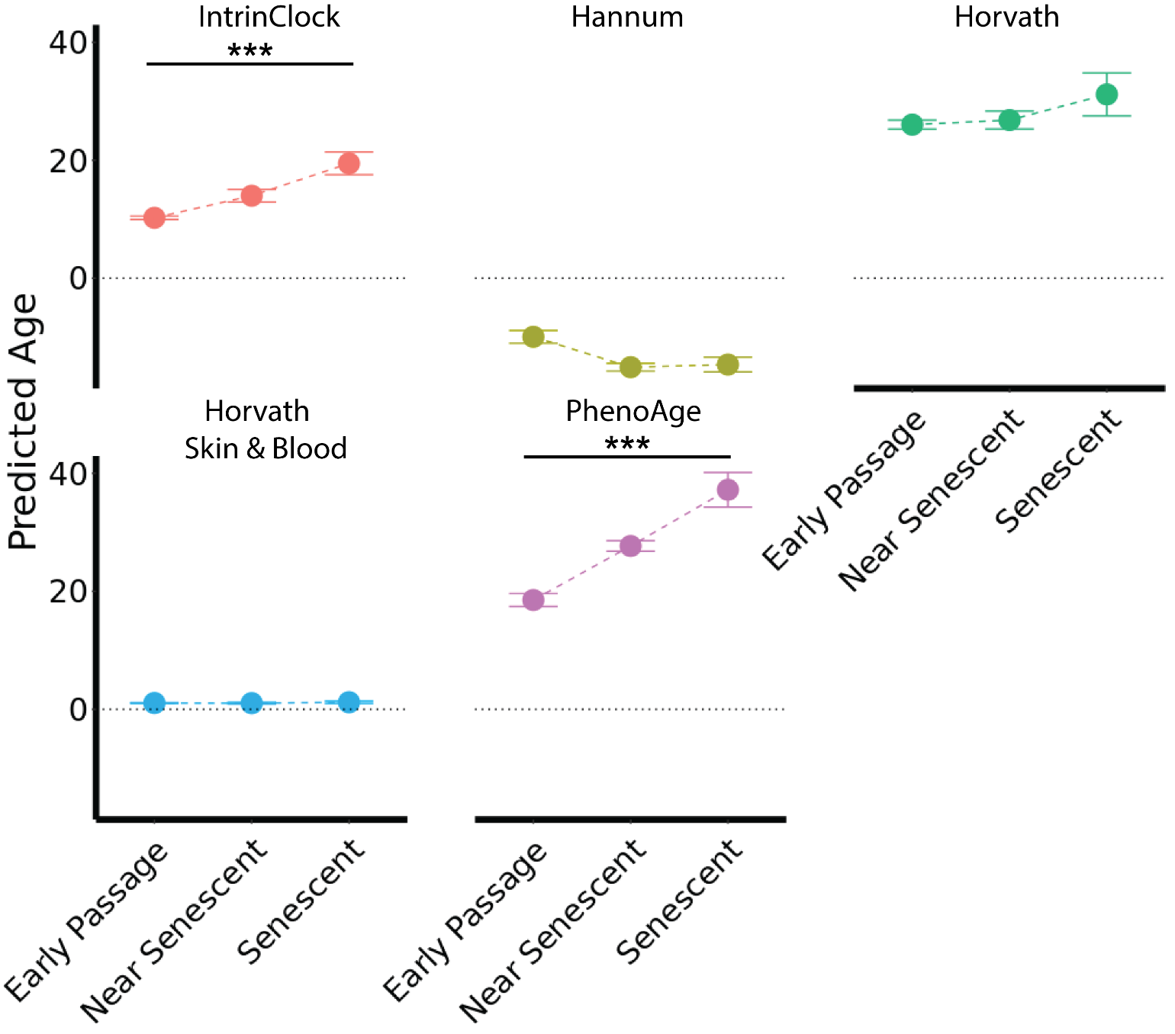
Supplementary Figure 9. Effect of replicative senescence in fibroblasts on five epigenetic clocks. DNA methylation data from GSE91069. *** t-test p-value > .001

Supplemental Tables

Supplementary Table 1. List of datasets used in this study for building and/or validating the IntrinClock.
GSE # | Citation | Tissue(s) | N | Platform
GSE41826 | Guintivano 2013 | Brain | 145 | 450K
GSE42861 | Liu 2013 | Blood | 689 | 450K
GSE42700 | Martino 2013 | Brain | 53 | 450K
GSE115278 | Arpon 2019 | Blood | 474 | 450K, EPIC
GSE52588 | Bacalini 2015 | Blood | 87 | 450K
GSE201724 | Bartlett 2022 | Breast | 18 | EPIC
GSE178887 | Bauer 2021 | Blood | 37 | 450K
GSE191276 | Brennan 2022 | Blood | 6 | EPIC
GSE136583 | Cerapio 2021 | Liver | 62 | EPIC
GSE59157 | Charlton 2014 | Kidney | 92 | 450K
GSE159898 | Li 2021 | Colorectal | 44 | EPIC
GSE210245 | Clement 2022 | Blood | 36 | EPIC
GSE112987 | Cobben 2019 | Blood | 103 | 450K
GSE203399 | Cullell 2022 | Blood | 121 | 450K, EPIC
GSE193879 | Davalos 2022 | Blood | 127 | EPIC
GSE201752 | Estupiñán-Moreno 2022 | Blood | 113 | EPIC
GSE129428 | Fries 2020 | Brain | 64 | EPIC
GSE63347 | Horvath 2015 | Brain | 71 | 450K
GSE179414 | Garcia-Prieto 2022 | Blood | 157 | EPIC
GSE66351 | Gasparoni 2018 | Brain | 190 | 450K
GSE99029 | Gopalan 2017 | Saliva | 57 | 450K
GSE191200 | De Witte 2022 | Brain | 56 | EPIC
GSE152026 | Hannon 2021 | Blood | 929 | EPIC
GSE40279 | Hannum 2013 | Blood | 656 | 450K
GSE119078 | Hearn 2020 | Saliva | 59 | 450K
GSE92767 | Hong 2017 | Saliva | 54 | 450K
GSE61256 | Horvath 2014 | Liver | 79 | 450K
GSE78874 | Horvath 2016 | Saliva | 259 | 450K
GSE141682 | Xiao 2021 | Blood | 42 | EPIC
GSE120610 | McEwen 2018 | Blood | 156 | EPIC
GSE40360 | Huynh 2013 | Brain | 46 | 450K
GSE149282 | Ishak 2020 | Colon | 24 | EPIC
GSE124366 | Islam 2019 | Buccal, Blood | 215 | 450K
GSE52068 | Jiang 2015 | Nasopharynx | 48 | 450K
GSE88883 | Johnson 2017 | Breast | 100 | 450K
GSE69270 | Kananen 2016 | Blood | 184 | 450K
GSE154566 | Kandaswamy 2021 | Buccal, Blood | 963 | 450K, EPIC
GSE122288 | Kasuga 2022 | Blood | 61 | EPIC
GSE157131 | Kho 2020 | Blood | 1218 | 450K, EPIC
GSE167202 | Konigsberg 2021 | Blood | 525 | EPIC
GSE70977 | Langevin 2015 | Buccal | 223 | 450K
GSE141256 | Lewis 2020 | Small Intestine, Colon | 84 | 450K, EPIC
GSE106648 | Kular 2018 | Blood | 279 | 450K
GSE59685 | Lunnon 2014 | Brain | 526 | 450K
GSE201872 | Magnaye 2022 | Bronchi | 142 | 450K, EPIC
GSE114134 | Martino 2018 | Blood | 205 | EPIC
GSE188593 | Muse 2022 | Skin | 64 | EPIC
GSE85566 | Nicodemus-Johnson 2016 | Lung | 115 | 450K
GSE166611 | Unpublished, Nonino 2016 | Blood | 32 | 450K
GSE190540 | Vyas 2021 | Blood | 90 | EPIC
GSE213478 | Oliva 2023 | Breast, Colon, Kidney, Lung, Skeletal Muscle, Ovary, Prostate, Testis, Blood | 987 | EPIC
GSE112179 | Pai 2019 | Brain | 100 | 450K
GSE203332 | Pihlstrøm 2022 | Brain | 336 | EPIC
GSE137223 | Policicchio 2020 | Brain | 33 | 450K
GSE61195 | Renauer 2015 | Blood | 21 | 450K
GSE133062 | Ringh 2019 | Bronchi | 70 | EPIC
GSE151017 | Ringh 2021 | Bronchi | 78 | EPIC
GSE90124 | Roos 2017 | Skin | 322 | 450K
GSE184269 | Roy 2021 | Blood | 167 | EPIC
GSE112611 | Somineni 2019 | Blood | 402 | EPIC
GSE178925 | Takeuchi 2022 | Blood | 24 | EPIC
GSE146376 | Thompson 2020 | Lung | 280 | EPIC
None yet | This study | Blood | 30 | EPIC
GSE50660 | Tsaprouni 2014 | Blood | 464 | 450K
GSE72556 | Oelsner 2017 | Saliva | 93 | 450K
GSE89707 | Viana 2016 | Brain | 49 | 450K
GSE151407 | Voisin 2020 | Skeletal Muscle | 78 | EPIC
GSE61107 | Wockner 2014 | Brain | 47 | 450K
GSE49393 | Xu 2014 | Brain | 48 | 450K
GSE174442 | Xu 2019 | Blood | 256 | 450K
GSE128235 | Zannas 2019 | Blood | 537 | 450K

Supplementary Table 2. Antibody mix used for sorting T cells.
Target | Fluorophore | Clone | Company
CD3 | PE-Cy7 | UCHT1 | BioLegend
CD8 | APC | SK1 | BioLegend
CD4 | Pacific Blue | OKT4 | BioLegend
CD28 | PE | B353546 | BioLegend
CD45RO | BV785 | UCHL1 | BioLegend

Supplementary Table 3. Antibody mix used for sorting B cells, CD56_{dim} CD16⁺ NK cells, and classical monocytes.
Target | Fluorophore | Clone | Company
CD14 | BV650 | M5E2 | BioLegend
IgD | PerCP Cy5.5 | IA6-1 | BioLegend
CD3 | Pacific Blue | OKT4 | BioLegend
CD19 | APC | HIB19 | BioLegend
CD16 | PE-Cy7 | 3G8 | BioLegend
CD27 | FITC | O323 | BioLegend

Supplementary Table 4. Antibody mix used for high-dimensional phenotyping of peripheral blood mononuclear cells.
Specificity | Fluorochrome | Vendor | Catalog # | Clone # | Lot #
CD3 | BV510 | BioLegend | 344828 | SK7 | B364399
CD4 | cFluor YG584 | Cytek | R7⁻20042 | SK3 | F⁻012022⁻01
CD8 | BUV805 | BD Biosciences | 612889 | SK1 | 2006191
CD14 | Spark NIR 685 | BioLegend | 367150 | 63D3 | B343008
CD16 | BUV496 | BD Biosciences | 612944 | 3G8 | 1348178
CD19 | BV570 | BioLegend | 302236 | HIB19 | B350345
CD25 | PE-Fire 700 | BioLegend | 356146 | M-A251 | B357965
CD27 | APC-H7 | BD Biosciences | 560222 | M-T271 | 1260248
CD28 | PE-Cy5 | BioLegend | 302910 | CD28.2 | B336927
CD38 | APC-Fire 810 | BioLegend | 356644 | HIT2 | B365111
CD39 | BUV661 | BD Biosciences | 749967 | TU66 | 2075880
CD45 | PerCP | BioLegend | 386506 | 2D1 | B326914
CD45RA | BUV395 | BD Biosciences | 740315 | 5H9 | 1356975
CD49d | APC | BioLegend | 304308 | 9F10 | B270195
CD56 (NCAM1) | BUV737 | BD Biosciences | 612766 | NCAM16.2 | 1210146
CD57 (HNK-1) | eFluor 450 | Invitrogen | 48-0577-42 | TB01 | 2437632
CD95 (Fas) | BV650 | BioLegend | 305642 | DX2 | B324443
CD127 | APC-R700 | BD Biosciences | 565185 | HIL-7R-M21 | 1341730
CD159a (NKG2a) | Alexa Fluor 647 | BioLegend | 375105 | S19004C | B325094
CD161 (NK1.1) | PE-eFluor 610 | Invitrogen | 61-1619-42 | HP-3G10 | 2446967
CD183 (CXCR3) | PE-Cy7 | BioLegend | 353720 | G025H7 | B319137
CD184 (CXCR4) | BV605 | BioLegend | 306522 | 12G5 | B301424
CD195 (CCR5) | BUV563 | BD Biosciences | 741401 | 2D7/CCR5 | 1348905
CD196 (CCR6) | BV711 | BioLegend | 353436 | G034E3 | B323435
CD197 (CCR7) | BV421 | BioLegend | 353208 | G043H7 | B337639
CD279 (PD-1) | BV785 | BioLegend | 329930 | EH12.2H7 | B351259
HLA-DR | BV750 | BioLegend | 307672 | L243 | B368880
IgD | PerCP-Cy5.5 | BioLegend | 348208 | IA6-2 | B366177
Klrg1 | PE-Fire 810 | BioLegend | 367733 | SA231A2 | B371259
TCRγδ | BUV615 | BD Biosciences | 751308 | 11F2 | 2271540
Tigit | BV480 | BD Biosciences | 747843 | 741182 | 2272802

