Discovery of a selective YTHDC1 inhibitor that targets acute myeloid leukemia
Supplementary Information

SUPPLEMENTARY INFORMATION GUIDE
Supplementary Table 1-4
Supplementary Figure 1
Supplementary Note

Table of contents
Supplementary Table 1 | Data collection and refinement statistics for YTHDC1 YTH domain in complex with Hit-1 and YL-5092.
Supplementary Table 2 | Kinase inhibitory activities of compound YL-5092@1 µM against 416 kinases.
Supplementary Table 3 | Genetic background of the AML patients used in the study (related to Fig. 3b and 3f).
Supplementary Table 4 | Pharmacokinetic parameters for YL-5092 in BALB/c mice following intraperitoneal injection (related to Extended Data Fig. 7).
Supplementary Figure 1 | Gating strategy for the determination of the HSPC levels upon treatment with vehicle or YL-5092 in vivo (related to Extended Data Fig. 9i and 9j).

Supplementary Note - Chemical synthesis

Supplementary Table 1 | Data collection and refinement statistics for YTHDC1 YTH domain in complex with Hit-1 and YL-5092.

 | YTHDC1+Hit-1 | YTHDC1+YL-5092
Data collection
Space group | P1 | P22121
Cell dimensions
a, b, c (Å) | 54.16, 77.38, 105.24 | 73.15, 74.41, 75.54
α, β, γ (°) | 112.72, 93.18, 104.43 | 90.00, 90.00, 90.00
Resolution (Å) | 50-2.25 (2.29-2.25) * | 50.0-1.6 (1.63-1.60) *
R_{merge} | 0.07(0.54) | 0.11(0.96)
I / σI | 16.6 (2.27) | 22.5 (3.5)
Completeness (%) | 98.1 (97.5) | 100 (99.9)
Redundancy | 3.5 (3.6) | 12.6(9.9)
Refinement
Resolution (Å) | 29.47-2.40 | 37.7-1.65
No. reflections | 57479 | 49919
R_{work} / R_{free} | 0.23/0.27 | 0.19/0.22
No. atoms
Protein | 9896 | 2562
Ligand/ion | 312 | 103
Water | 222 | 382
B-factors
Protein | 30.0 | 15.0
Ligand/ion | 33.4 | 17.8
Water | 27.0 | 23.9
R.m.s. deviations
Bond lengths (Å) | 0.002 | 0.005
Bond angles (°) | 0.56 | 0.83
* Values in parentheses are for highest-resolution shell.

Supplementary Table 2 | Kinase inhibitory activities of compound YL-5092@1 µM against 416 kinases. ª

Kinase | Activity  (%) | Kinase | Activity  (%) | Kinase | Activity  (%)
AAK1(h) | 92 | Flt4(h) | 90 | PhKγ2(h) | 98
Abl(h) | 93 | Fms(h) | 53 | Pim-1(h) | 103
Abl (H396P) (h) | 101 | Fms(Y969C)(h) | 74 | Pim-2(h) | 106
Abl (M351T)(h) | 97 | Fyn(h) | 87 | Pim-3(h) | 99
Abl (Q252H) (h) | 91 | GAK(h) | 96 | PKA(h) | 99
Abl(T315I)(h) | 97 | GCK(h) | 70 | PKAcβ(h) | 107
Abl(Y253F)(h) | 97 | GCN2(h) | 106 | PKBα(h) | 92
ACK1(h) | 82 | GRK1(h) | 91 | PKBβ(h) | 102
ACTR2(h) | 108 | GRK2(h) | 92 | PKBγ(h) | 99
ALK(h) | 92 | GRK3(h) | 107 | PKCα(h) | 96
ALK1(h) | 98 | GRK4(h) | 90 | PKCβI(h) | 100
ALK2(h) | 107 | GRK5(h) | 99 | PKCβII(h) | 99
ALK4(h) | 93 | GRK6(h) | 103 | PKCγ(h) | 109
ALK6(h) | 104 | GRK7(h) | 88 | PKCδ(h) | 86
Arg(h) | 100 | GSK3α(h) | 100 | PKCε(h) | 106
AMPKα1(h) | 86 | GSK3β(h) | 95 | PKCη(h) | 94
AMPKα2(h) | 102 | Haspin(h) | 99 | PKCι(h) | 92
A-Raf(h) | 95 | Hck(h) | 92 | PKCμ(h) | 95
ARK5(h) | 89 | Hck(h) activated | 100 | PKCθ(h) | 99
ASK1(h) | 92 | HIPK1(h) | 101 | PKCζ(h) | 98
Aurora-A(h) | 79 | HIPK2(h) | 102 | PKD2(h) | 91
Aurora-B(h) | 59 | HIPK3(h) | 108 | PKD3(h) | 70
Aurora-C(h) | 89 | HIPK4(h) | 108 | PKG1α(h) | 94
Axl(h) | 73 | HPK1(h) | 90 | PKG1β(h) | 90
BIKe(h) | 117 | HRI(h) | 118 | PKR(h) | 96
Blk(h) | 89 | ICK(h) | 110 | Plk1(h) | 109
BMPR2(h) | 101 | IGF-1R(h) | 110 | Plk3(h) | 100
Bmx(h) | 85 | IGF-1R(h) | 98 | Plk4(h) | 103
BRK(h) | 106 | IKKα(h) | 95 | PRAK(h) | 78
BrSK1(h) | 98 | IKKβ(h) | 95 | PRKG2(h) | 76
BrSK2(h) | 89 | IKKε(h) | 104 | PRK1(h) | 88
BTK(h) | 110 | IR(h) | 101 | PRK2(h) | 87
BTK(R28H)(h) | 103 | IR(h), activated | 99 | PrKX(h) | 106
B-Raf(h) | 88 | IRE1(h) | 91 | PRP4(h) | 103
B-Raf(V599E)(h) | 94 | IRR(h) | 104 | PTK5(h) | 89
CaMKI(h) | 108 | IRAK1(h) | 100 | Pyk2(h) | 87
CaMKIβ(h) | 101 | IRAK4(h) | 99 | Ret(h) | 92
CaMKIγ(h) | 107 | Itk(h) | 94 | Ret (V804L)(h) | 89
CaMKIIα(h) | 77 | JAK1(h) | 87 | Ret(V804M)(h) | 103
CaMKIIβ(h) | 71 | JAK2(h) | 98 | RIPK1(h) | 82
CaMKIIγ(h) | 70 | JAK3(h) | 94 | RIPK2(h) | 74
CaMKIδ(h) | 89 | JNK1α1(h) | 103 | ROCK-I(h) | 99
CaMKIIδ(h) | 60 | JNK2α2(h) | 101 | ROCK-II(h) | 56
CaMKIV(h) | 94 | JNK3(h) | 112 | Ron(h) | 77
CaMKK1(h) | 67 | KDR(h) | 85 | Ros(h) | 101
CaMKK2(h) | 82 | LATS1(h) | 111 | Rse(h) | 100
Cdc7/cyclinB1(h) | 79 | LATS2(h) | 106 | Rsk1(h) | 81
CDK1/cyclinB(h) | 88 | Lck(h) | 73 | Rsk2(h) | 62
CDK2/cyclinA(h) | 93 | Lck(h) activated | 90 | Rsk3(h) | 53
CDK2/cyclinE(h) | 87 | LIMK1(h) | 91 | Rsk4(h) | 70
CDK3/cyclinE(h) | 107 | LIMK2(h) | 89 | SAPK2a(h) | 113
CDK4/cyclinD3(h) | 113 | LKB1(h) | 77 | SAPK2a(T106M)(h) | 106
CDK5/p25(h) | 101 | LOK(h) | 61 | SAPK2b(h) | 107
CDK5/p35(h) | 92 | Lyn(h) | 90 | SAPK3(h) | 103
CDK6/cyclinD3(h) | 85 | LRRK2(h) | 100 | SAPK4(h) | 104
CDK7/cyclinH (h) | 73 | LTK(h) | 99 | SBK1(h) | 83
CDK9/cyclin T1(h) | 103 | MAK(h) | 97 | SGK(h) | 103
CDK14/cyclinY(h) | 80 | MAPK1(h) | 105 | SGK2(h) | 95
CDK16/cyclinY(h) | 112 | MAPK2(h) | 96 | SGK3(h) | 97
CDK17/cyclinY(h) | 103 | MAP4K3(h) | 94 | SIK(h) | 102
CDK18/cyclinY(h) | 101 | MAP4K4(h) | 87 | SIK2(h) | 81
CDKL1(h) | 113 | MAP4K5(h) | 84 | SIK3(h) | 73
CDKL2(h) | 55 | MAPKAP-K2(h) | 103 | SLK(h) | 63
CDKL3(h) | 85 | MAPKAP-K3(h) | 102 | Snk(h) | 89
CDKL4(h) | 90 | MATK(h) | 84 | SNRK(h) | 94
ChaK1(h) | 94 | MEK1(h) | 105 | Src(1-530)(h) | 93
CHK1(h) | 80 | MEK2(h) | 105 | Src(T341M)(h) | 89
CHK2(h) | 104 | MARK1(h) | 87 | SRMS(h) | 82
CHK2(I157T)(h) | 105 | MARK3(h) | 76 | SRPK1(h) | 88
CHK2(R145W)(h) | 97 | MARK4(h) | 100 | SRPK2(h) | 93
CK1α(h) | 100 | MEKK2(h) | 79 | STK16(h) | 73
CK1ε(h) | 96 | MEKK3(h) | 106 | STK25(h) | 106
CK1γ1(h) | 92 | MELK(h) | 66 | STK32A(h) | 99
CK1γ2(h) | 88 | Met(h) | 96 | STK32B(h) | 95
CK1γ3(h) | 96 | Met(D1246H)(h) | 116 | STK32C(h) | 101
CK1δ(h) | 89 | Met(D1246N)(h) | 105 | STK33(h) | 91
CK2(h) | 113 | Met(M1268T)(h) | 103 | STK39(h) | 103
CK2α1(h) | 105 | Met(Y1248C)(h) | 105 | Syk(h) | 97
CK2α2(h) | 99 | Met(Y1248D)(h) | 102 | TAF1L(h) | 84
CLIK1(h) | 124 | Met(Y1248H)(h) | 95 | TAK1(h) | 91
CLK1(h) | 93 | MINK(h) | 80 | TAO1(h) | 96
CLK2(h) | 80 | MKK3(h) | 97 | TAO2(h) | 81
CLK3(h) | 89 | MKK6(h) | 103 | TAO3(h) | 86
CLK4(h) | 80 | MLCK(h) | 77 | TBK1(h) | 102
cKit(h) | 87 | MLK1(h) | 93 | Tec(h) activated | 104
cKit(D816V)(h) | 94 | MLK2(h) | 96 | TGFBR1(h) | 109
cKit(D816H)(h) | 95 | MLK3(h) | 79 | TGFBR2(h) | 94
cKit(V560G)(h) | 89 | MLK4(h) | 111 | Tie2 (h) | 124
cKit(V654A)(h) | 86 | Mnk1(h) | 85 | Tie2(R849W)(h) | 108
COT(h) | 116 | Mnk2(h) | 60 | Tie2(Y897S)(h) | 104
CRIK(h) | 100 | MOK(h) | 101 | TLK1(h) | 97
CSK(h) | 120 | MRCKα(h) | 111 | TLK2(h) | 99
c-RAF(h) | 97 | MRCKβ(h) | 100 | TNIK(h) | 57
cSRC(h) | 97 | MRCKγ(h) | 89 | TRB2(h) | 87
DAPK1(h) | 97 | MSK1(h) | 82 | TrkA(h) | 99
DAPK2(h) | 100 | MSK2(h) | 82 | TrkB(h) | 97
DCAMKL1(h) | 107 | MSSK1(h) | 98 | TrkC(h) | 66
DCAMKL2(h) | 102 | MST1(h) | 75 | TSSK1(h) | 82
DCAMKL3(h) | 81 | MST2(h) | 97 | TSSK2(h) | 103
DDR1(h) | 60 | MST3(h) | 74 | TSSK3(h) | 96
DDR2(h) | 120 | MST4(h) | 105 | TSSK4(h) | 123
DMPK(h) | 96 | mTOR(h) | 110 | TTBK1(h) | 104
DRAK1(h) | 105 | mTOR/FKBP12(h) | 100 | TTBK2(h) | 97
DRAK2(h) | 104 | MuSK(h) | 87 | TTK(h) | 95
DYRK1A(h) | 87 | MYLK2(h) | 93 | Txk(h) | 101
DYRK1B(h) | 88 | MYO3B(h) | 93 | ULK1(h) | 96
DYRK2(h) | 110 | NDR1(h) | 91 | ULK2(h) | 84
DYRK3(h) | 99 | NDR2(h) | 98 | ULK3(h) | 96
eEF-2K(h) | 107 | NEK1(h) | 88 | VRK1(h) | 99
EGFR(h) | 105 | NEK2(h) | 94 | VRK2(h) | 106
EGFR(L858R)(h) | 112 | NEK3(h) | 114 | Wee1(h) | 88
EGFR(L861Q)(h) | 98 | NEK4(h) | 59 | Wee1B(h) | 91
EGFR(T790M)(h) | 107 | NEK5(h) | 88 | WNK1(h) | 89
EGFR  (T790M,L858R)(h) | 92 | NEK6(h) | 105 | WNK2(h) | 82
EphA1(h) | 103 | NEK7(h) | 94 | WNK3(h) | 103
EphA2(h) | 93 | NEK9(h) | 71 | WNK4(h) | 86
EphA3(h) | 102 | NIM1(h) | 112 | Yes(h) | 86
EphA4(h) | 89 | NEK11(h) | 100 | ZAK(h) | 86
EphA5(h) | 104 | NLK(h) | 98 | ZAP-70(h) | 94
EphA7(h) | 100 | NUAK2(h) | 89 | ZIPK(h) | 98
EphA8(h) | 114 | OSR1(h) | 99 | ATM(h) | 103
EphB2(h) | 84 | p70S6K(h) | 88 | ATR/ATRIP(h) | 108
EphB1(h) | 109 | p70S6Kβ(h) | 105 | DNA-PK(h) | 111
EphB3(h) | 98 | PAK1(h) | 88 | PI3 Kinase (p110b/p85a)(h) | 102
EphB4(h) | 125 | PAK2(h) | 96 | PI3 Kinase (p120g)(h) | 112
ErbB2(h) | 112 | PAK4(h) | 91 | PI3 Kinase (p110d/p85a)(h) | 70
ErbB4(h) | 102 | PAK3(h) | 94 | PI3 Kinase (p110a/p85a)(h) | 97
FAK(h) | 119 | PAK5(h) | 91 | PI3 Kinase (p110a(E542K)/p85a)(h) | 84
Fer(h) | 102 | PAK6(h) | 100 | PI3 Kinase (p110a(H1047R)/p85a)(h) | 99
Fes(h) | 100 | PAR-1Bα(h) | 95 | PI3 Kinase (p110a(E545K)/p85a)(h) | 94
FGFR1(h) | 98 | PASK(h) | 100 | PI3 Kinase (p110a/p65a)(h) | 95
FGFR1(V561M)(h) | 103 | PEK(h) | 99 | PI3KC2a(h) | 84
FGFR2(h) | 92 | PDGFRα(h) | 67 | PI3KC2g(h) | 97
FGFR2(N549H)(h) | 93 | PDGFRα  (D842V)(h) | 51 | PIP4K2a(h) | 92
FGFR3(h) | 98 | PDGFRα  (V561D)(h) | 57 | PIP5K1a(h) | 100
FGFR4(h) | 128 | PDGFRβ(h) | 114 | PIP5K1g(h) | 93
Fgr(h) | 101 | PDHK2(h) | 81
Flt1(h) | 90 | PDHK4(h) | 94
Flt3(D835Y)(h) | 72 | PDK1(h) | 95
Flt3(h) | 58 | PhKγ1(h) | 96
ª The bioactivity data were determined from Kinase Profiler of Eurofins. The ATP concentration used was Km valu
Supplementary Table 3 | Genetic background of the AML patients used in the study (related to Fig 3b and 3f).

AML patient | Gender | Age at diagnosis | Karyotype | Genetic alteration
Patient #1 | male | 32 | 46, XY, t (6; 11) (q27; q23) | MLL/AF6 (+), EVI1 (+), NRAS (c.35G>A, p. Gly12Asp), ZRSR2 (c.757G>T, p. Val253Leu), GATA1 (c.675C>A, p. Cys225Ter)
Patient #2 | male | 45 | normal | CEBPA (c.937_939dup, p. Lys313dup; c.141del, p.Ala48ProfsTer112), JAK3 (c.2570T>C, p. Leu857Pro)
Patient #3 | male | 62 | normal | NRAS (c.181C>A, p. Gln61Lys), FLT3-ITD (+), FLT3 (c.2505T>G, p. Asp835Glu), CEBPA (c.957_968del, p. Asp320_Arg 323del)
Patient #4 | male | 22 | normal | FLT3-ITD (+), WT1 (c.1239dup, p. Gln414ThrfsTer10), CEBPA (c.937_939dup, p. Lys313dup; c.63_65delinsAACCT, pSer21ArgfsTer140)
Patient #5 | male | 46 | 50，XY, + 3，+ 8，del(11)(q23)，+ 19，+ 19(4)/51，idem，+ 21(16) | FLT3-ITD (+), CBL (c.1096-1G>T) FLT3 (c.2039C>T, p. ALa680Val), PTPN11 (c.179G>T, p. Gly60Val)

Supplementary Table 4 | Pharmacokinetic parameters for YL-5092 in BALB/c mice following intraperitoneal injection (related to Extended Data Fig.7).

Parameter | YL-5092
Dose (mg/kg) | 70
C_{max} (ng/mL) | 23718 ± 2166
T_{max} (h) | 1.33 ± 0.58
T_{1/2} (h) | 2.12 ± 0.32
AUC_{0-t} (h*ng/mL) | 161350 ±9477
AUC_{INF_obs} (h*ng/mL) | 161500 ± 9507
MTR_{INF_obs} (h) | 4.69 ± 0.22
CLz/F (L/h/kg) | 0.43 ± 0.03
Vz/F (L/kg) | 1.33 ± 0.21

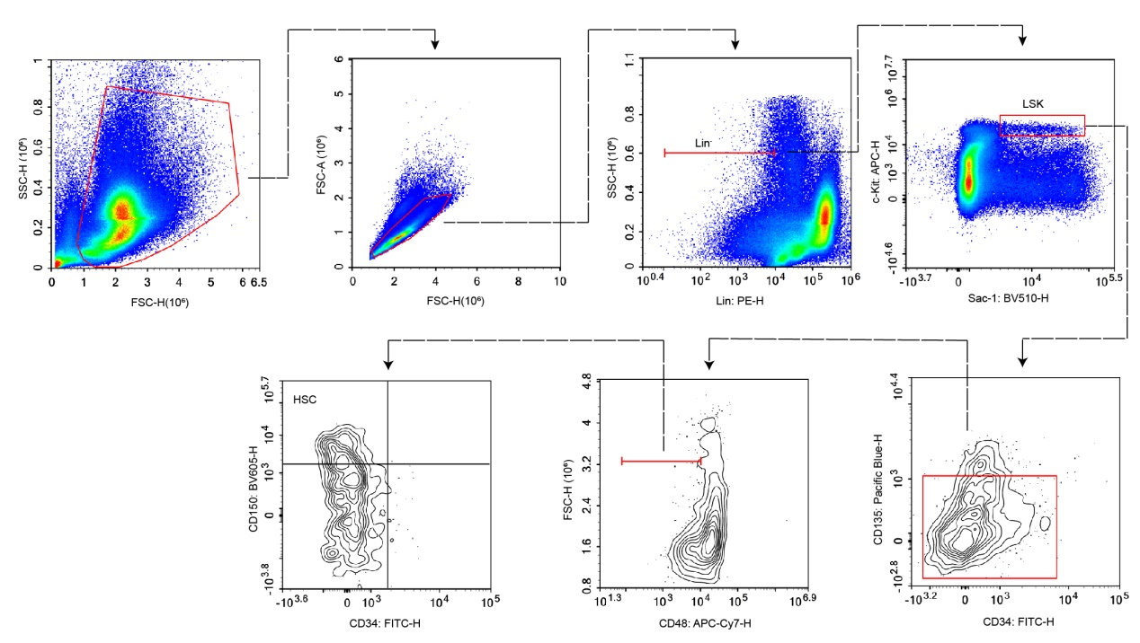

Supplementary Figure 1 | Gating strategy for the determination of the HSPC levels upon treatment with vehicle or YL-5092 in vivo (related to Extended Data Fig. 9i and 9j).

Supplementary Note - Chemical synthesis
General Remarks and Instrumentation
Ethanol, methanol, ethyl acetate, dichloromethane, 1,4-dioxane, and DMF were obtained from standard suppliers and used without further purification. All chemicals were purchased from Bidepharm Technology Co. Ltd, Energy Chemical, or Alfa Aesar and used without further purification. Anhydrous solvents were purchased from J&K Scientific. All reactions were monitored by thin layer chromatography (TLC) and visualization was achieved by using ultraviolet light (254 nm) or display by iodine reagent. Column chromatography was carried out using Biotage Isolera flash purification system under proper pressure. ¹H NMR and ¹³C NMR were recorded on a Bruker AV-400 spectrometer at 400 MHz, respectively. Coupling constants (J) are expressed in hertz (Hz). Chemical shifts (δ) of NMR are reported in parts per million (ppm) units. Low resolution ESI-MS readings were recorded on an Agilent 1200-G6410A mass spectrometer. High-resolution mass spectra were recorded on Q-TOF Premier mass spectrometer (Micromass, Manchester, UK). The purity of final compounds was assessed by HPLC. HPLC analysis was performed on the Waters e2695 HPLC system with the use of a phenomenex-C18 reversed-column (4.6 mm × 150 mm, 5 μm). The binary solvent system (A/B) was as follows: water (A) and MeCN (B). The absorbance was detected at 285 nm and the flow rate was 1.2 mL/min. The purity of compounds was determined to be over 95% by HPLC analysis.

Procedure for the synthesis of C-1

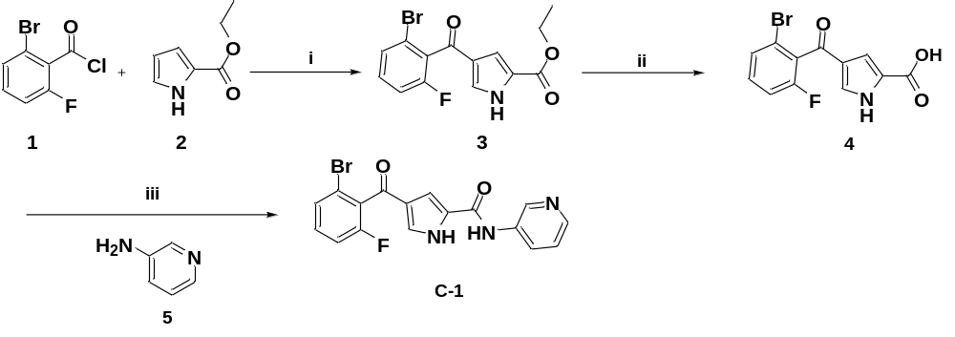
Reagents and conditions: (i) AlCl₃, dry DCM, 0 ℃-rt, 16 h; (ii) NaOH, EtOH: H₂O, 80 ℃, 1.5 h; (iii) 1-propanphosphonic acid cyclic anhydride (T3P), DMAP, dry THF, RT, 12 h, 79%.

Ethyl 4-(2-bromo-6-fluorobenzoyl)-1H-pyrrole-2-carboxylate (3) To a suspension of AlCl₃(4 g, 30 mmol) in DCM (1 mL/mmol AlCl₃) at 0 °C was added 2-bromo-6-fluorobenzoyl chloride (3.27 mL, 24 mmol) followed by ethyl 1H-pyrrole-2-carboxylate (1.5 g, 12 mmol). The resulting mixture was allowed to reach room temperature and stirred for 16 h. The reaction was quenched at 0 °C with a 1 M aqueous solution of HCl (20 mL). The product was extracted with DCM (3 × 100 mL), washed with an aqueous saturated solution of NaHCO₃(2 × 100 mL) and brine (100 mL). Combined organic layers were dried over Na₂SO₄ and concentrated in vacuo to afford the title compound 3 as a white solid. ¹H NMR (400 MHz, DMSO-d₆) δ 12.90 (s,1H), 7.59 (d, J = 8.3 Hz, 1H) 7.52 (s, 1H), 7.50 (dd, J = 6.3, 8.3 Hz, 1H), 7.39-7.43 (m, 1H), 7.00 (s,1H), 4.21 (q, J = 6.9 Hz, 2H), 1.25 (t, J = 7.0 Hz, 3H). MS (ESI, positive ion) m/z: 325.9 [M + H]⁺.

4-(2-bromo-6-fluorobenzoyl)-1H-pyrrole-2-carboxylic acid (4) 2 N aqueous NaOH solution (10.0 mL, 20.0 mmol) was added to a solution of the ethyl 4-(2-bromo-6-fluorobenzoyl)-1H-pyrrole-2-carboxylate (3, 1.00 g, 3.08 mmol) in EtOH (5.0 mL). This mixture was stirred at 80 ℃ for 1.5 h and evaporated under reduced pressure. The residue was diluted with water and acidified with an aqueous solution of hydrochloric acid (3 N). This aqueous mixture was extracted with ethyl acetate (2 × 50 mL), and the combined organic extracts were washed with brine (50 mL), dried over sodium sulphate, filtered. The solvent was removed under vacuum and used for next step without further purification.

4-(2-bromo-6-fluorobenzoyl)-N-(pyridin-3-yl)-1H-pyrrole-2-carboxamide (C-1) A dry THF solution (30 mL) containing 4-(2-bromo-6-fluorobenzoyl)-1H-pyrrole-2-carboxylic acid (4, 0.50 g, 1.70 mmol), pyridin-3-amine (0.16 g, 1.70 mmol), 4-dimethylaminopyridine (0.42 g, 3.40 mmol) and T3P (50 wt. % in Ethyl acetate, 1.00 mL) were stirred at room temperature for 12 h. Quenched with water and the reaction mixture was removed under reduced pressure. The residue was loaded on the silica gel and purified.by chromatography (petroleum ether/ethyl acetate = 1: 6) to afford the title compound C-1 as a white solid. Yield 79%. ¹H NMR (400 MHz, DMSO-d₆) δ 12.71 (s, 1H), 10.25 (s, 1H), 8.90 (s, 1H), 8.31 (s, 1H), 8.14 (d, J = 6.8 Hz, 1H), 7.62 (d, J = 7.9 Hz, 1H), 7.56 – 7.42 (m, 3H), 7.39 (dt, J = 8.3, 4.0 Hz, 1H). ¹³C NMR (101 MHz, DMSO) δ 185.35, 159.19, 144.88, 142.12, 135.98, 132.69, 132.61, 130.54, 130.31, 129.86, 129.36, 129.33, 128.63, 127.48, 125.43, 124.04, 119.58, 119.52, 115.95, 115.74, 112.13. HRMS (m/z): calculated for C₁₇H₁₁BrFN₃O₂⁺ [M+H] ⁺ 388.0019; found, 388.0092.

Procedure for the synthesis of C-8

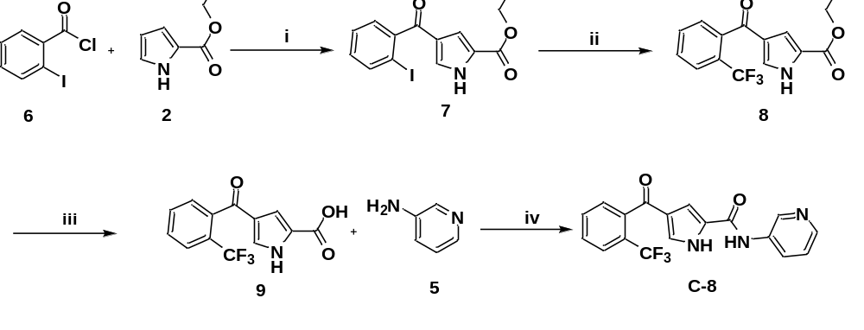
Reagents and conditions: (i) AlCl₃, dry DCM, 0 ℃-rt, 10 h; (ii) Methyl difluoro(fluorosulphonyl)acetate, CuI, dry DMF, 80 ℃, 12 h; (iii) NaOH, EtOH, H₂O, 75 ℃, 1.5 h; (iv) T3P, DMAP, dry THF, rt, 12h, 85%.

Ethyl 4-(2-iodobenzoyl)-1H-pyrrole-2-carboxylate (7) To a suspension of AlCl₃ (27.15 mmol) in anhydrous DCM at 0 °C was added 2-iodobenzoyl chloride (5.77 g, 21.72 mmol) followed by ethyl 1H-pyrrole-2-carboxylate (1.50 g, 10.86 mmol). The resulting mixture was allowed to reach room temperature and stirred for 10 h. The reaction was quenched at 0 °C with a 1 M hydrochloric acid (20 mL). The product was extracted with DCM (3 × 100 mL) and washed with a saturated aqueous NaHCO₃ (2 × 100 mL) and brine (100 mL). The combined organic layers were dried over Na₂SO₄ and concentrated in vacuo to afford the title compound as a white solid. ¹H NMR (400 MHz, DMSO-d₆) δ 11.94 (s, 1H), 8.05 (d, J = 1.5 Hz, 1H), 7.98 (d, J = 7.5 Hz, 1H), 7.71 (dd, J = 7.5, 1.5 Hz, 1H), 7.58 (t, J = 4.8 Hz, 1H), 2.89 (d, J = 4.8 Hz, 3H). MS (ESI, positive ion) m/z: 369.8 [M + H]⁺.

Ethyl 4-(2-(trifluoromethyl)benzoyl)-1H-pyrrole-2-carboxylate (8) A Schleck tube was charged with CuI (0.2 mol) and ethyl 4-(2-iodobenzoyl)-1H-pyrrole-2-carboxylate (2.71 mmol ). anhydrous DMF (20 mL) and FSO₂CF₂COOMe (1.56 g, 8.13 mmol) were added under argon atmosphere. The reaction mixture was then heated stepwise to 80 °C and stirred for 12 h. water (40 mL) was added, and the mixture was extracted with ethyl acetate (3 × 20 mL), dried over Na₂SO₄ and concentrated to afford crude product. The residue was loaded on the silica gel and purified by chromatography column to afford ethyl 4-(2-(trifluoromethyl)benzoyl)-1H-pyrrole-2-carboxylate (8) as white solid.¹H NMR (400 MHz, DMSO-d₆) δ 12.77 (s, 1H), 7.87 (dd, J = 7.6, 1.4 Hz, 1H), 7.81-7.71 (m, 2H), 7.58 (d, J = 7.1 Hz, 1H), 7.39 (d, J = 1.7 Hz, 1H), 6.97 (d, J = 1.7 Hz, 1H), 4.26 (q, J = 7.1 Hz, 2H), 1.28 (t, J = 7.1 Hz, 3H). MS (ESI, positive ion) m/z: 311.9 [M + H]⁺.

4-(2-(trifluoromethyl)benzoyl)-1H-pyrrole-2-carboxylic acid (9) A solution of m ethyl 4-(2-(trifluoromethyl)benzoyl)-1H-pyrrole-2-carboxylate 8 (200 mg) in EtOH (30 mL) was treated with 2 M NaOH aqueous solution (20 mL). The reaction mixture was stirred for 1.5 h at 75 ℃. The completion of the reaction was confirmed by TLC then the EtOH was concentrated then the solution was acidified to pH ∼3 using hydrochloric acid. The aqueous layer was extracted with ethyl acetate and the combined organic layers were concentrated. The crude intermediate 9 was used in the next step without further purification.

N-(pyridin-3-yl)-4-(2-(trifluoromethyl)benzoyl)-1H-pyrrole-2-carboxamide (C-8) A THF solution (10 mL) containing pyridin-3-amine (5, 0.15 g, 1.58 mmol), 4-(2-(trifluoromethyl)benzoyl)-1H-pyrrole-2-carboxylic acid (9, 0.45 g, 1.58 mmol), T3P (50 wt. % in Ethyl acetate, 1.88 mL, 3.16 mmol) and DMAP (0.18 g, 3.16 mmol) was stirred at room temperature for 12 h. Quenched with water and the reaction mixture was removed under reduced pressure. The residue was loaded on the silica gel and purified by chromatography (petroleum ether/ethyl acetate = 1: 5) to afford the title compound in 85% yield as a white solid. ¹H NMR (400 MHz, DMSO-d₆) δ 12.63 (s, 1H), 10.24 (s, 1H), 8.90 (d, J = 2.5 Hz, 1H), 8.30 (dd, J = 4.6, 1.4 Hz, 1H), 8.14 (dt, J = 8.5, 2.0 Hz, 1H), 7.89 (d, J = 7.7 Hz, 1H), 7.79 (dt, J = 15.6, 7.5 Hz, 2H), 7.63 (d, J = 7.4 Hz, 1H), 7.50 (s, 1H), 7.39 (dd, J = 8.3, 4.7 Hz, 1H), 7.34 (s, 1H). ¹³C NMR (101 MHz, DMSO-d₆) δ 189.53, 159.30, 144.83, 142.06, 139.45, 139.43, 136.03, 132.80, 130.54, 129.80, 128.63, 128.23, 127.43, 127.11, 127.06, 126.62, 126.31, 125.64, 124.04, 122.93, 112.59. HRMS (m/z): calculated for C₁₈H₁₂F₃N₃O₂⁺ [M+H]⁺ 360.0949; found, 360.0952
Other compounds (C-2 ~ C-7, C-9 ~ C-38 and YL-NC) were synthesized following the same methods as those for compound C-1 or C-8.
Spectral data for other compounds.
No. | Structure | NMR | HRMS
C-2 | 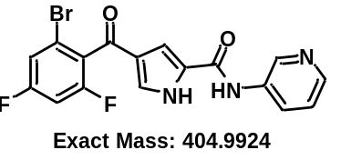 | ¹H NMR (400 MHz, DMSO-d₆) δ 12.73 (s, 1H), 10.24 (s, 1H), 8.90 (s, 1H), 8.31(s, 1H), 8.14 (s, 1H), 7.68-7.40 (m, 5H). ¹³C NMR (101 MHz, DMSO-d₆) δ 184.64, 161.48, 161.34, 160.63, 160.49, 159.18, 158.16, 158.02, 144.89, 142.11, 135.99, 130.38, 128.72, 127.48, 125.44, 124.07, 120.42, 120.34, 120.29, 120.22, 117.26, 117.23, 117.01, 116.98, 112.04, 105.21, 104.95, 104.69. | 405.9995
C-3 | 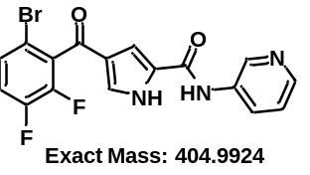 | ¹H NMR (400 MHz, DMSO-d₆) δ 12.78 (s, 1H), 10.26 (s, 1H), 8.90 (d, J = 2.5 Hz, 1H), 8.31 (dd, J = 4.7, 1.5 Hz, 1H), 8.14 (dt, J = 8.6, 1.9 Hz, 1H), 7.68-7.57 (m, 3H), 7.54 (s, 1H), 7.39 (dd, J = 8.3, 4.7 Hz, 1H). ¹³C NMR (101 MHz, DMSO-d₆) δ 183.88, 159.17, 150.86, 150.76, 148.40, 148.30, 148.26, 145.92, 145.79, 144.90, 142.12, 135.96, 132.19, 132.00, 130.81, 129.93, 129.89, 129.86, 129.83, 128.91, 127.50, 125.01, 124.04, 120.07, 119.89, 113.77, 113.73, 113.70, 112.03. | 405.9992
C-4 | 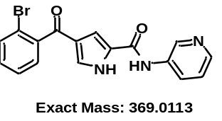 | ¹H NMR (400 MHz, DMSO-d₆) δ 12.61 (s, 1H), 10.24 (s, 1H), 8.91 (d, J = 2.6 Hz, 1H), 8.28 (dt, J = 4.8, 1.2 Hz, 1H), 8.17-8.14 (m, 1H), 7.74 (d, J = 7.9 Hz, 1H), 7.55-7.40 (m, 4H), 7.38 (dd, J = 8.3, 4.7 Hz, 1H), 7.30 (d, J = 1.4 Hz, 1H). ¹³C NMR (101 MHz, DMSO-d₆) δ 189.43, 159.96, 144.57, 142.35, 141.93, 136.22, 133.34, 131.47, 128.94, 128.00, 127.16, 125.46, 124.00, 118.81, 112.97. | 370.0185
C-5 | 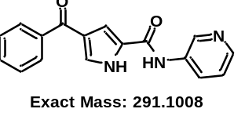 | ¹H NMR (400 MHz, DMSO-d₆) δ 12.57 (s, 1H), 10.25 (s, 1H), 8.95 (s, 1H), 8.32 (s, 1H), 8.17 (d, J = 8.3 Hz, 1H), 7.84-7.81 (m, 2H), 7.69-7.60 (m, 2H), 7.61-7.50 (m, 3H), 7.40 (s, 1H). ¹³C NMR (101 MHz, DMSO-d₆) δ 189.85, 159.46, 144.71, 142.02, 139.54, 132.26, 129.21, 129.03, 128.99, 127.70, 127.30, 124.76, 113.45. | 292.1080
C-6 | 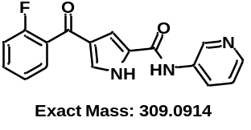 | ¹H NMR (400 MHz, DMSO-d₆) δ 12.62 (s, 1H), 10.25 (s, 1H), 8.91 (d, J = 2.5 Hz, 1H), 8.30 (d, J = 4.0 Hz, 1H), 8.16 (d, J = 8.7 Hz, 1H), 7.65-7.57 (m, 3H), 7.46 (s, 1H), 7.41-7.34 (m, 3H). ¹³C NMR (101 MHz, DMSO-d₆) δ 186.79, 160.53, 159.33, 158.06, 144.81, 142.04, 136.07, 133.11, 133.02, 130.23, 130.20, 129.60, 128.68, 128.53, 128.05, 127.40, 125.83, 125.07, 125.04, 124.05, 116.86, 116.65, 112.71. | 310.0976
C-7 | 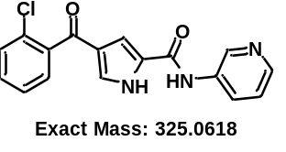 | ¹H NMR (400 MHz, DMSO-d₆) δ 12.63 (s, 1H), 10.25 (s, 1H), 8.91 (d, J = 2.5 Hz, 1H), 8.30 (d, J = 4.7 Hz, 1H), 8.15 (d, J = 8.3 Hz, 1H), 7.66-7.45 (m, 5H), 7.45-7.31 (m, 2H). ¹³C NMR (101 MHz, DMSO-d₆) δ 188.90, 159.30, 144.83, 142.07, 139.89, 136.05, 131.61, 130.37, 129.96, 129.74, 129.06, 128.25, 127.64, 127.42, 125.56, 124.04, 112.61. | 326.0687
C-9 | 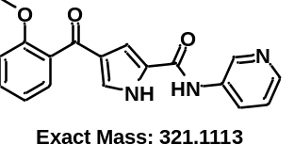 | ¹H NMR (400 MHz, DMSO-d₆) δ 12.45 (s, 1H), 10.21 (s, 1H), 8.92 (d, J = 2.5 Hz, 1H), 8.29 (dd, J = 4.7, 1.5 Hz, 1H), 8.16 (m, 1H), 7.53-7.45 (m, 2H), 7.38 (dd, J = 8.3, 4.7 Hz, 1H), 7.34-7.26 (m, 2H), 7.17 (d, J = 8.3 Hz, 1H), 7.05 (t, J = 7.4 Hz, 1H), 3.75 (s, 3H). ¹³C NMR (101 MHz, DMSO-d₆) δ 190.03, 159.46, 156.69, 144.74, 142.04, 136.13, 131.64, 130.55, 129.07, 128.64, 127.63, 127.36, 126.66, 124.02, 120.69, 112.65, 112.45, 55.96. | 322.1182
C-10 | 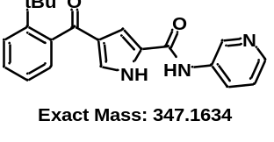 | ¹H NMR (400 MHz, DMSO-d₆) δ 12.52 (s, 1H), 10.23 (s, 1H), 8.92 (d, J = 2.6 Hz, 1H), 8.30 (dd, J = 4.7, 1.5 Hz, 1H), 8.21-8.10 (m, 1H), 7.56 (d, J = 8.0 Hz, 1H), 7.49 (s, 1H), 7.46-7.36 (m, 2H), 7.31-7.26 (m, 2H), 7.17 (dd, J = 7.6, 1.5 Hz, 1H), 1.32 (s, 9H). ¹³C NMR (101 MHz, DMSO-d₆) δ 194.82, 159.42, 147.55, 144.76, 142.08, 140.54, 136.10, 129.34, 129.12, 128.07, 127.85, 127.59, 127.49, 127.40, 125.44, 124.00, 112.75, 36.39, 32.31. | 348.1701
C-11 | 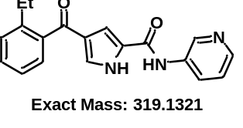 | ¹H NMR (400 MHz, DMSO-d₆) δ 12.54 (s, 1H), 10.24 (s, 1H), 8.92 (s, 1H), 8.30 (d, J = 4.7 Hz, 1H), 8.15 (d, J = 8.3 Hz, 1H), 7.51 (s, 1H), 7.45 (t, J = 7.5 Hz, 1H), 7.40-7.30 (m, 5H), 2.64 (q, J = 7.5 Hz, 2H), 1.10 (t, J = 7.5 Hz, 3H). ¹³C NMR (101 MHz, DMSO-d₆) δ 192.45, 159.41, 144.77, 142.06, 142.01, 140.04, 136.10, 130.24, 129.80, 129.27, 127.91, 127.75, 127.38, 126.53, 125.83, 124.02, 112.84, 26.10, 16.55. | 320.1388
C-12 | 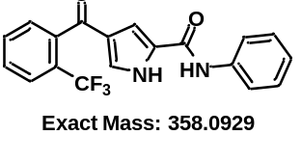 | ¹H NMR (400 MHz, DMSO-d₆) δ 12.58 (s, 1H), 10.07 (s, 1H), 7.89 (d, J = 7.8 Hz, 1H), 7.86-7.69 (m, 4H), 7.64 (d, J = 7.4 Hz, 1H), 7.54 (s, 1H), 7.35 (dd, J = 15.6, 7.7 Hz, 3H), 7.10 (t, J = 7.4 Hz, 1H). ¹³C NMR (101 MHz, DMSO-d₆) δ 189.54, 158.99, 139.54, 139.52, 139.33, 132.74, 130.47, 129.54, 129.11, 128.77, 128.64, 127.12, 127.07, 127.03, 126.98, 126.66, 126.35, 125.60, 123.93, 122.94, 120.52, 112.10. | 359.1007
C-13 | 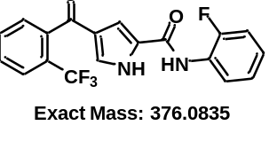 | ¹H NMR (400 MHz, DMSO-d₆) δ 12.58 (s, 1H), 9.98 (s, 1H), 7.89 (d, J = 7.7 Hz, 1H), 7.85-7.69 (m, 2H), 7.65-7.54 (m, 2H), 7.45 (s, 1H), 7.41-7.11 (m, 4H). ¹³C NMR (101 MHz, DMSO-d₆) δ 189.52, 159.05, 157.36, 154.91, 139.50, 132.77, 130.49, 129.44, 129.02, 128.62, 128.13, 127.56, 127.34, 127.26, 127.07, 127.02, 126.58, 126.27, 125.61, 125.50, 124.79, 124.76, 116.41, 116.22, 112.68. | 377.0909
C-14 | 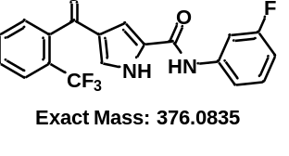 | ¹H NMR (400 MHz, DMSO-d₆) δ 12.60 (s, 1H), 10.21 (s, 1H), 7.89 (d, J = 7.7 Hz, 1H), 7.86-7.68 (m, 3H), 7.62 (d, J = 7.4 Hz, 1H), 7.55-7.49 (m, 2H), 7.38 (q, J = 7.8 Hz, 1H), 7.32 (s, 1H), 6.91 (td, J = 8.4, 2.5 Hz, 1H). ¹³C NMR (101 MHz, DMSO-d₆) δ 189.52, 163.73, 161.34, 159.16, 141.18, 141.07, 139.47, 139.45, 132.76, 130.77, 130.67, 130.50, 129.83, 128.63, 128.40, 127.09, 127.04, 126.66, 126.35, 125.63, 122.93, 116.10, 116.07, 112.45, 110.43, 110.22, 107.26, 107.00. | 377.0914
C-15 | 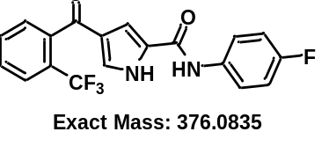 | ¹H NMR (400 MHz, DMSO-d₆) δ 12.55 (s, 1H), 10.10 (s, 1H), 7.89 (d, J = 7.1 Hz, 1H), 7.87-7.65 (m, 4H), 7.62 (d, J = 7.4 Hz, 1H), 7.47 (d, J = 1.6 Hz, 1H), 7.29 (d, J = 1.6 Hz, 1H), 7.25 – 7.12 (m, 2H). ¹³C NMR (101 MHz, DMSO-d₆) δ 189.54, 159.86, 158.92, 157.47, 139.50, 135.65, 132.73, 130.47, 129.58, 128.62, 127.07, 127.02, 126.66, 126.34, 125.60, 122.34, 122.27, 115.80, 115.58, 112.09. | 377.0907
C-16 | 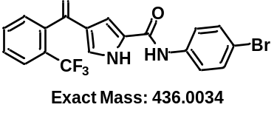 | ¹H NMR (400 MHz, DMSO-d₆) δ 12.58 (s, 1H), 10.15 (s, 1H), 7.88 (d, J = 7.7 Hz, 1H), 7.83-7.70 (m, 4H), 7.62 (d, J = 7.4 Hz, 1H), 7.57-7.47 (m, 3H), 7.31 (s, 1H). ¹³C NMR (101 MHz, DMSO-d₆) δ 189.51, 159.03, 139.49, 139.47, 138.75, 132.72, 131.93, 130.46, 129.75, 128.63, 128.52, 127.11, 127.07, 127.02, 126.98, 126.68, 126.37, 125.63, 122.35, 115.61, 112.36. | 437.2372
C-17 | 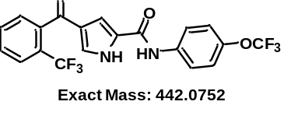 | ¹H NMR (400 MHz, DMSO-d₆) δ 12.59 (s, 1H), 10.22 (s, 1H), 7.99-7.67 (m, 5H), 7.62 (d, J = 7.4 Hz, 1H), 7.51 (d, J = 1.5 Hz, 1H), 7.36 (d, J = 8.7 Hz, 2H), 7.31 (d, J = 1.6 Hz, 1H). ¹³C NMR (101 MHz, DMSO-d₆) δ 189.50, 159.07, 144.20, 144.18, 139.48, 139.45, 138.56, 132.74, 130.49, 129.75, 128.63, 128.43, 127.12, 127.07, 127.03, 126.97, 126.66, 126.34, 125.62, 122.92, 121.98, 121.76, 119.34, 112.37. | 443.0832
C-18 | 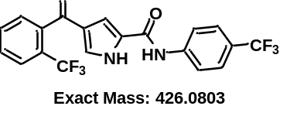 | ¹H NMR (400 MHz, DMSO-d₆) δ 12.63 (s, 1H), 10.35 (s, 1H), 7.97 (d, J = 8.5 Hz, 2H), 7.89 (d, J = 7.7 Hz, 1H), 7.83-7.69 (m, 4H), 7.63 (d, J = 7.4 Hz, 1H), 7.55 (d, J = 1.5 Hz, 1H), 7.34 (d, J = 1.5 Hz, 1H). ¹³C NMR (101 MHz, DMSO-d₆) δ 189.50, 159.29, 143.03, 139.43, 139.41, 132.79, 130.55, 129.98, 128.64, 128.27, 127.15, 127.11, 127.06, 127.01, 126.64, 126.48, 126.45, 126.41, 126.37, 126.32, 126.21, 125.65, 124.01, 123.69, 123.51, 122.92, 120.22, 112.77 | 427.0882
C-19 | 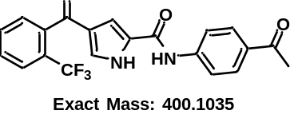 | ¹H NMR (400 MHz, DMSO-d₆) δ 12.62 (s, 1H), 10.33 (s, 1H), 7.97 (d, J = 8.8 Hz, 2H), 7.93-7.86 (m, 3H), 7.84-7.73 (m, 2H), 7.62 (d, J = 7.3 Hz, 1H), 7.55 (d, J = 1.6 Hz, 1H), 7.34 (d, J = 1.5 Hz, 1H), 2.54 (s, 3H). ¹³C NMR (101 MHz, DMSO-d₆) δ 197.06, 189.53, 159.22, 143.80, 139.42, 139.40, 132.81, 132.28, 130.56, 130.00, 129.83, 128.64, 128.35, 127.12, 127.07, 126.62, 126.31, 125.65, 122.92, 119.57, 112.78, 26.91. | 401.1107
C-20 | 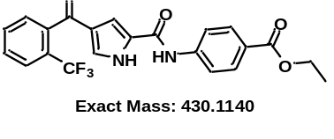 | ¹H NMR (400 MHz, DMSO-d₆) δ 12.62 (s, 1H), 10.33 (s, 1H), 8.01-7.85 (m, 5H), 7.82-7.73 (m, 2H), 7.62 (d, J = 7.4 Hz, 1H), 7.55 (s, 1H), 7.34 (s, 1H), 4.30 (q, J = 7.1 Hz, 2H), 1.32 (t, J = 7.1 Hz, 3H). ¹³C NMR (101 MHz, DMSO-d₆) δ 189.52, 165.82, 159.22, 143.81, 139.43, 139.41, 132.80, 130.58, 130.01, 128.64, 128.36, 127.11, 127.07, 126.61, 126.30, 125.65, 124.82, 122.92, 119.68, 112.80, 60.92, 14.68. | 431.1214
C-21 | 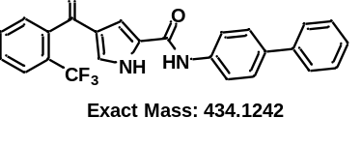 | ¹H NMR (400 MHz, DMSO-d₆) δ 12.58 (s, 1H), 10.14 (s, 1H), 7.97-7.72 (m, 5H), 7.72-7.55 (m, 5H), 7.52 (d, J = 1.6 Hz, 1H), 7.46 (t, J = 7.7 Hz, 2H), 7.39-7.26 (m, 2H). ¹³C NMR (101 MHz, DMSO-d₆) δ 189.55, 159.00, 140.17, 139.52, 138.84, 135.61, 132.77, 130.50, 129.64, 129.36, 128.75, 128.65, 127.50, 127.33, 127.09, 127.05, 126.73, 125.63, 120.82, 112.19. | 435.1310
C-22 | 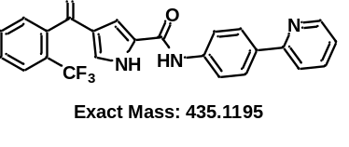 | ¹H NMR (400 MHz, DMSO-d₆) δ 12.59 (s, 1H), 10.19 (s, 1H), 8.65 (dd, J = 5.0, 1.7 Hz, 1H), 8.10 (d, J = 8.6 Hz, 2H), 7.94 (d, J = 8.0 Hz, 1H), 7.92-7.83 (m, 4H), 7.81-7.74(m, 2H), 7.64 (d, J = 7.4 Hz, 1H), 7.54 (s, 1H), 7.37-7.25 (m, 2H). ¹³C NMR (101 MHz, DMSO-d₆) δ 189.53, 159.02, 156.06, 149.90, 140.26, 139.51, 137.59, 134.10, 132.79, 130.53, 129.68, 128.66, 127.36, 127.11, 127.06, 126.63, 126.32, 125.62, 122.59, 120.37, 120.10, 112.32. | 436.1259
C-23 | 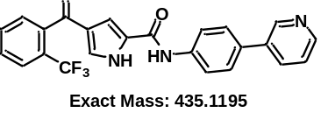 | ¹H NMR (400 MHz, DMSO-d₆) δ 12.60 (s, 1H), 10.18 (s, 1H), 8.91 (d, J = 2.5 Hz, 1H), 8.55 (d, J = 4.2 Hz, 1H), 8.07 (d, J = 8.1 Hz, 1H), 7.89 (d, J = 8.2 Hz, 3H), 7.85-7.70 (m, 4H), 7.63 (d, J = 7.5 Hz, 1H), 7.53 (s, 1H), 7.47 (dd, J = 8.0, 4.7 Hz, 1H), 7.32 (s, 1H). ¹³C NMR (101 MHz, DMSO-d₆) δ 189.54, 159.05, 148.53, 147.78, 139.49, 135.56, 134.06, 132.79, 132.37, 130.53, 129.70, 128.65, 127.59, 127.15, 127.10, 127.06, 127.01, 126.63, 126.32, 125.62, 124.30, 122.94, 120.88, 112.27. | 436.1262
C-24 | 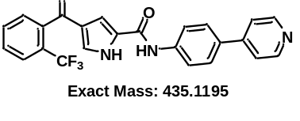 | ¹H NMR (400 MHz, DMSO-d₆) δ 12.60 (s, 1H), 10.23 (s, 1H), 8.61 (d, J = 6.1 Hz, 2H), 7.91 (t, J = 8.3 Hz, 3H), 7.88-7.74 (m, 4H), 7.71 (d, J = 6.2 Hz, 2H), 7.63 (d, J = 7.4 Hz, 1H), 7.54 (s, 1H), 7.32 (s, 1H). ¹³C NMR (101 MHz, DMSO-d₆) δ 189.53, 159.09, 150.64, 146.86, 140.53, 139.47, 132.79, 132.19, 130.53, 129.77, 128.65, 128.60, 127.63, 127.11, 127.06, 126.64, 126.33, 125.63, 121.10, 120.74, 112.41. | 436.1267
C-25 | 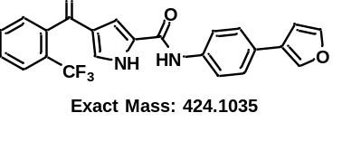 | ¹H NMR (400 MHz, DMSO-d₆) δ 12.58 (s, 1H), 10.11 (s, 1H), 8.16 (s, 1H), 7.91 (d, J = 7.7 Hz, 1H), 7.85-7.75 (m, 5H), 7.66-7.61 (m, 3H), 7.52 (s, 1H), 7.33 (s, 1H), 6.97 (d, J = 0.9 Hz, 1H). ¹³C NMR (101 MHz, DMSO-d₆) δ 189.54, 158.89, 144.65, 139.52, 139.49, 139.23, 138.15, 132.79, 130.51, 129.54, 128.72, 128.65, 127.61, 127.10, 127.05, 126.62, 126.31, 126.28, 125.99, 125.66, 125.59, 122.94, 120.73, 112.08, 109.08 | 425.1110
C-26 | 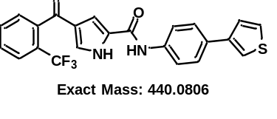 | ¹H NMR (400 MHz, DMSO-d₆) δ 12.58 (s, 1H), 10.11 (s, 1H), 7.89 (d, J = 7.7 Hz, 1H), 7.86-7.78 (m, 4H), 7.76 (d, J = 7.5 Hz, 1H), 7.71 (d, J = 8.6 Hz, 2H), 7.67-7.60 (m, 2H), 7.56 (d, J = 5.0 Hz, 1H), 7.52 (s, 1H), 7.31 (s, 1H). ¹³C NMR (101 MHz, DMSO-d₆) δ 189.53, 158.92, 141.59, 139.53, 139.50, 138.38, 132.78, 130.88, 130.51, 129.58, 128.74, 128.66, 127.43, 127.10, 127.05, 126.80, 126.64, 126.48, 126.32, 125.67, 125.60, 122.94, 120.71, 120.45, 112.12. | 441.0883
C-27 | 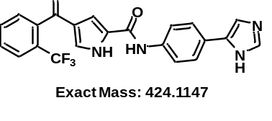 | ¹H NMR (400 MHz, DMSO-d₆) δ 12.56 (s, 1H), 12.15 (s, 1H), 10.06 (s, 1H), 7.89 (d, J = 7.8 Hz, 1H), 7.85-7.67 (m, 7H), 7.63 (d, J = 7.5 Hz, 1H), 7.49 (s, 2H), 7.29 (s, 1H). ¹³C NMR (101 MHz, DMSO-d₆) δ 189.54, 158.80, 139.53, 137.43, 136.28, 132.78, 130.51, 129.46, 128.82, 128.66, 127.14, 127.09, 127.05, 126.99, 126.30, 125.57, 124.96, 122.94, 120.61, 112.01. | 425.1217
C-28 | 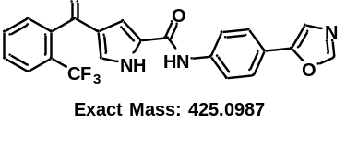 | ¹¹H NMR (400 MHz, DMSO-d₆) δ 12.56 (s, 1H), 10.18 (s, 1H), 8.41 (s, 1H), 7.94-7.84 (m, 3H), 7.82-7.75 (m, 2H), 7.72 (s, 1H), 7.70 (s, 1H), 7.61 (d, J = 12.2 Hz, 2H), 7.50 (s, 1H), 7.31 (s, 1H). ¹³C NMR (101 MHz, DMSO-d₆) δ 189.53, 159.04, 151.87, 150.97, 139.70, 139.50, 139.48, 132.76, 130.50, 129.74, 128.65, 128.58, 127.14, 127.09, 127.04, 127.00, 126.66, 126.34, 125.64, 125.13, 123.00, 121.51, 120.70, 112.37. | 426.1230
C-29  (YL-5092) | 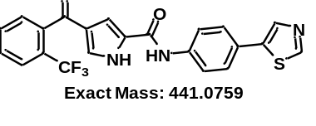 | ¹H NMR (400 MHz, DMSO-d₆) δ 12.59 (s, 1H), 10.19 (s, 1H), 9.05 (s, 1H), 8.26 (s, 1H), 7.89 (d, J = 7.7 Hz, 1H), 7.84 (d, J = 8.6 Hz, 2H), 7.82-7.72 (m, 2H), 7.68 (d, J = 8.4 Hz, 2H), 7.63 (d, J = 7.4 Hz, 1H), 7.52 (s, 1H), 7.32 (s, 1H). ¹³C NMR (101 MHz, DMSO-d₆) δ 189.53, 159.01, 153.37, 139.57, 139.49, 139.47, 139.18, 138.93, 132.78, 130.51, 129.71, 128.65, 128.58, 127.51, 127.15, 127.10, 127.05, 127.00, 126.64, 126.26, 125.66, 125.63, 122.94, 120.86, 112.33. ¹⁹F NMR (376 MHz, DMSO-d₆) δ -56.77. | 442.0835
C-30 | 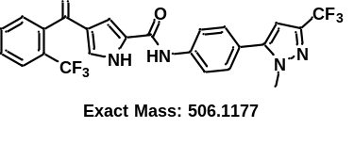 | ¹H NMR (400 MHz, DMSO-d₆) δ 12.62 (s, 1H), 10.24 (s, 1H), 7.91 (t, J = 7.9 Hz, 3H), 7.83-7.74 (m, 2H), 7.63 (d, J = 7.4 Hz, 1H), 7.59 (d, J = 8.7 Hz, 2H), 7.54 (s, 1H), 7.32 (s, 1H), 6.89 (s, 1H), 3.95 (s, 3H). ¹³C NMR (101 MHz, DMSO-d₆) δ 189.52, 159.15, 145.08, 140.24, 139.75, 139.48, 132.81, 130.55, 129.83, 129.70, 128.65, 128.53, 127.12, 127.07, 126.32, 125.66, 125.63, 123.90, 120.71, 120.36, 112.41, 104.49, 38.83. | 507.1255
C-31 | 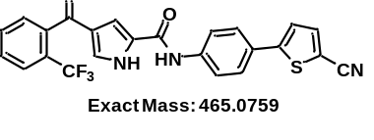 | ¹H NMR (400 MHz, DMSO-d₆) δ 12.61 (s, 1H), 10.25 (s, 1H), 7.98 (d, J = 4.0 Hz, 1H), 7.90-7.87 (m, 3H), 7.83-7.74 (m, 4H), 7.63 (d, J = 4.3 Hz, 2H), 7.53 (s, 1H), 7.33 (s, 1H). ¹³C NMR (101 MHz, DMSO-d₆) δ 189.51, 159.06, 151.62, 140.76, 140.69, 139.46, 132.80, 130.54, 129.81, 128.65, 128.48, 127.23, 127.15, 126.64, 126.32, 125.63, 124.24, 122.93, 120.75, 115.00, 112.47, 106.29. | 466.5337
C-32 | 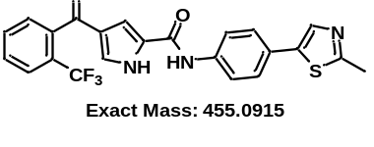 | ¹H NMR (400 MHz, DMSO-d₆) δ 12.59 (s, 1H), 10.18 (s, 1H), 7.96 (s, 1H), 7.89 (d, J = 7.7 Hz, 1H), 7.86-7.71 (m, 4H), 7.64-7.59 (m, 3H), 7.53 (s, 1H), 7.32 (d, J = 1.8 Hz, 1H), 2.66 (s, 3H). ¹³C NMR (101 MHz, DMSO-d₆) δ 189.52, 164.54, 158.99, 139.50, 139.48, 139.24, 138.42, 137.89, 132.76, 130.50, 129.69, 128.64, 128.61, 127.07, 126.65, 126.63, 126.34, 125.66, 125.62, 122.94, 120.85, 112.29, 19.41. | 456.0987
C-33 | 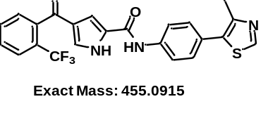 | ¹H NMR (400 MHz, DMSO-d₆) δ 12.61 (s, 1H), 10.21 (s, 1H), 8.97 (s, 1H), 7.97-7.83 (m, 3H), 7.85-7.69 (m, 2H), 7.63 (d, J = 7.4 Hz, 1H), 7.55 (s, 1H), 7.49 (d, J = 8.5 Hz, 2H), 7.32 (d, J = 1.7 Hz, 1H), 2.48 (s, 3H). ¹³C NMR (101 MHz, DMSO-d₆) δ 189.52, 159.06, 151.61, 148.05, 139.50, 139.48, 139.15, 132.77, 131.57, 130.51, 129.77, 128.65, 128.61, 127.10, 127.05, 126.83, 126.65, 126.34, 125.66, 125.62, 122.94, 120.61, 112.31, 16.49. | 456.0988
C-34 | 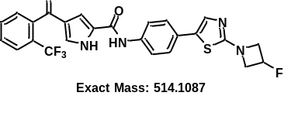 | ¹H NMR (400 MHz, DMSO-d₆) δ 12.55 (s, 1H), 10.11 (s, 1H), 7.89 (d, J = 7.7 Hz, 1H), 7.84-.71 (m, 4H), 7.62 (d, J = 7.4 Hz, 1H), 7.55 (s, 1H), 7.53-7.42 (m, 3H), 7.30 (s, 1H), 5.62 (tt, J = 6.0, 3.1 Hz, 0.5H), 5.48 (tt, J = 6.1, 3.1 Hz, 0.5H), 4.43-4.31 (m, 2H), 4.20-4.08 (m, 2H). ¹³C NMR (101 MHz, DMSO-d₆) δ 189.52, 169.70, 169.68, 158.87, 139.51, 139.48, 138.16, 135.63, 132.78, 130.51, 129.61, 128.83, 128.66, 128.64, 127.46, 127.09, 127.05, 126.63, 126.32, 125.80, 125.60, 122.93, 120.88, 112.16, 85.61, 83.60, 61.41, 61.16. | 515.1151
C-35 | 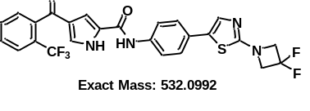 | ¹H NMR (400 MHz, DMSO-d₆) δ 12.56 (s, 1H), 10.12 (s, 1H), 7.89 (d, J = 7.7 Hz, 1H), 7.85-7.66 (m, 4H), 7.62 (d, J = 9.5 Hz, 2H), 7.49 (d, J = 6.9 Hz, 3H), 7.30 (s, 1H), 4.53 (t, J = 12.2 Hz, 4H). ¹³C NMR (101 MHz, DMSO-d₆) δ 189.51, 169.06, 158.90, 139.50, 138.44, 135.47, 132.78, 130.51, 130.21, 129.63, 128.64, 127.13, 127.10, 126.32, 126.01, 125.66, 125.60, 122.94, 120.87, 117.11, 112.19, 65.13, 64.86, 64.60. | 533.1067
C-36 | 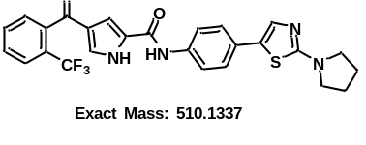 | ¹H NMR (400 MHz, DMSO-d₆) δ 12.54 (s, 1H), 10.08 (s, 1H), 7.89 (d, J = 7.2 Hz, 1H), 7.85-7.70 (m, 4H), 7.62 (d, J = 7.4 Hz, 1H), 7.52 (s, 1H), 7.48 (s, 1H), 7.43 (d, J = 8.7 Hz, 2H), 7.29 (s, 1H), 3.45-3.39 (m, 4H), 2.04-1.95 (m, 4H). ¹³C NMR (101 MHz, DMSO-d₆) δ 189.54, 166.25, 158.82, 139.51, 139.49, 137.51, 136.11, 132.76, 130.50, 129.55, 128.72, 128.64, 128.17, 127.09, 127.04, 126.63, 126.32, 125.66, 125.59, 125.36, 125.25, 122.94, 120.92, 112.07, 49.72, 25.61. | 511.1415
C-37 | 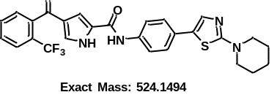 | ¹H NMR (400 MHz, DMSO-d₆) δ 12.55 (s, 1H), 10.09 (s, 1H), 7.89 (d, J = 7.7 Hz, 1H), 7.85-7.67 (m, 4H), 7.62 (d, J = 7.4 Hz, 1H), 7.50 (d, J = 8.5 Hz, 2H), 7.44 (d, J = 8.6 Hz, 2H), 7.30 (s, 1H), 3.44 (d, J = 4.6 Hz, 4H), 1.61 (s, 6H). ¹³C NMR (101 MHz, DMSO-d₆) δ 189.52, 170.09, 158.85, 139.52, 139.50, 137.78, 135.64, 132.75, 130.48, 129.57, 128.72, 128.63, 127.89, 127.08, 127.04, 126.65, 126.34, 126.15, 125.61, 125.47, 122.94, 120.90, 112.11, 49.50, 25.07, 24.06. | 525.1569
C-38 | 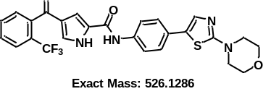 | ¹H NMR (400 MHz, DMSO-d₆) δ 10.13 (s, 1H), 7.88 (d, J = 7.8 Hz, 1H), 7.84-7.67 (m, 4H), 7.63 (d, J = 7.4 Hz, 1H), 7.57 (s, 1H), 7.53 (s, 1H), 7.47 (d, J = 8.3 Hz, 2H), 7.32 (s, 1H), 3.72 (t, J = 4.7 Hz, 4H), 3.41 (t, J = 4.7 Hz, 4H). ¹³C NMR (101 MHz, DMSO-d₆) δ 189.53, 170.30, 158.88, 139.53, 139.51, 138.06, 135.52, 132.74, 130.47, 129.61, 128.71, 128.64, 127.59, 127.15, 127.08, 127.03, 126.67, 126.35, 125.67, 125.62, 122.94, 120.91, 112.15, 65.83, 48.62. | 527.1368
YL-NC | 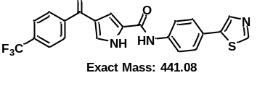 | ¹H NMR (400 MHz, DMSO-d₆) δ 12.63 (s, 1H), 10.20 (s, 1H), 9.05 (s, 1H), 8.27 (s, 1H), 8.00 (d, J = 8.0 Hz, 2H), 7.93 (d, J = 8.1 Hz, 2H), 7.86 (d, J = 8.7 Hz, 2H), 7.74-7.64 (m, 3H), 7.61 (s, 1H). ¹³C NMR (101 MHz, DMSO-d₆) δ 189.10, 188.93, 159.10, 159.05, 153.38, 143.12, 139.62, 139.19, 137.88, 131.96, 131.64, 130.89, 129.70, 129.66, 128.37, 127.52, 126.23, 126.03, 126.00, 125.96, 125.92, 125.75, 124.34, 123.04, 120.82, 113.07. ¹⁹F NMR (376 MHz, DMSO-d₆) δ -61.41. | 442.0835

NMR spectra of all compounds

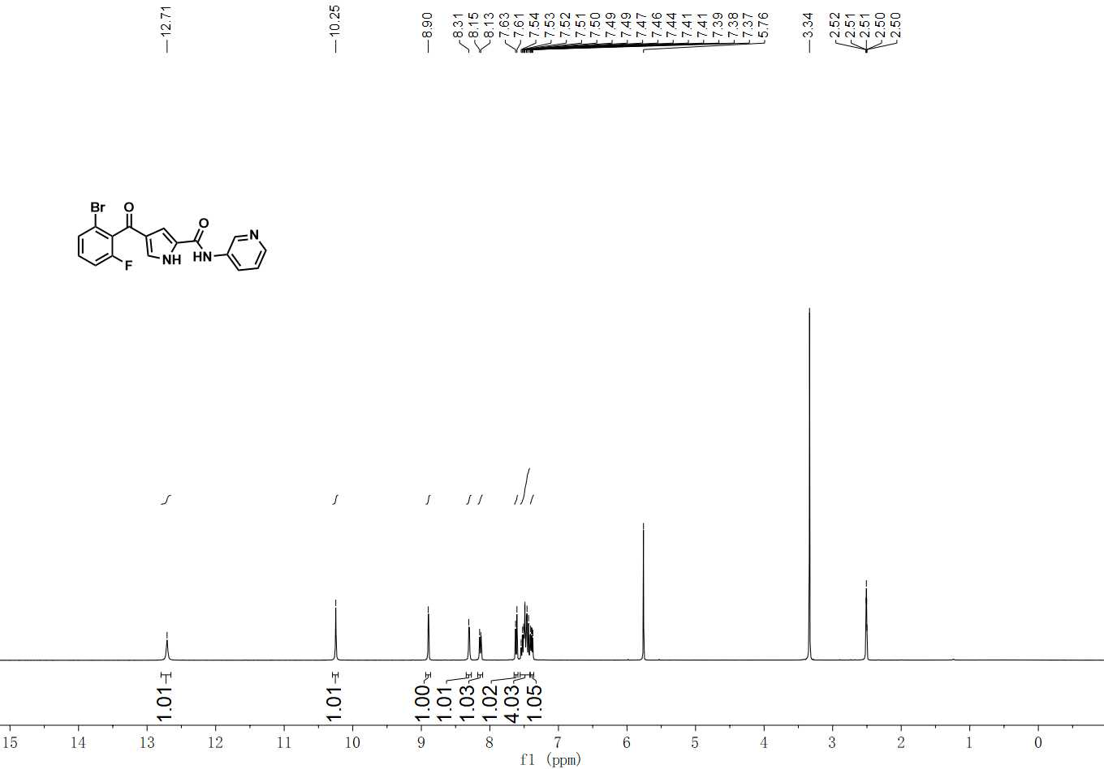
¹H NMR spectrum of C-1

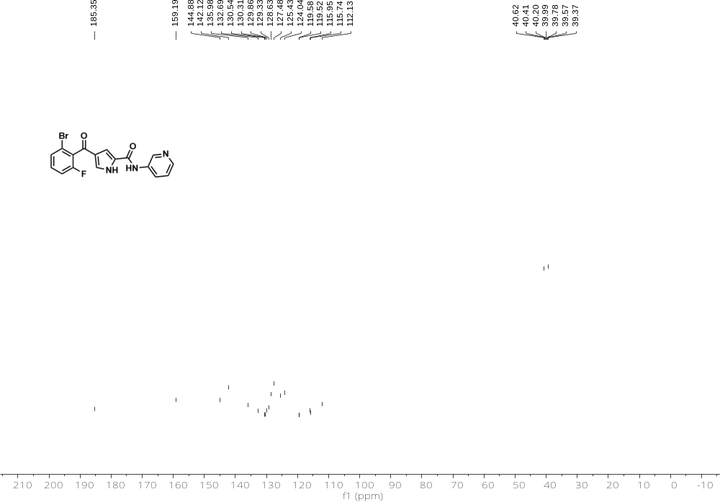
¹³C NMR spectrum of C-1

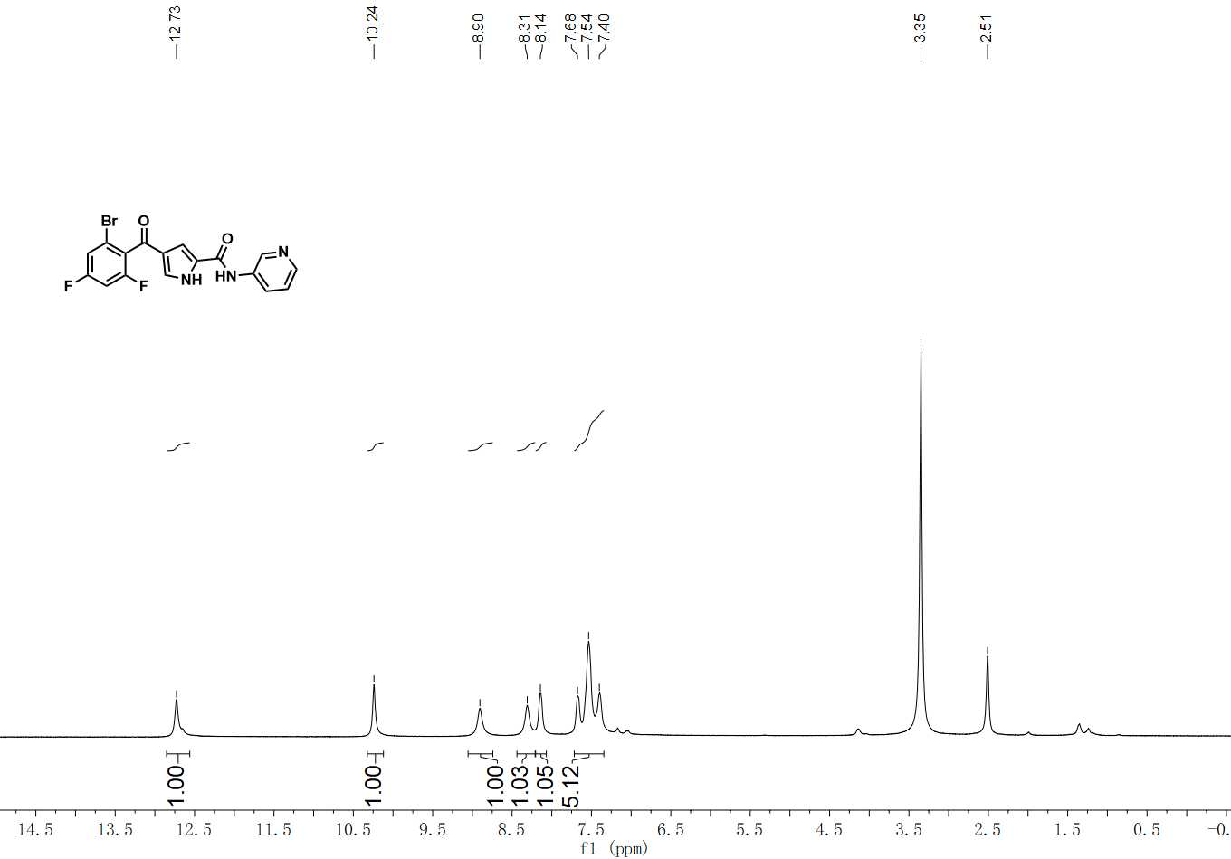
¹H NMR spectrum of C-2

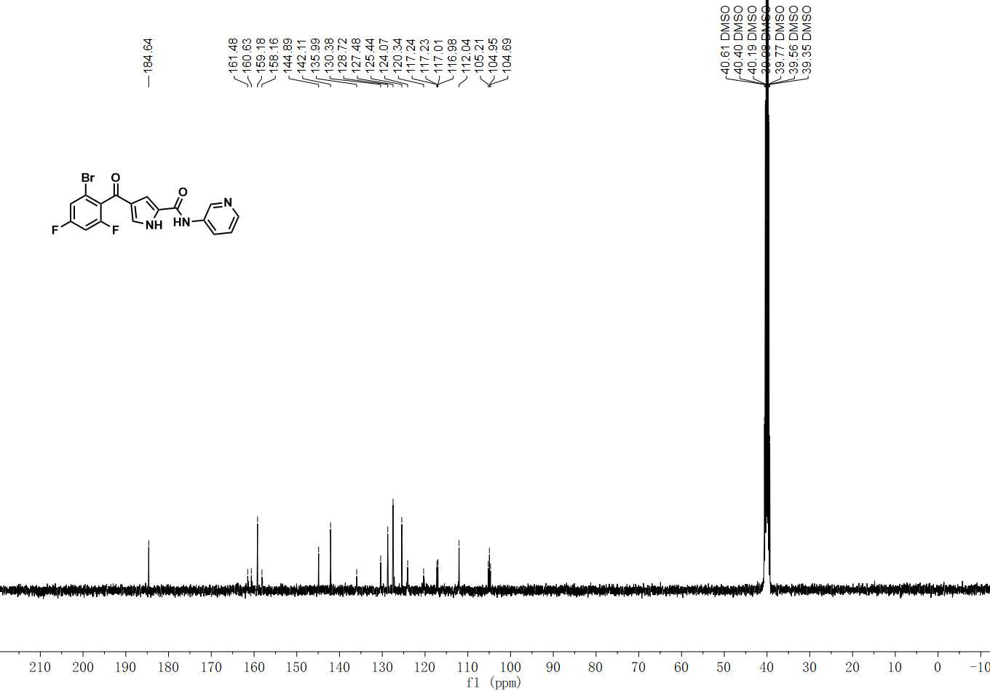
¹³C NMR spectrum of C-2

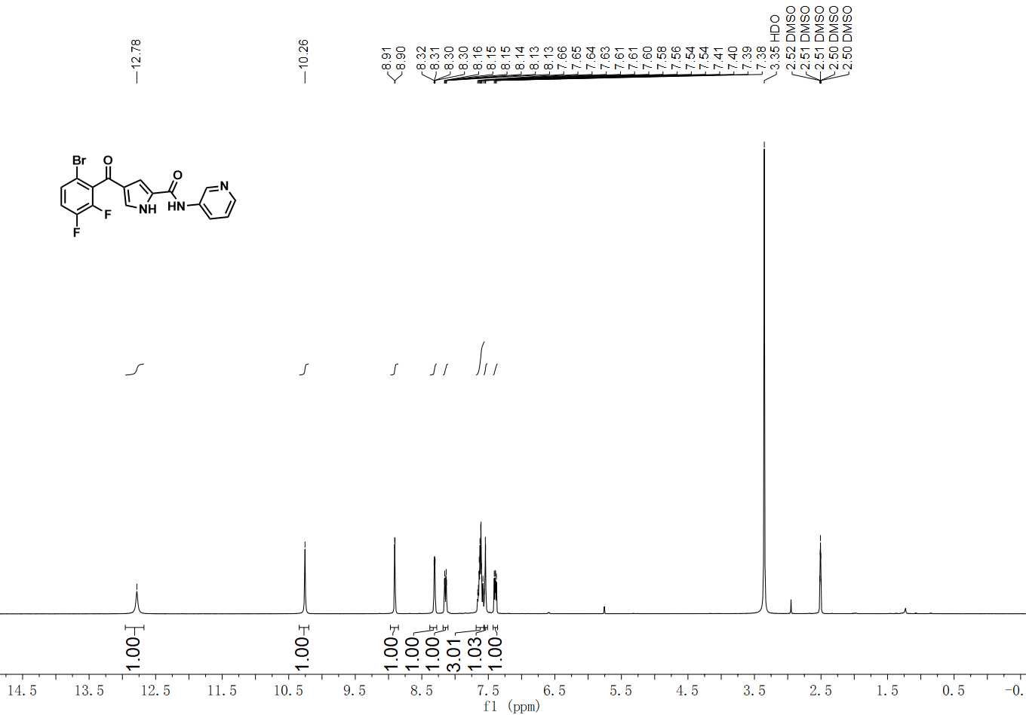

¹H NMR spectrum of C-3

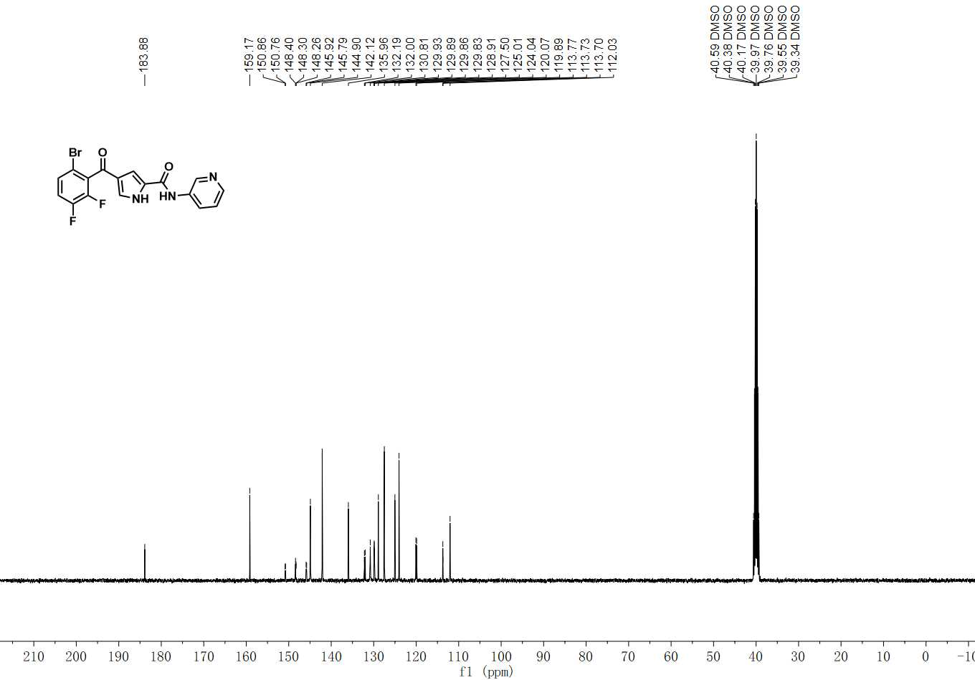

¹³C NMR spectrum of C-3

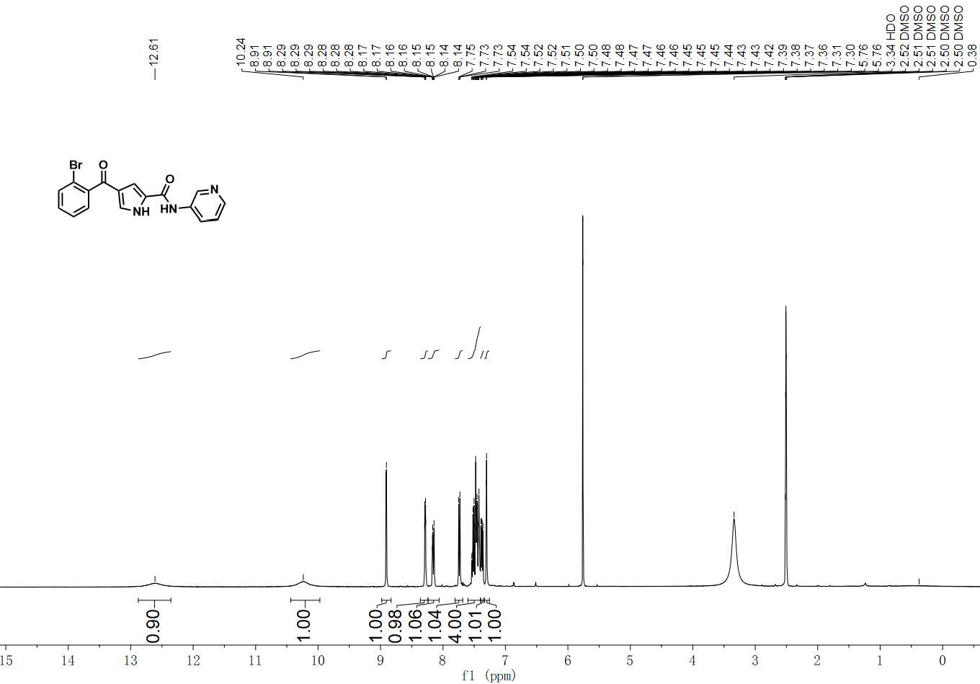

¹H NMR spectrum of C-4

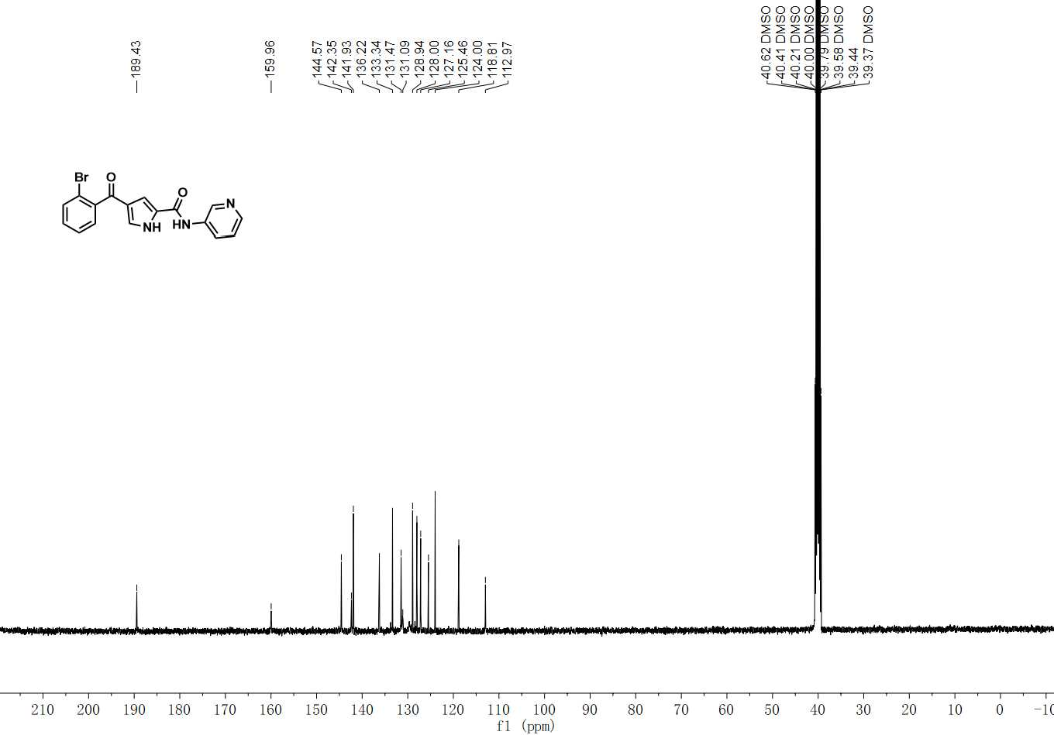

¹³C NMR spectrum of C-4

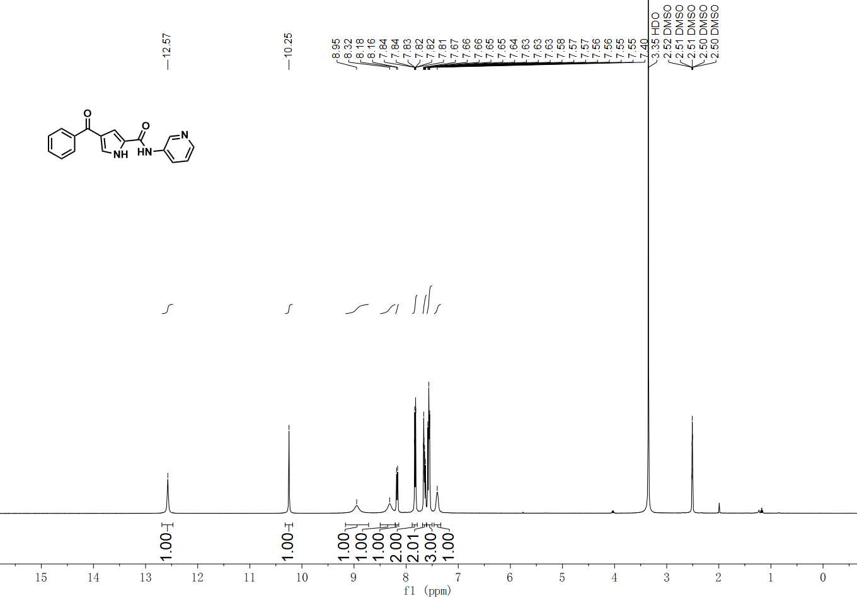

¹H NMR spectrum of C-5

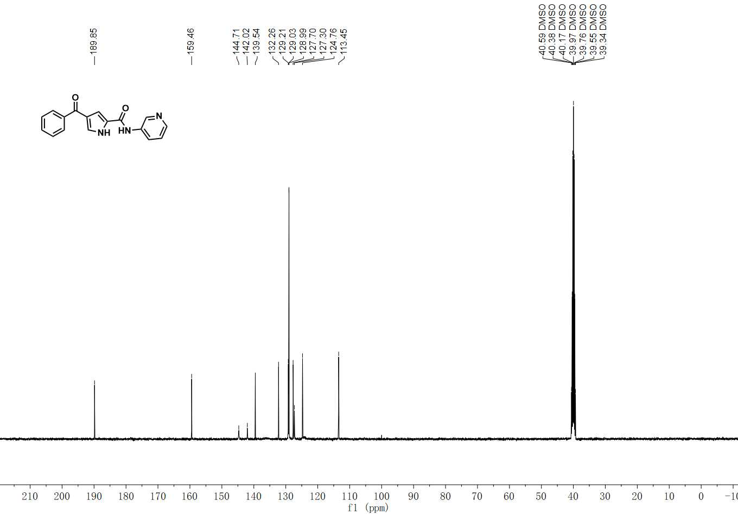

¹³C NMR spectrum of C-5

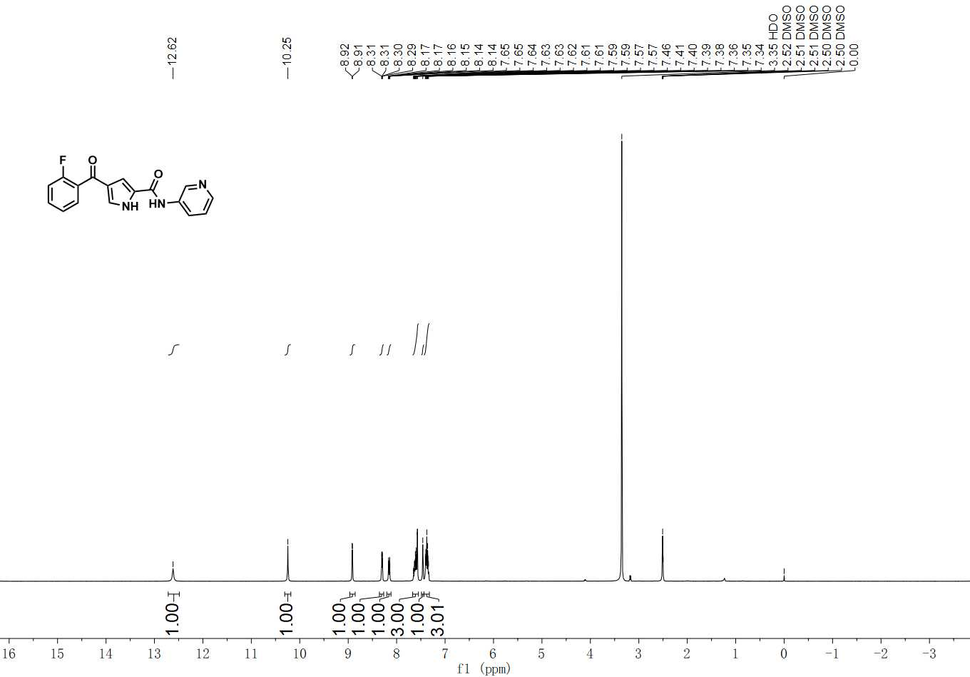

¹H NMR spectrum of C-6

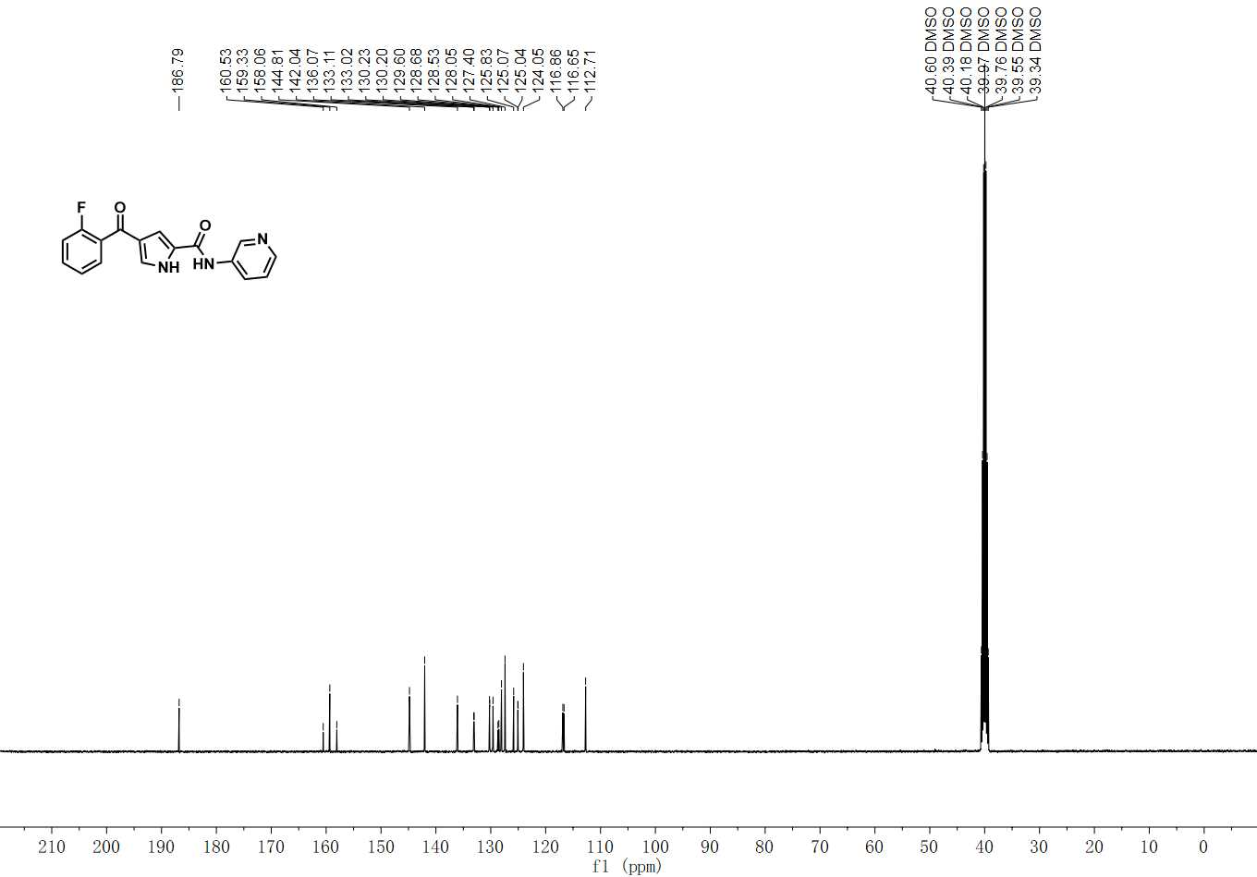

¹³C NMR spectrum of C-6

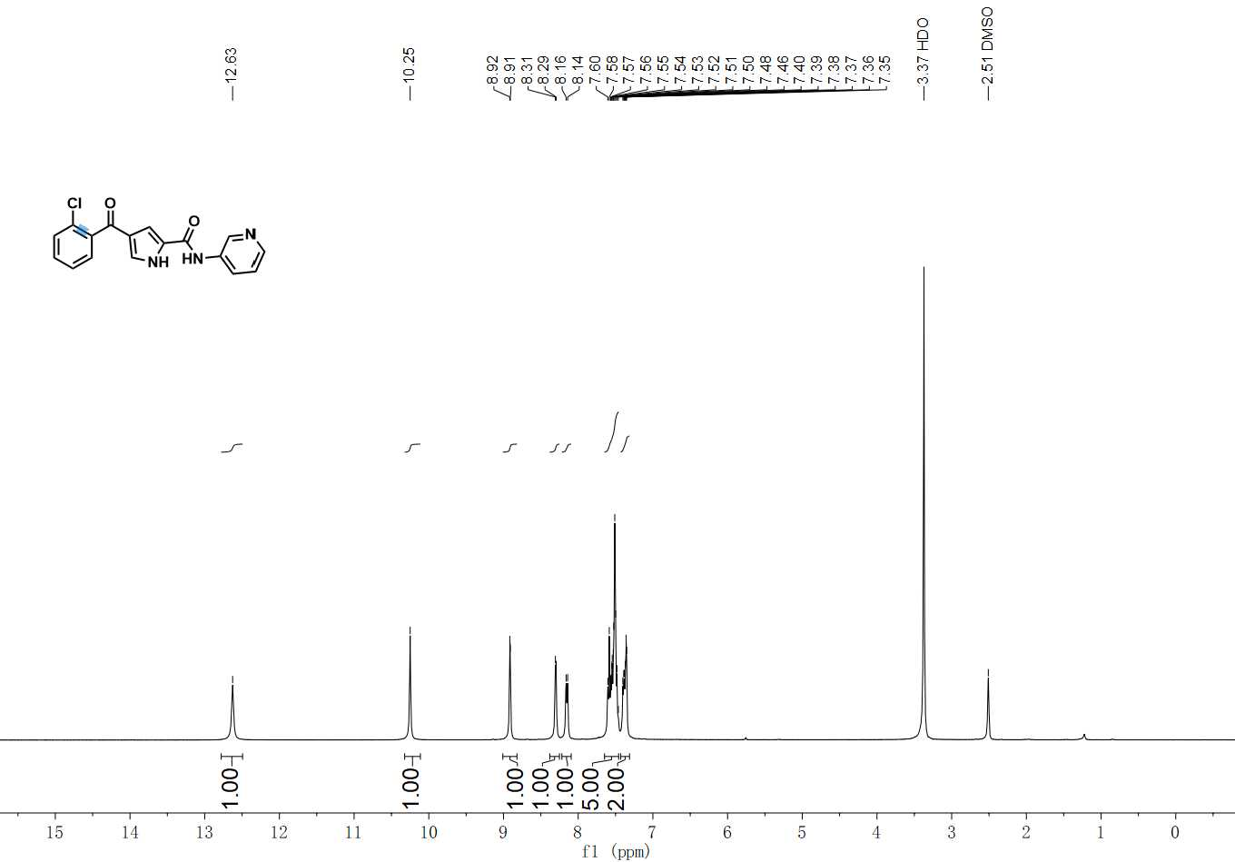

¹H NMR spectrum of C-7

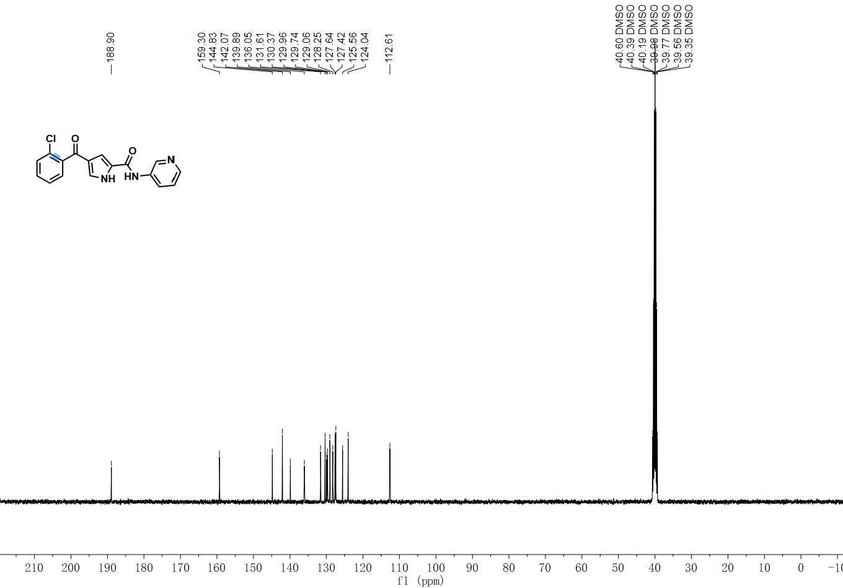

¹³C NMR spectrum of C-7

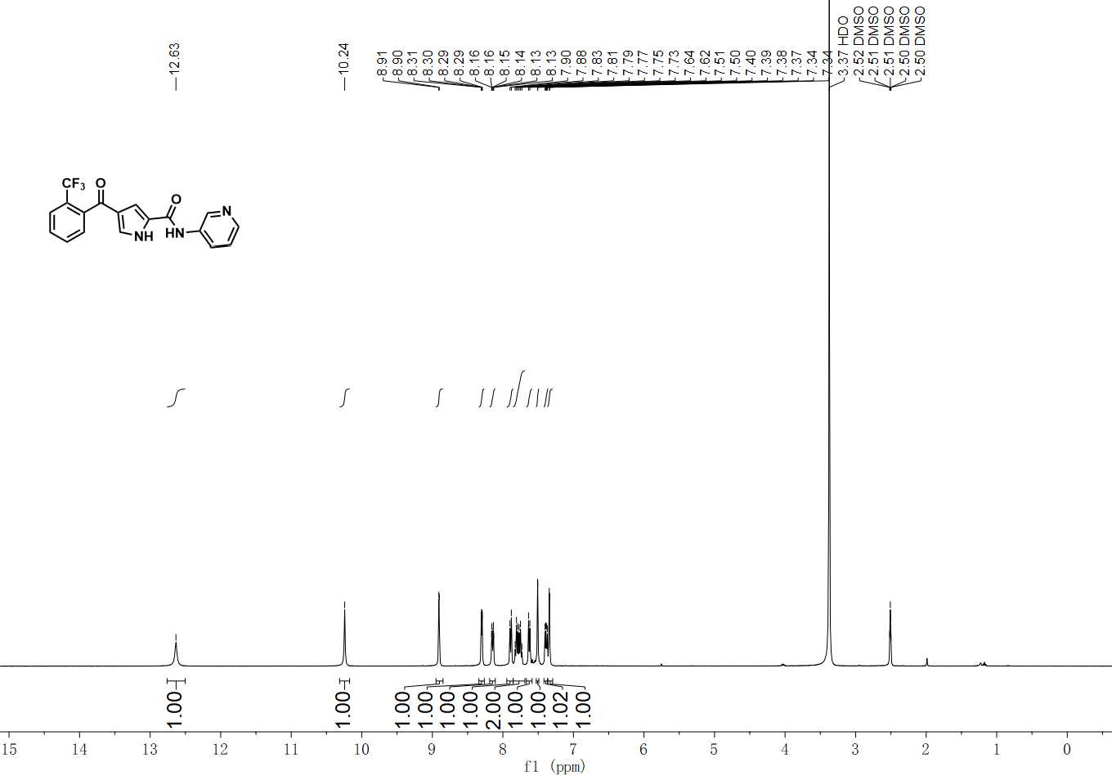

¹H NMR spectrum of C-8

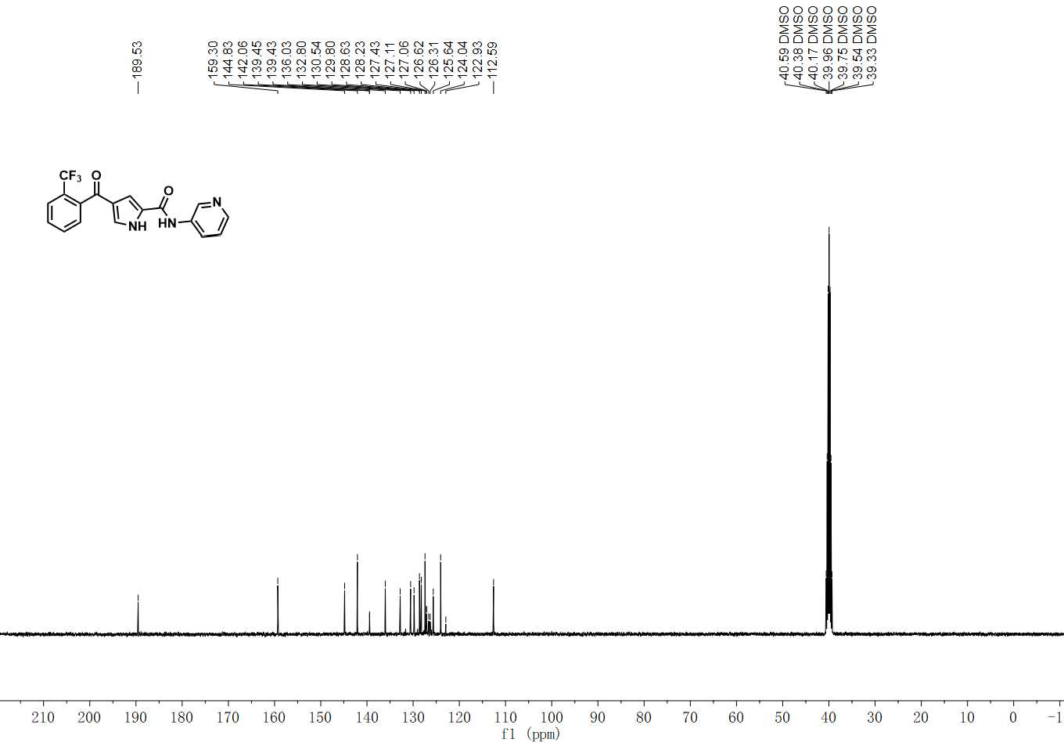

¹³C NMR spectrum of C-8

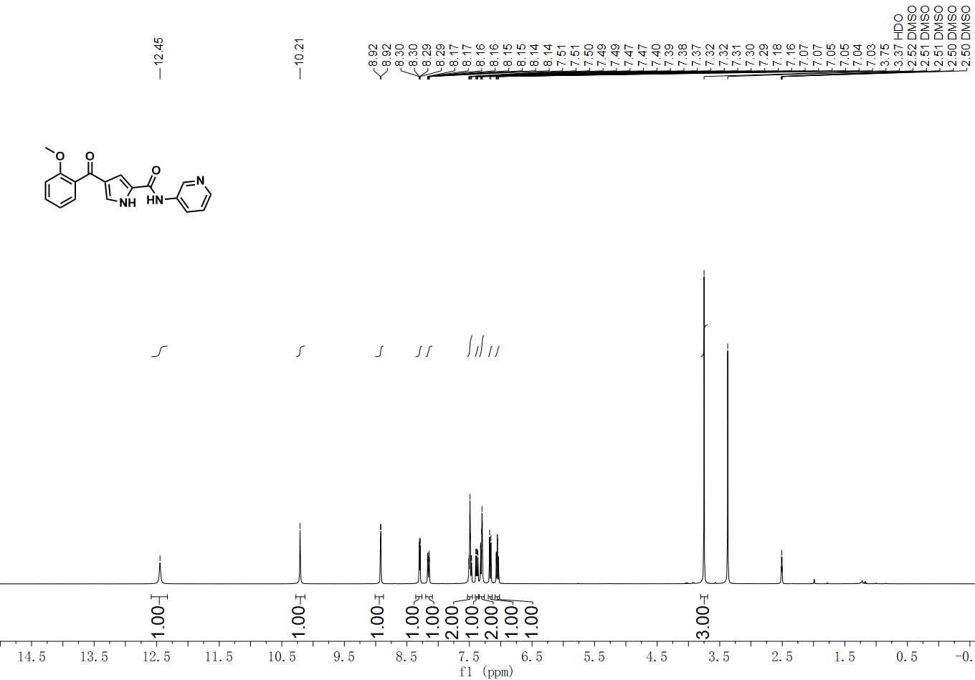

¹H NMR spectrum of C-9

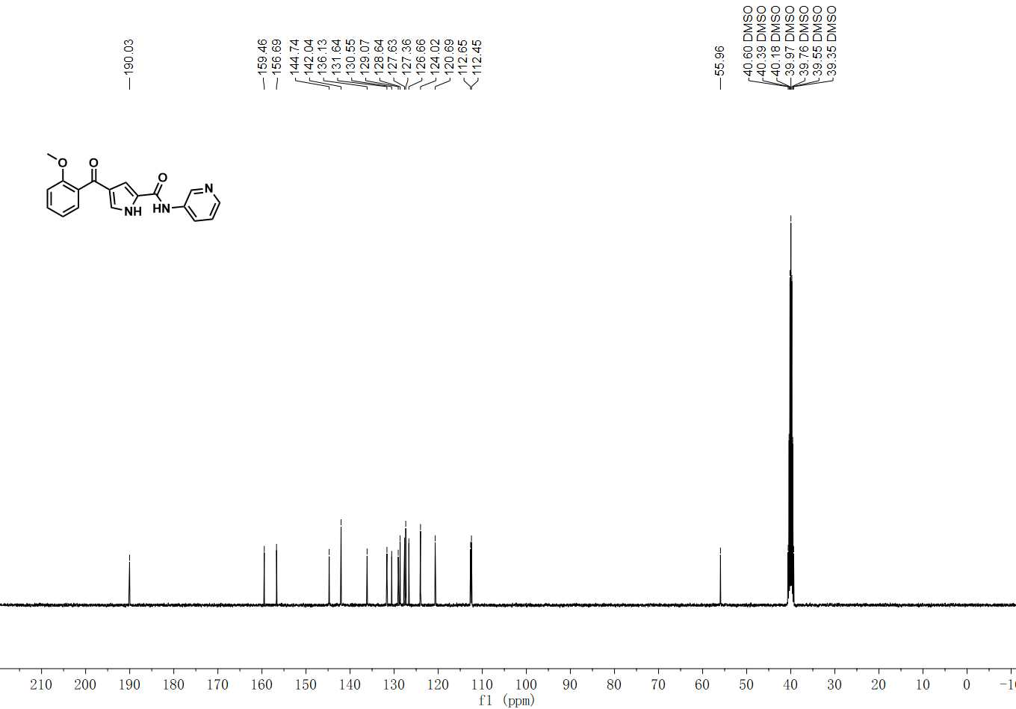

¹³C NMR spectrum of C-9

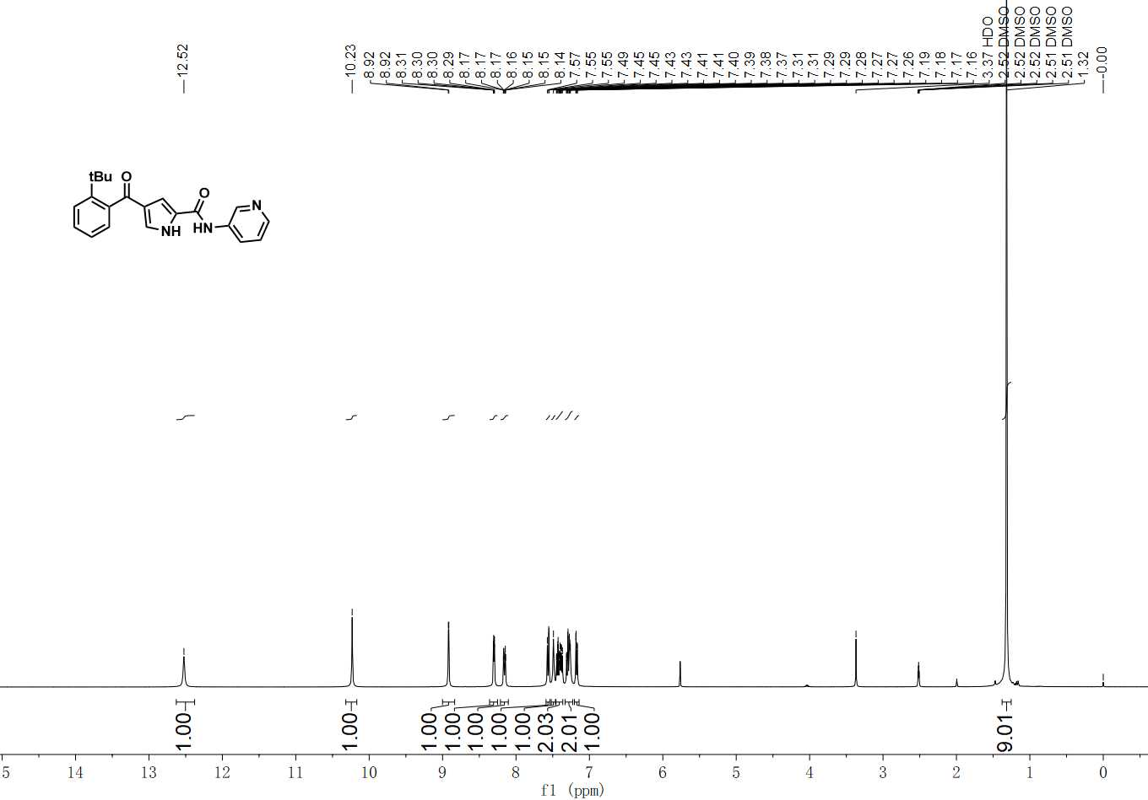

¹H NMR spectrum of C-10

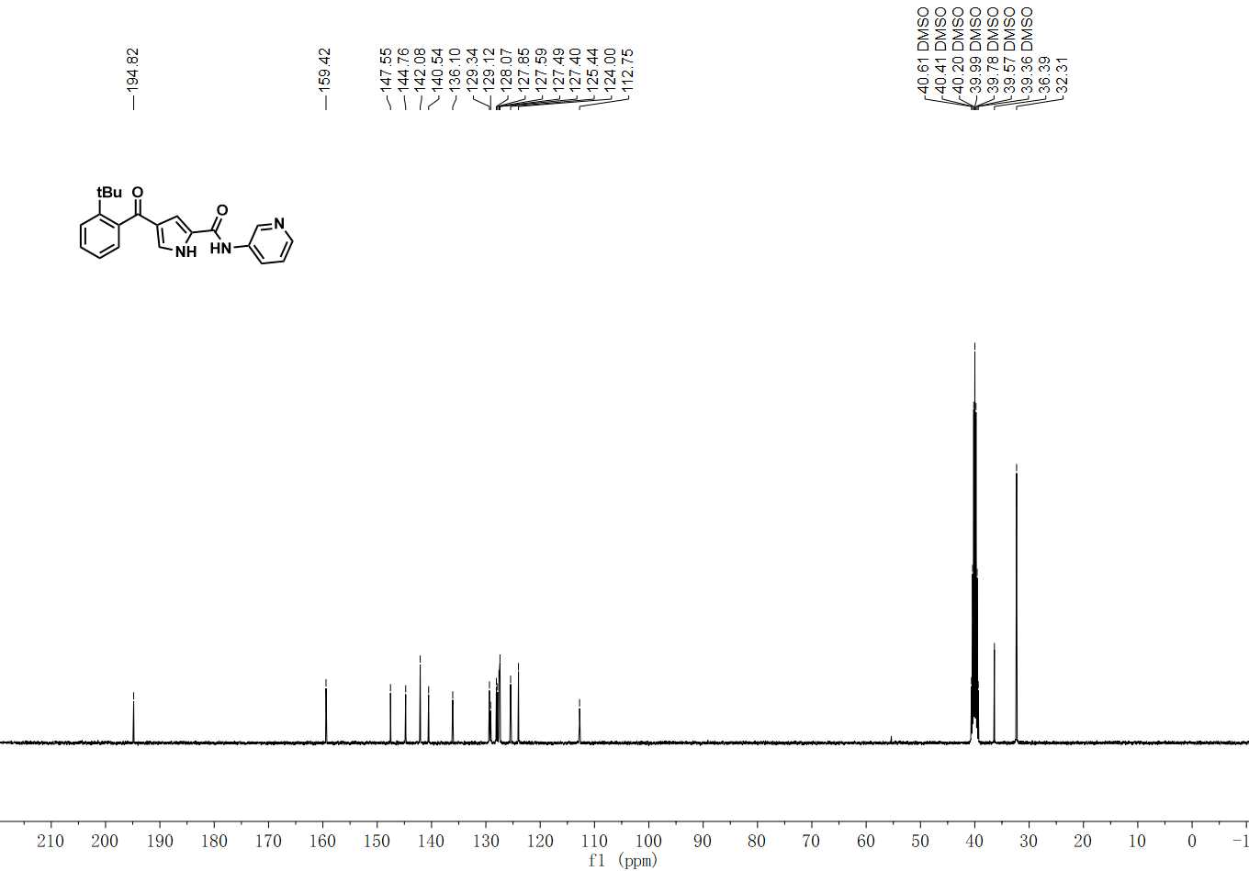

¹³C NMR spectrum of C-10

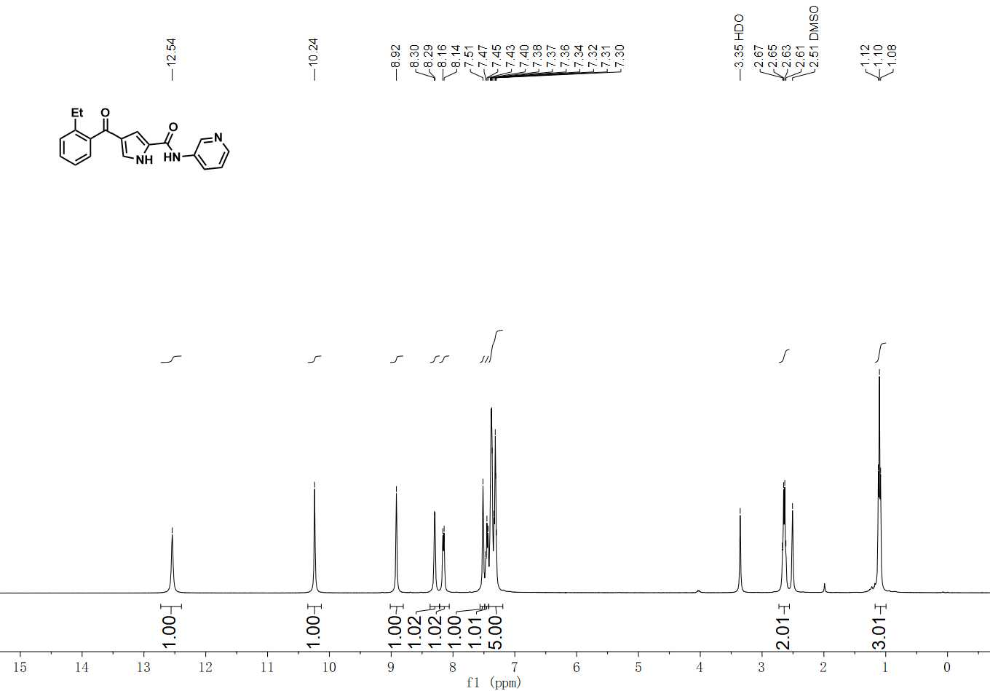

¹H NMR spectrum of C-11

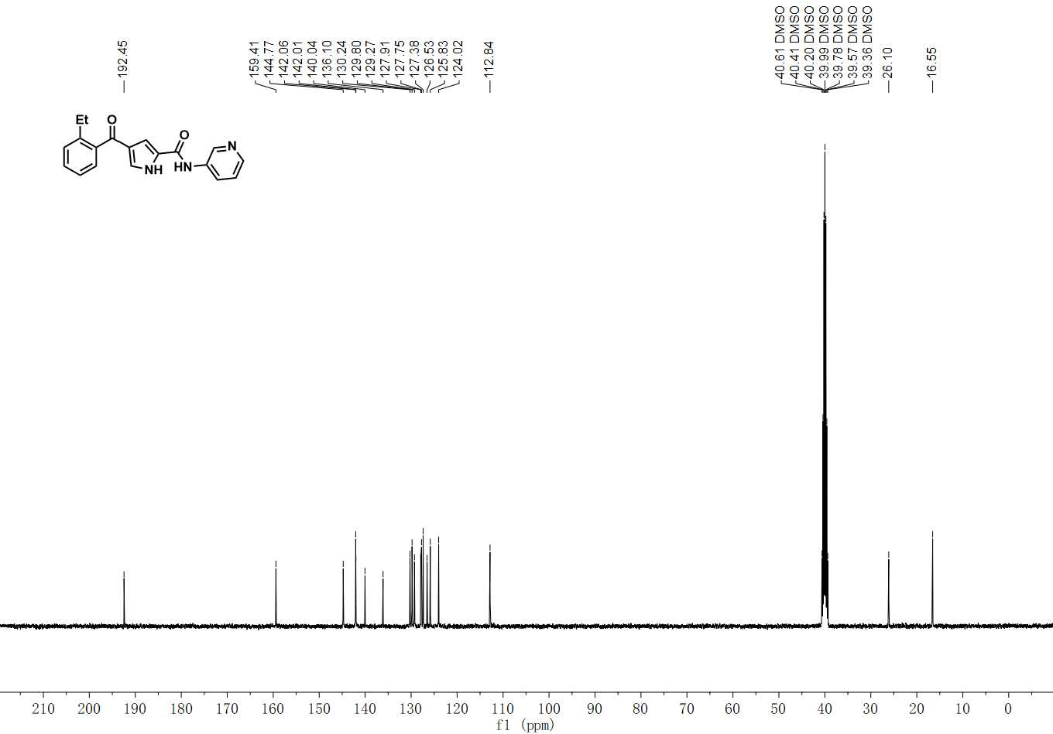

¹³C NMR spectrum of C-11

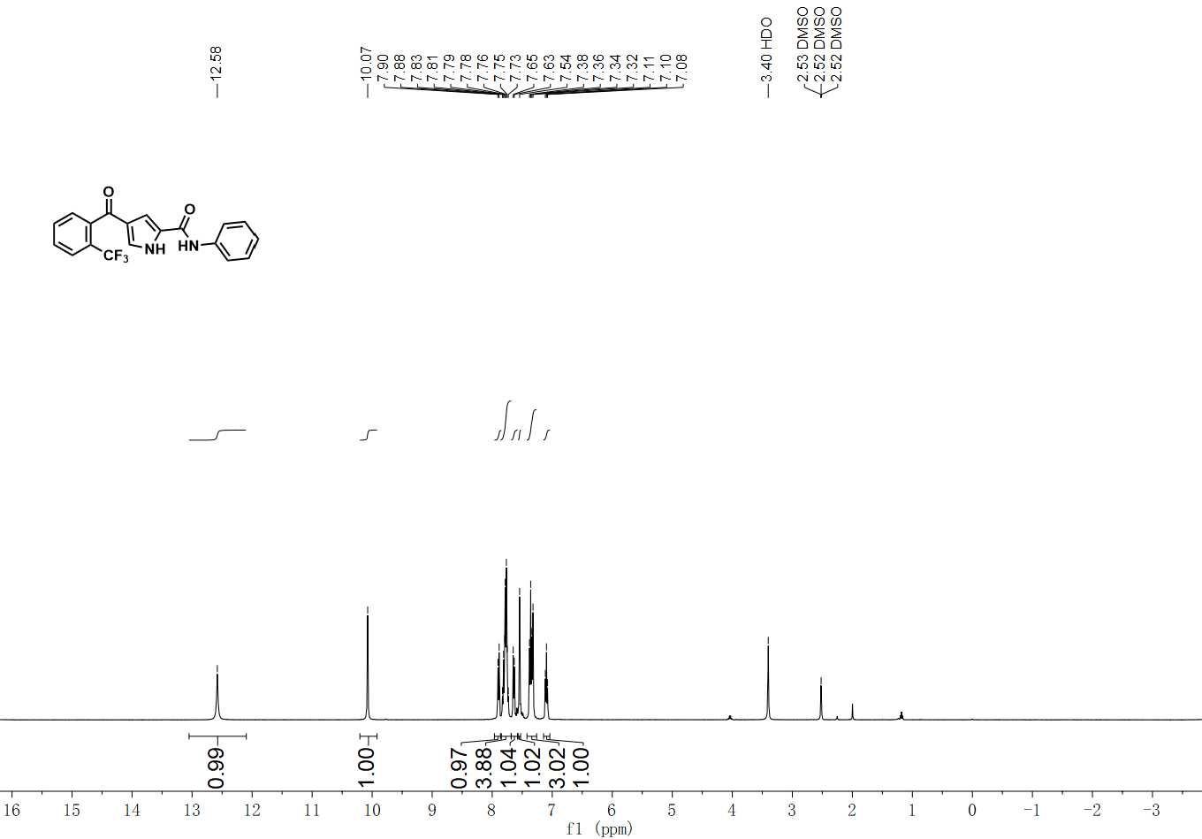

¹H NMR spectrum of C-12

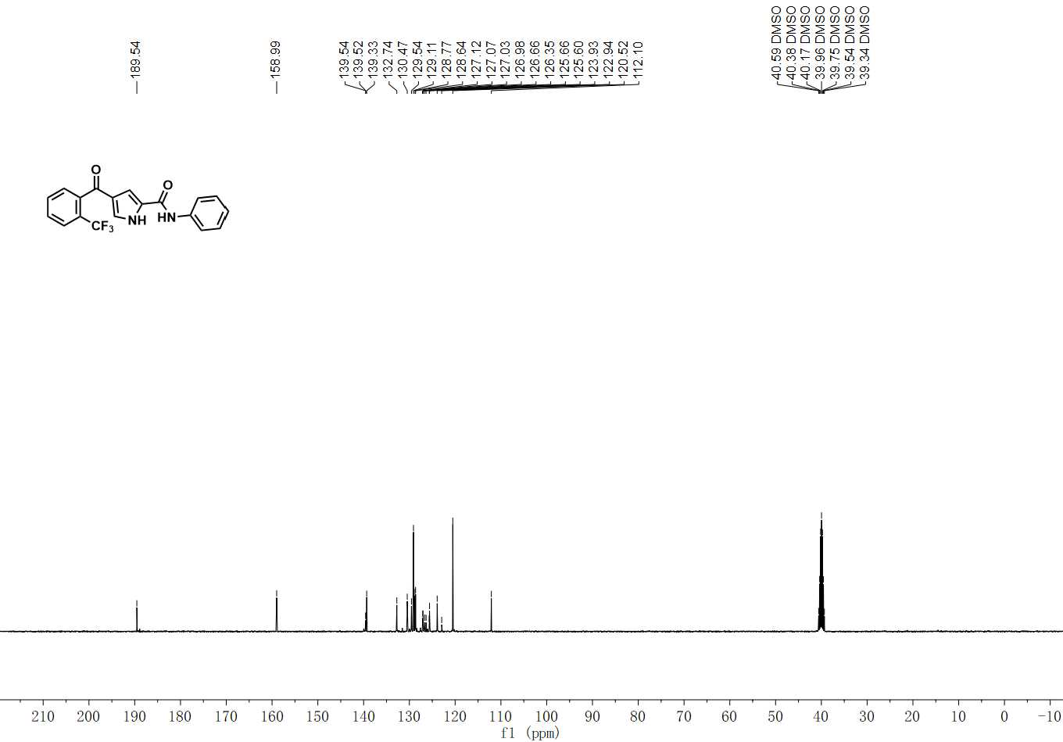

¹³C NMR spectrum of C-12

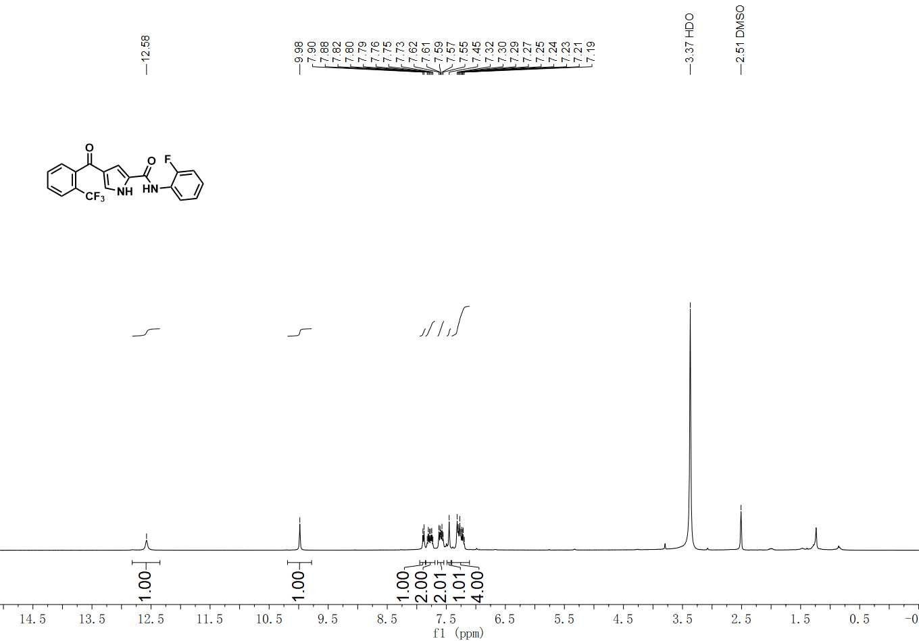

¹H NMR spectrum of C-13

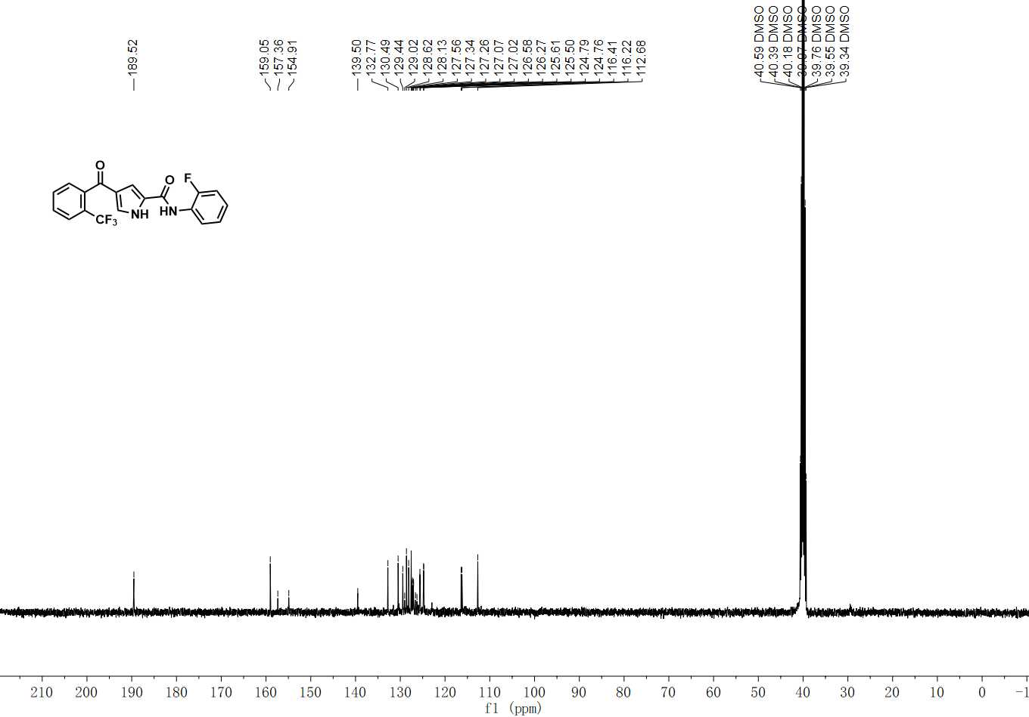

¹³C NMR spectrum of C-13

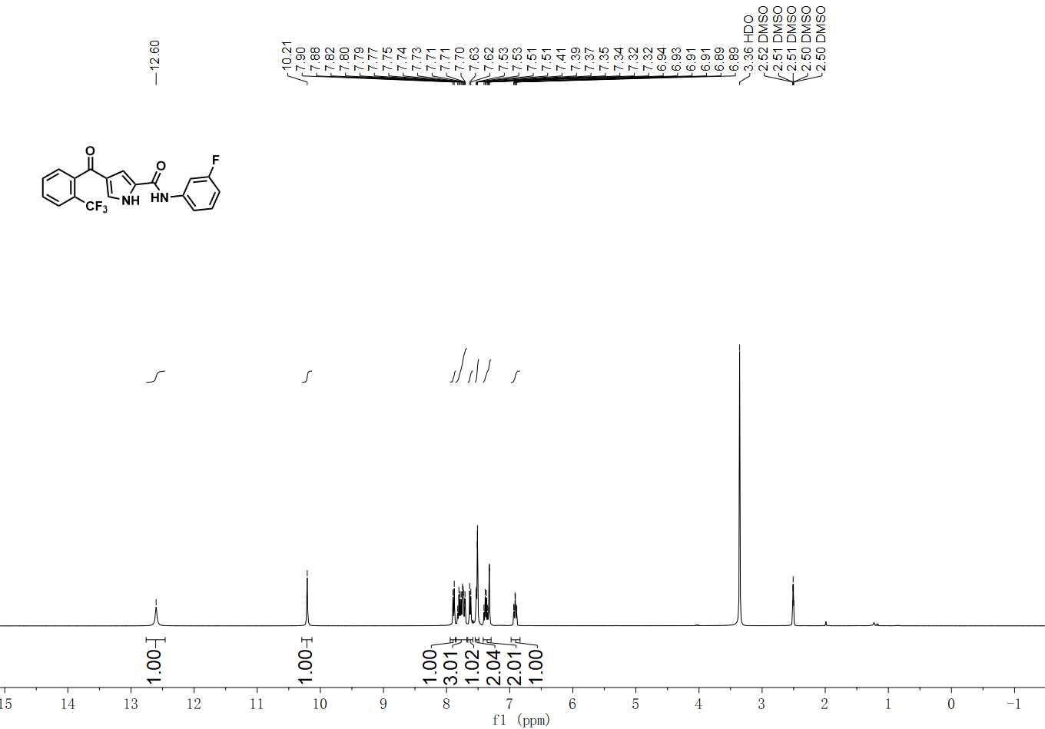

¹H NMR spectrum of C-14

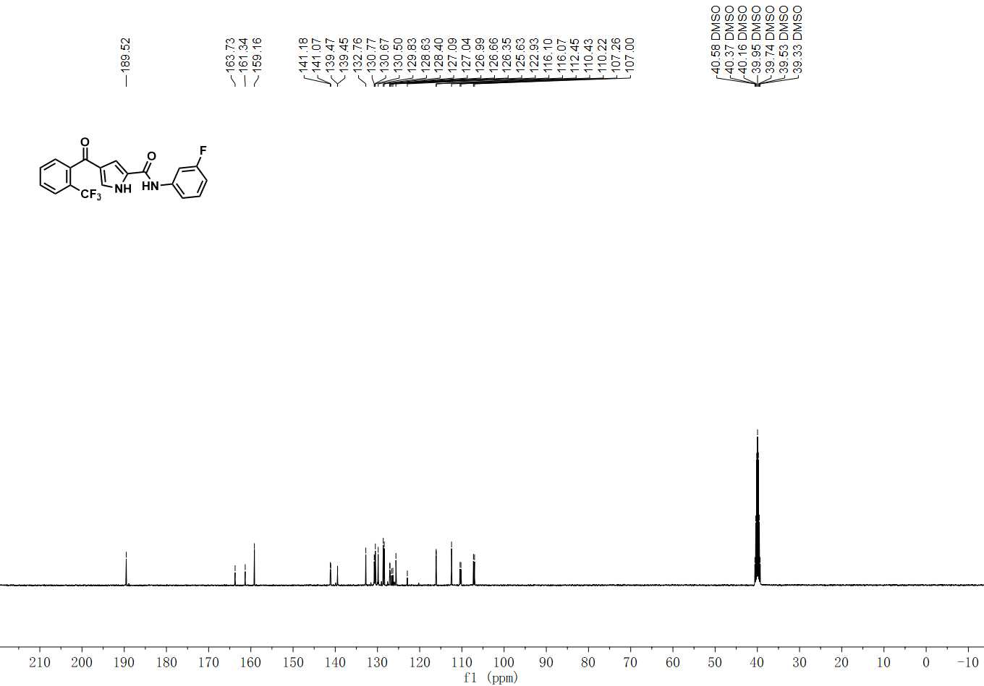

¹³C NMR spectrum of C-14
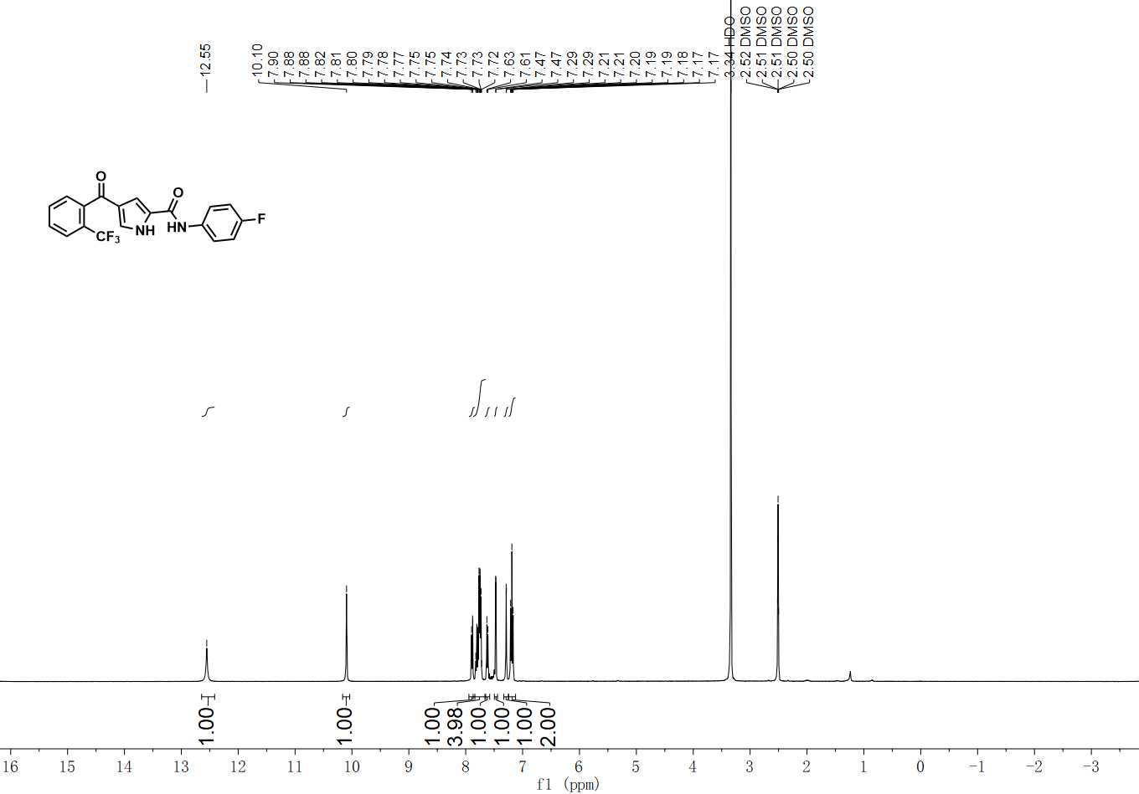

¹H NMR spectrum of C-15

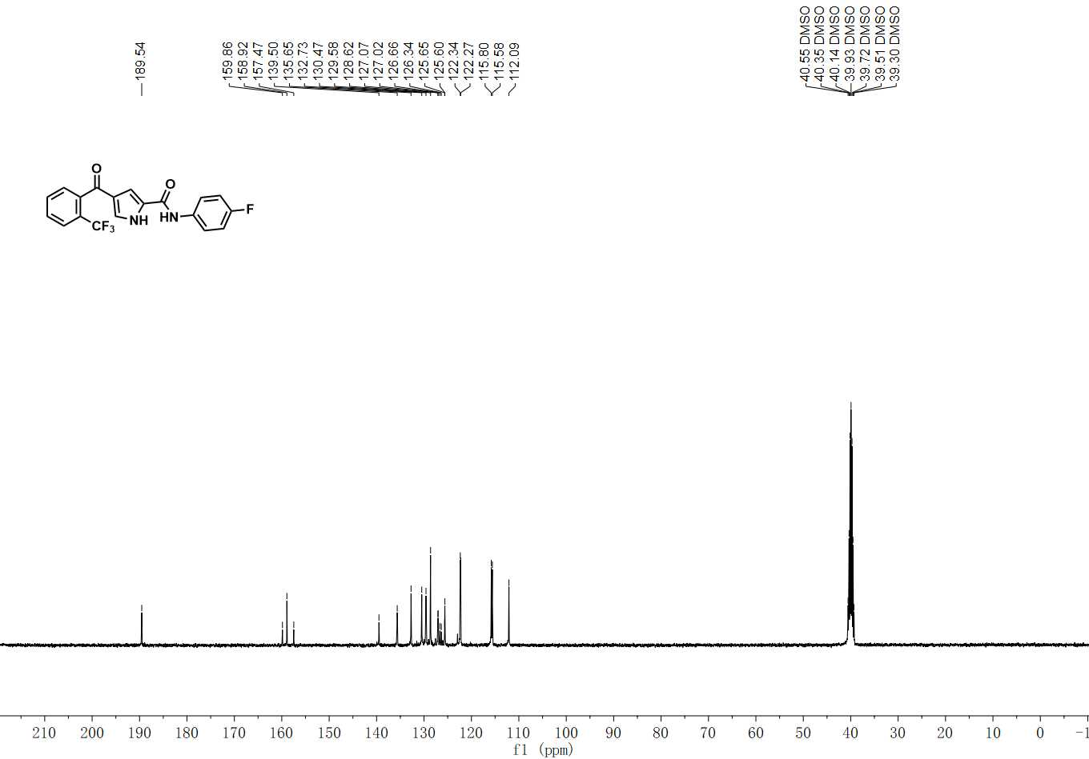

¹³C NMR spectrum of C-15

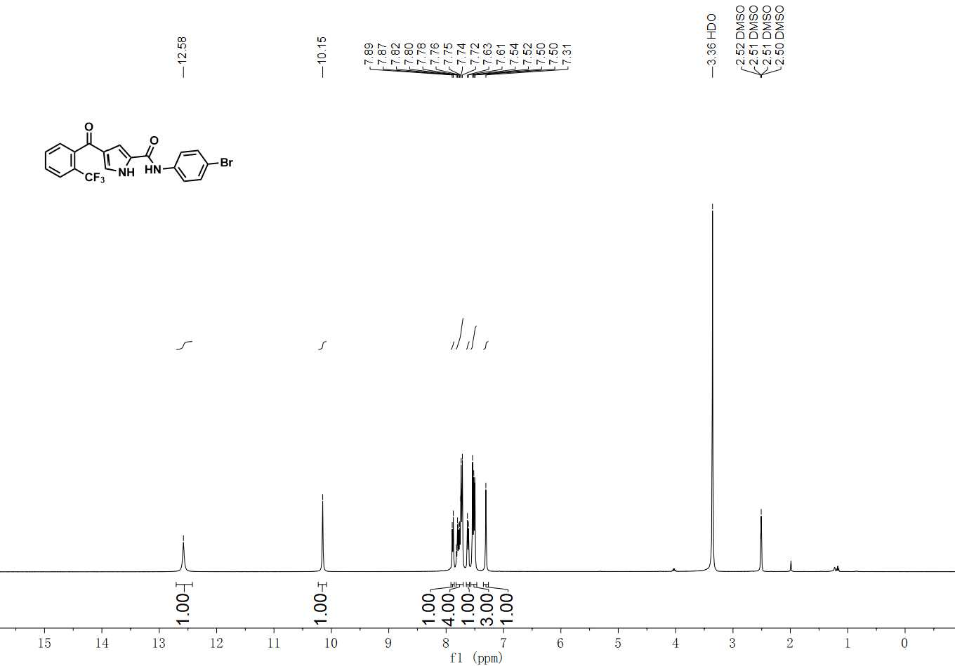

¹H NMR spectrum of C-16

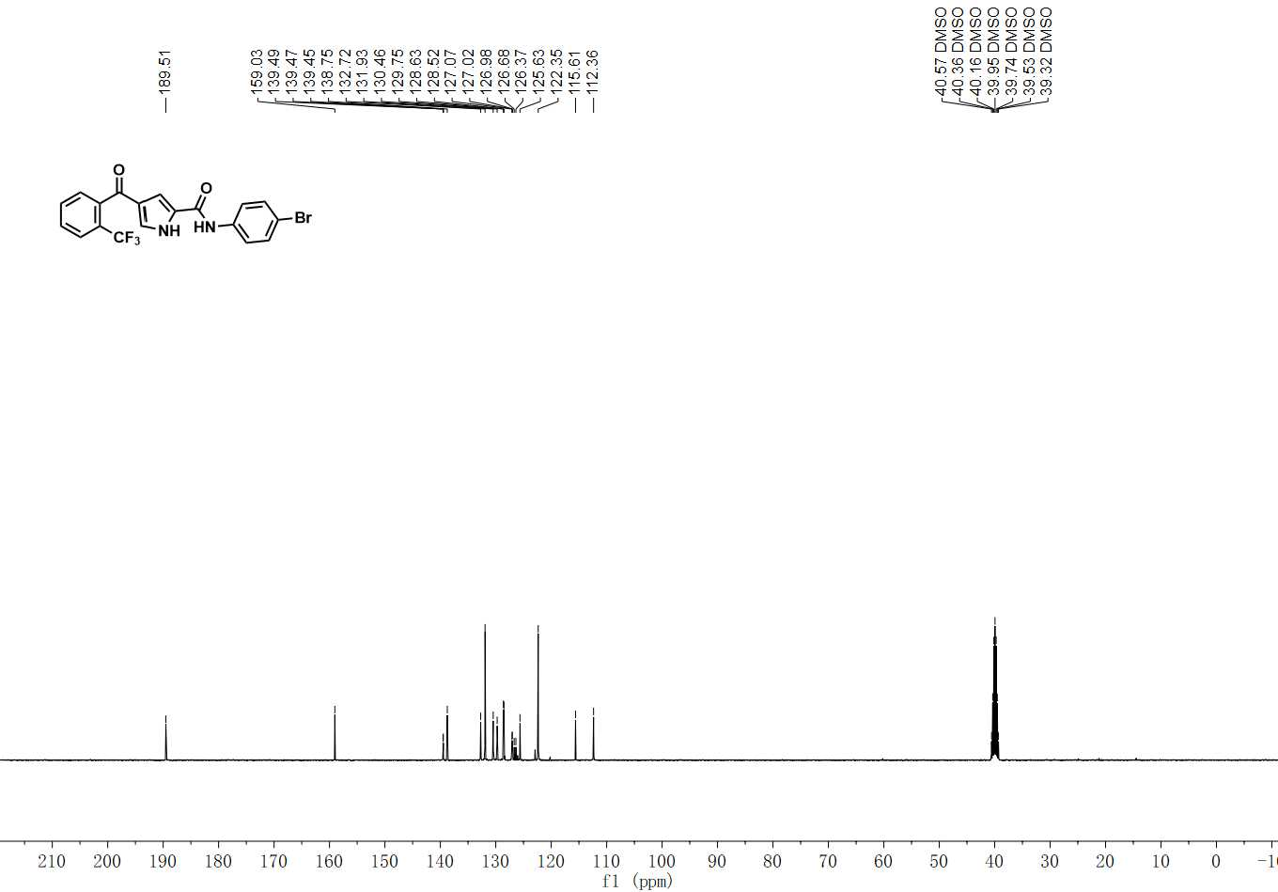

¹³C NMR spectrum of C-16

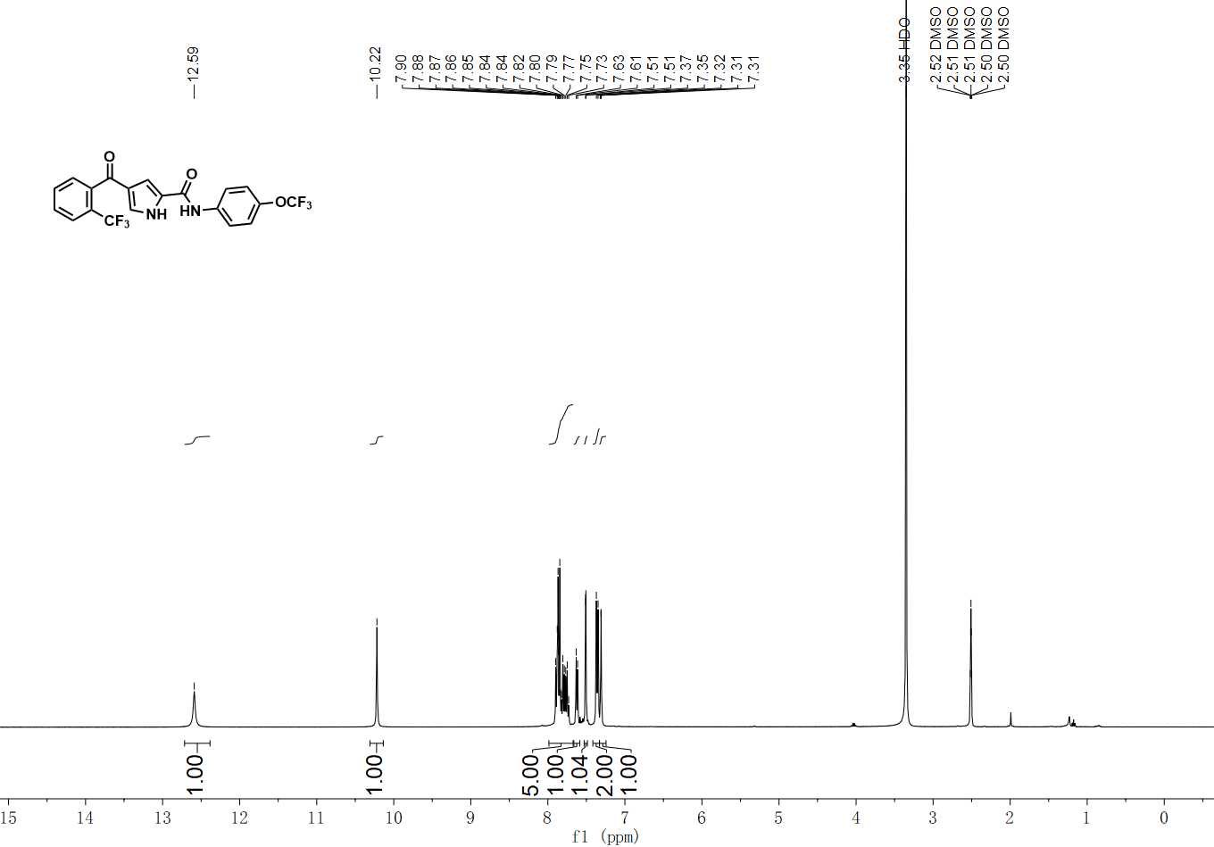

¹H NMR spectrum of C-17

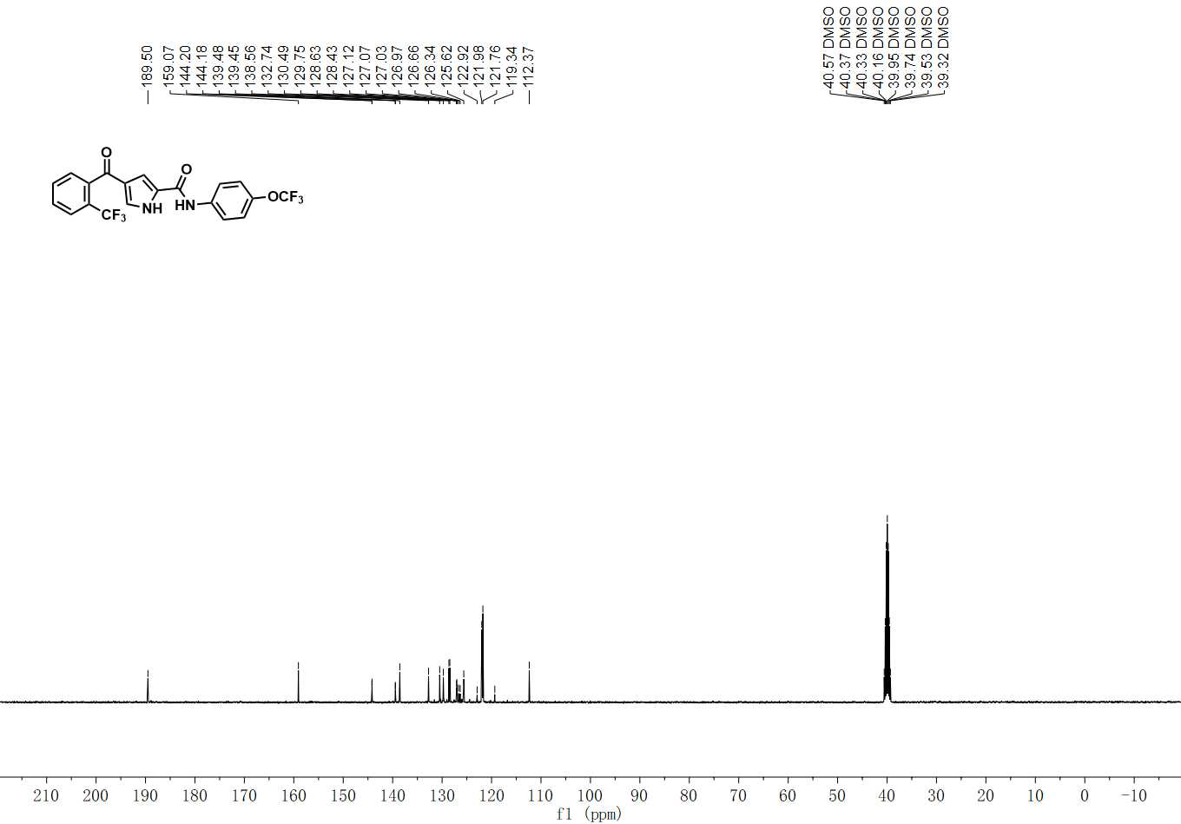

¹³C NMR spectrum of C-17

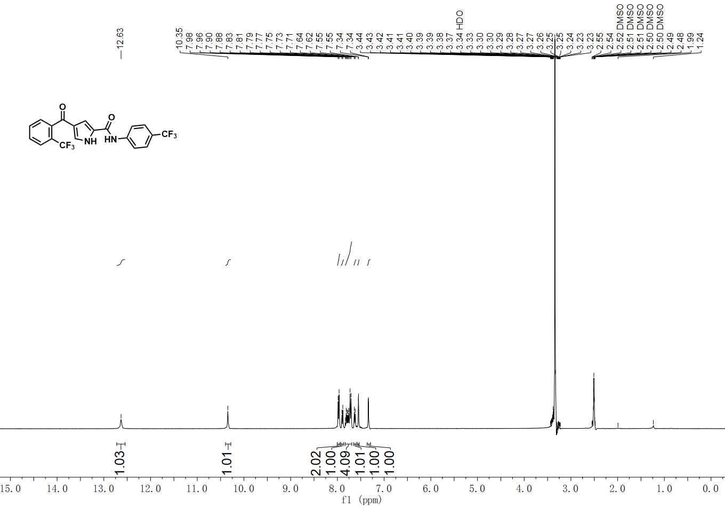

¹H NMR spectrum of C-18

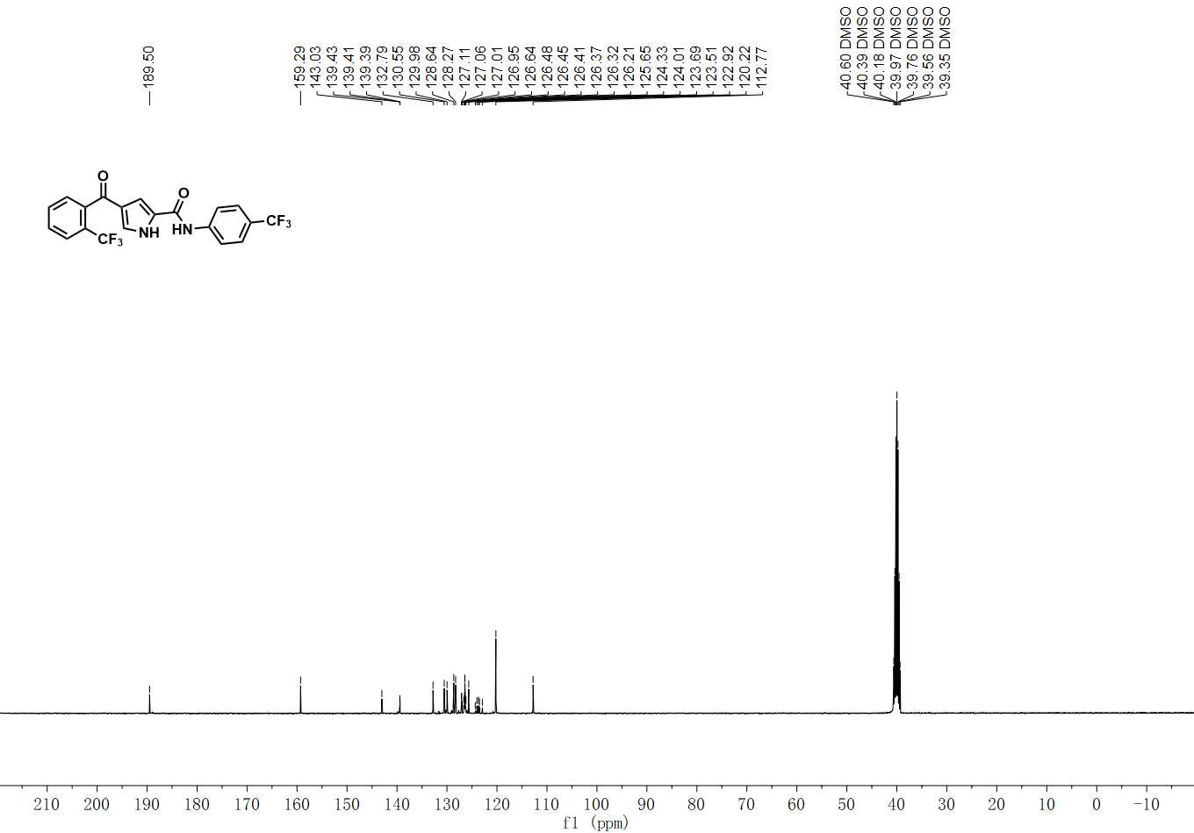

¹³C NMR spectrum of C-18

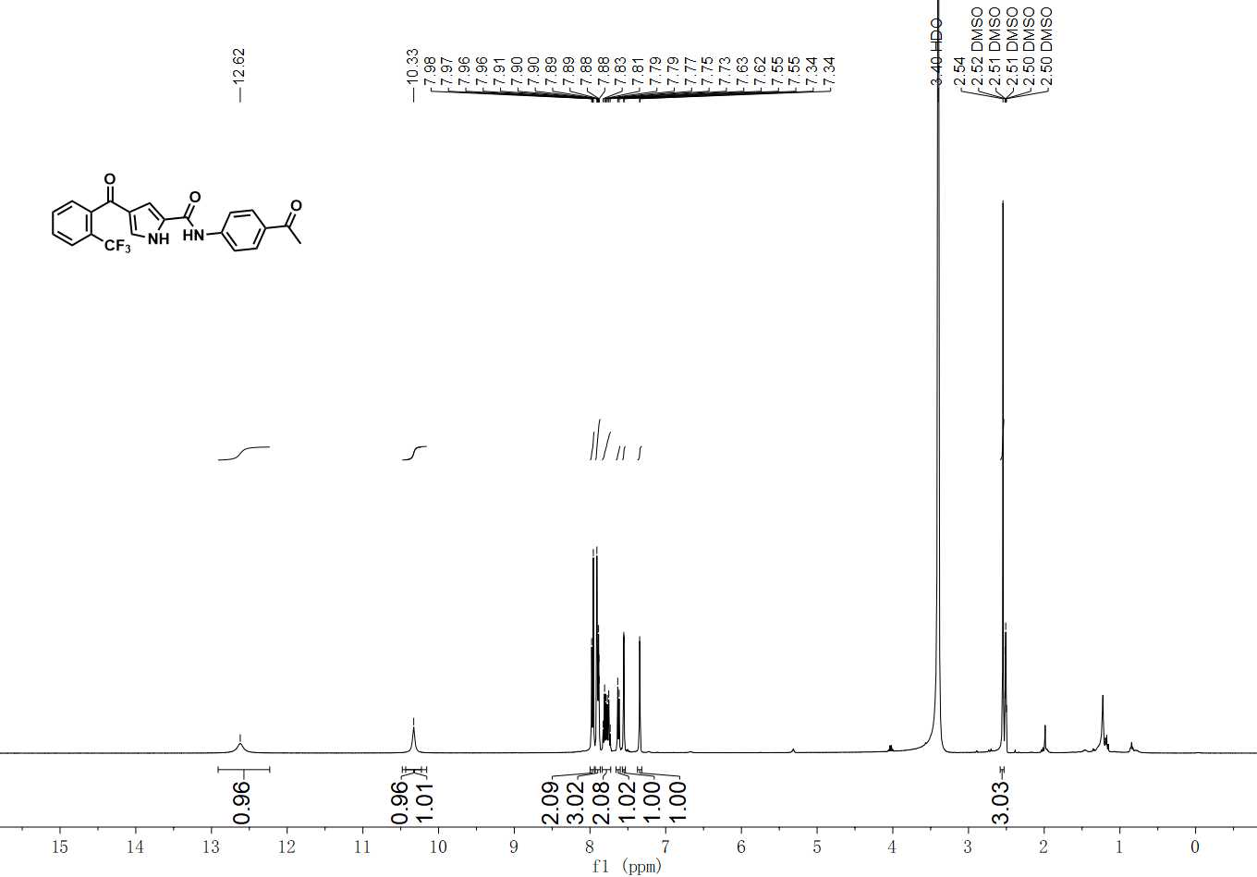

¹H NMR spectrum of C-19

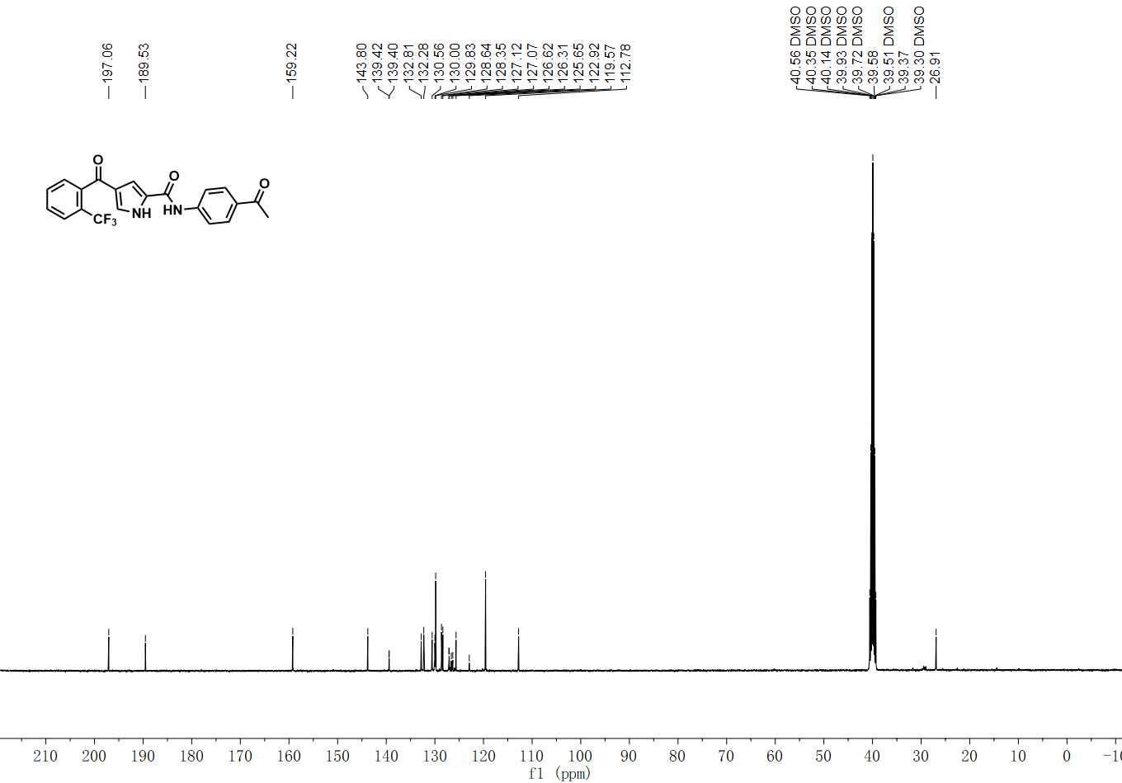

¹³C NMR spectrum of C-19

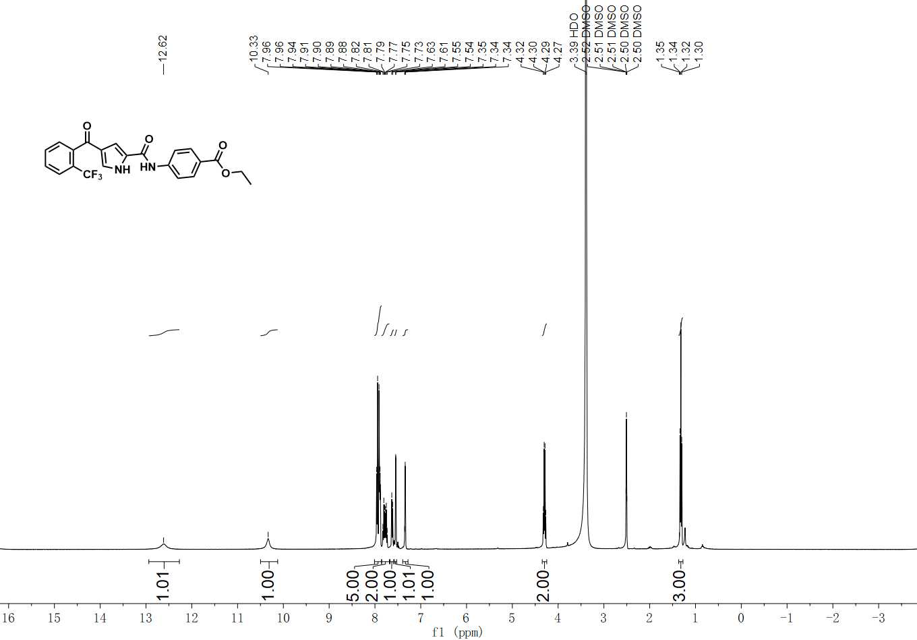

¹H NMR spectrum of C-20

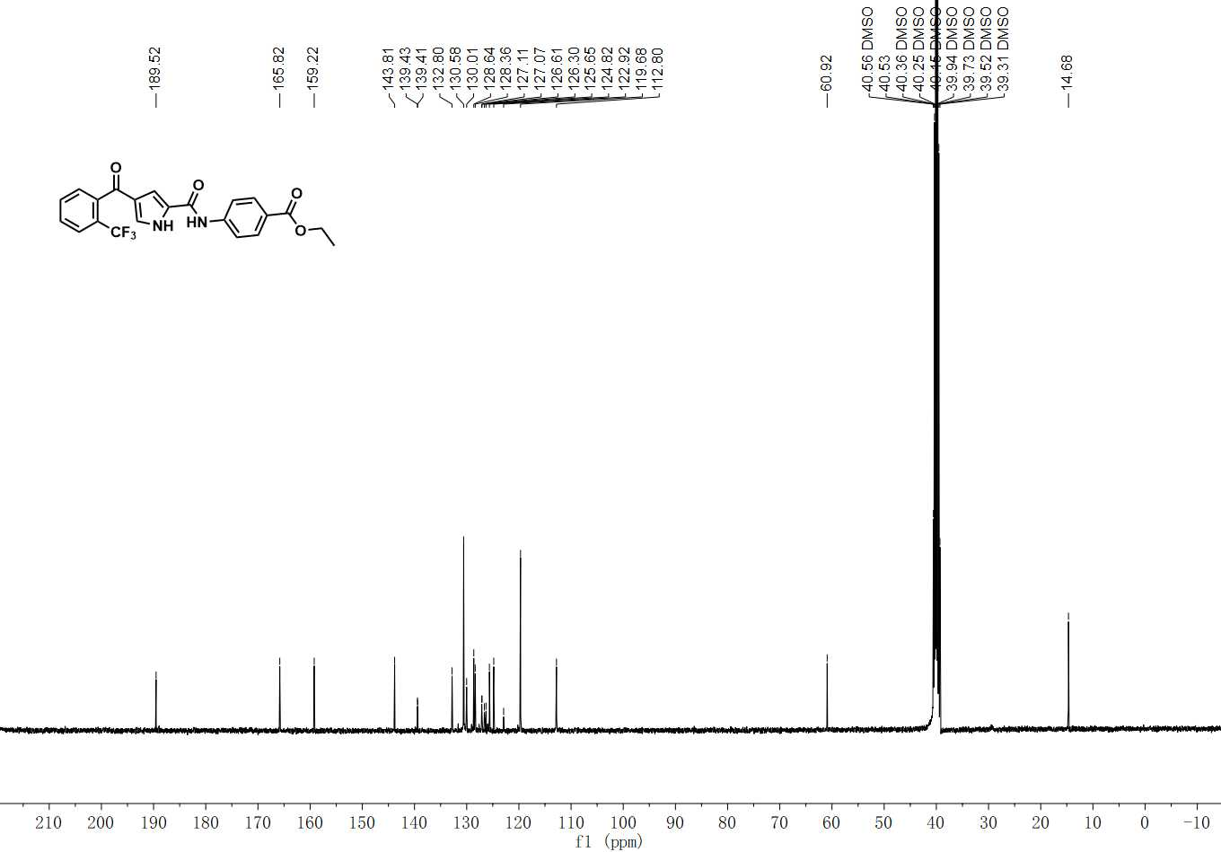

¹³C NMR spectrum of C-20

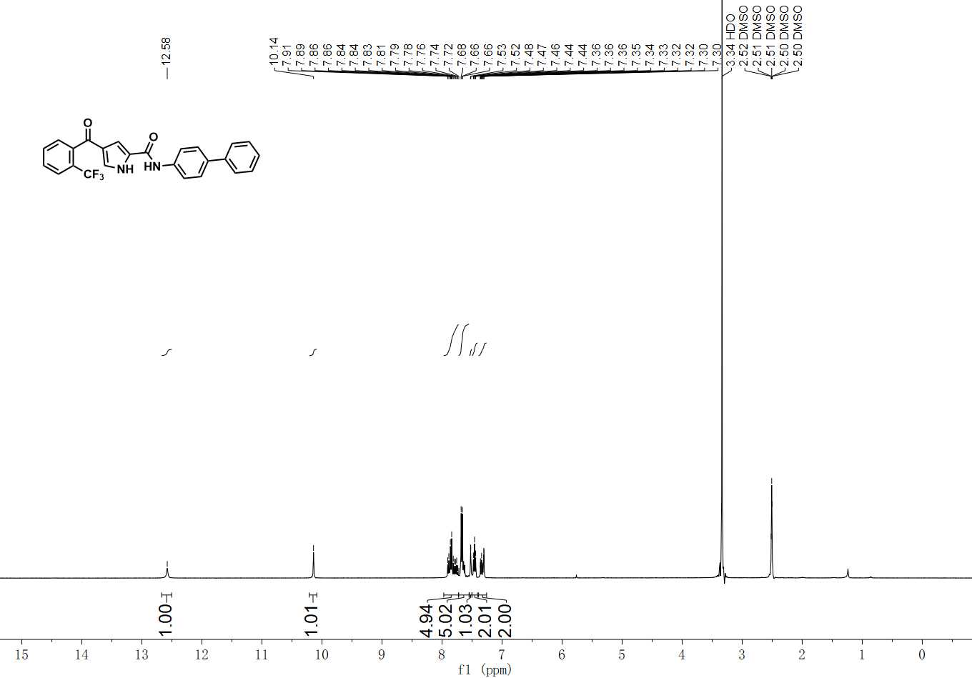

¹H NMR spectrum of C-21

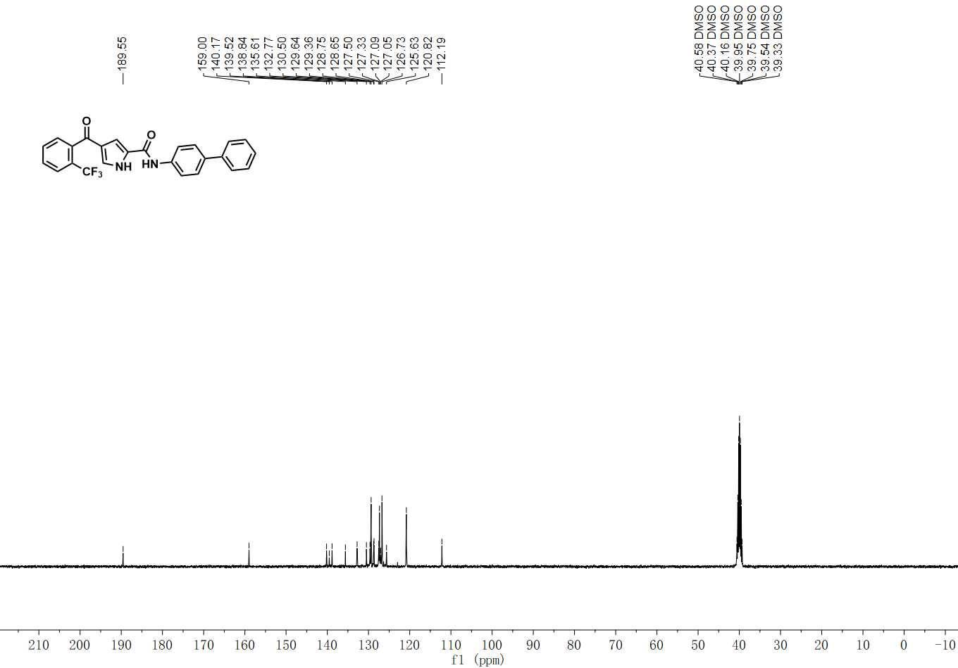

¹³C NMR spectrum of C-21

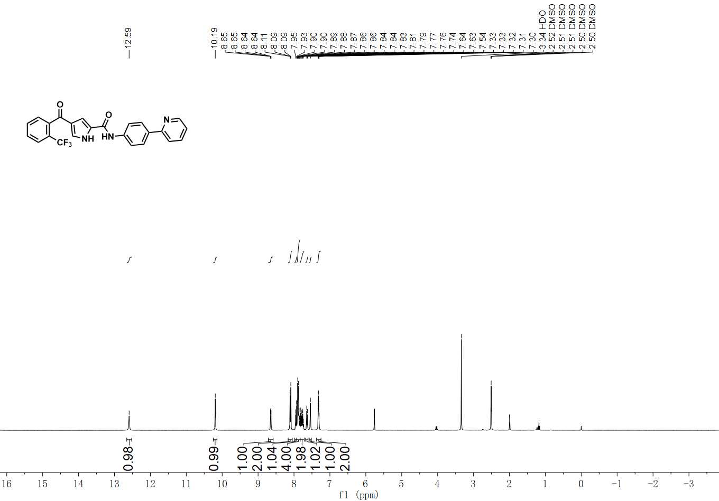

¹H NMR spectrum of C-22

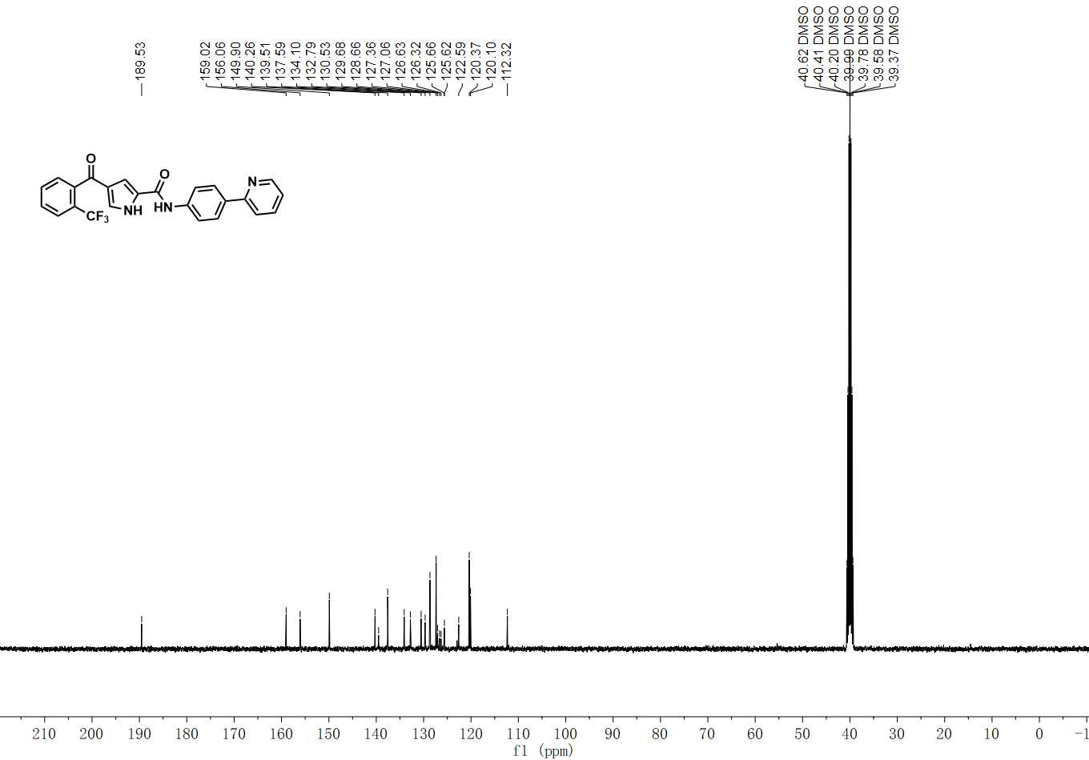

¹³C NMR spectrum of C-22

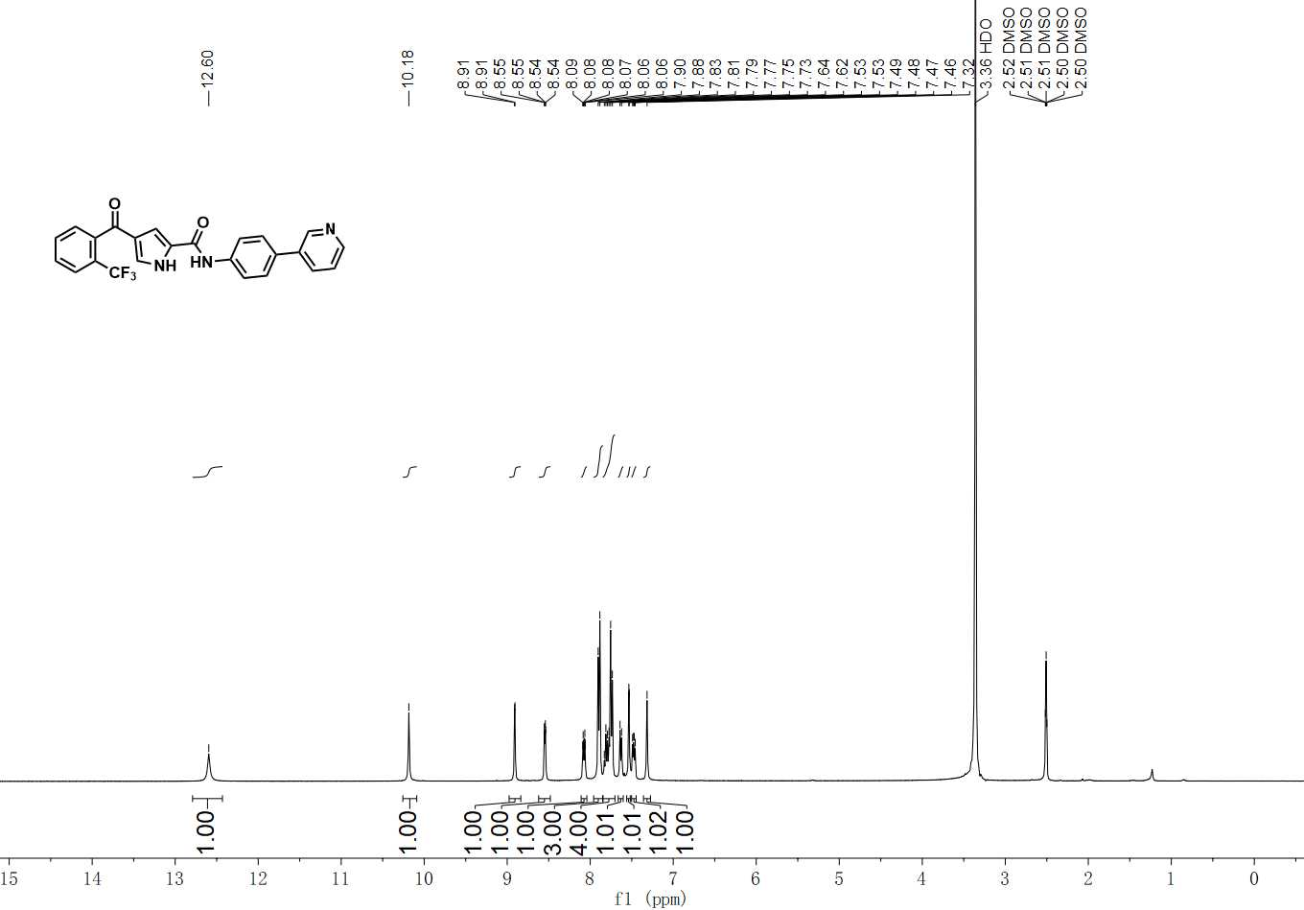

¹H NMR spectrum of C-23

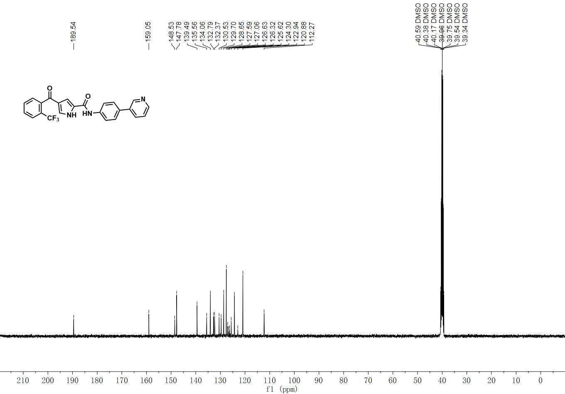

¹³C NMR spectrum of C-23

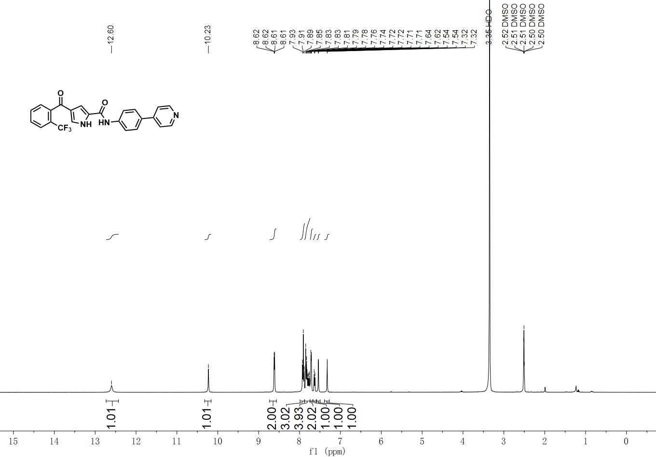

¹H NMR spectrum of C-24

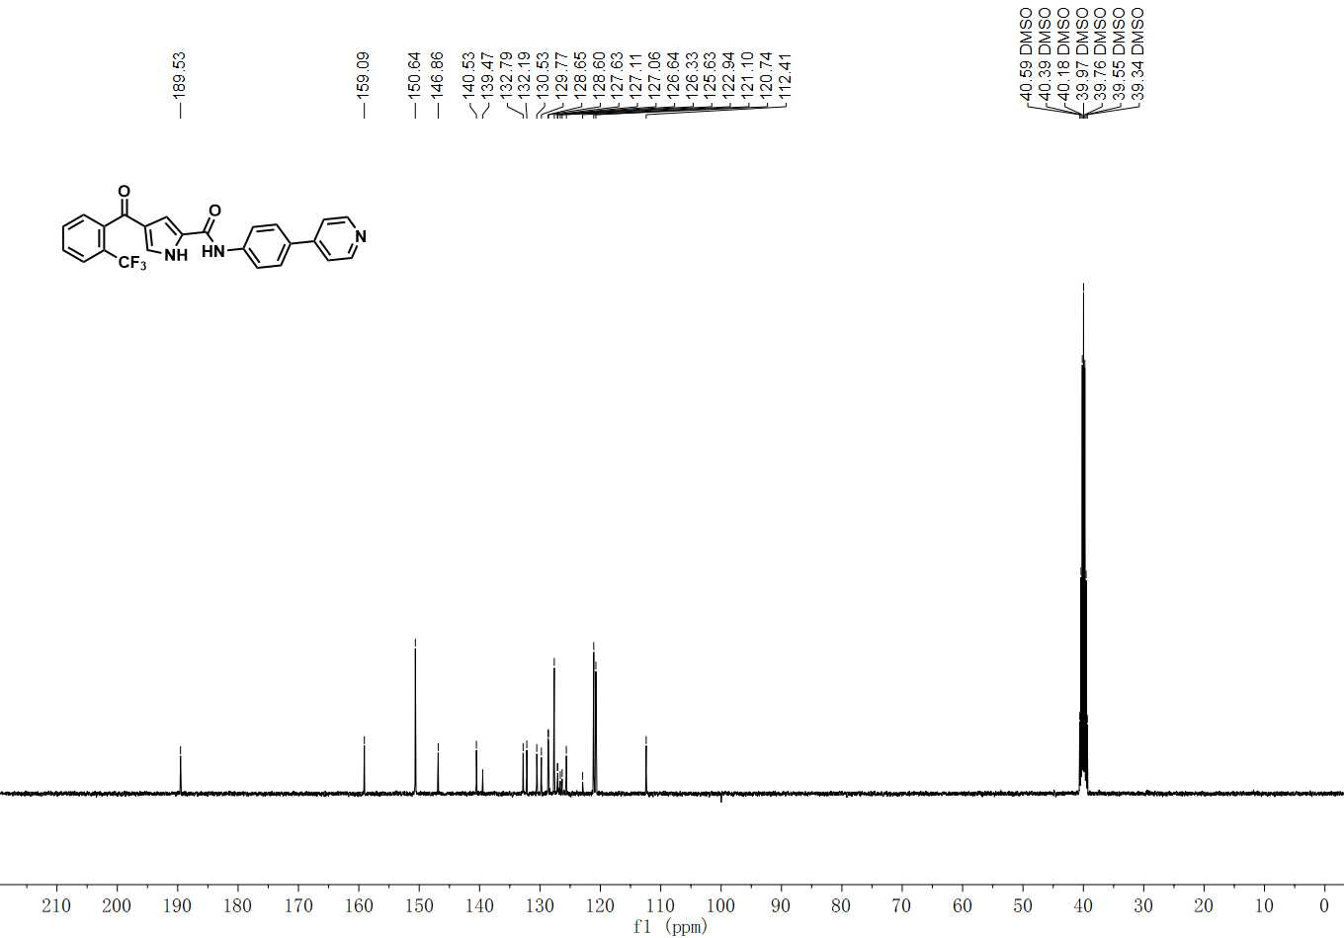

¹³C NMR spectrum of C-24

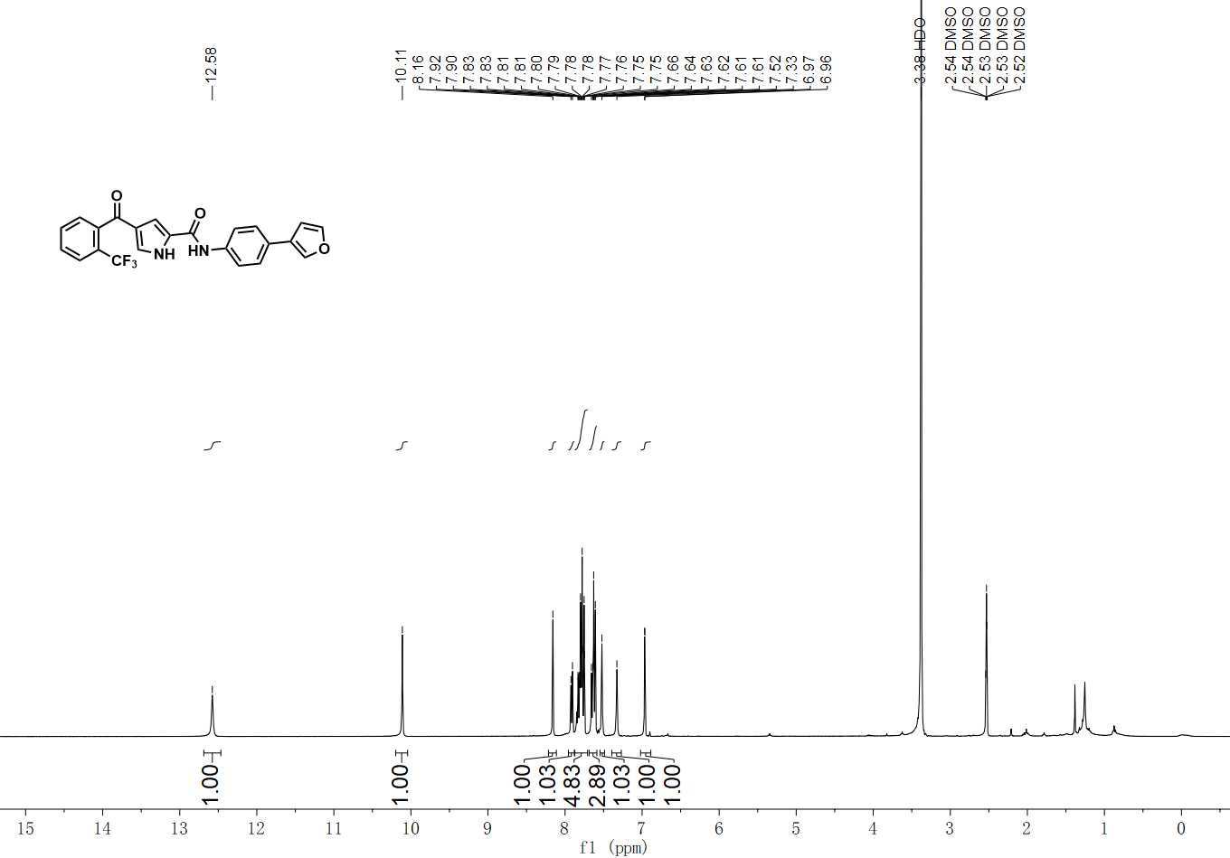

¹H NMR spectrum of C-25

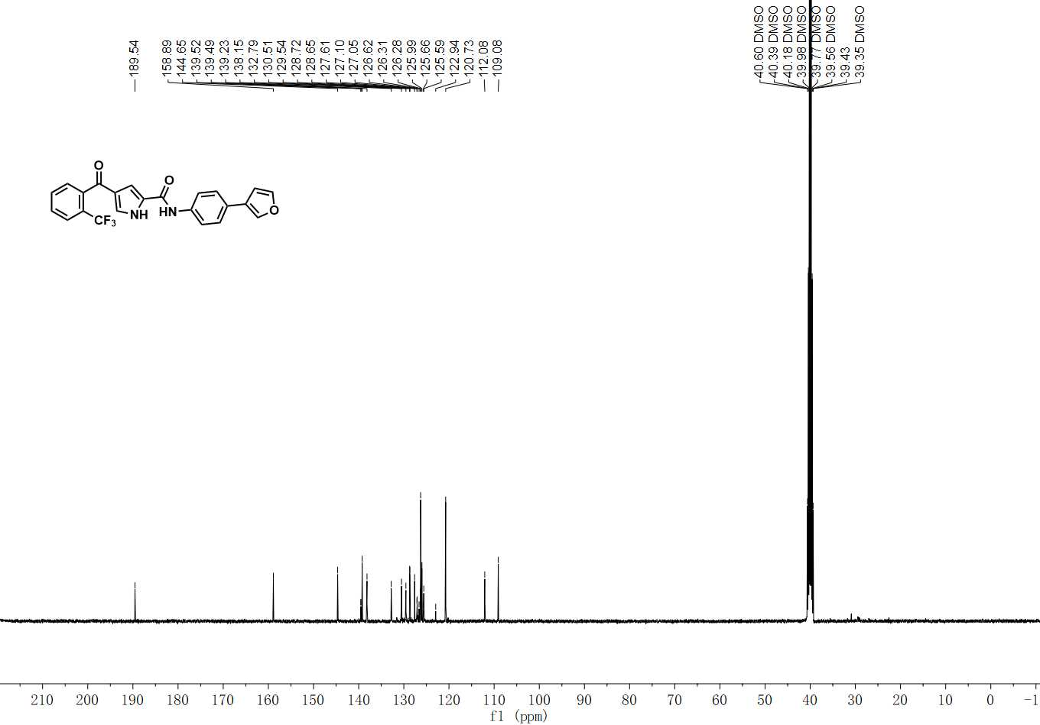

¹³C NMR spectrum of C-25

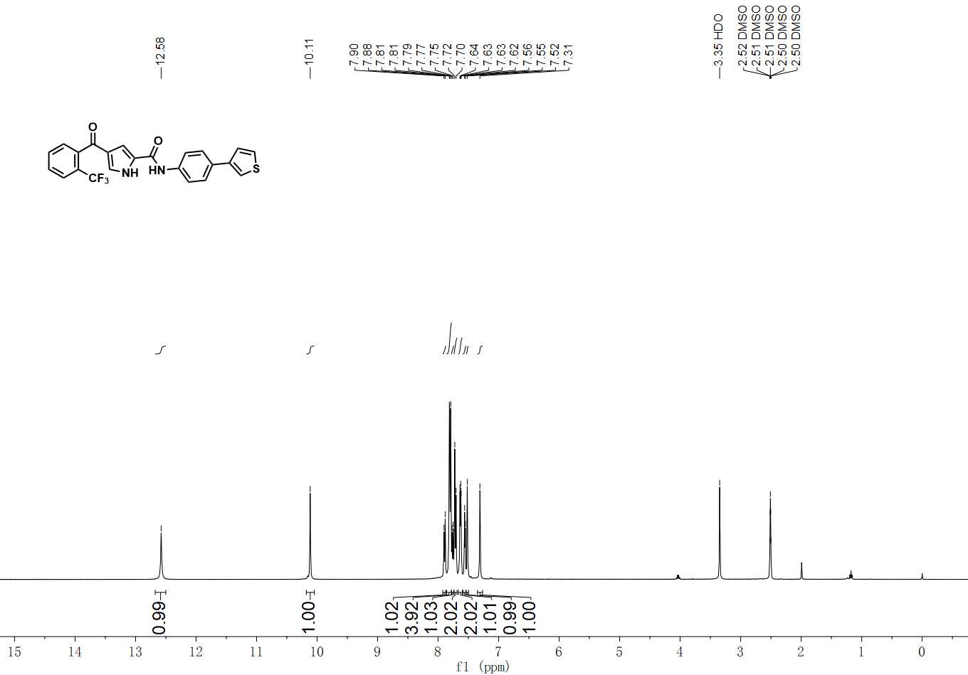

¹H NMR spectrum of C-26

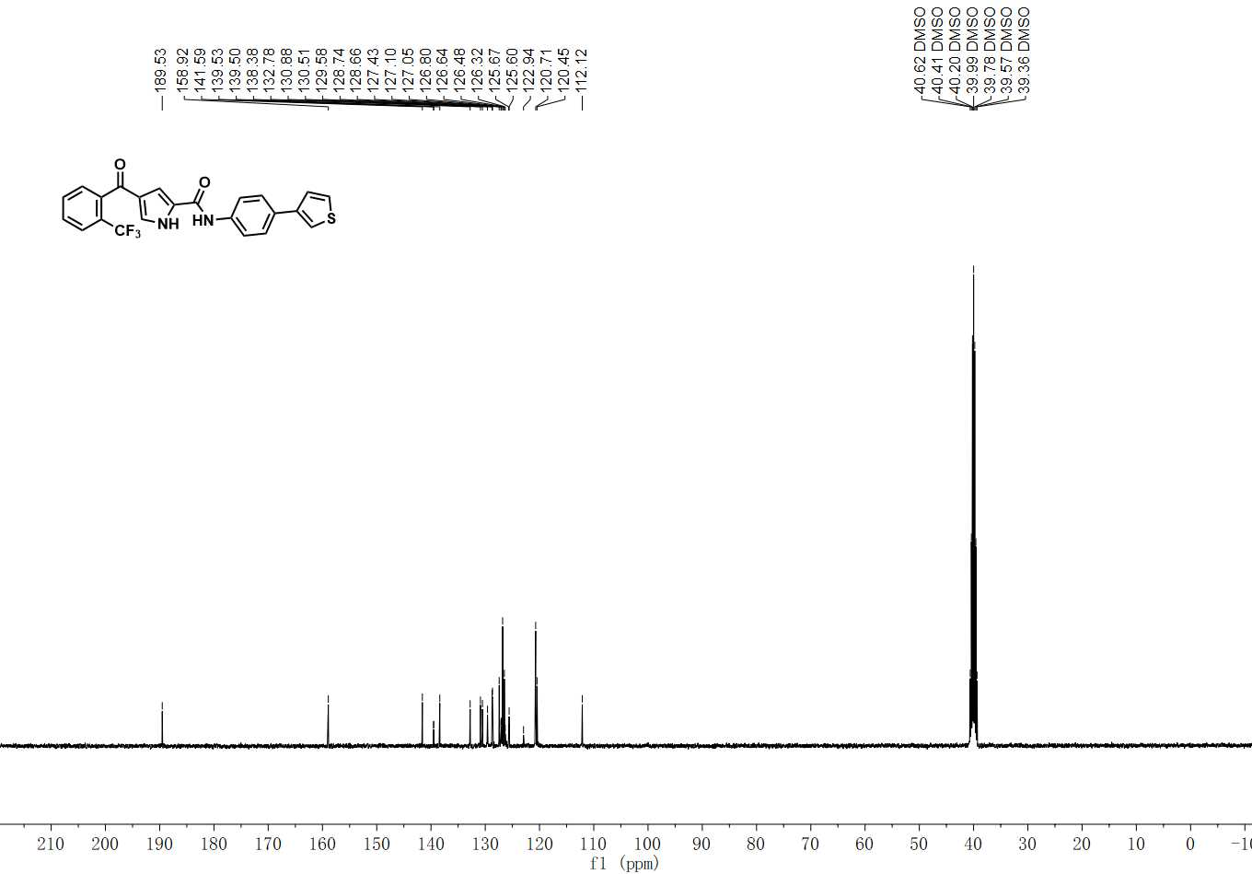

¹³C NMR spectrum of C-26

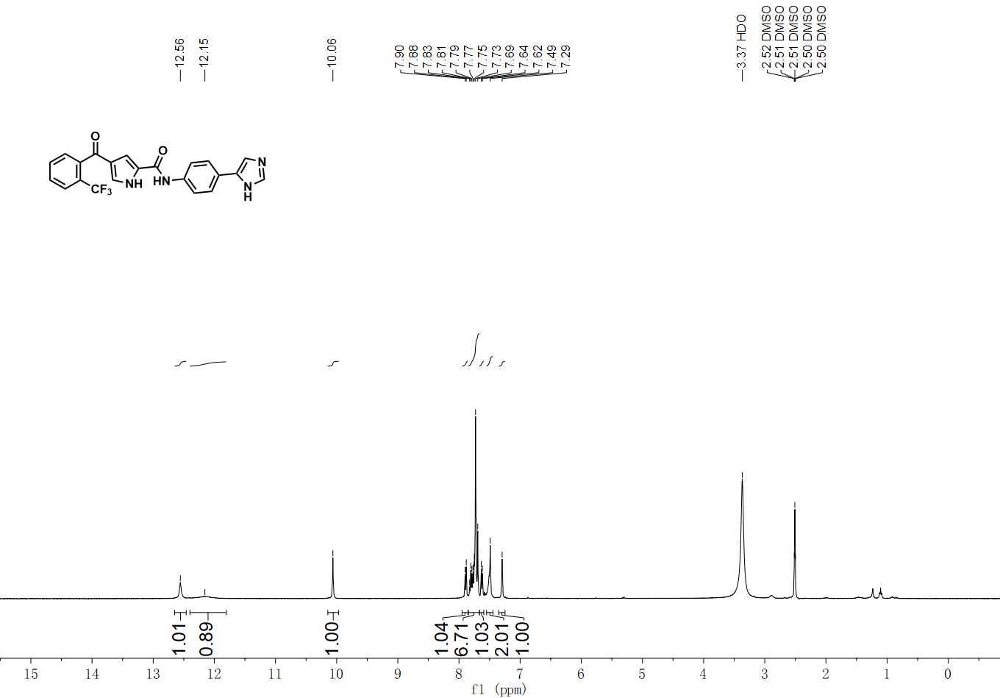

¹H NMR spectrum of C-27

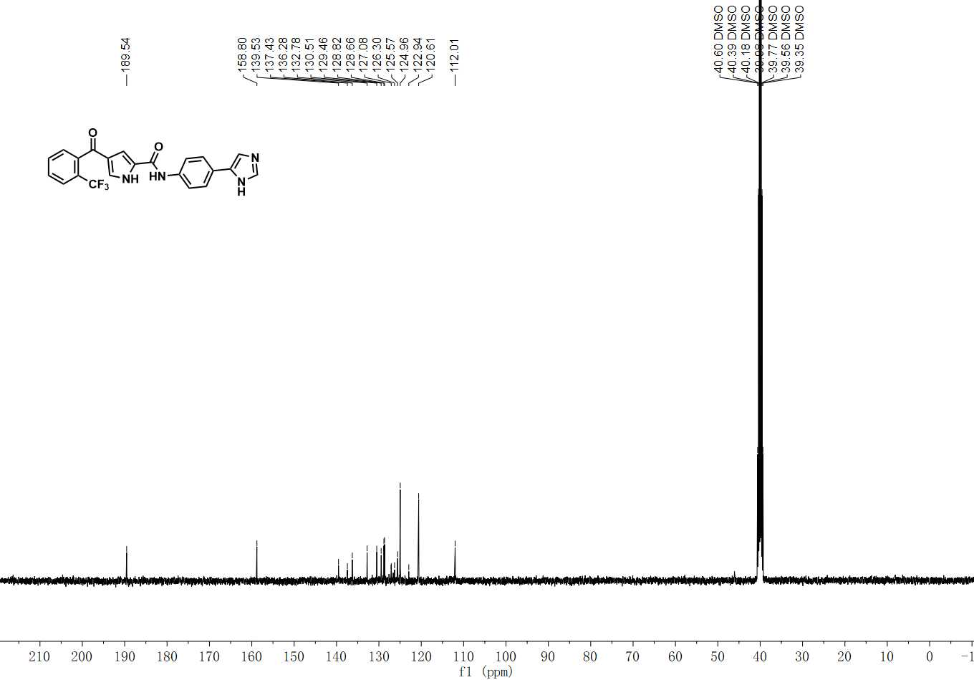

¹³C NMR spectrum of C-27

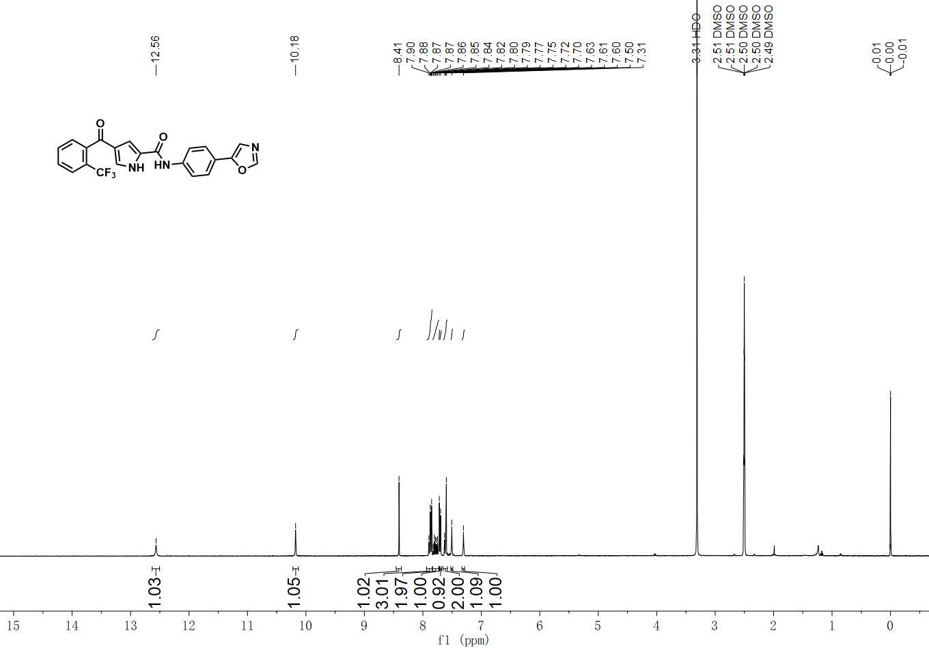

¹H NMR spectrum of C-28

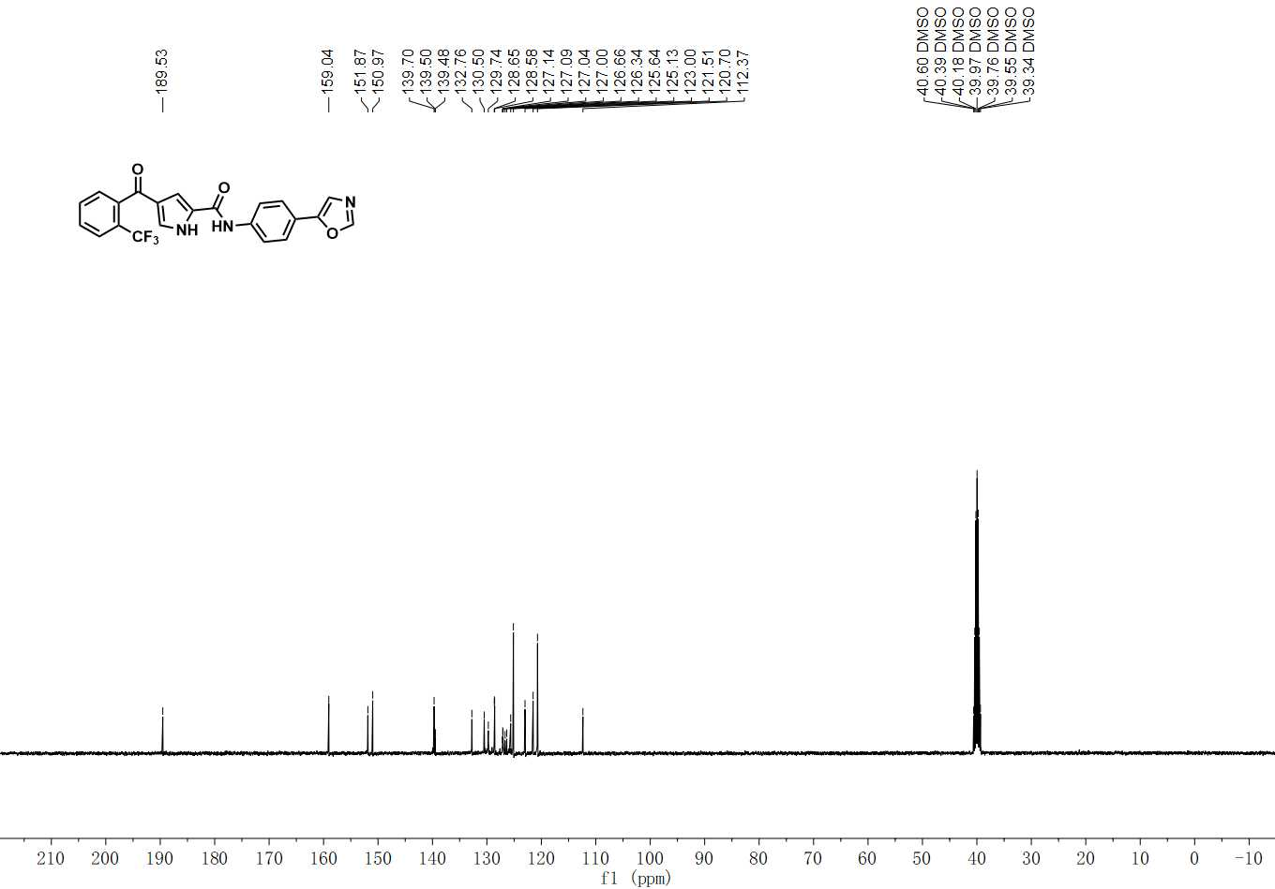

¹³C NMR spectrum of C-28

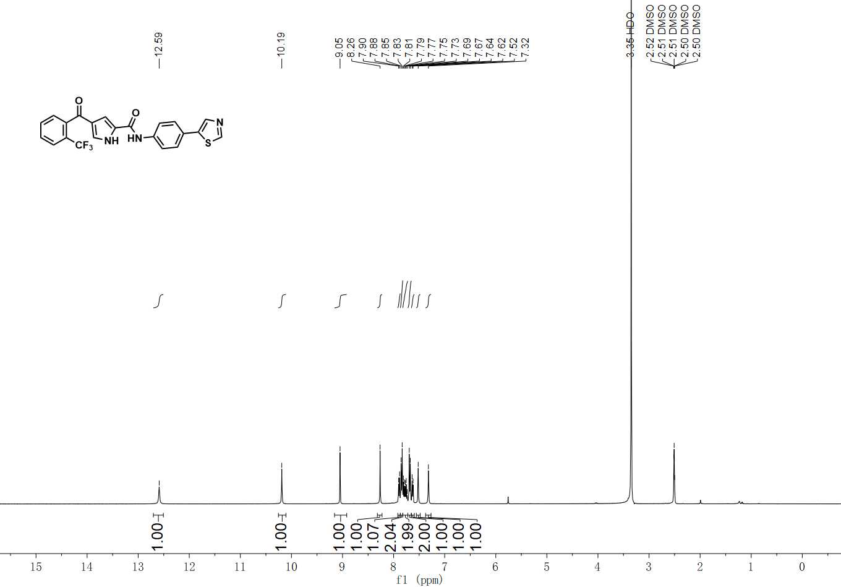

¹H NMR spectrum of C-29

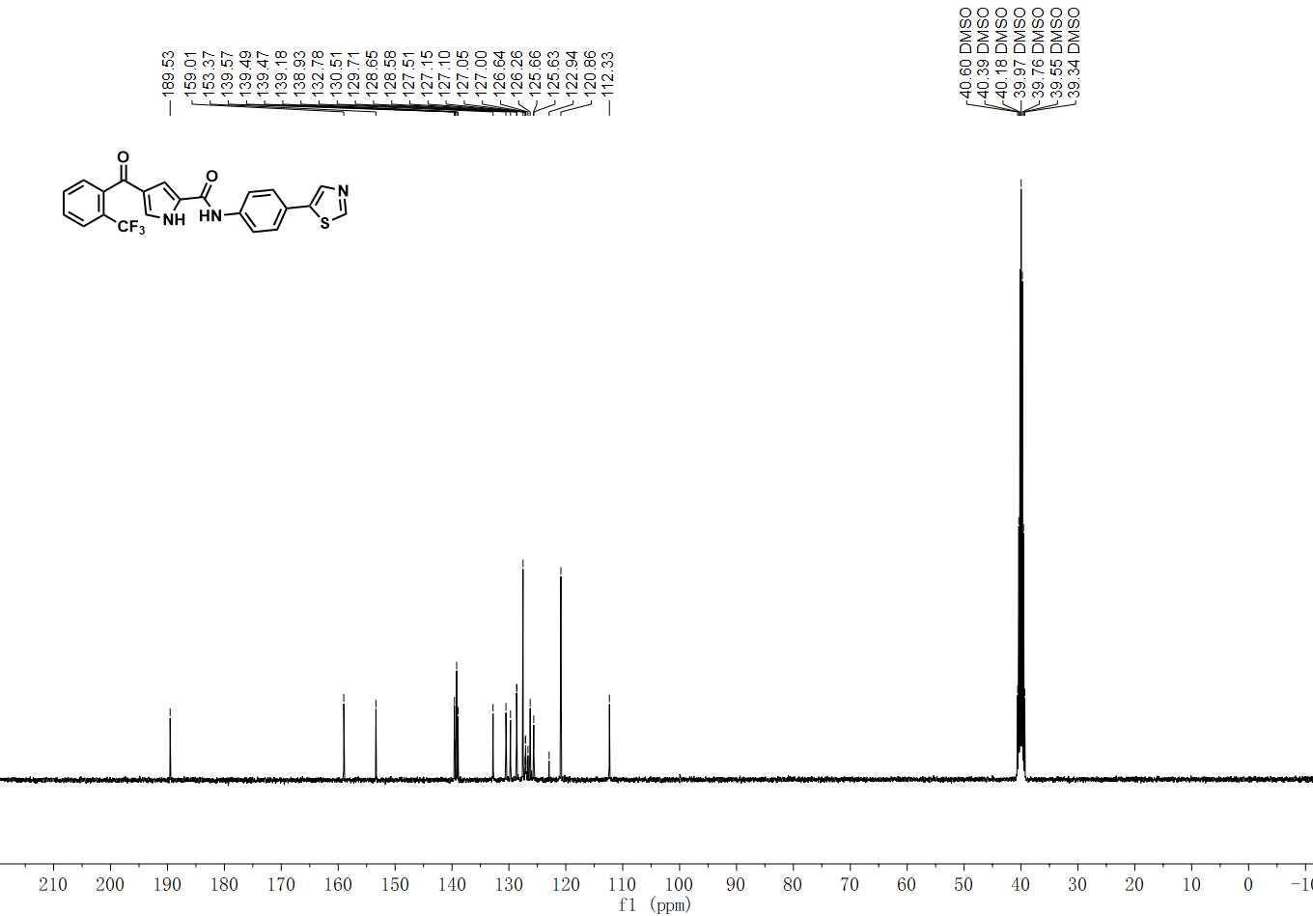

¹³C NMR spectrum of C-29

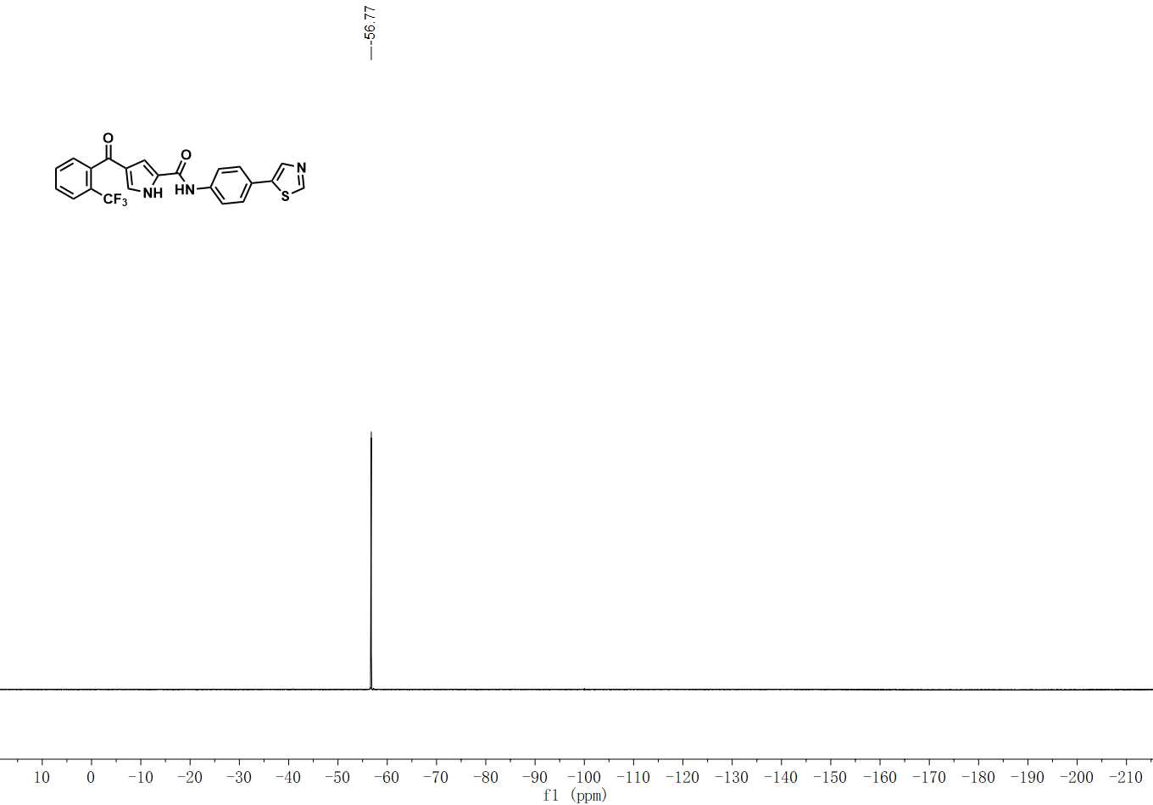
¹⁹F NMR spectrum of C-29

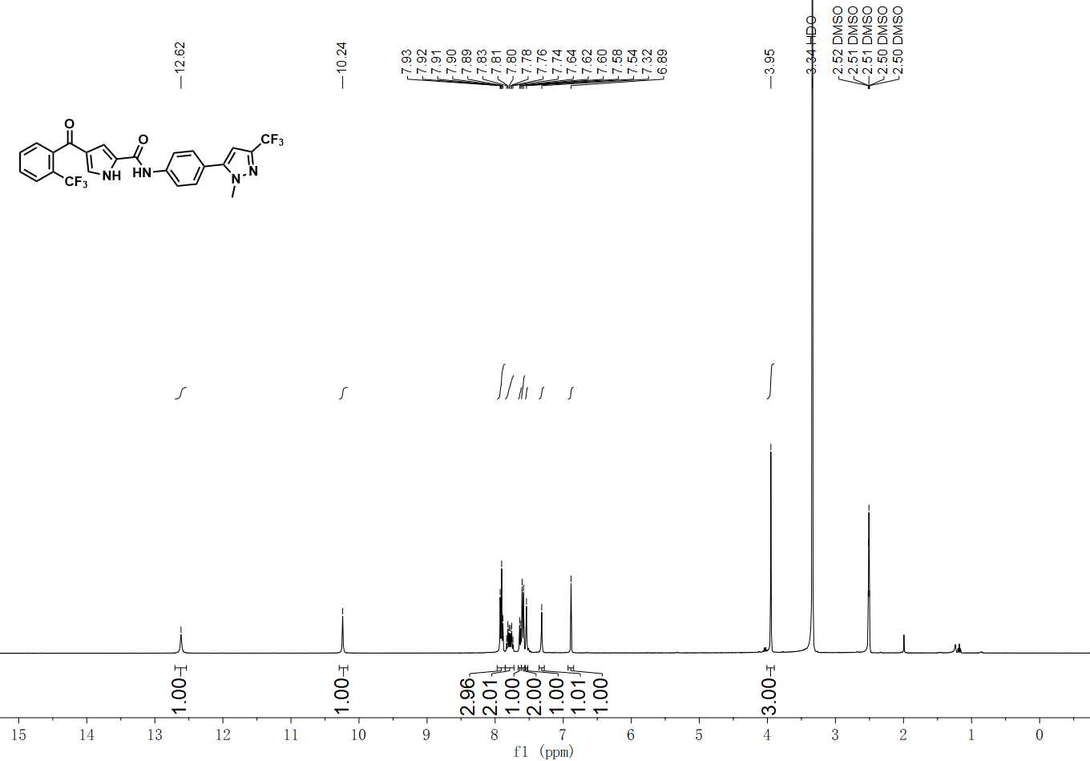

¹H NMR spectrum of C-30

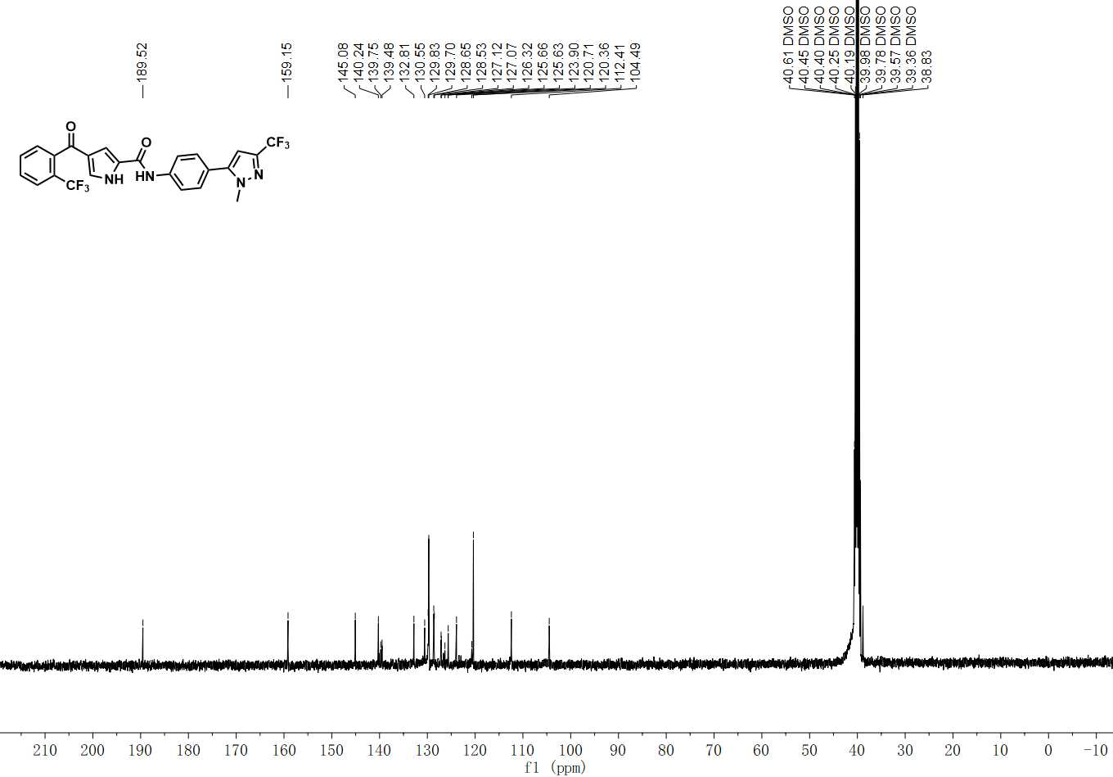

¹³C NMR spectrum of C-30

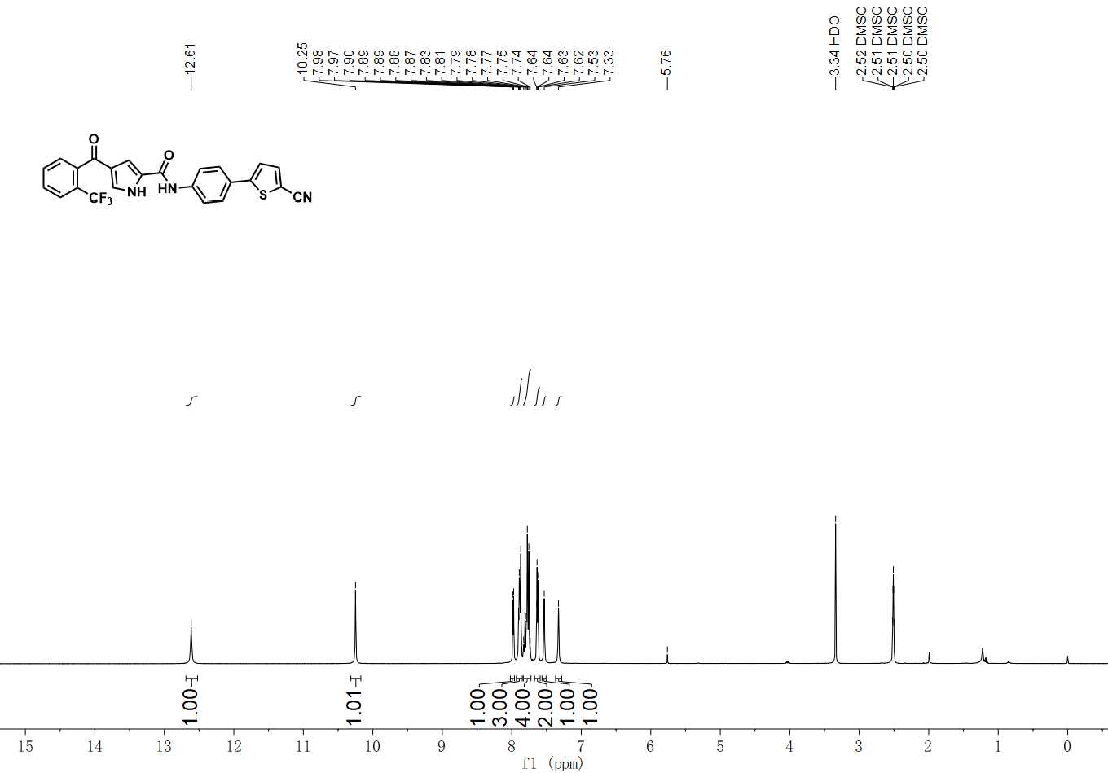

¹H NMR spectrum of C-31

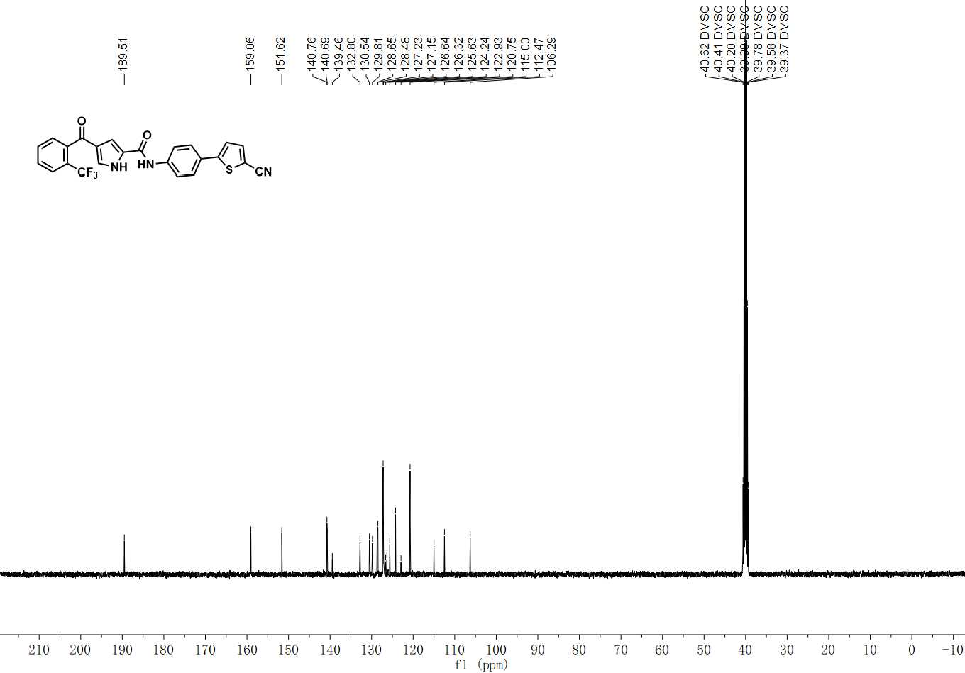

¹³C NMR spectrum of C-31

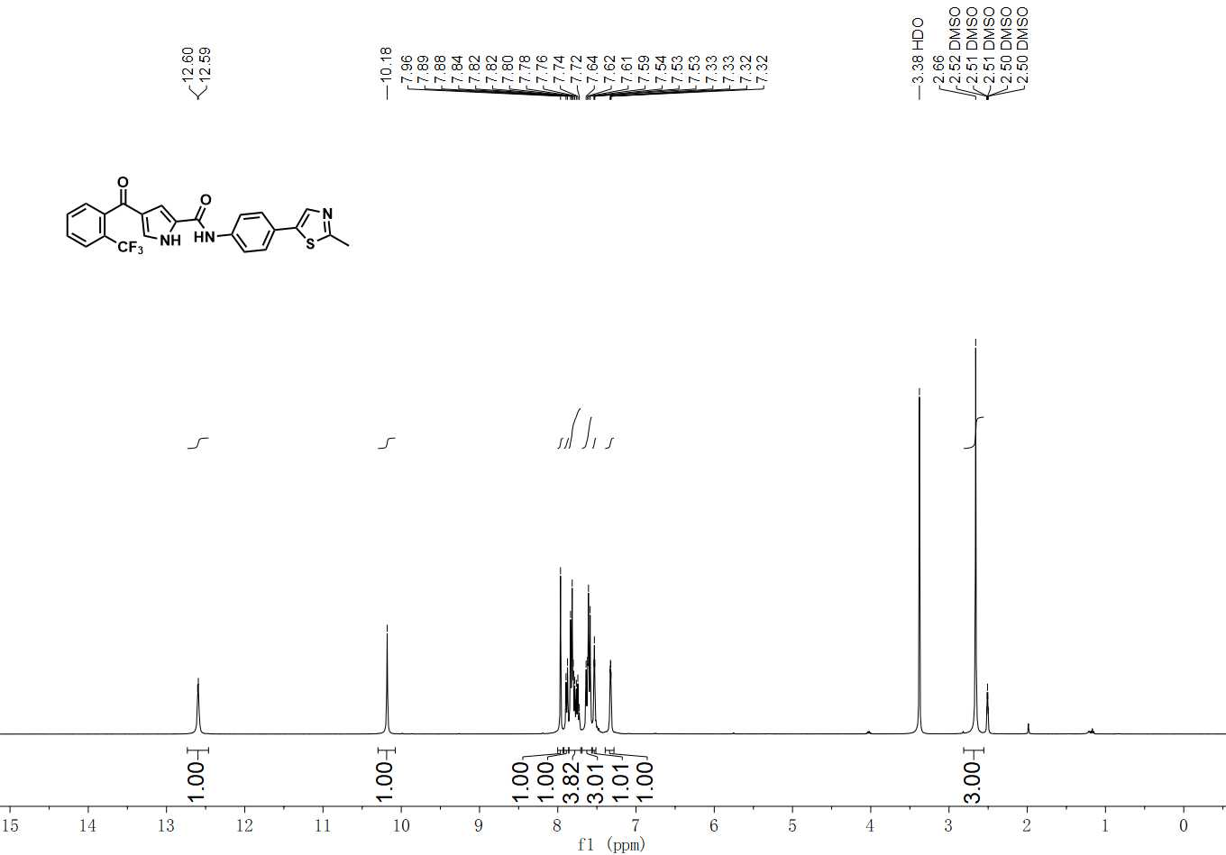

¹H NMR spectrum of C-32

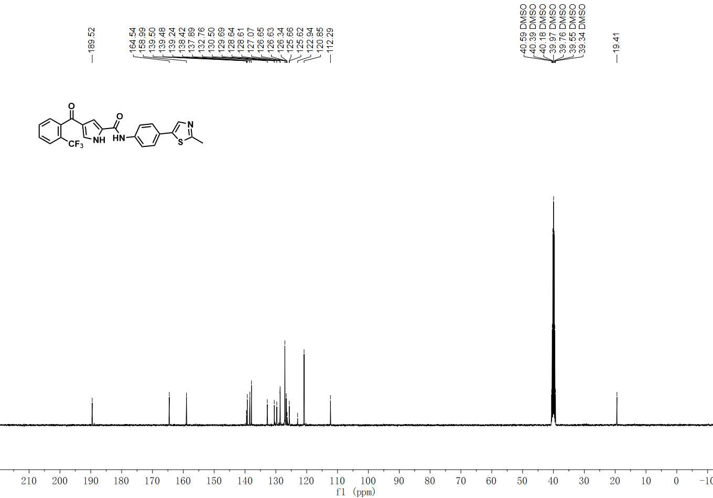

¹³C NMR spectrum of C-32

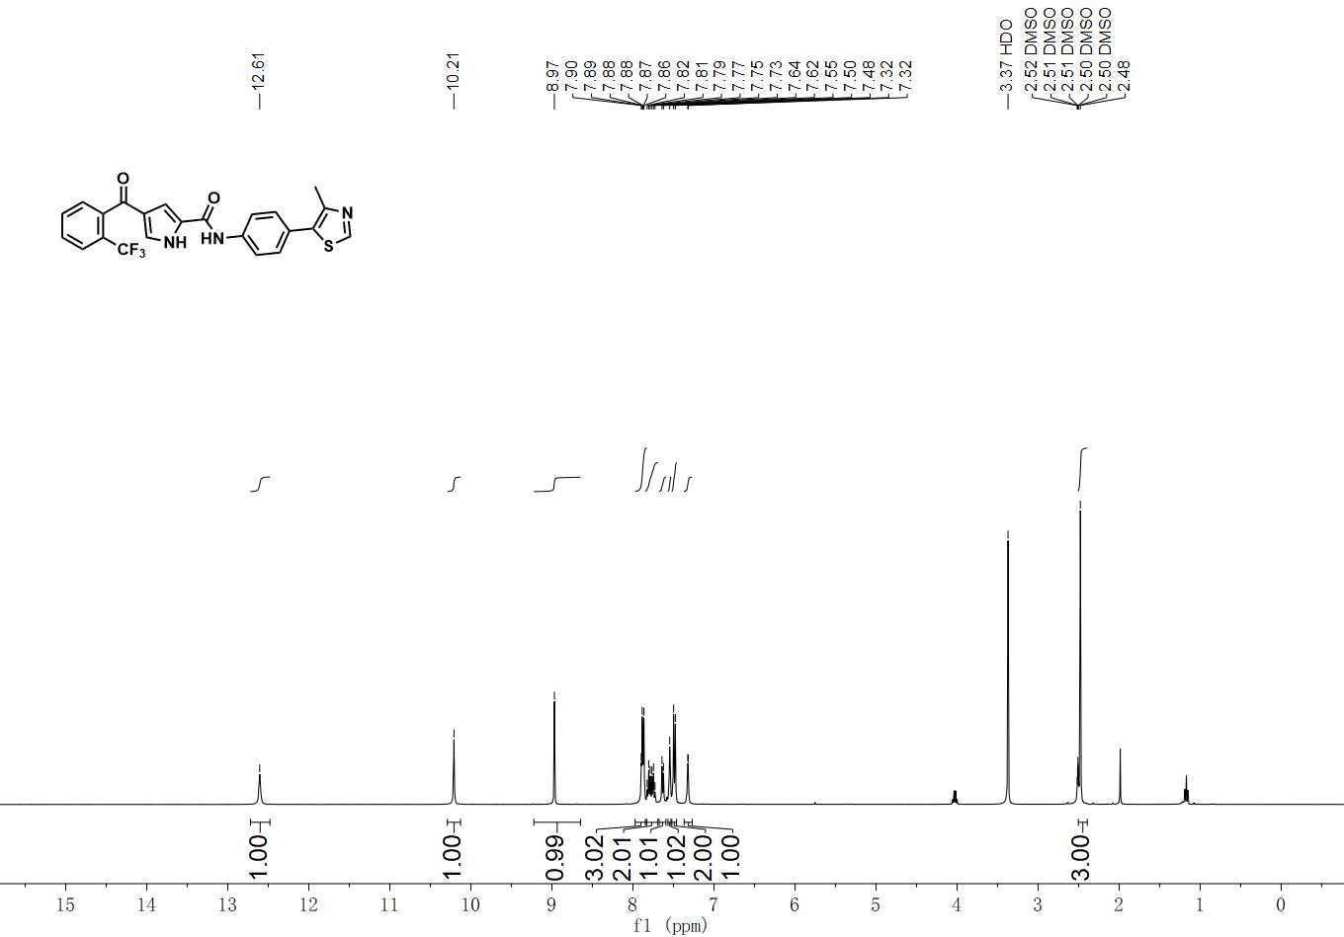

¹H NMR spectrum of C-33

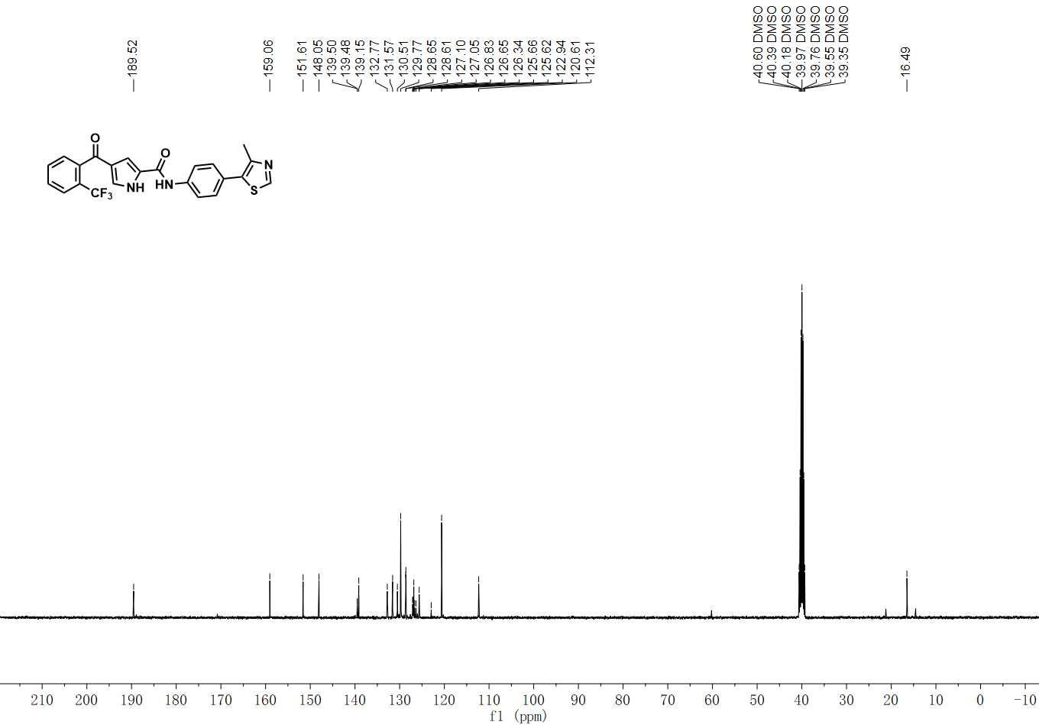

¹³C NMR spectrum of C-33

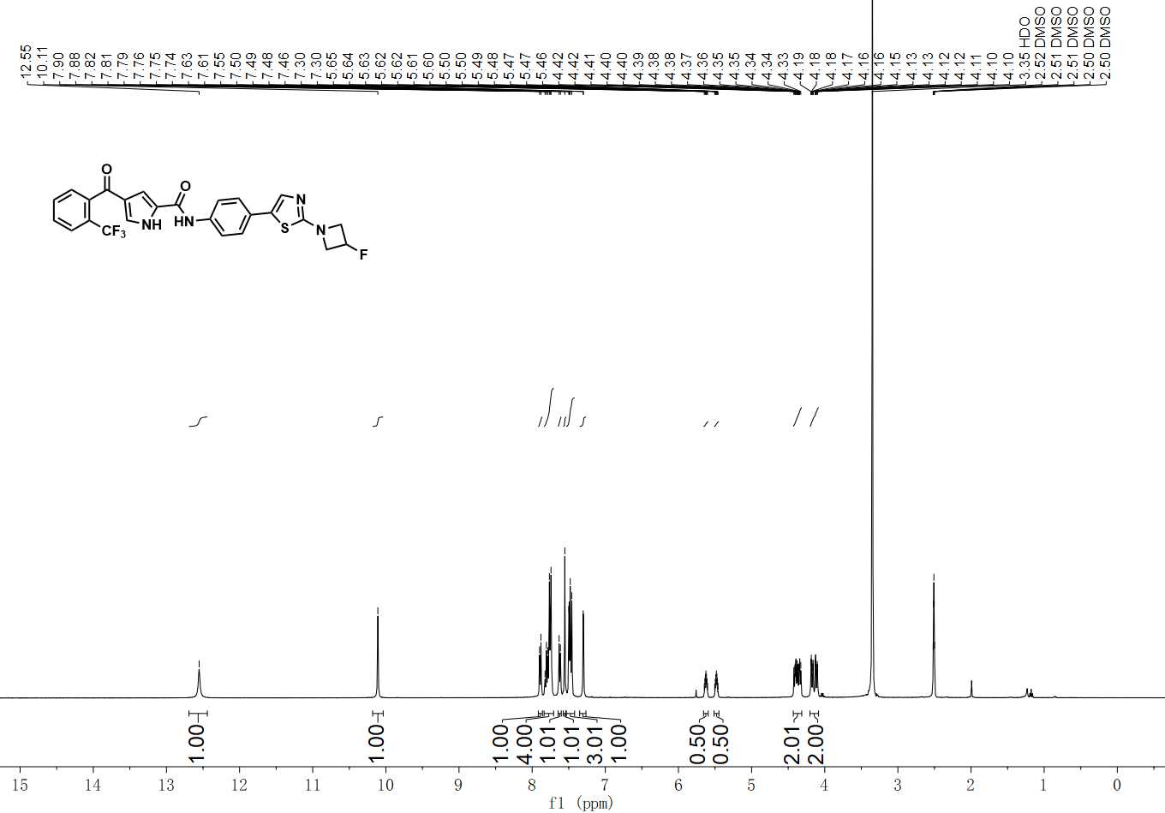

¹H NMR spectrum of C-34

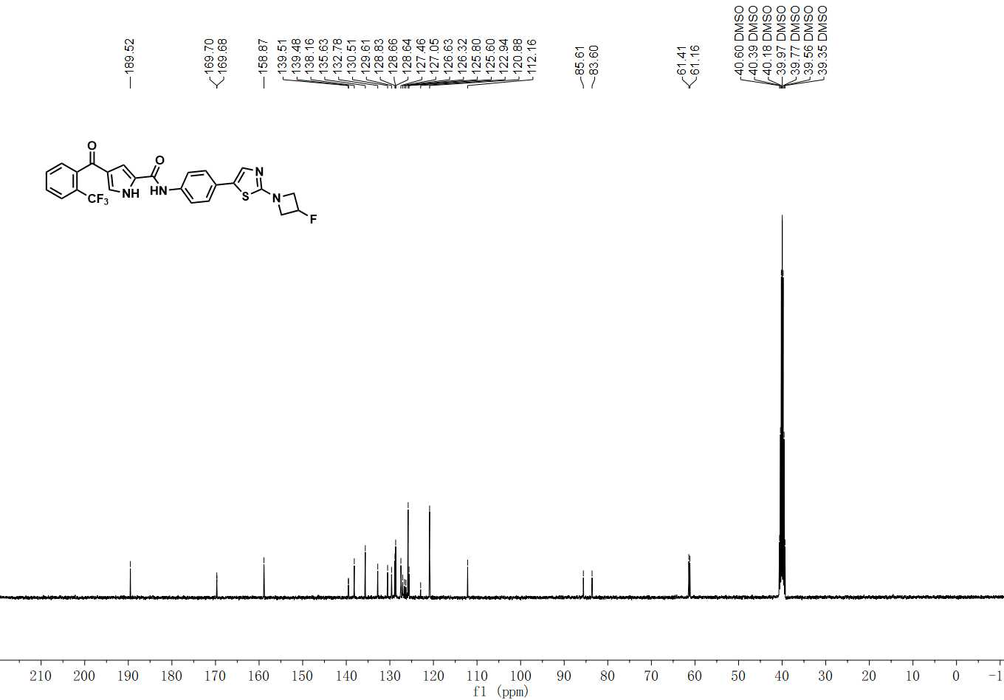

¹³C NMR spectrum of C-34

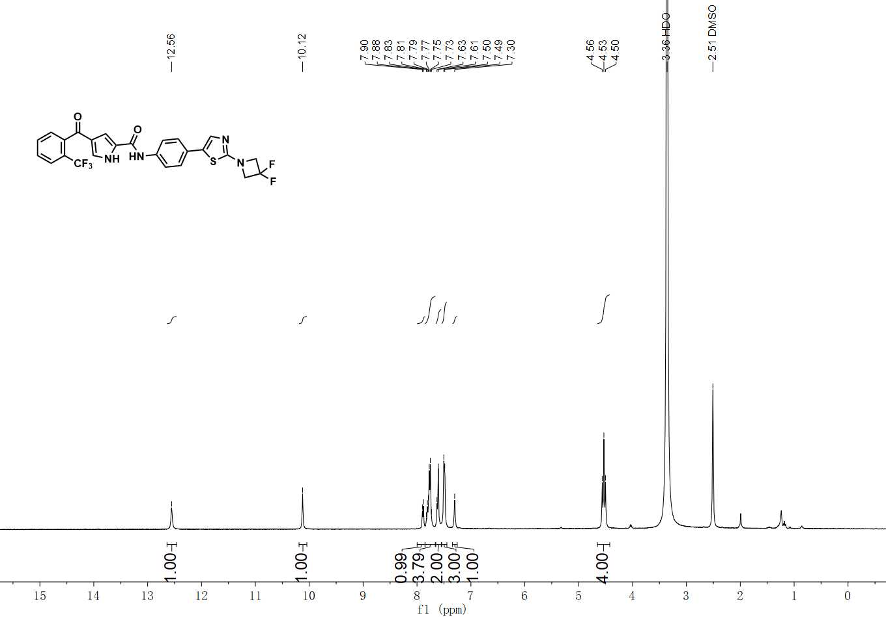

¹H NMR spectrum of C-35

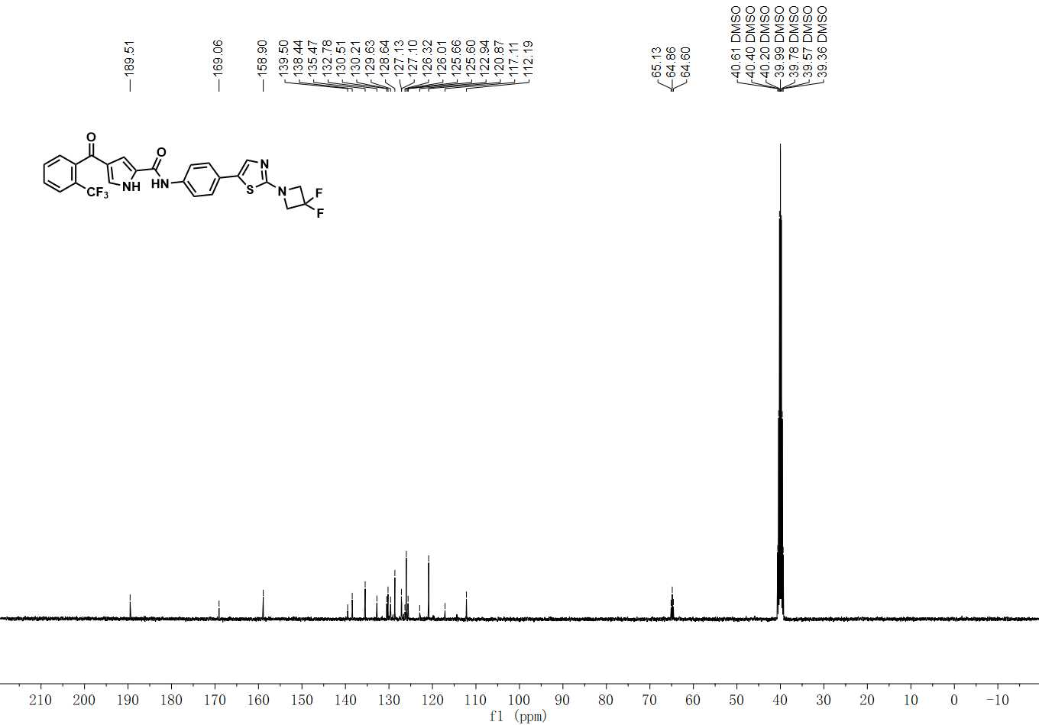

¹³C NMR spectrum of C-35

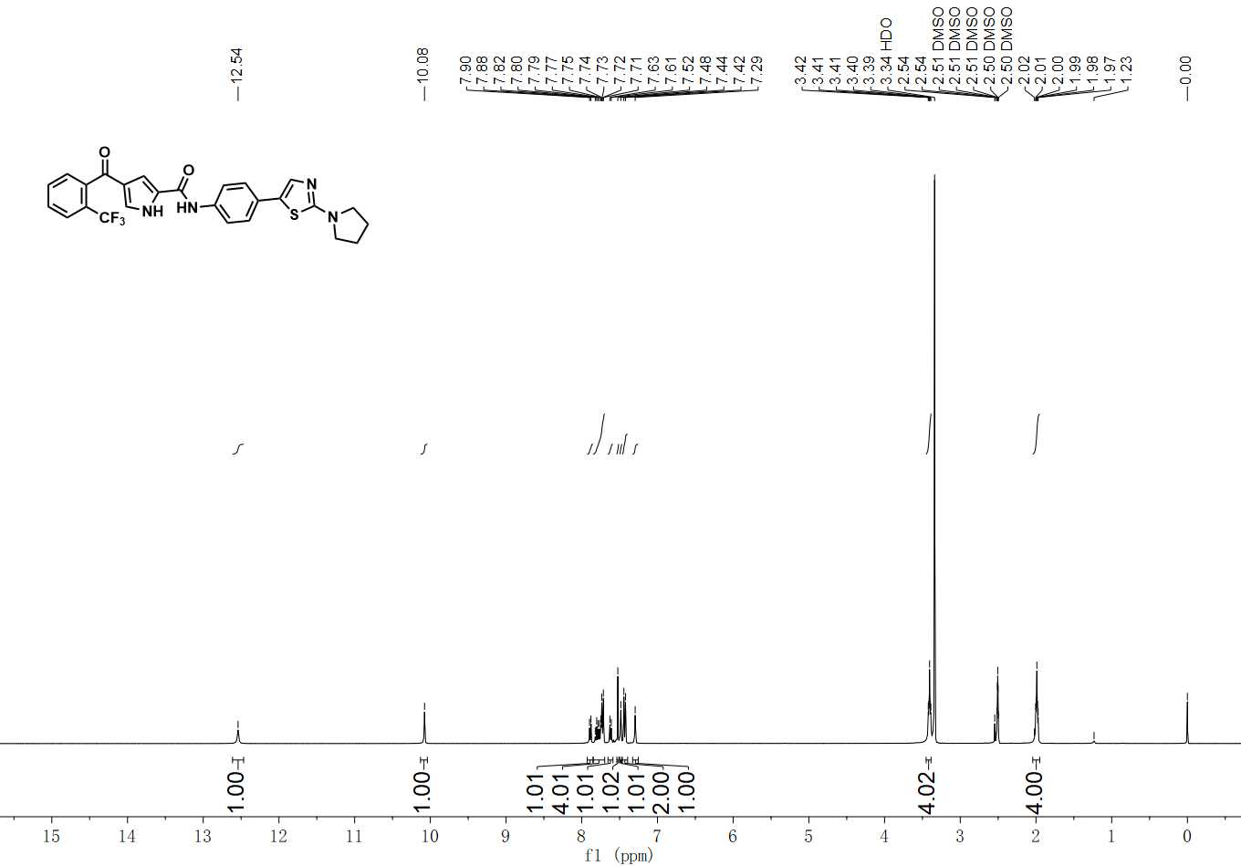

¹H NMR spectrum of C-36

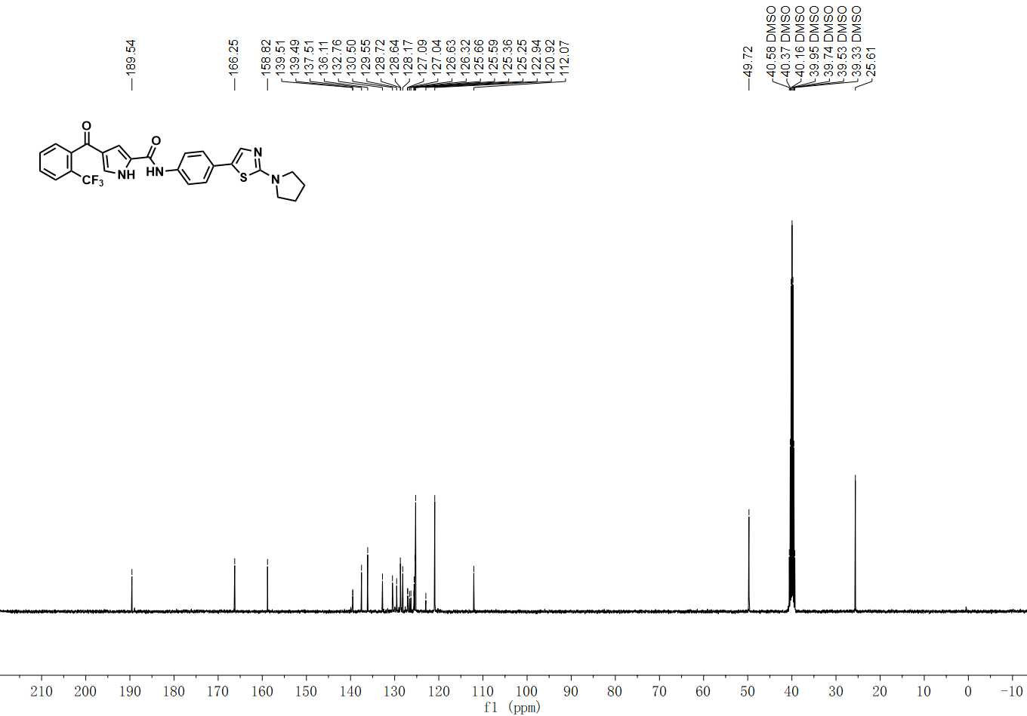

¹³C NMR spectrum of C-36

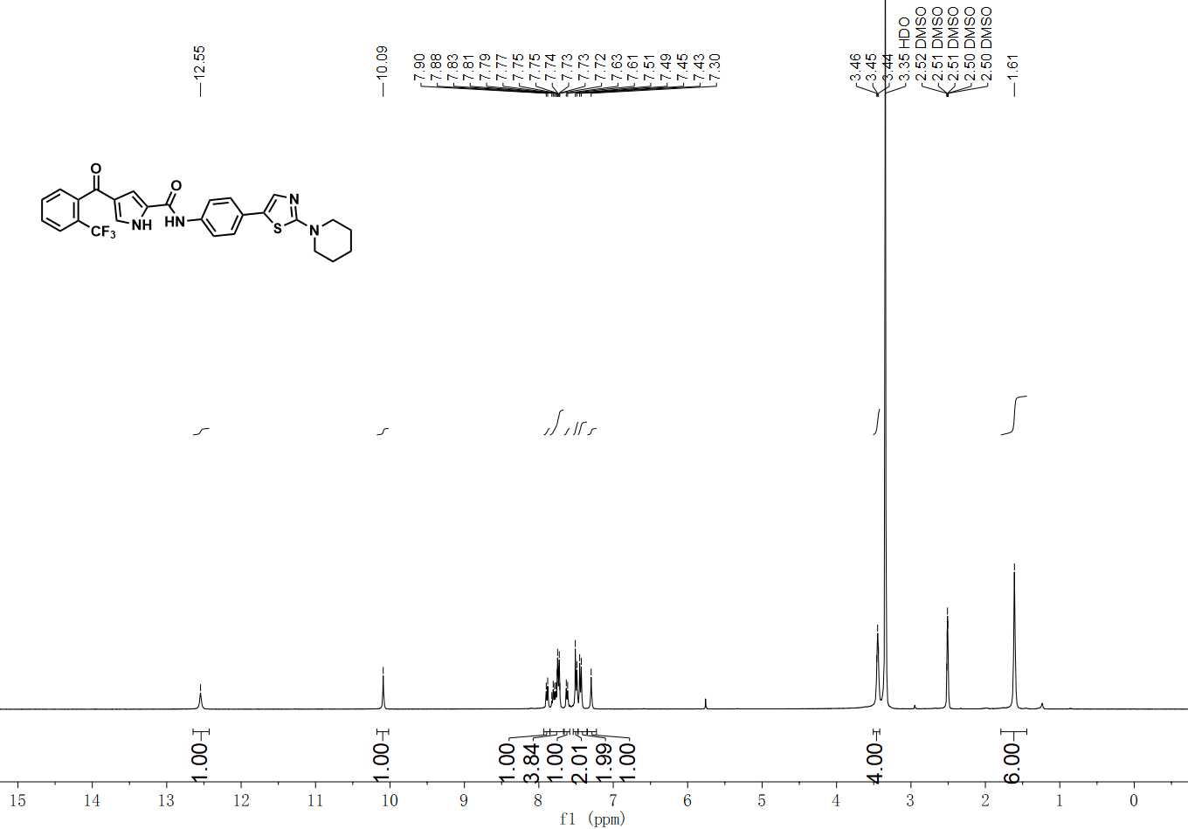

¹H NMR spectrum of C-37

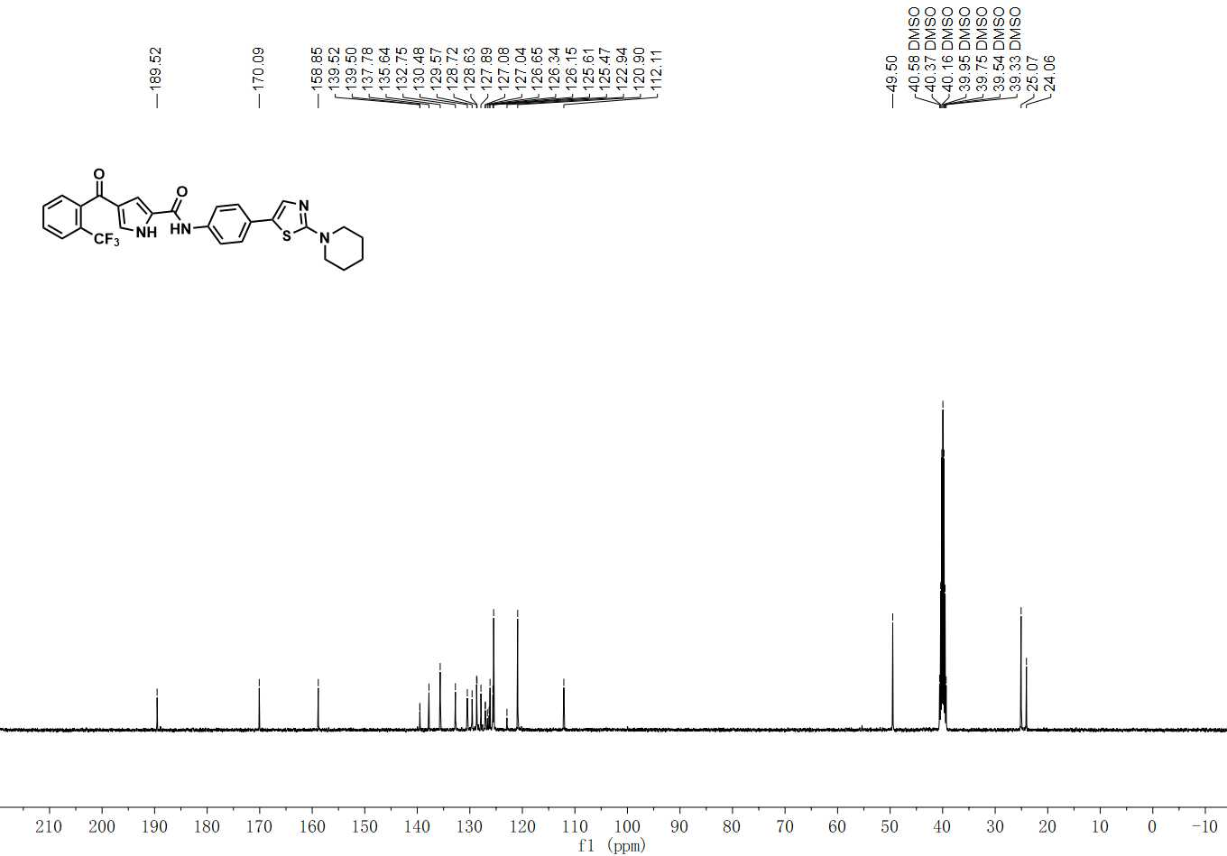

¹³C NMR spectrum of C-37

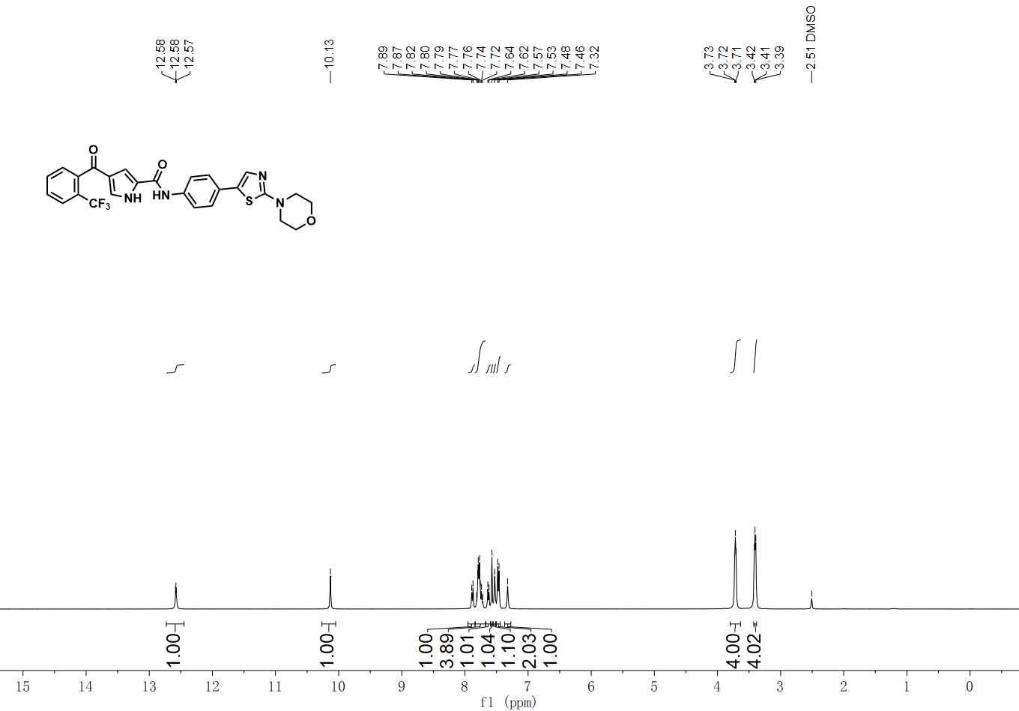

¹H NMR spectrum of C-38

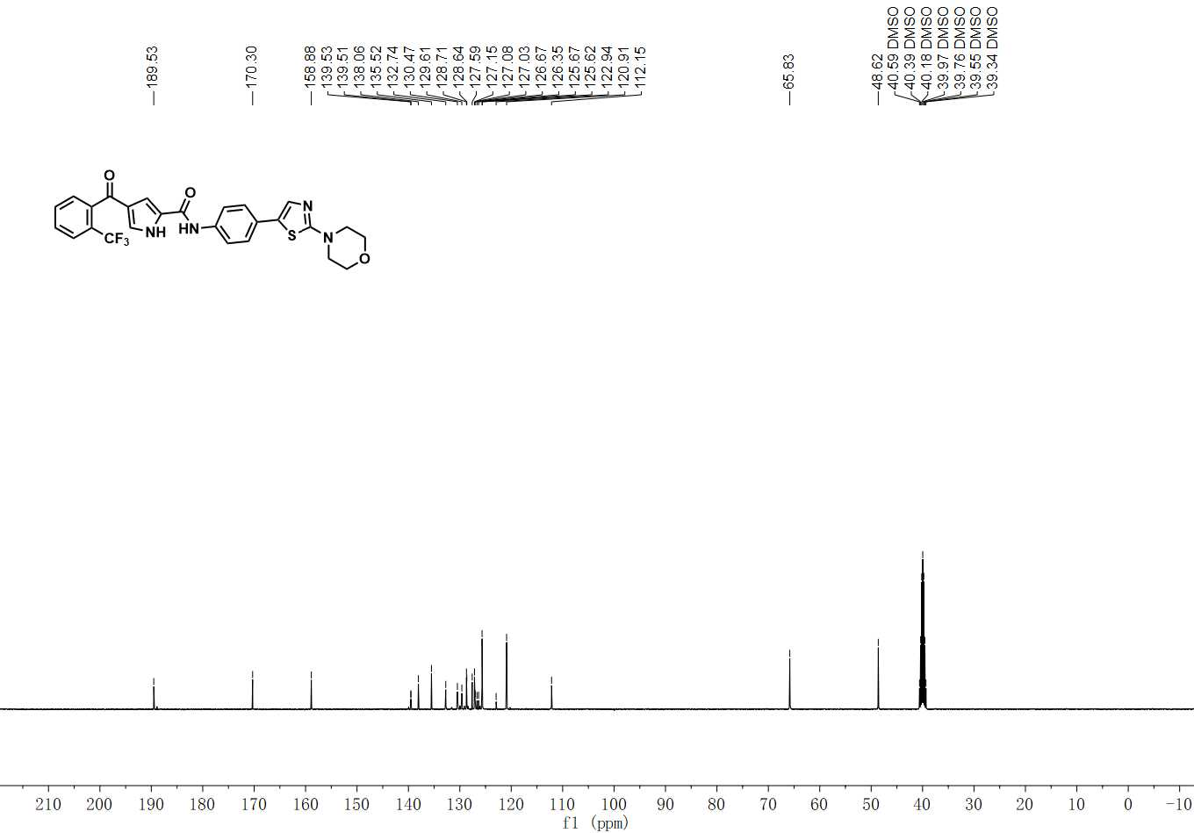

¹³C NMR spectrum of C-38

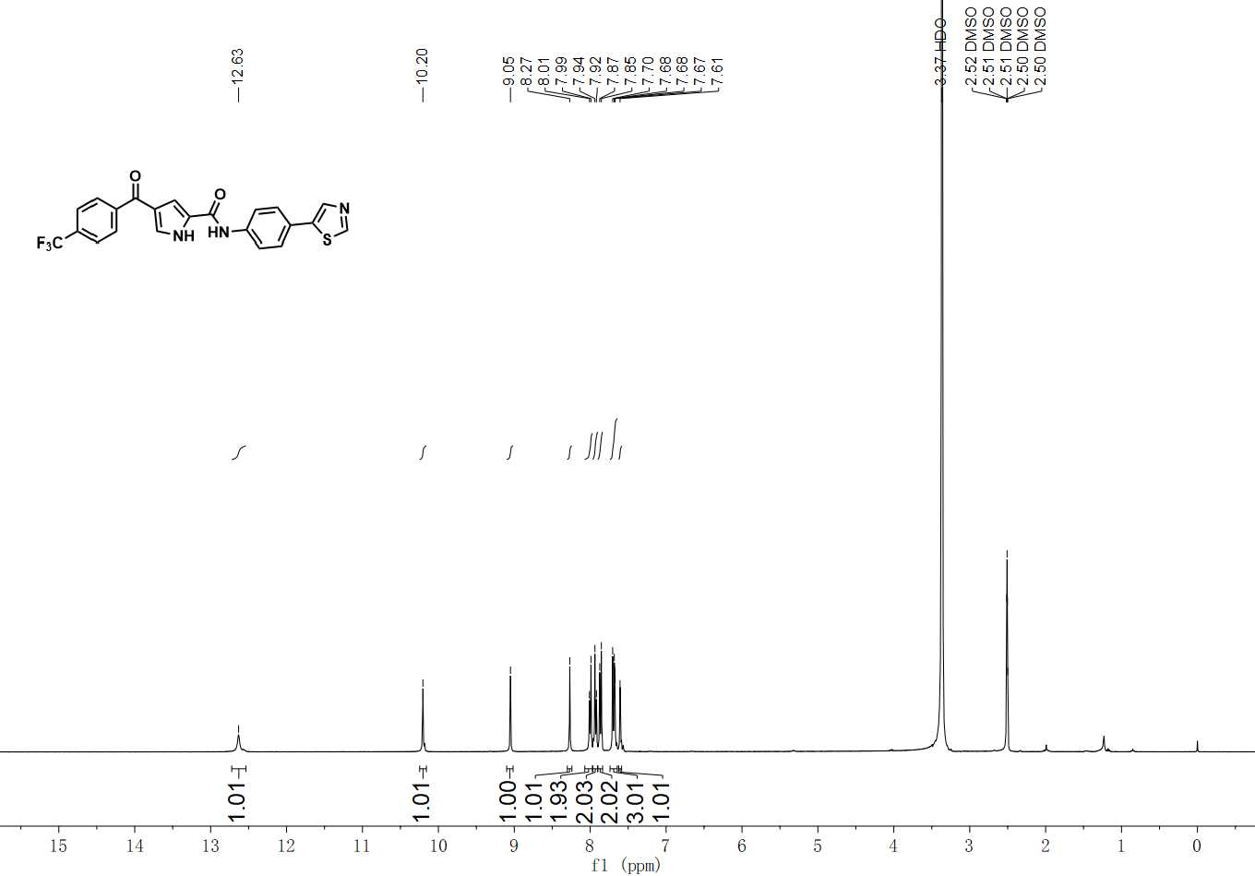

¹H NMR spectrum of YL-NC

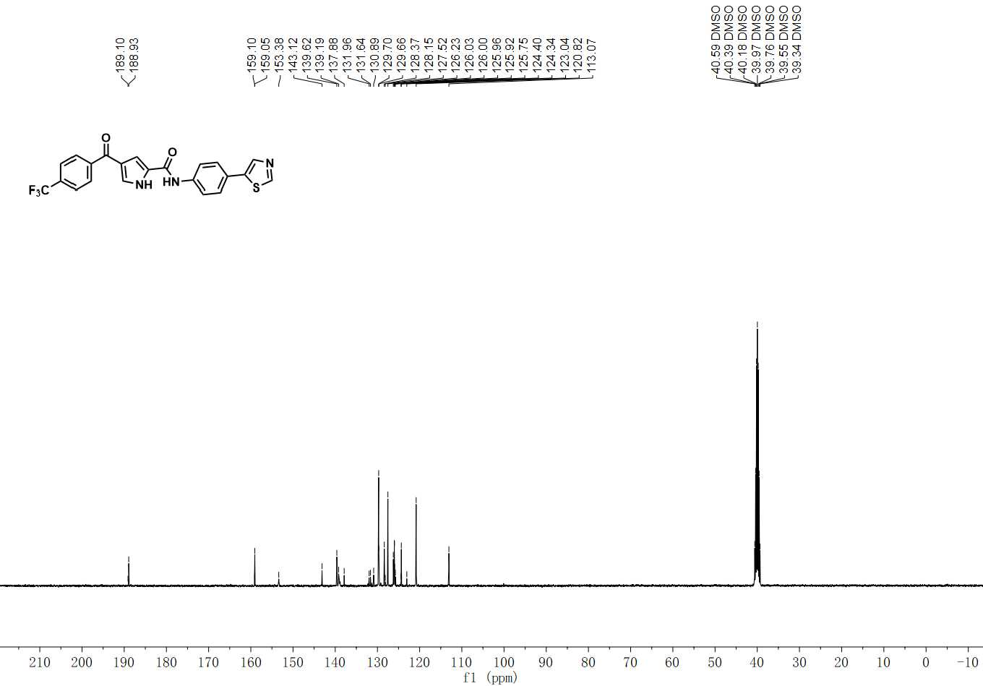

¹³C NMR spectrum of YL-NC

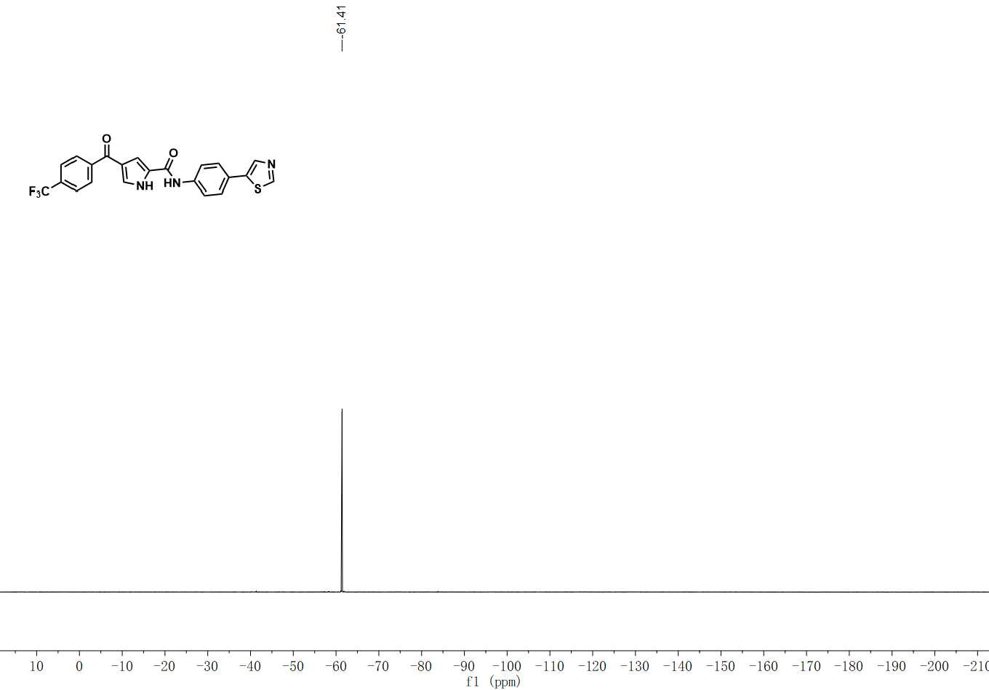
¹⁹F NMR spectrum of YL-NC
HRMS spectra of all compounds

C-1

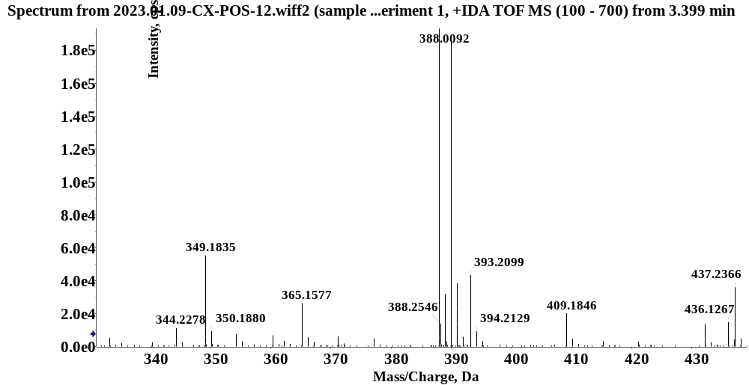
C-2

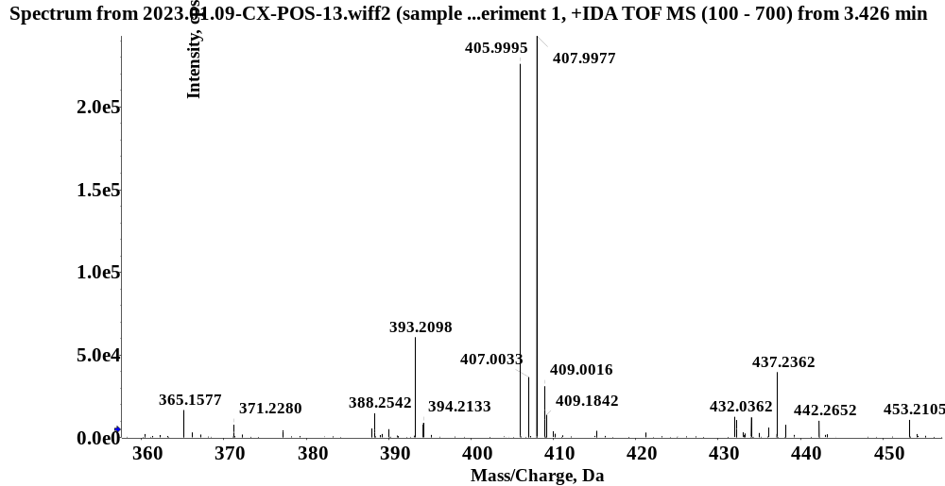
C-3

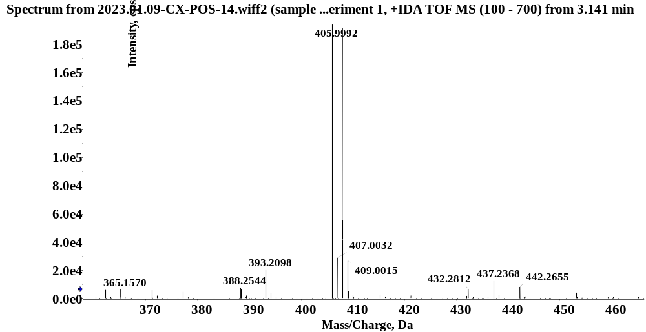
C-4

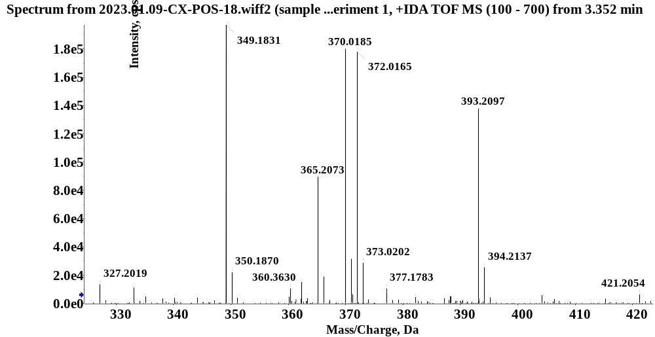
C-5

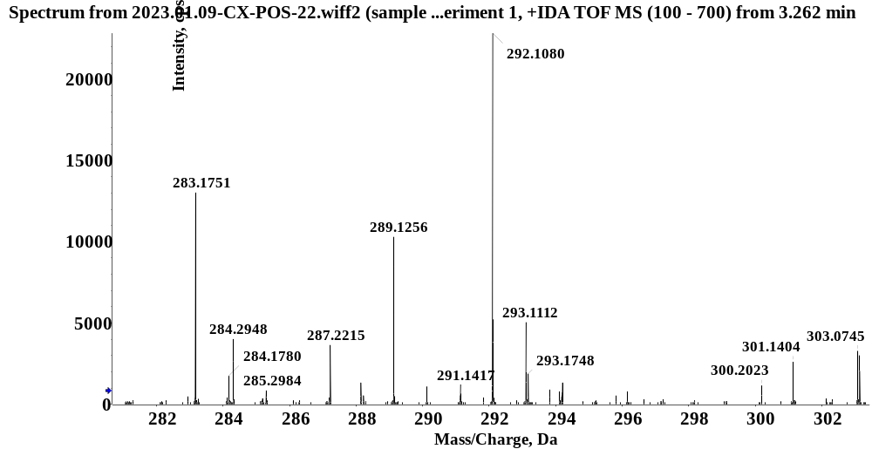
C-6

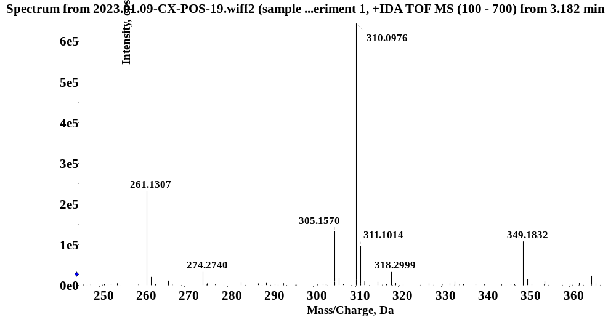
C-7

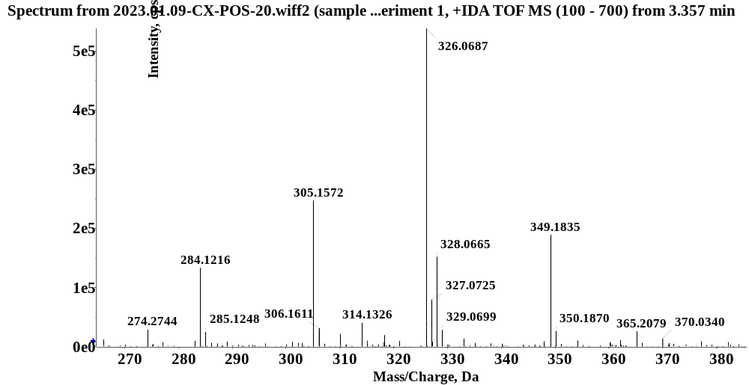
C-8

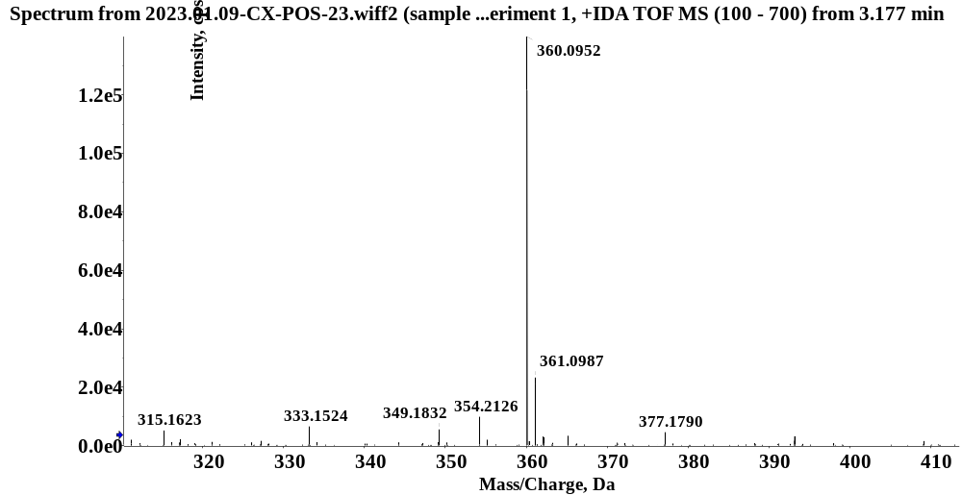
C-9

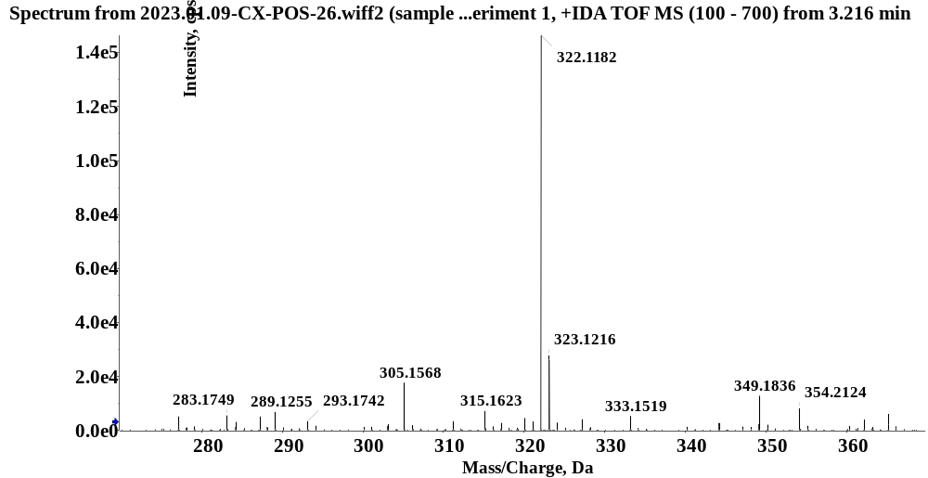
C-10

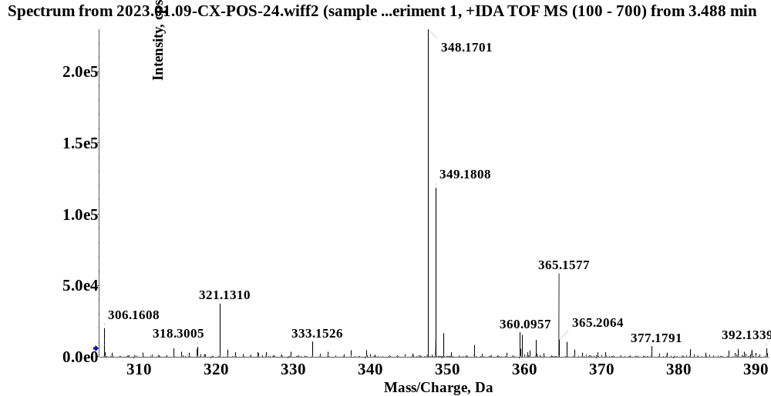
C-11

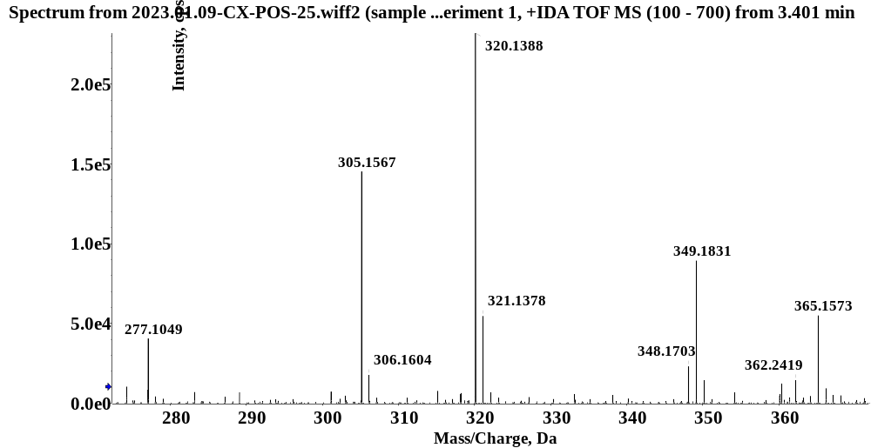
C-12

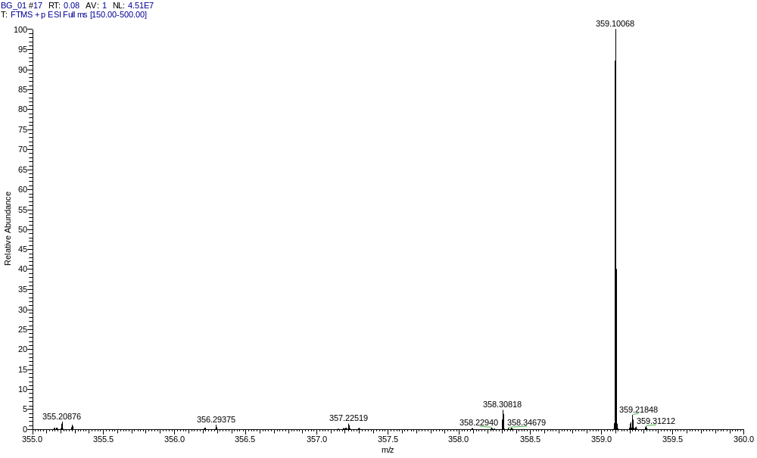
C-13

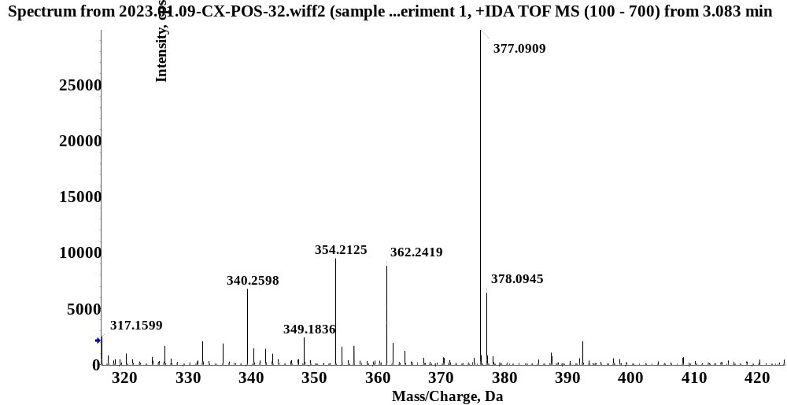
C-14

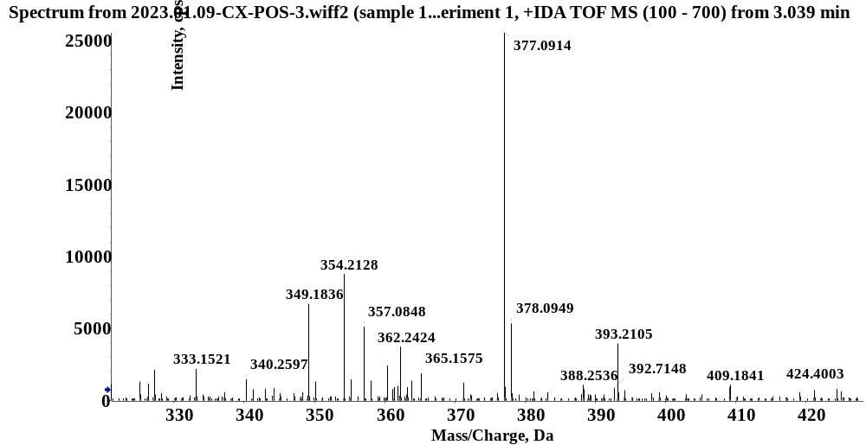
C-15

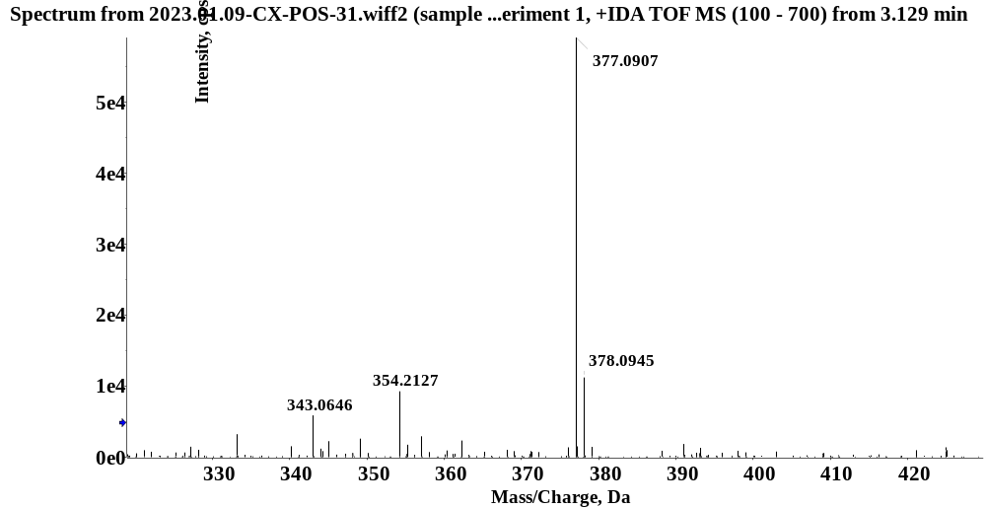
C-16

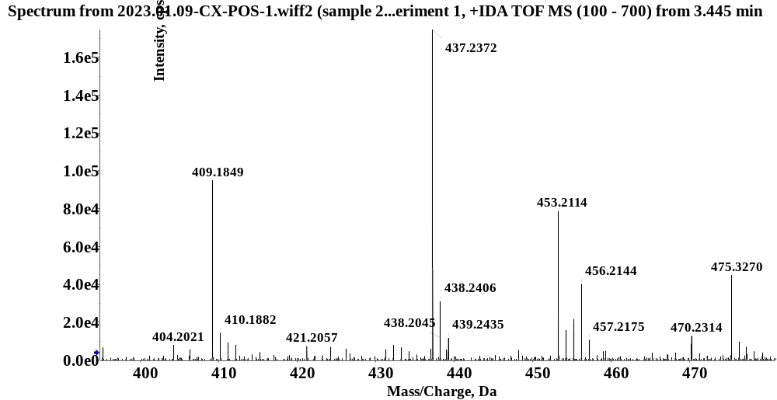
C-17

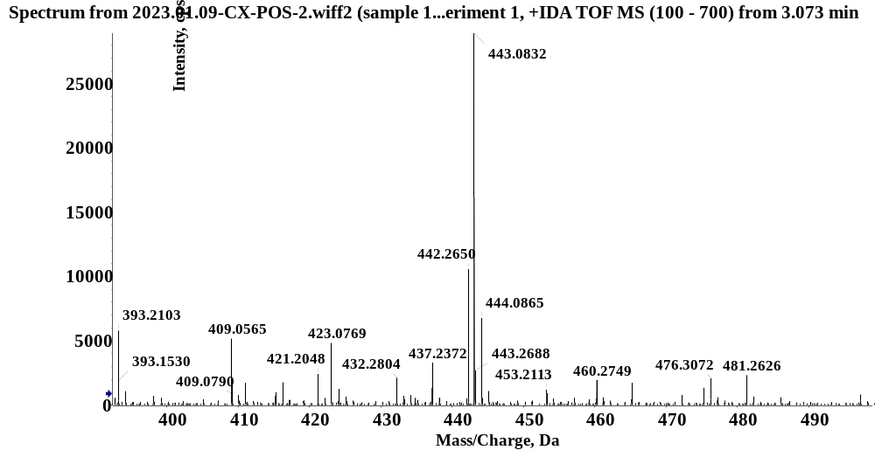
C-18

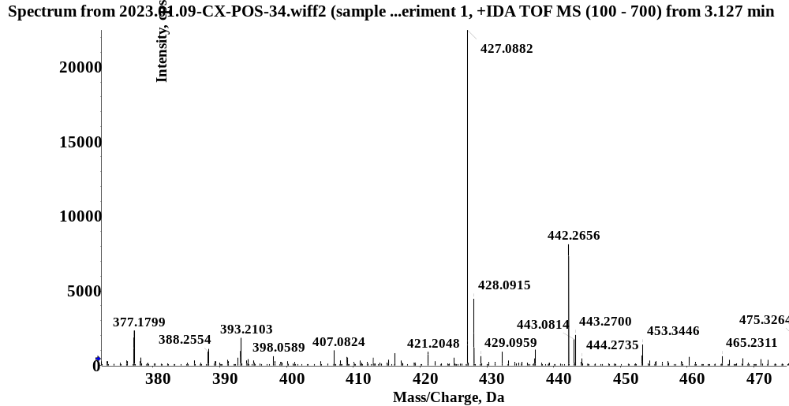
C-19

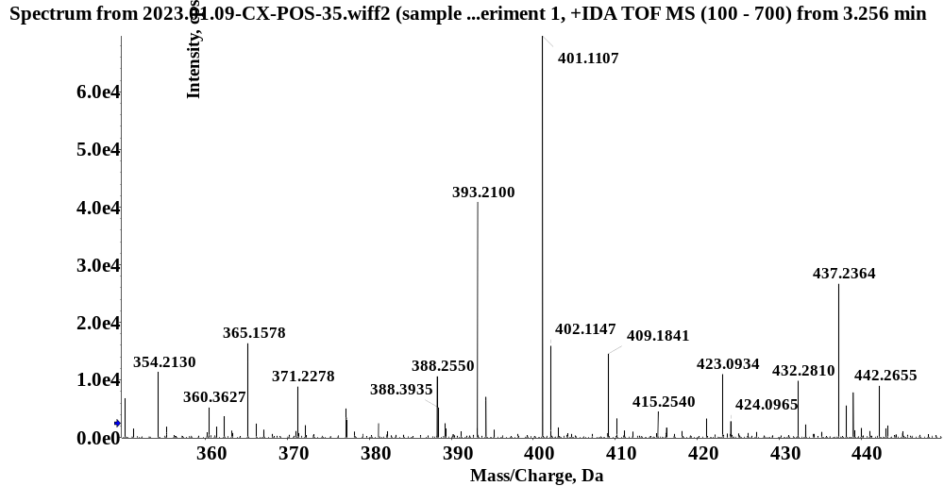
C-20

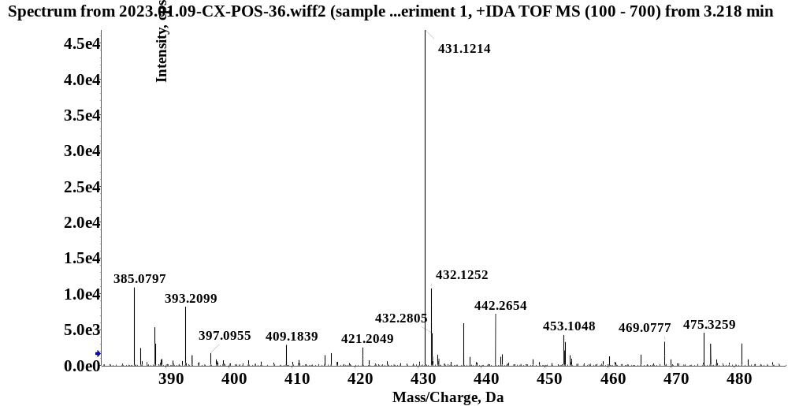
C-21

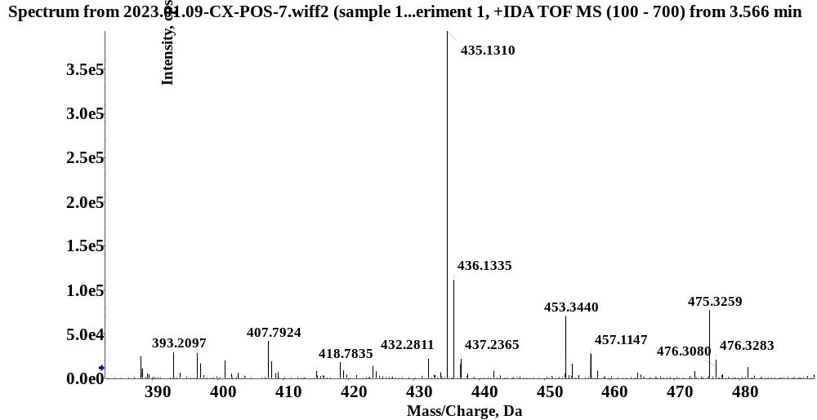
C-22

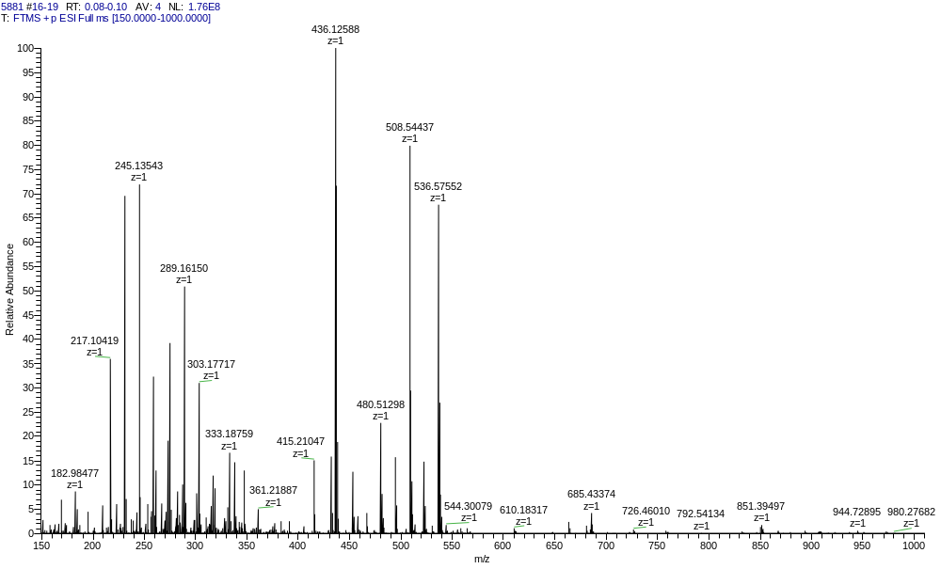
C-23

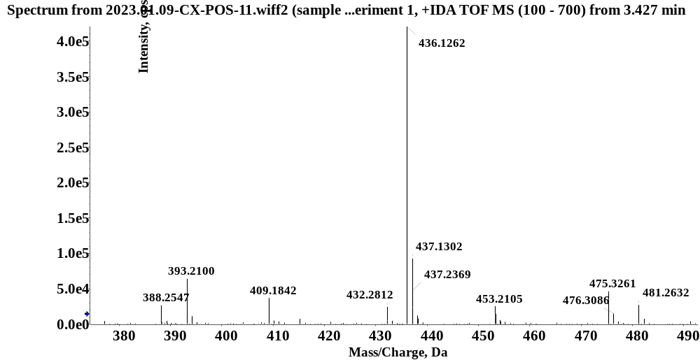
C-24

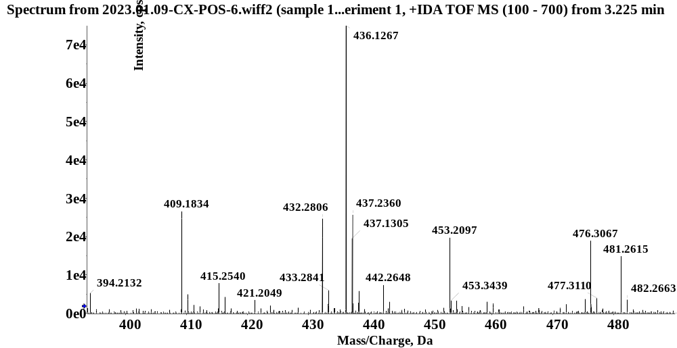
C-25

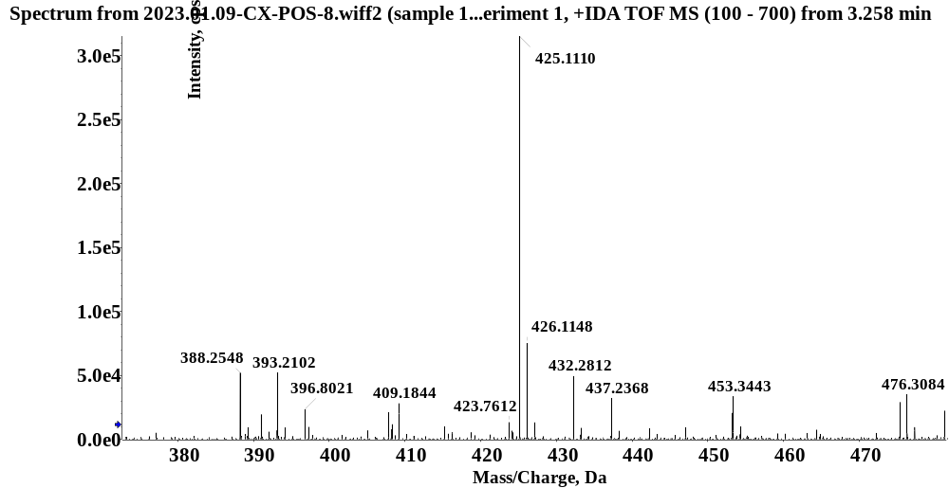
C-26

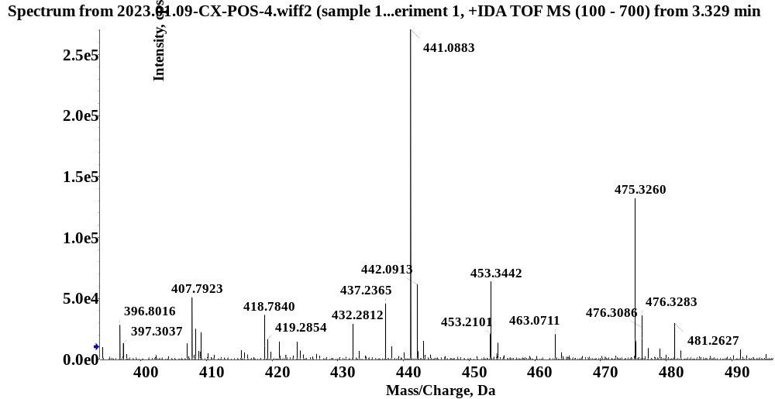
C-27

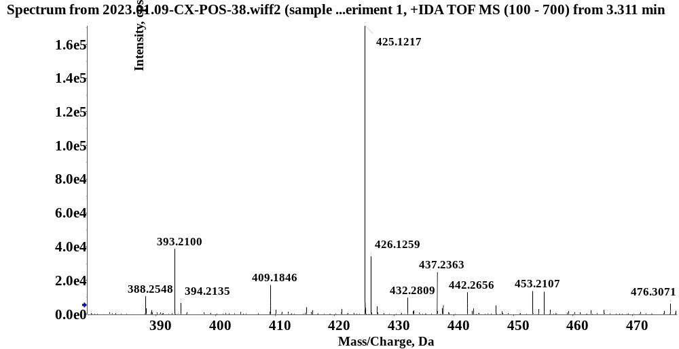
C-28

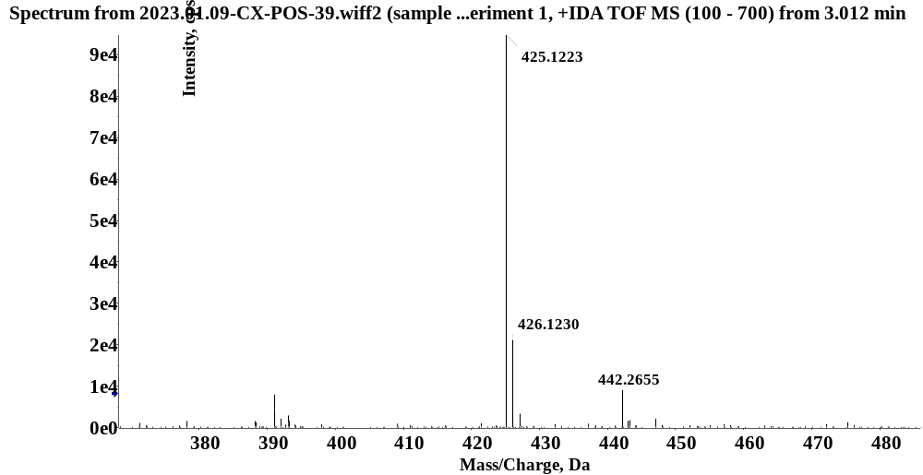
C-29

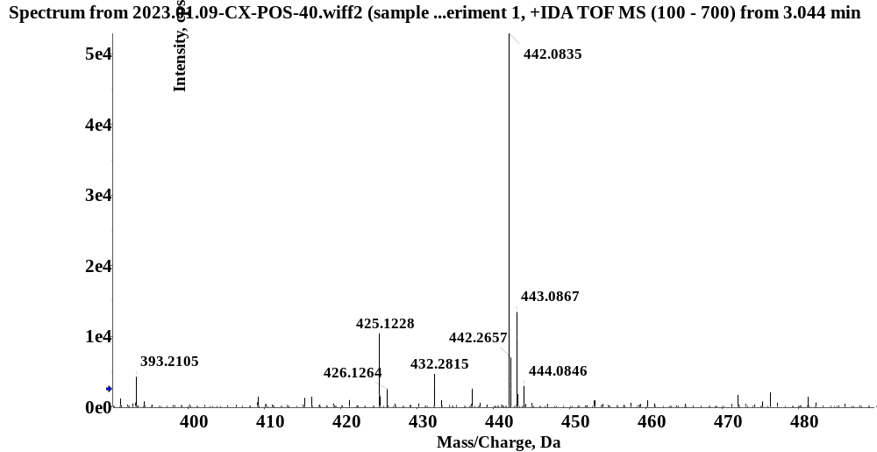
C-30

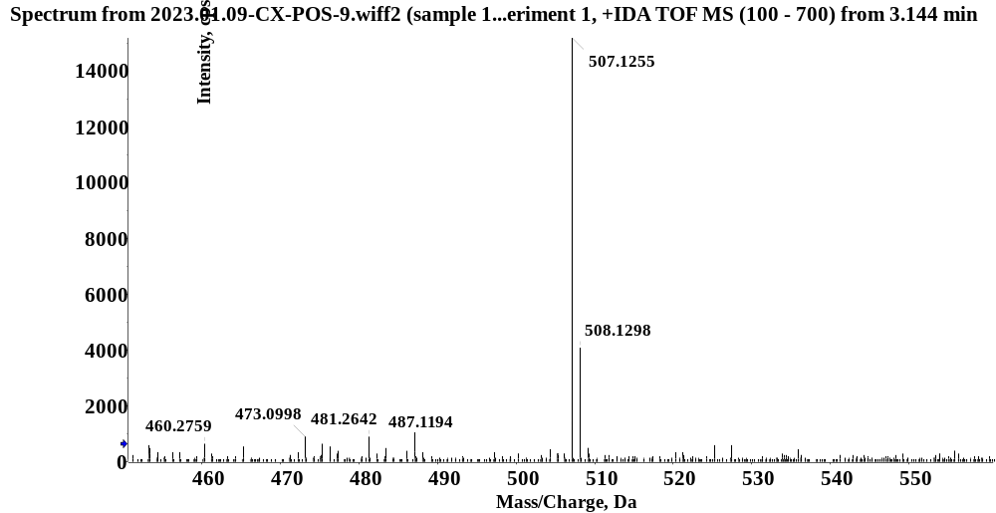
C-31

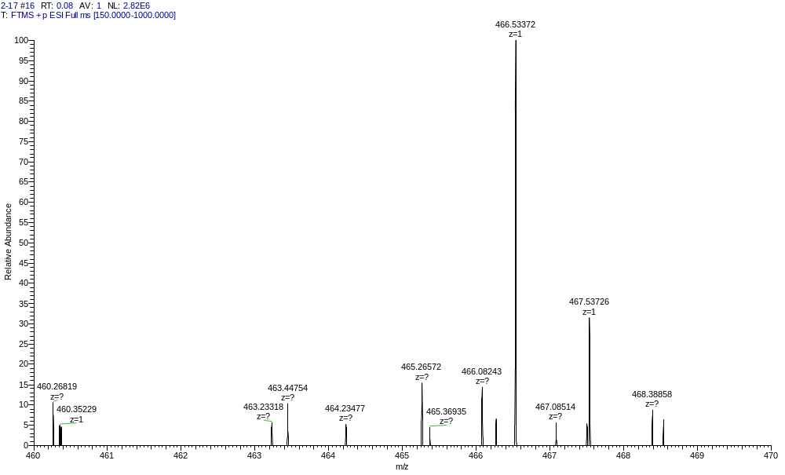
C-32

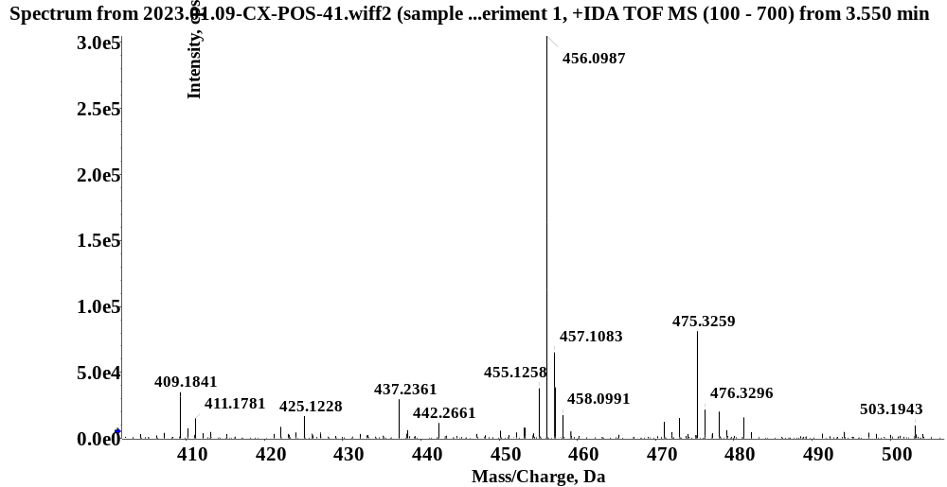
C-33

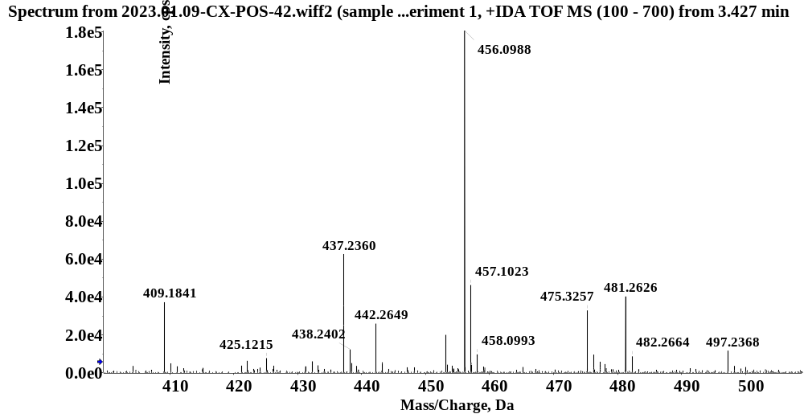
C-34

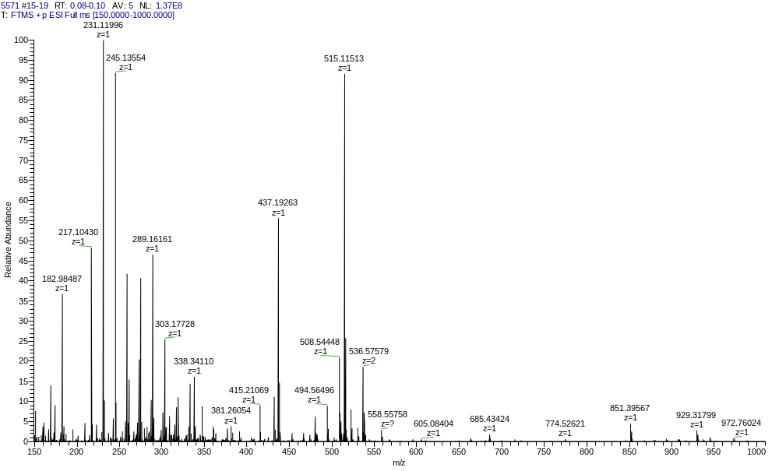
C-35

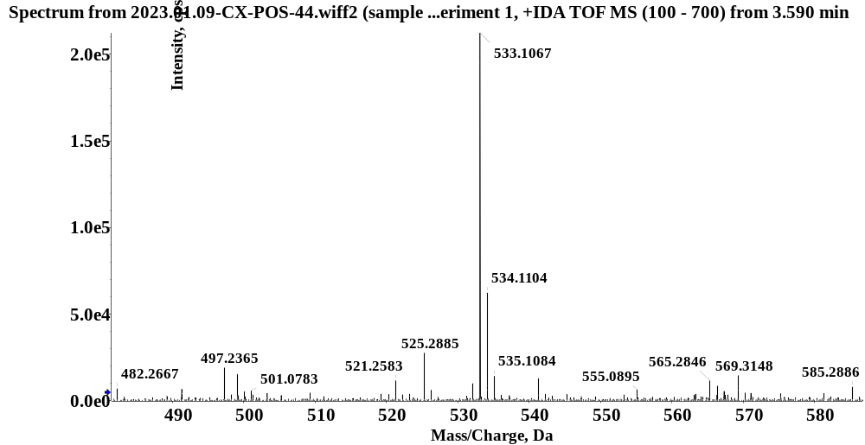
C-36

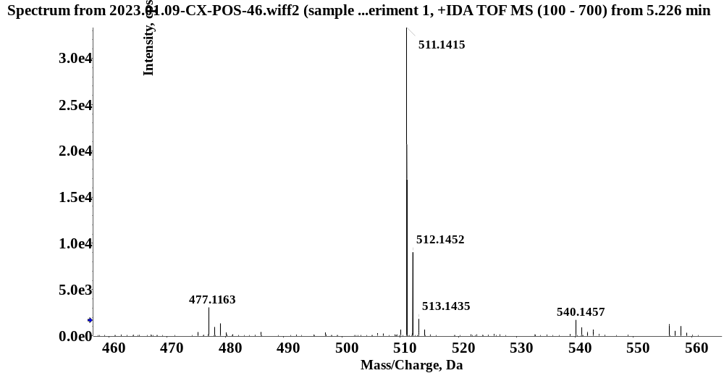
C-37

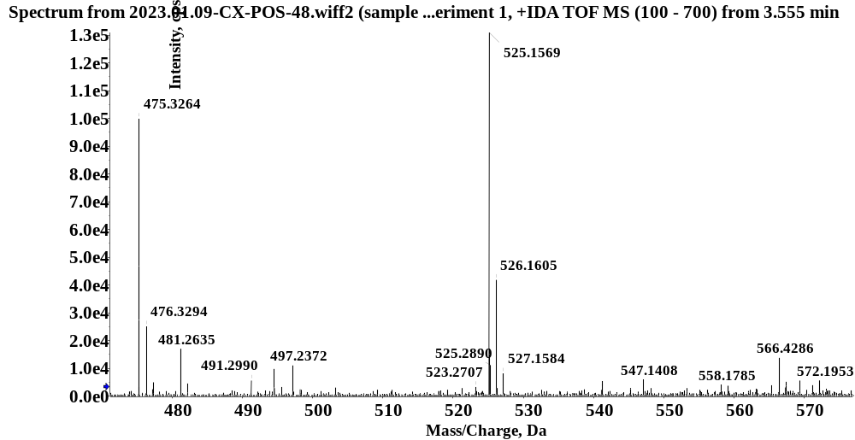
C-38

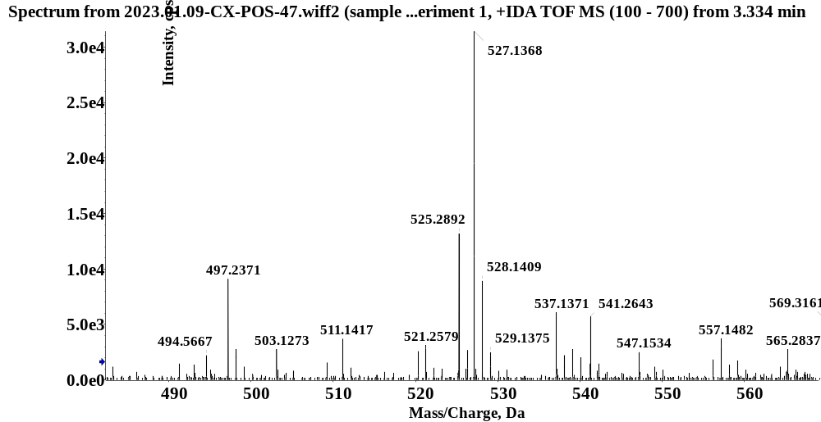
YL-NC

