SUPPORTING MATERIAL

Enyne acetogenins from Porcelia macrocarpa fruit peels displayed anti-Trypanosoma cruzi activity in vitro and cause a reduction in the intracellular calcium level in the parasites

Fernanda Thevenard¹, Ivanildo A. Brito¹, Thais A. Costa-Silva^{1,3},
Andre G. Tempone^{2*}, João Henrique G. Lago^{1*}

¹Centre for Natural and Human Sciences, Federal University of ABC, São Paulo, Brazil
²Centre for Parasitology and Mycology, Instituto Adolfo Lutz, São Paulo, Brazil
³SENAI Institute of Innovation in Biotechnology, 01130-000, São Paulo, Brazil

*Corresponding authors: andre.tempone@ial.sp.gov.br and joao.lago@ufabc.edu.br
Contents

Figure S1 - ¹H NMR spectrum (δ, CDCl₃, 500 MHz) of fraction D-1 composed of 1 – 4 3
Figure S2 - ¹³C NMR spectrum (δ, CDCl₃, 125 MHz) of fraction D-1 composed of 1 – 4 4
Figure S3 - DEPT spectrum (δ, CDCl₃, 125 MHz) of fraction D-1 composed of 1 – 4 5
Figure S4 – ESI-HRMS (positive mode) for compound 1 6
Figure S5 – ESI-HRMS (positive mode) for compound 2 7
Figure S6 – ESI-HRMS (positive mode) for compound 3 8
Figure S7 – ESI-HRMS (positive mode) for compound 4 9
Table S1 – ¹H and ¹³C NMR data to compounds 1 and 3 (δ/ppm, 500 and 125 MHz, CDCl₃) 10
Table S2 – ¹H and ¹³C NMR data to compounds 2 and 4 (δ/ppm, 500 and 125 MHz, CDCl₃) 11

Figure S1 - ¹H NMR spectrum (δ, CDCl₃, 500 MHz) of fraction D-1 composed of 1 – 4

Figure S2 - ¹³C NMR spectrum (δ, CDCl₃, 125 MHz) of fraction D-1 composed of 1 – 4
Figure S3 - DEPT spectrum (δ, CDCl₃, 125 MHz) of fraction D-1 composed of 1 – 4
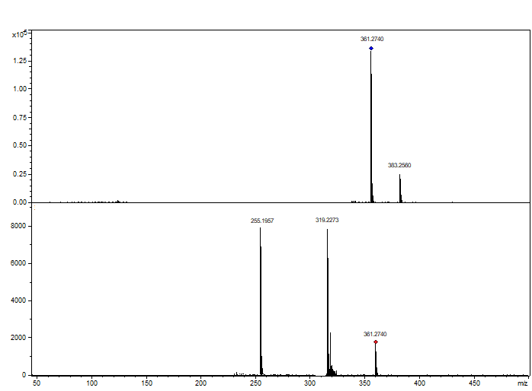
Figure S4 – ESI-HRMS (positive mode) for compound 1
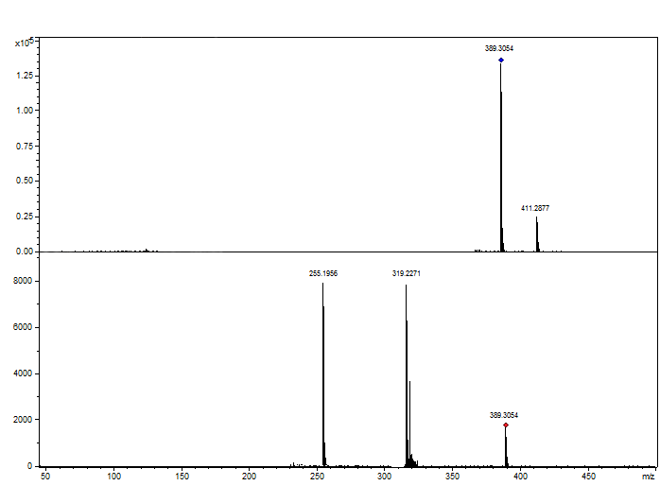
Figure S5 – ESI-HRMS (positive mode) for compound 2
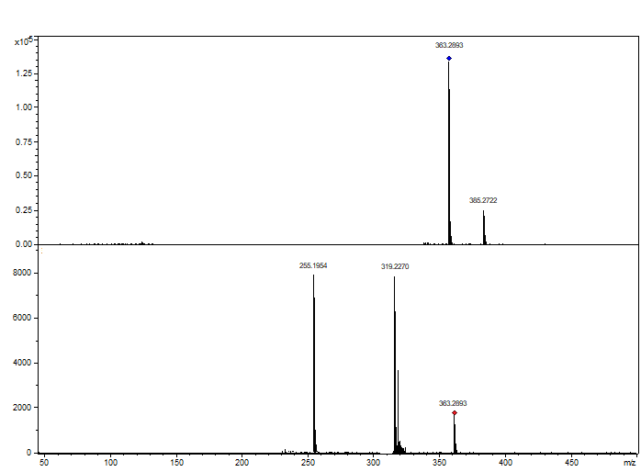
Figure S6 – ESI-HRMS (positive mode) for compound 3
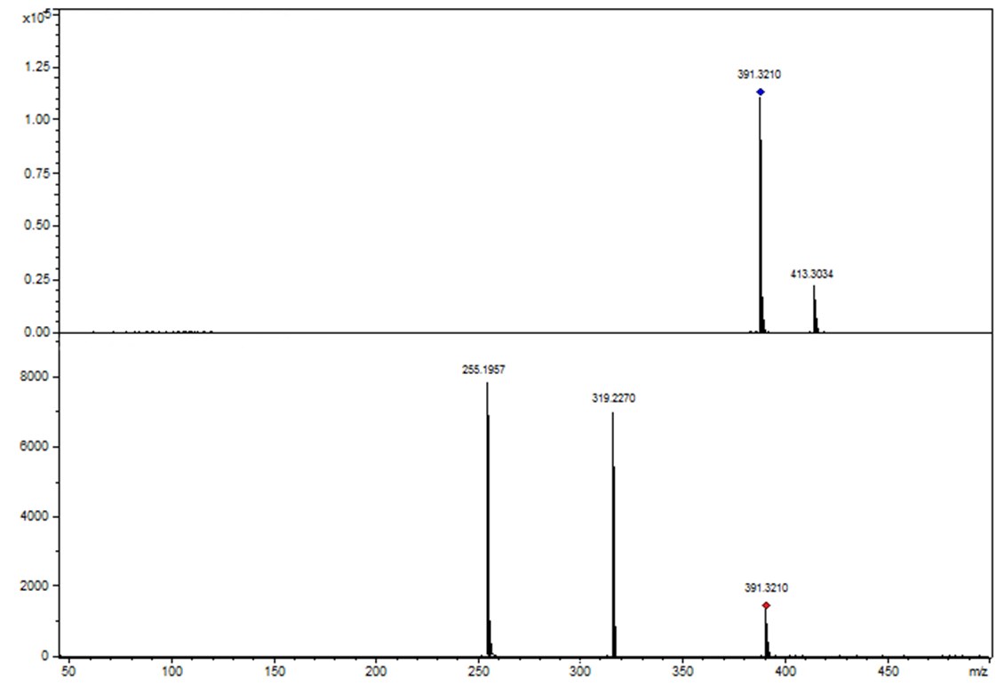
Figure S7 - ESI-HRMS (positive mode) for compound 4

Table S1 – ¹H and ¹³C NMR data to compounds 1 and 3 (δ/ppm, 500 and 125 MHz, CDCl₃)
position | 1 |  | 3
position | δ_{H} (multiplicity, J/Hz) | δ_{C} | δ_{H} (multiplicity, J/Hz) | δ_{C}
1 | - | 177.5 (C) | - | 177.5 (C)
2 | 2.58 (dt, 10.0 and 4.8) | 47.6 (CH) | 2.58 (dt, 10.0 and 4.8) | 47.6 (CH)
3 | 4.31 (dd, 4.8 and 3.0) | 71.3 (CH) | 4.31 (dd, 4.8 and 3.0) | 71.3 (CH)
4 | 4.46 (dq, 6.5 and 3.0) | 78.7 (CH) | 4.46 (dq, 6.5 and 3.0) | 78.7 (CH)
5 | 1.43 (d, 6.5) | 13.7 (CH₃) | 1.43 (d, 6.5) | 13.7 (CH₃)
1’ | 1.82 (m) | 23.3 (CH₂) | 1.82 (m) | 23.3 (CH₂)
2’ | 1.63 (m) | 27.6 (CH₂) | 1.63 (m) | 27.6 (CH₂)
3’ - 9’ | 1.27 (br s) | 28.6 – 29.7 (CH₂) | 1.27 (br s) | 28.6 – 29.7 (CH₂)
10’ | 2.14 (t, 6.6) | 19.6 (CH₂) | 2.14 (t, 6.6) | 19.6 (CH₂)
11’ | - | 80.1 (C) | - | 80.1 (C)
12’ | - | 80.2 (C) | - | 80.2 (C)
13’ | 5.48 (t, 10.7) | 115.2 (CH) | 5.48 (t, 10.7) | 115.2 (CH)
14’ | 6.04 (dt, 10.7 and 7.6) | 137.6 (CH) | 6.04 (dt, 10.7 and 7.6) | 137.6 (CH)
15’ | 1.27 (br s) | 29.7 (CH₂) | 1.27 (br s) | 29.7 (CH₂)
16’ | 1.27 (br s) | 33.7 (CH₂) | 1.27 (br s) | 33.7 (CH₂)
17’ | 5.82 (ddt, 16.9, 9.9 and 6.8) | 139.2 (CH) | 1.27 (br s) | 22.7 (CH₂)
18’ | 4.97 (m) | 114.5 (CH₂) | 0.88 (t, 7.6) | 14.1 (CH₃)
Table S2 – ¹H and ¹³C NMR data to compounds 2 and 4 (δ/ppm, 500 and 125 MHz, CDCl₃)
position | 2 |  | 4
position | δ_{H} (multiplicity, J/Hz) | δ_{C} | δ_{H} (multiplicity, J/Hz) | δ_{C}
1 | - | 177.5 (C) | - | 177.5 (C)
2 | 2.58 (dt, 10.0 and 4.8) | 47.6 (CH) | 2.58 (dt, 10.0 and 4.8) | 47.6 (CH)
3 | 4.31 (dd, 4.8 and 3.0) | 71.3 (CH) | 4.31 (dd, 4.8 and 3.0) | 71.3 (CH)
4 | 4.46 (dq, 6.5 and 3.0) | 78.7 (CH) | 4.46 (dq, 6.5 and 3.0) | 78.7 (CH)
5 | 1.43 (d, 6.5) | 13.7 (CH₃) | 1.43 (d, 6.5) | 13.7 (CH₃)
1’ | 1.82 (m) | 23.3 (CH₂) | 1.82 (m) | 23.3 (CH₂)
2’ | 1.63 (m) | 27.6 (CH₂) | 1.63 (m) | 27.6 (CH₂)
3’-9’ | 1.27 (br s) | 28.6 – 29.7 (CH₂) | 1.27 (br s) | 28.6 – 29.7 (CH₂)
10’ | 2.14 (t, 6.6) | 19.6 (CH₂) | 2.14 (t, 6.6) | 19.6 (CH₂)
11’ | - | 80.1 (C) | - | 80.1 (C)
12’ | - | 80.2 (C) | - | 80.2 (C)
13’ | 5.48 (t, 10.7) | 115.2 (CH) | 5.48 (t, 10.7) | 115.2 (CH)
14’ | 6.04 (dt, 10.7 and 7.6) | 137.6 (CH) | 6.04 (dt, 10.7 and 7.6) | 137.6 (CH)
15’ – 18’ | 1.27 (br s) | 28.6 – 33.7 (CH₂) | 1.27 (br s) | 28.6 – 33.7 (CH₂)
19’ | 5.82 (ddt, 16.9, 9.9 and 6.8) | 139.2 (CH) | 1.27 (br s) | 22.7 (CH₂)
20’ | 4.97 (m) | 114.5 (CH₂) | 0.88 (t, 7.6) | 14.1 (CH₃)

