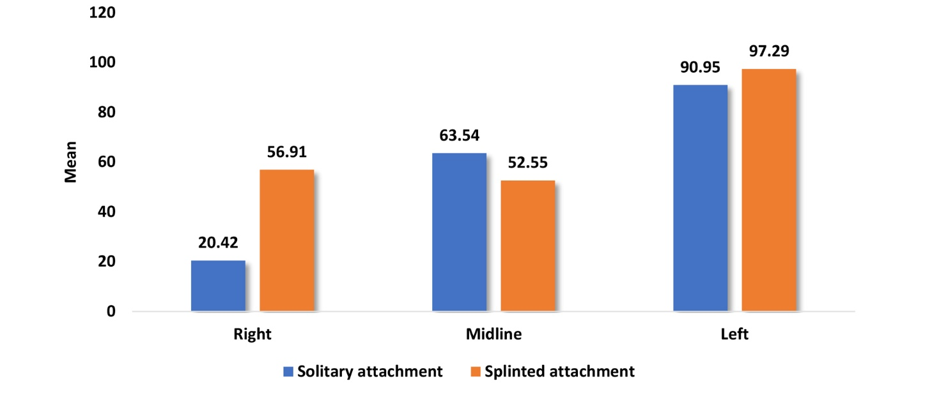
Graph.1: Comparison of mean overall microstrain values between solitary attachment and splinted attachment during unilateral vertical load application for different implant positions.

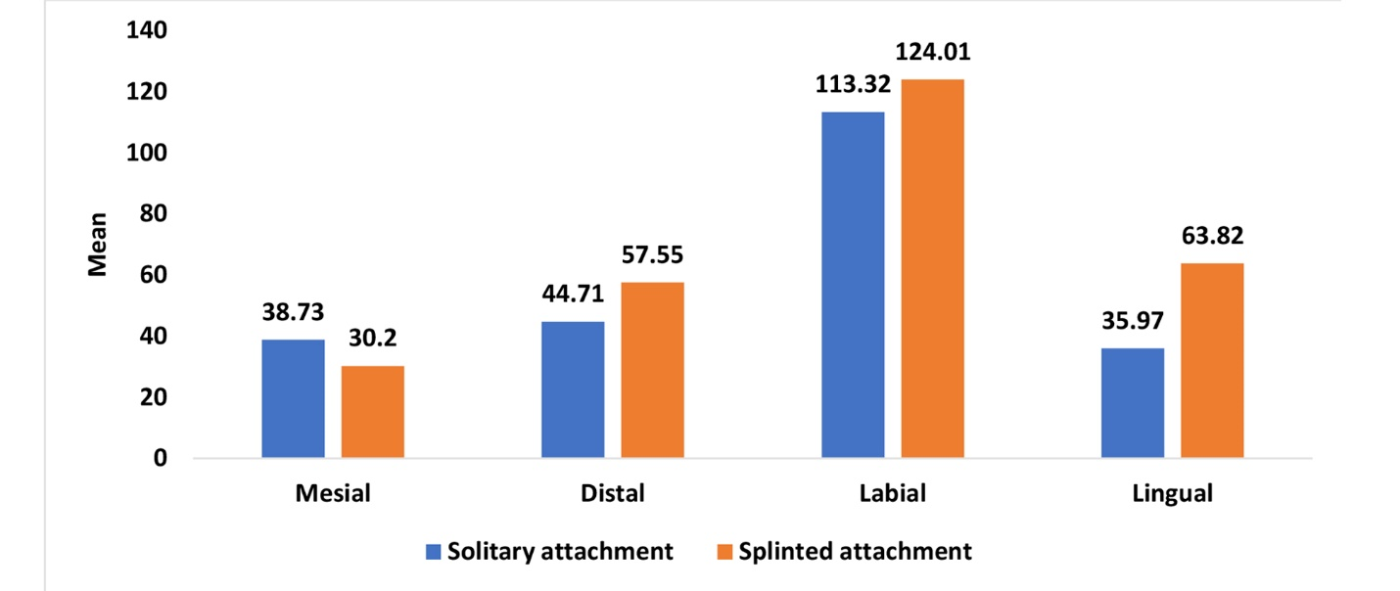
Graph.2: Comparison of mean overall microstrain values during unilateral vertical load application between solitary attachment and splinted attachment for different implant surfaces.

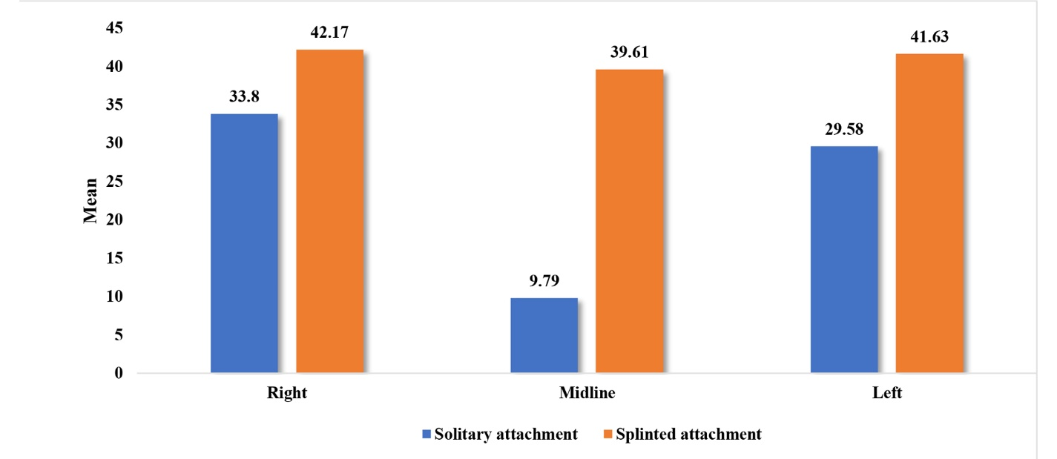
Graph.3: Comparison of mean overall microstrain values between solitary attachment and splinted attachment during bilateral vertical load application for different implant positions.

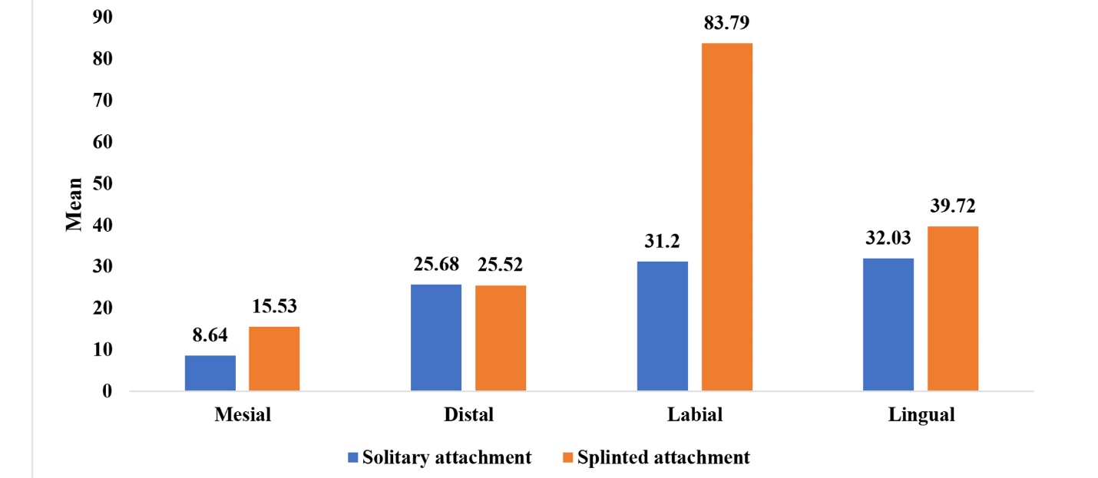
Graph.4: Comparison of mean overall microstrain values during bilateral vertical load application between solitary attachment and splinted attachment for different implant surfaces.

