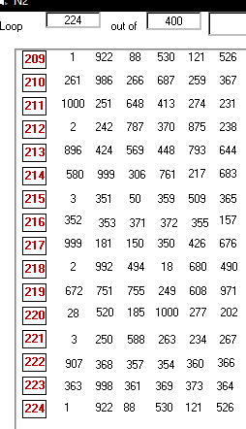
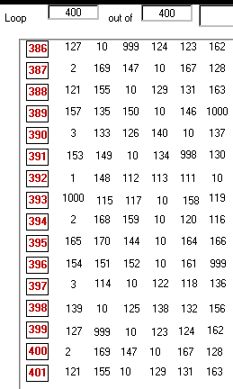










The Sherpa hypothesis: Phenotype-Protecting Disordered Proteins stabilize the phenotypes of neurons and oligodendrocytes

Vic Norris,¹* Judit Oláh,² Sergey N. Krylov,³ Vladimir N. Uversky,⁴ and Judit Ovádi²

Figure S1. A PPDP can protect the phenotype from perturbation.
The learnt sequence of states in the Active subset is shown in the left part of the figures and the perturbed state in the right part. a: In the absence of a PPDP element, very few of the active elements in the learnt state are preserved; two of their addresses are shown. b: In the presence of a PPDP element (Element-10) the learnt sequence is preserved as indicated for a few states with the blue line and the black ovals. The black arrow represents time. The data were obtained from the CocoIDP825NatComm program.

Figure S2. Introduction of a second PPDP causes the phenotype to be lost.
The learnt sequence of Active states contains only the PPDP Element-10 and the contents of its fields (left panel). This sequence is disrupted by the presence of a second PPDP element (Element-312) (right panel). The black arrow represents time.

Figure S3. Elimination of the second PPDP can allow recovery.
The learnt sequence of Active states (left panel) is lost in the presence of a second PPDP element (Element-640) (centre panel); when the second PPDP element is removed and when the order of the learnt sequence is restored by the forced presence of an input, the learnt sequence is largely recovered (right panel). The blue arrow shows the restoration of one of the states in the learnt sequence. The black arrow represents time. The data were obtained from the CocoIDP827NatComm program.

Figure S4. Functional intrinsic disorder of SYN and TPPP.
Left panel. NMR solution structure of human SYN bound to a micelle of the detergent sodium lauroyl sarcosinate (SLAS) (PDB ID: 2KKW) [1]. Right panel. A. NMR solution structure of human homologue TPPP (TPPP3/p20) (PDB ID: 2JRF) (https://www.rcsb.org/structure/2JRF), a homologue of TPPP.

REFERENCE

1 Rao, J. N., Jao, C. C., Hegde, B. G., Langen, R. & Ulmer, T. S. A combinatorial NMR and EPR approach for evaluating the structural ensemble of partially folded proteins. Journal of the American Chemical Society 132, 8657-8668, doi:10.1021/ja100646t (2010).

