Network stability and accuracy
Two approaches were used to determine the accuracy and stability of the depressive-anxiety symptoms network. Firstly, most of the edges were proven stable via nonparametric bootstraps (Fig S1). Secondly, the case dropping bootstrap procedure indicated that after dropping different proportions of the sample the value of bridge expected influence remained higher stability. Difference tests for expected influence and bridge expected influence is illustrated in Figure S2.
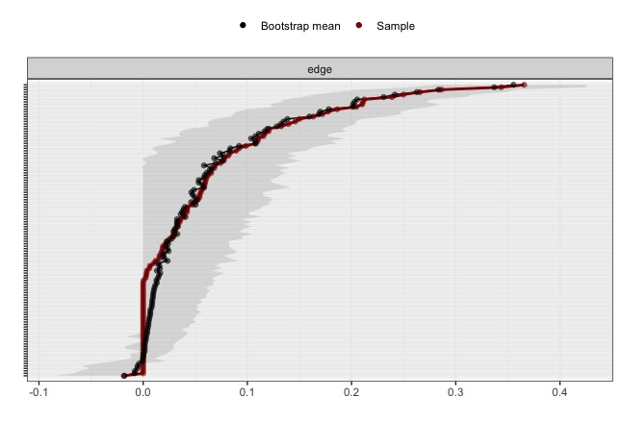
Figure S1 The accuracy of the edge weights. The black line represents the mean value of the bootstrapped edge weights. The red line represents the edge weights of the sample. The grey area indicates the 95% confidence interval.
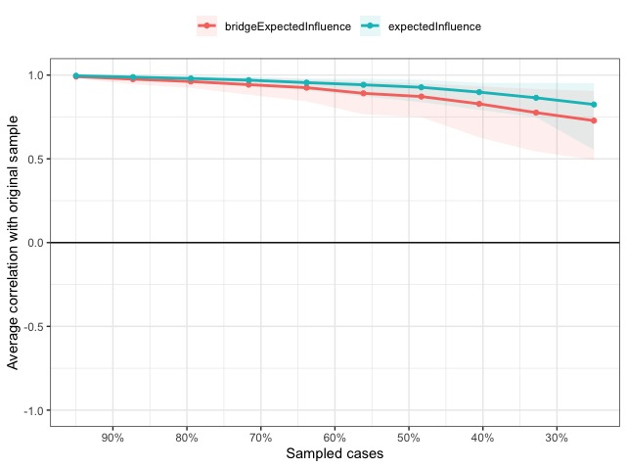
Figure S2 The stability of network structure by case dropping subset bootstrap. The green line represents the expected influence and the green zone represents the 95% confidence intervals of the bootstrapped sample. The red line represents the bridge expected influence and the red zone represents the 95% confidence intervals of the bootstrapped sample.

The expected influence and bridge expected influence of the non-SI network was unstable (CS=0.13), while the expected influence displayed less stable network structures (CS=0.28) (Fig S3). In the network of the SI group, both expected influence and bridge expected influence demonstrated a CS higher than 0.25 (bridge expected influence CS=0.44; expected influence CS=0.672), demonstrating a stable network structure (Fig S4).
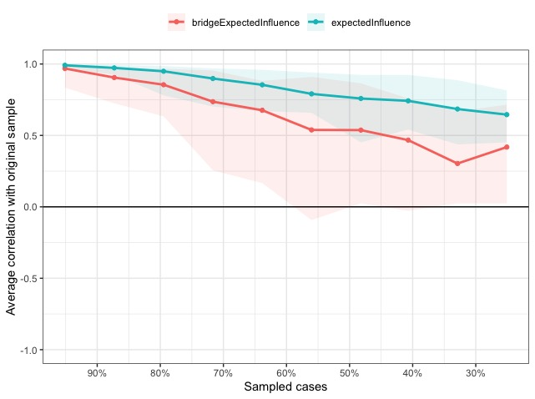
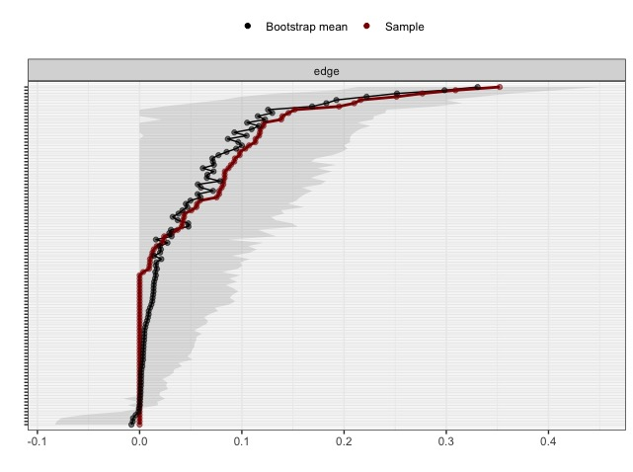

Figure S3 a) The accuracy of the edge weights among the non-SI group. The black line represents the mean value of the bootstrapped edge weights. The red line represents the edge weights of the sample. The grey area indicates the 95% confidence interval. b) The stability of network structure by case dropping subset bootstrap among the non-ideation group. The green line represents the expected influence and the green zone represents the 95% confidence intervals of the bootstrapped sample. The red line represents the bridge expected influence and the red zone represents the 95% confidence intervals of the bootstrapped sample.

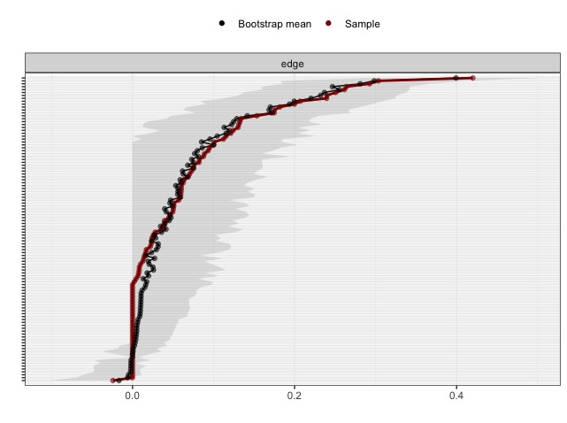
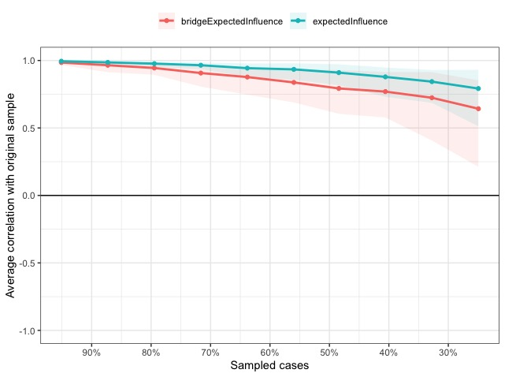

Figure S4 a) The accuracy of the edge weights among the SI group. The black line represents the mean value of the bootstrapped edge weights. The red line represents the edge weights of the sample. The grey area indicates the 95% confidence interval. b) The stability of network structure by case dropping subset bootstrap among the ideation group. The green line represents the expected influence and the green zone represents the 95% confidence intervals of the bootstrapped sample. The red line represents the bridge expected influence and the red zone represents the 95% confidence intervals of the bootstrapped sample.

Table S1

Estimated Edge Weights among Adolescents (n=716)
 | Anhedonia | Sad Mood | Sleep | Energy | Appetite | Guilty | Concentration | Motor | Suicide | Nervous | Control Worry | Worry A Lot | Relax | Restless | Irritable | Afraid
Anhedonia
Sad Mood | 0.16
Sleep | 0.03 | 0.03
Energy | 0.29 | 0.05 | 0.18
Appetite | 0.04 | 0.04 | 0.24 | 0.17
Guilty | 0.05 | 0.21 | 0.00 | 0.08 | 0.00
Concentration | 0.05 | 0.00 | 0.00 | 0.04 | 0.05 | 0.15
Motor | 0.04 | 0.00 | 0.06 | 0.00 | 0.00 | 0.02 | 0.21
Suicide | 0.00 | 0.21 | 0.12 | 0.00 | 0.00 | 0.13 | 0.00 | 0.14
Nervous | 0.12 | 0.12 | 0.02 | 0.06 | 0.00 | 0.06 | 0.00 | 0.00 | 0.00
Control Worry | 0.00 | 0.01 | 0.00 | 0.03 | 0.05 | 0.09 | 0.02 | 0.00 | 0.00 | 0.27
Worry A Lot | 0.07 | 0.06 | 0.00 | 0.00 | 0.02 | 0.00 | 0.00 | 0.04 | 0.00 | 0.11 | 0.34
Relax | -0.02 | 0.00 | 0.07 | 0.03 | 0.00 | 0.08 | 0.02 | 0.00 | 0.00 | 0.07 | 0.12 | 0.20
Restless | 0.00 | 0.00 | 0.02 | 0.00 | 0.02 | 0.01 | 0.08 | 0.25 | 0.07 | 0.00 | 0.00 | 0.03 | 0.37
Irritable | 0.04 | 0.03 | 0.00 | 0.03 | 0.04 | 0.01 | 0.01 | 0.00 | 0.06 | 0.15 | 0.00 | 0.00 | 0.07 | 0.19
Afraid | 0.00 | 0.10 | 0.00 | 0.00 | 0.06 | 0.00 | 0.00 | 0.09 | 0.11 | 0.00 | 0.06 | 0.06 | 0.02 | 0.08 | 0.11

Table S2

Estimated Edge Weights among Non-SI Group (n=307)
 | Anhedonia | Sad Mood | Sleep | Energy | Appetite | Guilty | Concentration | Motor | Nervous | Control Worry | Worry A Lot | Relax | Restless | Irritable | Afraid
Anhedonia
Sad Mood | 0.14
Sleep | 0.00 | 0.00
Energy | 0.28 | 0.02 | 0.11
Appetite | 0.01 | 0.00 | 0.20 | 0.15
Guilty | 0.04 | 0.15 | 0.00 | 0.09 | 0.00
Concentration | 0.08 | 0.00 | 0.00 | 0.00 | 0.00 | 0.10
Motor | 0.08 | 0.00 | 0.00 | 0.00 | 0.00 | 0.00 | 0.21
Nervous | 0.12 | 0.10 | 0.08 | 0.08 | 0.00 | 0.04 | 0.00 | 0.00
Control Worry | 0.00 | 0.10 | 0.01 | 0.00 | 0.01 | 0.12 | 0.04 | 0.00 | 0.31
Worry A Lot | 0.06 | 0.00 | 0.00 | 0.00 | 0.02 | 0.00 | 0.00 | 0.09 | 0.11 | 0.35
Relax | 0.00 | 0.00 | 0.03 | 0.08 | 0.00 | 0.02 | 0.01 | 0.00 | 0.08 | 0.12 | 0.14
Restless | 0.00 | 0.00 | 0.04 | 0.00 | 0.01 | 0.05 | 0.06 | 0.22 | 0.00 | 0.00 | 0.00 | 0.25
Irritable | 0.04 | 0.00 | 0.00 | 0.04 | 0.08 | 0.00 | 0.00 | 0.00 | 0.12 | 0.00 | 0.00 | 0.08 | 0.09
Afraid | 0.00 | 0.09 | 0.00 | 0.01 | 0.08 | 0.00 | 0.00 | 0.12 | 0.00 | 0.01 | 0.02 | 0.00 | 0.06 | 0.11

Table S3

Estimated Edge Weights among SI Group (n=409)
 | Anhedonia | Sad Mood | Sleep | Energy | Appetite | Guilty | Concentration | Motor | Nervous | Control Worry | Worry A Lot | Relax | Restless | Irritable | Afraid
Anhedonia
Sad Mood | 0.17
Sleep | 0.03 | 0.13
Energy | 0.29 | 0.04 | 0.20
Appetite | 0.06 | 0.05 | 0.24 | 0.18
Guilty | 0.06 | 0.26 | 0.00 | 0.06 | 0.00
Concentration | 0.00 | 0.00 | 0.00 | 0.05 | 0.13 | 0.15
Motor | 0.00 | 0.02 | 0.11 | 0.00 | 0.00 | 0.08 | 0.18
Nervous | 0.12 | 0.12 | 0.00 | 0.05 | 0.00 | 0.07 | 0.03 | 0.00
Control Worry | 0.00 | 0.00 | 0.00 | 0.08 | 0.09 | 0.06 | 0.00 | 0.00 | 0.21
Worry A Lot | 0.06 | 0.08 | 0.00 | 0.00 | 0.02 | 0.04 | 0.00 | 0.00 | 0.10 | 0.30
Relax | -0.02 | 0.01 | 0.06 | 0.00 | 0.00 | 0.09 | 0.01 | 0.00 | 0.04 | 0.13 | 0.25
Restless | 0.00 | 0.00 | 0.00 | 0.00 | 0.01 | 0.00 | 0.06 | 0.26 | 0.07 | 0.01 | 0.02 | 0.42
Irritable | 0.04 | 0.05 | 0.00 | 0.00 | 0.00 | 0.04 | 0.05 | 0.00 | 0.13 | 0.02 | 0.06 | 0.01 | 0.24
Afraid | 0.00 | 0.10 | 0.02 | 0.00 | 0.01 | 0.01 | 0.01 | 0.07 | 0.00 | 0.12 | 0.10 | 0.02 | 0.07 | 0.09

