The impact of COVID-19-related restrictions on pregnancy and abortion rates in the Republic of Georgia
BMC Health Services Research
Nia Khachidze^{1*}, Tinatin Manjavidze¹, Erik Eik Anda¹, Ingvild Hersoug Nedberg², Ingvild Fossgard Sandøy³, Charlotta Rylander¹
¹Department of Community Medicine, Faculty of Health Sciences, UiT The Arctic University of Norway, Tromsø, Norway
²Department of Health and Care Sciences, Faculty of Health Sciences, UiT The Arctic University of Norway, Tromsø, Norway
³Center for Intervention Science in Maternal and Child Health, Centre for International Health, Department of Global Public Health and Primary Care, University of Bergen, Bergen, Norway
*Corresponding author, nia.khachidze@uit.no

Supplementary Information
Supplementary Fig. 1 Multiple ITSA comparing a)pregnancy and b)abortion rates in adolescents and older women.
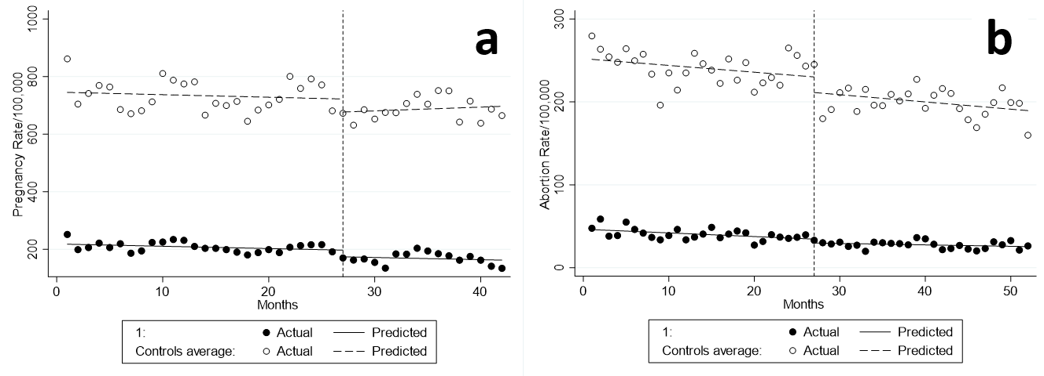
Pre-pandemic period: 1 January 2018-31 March 2020; Pandemic period for pregnancies: 1 April 2020-30 June 2021; for abortions: 1 April 2020-30 April 2022. Adolescents: 13-19 years (• - treated); older women: 20-49 years (○ - controls). Intervention started at month 27.
ITSA: Interrupted time series analysis

Supplementary Table 1 Baseline rates, trends, and changes in pregnancy and abortion rates in adolescents and older women
 | Baseline rateª in older women | Monthly rate change in older women in the pre-pandemic period^{b} | Baseline rateª difference in adolescents compared to older women | Rate difference in adolescents compared to older women in the pre-pandemic period^{b} | Immediate rate change during the 1- month strict lockdown^{c} in adolescents | Monthly rate difference in older women in the pandemic period^{d} compared to the pre-pandemic period^{c} | Additional rate change in adolescents compared to older women during the 1-month strict lockdown^{c} | Additional rate difference in the pandemic period^{d} compared to the pre-pandemic period^{c} in adolescents compared to older women
 | Pregnancies/abortions per 100,000 women | Pregnancies/abortions per 100,000/month (95% CI) | Pregnancies/abortions per 100,000 women (95% CI) | Pregnancies/abortions per 100,000 women (95% CI) | Pregnancies/abortions per 100,000 women (95% CI) | Pregnancies/abortions per 100,000/month (95% CI) | Pregnancies/abortions per 100,000 women (95% CI) | Pregnancies/abortions per 100,000/month (95% CI)
Pregnancies | 744.8 | -0.9 (-4.2 to 2.4) | -527.2 | -0.1 (-3.3 to 3.5) | -45.1 (-102.2 to 12.1) | 2.19 (-2.5 to 7.0) | 21.8 (-40.4 to 84.0) | -2.16 (-7.6 to 3.2)
Abortions | 251.2 | -0.8 (-2.0 to 0.4) | -205.2 | 0.4 (-0.9 to 1.6) | -18.8 (-40.5 to 2.9) | -0.1 (-1.7 to 1.6) | 14.1 (-8.16 to 36.4) | 0.33 (-1.3 to 2.0)

ªJanuary 2018; ^{b}1 January 2018-31 March 2020; ^{c}April 2020; ^{d}for pregnancies: 1 April 2020-30 June 2021; for abortions: 1 April 2020-30 April 2022. Adolescents: 13-19 years; older women: 20-49 years.
CI: confidence interval; ITSA: Interrupted time series analysis

