A robust method for the rapid generation of nanobodies
Zhiqing Tao ^{1,2†}, Huan Wang ^{3†}, Xiaoling Zhao ^{4,5†}, Juan Zhang ⁴, Guosheng Jiang ³, Bin Yu ^{1.2}, Yihao Chen ^{1.2}, Mingjun Zhu ^{1.2}, Junli Long ^{1.2}, Lei Yin ⁶, Xu Zhang ^{1,2}, Maili Liu ^{1,2,7}, Lichun He ^{*1,2}
1. State Key Laboratory of Magnetic Resonance and Atomic Molecular Physics, National Center for Magnetic Resonance in Wuhan, Innovation Academy for Precision Measurement Science and Technology, Chinese Academy of Sciences, Wuhan 430071, China.
2. University of Chinese Academy of Sciences, Beijing, 100049, China.
3. School of Life Science and Technology, Weifang Medical University, Weifang, Shandong 261053, China.
4. Department of Reproductive Medicine, General Hospital of Central Theater Command of the People's Liberation Army, Wuhan, Hubei 430061, China.
5. Qinhe Life Science Ltd. Wuhan 430000, China
6. State Key Laboratory of Virology, Hubei Key Laboratory of Cell Homeostasis, College of Life Sciences, Department of Clinical Oncology, Renmin Hospital of Wuhan University, Wuhan University, Wuhan, Hubei Province, 430072, China.
7. Optics Valley Laboratory, Hubei 430074, China.
* Lichun He: helichun@apm.ac.cn

Supporting Information Text
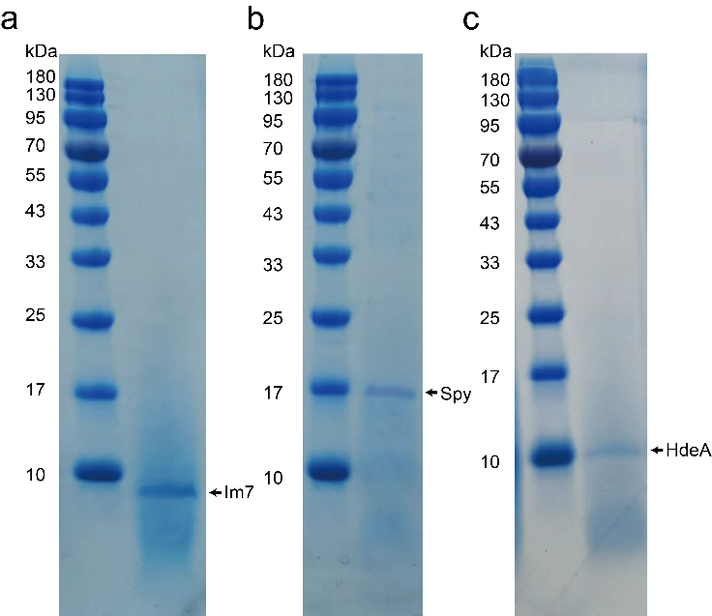

Fig. S1. SDS-PAGE analysis of the secretion of recombinant proteins fused with the pelB signal peptide. a. SDS-PAGE analysis of Im7 protein secreted in the supernatant of the culture medium of E. coli. b. SDS-PAGE analysis of Spy protein secreted in the supernatant of the culture medium of E. coli. c. SDS-PAGE analysis of HdeA protein secreted in the supernatant of the culture medium of E. coli. The supernatant of the cell culture medium was applied for the SDS-PAGE analysis without concentrating.

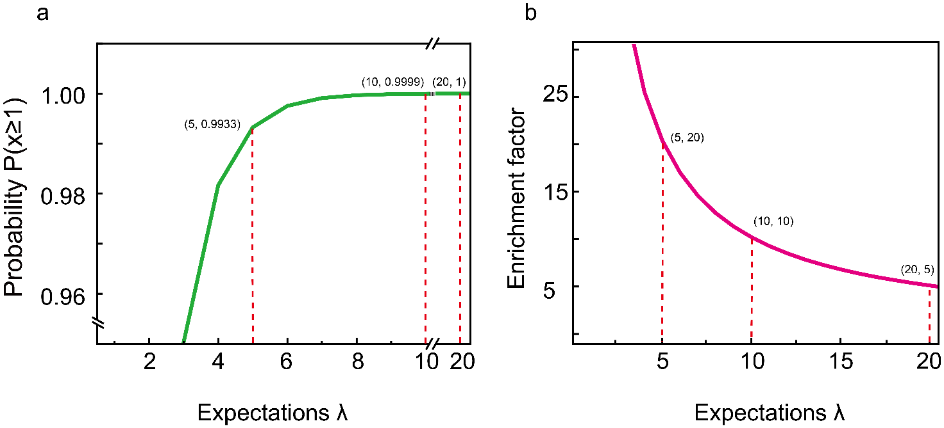

Fig. S2. The theoretical model for the enrichment of positive clones. a. Plot of the probability of at least one positive clone presenting in the division (m) taken from the identified positive well against the value of λ. b. Plot of the enrichment factor against the value of λ.

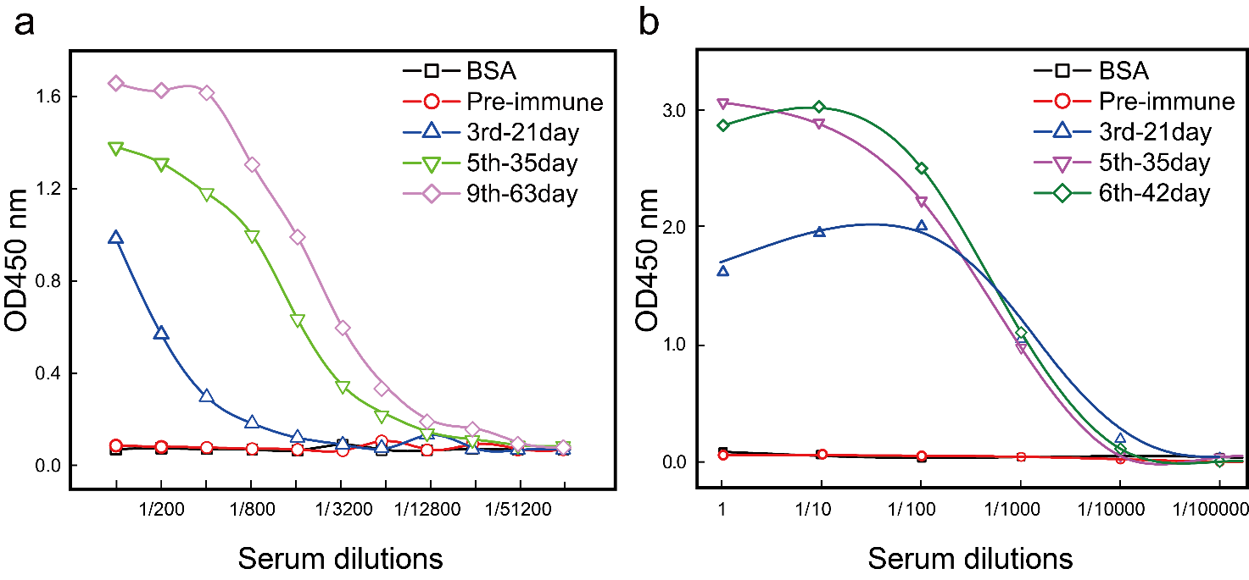
Fig. S3. Assessment of the antibodies in the serum samples from llamas immunized with Pfu DNA polymerase (a) and DR5 (b) by ELISA assays. A secondary rabbit anti-camelid antibody conjugated with the Horseradish peroxidase (HRP) was used for detecting and visualizing the presence of the antigen-specific binding camel antibody.

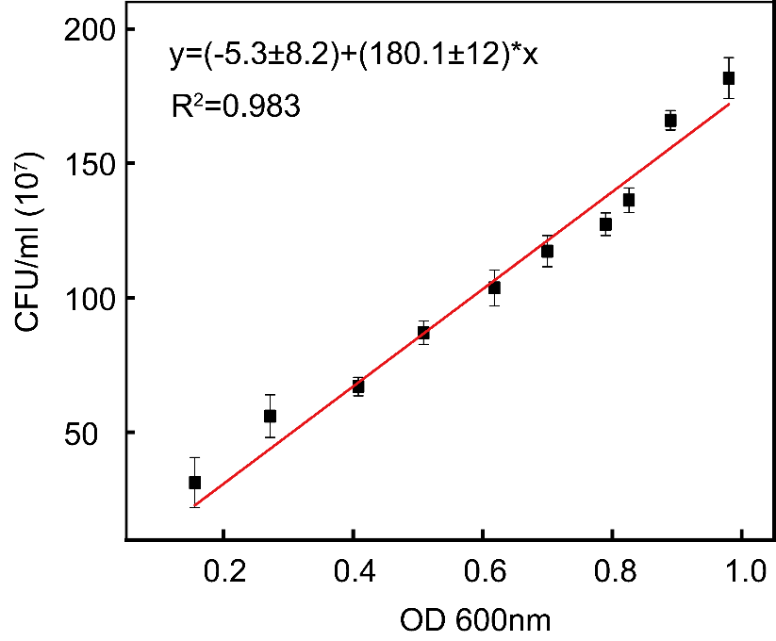
Fig. S4. Standard curve of E. coli number against the value of OD₆₀₀. The number of E. coli and the value of OD₆₀₀ were graphed on the y-axis and x-axis respectively.

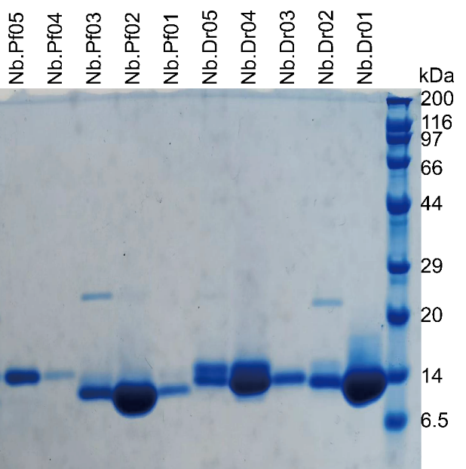
Fig. S5. SDS-PAGE analysis of the elution fraction of each nanobody. 0.1 L supernatant of the cell culture medium of each nanobody was mixed with 1 ml of Ni-NTA beads for 30 mins and then eluted with 5 ml of PBS buffer with 500mM imidazole respectively.

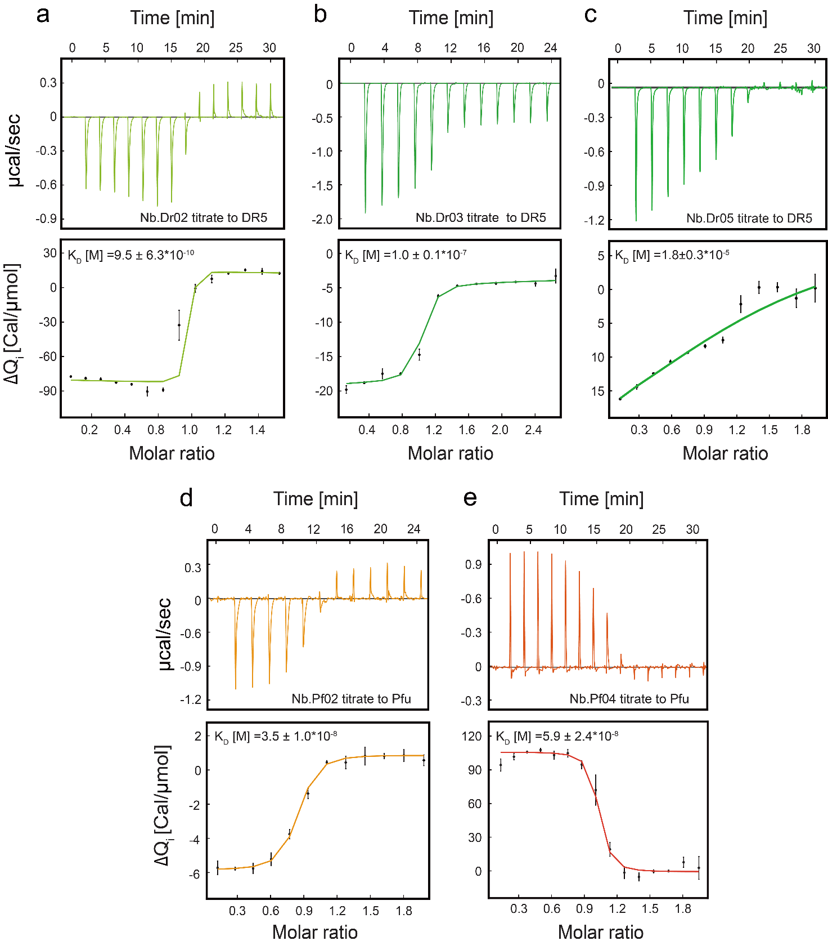
Fig. S6. Determination of the binding affinities of isolated nanobodies. (a-c). Results of ITC measurements of three monoclonal nanobodies Nb.Dr02 (a), Nb.Dr03 (b), and Nb.Dr05 (c) against DR5 protein respectively. (d-e) Results of ITC measurements of two monoclonal nanobodies Nb.Pf02 (d) and Nb.Pf04 (e) against Pfu DNA polymerase respectively. Values of the binding equilibrium constant were indicated on corresponding figures.
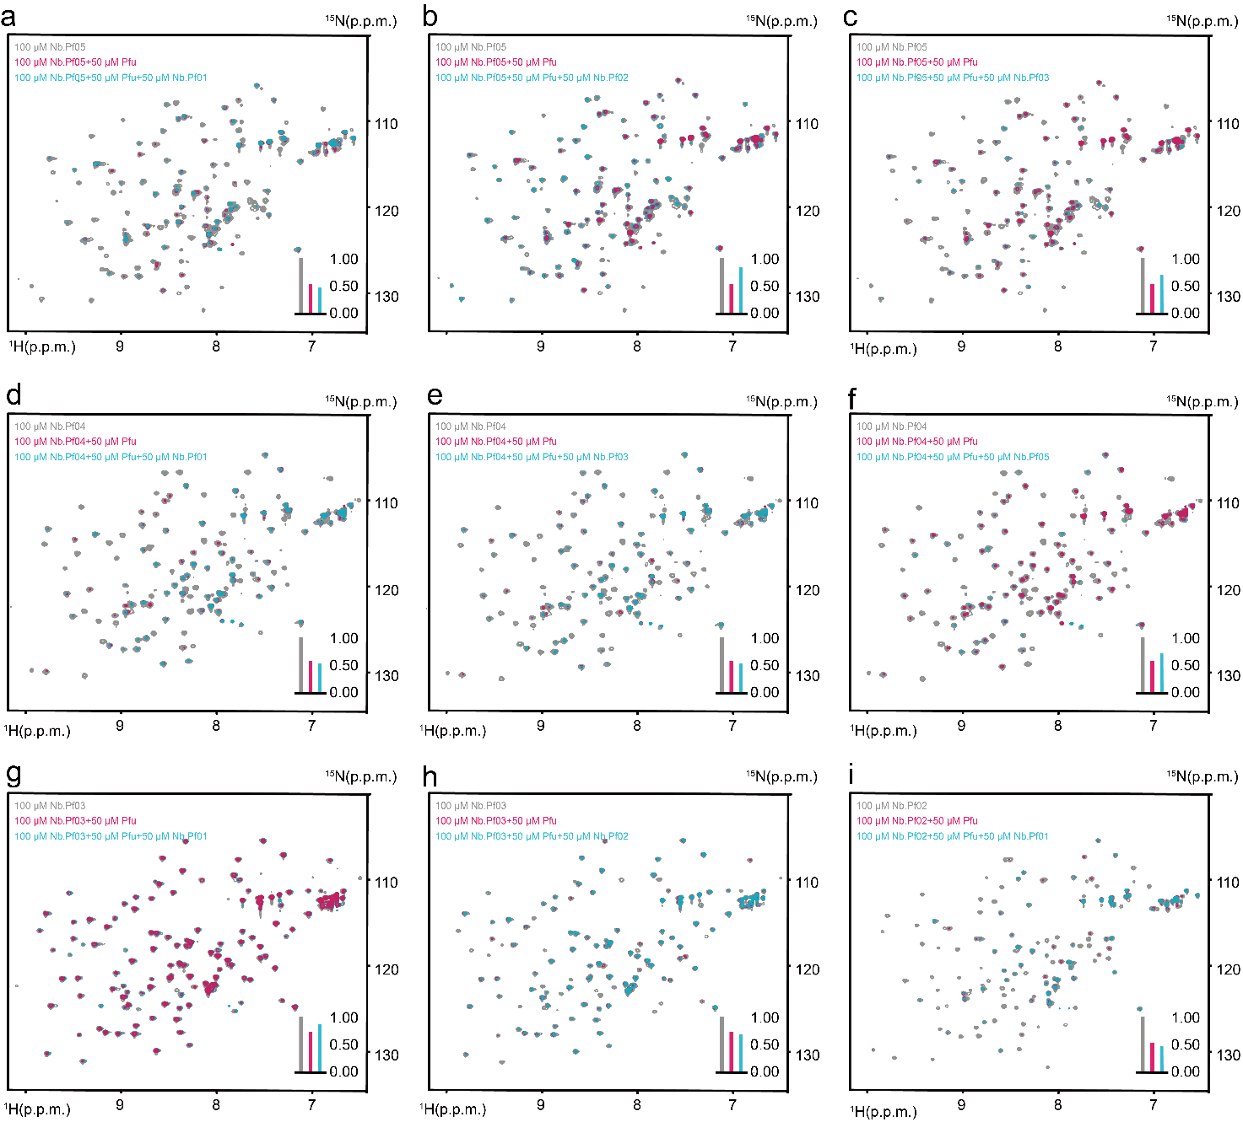
Fig. S7. NMR-based competitive binding assay of different isolated monoclonal nanobodies on Pfu DNA polymerase. ¹⁵N-¹H HSQC spectra were employed to measure the binding of a ¹⁵N labeled nanobody with Pfu DNA polymerase in the presence of a second unlabeled nanobody. (a-i) The mutual competition statuses of every two isolated Pfu DNA polymerase nanobodies were probed. ¹⁵N-¹H HSQC spectrum of the ¹⁵N labeled nanobody was colored in grey. ¹⁵N-¹H HSQC spectrum of the ¹⁵N labeled nanobody in the presence of the Pfu DNA polymerase was colored in magenta. ¹⁵N-¹H HSQC spectrum of the ¹⁵N labeled nanobody in the presence of both Pfu DNA polymerase and a second unlabeled nanobody was colored in cyan. The concentration of each ¹⁵N labeled nanobody was 100 µM. The concentration of Pfu DNA polymerase was 50 µM. The concentration of the second unlabeled nanobody was 50 µM. The bar graph in the bottom right corner of each spectrum illustrated the relative peak intensity. The gray bar indicated the relative peak intensity of the ¹⁵N-¹H HSQC spectrum of ¹⁵N labeled nanobody. The magenta bar indicated the relative peak intensity of the ¹⁵N-¹H HSQC spectrum of ¹⁵N labeled nanobody in the presence of the Pfu DNA polymerase. The cyan bar indicated the relative peak intensity of the ¹⁵N-¹H HSQC spectrum of ¹⁵N labeled nanobody in the presence of both Pfu DNA polymerase and a second unlabeled nanobody. All the spectra were recorded at 25 ℃ on Bruker Avance-600 spectrometers. Data were processed in the same way and displayed with the same contour level. and displayed with the same contour level.

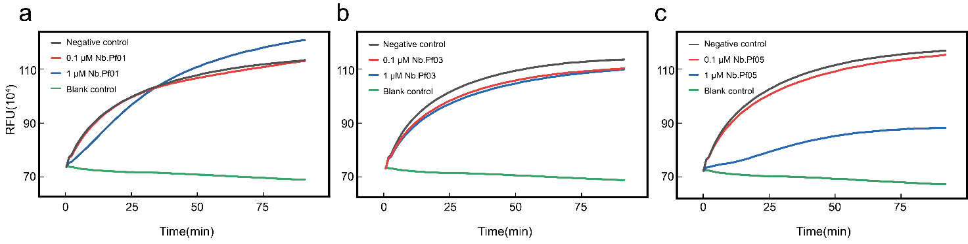
Fig. S8. Assessment of the blocking effect of isolated nanobodies on Pfu DNA polymerase. (a-c) Real-Time Quantitative PCR was employed to verify the block effect of Nb.Pf01(a), Nb.Pf03 (b) and Nb.Pf05 (c). The black line represents the control group with Pfu DNA polymerase. The red and blue lines represent the experimental group with Pfu DNA polymerase and a final concentration of 0.1 µM (red) and 1 µM (blue) of the isolated monoclonal nanobody, respectively. The green line represents the blank group with no Pfu DNA polymerase.

