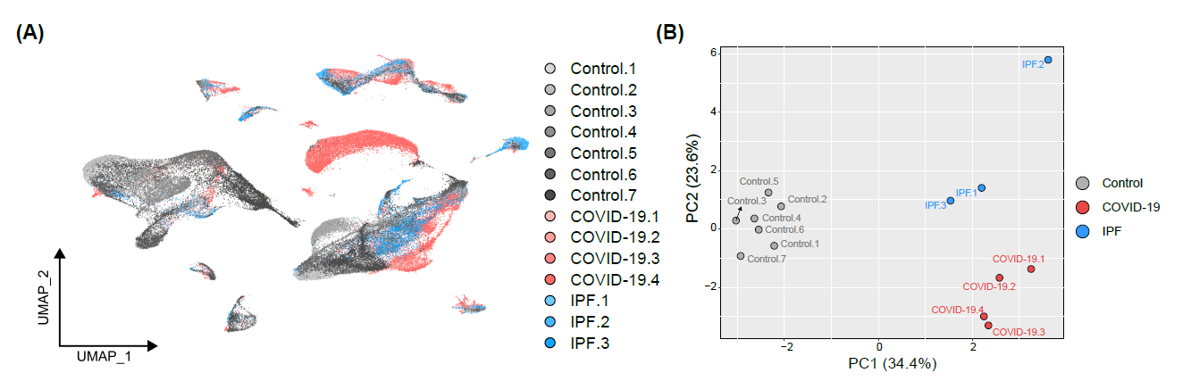
Supplementary Figure 1. Cell fraction of each sample was conserved across disease conditions. (A) UMAP plot grouped by sample and color. (B) PCA of cell fraction ratio for each sample.
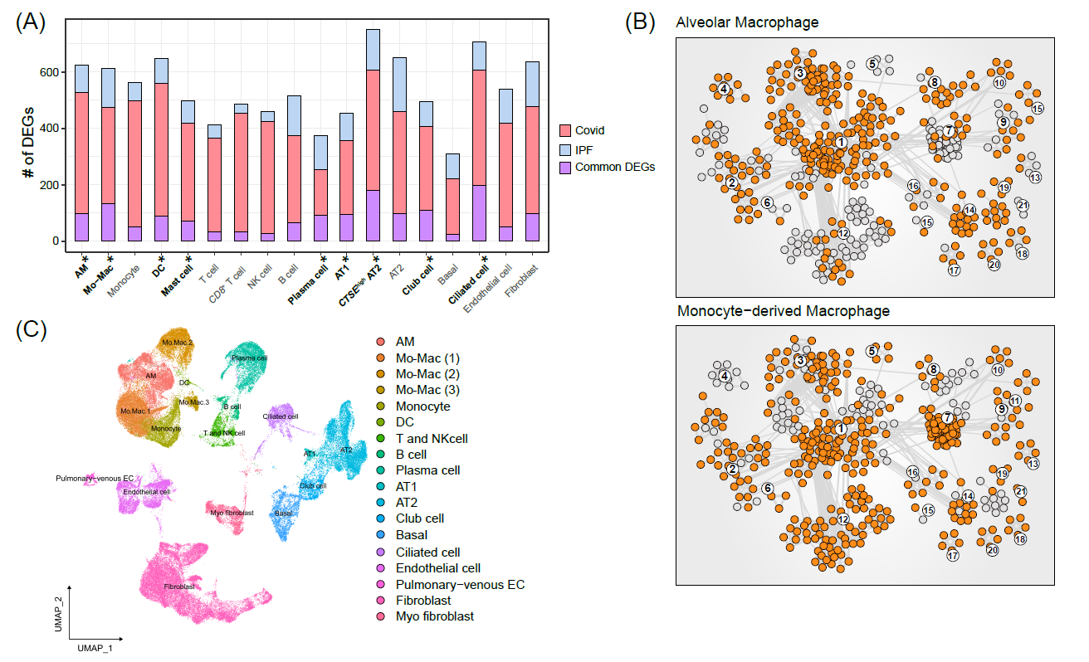
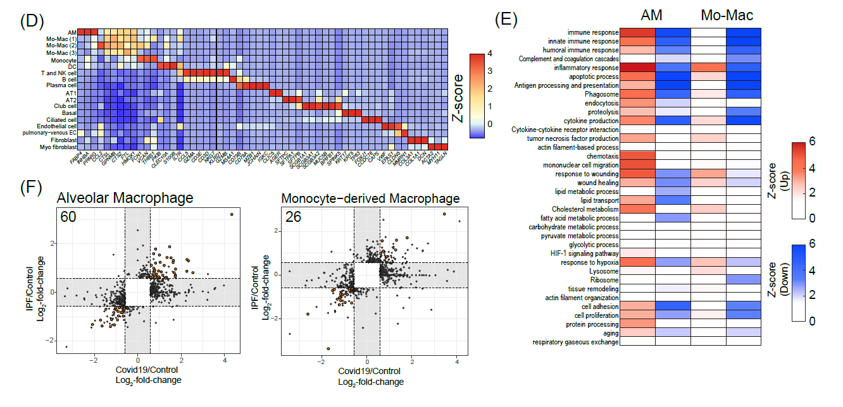
Supplementary Figure 2. Common DEG-mediated alteration of biological pathways was significant in COVID-19. (A) Proportion of common DEGs in 18 cell types in COVID-19 vs. control and IPF vs. control comparisons. Cell types with asterisks have significant numbers of common DEGs according to a permutation test (p < 0.00001). (B) Significant GOBP and KEGG pathway terms in the process network are colored orange for AMs (upper panel) and Mo-Macs (lower panel). (C) UMAP of samples from COVID-19 patients and control donors (GSE158127) used to validate common DEGs. (D) Cell type marker gene expression in COVID-19 patients vs. control donor used for validation. (E) Functional enrichment analyses for AMs and Mo-Macs (1). Each row in the heatmap corresponds to Fig. 2B. (F) In the dot plot, orange represents matched common DEGs in COVID-19 patients vs. control donor used for validation. Numbers of validated common DEGs for each cell type are shown in the upper left panel.

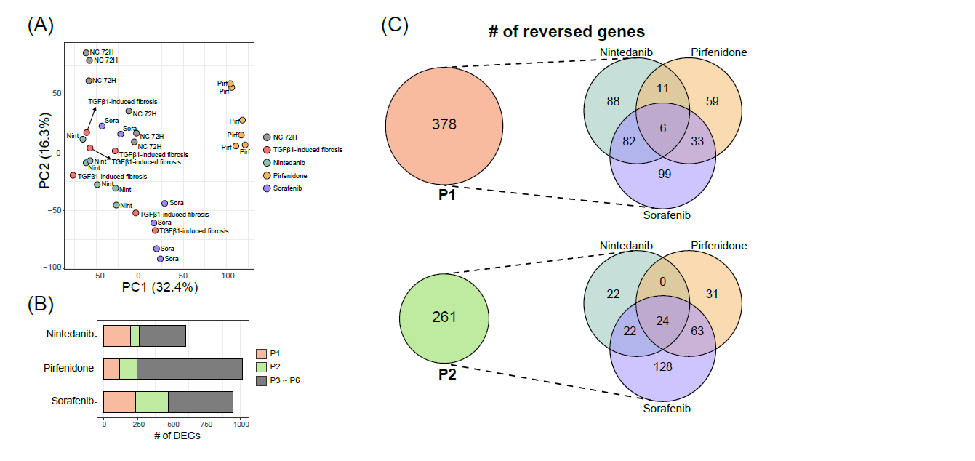
Supplementary Figure 3. Antifibrotic drug-mediated alterations in gene expression reversed TGF-β1-induced fibrosis-mediated gene expression. (A) PCA showing similarities in gene expression among samples. (B) Numbers of reversed genes and DEGs in antifibrotic drug group vs. fibrosis group. (C) Venn diagram showing the occupancy of reversed genes in each antifibrotic drug group. Reversed gene sets are assigned to P1 and P2.
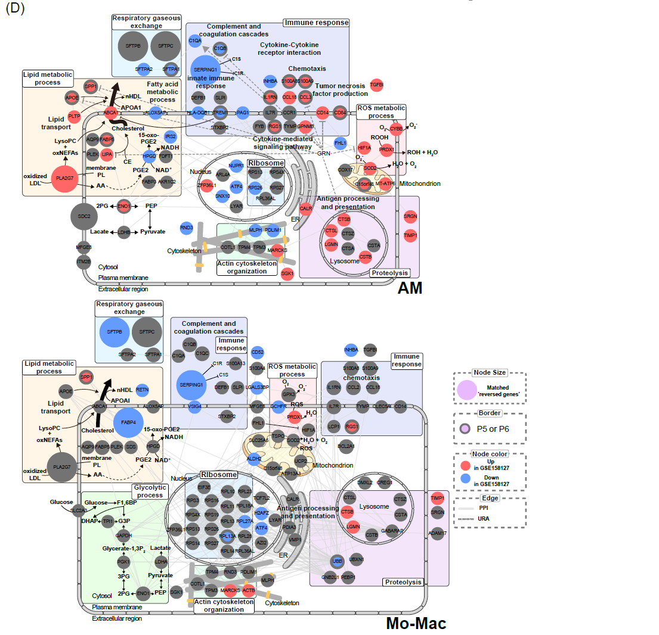
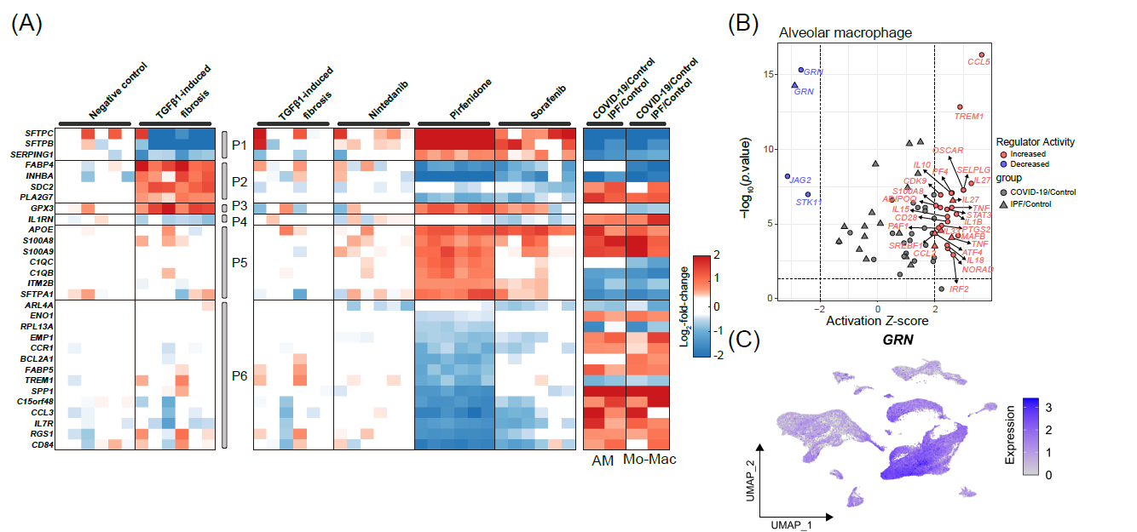
Supplementary Figure 4. Lipid metabolisms is a major target of antifibrotic drugs in COVID-19 and IPF macrophages. (A) Heatmap showing gene expression corresponding to P1–P6 in Fig. 3A. Expression heatmap in rat TGFβ1-induced pulmonary fibrosis model represented in the molecular network. Left and middle panels indicate negative control, TGFβ1-induced fibrosis groups, and antifibrotic drugs groups. Right panel indicates alveolar macrophages and monocyte-derived macrophages in COVID-19 vs. control and IPF vs. control comparisons. (B) Upstream regulator analysis of DEGs in alveolar macrophages COVID-19 vs. control and IPF vs. control comparisons. |Activation Z-score| > ±2 and p < 0.05 were the threshold cutoffs of statistical significance. (C) GRN expression in all cell types based on the scRNA-Seq for COVID-19, IPF, and control donors. (D) Red and blue genes in the molecular network are common DEGs matched to others in the COVID-19 dataset.

