Efficacy and safety of Sanzi-huangshi pill as an adjuvant therapy in lower-risk myelodysplastic syndrome: study protocol for a multi-center randomized controlled trial
The form, color, package and label of investigational manufactured products
Trial Drug Description
Drug Name: Sanzi-huangshi Pills
Usage and Dosage: 3 times a day, 12 capsules each time, take orally after meals.
Storage Conditions: Medicines should be stored in a cool and dry environment.
Production batch number: 20200701
Production date: July 25, 2020
Term of validity: 12 months
Precautions: It is only used for clinical research and must be used under the evaluation and guidance of clinicians
Manufacturer: Shanghai Municipal Hospital of Traditional Chinese Medicine
One sachet containing 12 pills for only one meal
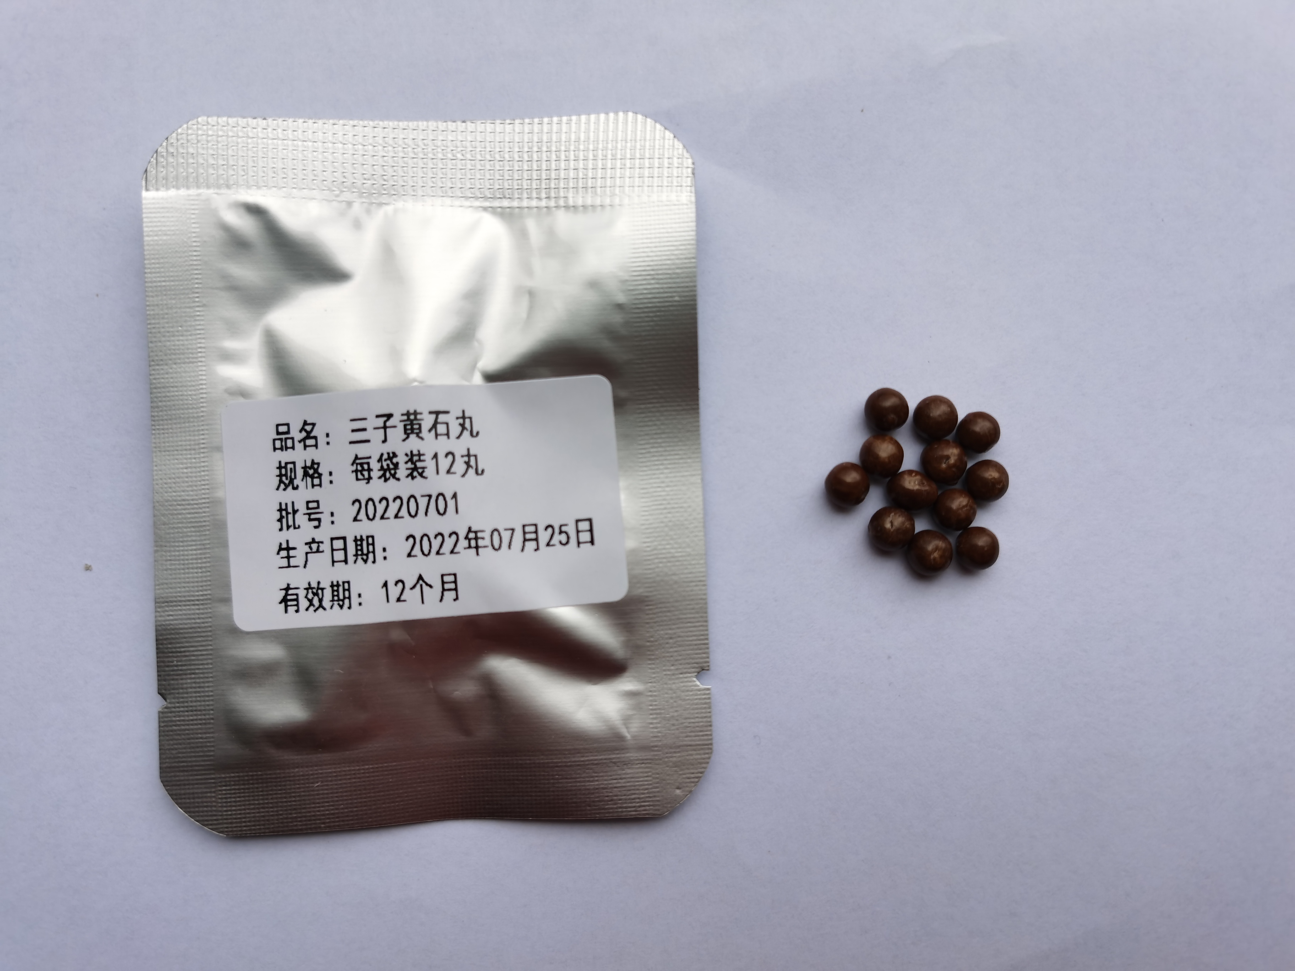

One large bag containing 21 sachets of pills for 21 times in 7 days
