Extended Data Figures

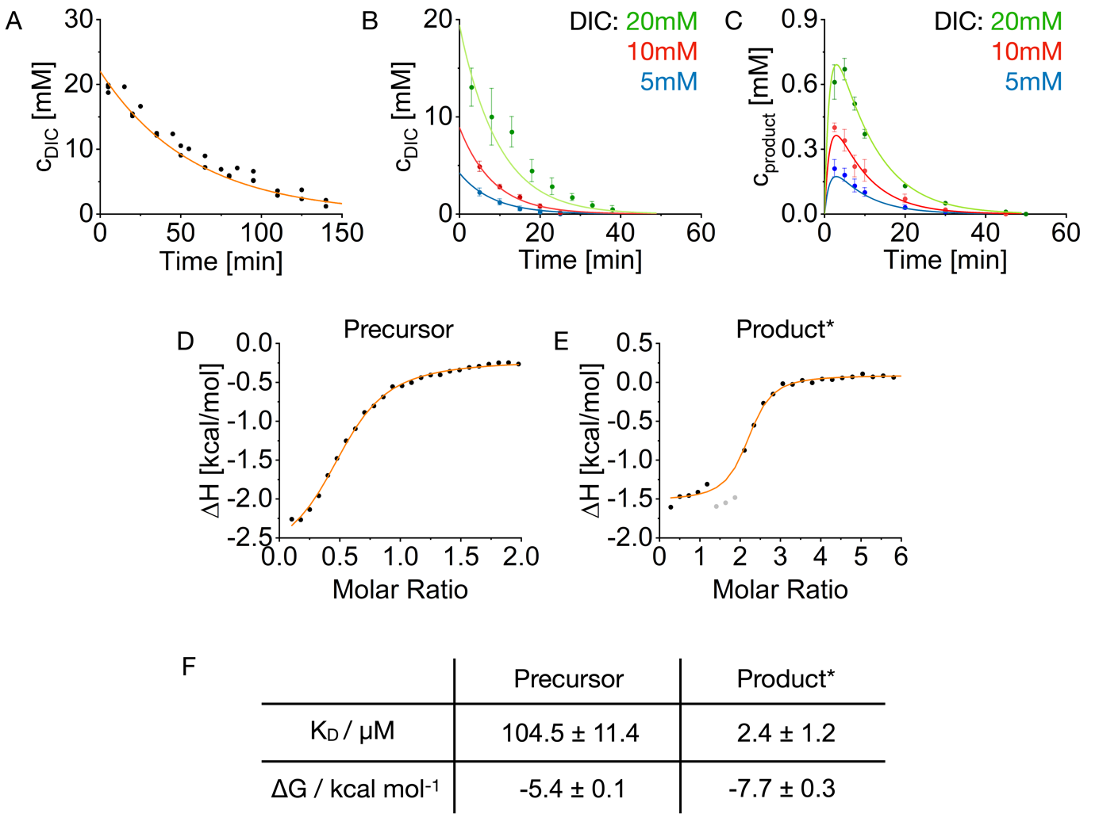
Extended Data Fig. 1. Determination of the reaction constants and binding affinities.
A. Kinetics of 20 mM DIC hydration in 200 mM MES buffer at pH 5.3 measured by NMR. B. Kinetics of the DIC hydration catalyzed by the precursor. Conditions were 10 mM precursor and 200 mM MES at pH 5.3. Error bars represent the standard deviation of triplicate measurements (N=3). Solid lines represent the fits of the kinetic model. C. Formation of the product upon addition of DIC measured by HPLC. Conditions were 10 mM precursor and 200 mM MES at pH 5.3. Error bars represent the standard deviation of triplicate measurements (N=3). Solid lines represent the fits of the kinetic model. D-F. The change in enthalpy measured by ITC for the interaction between precursor (D) or product* (E) and pSS. Gray data points were not included in the fitting because they showed signs of coacervation. The solid lines represent the fit of the PEAQ-ITC Analysis software. F. Dissociation constant K_{D} and free energy ΔG of the interaction between precursor/product* and pSS.

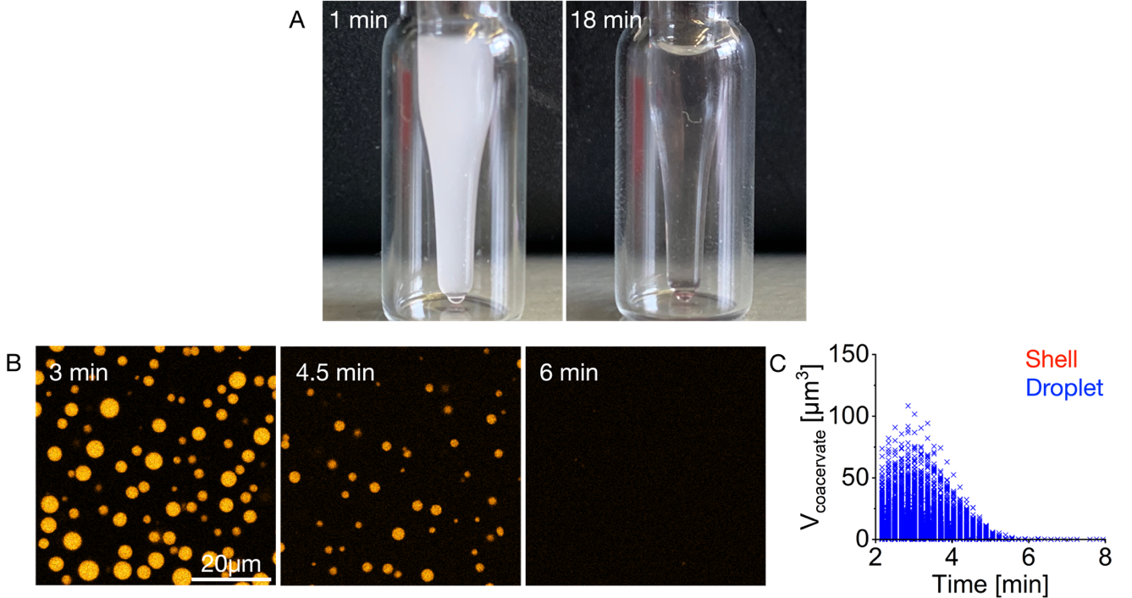
Extended Data Fig. 2. Batch fueling of active droplets. A. Images of an HPLC inlet containing a solution of 22 mM precursor, 12 mM pSS, and 0.1 µM sulforhodamine B in 200 mM MES buffer at pH 5.3 fueled with 20 mM DIC. After adding the fuel, the sample turned turbid (1 min), and a clear solution was obtained again after 18 min. B. Confocal microscopy of a solution from A with 0.1 µM sulforhodamine B and fueled with 10 mM DIC. The active droplets grew and fused initially, but their size stayed below the size of the active droplets fueled with 20 mM DIC (Fig. 1B,C). After around 4 min, they started to dissolve without forming spherical shells. Imaging was done in PVA-coated ibidi chambers. C The volume of each active droplet (blue) is plotted for each time point. No spherical shells (red) were observed. Experiments were performed in triplicate (N=3).

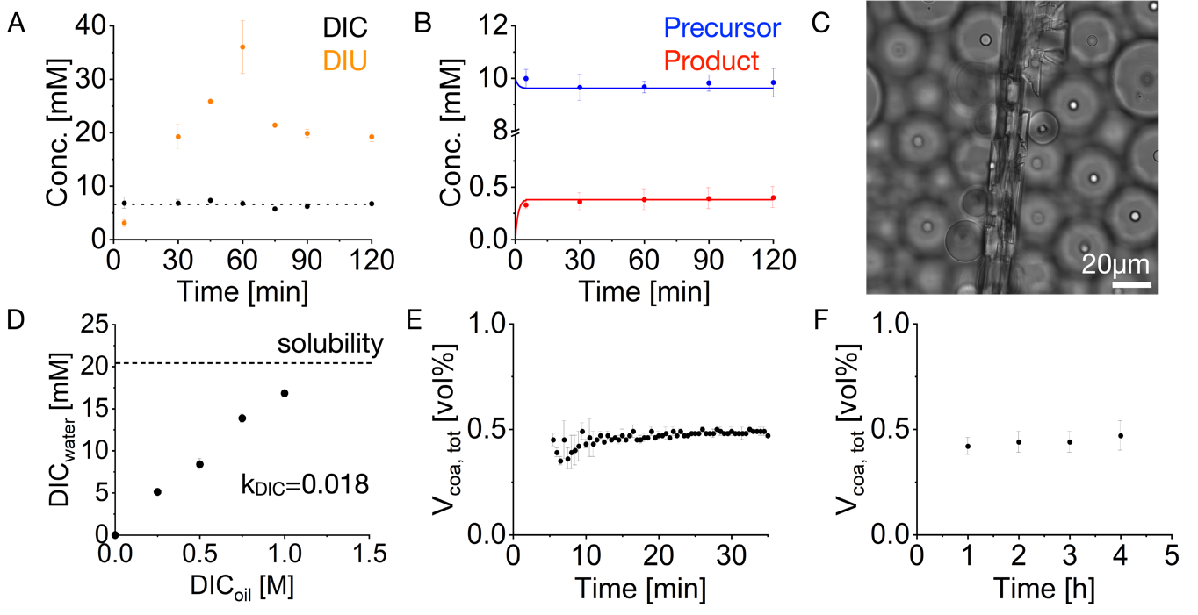
Extended Data Fig. 3. Total coacervate volumes and reactant concentrations in a steady state. A. DIC (fuel) and DIU (waste) concentrations under steady-state conditions were determined by NMR. Conditions were 10 mM precursor and 200 mM MES at pH 5.3. To achieve a steady state, perfluorinated oil containing 0.5 M DIC was added to the aqueous phase. The dotted line represents the average DIC concentration of 6.6 mM. Error bars represent the standard deviation of triplicate measurements (N=3). B. Analytical HPLC determined average precursor and product concentrations under steady-state conditions. Conditions were 10 mM precursor and 200 mM MES at pH 5.3. To achieve a steady state, perfluorinated oil containing 0.5 M DIC was added to the aqueous phase. Error bars represent the standard deviation of triplicate measurements (N=3). Solid lines represent the steady-state concentration of DIC calculated by the kinetic model (see methods I.F and I.G) of 6.6 mM. C. A representative bright field image of a DIU crystal formed in the oil phase during a steady-state experiment. D. The dependency of the DIC concentration in the oil phase on the DIC concentration in the aqueous phase. The aqueous phase consisted of 200 mM MES at pH 5.3, and the oil phase of Novec 7500 perfluorinated oil. The dotted line represents the DIC concentration in the aqueous phase if an excess of pure DIC was added on top of the aqueous phase without the oil phase. The average partitioning coefficient of DIC between the aqueous phase and the oil phase was k_{DIC} = 0.018. Error bars represent the standard deviation of triplicate measurements (N=3). E. Total coacervate volume in one microfluidic reactor in the first 30 min after adding fuel. Conditions were 10 mM precursor, 5 mM pSS, and 200 mM MES at pH 5.3 with 0.5 M DIC. F. Average total coacervate volume of different microfluidic reactors over 4 h. Conditions were the same as in E. Error bars represent the standard deviation of at least 30 measurements spread over 3 independent experiments.

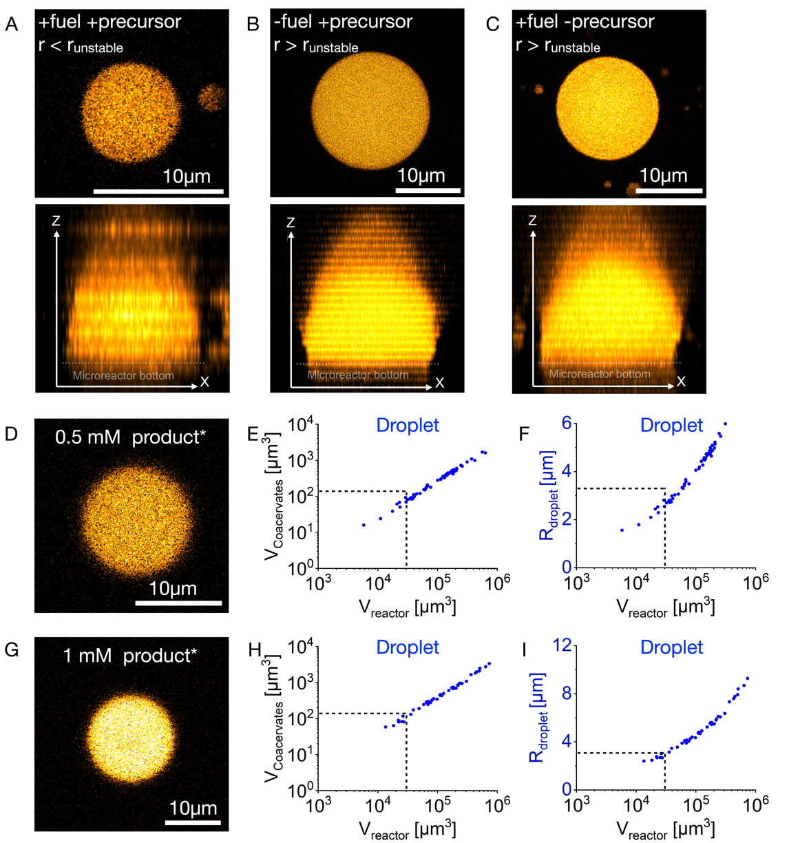

Extended Data Fig. 4. Wetting of active and passive droplets without transitioning into a shell. All experiments were performed in microfluidic reactors. 5 mM pSS, 200 mM MES at pH 5.3, and 0.1 µM sulforhodamine B as a dye were used. A-C The upper row of images shows the XY-plane at the center of the droplet to demonstrate that no spherical shell was formed. The bottom row of images shows the XZ-projection of the active/passive droplet to demonstrate the wetting at the bottom of the microreactor. A. A representative active droplet with r < r_{unstable} is shown 6 h after adding fuel. In addition to the abovementioned conditions, the sample contained 10 mM precursor, and 0.5 M DIC was added to the oil phase to achieve a steady state. B. A representative passive droplet with r > r_{unstable} is shown 6 h after the induction of droplet formation. Conditions were 9 mM precursor, 1 mM product* with no DIC in the oil phase. Additionally, 1 w% Krytox 157 FSH was added to the oil phase. C. A representative passive droplet with r > r_{shell} is shown 6 days after the induction of droplet formation. These passive droplets consist only of product* and pSS without the precursor. Since the added fuel cannot react with the product*, these droplets are thus passive. Conditions were 0 mM precursor, 2 mM product* with 0.5 M DIC in the oil phase to achieve a steady state. D-I. Images were acquired 4 h after the induction of droplet formation. Dashed lines represent the container size, coacervate volume, and size upon which spherical shell formation was observed for active droplets. All experiments were performed in triplicate (N=3). D-F. Conditions were 9.5 mM precursor and 0.5 mM product*. G-I. Conditions were 9 mM precursor and 1 mM product*. To show that passive droplets do not transition into shells, a micrograph of a representative passive coacervate-based droplet (D, G), the volume of the total coacervate material (E, H) for every individual microreactor, and the radius (F, I) of the passive droplet in every individual microreactor is shown.
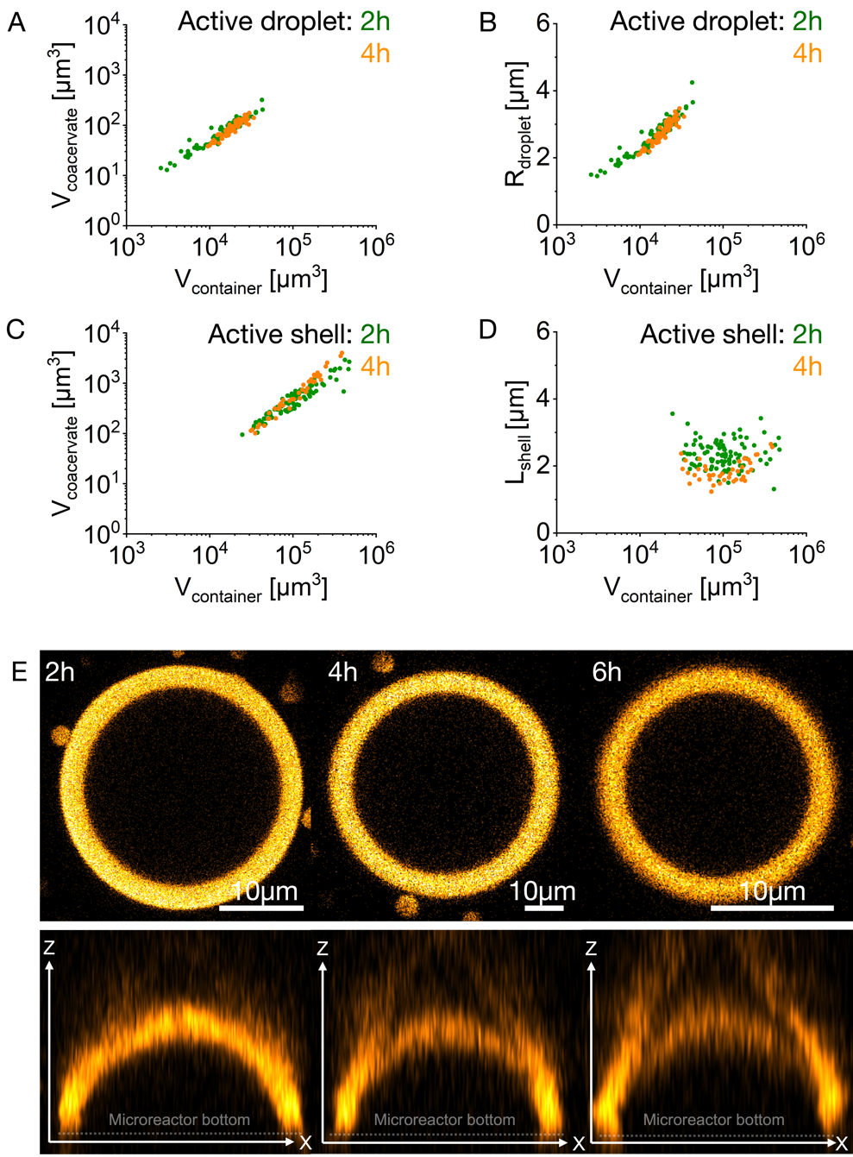

Extended Data Fig. 5. Stability of active spherical shells. All experiments were performed in microreactors. Conditions were 10 mM precursor, 5 mM pSS, and 200 mM MES at pH 5.3 with 0.1 µM sulforhodamine B. 0.5 M DIC was added to the oil phase to achieve a steady state. A, C. The volume of the total coacervate material 2 h and 4 h after the induction of coacervation is shown for every individual microreactor that contained an active droplet (A) or an active shell (C). The volume of active droplets and active shells, as well as the threshold upon which shells were formed, did not change between 2 h and 4 h. B, D. The radius of the active droplet (B) as well as the shell thickness L_{shell} of the active shell (D) in every individual microreactor is shown 2 h and 4 h after the induction of coacervation. The radius of active droplets and L_{shell} of active shells, and the threshold upon which shells are formed did not change between 2 h and 4 h. All experiments were performed in triplicate (N=3). E. A representative active shell 2 h, 4 h, and 6 h after the induction of coacervation. In the upper row, the XY-plane of an active shell is shown, and in the bottom row, the XZ-plane through the middle of the 3D projection of the respective active shell is shown.

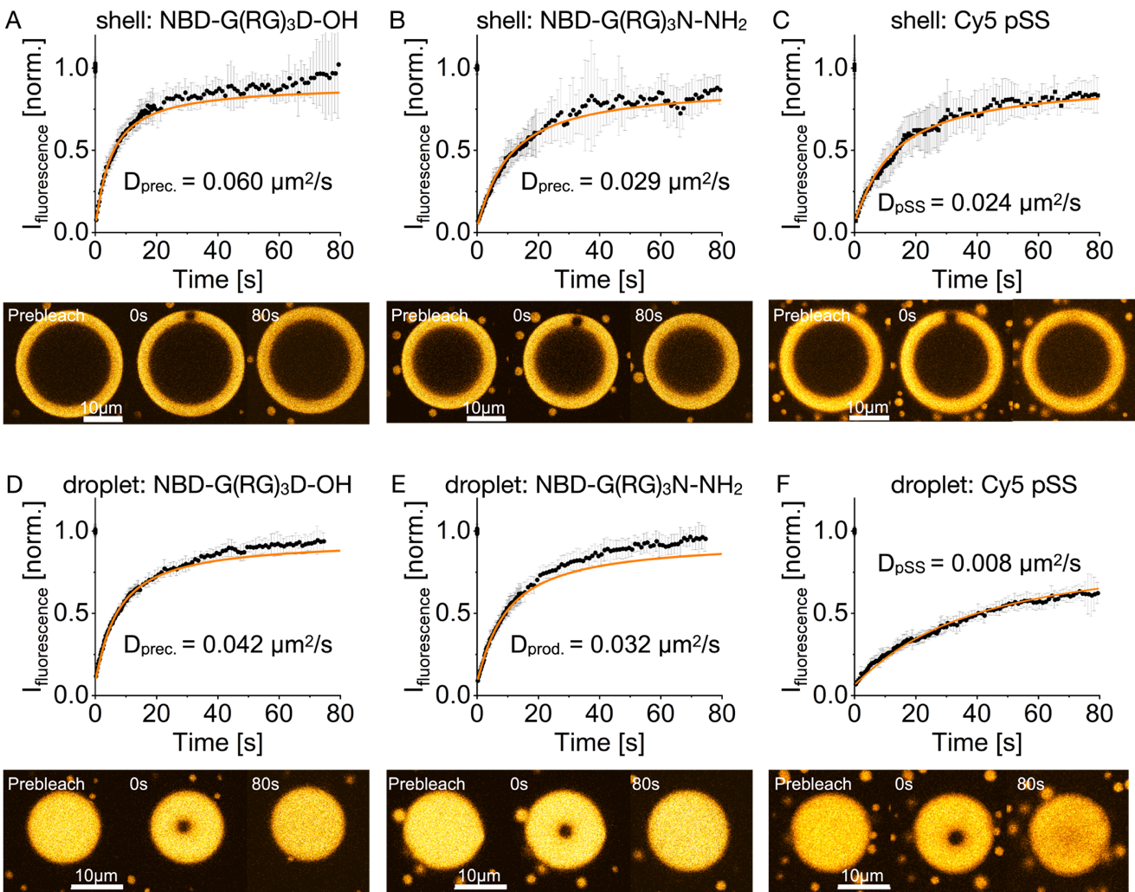
Extended Data Fig. 6. FRAP of active droplets and active spherical shells. All experiments were performed in microreactors. Conditions were 10 mM precursor, 5 mM pSS, and 200 mM MES at pH 5.3 with 1 µM of the respective dye. 0.5 M DIC was added to the oil phase to achieve a steady state. Error bars represent the standard deviation of 10 different measurements (N=10). The time series shows the fluorescence recovery of a representative active shell. A-C. FRAP of the labeled precursor (A), labeled product* (B), and labeled pSS (C) shells 3 h after the induction of coacervation. D-F. FRAP of the labeled precursor (D), the labeled product* (E), and of the labeled pSS (F) active droplets 1 h after the induction of coacervation. Active droplets were imaged before they transitioned into a spherical shell.

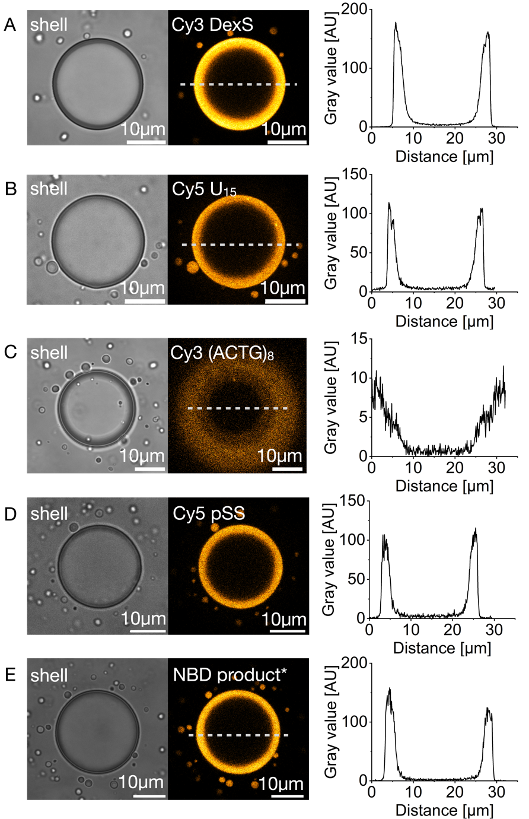

Extended Data Fig. 7. Partitioning of fluorescent molecules into the active spherical shells. Conditions were 10 mM precursor, 5 mM pSS, and 200 mM MES at pH 5.3 with 1 µM of the respective dye. 0.5 M DIC was added to the oil phase to achieve a steady state. Active spherical shells were imaged 3 h after the induction of coacervation. A-E. Bright-field image of an active shell containing Cy3 labeled dextran sulfate (Cy3 DexS, excitation at 552 nm, A), Cy5 labeled 15-mer of oligouridylic acid (Cy5 U₁₅, excitation at 638 nm, B) Cy3 labeled (ATCG)₈ (Cy3 (ATCG)₈, excitation at 552 nm, C), Cy5 labeled pSS (Cy5 pSS, excitation at 638 nm, D), and NBD labeled product* (excitation at 488 nm, E). The line profile of the fluorescence along the dotted line is shown.

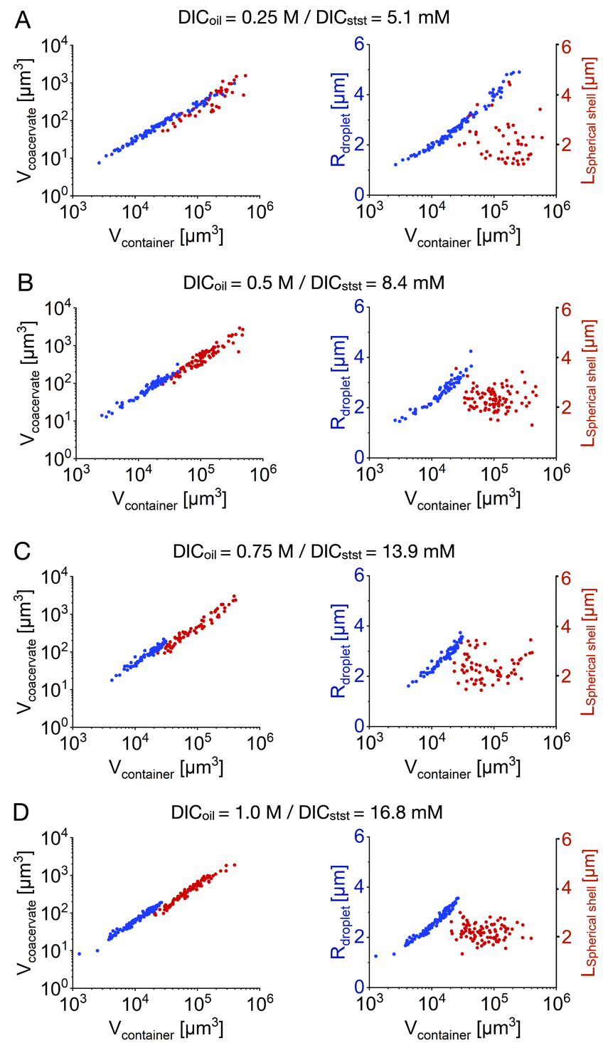

Extended Data Fig. 8. Spherical shell formation with varying fuel concentrations. Conditions were 10 mM precursor, 5 mM pSS, and 200 mM MES at pH 5.3 with 0.1 µM sulforhodamine B. The indicated amount of DIC_{oil} was added to the oil phase to achieve a steady-state concentration of DIC_{stst} in the microfluidic reactors. After forming the spherical shells, active droplets and shells were measured at 0.5 h. A-D. Left: The volume of the total coacervate material is shown for every individual microreactor that contained an active droplet (blue) or an active shell (red). Right: The radius of the active droplet (blue) and the shell thickness L (red) of the active shell in every individual microreactor is shown. All experiments were performed in triplicate (N=3).

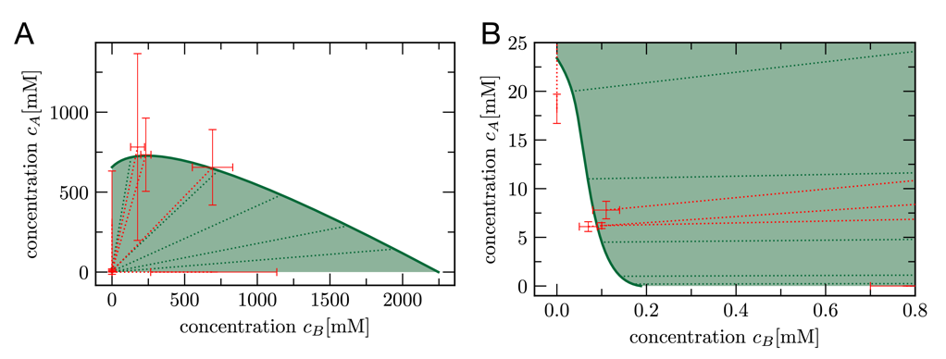

Extended Data Fig. 9. Phase diagram. A-B. Five independent measurements (red data points with error bars) of different phase equilibria were used to fit the binodal line (solid green line) where two phases can coexist. The two corresponding concentration measurements are connected by a red dotted line, while the green dotted lines show a representative selection of tie lines of the model.

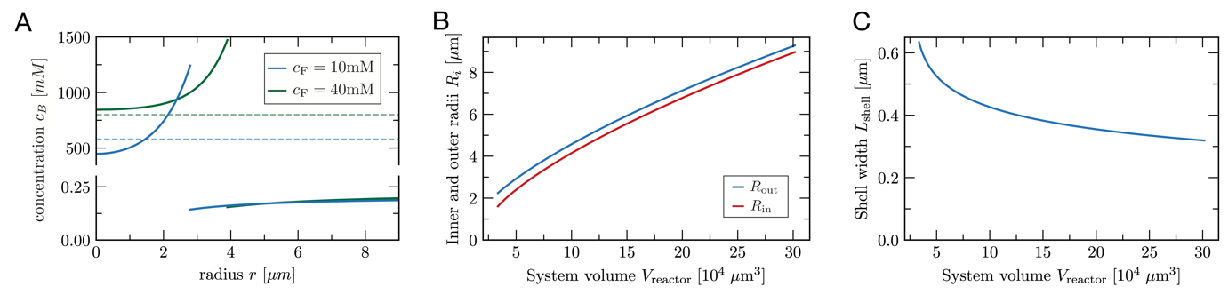
Extended Data Fig. 10. Influence of different parameters on the spinodal instability at the droplet core and the shell width. A. Influence of fuel concentration on spinodal instability at the droplet's core. Radial concentration profiles for two different fuel concentrations are shown. For the lower fuel concentration (blue), the core of a droplet reaches the spinodal concentration (blue dashed). The stationary droplet is larger for the higher fuel concentration (green). However, the concentration at the core stays above the corresponding spinodal concentration (green dashed) due to weaker gradients resulting from a higher activation inside. For systems with high fuel concentrations, the precursor $A$ gets activated and forms the product $B$ inside the droplet. B-C. Influence of the system size on the shell width. Both interface radii increase as a function of system volume (B), but despite the 400 % increase of both radii, the distance between them $L_{shell}=R_{out}-R_{in}$ decreases only by 30 % (C).

