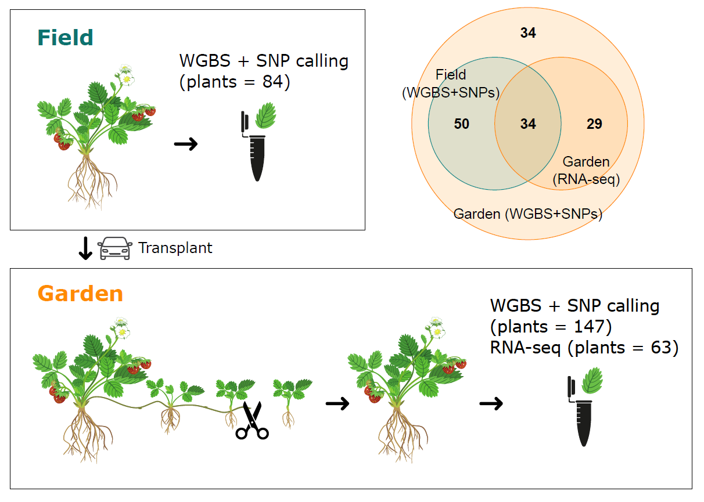
Supplementary figures

Figure S1: Experimental design. We performed whole genome bisulfite sequencing (WGBS) and inferred single nucleotide polymorphisms (SNPs) from these data from leaf tissue collected from 84 plants belonging to 21 populations grown in their wild conditions (field, top). We transplanted 147 plants (7 plants per population) in a common garden (bottom), where we clonally propagated them for one year. For all the plants, we performed WGBS and inferred SNPs from leaf tissue of adult clonal offspring of at least the third generation, and RNA-sequencing for 63 individuals (3 plants per population). The Venn diagram shows the overlap between the number of field (blue) and garden (orange) samples used for WGBS and SNP calling, and the garden samples used for RNA-sequencing.
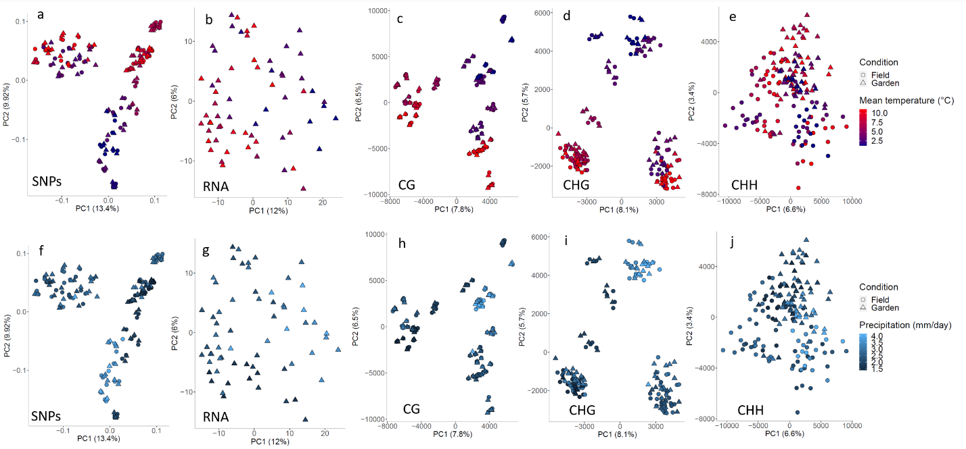

Figure S2: Principal component analysis (PCA) for genetic variants (SNPs), gene expression (RNA) and DNA methylation colored by mean temperature (a-e) and precipitation (f-j). SNPs (a, f), gene expression (b, g), and CG (c, h), CHG (d, i) and CHH (e, j) methylated positions. For SNPs and methylated positions, field plants: n = 84, garden plants: n = 84. For gene expression, garden plants: n = 63.

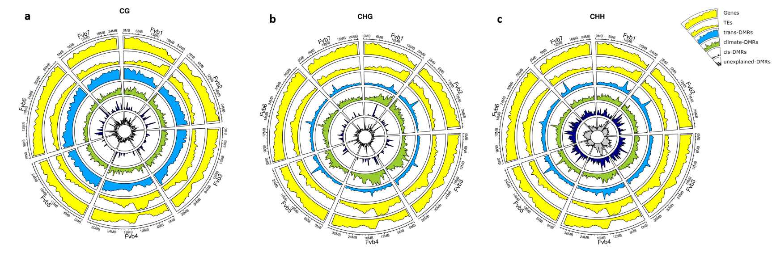
Figure S3: Distribution of the strongest differentially methylated region (DMR) predictor in the garden. Circos plots showing the density of garden-DMRs, genes and TEs for all the chromosomes (Fvb) in the CG (a), CHG (b) and CHH (c) contexts. From outer to inner circles: gene and TE annotations (yellow), predicted DMRs in trans (light blue), climate-predicted DMRs (green), predicted DMRs in cis (dark blue) and unexplained DMRs (grey). DMRs where all the three predictors failed to explain >10% of the variance are classified as “unexplained”.

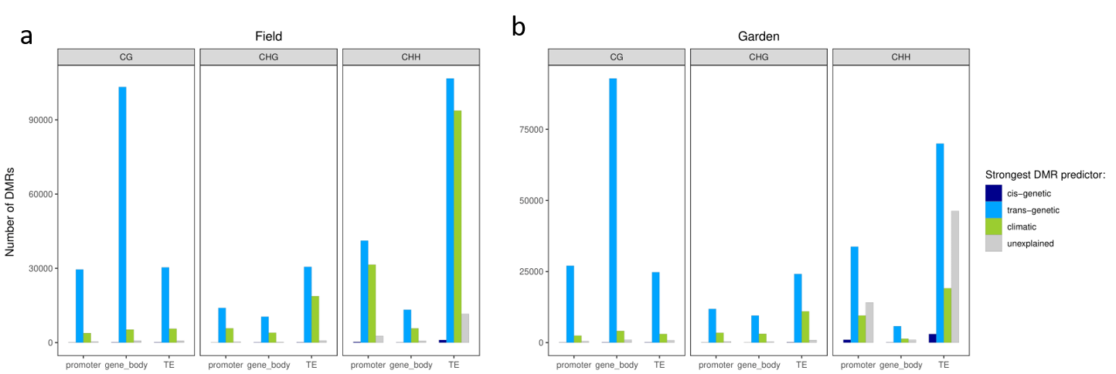

Figure S4: Number of cis-, trans-, climate-predicted and unexplained DMRs overlapping gene promoters, gene bodies or transposable elements (TEs). (a) Field plants: n = 84. (b) Garden plants: n = 84.

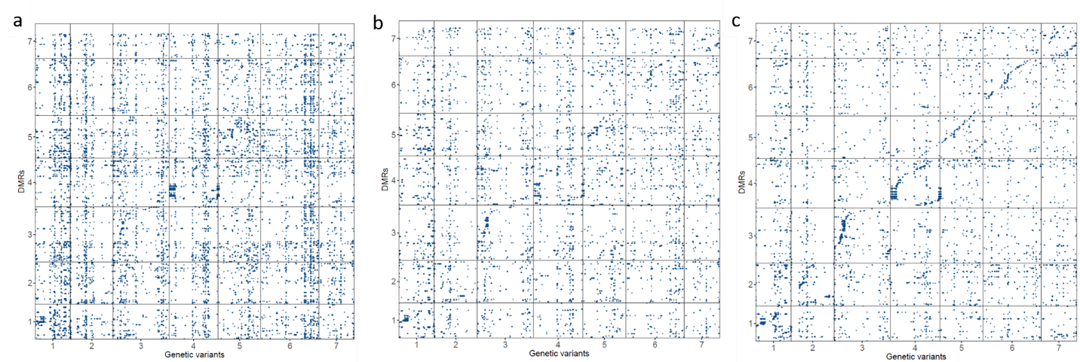
Figure S5: Dot plots for genome-wide association (GWA) analyses for climate-predicted DMRs overlapping promoters. (a) CG-, (b) CHG- and (c) CHH-DMRs. For each DMR, only SNPs significantly associated upon Bonferroni correction are plotted. The analysis was performed using all the available garden plants (n = 147).

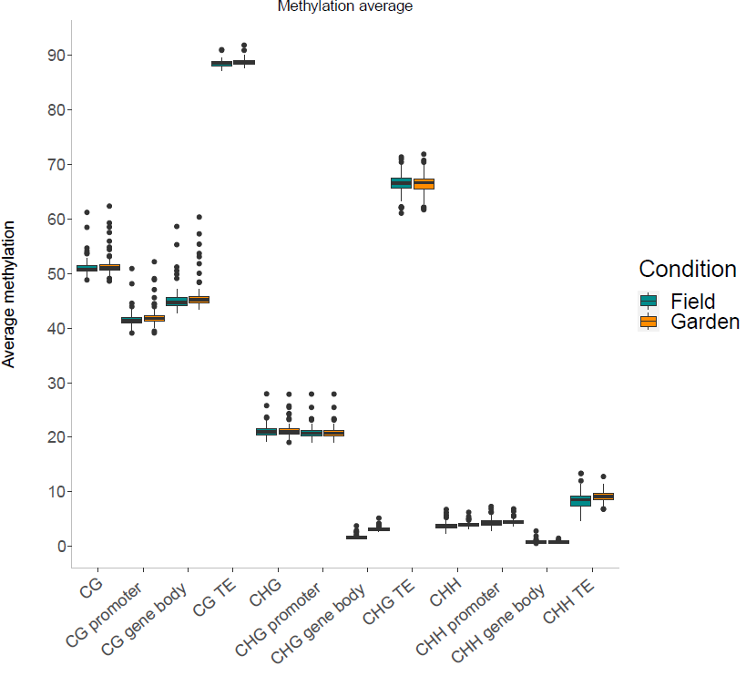
Figure S6: Boxplots showing methylation distribution across different genomic features for field and garden conditions. CG, CHG and CHH: genome-wide methylation levels in the three sequence contexts.

