Supplementary Figure 1
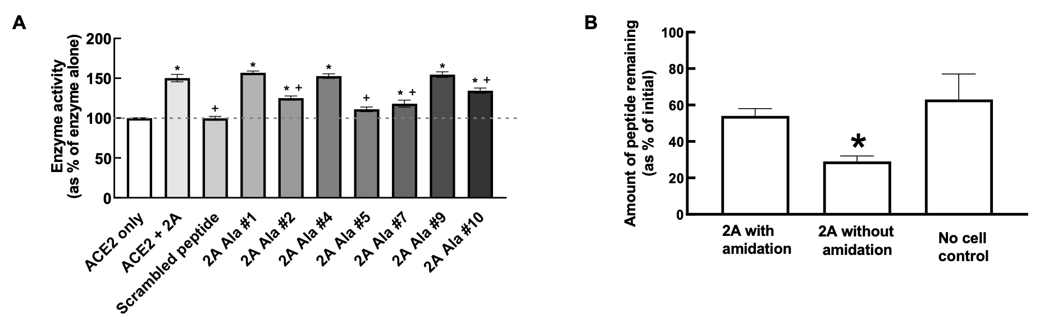
Supplementary Figure 1: (A) Alanine (Ala) substitutions on ACE2 activity (horizontal dashed line indicates ACE2 activity alone; significantly different compared to ⁺ACE2 +2A or *ACE2 alone, one-way ANOVA followed by Tukey’s post-hoc test, P<0.05; n=5. (B) Relative amounts of 2A remaining in HEK293 cells, *significantly different compared to 2A with amidation, (n=4-5; P=0.01; unpaired t-test). Data are mean ± SEM. Abbreviations are as for Figure 1.

Supplementary Figure 2
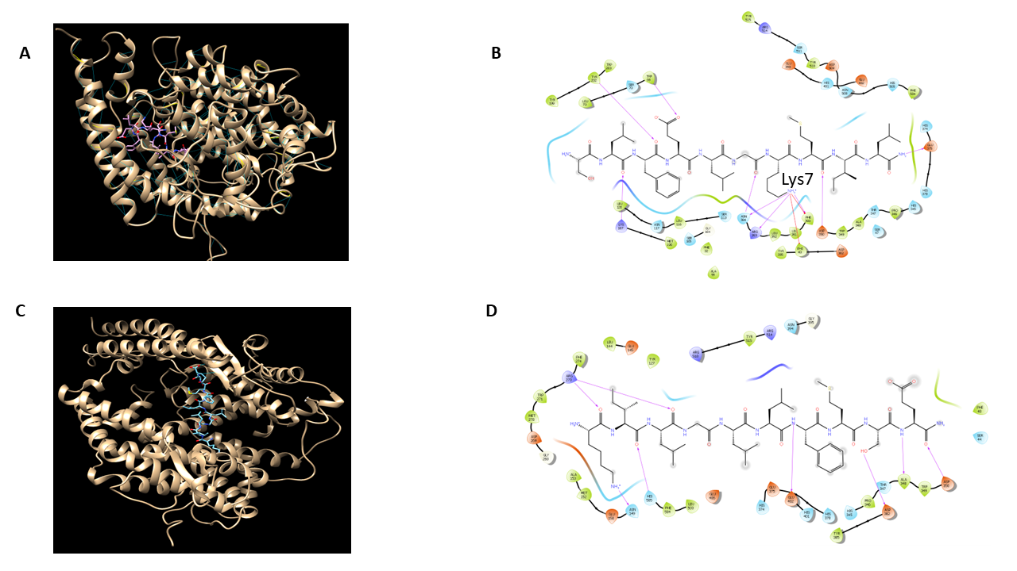
Supplementary Fig 2: (A) predicted hydrogen bond pairing between 2A/ACE2 (B) predicted ligand interaction diagram for 2A/ACE2, (B) predicted hydrogen bond pairing between scrambled peptide/ACE2 and (C) predicted ligand interaction diagram for ACE2/scrambled peptide.
Supplementary Figure 3
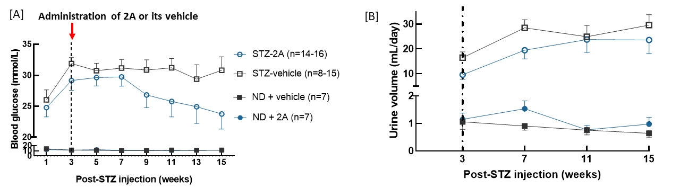

Supplementary Figure 3: 2A prevented the increase in blood glucose levels and loss of body weight in type 1 diabetic mice. (A) Blood glucose levels post-STZ injection in ND-vehicle (n = 7), ND-2A (n = 7), STZ-vehicle (n = 8-15), and STZ-2A mice (n = 14-16), (B) 24-hour urine volume in all cohorts over 3 months treatment period. Vertical dotted line indicates when treatment with 2A or vehicle commenced. Abbreviations: ND: non-diabetic; STZ: streptozotocin.

Supplementary Figure 4
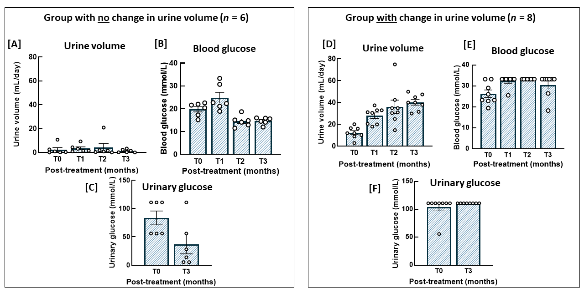
Supplementary Figure 4: 2A is more effective in dampening the increase in blood glucose levels when baseline blood glucose levels are low. (A) Urine volume, blood glucose levels and urinary glucose levels between pre-treatment (T0 months; mice have established diabetes but immediately prior to starting 2A treatment) and post-treatment (T3 months; mice received treatment for 3 months) in STZ-2A mice (n = 6) where urine volume did not change from T0 to T3. (B) Urine volume, blood glucose levels and urinary glucose levels between pre-treatment (T0 months; mice have established diabetes but immediately prior to starting 2A treatment) and post-treatment (T3 months; mice received treatment for 3 months) in STZ-2A mice (n = 8) where urine volume did increase from T0 to T3. Data are mean ± SEM. Individual points indicate different animals.

Supplementary Figure 5
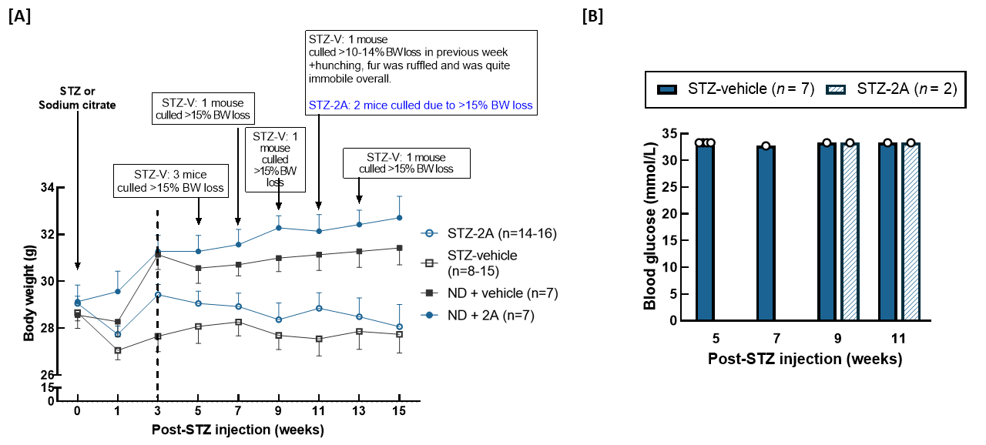

Supplementary Figure 5: Weekly body weight and blood glucose of mice that were culled before study end.
(A) Body weight over the 3 months treatment period. Number of animals in each group at the start of the experiment are as follows: ND-vehicle (n = 7), ND-2A (n = 7), STZ-vehicle (n = 15), and STZ-2A (n = 16). All the non-diabetic mice survived until study end. Arrows indicate when mice were culled due to excess loss of body weight. Vertica dotted line indicates when treatment with 2A or vehicle commenced (B) Endpoint blood glucose levels of mice that were euthanised prior to study end. Data are mean ± SEM. Abbreviations: ND: non-diabetic; STZ: streptozotocin.

Supplementary Table 1: Body weight and organ weights of mice at 12 weeks post-treatment

 | ND-vehicle  (n = 7) | ND-2A  (n = 7) | STZ-vehicle  (n = 8) | STZ-2A  (n = 14)
Body weight (g) | 31 ± 0.60 | 32 ± 0.90 | 28 ± 0.90 | 28 ± 10
Right kidney weight (g) | 0.22 ± 0.01 | 0.23 ± 0.01 | 0.26 ± 0.01 | 0.26 ± 0.01
Left kidney weight (g) | 0.21 ± 0.01 | 0.21 ± 0.01 | 0.24 ± 0.02 | 0.25 ± 0.01
Heart weight (g) | 0.22 ± 0.01 | 0.21 ± 0.01 | 0.20 ± 0.01 | 0.21 ± 0.01
Liver weight (g) | 1.40 ± 0.09 | 1.50 ± 0.09 | 1.80 ± 0.09* | 1.60 ± 0.06

*P < 0.05 compared to ND-vehicle; one-way ANOVA followed by Tukey’s post-hoc test. Data are mean ± SEM. Abbreviations: ND: non-diabetic, STZ: streptozotocin.

