Strengthening the Reporting of Empirical Simulation Studies (STRESS)
Adapted the STRESS-DES, STRESS-ABM and STRESS-SD guidelines

STRESS guidelines: Monks, T., Currie, C. S., Onggo, B. S., Robinson, S., Kunc, M., & Taylor, S. J. (2019). Strengthening the reporting of empirical simulation studies: Introducing the STRESS guidelines. Journal of Simulation, 13(1), 55-67. https://doi.org/10.1080/17477778.2018.1442155
The red text are the items from the STESS-DES, STESS-ABM, and the STRESS-SD guidelines. These have been combined and retained in the text for reference as the model presented is a hybrid simulation. Please note that although every effort has been made to explain the model in as much detail as possible, there may be some components or mechanics which are unclear to the reader. The model is available, see section 6 of this document.

Objectives

Purpose of the model
Explain the background and objectives/rationale for the model.
The purpose of the hybrid optimisation simulation model is to investigate cleaner schedules to guarantee hospital hygiene levels. Hospital hygiene levels are related to the proportion of cleaning jobs that are satisfied within specified time limits. Two types of job are considered, 1) scheduled jobs, the where and when are known, and 2) ad-hoc jobs, the where and when are unknown. The where, in the model is represented by a collection of hospital locations (e.g., wings, departments) each with sub locations (e.g., operating theatres, wards, offices, toilets, corridors etc.). The when, in the model is model time the job is generated, deterministically or stochastically for scheduled and ad-hoc jobs respectively.

Daily cleaner schedules include the number cleaners available; their shift start and end times, and scheduled break times and durations. Different job profiles e.g., volumes, locations, and ratios of scheduled and ad-hoc jobs can be assessed against different cleaner schedules to determine the hospital hygiene level. The cleaner utilisation incorporates the uncertain cleaning time associated with each job and the uncertain travel time between jobs and excludes break and idle time.

Model Outputs
State the qualitative or quantitative system level outputs that emerge from agent interactions within the ABS.

Define all quantitative performance measures that are reported, using equations where necessary. Specify how and when they are calculated during the model run along with how any measures of error such as confidence intervals are calculated.

Describe all outcome variables that are reported. Include details on how they are calculated during the model run. These might be as simple as detailing which specific stocks/levels are of key interest or may involve detailing equations.

The model collects many results, the key results are provided in Table 1. The where in Table 1 is the model agent, for a list of agents see Figure 3.

Table 1: Main model key performance indicators (KPIs)
Output (unit) | How (where is underlined)
Average waiting time per job  (minutes) | Each job has variables to record various times, waiting, cleaning duration, length of stay etc.
Number of timed out jobs, those which exceed waiting time limit (jobs) | Each location records how many jobs exceed their waiting time limit.
Average cleaner overtime per location (minutes) | The cumulative cleaning duration for jobs which exceeds their waiting time threshold in each location is recorded
Cumulative cleaner overtime all locations (minutes) | The sum of the cleaner overtime per location for all locations is calculated in the main agent
Average cleaner utilisation (% cleaning or moving) | Each cleaner records their utilisation, through their state chart = (cleaning + moving) / (idle + moving + cleaning + break). The average cleaner utilisation is calculated in the main agent.
Average cleaner idle time per shift (minutes) | Each cleaner records their idle time, through their state chart = idle. The average cleaner idle time is calculated in the main agent.
Cumulative cleaner idle time (minutes) | The sum idle time per cleaner for all cleaners is calculated in the main agent

Table 2 lists additional model results available to evaluate scenarios and for validation. The Agent in Table 2 is the model agent, for a list of agents see Figure 3.

Table 2: Additional selected model KPIs
Agent | Additional results (units)
Job | Time arrived (minutes).  Time left (minutes).  Cleaning time (minutes).  Length of stay (minutes).  Times interrupted (count).
Location | Jobs waiting time by time intervals (user-defined), job type (scheduled, ad-hoc) (jobs waiting time/time interval)  Job arrivals by time intervals (user-defined), job type (scheduled, ad-hoc) (jobs/time interval)  Jobs timed out by time intervals (user-defined) (jobs/time interval)  Overtime required out by time intervals (user-defined) (jobs/time interval)
Cleaner | Matrix collecting changes between locations. (count)  State (not working, idle, moving, cleaning, break) the cleaner is in over time
Main | Arrival patterns at all locations by user-defined time interval (jobs/time)  Other aggregate and cumulative results

Experimentation Aims
If the model has been used for experimentation, state the objectives that it was used to investigate. Or state the research questions that it was used to answer.

a.) Theory driven analysis – Provide details and reference the theories that are tested within the model (ABS).

b.) Scenario/Policy based analysis – Provide a name and description for each scenario, providing a rationale for the choice of scenarios and ensure that item 2.3 (below) is completed.

c.) Design of experiments – Provide details of the overall design of the experiments with reference to performance measures and their parameters (provide further details in data below).

d.) Simulation Optimisation – (if appropriate) Provide full details of what is to be optimised, the parameters that were included and the algorithm(s) that was used. Where possible provide a citation of the algorithm(s).

We use a combined scenario-based analysis and simulation optimisation approach to evaluate alternative cleaner schedules, to different (job) demand profiles illustrated in Figure 18. Scheduled jobs and ad-hoc jobs distributions were provided by our partner hospital and fed into the simulation model to generate job demand curves which were used in the optimisation model to determine alternative optimal cleaner schedules given certain constraints. The optimisation model is described in the paper. The six scenarios, optimal cleaner schedules given the constrains, are presented in section 2.3.

Logic

Base model overview diagram
Describe the base model using appropriate diagrams and description. This could include one or more process flow, activity cycle or equivalent diagrams sufficient to describe the model to readers. The goal is to describe the breadth and depth of the model with respect to the system being studied (DES).

Provide one or more of: state chart, process flow or equivalent diagrams to describe the basic logic of the base model to readers. (ABS)

Provide one or more causal loop, stock and flow or equivalent diagrams to describe the basic logic of base model to readers. To aid readers understanding authors should document the key feedback loops that drive system behaviour. (SD)

Avoid complicated diagrams in the main text.

The proposed hybrid simulation model interacts with a Mixed Integer Program (MIP) to optimise cleaner schedules to satisfy demand (cleaning jobs). See Figure 1 for a simple representation of the overall framework. The optimisation model is provided and explained in the RESS paper.

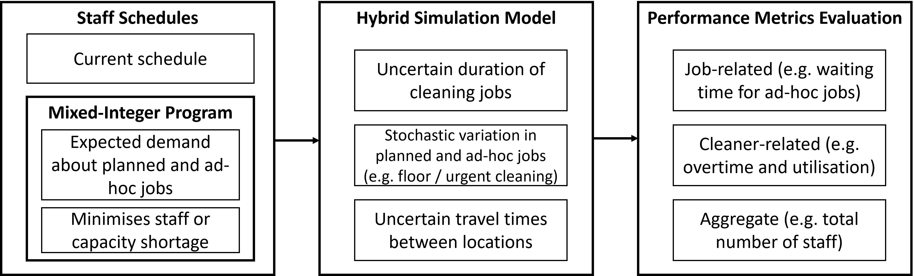
Figure 1: Hybrid optimisation simulation model

Base model logic
Give details of the base model logic. Give additional model logic details sufficient to communicate to the reader how the model works (DES).

This could be text to explain the overview diagram along with extra details including ABS product and process patterns. Include details of all intermediate calculations (ABS).

Give details of the base model logic in terms of feedback loops. This could be text to explain the overview diagram along with extra details including any use of system archetypes (SD).

The basic model logic is illustrated in Figure 2. Each hospital consists of a set of locations (e.g., blocks, wings, buildings) which can consist of sublocations (e.g., wards, rooms, offices, toilets etc), which require regular cleaning performed by a qualified cleaner, as well as ad-hoc cleaning in response to incidents, e.g., spillages, vomiting, etc. The base model parameters and the scenario parameters are presented in section 3.3.

An Excel User Interface is used to import the following into the simulation model:
- create a population of location agents, to represent the hospital of interest
- load job information, job schedules per location and distributions for ad-hoc jobs
- cleaner schedules (from optimisation) to generate cleaners and their working patterns
- a cleaner travel time matrix specifying the movement between and within locations.

Section 2.4.2 contains a more detailed description of the model mechanics including a more detailed illustration, see Figure 3. The model is also available see the code access section 6 for more information.

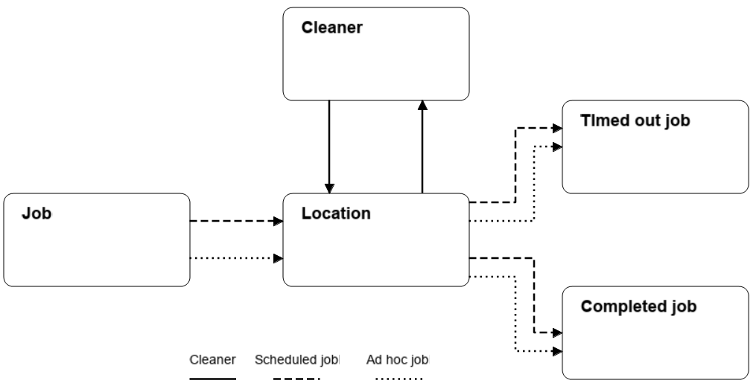
Figure 2: Base simulation model logic (Job = Demand)

Scenario logic
Give details of the logical difference between the base case model and policies, scenarios, and experiments. This could be incorporated as text or where differences are substantial could be incorporated in the same manner as 2.2.

The investigated scenarios relate to alternative cleaner schedules, based on the number of cleaners available and their shift schedules (start time, end time, number of breaks, breaks duration), and cleaner constraints e.g., working hours and break requirements. Table 3 summaries the differences. More detailed schedules are presented in Section 3.3 and are a mix of those created by the optimisation model and those not. Other model mechanics in terms of processes and process time distributions remains the same across scenarios.

Table 3: Scenario overview a day consist of 96 x 15-minute intervals (24 hours). The cleaner schedules are optimised against demand patterns generated from the simulation model, based on historical data, from 50 simulation iterations.
No. | Objective | Start times | Breaks | Shift Durations | Cleaners | Total Periods
S0 | Status quo | Fix | Fix | 7-9 hours | 13 | 418
S1 | Model 1 | Fix | Flex | 7-9 hours | 26 | 860
S2 | Model 1 | Fix | Flex | 10 hours | 26 | 936
S3 | Model 1 | Flex | Fix | 7-9 hours | 18 | 588
S4 | Model 1 | Flex | Fix | 10 hours | 15 | 568
S5 | Model 1 | Flex | Flex | 7-9 hours | 17 | 554
S6 | Model 1 | Flex | Flex | 10 hours | 14 | 520
S7 | Model 2 | Fix | Flex | 7-9 hours | 13 | 384
S8 | Model 2 | Fix | Flex | 10 hours | 13 | 396
S9 | Model 2 | Flex | Fix | 7-9 hours | 13 | 350
S10 | Model 2 | Flex | Fix | 10 hours | 13 | 424
S11 | Model 2 | Flex | Flex | 7-9 hours | 13 | 350
S12 | Model 2 | Flex | Flex | 10 hours | 13 | 424

Components

Environment
Describe the environment agents interact within, indicating its structure, and how it is generated. For example, are agents bound within a homogeneous grid, or do they have continuous movement through a detailed landscape incorporating geographic or environmental information?

The environment is a population of location agents that represent the various parts of a hospital, e.g., buildings, and rooms within them. The generated scheduled and ad-hoc jobs are placed in these locations. The Cleaner agents travel between jobs and move through the network of locations based on travel times sampled from distributions and a travel time matrix, see section 3.3. Simple model visualisations represent the generation of jobs by location and their status (queuing or being cleaned), and the status of cleaners, moving, cleaning, on break or idle.

Agents
List all agents and agent groups within the simulation. Include a description of their role in the model, their possible states, state transitions, and all their attributes.

Describe all decision-making rules that agents follow in either algorithmic or equation form. Where relevant authors should report:

• The data that agents’ access (I.e., internal attributes or external information from the environment) and how it is used.
• The objectives agents seek to achieve.
• The algorithms, optimisations, heuristics, and rules that agents use to achieve objectives.
• How agents work together within a group along with any rules for changes in group membership.
• Predictions of future events and adaptive action.

The model consists of ten agents as depicted in Figure 3. These are AnyLogic agents (see section 5.1) There are four main agents: 1) Main, 2) Job (Demand), 3) Location and 4) Cleaner. The other agents depicted in Figure 3 support the four main agents.
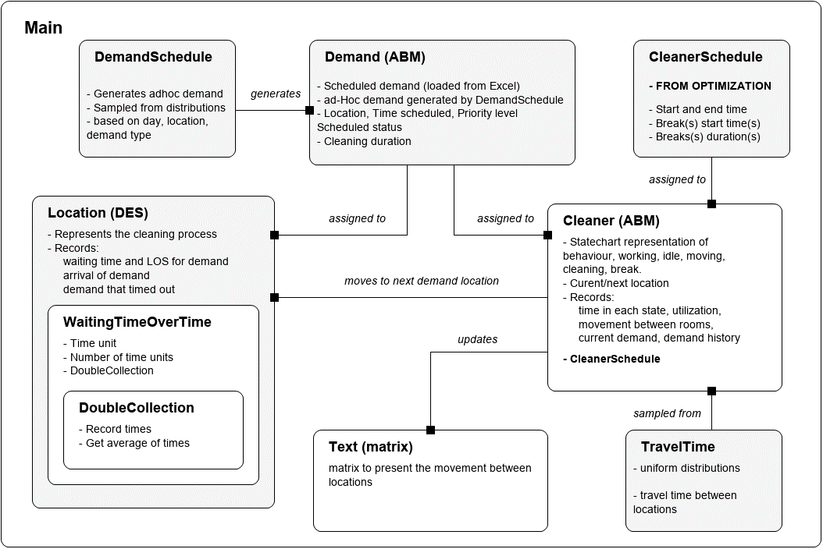
Figure 3: Simulation model overview (Job = Demand). The model consists of ten AnyLogic “agents” where each rectangle represents an agent 1) Main, 2) Demand, 3) Location, 4) Cleaner, 5) DemandSchedule, 6) CleanerSchedule, 7) WaitingTimeOverTime, 8) DoubleCollection, 9) Text, 10) TravelTime

Main
The Main agent is the environment in which all the other agents are placed. Figure 4 depicts a selected part of the Main agent which includes the agents red blocks in the top left (cleaners, cleanerSchedules, locations, demand, and scheduled_Demand), and the location visualisation at the bottom. The location visualisation is replicated for each agent in the Location agent population (a set of Location agents). The coloured Demand and Cleaner states in the top right denote the status of the jobs (demand) and the cleaners. The states are a key to explain the state of the Demand and Cleaner agents in the model visualisation. Functions (methods) to set parameters imported from the Excel User Interface and to collect results from the model over time are located and called from the Main agent, see the blue function blocks. Other AnyLogic blocks in this agent not visible in the Figure 4 include variables and collections to collect results and charts to present them. The complete model is available from the Mendeley Data repository see section 6.

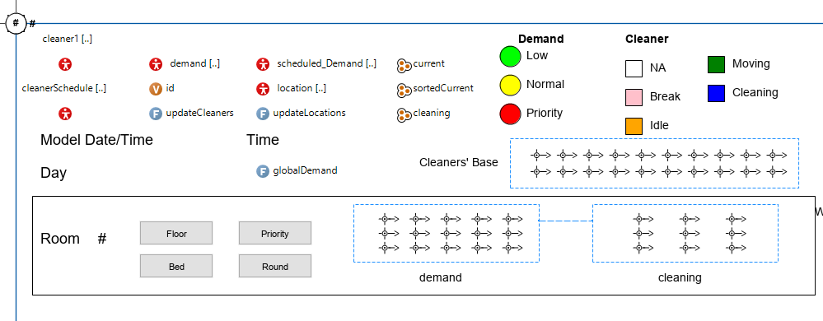
Figure 4: Main agent, the environment in which the other agents are placed (the red blocks in the top left). Visible in the Figure is a Location visualisation, the rectangle with the containing the word Room (these are dynamic and will be replicated based on the actual number of locations). Not visible in the Figure, other components relate to results collection and presentation. See section 6 for model availability.
Job (Demand) arrivals
Jobs (Demand) are represented as passive agents from an agent-based modelling (ABM) perspective or entities from a DES perspective, with attributes, see Figure 5. The design of the model allows for the job agent to be expanded as required. The job agent consists of parameters, variables, two events, two functions (1. toString; 2. setParameters) and a visualisation (circle in the top left, with # symbols). Variables the orange “v” blocks are used to record job related results, e.g., time stamps (arrival, exit), durations (waiting, cleaning, length of stay), etc. Parameters the grey blocks are used to provide inputs for the job. The setParameters function relates to scheduled demand, is called when the job is created and it populates some parameters and calls the main.setCleanAndWaitTime function to sample the cleaning duration, based on the job type (sublocation). The toString function is to output select key parameters and variables for visualisation purposes, these include time_arrived, travelTime, id_demand, shift_arrived, id_room, priority, id_cleaner_scheduled, id_cleaner_scheduled, time_scheduled, duration, scheduled.

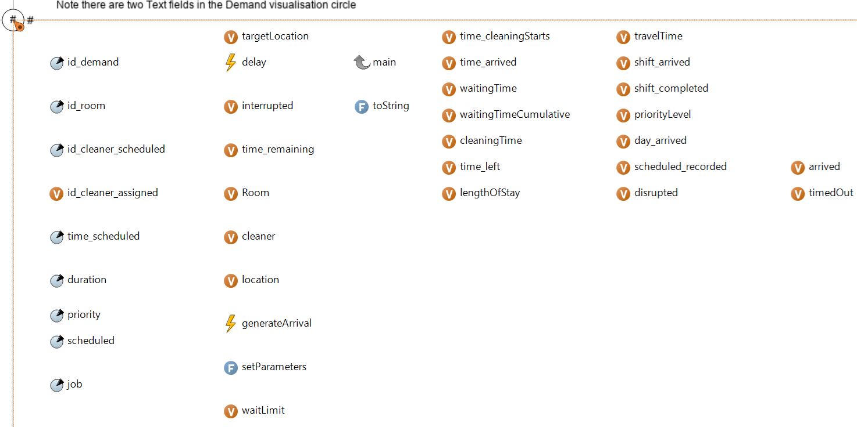
Figure 5: Job (Demand) agent, parameters, variables, functions (methods) and visualisation (top left)

Scheduled jobs are injected into the model at specific locations and times according to the schedule imported into the model, from the Excel User Interface Demand_scheduled sheet, an example of which is shown in Figure 6. The imported sheet is added to an AnyLogic equivalent database sheet “demand_scheduled” and used to generate the scheduled_Demand population of agents in the Main agent. The imported schedule includes parameters for the scheduled jobs: location, arrival time scheduled, scheduled a parameter to identify scheduled jobs, priority level, and job type (which is the sublocation). As the sublocation for scheduled demand is known the cleaning time duration can be sampled from the relevant distribution, by calling the main.setCleanAndWaitTime function.

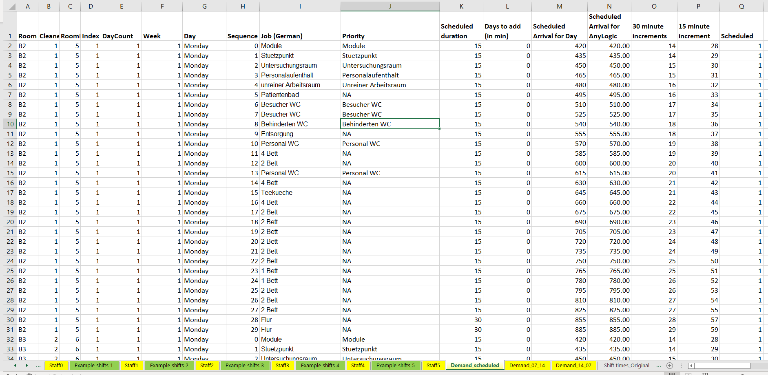
Figure 6: Excel User Interface - Scheduled Demand (Demand_scheduled sheet) extract
Three different types of ad-hoc jobs are available priority (priority = 15), bed (priority = 10) and floor (priority = 5), where higher number is higher priority. The ad-hoc jobs distributions imported into the base model relate to bed and floor jobs. The priority jobs are not currently used and will be implemented in a future model iteration.

Ad-hoc jobs are generated per location based on exponential interarrival time imported into the model from the Excel User Interface, see Figure 7 for an example afternoon/night pattern (14:00-07:00) by day of the week. There is also a similar day pattern (07:00-14:00). AnyLogic creates equivalent database sheets of the imported sheets called, demand_07_14 and demand 14_07. These sheets are used to populate the daySchedule and nightShedule DemandSchedule populations, located in the Main agent. These populations are used in conjunction with three events at the Main agent level: generate_Day, generate_Other and generate_Low to randomly assign ad-hoc jobs with cleaning durations sampled from the relevant distribution to specific locations by calling the Location.otherDemand() function.

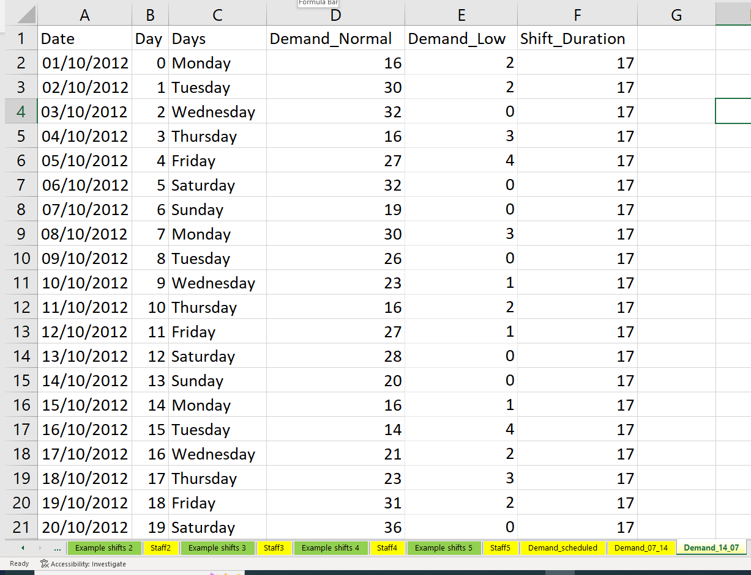
Figure 7: Excel User Interface - Ad-hoc afternoon/night (14:00-07:00) demand by day of the week. Demand is categorised into Normal (bed) and Low (floor)
Location
Each location is a discrete event simulation (DES) model, see Figure 8. The DES model consists of visualisation at the top of the Figure. The buttons allow the user to inject additional jobs into the model or to disrupt the current cleaning jobs, by introducing a ward (location) round. The DES model consists of three parts 1) arrivals and handling timed out demand, 2) cleaning and 3) disruptions, e.g., ward rounds, mealtimes etc.

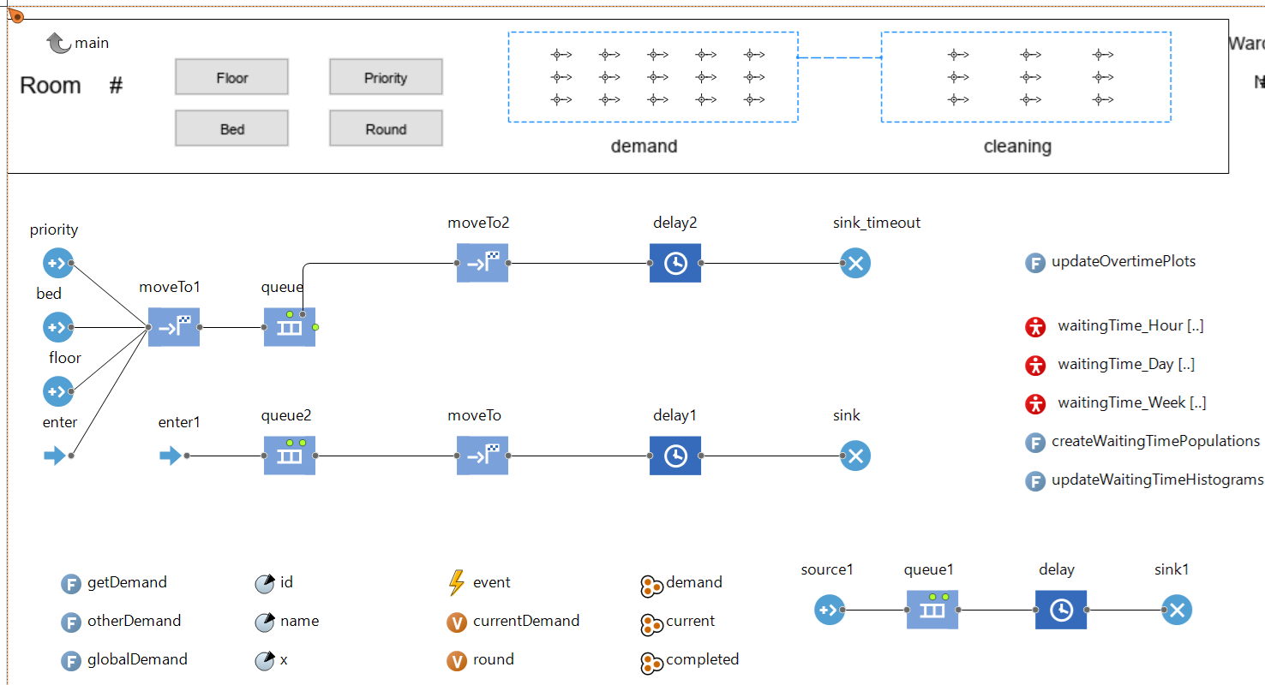
Figure 8: Location agent, parameters, variables, functions (methods), discrete event simulation components and visualisation (top). Not visible other components relate to results collection and presentation.

Arrivals and handling timed out demand are captured by the arrival blocks (sources) priority, bed, and floor and the enter block on the left to the sink_timeout block on the right in Figure 8. The source blocks are used to generate ad-hoc demand which is sampled from the main environment agent based on ad-hoc interarrival times for this location and on demand type, e.g., bed and floor imported from the Excel User Interface. The source blocks also generate demand when the related buttons are selected from the visualisation depicted. The moveTo1 block for visualisation purposes moves the job to the “demand” node visualisation at the top of the figure to an available attractor the black icons within the dashed blue rectangle. The job is then in the queue for this location. Queuing is managed at the main level the level above the location to coordinate the movement of cleaners between jobs in different locations, via two collections 1) current, which lists all outstanding jobs, and 2) sortedCurrent, which prioritises jobs by priority level and then on a first in first out basis. If jobs exceed their waitLimit they exit the queue block via the moveTo2 block which transfers the job (visualisation) from the “demand” node to the “cleaning” node where the job is cleaned using overtime at the delay2 block based on the jobs cleaning duration sampled when the job was created, before existing the model via the sink_timeout block.

Cleaning in the DES model is captured by the enter1 block to the sink block in Figure 8. Recall that the location queue is managed at the main agent the level above location. At the main level when the next job in the collection is a job in the queue block in the location agent, code (Main.scheduled) is called to move the job from the queue block to the enter1 block. The queue2 block is present for good modelling practice. The moveTo block synchronises the time it takes the job to travel to the “cleaning” node from the “demand” node in the location visualisation and the cleaner to travel from its previous location to the location of this job. The cleaner behaviour is controlled by the cleaner agent. The delay1 block captures the cleaning duration which is an attribute of the job sampled when the job was created, after cleaning is complete delay1 signals the cleaner that it can be released. After cleaning the job exits the model via the sink block and various results are recorded.

Disruptions in the model are represented by the source1 block to the sink1 block in Figure 8. Disruptions to cleaning activities in the model are at present limited to ward rounds. When a ward round occurs which can be sampled from a time dependent distribution or generated by clicking the “Round” button, a ward round entity enters the source1, this triggers a function in the delay which interrupt the jobs taking place in this location (in the delay1 block). The jobs are returned to the demand queue (queue block) until the ward round is complete. Cleaners cleaning in this location are released to attend queued jobs in other locations if they are disrupted. The interrupted jobs service times are reset to their sampled cleaning time when they were created, meaning they must start again.

The location requires a cleaner agent to cleaner and satisfy the job. In the base case the first available cleaner is used to respond to the cleaning job. The model permits specific cleaners to be assigned to specific jobs and/or locations, this functionality may be used in future iterations of the model. The locations are injected into the model upon start up based on information imported from the Excel User Interface Location sheet, shown in Figure 9, which updates the AnyLogic db_locations sheet. The db_locations sheet is used to create the population of Location agent in the main agent.
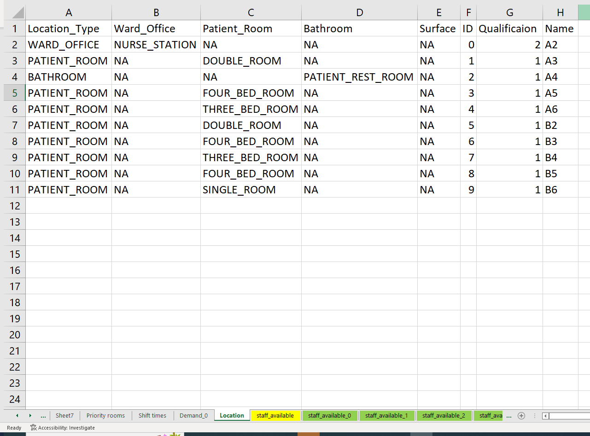
Figure 9: Excel User Interface - Locations (the number of rows and the Name are the most important coloumns)
Cleaner
A cleaner agent’s behaviour is captured using a statechart see Figure 10. Additional parameters, variables, functions, events, collections, datasets, and plots are used to influence the behaviour. The statechart and the schedule collection and associated functions drive the behaviour of the cleaner agents.

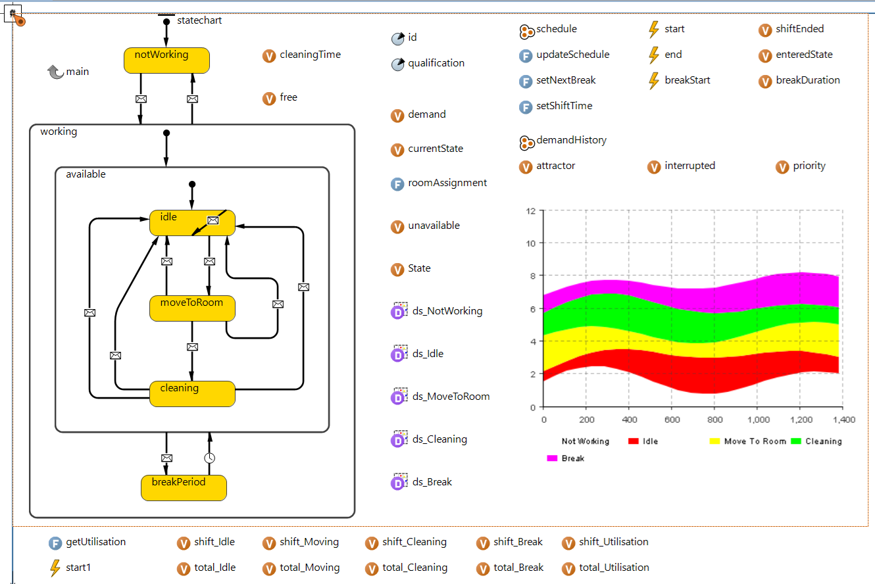
Figure 10: Cleaner agent, parameters, variables, functions (methods), state chart components and visualisation (top left). Note not all components are shown. Not visible, other components (most) relate to results collection and presentation.

The state chart consists of five major states not working, idle, moveToRoom, cleaning and breakPeriod. The cleaner can be in one of three meta states, notWorking, working (the remaining states) and available (same states as working apart from breakPeriod). Transitions between states are controlled primarily by messages sent from other parts of the model including specific jobs, locations, and the cleaner agent itself. Examples
- When a cleaner starts its shift and enters the idle shift it triggers a function at the main agent (Main.scheduled()) to check if any jobs are waiting, which is monitored at the main agent.
- If a job is waiting in the Main.sortedCurrent collection, the Main.scheduled() function moves the cleaning job from the appropriate location queue (Location.queue) to the location cleaning part of the location model (Location.enter1) and sends a message (“go”) triggering the cleaner to move to the cleaning job location, when the cleaning job reaches the Location.moveTo block. The cleaner demand variable (the cleaning job the cleaner is currently assigned) is updated and the cleaner and demand begin moving towards the cleaning visualisation in the location agent.
- When the job and the cleaner arrive at the delay1 block in the location an “arrived” message is sent to the cleaner triggering the transition to the cleaning state.
- Upon completing the cleaning process in Location.delay1, the Location.delay1 block sends a message (“finished”) to the cleaner to indicate the job is complete which triggers the transition back to the idle state in the cleaner statechart.
- The number of cleaners is determined by the Excel User Interface staff_available sheet, see Figure 11, which is imported to the AnyLogic db_cleaners sheet. The db_cleaners sheet is used to update the Main.cleaner1 population of cleaners.
- The cleaner schedules are imported from the Excel user interface from the staf_available sheet, see Figure 12, to the AnyLogic example_shifts sheet. The example_shifts sheet updates the Main.cleanerSchedule population of CleanerSchedules. The CleanSchedule agent class contains relevant schedule information, e.g., start times, end times, break times, variables to record specified stays in the model and functions for utilisation calculations. The Main.updateCleaners() function copies the relevant schedules for each cleaner to the Cleaner.schedule collection. The events in cleaner, “start”, “end” and “breakStart” are used in conjunction with the statechart to influence each cleaners behaviour.

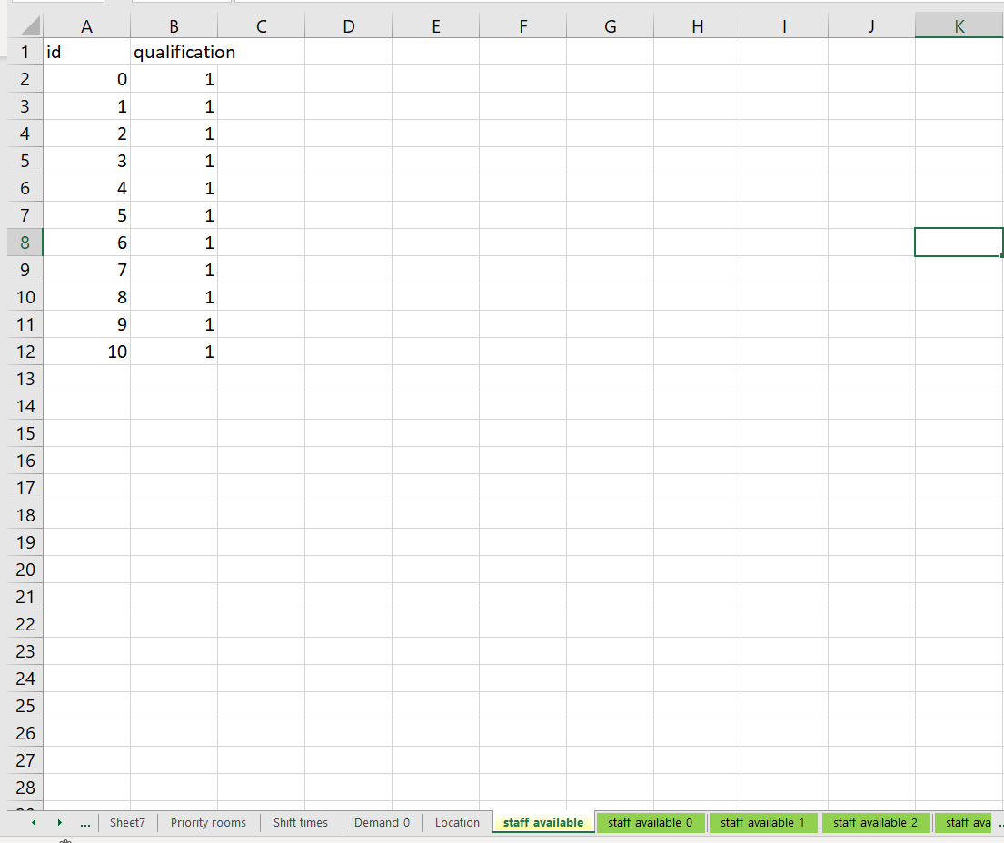
Figure 11: Excel User Interface - staff_available sheet (qualifications not used in this iteration of the model)

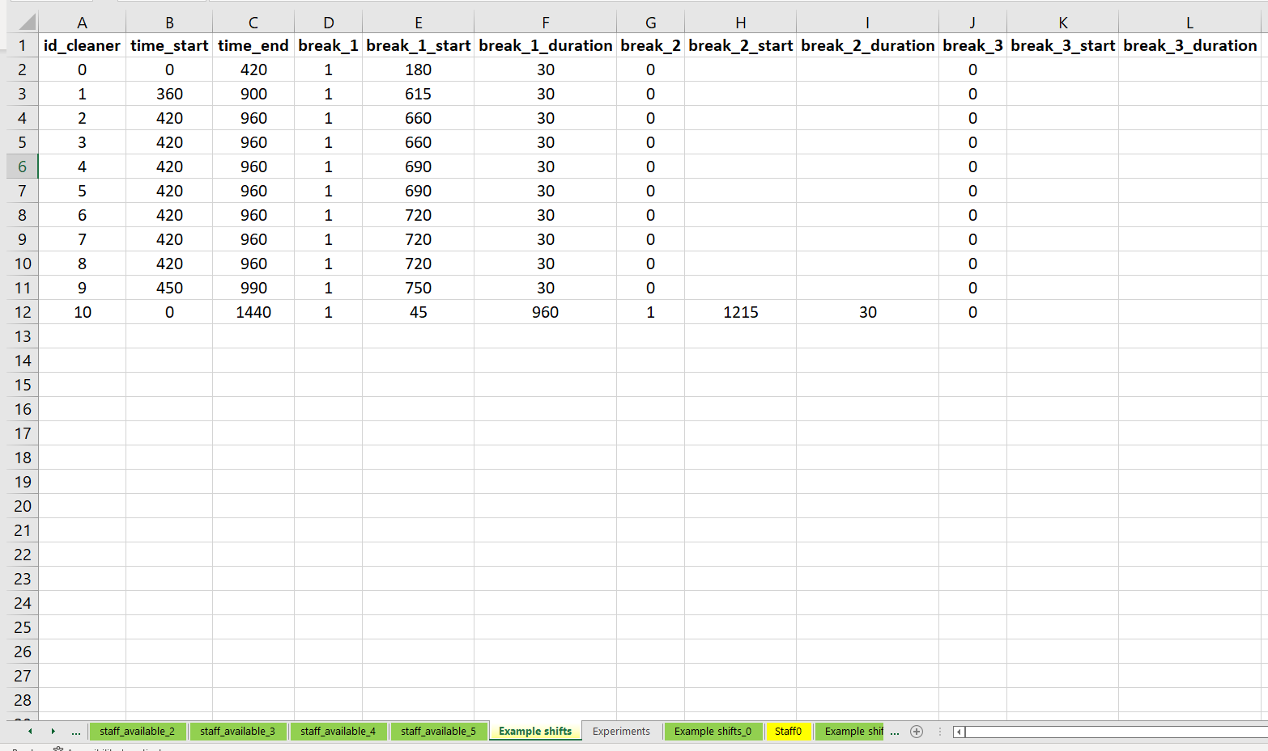
Figure 12: Excel User Interface - Example shifts sheet (the process to derive these is presented in section 3.2)

Interaction Topology
Describe how agents and agent groupings are connected with each other in the model define:
• with whom agents can interact,
• how recipients of interactions are selected
• what frequency interaction occurs.
• How agents handle and assign priorities to concurrent events

It is recommended that interactions are described using a combination of equations pseudo-code and logic diagrams.

Report how interactions are affected by agent states and the environment state

The high-level interactions are illustrated in Figure 3, note jobs are demand in this figure. The main interactions are:
- When a job is generated, a location is assigned, and the job is added to the locations waiting area.
- When the job arrives at a location it sends a message to all cleaners and if one is free a cleaner will travel to the location to satisfy the job.
- When a cleaner receives a message, if it is free it will travel to the location to clean the job.
- When a cleaner arrives at a location the job in the location will be moved to the cleaning visualisation of the location agent. The job will remain in this delay for the sampled time based on the job type parameter in the job agent.
- After the cleaning time has passed the delay delay1 in the location which represents cleaning the job will send a “finished” message to the cleaner to release the cleaner from the job and potentially the location.
- When a cleaner is released, it will check through the outstanding jobs by calling the Main.scheduled() function and will move to the next available job if there is one or return to the cleaners waiting area if there are no outstanding jobs.
- Other interactions have been discussed in section 2.4.2

Entry / Exit
Where relevant, define how agents are created and destroyed in the model.

The following are defined in the Excel User Interface and imported into the model.
- The number of locations is set in the Excel User Interface, see Figure 9. This is used upon model start up to create the Location agent population and their visualisations at the main level. These agents are not destroyed.
- All Scheduled demand (jobs) is defined in the Excel User Interface, see Figure 6. This is used upon model start up to create the scheduled_Demand agent population and their visualisations at the main level. Each job contains an event (generateArrival) to inject itself into the correct location when it is scheduled to arrive.
- The number of cleaners and cleaner schedules is set in the Excel User Interface, see Figure 11. This is used upon model start up to create the cleaner agent and the cleaner schedule agent populations at the main level. After initialisation, the schedules for the cleaners, see Figure 12, are assigned to collections in corresponding cleaner through calling the updateCleaners function.
- The Travel time matrix is set in the Excel User Interface TravelTime sheet, see Figure 13, and specifies the minimum and maximum times to move between locations and within locations. The default model travel time in the model is represented using uniform distributions.

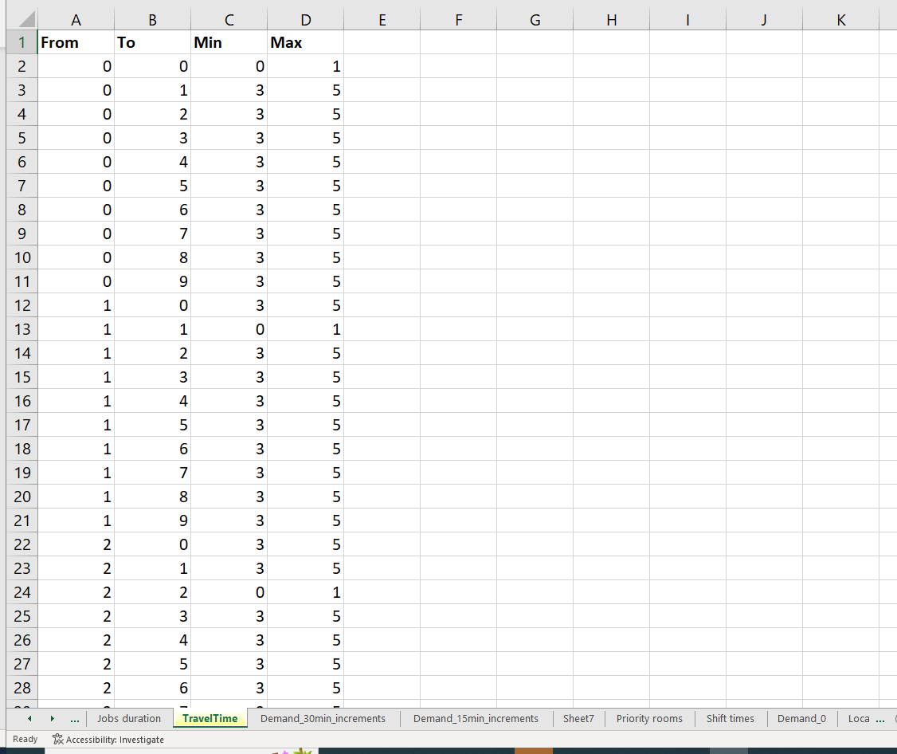
Figure 13: Excel User Interface - TravelTime sheet represents the minimum and maximum values for uniform distributions used to represent the travel time within and between locations

Data

Data sources
List and detail all data sources. Sources may include:
• Interviews with stakeholders,
• Samples of routinely collected data,
• Prospectively collected samples for the purpose of the simulation study,
• Public domain data published in either academic or organisational literature. Provide, where possible, the link and DOI to the data or reference to published literature.

All data source descriptions should include details of the sample size, sample date ranges and use within the study.
Data were obtained from hospital information systems and estimates provided by hospital staff. The key data are presented in section 3.3. Cleaner schedules were generated from the optimisation model which is summarised in section 3.2.

Pre-processing
Provide details of any data manipulation or filtering that has taken place before its use in the simulation, e.g., interpolation to account for missing data or the removal of outliers or filtering of large-scale data.

The simulation model was run under status quo conditions, e.g., the default staff schedule, scheduled demand patterns per location and the ad-hoc demand distributions by shift and location. The scheduled demand and ad-hoc demand curves were combined and used as inputs for the optimisation model to determine the optimal cleaner schedules based on the available cleaners and other constraints, specified in the paper. The process is illustrated in Figure 14.

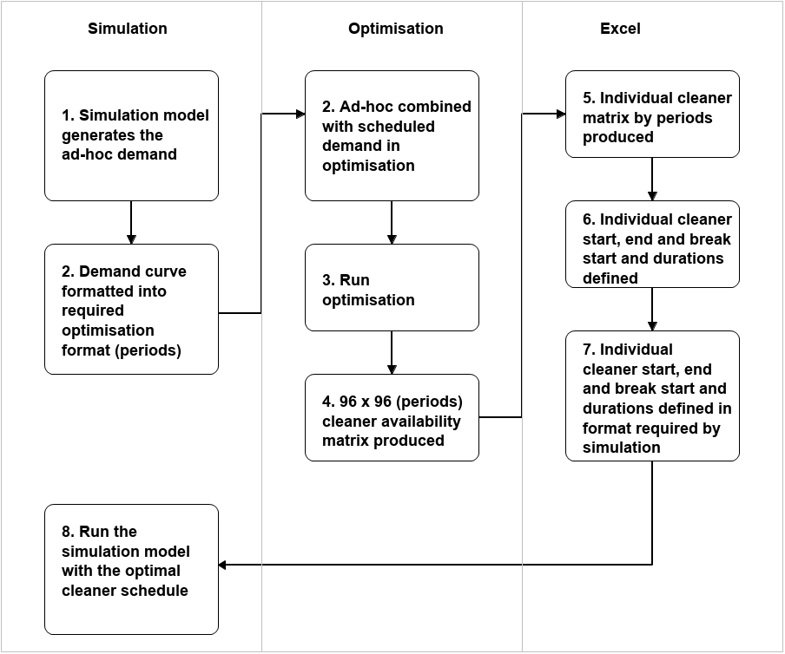
Figure 14: Pre-processing demand (job) data and cleaner schedules (4. The day is broken into 96 x 15-minute periods)

The optimisation model splits the model time horizon a single day into 96 x 96, 15-minute intervals. The scheduled demand is known, but the ad hoc demand is generated by the simulation model, as it’s generated based on the distributions input into the simulation model (see input parameters section 3.3). The simulation model collects job arrival information in 15-minute intervals, step 2 in Figure 14. Due to the sampling and associated uncertainty multiple runs are conducted. Table 4 shows an extract of the aggregate Demand data based on a single run of the simulation model, Demand (1 run), and averaged from 50 model runs, Demand (50 runs). The complete table is available in the appendix. The demand curves used in the optimisation model are presented in Figure 15.

Table 4: Demand curve construction from simulation model for the optimisation

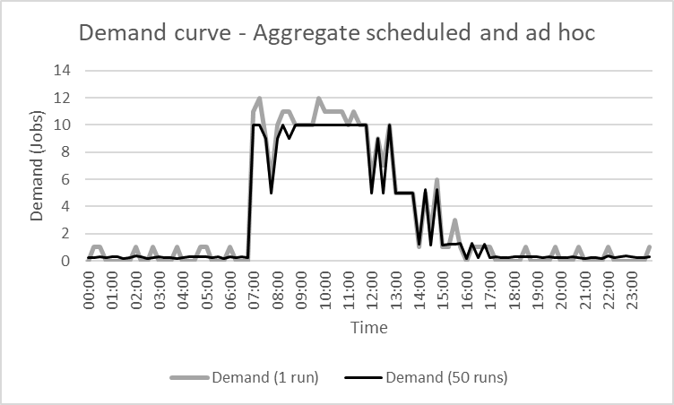
Figure 15: Demand (cleaning jobs) curves generated from simulation model for optimisation, based on Table 4.

The optimisation is run, step 3 in Figure 14, and the output from the optimisation includes a 96 x 96 matrix based on the 15-minute periods is produced, step 4 in Figure 14. Figure 16 illustrates part of the Availability Matrix which represents cleaner availability, a 1 denotes that a cleaner is working that 15-minute period. Each column in the matrix represents a shift type, the start and end time, and the start and end of any breaks during the day e.g., column 55 represents period 55, which begins at 13:30. The number of cleaners available in each shift type are specified in the fourth row, in this example no cleaners are scheduled in the 17 shift types presented, as the values beneath (row 3) 1, 55, 56, 57, 58, 59, 60, 61, 62, 63, 64, 65, 66, 67, 68, 69 and 96 are all 0.

Figure 16: Selected optimisation output, availability matrix (cleaner schedules). Complete Availability Matrix reduced for presentation purposes.
The Availability Matrix produced by the optimisation model needs to be transformed to produce individual cleaner schedules for the simulation model, step 5 in Figure 14. This is currently manually performed as follows in Excel. For each column (shift type) in the Availability Matrix, see Figure 16, in which cleaners are assigned the shift type is copied into a sheet with the zeros removed, if multiple cleaners are assigned to this shift type, it’s copied multiple times. Figure 17 shows part of an Excel sheet in which 14 cleaners have been assigned, the numbered columns 1-14. The “Cleaners” column in Figure 17 (second column) is the “Availability” column from the optimisation model in Figure 16, which is the total number of cleaners available for each 15-minute period. Similarly, the “Time” column (third column) is the same as the “Period” column in Figure 16. The “Minutes” column is the time in minutes from midnight and is used in the simulation model which runs in minutes. The “Total” column is the sum of available cleaners for a particular period (the row with the numbered cleaners), and the “Diff” column is the difference between the “Cleaners” and the “Total” columns. Once the “Availability Matrix” has been transformed into the format presented in Figure 17 the shifts for each cleaner can be summarised.

Figure 17: Transforming the optimisation availability matrix data into individual cleaner schedules. Complete sheet reduced for presentation purposes
Table 5 presents the summary information derived from Figure 17 for each cleaner, this is step 6 in Figure 14. The working shift duration of each cleaner in periods and hours is presented. The shift is then broken into its start and end time in minutes (simulation time units). The break schedules for each cleaner, the start time (B#_start) and duration (B#_duration) of the breaks are stated. Please note that if the cleaner had more than three breaks additional breaks can be added. The summary of cleaners shifts presented in Table 5 needs to be transformed into the required format for the simulation model.
Table 5: Overview derived from the optimisation results

The summary information of each cleaners shifts presented in Table 5, needs to be transformed into the required simulation model format, step 7 in Figure 14. Table 6 illustrates this format, taken the output presented in Table 5 and transforming it into the required format. This sheet, Table 6, is read into the simulation model to create the cleaners and the associated schedules, see Figure 12. In the future this process will be automated.

Table 6: Cleaner schedules in simulation model format

Input parameters
List all input variables in the model. Provide a description of their use and include parameter values. For stochastic inputs provide details of any continuous, discrete, or empirical distributions used along with all associated parameters. Give details of all time dependent parameters and correlation and any graphical functions. Where applicable define the time/spatial dependence of parameters and any correlation structure.

Clearly state:
• Base case data
• Data/input used in experimentation, where different from the base case.
• Where optimisation or design of experiments has been used, state the range of values that parameters can take.

Where theoretical distributions are used, state how these were selected and prioritised above other candidate distributions.

The input variables in the model are provided in Table 7. Inputs that were used for experimentation are denoted with “*”. All other inputs remain as stated in each experiment.

Table 7: Model inputs, for the base scenario.
Input | Values | Description (source)
Number of locations | 10 locations | A2, A3, A4, A5, A6, B2, B3, B4, B5, B6. Sub locations not explicitly modelled, captured by the job type, see below.
Scheduled job arrival patterns  (location and number of jobs) | A3, A4, A5, A6 = 21  B2, B3, B4, B5 = 30  B6 = 34 | Historical hospital scheduled demand. Total number of jobs for a single day are presented.
Ad hoc job arrival patterns  (location and mean number of jobs) | 07:00-14:00  A3, A4, A5, A6 = 0, 0  B2 = 5, 0  B3 = 1, 1  B4 = 4, 0  B5 = 1, 0  B6 = 4, 2  14:00-07:00  16, 2 | Distributions derived from recorded hospital ad hoc demand, for bed demand (normal) and floor demand (low). The value for normal and low demand are provided. These are exponential based on the period covered.  Data relate to 07:00-14:00 and 14:00-07:00  Ad hoc demand can come from any location.
Job types | 32 different job types | 1 bedroom, 2 bedrooms, 3 bedrooms, 4 bedrooms, lounge, disabled toilet, visitor toilet,  equipment room in, office, doctor's office, ward manager's office, waste disposal, equipment room, gynaecology, modular room, patient bathroom, staff toilet, staff accommodation, cleaning room, base, tea kitchen, changing room staff, unclean work room, examination room, urology, laundry room, the decentralized bed storage, hallway, milk kitchen, patient kitchen, warm bed room, baby changing room
Job cleaning time (mins) | Triangular (5,10,30)  Triangular (15,25,35) | Estimates provided by hospital, based on job scheduling.  Other rooms not specified below and ad hoc demand  decentralized bed storage, hallway, milk kitchen, patient kitchen, warm bed room, baby changing room
Job wait limit | 60 minutes | Estimate for all jobs. Jobs that exceed this limit are cleaned using overtime.
Travel time (mins) | Uniform (3,5)  Uniform (0,1) | Between locations (estimated)  Within locations (estimated)
* Number of cleaners (periods covered) | S0 = 13 (418)  S1 = 14 (520)  S2 = 15 (498)  S3 = 13 (484)  S4 = 16 (520)  S5 = 11 (362) | Status quo (base case). Cleaners have 7–9-hour shifts  10-hour shifts (Demand = single run)  Flexed status quo (Demand = single run)  10-shifts (Demand = 50 runs average)  Flexed status quo (Demand = 50 runs average)  Status quo minimise demand (Demand = 50 runs average)
* Cleaner schedules | See Figure 12 | S0 is the base case. S1-S5 were generated by the optimisation model.

The aggregate cleaner availability (schedules) generated by the optimisation are presented in Figure 18, these relate to step 3 in Figure 14. See Section 3.2 for an explanation of how this aggregate cleaner availability is translated into individual cleaner schedules for the simulation model.

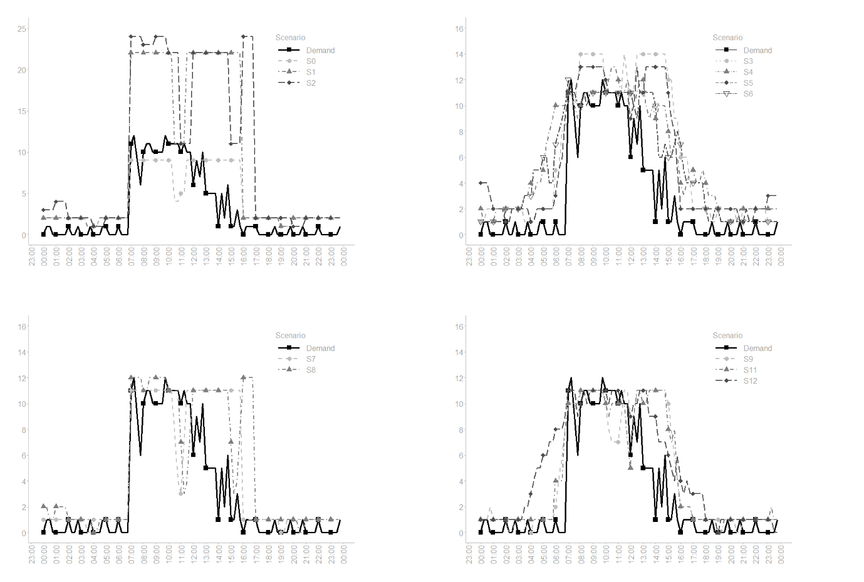
Figure 18: Cleaner schedules generated by the optimisation see Table 3.

Assumptions
Where data or knowledge of the real system is unavailable what assumptions are included in the model? This might include parameter values, distributions, or routing logic within the model (DES). State and justify the assumptions used to set input parameter values and distributions; agent interactions or behaviour; or model logic (ABS).

Any model must make simplifying assumptions to answer the specific question(s) posed and to maintain the correct scope, the key assumptions of this model are:
- Model starts from empty at 00:00 and there is no warm-up period. The rationale being that there are only ad hoc jobs between 00:00-07:00 from 07:00 scheduled demand begins.
- Cleaners take breaks when scheduled and currently will interrupt a job they are working on.
- The first available cleaner will travel to a job to clean it. Specific cleaners are not assigned to specific jobs or locations. They can be in future iterations.
- A 60-minute job wait limit is assumed. If a job is not satisfied within this time will be cleaned using overtime. In these instances, cleaning agents are not explicitly assigned, the job duration is recorded as the overtime and overtime cleaners are assumed to always be available.
- The travel time matrix is assumed but can be updated if new data becomes available.
- The ad hoc demand is sampled from exponential distributions and the period the demand relates to i.e., 07:00-14:00 and 14:00-07:00
- The cleaning time distributions for all job types are estimated by hospital staff.
- If a job is disrupted, it’s cleaning time is reset when it is the next to be cleaned.
- All cleaners can clean all jobs in all locations if they are available.
- Cleaner utilisation is the proportion of the cleaners shift the cleaner is cleaning or moving to a job.
- Cleaner idle time is the time the cleaner is available, not on break, or cleaning or moving to a new job.
- If all cleaners are busy and a higher priority job arrives, a randomly selected lower priority job will be interrupted. The interrupted job will return to the location job queue. When it recommences its cleaning time will be reset to the original sampled value contained in the demand (job) agent.

Experimentation

Initialisation
Report if the system modelled is terminating or non-terminating. State if a warm-up period has been used, its length and the analysis method used to select it. For terminating systems state the stopping condition.

State what if any initial model conditions have been included, e.g., pre-loaded queues and activities. Report whether initialisation of these variables is deterministic or stochastic (DES).

State what if any initial agent and environmental conditions have been included. For example, the initial agent population size, agent states and attributes, initial agent network structure(s), and resources within the environment. Report whether initialisation of these variables is deterministic or stochastic (ABS).

List all initial values of stocks and auxiliary variables within the model. Provide details of empirical or theoretical distributions used, if initial values are varied over multiple runs of the model (e.g., for calibration or optimisation) (SD).

The model is a terminating system which runs for a single day from midnight to midnight. The model begins from empty as there are no scheduled jobs generated between 00:00 to 07:00. Jobs generated during this period are few and ad-hoc therefore no warm-up period used.

Run length
Detail the run length of the simulation model and time units.
The model runs for one day in minutes (1440 minutes), from 30/08/2021 00:00 to 31/08/2021 00:00.

Estimation approach
State the method used to account for the stochasticity: For example, two common methods are multiple replications or batch means. Where multiple replications have been used, state the number of replications and for batch means, indicate the batch length and whether the batch means procedure is standard, spaced or overlapping. For both procedures provide a justification for the methods used and the number of replications/size of batches (DES/ABS).

State if the model is deterministic or stochastic (ABS). If the SD model includes stochastic inputs report if multiple replications or an alternative approach has been used in estimating model outputs. For model calibration or optimisation report the algorithm/search method used and the number replications (runs) of the simulation model (SD).

Multiple replications consisting of 50 runs, AnyLogic Parameter Variation Experiment, were used for experimentation. To determine the number of runs the behaviour of following KPIs: waiting time, timed out, cleaner overtime, cumulative overtime, cleaner utilisation, cleaner idle time, and cumulative idle time, were observed whilst changing the number of runs, see Table 8. The number of runs was tested with the scenario S5 cleaner schedule. The uncertainty relates to cleaning time, the travel time between jobs and ad hoc job creation. The model could run faster if the output to the console were reduced and over validation checks were disabled, which will be updated in future iterations.

Table 8: Model experimentation number of runs/replications determination. * denotes the number of runs selected.
Runs | Run time  (secs) | Waiting time (mins) | Timed out (jobs) | Cleaner overtime (mins) | Cumulative overtime  (mins) | Cleaner utilisation | Cleaner idle time (mins) | Cumulative idle time (mins)
10 | 54.05 | 9.907 | 15.000 | 14.714 | 220.707 | 0.618 | 155.200 | 1707.200
25 | 106.01 | 10.685 | 17.720 | 15.093 | 267.455 | 0.620 | 154.218 | 1696.400
50 * | 178.63 | 10.462 | 18.280 | 14.904 | 272.437 | 0.618 | 155.502 | 1710.520
75 | 282.85 | 10.749 | 16.253 | 15.160 | 246.393 | 0.622 | 152.859 | 1681.453
100 | 331.62 | 10.988 | 19.040 | 14.869 | 283.114 | 0.621 | 153.993 | 1693.920
125 | 427.65 | 10.593 | 16.840 | 15.208 | 255.988 | 0.618 | 155.209 | 1707.296
150 | 501.06 | 10.757 | 17.367 | 15.186 | 263.725 | 0.620 | 154.383 | 1698.213
175 | 582.39 | 10.641 | 17.023 | 15.084 | 256.686 | 0.620 | 154.629 | 1700.914
200 | 654.40 | 10.739 | 18.365 | 14.969 | 274.829 | 0.620 | 154.653 | 1701.185

Model outputs for the different runs (number of runs in brackets not part of the file name): Output_20220529_1759 (10), Output_20220529_1802 (25), Output_20220529_1753 (50), Output_20220529_1808 (75), Output_20220529_1833 (100), Output_20220529_1841 (125), Output_20220529_1902 (150), Output_20220529_1922 (175), Output_20220529_1945 (200)

Implementation

Software or programming language
State the operating system and version and build number.

State the name, version and build number of commercial or open-source DES/ABS/SD software that the model is implemented in. State the name and version of general-purpose programming languages used (e.g., Python 3.5).

Where frameworks and libraries have been used provide all details including version numbers.

Many modern SD packages provide specialised stocks to act as delays e.g., conveyers, queues, and ovens. Provide details all specialised stocks and where they are used in the model (SD).

The simulation model was built in AnyLogic 8 Personal Learning Edition 8.7.12, Build: 8.7.12.202205250418 x64. The Process Modeling Library 8.0.5 was required to build the model. Additional Java classes imported primarily for results collection and writing out include import java.io.*; java.io.FileWriter; java.nio.file.Path; java.util.Date; java.text.SimpleDateFormat; java.util.Collections.

The optimisation was built in Solver a Microsoft Excel add-in program. The simulation user interface was built in Microsoft Excel, Office 16. Post hoc statistical analysis of simulation model output was performed in RStudio 2021.09.0 Build 351, using the R version 4.1.3 (2022-03-10) “One Push-Up”.

Random sampling
State the algorithm used to generate random samples in the software/programming language used e.g., Mersenne Twister or Java.Random version x.y. If common random numbers are used, state how seeds (or random number streams) are distributed among sampling processes (DES).

We use the default AnyLogic random number generator, which is an instance of the Java class Random, a Linear Congruential Generator (LCG). A random seed is used for each experiment, in future iterations we could investigate specific random number streams to ensure replicability.

Model execution
State the event processing mechanism used e.g., three phase, event, activity, process interaction. Note that in some commercial software the event processing mechanism may not be published. In these cases, authors should adhere to item 5.1 software recommendations. State all priority rules included if entities/activities compete for resources.

If the ABS model has a time component, describe how time is modelled (e.g., fixed time steps or discrete event). State the order of variable updating within the model. In time-stepped execution state how concurrent events are resolved.

If the model is parallel, distributed and/or use grid or cloud computing, etc., state and preferably reference the technology used. For parallel and distributed simulations, the time management algorithms used. If the HLA is used then state the version of the standard, which run-time infrastructure (and version), and any supporting documents (FOMs, etc.)

Report the integration method used along with time step settings. (SD)

Information about AnyLogic model execution can be found here https://anylogic.help/anylogic/running/initialization-order.html#model-execution-order. The time component of the model is modelled using discrete events. The input data from the Excel User Interface is read in first and used to populate the various parts of the model previously explained. Java collections in the main agent (Main.current, Main.sortedCurrent, Main.cleaning) are used to keep an overview of the jobs that are being cleaned and those still to be cleaned. If jobs are disrupted these collections are updated accordingly. In terms of assigning cleaners to jobs, the first available cleaner is assigned to a job.

System Specification
State the model run time and specification of hardware used. This is particularly important for large scale models that require substantial computing power. For parallel, distributed and/or use grid or cloud computing, etc. state the details of all systems used in the implementation (processors, network, etc.)
The model takes on average 3.74 seconds to run a single iteration, and 178.63 seconds to run 50 replications.

The model runs on a Windows 64-bit operating system, Intel ® Core ™ i7 CPU 950 @3.07 GHz, 2.66 Hz, 24.0 GB RAM. Windows 10 Pro, Version 21H2, OS build, 19044.1706, Windows Feature Experience Pack 120.2212.4170.0.

Code Access

Computer Model Sharing Statement
Describe how someone could obtain the model described in the paper, the simulation software, and any other associated software (or hardware) needed to reproduce the results. Provide, where possible, the link and DOIs to these.

The dataset(s), the simulation model, the Excel User Interface, and the R code for to analyse to perform post-hoc simulation analysis supporting the conclusions of this article are available upon request from the authors

