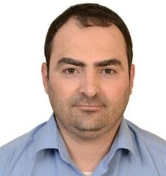

Yazeed Mohammad Qasaymeh Qasaymeh received BSc.Eng. degree from Mutah University, Karak, Jordan, in 2006, M.Sc.Eng. degree in engineering from college of Electrical and Computer Engineering, university sains malaysia, Pinang, Malaysia, in 2009, and Ph.D. degree in the college of Electrical and electronic Engineering, universiti sains malaysia, pinang, malaysia. He is currently associate professor in college of Engineering, Al-majmaah university at saudia arabia. His research interest is antennas array, wireless communication MIMO, distributed antenna systems.

