Extended Figure and Figure legends

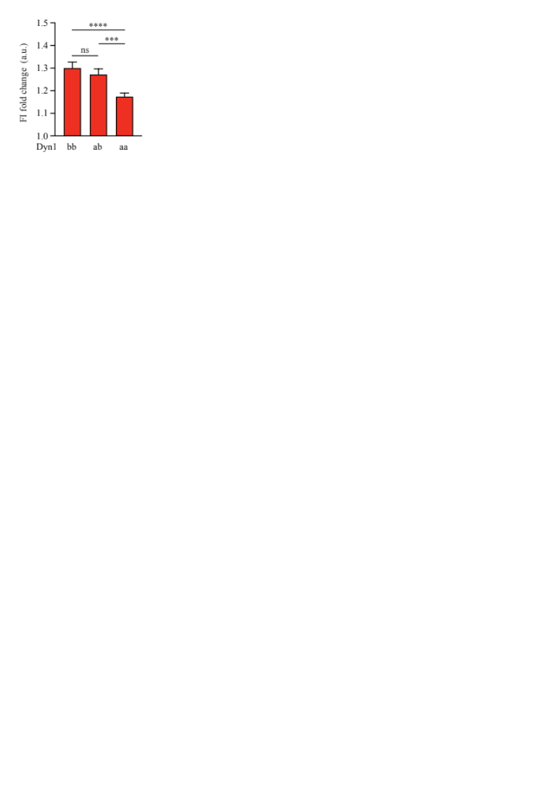
Extended data Figure 1: Average FI fold change of the entire plasma membrane of different Dyn1 isoforms
Average FI fold change of the entire plasma membrane of PC12 cell transfected with either Dyn1bb-GFP, Dyn1ab-GFP, or Dyn1aa-GFP following Ba²⁺ stimulation. (n=19 cells for Dyn1bb, n=26 cells for Dyn1ab, n=33 cells for Dyn1aa from 4 independent experiments; non-normally distributed paired data was analysed with Wilcoxon test; ns non-significant P>0.05, *P<0.05, ***P<0.001, ****P<0.0001; Mean ± SEM are plotted).

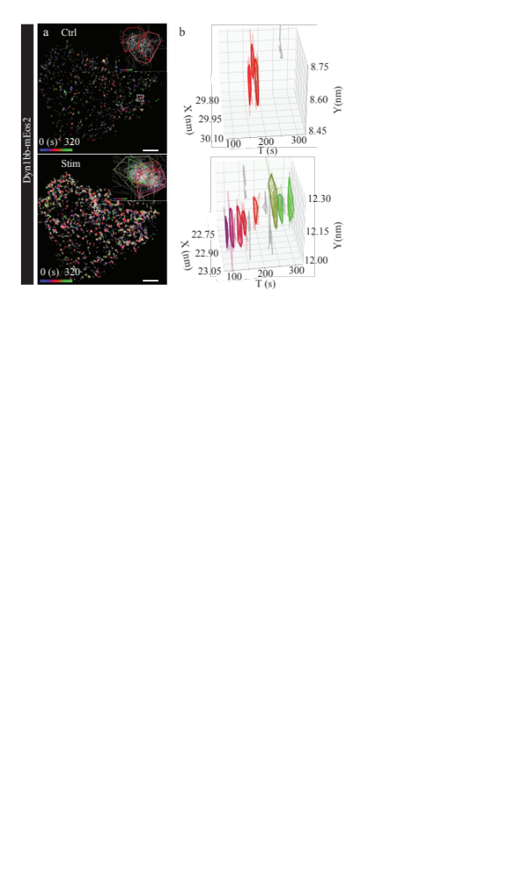
Extended data Figure 2: Representative 2D and 3D plots of Dyn1bb-mEos2 nanoclusters in PC12 cells
(a) Representative nanoclusters of Dyn1bb-mEos2 in either unstimulated (Ctrl) or stimulated (2 mM Ba²⁺) conditions in transfected PC12 cells. Scale bars, 5 μm. ROI (white box) from (a) is shown magnified in (b) which depicts a representative 3D [x,y,t] projection of a single spatial hotspot of Dyn1bb-mEos2 in unstimulated and stimulated conditions, which resolve into multiple spatiotemporal clusters indicated by colour.

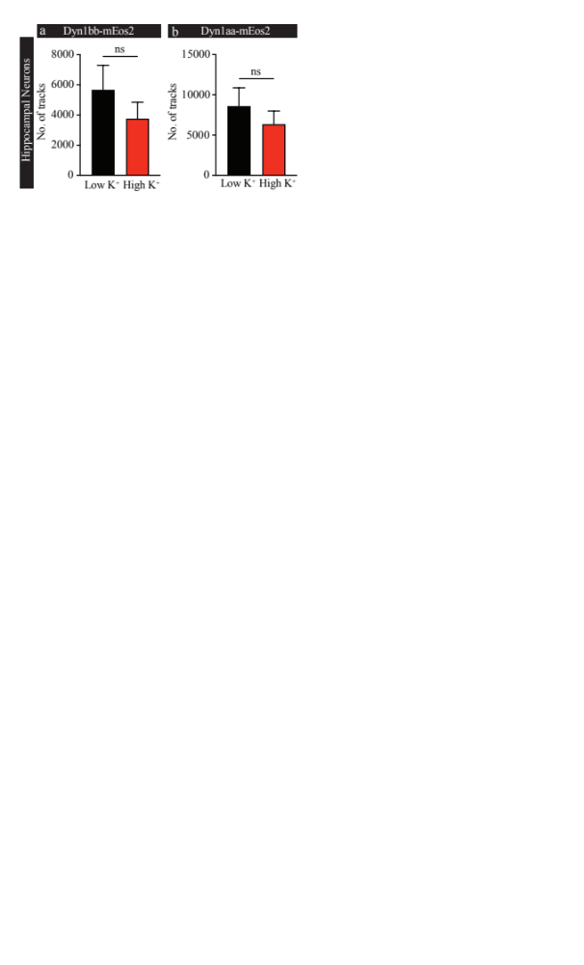
Extended data Figure 3: Average total number of tracks for short- and long-tail Dyn1 isoforms in hippocampal neurons
Average number of tracks for (a) Dyn1bb-mEos2 and (b) Dyn1aa-mEos2 in hippocampal neurons in low K+ and high K+ conditions. (n=20 cells for Dyn1bb, n=15 cells for Dyn1aa from 3 independent experiments; normally distributed paired data was analysed with paired student t test; ns non-significant P>0.05; Mean ± SEM are plotted).

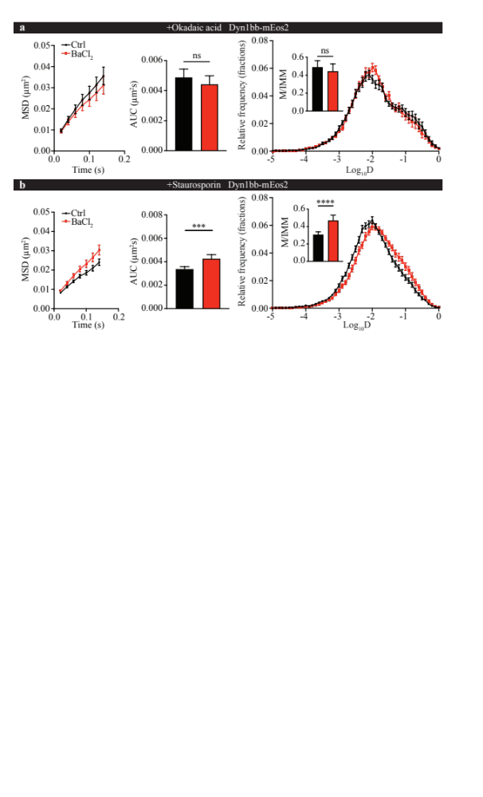
Extended data Figure 4: Phosphorylation and dephosphorylation affect the second concentration/clustering phase of short-tail Dyn1 isoforms
PC12 cells expressing Dyn1bb-mEos2 were pre-treated with either okadaic acid (1 µM for 30 min) or staurosporine (1 µM for 30 min). and imaged at 50 Hz in either unstimulated or stimulated (2 mM Ba²⁺) conditions. The single molecule mobility of Dyn1bb-mEos2 in unstimulated and stimulated PC12 cells was compared in the (a) okadaic acid condition and (b) staurosporine condition. From left to right: the average MSD (µm²), AUC of the MSD (arbitrary units; a.u), and mean frequency distribution of Log₁₀D with an insert showing the M/IMM fraction. (n=19 cells for the okadaic acid condition, n=20 for the staurosporine condition from 3 independent experiments; non-normally distributed paired data was analysed with the Wilcoxon test; ns non-significant P>0.05, ***P<0.001, ****P<0.0001; Mean ± SEM are plotted).

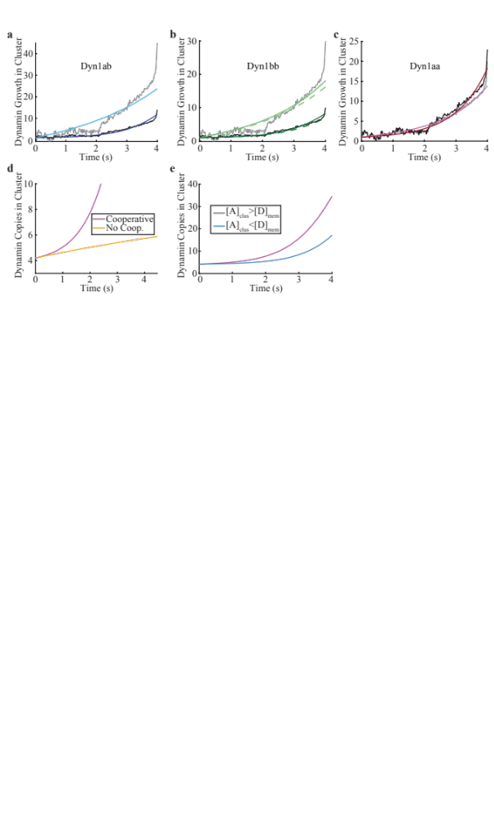
Extended data Figure 5: Model reproduces dynamics of dynamin accumulation in clusters for different isoforms
(a-c). Experimental curves are shown in grey and black for all figures. The scaling on the y-axis is controlled by the initial copies found in the model, and the relative increase is constrained by isoform-specific measurements (see Table 2). The initial copies of dynamin post-stimulation are coupled to the copies prior: they are increased by the factor of dynamin density increased on the membrane surface, as measured using SPT. Here we normalize the growth relative to the initial copies, so it starts at 1 for all curves. The factor increase for Dyn1ab is 7, for Dyn1bb is 5, and for Dyn1aa is only 2. (a) Dyn1ab pre-stimulation in light blue, and post-stimulation in dark blue. (b) Dyn1bb pre-stimulation in light green, post-stimulation in dark green. (c) Dyn1aa pre-stimulation in pink and post-stimulation in dark red. (d) The relative increase in density or copies within the cluster, has a shape that is sensitive to the addition of cooperativity. We introduce cooperativity in the model by allowing dynamin in the cluster to recruit itself via a rate k_{dyn} (pink curve). If k_{dyn}=0, no cooperativity occurs (gold curve), and the growth of dynamin in the cluster is linear before plateauing, which does not agree with the experimental observations. (e) The rise of dynamin in the cluster can be accelerated by increasing the density of ‘activators’, or molecules that are restricted to the cluster and recruit dynamin. These molecules represent dynamin binding partners that assemble into clusters prior to dynamin, such as adaptor proteins.

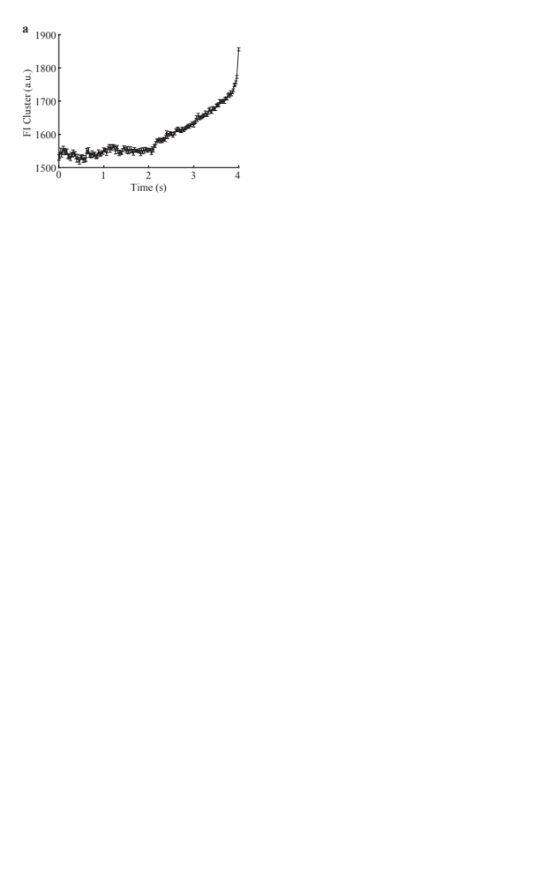
Extended data Figure 6. Fluorescence intensity measured during cluster formation
Because the extent of background fluorescence is not known from these measurements, we use the kinetics of this experimental data, but we scale the relative increase in density from time zero to time 4 s by the density increases during cluster formation measured using single-particle tracking (SPT). The density increases measured using SPT (Table 2) indicate an increase in dynamin copy numbers in clusters that seems much more consistent with formation of dynamin assemblies (10-30x increase). Our model does not describe the subsequent decrease in dynamin density, presumably following fission events, as we do not include a mechanism to stop assembly (such as fission).

