Table S1 Experimental diet nutritional composition. All other ingredients including vitamins and mineral content were equivalent.

Composition | High-fiber diet | Low-fiber diet
Protein | 19.4% | 19.4%
Total Lipids | 7.0% | 7.0%
Crude Fiber | 4.7% | 0.0%
Acid Detergent Fiber | 4.7% | 0.0%
Cellulose | 50 g/Kg | 0.0%
Wheat Starch | 404 g/Kg | 0.0%
Dextrinized Starch | 132 g/Kg | 0.0%
Glucose Monohydrate | 0.0% | 686 g/Kg
% total digestible energy calculated from protein | 21.0% | 21.0%
% total digestible energy calculated from lipids | 16.0% | 16.0%
% total digestible energy calculated from carbohydrate | 56.8% | 62%
Digestible Energy | 16.1 MJ/ Kg | 16.9 MJ/ Kg

Table S2 Assembly metrics for each MAG, listing the sample source, assembly type (Co for co-assembly), nearest GTDB representative, GTDB-linked Silva representative, GTDB representative size (Mbp), assembled MAG size (Mbp), number of assembled contigs, assembly N50 (bp), GC content, percent completion, percent contamination, number of total coding sequences (CDS), number of CAZy genes, number of MEROPS genes, and number of KO genes.
MAG | Source | Assembly | GTDB Rep | Silva Rep | Rep Size | MAG Size | Contigs | N50 | %GC | %Comp | %Cont | CDS | CAZy | MEROPS | KO
1 | HFD Raw | MEGAHIT | GCA_900760525.1 | N/A | 4.32 | 4.96 | 146 | 54455 | 46.3 | 99.44 | 0.90 | 4135 | 61 | 249 | 1657
2 | HFD Raw | MEGAHIT | ‡GCF_000455285.1 | JX101690 | 3.51 | 2.34 | 76 | 51265 | 28.2 | 100.00 | 0.00 | 2264 | 31 | 114 | 1212
3 | LFD Raw | MEGAHIT | GCF_001921825.1 | JX986969 | 2.29 | 2.08 | 132 | 21519 | 42.8 | 100.00 | 0.00 | 1842 | 14 | 87 | 1153
4 | LFD Enriched | MEGAHIT | GCF_000406965.1 | AHYV01000035 | 4.66 | 4.11 | 153 | 40941 | 39.1 | 99.31 | 2.75 | 4065 | 29 | 172 | 2295
5 | LFD Enriched | MEGAHIT | GCF_001591685.1 | CP023565 | 2.12 | 1.87 | 104 | 23233 | 40.1 | 94.10 | 0.26 | 1731 | 13 | 86 | 1086
6 | HFD Enriched | MEGAHIT Co | GCA_009774765.1 | GQ867460 | 2.65 | 2.56 | 41 | 94732 | 46.6 | 97.86 | 1.19 | 2030 | 22 | 159 | 1014
7 | HFD Enriched | SPAdes Co | GCF_900107675.1 | FKYL01000005 | 3.49 | 2.84 | 162 | 25332 | 59.1 | 96.63 | 0.24 | 2296 | 31 | 166 | 1126
8 | HFD Enriched | SPAdes Co | GCF_003612585.1 | AB702927 | 3.70 | 2.89 | 454 | 7154 | 45.8 | 89.79 | 2.43 | 2557 | 8 | 146 | 1352
9 | HFD Raw | MEGAHIT Co | GCF_000012825.1 | CP000139 | 5.16 | 4.78 | 80 | 84904 | 42.0 | 99.25 | 0.00 | 3922 | 75 | 250 | 1704
10 | LFD Enriched | MEGAHIT Co | GCF_000205025.1 | AB370250 | 2.83 | 2.69 | 75 | 61547 | 48.6 | 100.00 | 0.11 | 2448 | 5 | 128 | 1578
11 | LFD Enriched | SPAdes Co | GCF_002950215.1 | CP012735 | 4.94 | 4.77 | 64 | 116626 | 50.6 | 99.66 | 0.10 | 4502 | 29 | 220 | 3217
12 | LFD Enriched | SPAdes Co | GCA_009775375.1 | N/A | 3.57 | 2.79 | 400 | 8442 | 49.9 | 84.41 | 0.57 | 2336 | 24 | 137 | 1033
13 | LFD Enriched | SPAdes Co | GCF_000384195.1 | ARAE01000003 | 2.05 | 2.69 | 268 | 13688 | 47.4 | 95.28 | 2.86 | 2209 | 25 | 99 | 1150
14 | LFD Enriched | SPAdes Co | ‡GCF_009935865.1 | JQ084406 | 2.56 | 2.45 | 270 | 12152 | 44.8 | 95.94 | 0.31 | 2093 | 18 | 150 | 1027
15 | HFD Raw | SPAdes Co | GCF_000012845.1 | EU136681 | 4.81 | 5.21 | 73 | 160371 | 45.0 | 97.37 | 0.26 | 4071 | 33 | 260 | 1773
16 | LFD Enriched | SPAdes Co | GCF_003024925.1 | EF406429 | 2.87 | 2.11 | 82 | 36956 | 55.3 | 99.25 | 0.38 | 1756 | 15 | 106 | 1050
17 | LFD Enriched | SPAdes Co | GCF_000742135.1 | CP031734 | 5.54 | 5.10 | 59 | 130522 | 57.7 | 99.41 | 0.53 | 4724 | 37 | 221 | 3589
18 | HFD Raw | SPAdes | GCF_001564455.1 | CP011391 | 2.54 | 2.07 | 131 | 20854 | 55.2 | 96.70 | 1.35 | 1980 | 19 | 98 | 1148
19 | HFD Raw | MEGAHIT | GCF_001945605.1 | MPKA01000044 | 2.25 | 2.02 | 101 | 27233 | 42.6 | 97.04 | 2.43 | 2011 | 26 | 110 | 1175
20 | HFD Enriched | MEGAHIT | GCF_001729745.1 | CP017186 | 4.68 | 4.91 | 141 | 340735 | 55.4 | 98.03 | 0.48 | 4363 | 36 | 229 | 3337
21 | LFD Enriched | SPAdes | GCF_001544275.1 | CP025223 | 3.77 | 3.70 | 122 | 259027 | 40.0 | 99.25 | 0.57 | 3474 | 43 | 152 | 1996
22 | HFD Raw | SPAdes | ‡GCF_900169975.1 | FWEL01000003 | 3.12 | 1.58 | 208 | 9057 | 58.4 | 65.54 | 1.34 | 1491 | 4 | 47 | 688
23 | HFD Enriched | SPAdes Co | ‡GCF_900169975.1 | FWEL01000003 | 3.12 | 0.56 | 2 | 529317 | 53.0 | 43.10 | 0.00 | 576 | 0 | 21 | 314
Co: denotes a co-assembled MAG
‡: denotes a tree-based GTDB match

Table S3 KEGG Orthology definitions for indole, vitamin, short chain fatty acid, and bile salt immunoregulatory pathways. Pathways are grouped by final immunoregulatory product in each class, and pathways are labelled as directional reactions progressing from their initial substrate, key intermediate, and final product. Pathway definitions are given as a series of KO accession numbers in the KEGG module definition format, whereby genes which perform analogous reactions are separated by commas, individual reactions are separated by spaces, and reactions are grouped into parentheses when necessary. The cholesterol degrading gene ismA has no KO representative, and so a custom HMM of known and suspected ismA genes⁶⁸ was used instead. Pathway associated compounds are listed as KEGG compound accession numbers from initial substrate through final product. Note: Formatting for pathway definitions which span multiple lines may not copy correctly. Please use the pathway definitions provided in the supplementary data.
Class | Product | Pathway | Pathway Definition | Compounds
Indoles | Indole | Tryptophan → Indole | K01667 | C00078,C00463
Indoles | Indole-3-aldehyde | Tryptophan → Indole-3-acetonitrile → Indole-3-aldehyde | K01501 | C00078,C02937,C02938,C00954, C08493
Indoles | Indole-3-aldehyde | Tryptophan → Indole-3-acetonitrile → Indole-3-acetamide → Indole-3-aldehyde | (K20807,K01721) (K01426,K21801) | C00078,C02937,C02938,C02693, C00954,C08493
Indoles | Indole-3-aldehyde | Tryptophan → Indole-3-acetamide → Indole-3-aldehyde | K01426,K21801 | C00078,C02693,C00954,C08493
Indoles | Indole-3-aldehyde | Tryptophan → Tryptamine → Indole-3-aldehyde | K00128,K14085,K00149,K11817,K22417 | C00078,C00398,C00637,C00954, C08493
Indoles | Indole-3-aldehyde | Tryptophan → Indole-3-pyruvate → Indole-3-aldehyde | K04103 (K00128,K14085,K00149,K11817,K22417) | C00078,C00331,C00637,C00954, C08493
Indoles | Indole-3-propionate | Tryptophan → Indole-3-propionate | K13607 K24016 | C00078,C00331,C22006,C21283, C22236
Vitamins | Vitamin B9 | Guanosine 5'-triphosphate  → 7,8-Dihydroneopterin 2',3'-c-P → Dihydropteroate | K17488 K17487 (K13939,K13940,K01633,K09739) (K13939,K13940,K00950,K13941,K07142) (K13939,  K00796,K13941,K24102,K18974,K18824,K18825) | C00044,C20567,C20566,C04874, C01300,C04807,C00921
Vitamins | Vitamin B9 | Guanosine 5'-triphosphate  → 7,8-Dihydroneopterin 3'-P → Dihydropteroate | K01497,K14652 K22100 (K13939,K13940,K00950, K13941,K07142,K22102) (K13939,K00796,K13941,  K24102,K18974,K18824,K18825) | C00044,C01304,C05925,C04874, C01300,C04807,C00921
Vitamins | Vitamin B9 | Chorismate → Dihydropteroate | (K13950,K01664,K01665,K03342) (K02619,K18482,  K03342) (K13939,K00796,K13941,K24102,K18974, K18824,K18825) | C00251,C11355,C00568,C00921
Vitamins | Vitamin B9 | Dihydropteroate → Vitamin B9 | (K01930,K11754,K22099,K11754,K20457,K22099, K24102),K01307 (K00287,K18589,K19643,K18590, K19644,K18591,K13998) | C00921,C00415,C00101,C00504
Vitamins | Retinoate | Vitamin A → 9-cis-Retinal → Retinoate | (K11147,K11148,K00061,K11152,K11153) (K00157, K07249) | C16682,C16681,C15493
Vitamins | Retinoate | Vitamin A → Retinal → Retinoate | (K13951,K13980,K13952,K13953,K00001,K00121, K15734,K13369,K11150,K11151,K11152,K11153, K11161,K11154,K11146,K11147,K11148,K11149) (K00157,K07249) | C00473,C00376,C00777
Vitamins | Adenosylcobalamin | Vitamin B12 → Adenosylcobalamin | K00798,K19221,K04032 | C00853,C00194
Vitamins | Adenosylcobalamin | Cobyrinate a,c-diamide → Adenosylcobalamin | (K00798,K19221) K02232 (K02225,K02227) K02233 | C06504,C06506,C06507,C06508, C06509,C06510,C00194
Vitamins | Adenosylcobalamin | Dimethylbenzimidazole → Adenosylcobalamin | K00768 (K02226,K22316) K02233 | C03114,C04778,C05775,C06510, C00194

Table S3 Continued…
Class | Product | Pathway | Pathway Definition | Compounds
Short Chain Fatty Acids | Acetate | Acetyl-CoA → Acetate | K01067,K18118,K01026,K01905 | C00024,C00033
Short Chain Fatty Acids | Acetate | Acetyl-CoA → Acetyl-P → Acetate | (K13788,K00625,K15024,K04020),K00158 (K00925, K01512) | C00024,C00022,C00227,C00033
Short Chain Fatty Acids | Acetate | Acetyl-CoA → Acetyladenylate → Acetate | K01895,K01913 | C00024,C05993,C00033
Short Chain Fatty Acids | Acetate | Acetyl-CoA → Acetaldehyde → Acetate | (K00132,K04072,K04073,K18366,K04021) (K00128, K14085,K00149,K00138) | C00024,C00084,C00033
Short Chain Fatty Acids | Acetate | Pyruvate → Lactate → Acetate | (K00016,K00101) K00467 | C00022,C00256,C00186,C00033
Short Chain Fatty Acids | Acetate | Pyruvate → Acetate | K00156 | C00022,C00033
Short Chain Fatty Acids | Propionate | Acetyl-CoA → Propanoyl-CoA | (K03416,K17489,K17490,K11262,K01946,K01962, K02160,K01961,K01963,K11263,K18472,K19312, K22568,K01964,K15037,K15036) K14468 K05605 (K01692,K01825,K01782,K07515,K07514,K07511,  K14729) (K00248,K00232,K19745,K20143) | C00024,C00083,C05989,C00222, C01013,C05668,C00894,C00100
Short Chain Fatty Acids | Propionate | Pyruvate → Propanoyl-CoA | (K00016,K00101) K01026 (K20626,K20627) (K00248, K00232,K19745,K20143) | C00022,C00256,C00186,C00827, C00894,C00100
Short Chain Fatty Acids | Propionate | Methylglyoxal → Propanoyl-CoA | (((K18471,K08325) K00005),((K00005,K17741,K23257) K00048)) (K01699,K13919,K13920) K13922 | C00546,C05235,C00424,C00583, C00479,C00100
Short Chain Fatty Acids | Propionate | Succinate → Propanoyl-CoA | (K01899,K01900,K01902,K01903,K01899,K01900) (K01847,K01849,K01848) K05606 (K03416,K11264, K18426) | C00042,C04593,C04225,C02225, C21250,C00091,C01213,C06002, C02170,C00683,C00100
Short Chain Fatty Acids | Propionate | Propanoyl-CoA → Propanoyl-P → Propionate | (K13788,K00625,K15024,K13923) (K00925,K00932, K19697) | C00100,C02876,C00163
Short Chain Fatty Acids | Propionate | Propanoyl-CoA → Propanyladenylate → Propionate | (K01895,K01908) (K01895,K01908) | C00100,C05983,C00163
Short Chain Fatty Acids | Propionate | Propanoyl-CoA → Propionate | K01026,K01905,K22224,K24012 | C00100,C00163
Short Chain Fatty Acids | Butyrate | Acetyl-CoA → Butanoyl-CoA | K00626 (((K00022,K07516,K01825,K01782,K07514, K00074) (K01692,K01825,K01782,K07515,K07514, K07511,K01715)),((K00022,K07516,K01825,K01782, K07514,K00074) (K01782,K01825) K17865),(K00023 (K01782,K01825) (K01692,K01825,K01782,K07515,  K07514,K07511,K01715)),(K00023 K17865)) (K17829, K00209,K00248) | C00024,C00332,C00164,C01144, C03561,C00877,C01412,C00136
Short Chain Fatty Acids | Butyrate | Butanoyl-CoA → Butyrate | (K00634 K00929),(K01034,K01035,K19709) | C00136,C02527,C00246
Bile Salts | Glycine/Taurine | Glyco/Tauro-cholate/chenodeoxycholate  → Glycine/Taurine | K01442 | C01921,C05465,C00695,C02528, C00037,C00245
 | Coprostanol | Cholesterol → Coprostanol | ismA HMM | C00187,C00599,C03091,

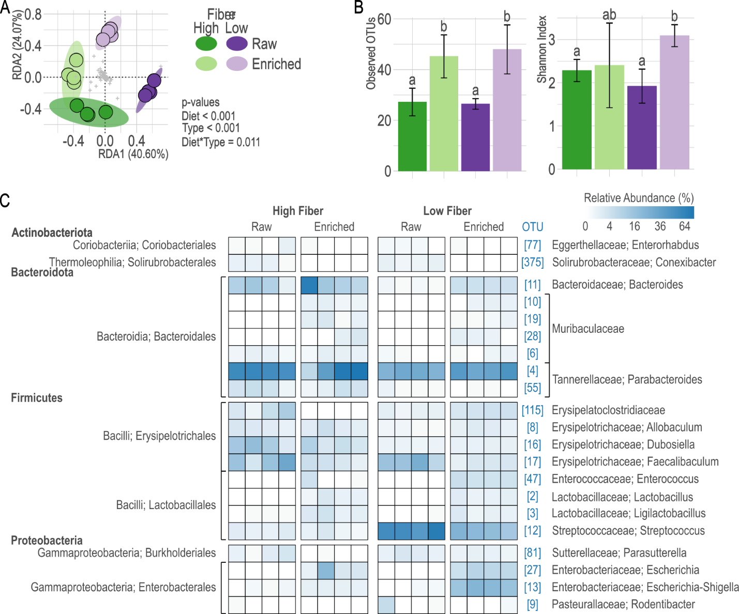
Fig. S1 16S rRNA gene amplicon diversity metrics and community profiles of raw and enriched milk. The RDA ordination (A) highlights differences in the composition of bacterial communities between treatments as represented by Hellinger-transformed OTU relative abundances. The ordination was constrained by the significant factors diet and milk type. Ellipses indicate the 95% confidence intervals of each treatment group. The bar graphs (B) display the alpha diversity of bacterial communities as represented by the average number of observed OTUs and average Shannon diversity index per treatment, along with their 95% confidence intervals. Letters above the bars indicate significantly similar communities based on Tukey’s HSD (p < 0.05). The heatmap (C) displays the Hellinger-transformed OTU relative abundances of OTUs with ≥1.0% relative abundance in at least one sample. OTUs are grouped alphabetically by decreasing taxonomic rank.

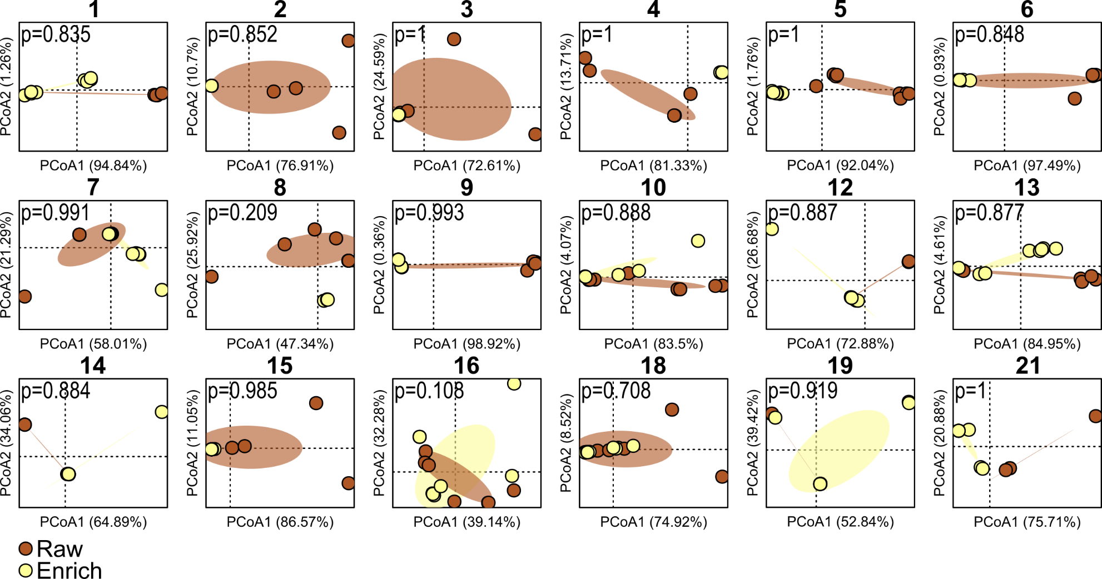

Fig. S2 PCoAs of Raw vs Enriched MAG variant ANI distance matrices. MAG IDs are listed above each biplot, and PERMANOVA p-values are listed within each biplot. Colored dots are individual samples, and ellipses represent standard deviation for each sample set.

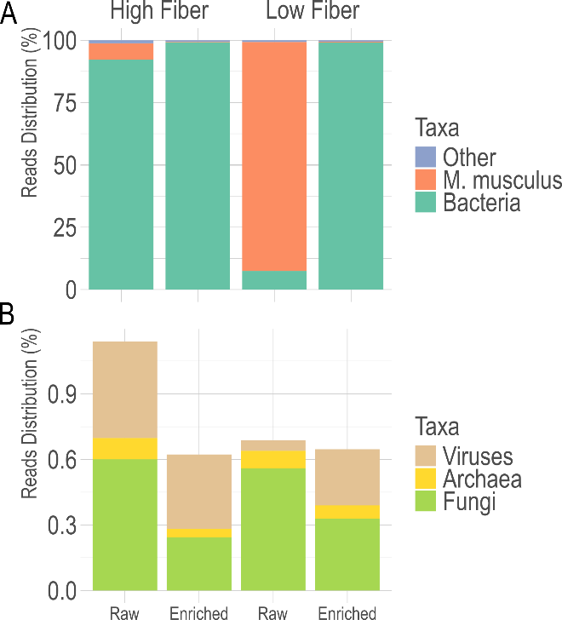

Fig. S3 Total reads distribution bar graph showing the average percent distribution of A) Bacteria and Mus musculus, and B) other minor kingdoms from all samples.

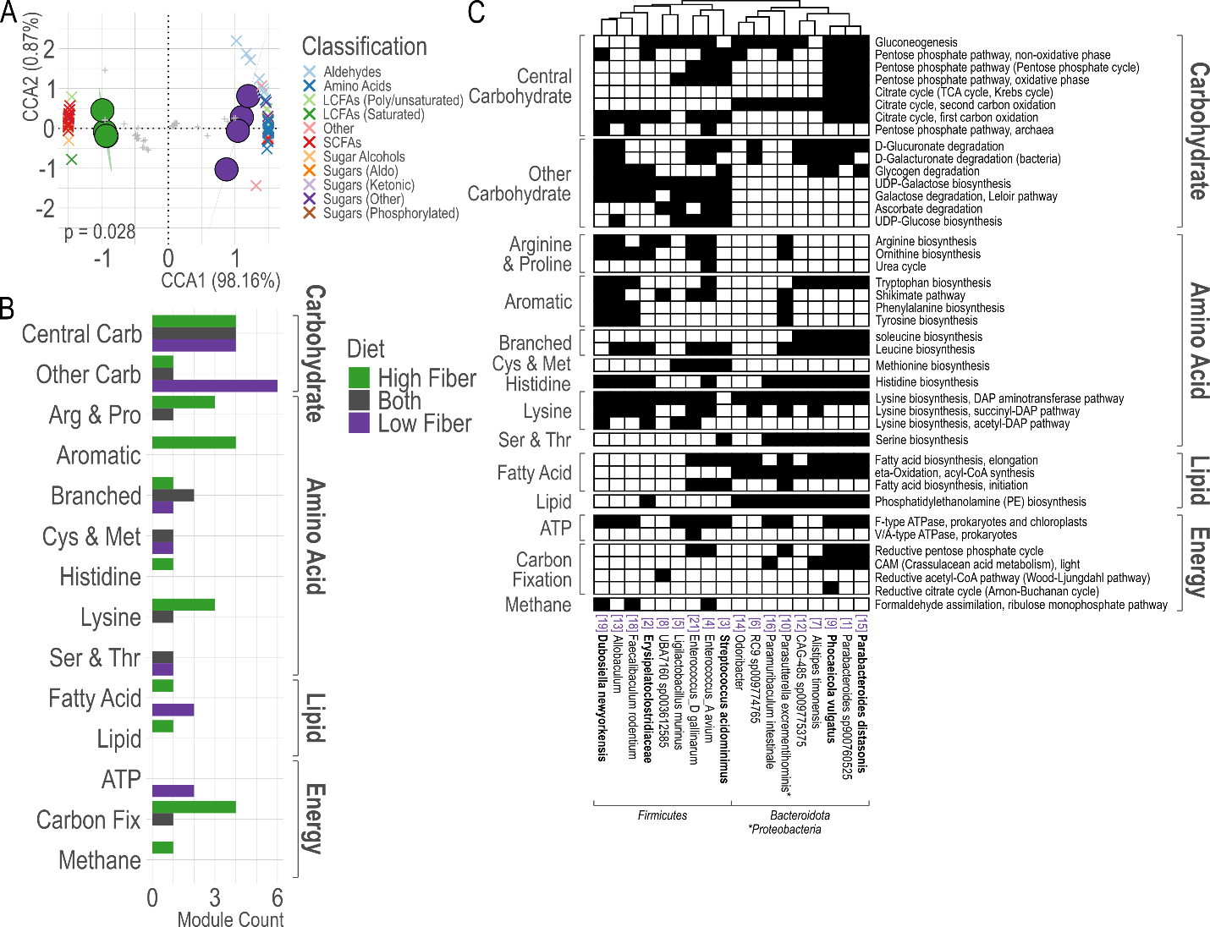

Fig. S4 Distribution of central carbohydrate, amino acid, lipid, and energy metabolism pathways. A) CCA of Hellinger-transformed trait abundances. Colored circles are milk samples, ellipses are the CI95 of sample groups, and grey +s are genes. Vectors of significant (p < 0.03) standardized metabolite abundances are mapped onto CCA as Xs colored by classification. B) The count of indicator central metabolic pathways (by class) in HFD and LFD milk, as well as those present in Both but not significantly aligned. C) Presence of indicator central metabolic pathways across all MAGs. MAGs are clustered by profile similarity, and the associated dendrogram is plotted above the heatmap. Pathway profiles are also clustered by similarity, and then regrouped by class. Major and dominant MAGs are in bold.

