Supplementary Information
Spontaneously Sn Doped Bi/BiO_{x} Nanowires Toward High-Performance CO₂ Electroreduction to Formate
Yang zhao¹, Xunlin Liu², Zhixiao Liu², Xin Lin¹, Jiao Lan¹, Yanlong Zhang¹, Ying-Rui Lu³, Ming Peng¹, Ting-Shan Chan³, Yongwen Tan^{1*}
¹ College of Materials Science and Engineering, State Key Laboratory of Advanced Design and Manufacturing for Vehicle Body, Hunan University, Changsha, Hunan 410082, China
²College of Materials Science and Engineering, Hunan University, Changsha, Hunan 410082, China
³National Synchrotron Radiation Research Center, Hsinchu 300, Taiwan
*Corresponding Author: tanyw@hnu.edu.cn

Supplementary Figures
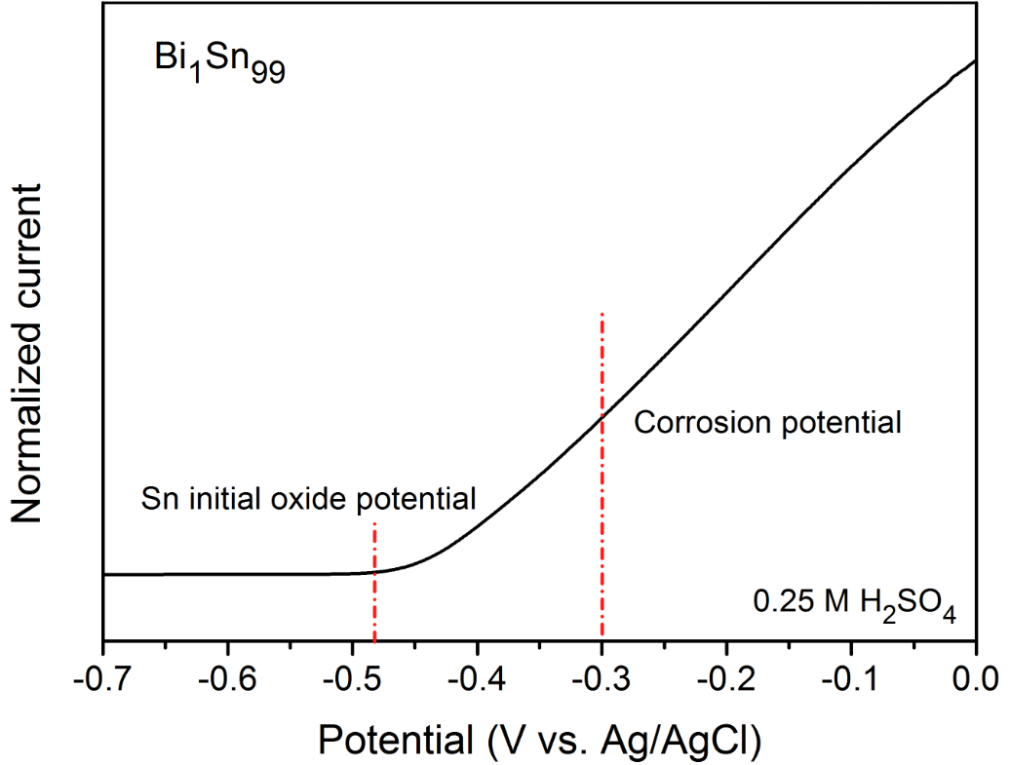
Supplementary Figure 1. The linear sweep voltammetry (LSV) curve of Bi₁Sn₉₉ in 0.25 M H₂SO₄. The oxidation (or dissolution) peak of Sn phase is from ~-0.48 V vs. Ag/AgCl, we selected the corrosion potential of -0.3 V for the selective dissolution of the Sn phase.

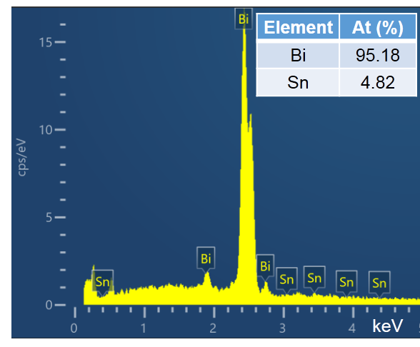
Supplementary Figure 2. EDS elemental distributions of Bi/Bi(Sn)O_{x} NWs after dealloying.

Supplementary Figure 3. Ternary phase diagram of the Bi–Sn–O system calculated at 300 °C, 1 atm¹.

Supplementary Figure 4. Schematic illustration of the flow cell configuration.

Supplementary Figure 5. XRD patterns of commercial Bi₂O₃, Bi, and SnO₂.

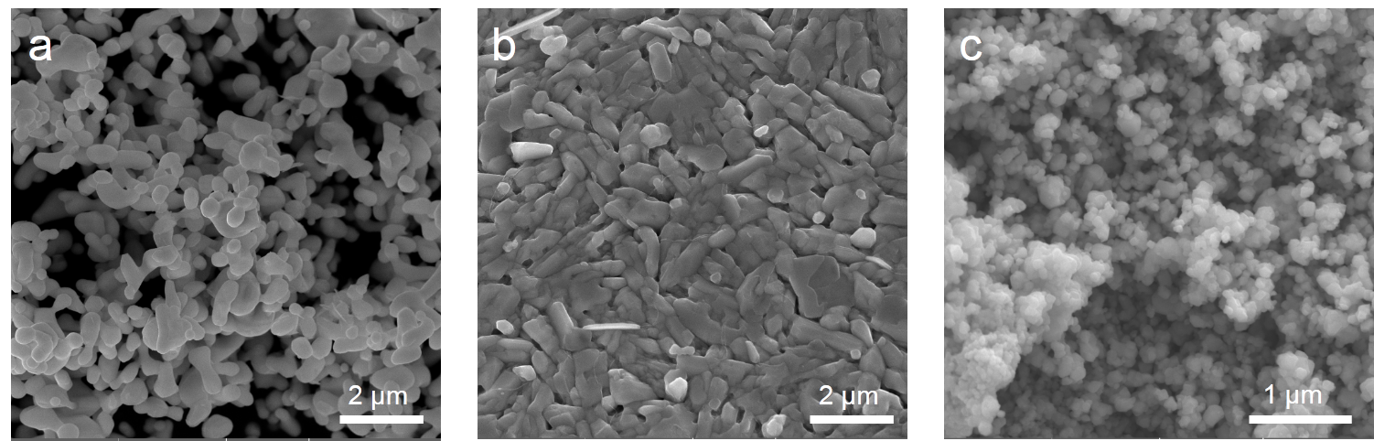
Supplementary Figure 6. SEM images of commercial Bi₂O₃ (a), Bi (b), and SnO₂ (c).

Supplementary Figure 7. A representative GC spectrum of gas product, which was produced on Bi/Bi(Sn)O_{x} NWs catalyst at -0.7 V vs. RHE.

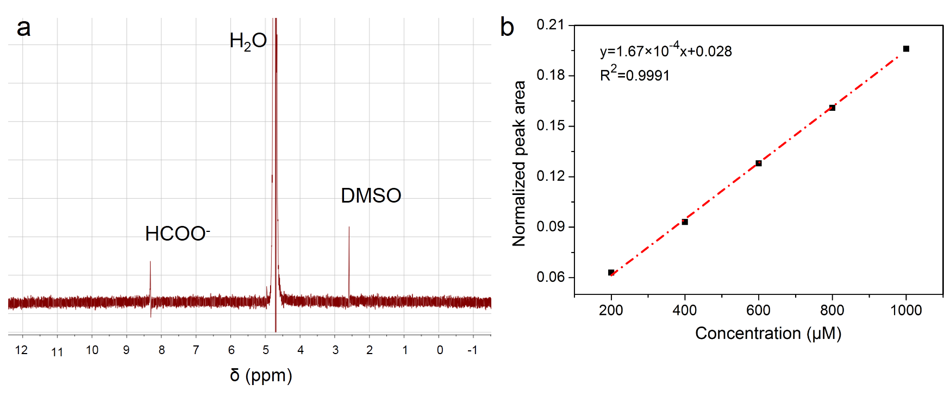
Supplementary Figure 8. (a) A representative 1H-NMR spectrum of a liquid sample, which was produced on Bi/Bi(Sn)O_{x} NWs catalyst at -0.7 V vs. RHE after 1 hour of electrolysis, (b) Established calibration curve.

Supplementary Figure 9. H₂, CO, and formate FEs of commercial (a) Bi₂O₃, (b) SnO₂, (c) Bi.

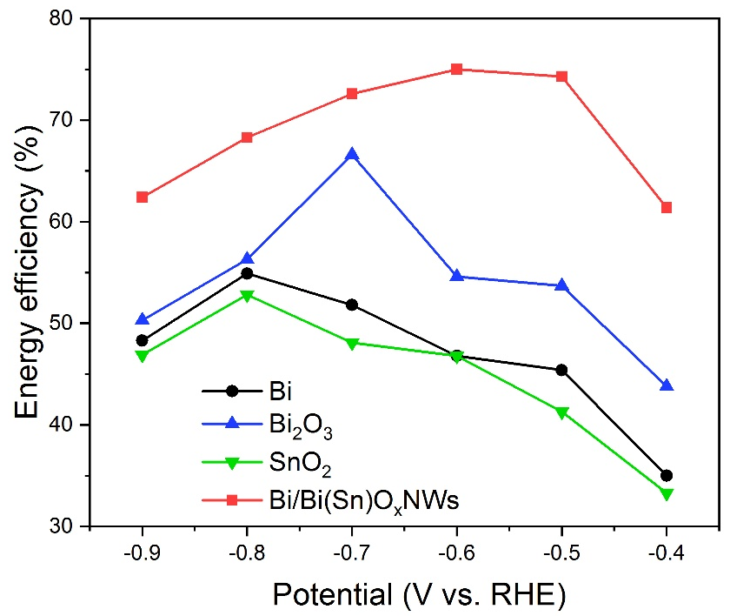
Supplementary Figure 10. Energy efficiency of Bi₂O₃, Bi, SnO₂, and Bi/Bi(Sn)O_{x} NWs at different applied potentials.

Supplementary Figure 11. Tafel plots of the Bi₂O₃, Bi, SnO₂, and Bi/Bi(Sn)O_{x} NWs in 1 M KOH.

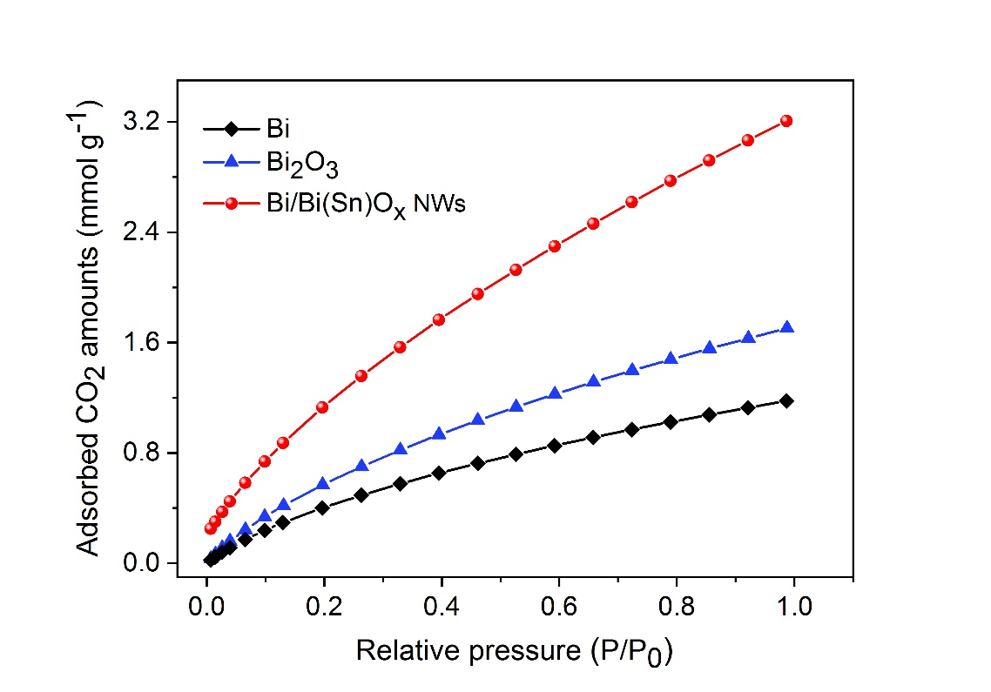
Supplementary Figure 12. CO₂ adsorption isotherms of the Bi₂O₃, Bi, and Bi/Bi(Sn)O_{x} NWs.

Supplementary Figure 13. Electrochemical impedance spectroscopy (EIS) of the different Bi₂O₃, SnO₂, Bi, and Bi/Bi(Sn)O_{x} NWs catalysts. EIS plots were performed in the frequency range of 0.01 to 10⁶ Hz at -0.4 V vs. RHE.

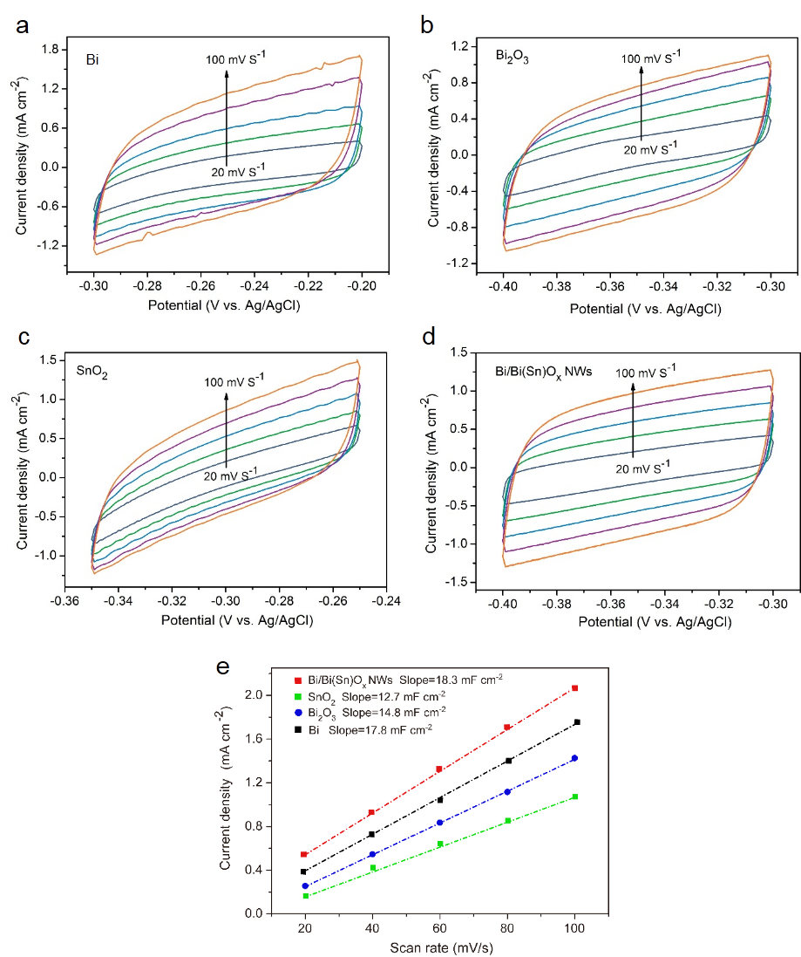
Supplementary Figure 14. (a-c) Cyclic Voltammetry (CV) curves of the catalysts (a) Bi, (b) Bi₂O₃, (c) SnO₂, and (d) Bi/Bi(Sn)O_{x} NWs. (e) The capacitive current densities plotted against scan rate.

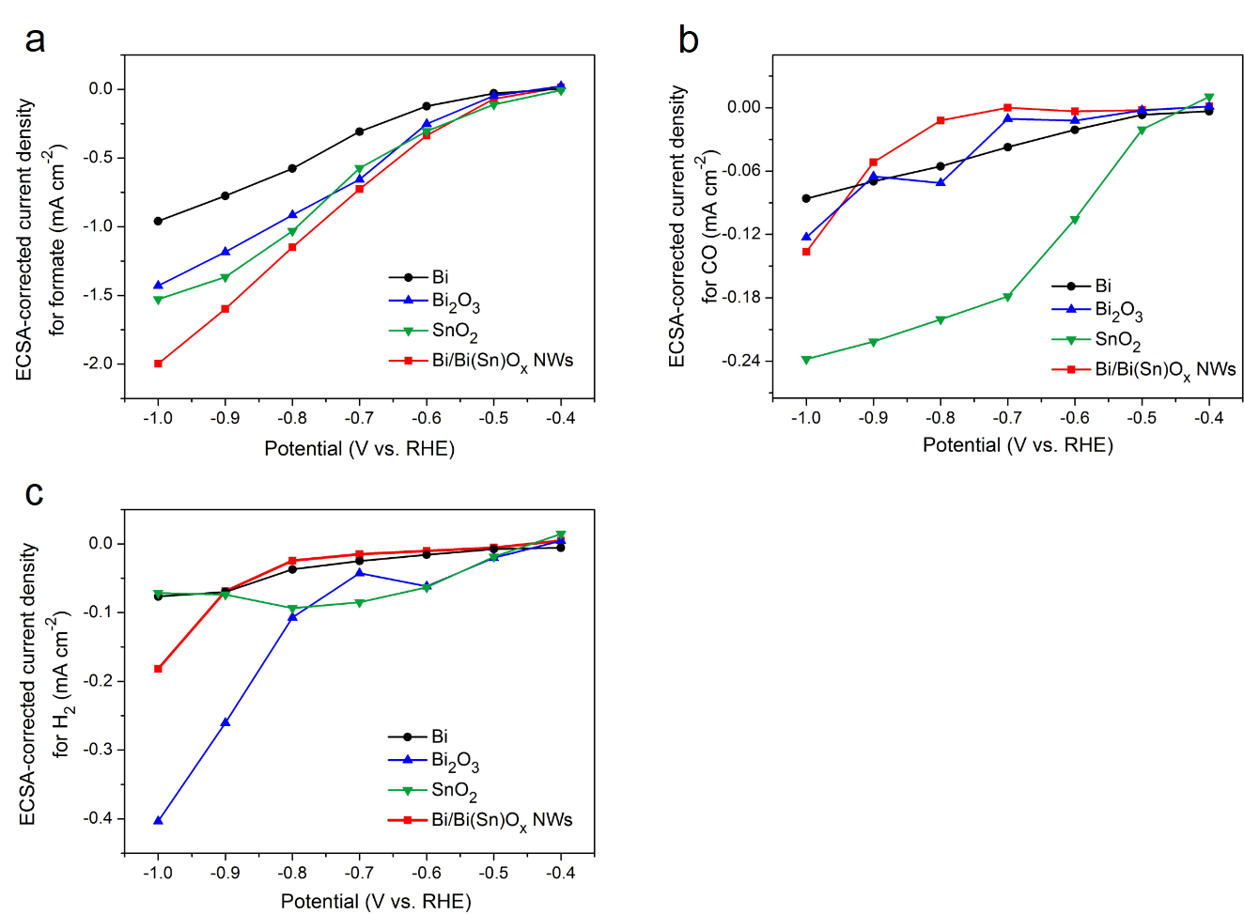
Supplementary Figure 15. ECSA-corrected current density of formate (a), CO (b), H₂ (c) for the Bi, Bi₂O₃, SnO₂ and Bi/Bi(Sn)O_{x} NWs catalysts at various applied potentials.
The calculation of ECSA was according to the formula, ECSA = R_{f}*S, in which S represents the geometric area of work electrode (1 cm²). The roughness factor (R_{f}) was obtained from the formula, R_{f} = C_{dl}/C_{s}, in which double layer capacitance (C_{dl}) was the half of the slope in Fig.S14. And the C_{s} (general specific capacitance of metal oxide) corresponds to the average double layer capacitance of a smooth oxide surface about 70 μF cm⁻².

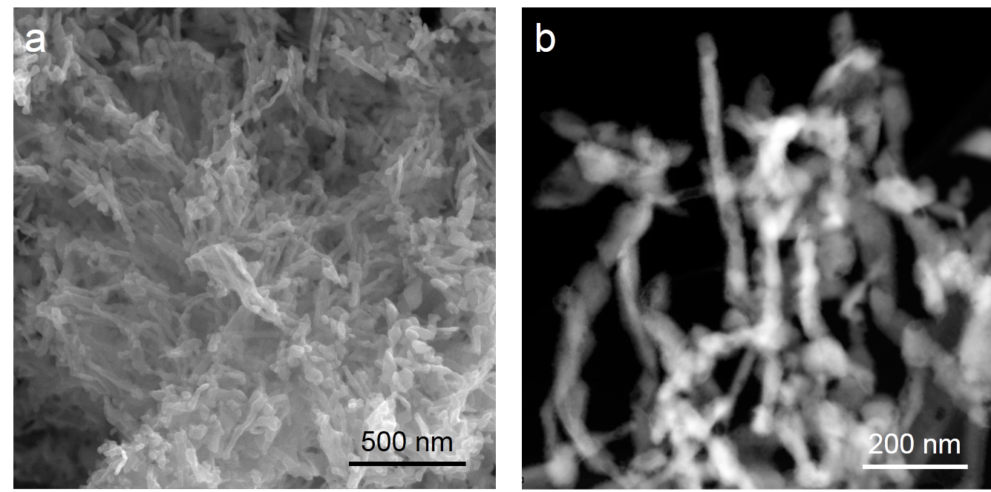
Supplementary Figure 16. (a) SEM and (b) TEM images of Bi/Bi(Sn)O_{x} NWs after 10 h stability testing.

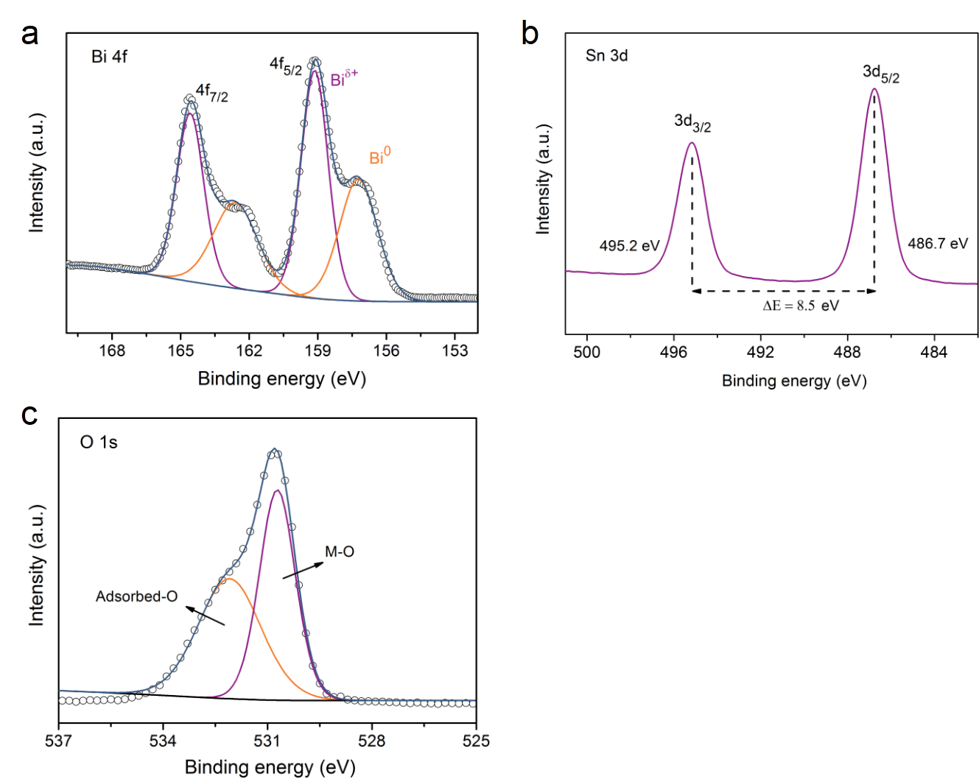
Supplementary Figure 17. (a) Bi 4f, (b) Sn 3d and (c) O 1s XPS spectra of Bi/Bi(Sn)O_{x} NWs after 10 h CO₂ reduction at -0.7 V vs. RHE.

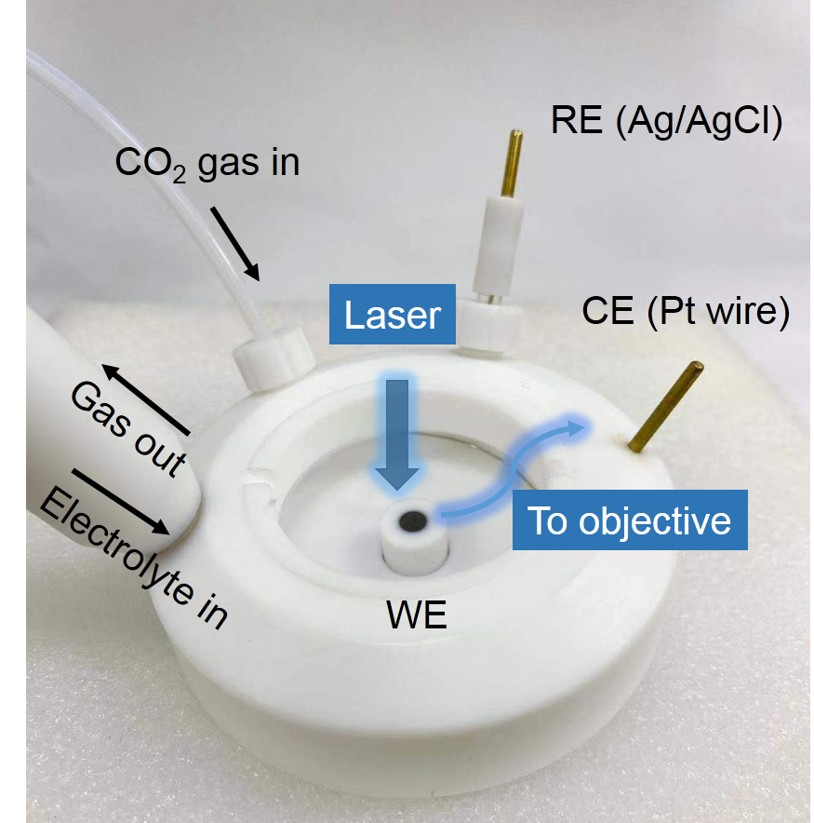

Supplementary Figure 18. A photograph of In-situ Raman electrolysis cell.

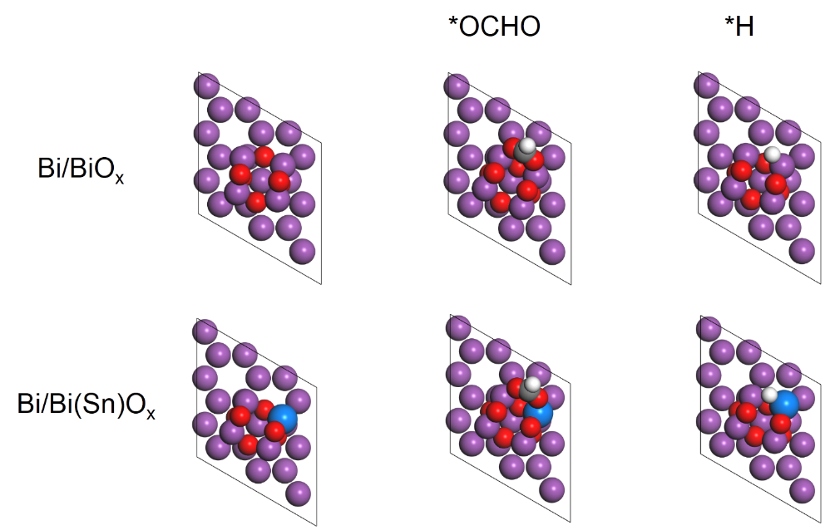
Supplementary Figure 19. DFT calculation models of *OCHO, and *H adsorption on Bi/BiO_{x} and Bi/Bi(Sn)O_{x}. Bi, pink; Sn, Bule; C, grey; O, red; H, white.
Supplementary Table 1. Elemental compositions of Bi/Bi(Sn)O_{x} NWs based on XPS and EDS characterizations.
 | Bi (at%) | Sn (at%) | O (at%)
XPS | 34.5 | 5.1 | 60.4
XPS (after Ar⁺ etch) | 51.5 | 3.4 | 45.1
EDS | 95.2 | 4.8 | /

Supplementary Table 2. Free energy of *OCHO, *H absorption and E_{p} on various DFT models.
Catalysts | *OCHO (eV) | *H (eV) | E_{p} (eV)
Bi/BiO_{x} | -0.65 | 0.32 | -2.68
Bi/Bi(Sn)O_{x} | -0.13 | 0.6 | -2.25

Supplementary Table 3. Electrochemical CO₂ reduction performance of recently Bi, Sn-based catalysts in flow cell.
Catalyst | Electrolyte | Potential range for FEs of >90%  (V vs. RHE) | Potential window (mV) | j @ -1.0 V  (mA cm⁻²) | Ref.
Bi/Bi(Sn)O_{x} NWs | 1 M KOH | -0.5 ~ -0.9 | 400 | 301.4 | This work
Bi nanosheets | 0.5 M KHCO₃ | -0.7 ~ -0.8 | 100 | ~120 | ²
Sn₈₀Bi₂₀@Bi-SnOx | 0.5 M KHCO₃ | −0.67 ~ −0.92 | 250 | ~40 | ³
Bi NSs | 1 M KOH | -0.48 ~-0.67 | 190 | ＞400 | ⁴
Bi@Sn NPs | 2 M KHCO₃ | -0.81 ~ -1.15 | 340 | ~150 | ⁵
Bismuthene nanosheets | 1 M KHCO₃ | −0.65 ~ −1.4 | 750 | ~110 | ⁶
Bi₂O₃@C-800 | 1 M KOH | -0.4 ~ -1.1 | 700 | ~220 | ⁷
Bi-ene | 1 M KOH | -0.57 ~ -0.75 | 180 | ＞300 | ⁸
NTD-Bi | 1 M KOH | -0.52 ~-0.58 | 60 | ＞300 | ⁹
SnO₂ nanosheet | 1 M KOH | -1.01~-1.13 | 120 | ~200 | ¹⁰
Sn_{2.7}Cu | 1 M KOH | -0.4~-0.7 | 300 | ＞400 | ¹¹
H–Sn₃O4 NS | 1 M KOH | -1.02 | / | 421 | ¹²

References
1 Tang, J. et al. Advantages of eutectic alloys for creating catalysts in the realm of nanotechnology-enabled metallurgy. Nat. Commun. 10, 4645 (2019).
2 Yi, L. et al. Molten salt assisted synthesis of bismuth nanosheets for long-term continuously electrocatalytic conversion CO₂ to formate. Angew. Chem. Int. Ed. 59, 2-10 (2020).
3 Yang, Q. et al. Novel Bi-doped amorphous SnO_{x} nanoshells for efficient electrochemical CO₂ reduction into formate at low overpotentials. Adv. Mater. 32, 2002822 (2020).
4 Yang, J. et al. Bi-based metal-organic framework derived leafy bismuth nanosheets for carbon dioxide electroreduction. Adv. Energy Mater. 10, 2001709 (2020).
5 Xing, Y. et al. Bi@Sn core-shell structure with compressive strain boosts the electroreduction of CO₂ into formic acid. Adv. Sci. 7, 1902989 (2020).
6 Ma, W. et al. Monoclinic scheelite bismuth vanadate derived bismuthene nanosheets with rapid kinetics for electrochemically reducing carbon dioxide to formate. Adv. Funct. Mater. 31, 2006704 (2020).
7 Deng, P. et al. Metal-organic framework-derived carbon nanorods encapsulating bismuth oxides for rapid and selective CO₂ electroreduction to formate. Angew. Chem. Int. Ed. 59, 10807-10813 (2020).
8 Cao, C. et al. Metal-organic layers derived atomically thin bismuthene for efficient carbon dioxide electroreduction to liquid fuel. Angew. Chem. Int. Ed. 59, 15014–15020 (2020).
9 Gong, Q. et al. Structural defects on converted bismuth oxide nanotubes enable highly active electrocatalysis of carbon dioxide reduction. Nat. Commun. 10, 2807 (2019).
10 Li, J. et al. Two-dimensional SnO₂ nanosheets for efficient carbon dioxide electroreduction to formate. ACS Sustain. Chem. Eng. 8, 4975-4982 (2020).
11 Ye, K. et al. In situ reconstruction of hierarchical Sn-Cu/SnO_{x} core/shell catalyst for high-performance CO₂ electroreduction. Angew. Chem. Int. Ed. 59, 4814 –4821 (2020).
12 Liu L. X. et al. Tuning Sn₃O₄ for CO₂ reduction to formate with ultra-high current density. Nano Energy 77, 105296 (2020).

