1 Stress-strain relationship
Taking S3 series as an example, the stress-strain curves of some samples were shown in Figure S2. As can be seen, the stress-strain curves of all samples show a two-segment linear form, and the axial strain is not more than 2%, showing a brittle failure. With the increase of axial strain, the axial stress of S3-0 increases slowly, and decreases rapidly when the ultimate strength is reached. When the raw material is mixed with ball milling, the stress-strain curve of the sample changes obviously, and most importantly, the axial strain corresponding to the ultimate strength decreases gradually. However, at low axial strain, the linear fit of the curve is better, and when the stress reaches the extreme value, the curve shows an obvious turning point. After cement clinker is added, the slope of the curve increases gradually both under low axial strain and high axial strain, and the strain value of brittle failure is inversely proportional to the amount of clinker.
According to the above phenomena, ball milling has obvious effect on improving the mechanical properties of OBM. In the process of axial stress loading, the specimens showed a significant increase in ultimate stress while resisting the axial deformation. The deformation velocity of the specimens treated by ball milling increases linearly with the increase of axial strain before reaching the stress extreme value. After reaching the ultimate stress, obvious fracture occurs, and the axial stress decreases linearly, which is a brittle fracture (Tang et al. 2022). However, with the incorporation of cement clinker, the brittle fracture phenomenon of the sample becomes more obvious, indicating that the mechanical properties are enhanced.

2 Fraction distribution of Ni and Co
The result of acid soluble fraction (F1), reducible fraction (F2), oxidizable fraction (F3), and residual fraction (F4) distribution of Ni and Co was detected by BCR sequential extraction (Rizwan et al. 2021) procedure and showed in Figure S3.
In Figure S3a, S1-0, S2-0, S3-0 and S4-0 are mixtures without ball milling treatment, and F1 proportions of Ni are 25.03%, 28.71%, 27.37% and 29.11%, respectively, while the F1 proportions of samples after ball milling treatment all drop below 10%. Among them, F4 proportions of S4-5 reached 70.51%, which was the largest value of all samples. At this time, it was difficult for Ni to have environmental risk. These results are basically consistent with the rule of toxic leaching content in Figure 2. The results show that the stability of Ni can be effectively improved by ball milling and low alkali curing, and it can be transformed into stable state.
In Figure S3b, after ball milling and low-alkali curing, F4 proportions of Co in different samples remained above 65%, indicating that the curing effect of Co by this method was quite effective. Compared with S1-0, S2-0, S3-0 and S4-0, the proportions of F1, F2, F3 and F4 of Co are average, while the morphology of the rest samples is substantially transformed to F4, showing good environmental friendliness. It follows that most of the contaminated ions in the tailings would not be activated ultimately, and the curing method used in this study would not increase the risk of environmental pollution (Liu et al. 2022).

References
Liu WJ, Hu TP, Mao Y, Shi MM, Cheng C, Zhang JQ, Qi SH, Chen W, Xing XL (2022): The mechanistic investigation of geochemical fractionation, bioavailability and release kinetic of heavy metals in contaminated soil of a typical copper-smelter. Environmental Pollution 306
Rizwan MS, Imtiaz M, Zhu J, Yousaf B, Hussain M, Ali L, Ditta A, Ihsan MZ, Huang GY, Ashraf M, Hu HQ (2021): Immobilization of Pb and Cu by organic and inorganic amendments in contaminated soil. Geoderma 385
Tang YX, Xiao JZ, Zhang HH, Duan ZH, Xia B (2022): Mechanical properties and uniaxial compressive stress-strain behavior of fully recycled aggregate concrete. Construction and Building Materials 323

Figure and Table Caption
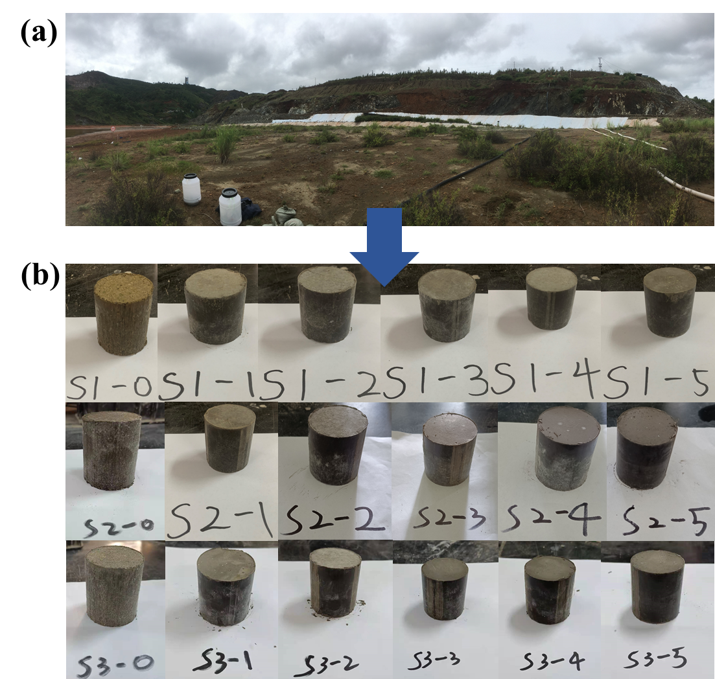

Figure S1 Photos of samples after 28d curing at room temperature.
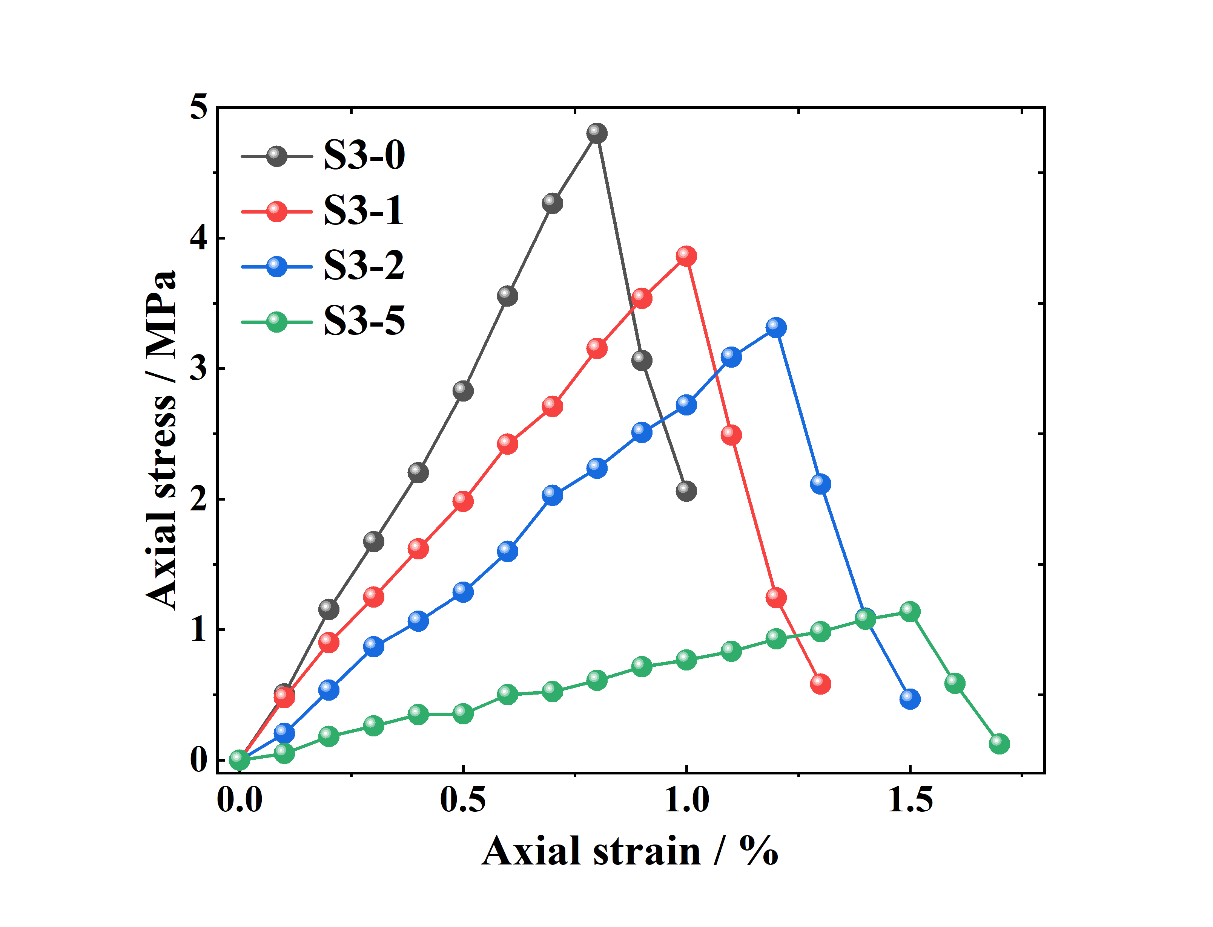

Figure S2 The stress-strain curve of samples.
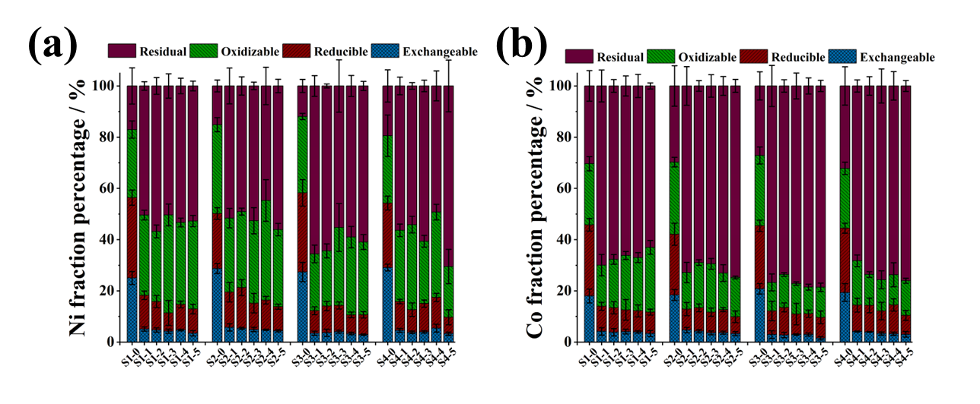

Figure S3 Proportion of each chemical form of heavy metals in samples, (a) Ni, (b) Co.
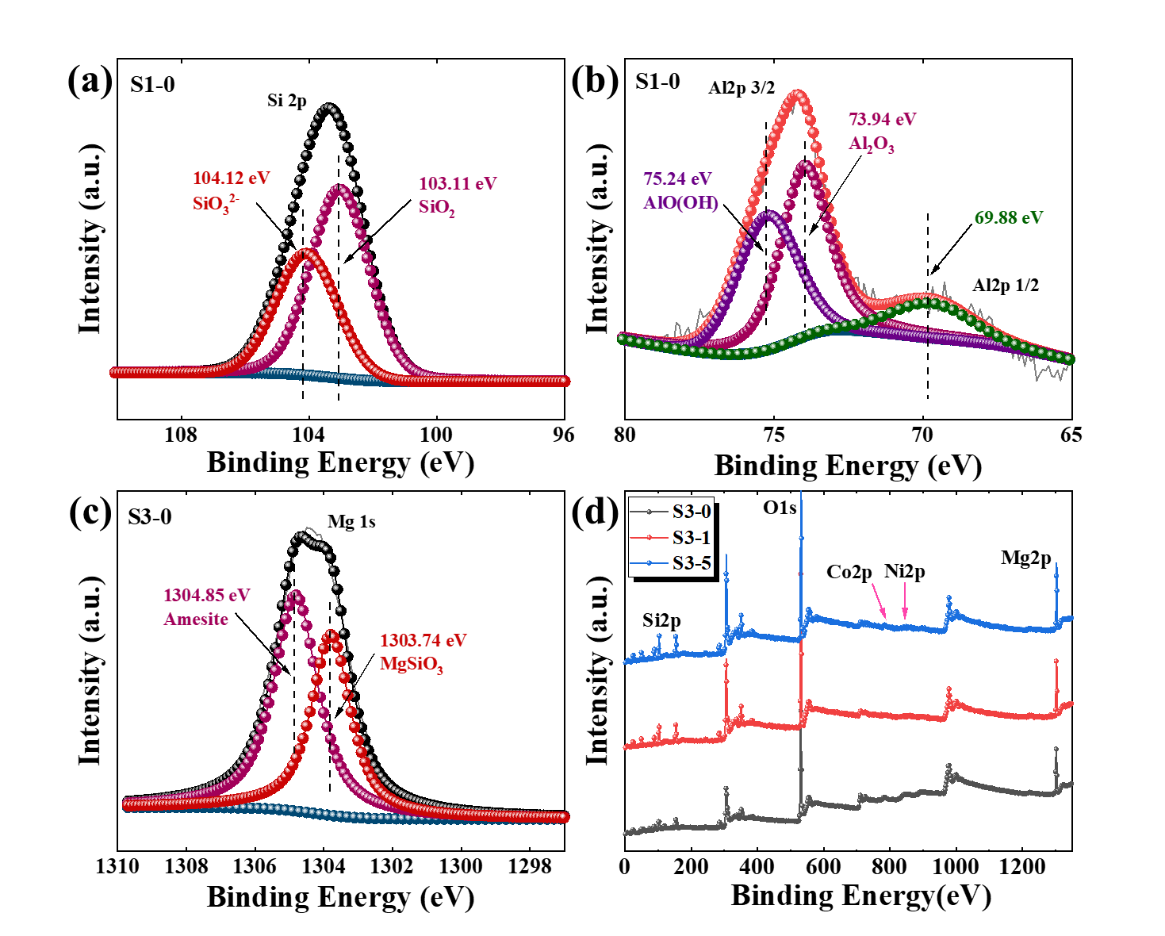

Figure S4 XPS analysis results of samples: (a) S1-0 Si, (b) S1-0 Al, (c) S3-0 Mg.

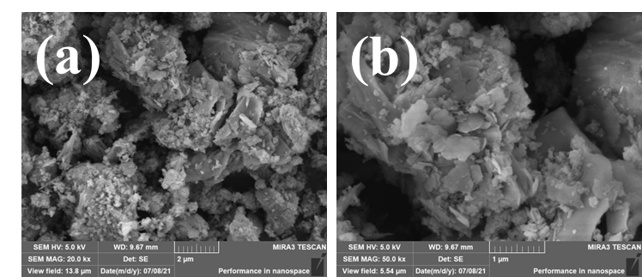

Figure S5 The microscopic morphology of samples: (a) S3-0, (b) S3-0.

Table S1 Variable design of ball milling
Quality ratio V_{ma}  (Tailings: ash) | Sample number | Process method
7:1 | M1 | Ball-milling
7:1 | N1 | No ball-milling
5:1 | M2 | Ball-milling
5:1 | N2 | No ball-milling
3:1 | M3 | Ball-milling
3:1 | N3 | No ball-milling
1:1 | M4 | Ball-milling
1:1 | N4 | No ball-milling
/ | BA | Ball-milling
/ | OOM | Ball-milling

