Supplementary Information
Ultra-High Capacity, Multifunctional Nanoscale Sorbents for PFOA and PFOS Treatment
Junseok Leeª, Changwoo Kim^{b}, Chen Liu^{c}, Michael Wong^{d}, Natalie L. Capiro^{e}, Kurt D. Pennell^{c}, and John D. Fortner^{*,a}
ªDepartment of Chemical and Environmental Engineering, Yale University, New Haven, CT, 06511 United States
^{b}School of Earth Sciences and Environmental Engineering, Gwangju Institute of Science and Technology, Gwangju 61005, Republic of Korea
^{c}School of Engineering, Brown University, Providence, RI, 02912 United States
^{d}Department of Biological and Chemical Engineering, Rice University, Houston, TX 77005 United States
^{e}Department of Civil and Environmental Engineering, Auburn University, Auburn, AL, 36849 United States

*To whom correspondence should be addressed:
John D. Fortner: Tel: +1-314-935-9293; Email: john.fortner@yale.edu
Supplementary Information Text
Materials
Iron oxy hydroxide (FeOOH, catalyst grade), oleic acid (OA, 90%), 1-octadecene (1-ODE, 90%), branched polyethyleneimine (PEI, MW = 10k and 25k), cetyltrimethylammonium bromide (CTAB, 95%), polyethyleneglycol (PEG, MW = 5k), hexane (98.5%), acetone (99.5%), ethanol (99.9%), nitric acid (HNO₃, 70%), sodium hydroxide (NaOH, 97%), perfluorooctanoic acid (>96%, CAS: 335-67-1, MW = 414.07), and heptadecafluorooctanesulfonic acid solution (~40% in H₂O, CAS: 1763-23-1, MW = 500.13), sodium bicarbonate (NaHCO₃, 99.7%), magnesium chloride hexahydrate (MgCl₂·6H₂O, 99%), calcium chloride dehydrate (CaCl₂·2H₂O, 99%), sodium metasilicate nonahydrate (Na₂SiO₃·9H₂O, 98%), and sodium phosphate dibasic heptahydrate (Na₂HPO₄·7H₂O, 98%) were purchased from Sigma-Aldrich. Nitrogen gas (N₂, 99.999%) was used to synthesize NCs.

Measurement of PFAS Concentration
Measurement of both PFOA and PFOS concentrations, along with their corresponding ¹³C-labeled internal standards, was conducted by the method referred in McCord et al.¹ We used a Waters ACQUITY ultra performance liquid chromatograph coupled with a Waters Xevo triple quadrupole mass spectrometer (UPLC-MS) (Waters Corporation, Milford, MA). The injection volume was 10 μL. Solvent A contained 95% DI water and 5% methanol with 2 mM ammonium acetate. Solvent B contained 100% methanol with 2 mM ammonium Acetate. all solvents were prepared with LC-MS grade, purchased from Honeywell Burdick & Jackson (Muskegon, MI). The gradient started with 90% A and 10% B and held for 1 min, then ramped to 15% A and 85% B at 5min, then 0% A and 100% B at 5.1 min, maintained at 100% B until 7 min and ramped back to 90% A and 10% B at 7.5 min. The eluent was then held at 90% A and 10% B until the end of the 10 min run. Column temperature was 50°C and source temperature was 150°C. Desolvation temperature was 350°C and desolvation gas flow was 650°C. Analytes were separated on a Waters BEH C-18 column (1.7 μm dia., 2.1 × 50 mm²) at a flow rate of 0.4 mL/min with an eluent gradient containing 2 mM ammonium acetate in water or methanol. The mass spectrometer was operated in negative electrospray ionization (ESI-) with multiple reaction monitoring (MRM). The method was able to detect 40 PFAS, precursors and ¹³C labeled standards with a total run time of approximately 10 min and detection limits ranging from 5 to 20 ng/L.

SI References
1 McCord, J., Newton, S. & Strynar, M. Validation of quantitative measurements and semi-quantitative estimates of emerging perfluoroethercarboxylic acids (PFECAs) and hexfluoroprolyene oxide acids (HFPOAs). Journal of Chromatography A 1551, 52-58 (2018).

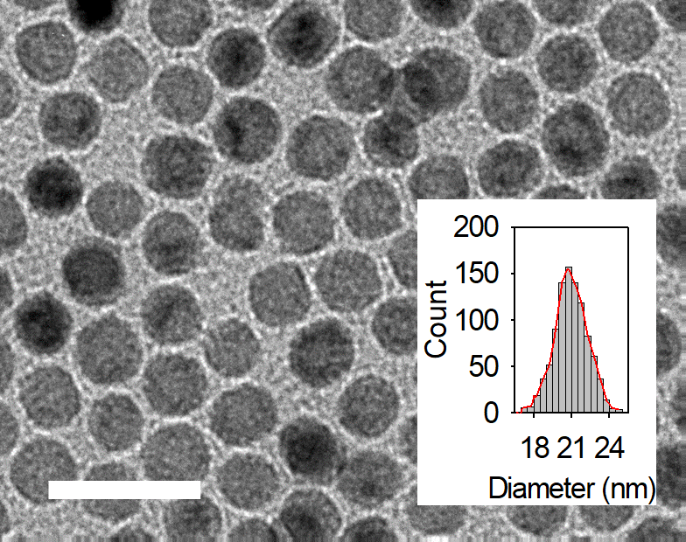
Supplementary Fig. 1. TEM images of monodisperse iron oxide nanoparticles (IONCs) and histograms of the size distribution of NCs. Average diameter of NCs was measured using Image-Pro 6.0 with over a thousand counted. Scale bar is 50 nm.
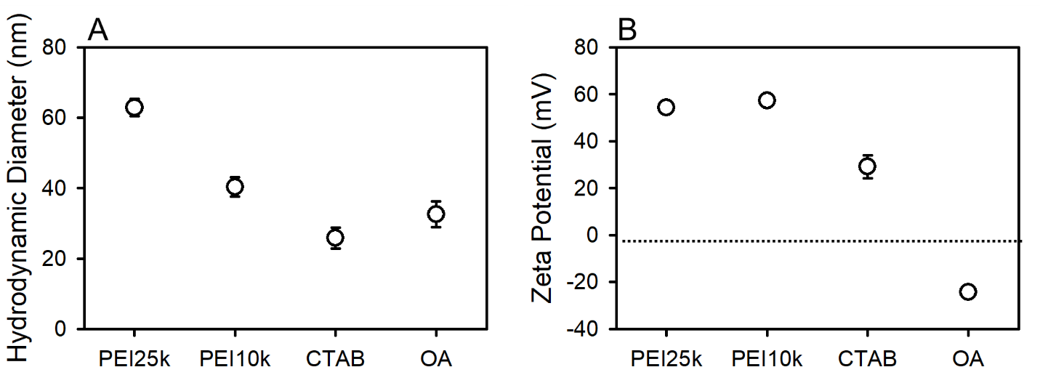
Supplementary Fig. 2. (A) Hydrodynamic diameters and (B) zeta potential of organic functionalized IONCs with polyethyleneimine (PEI), cetyltrimethylammonium bromide (CTAB), and oleic acid (OA) at pH 7.0 ± 0.2.
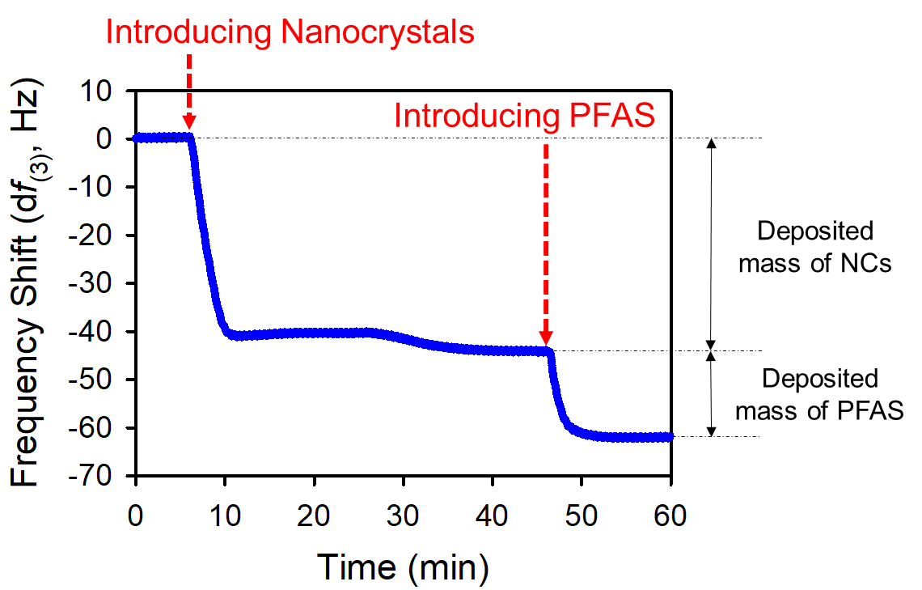
Supplementary Fig. 3. Real time frequency responses of QCM-D for PFAS sorption on organic functionalized iron oxide nanocrystals (IONCs) coated Q-sensor.
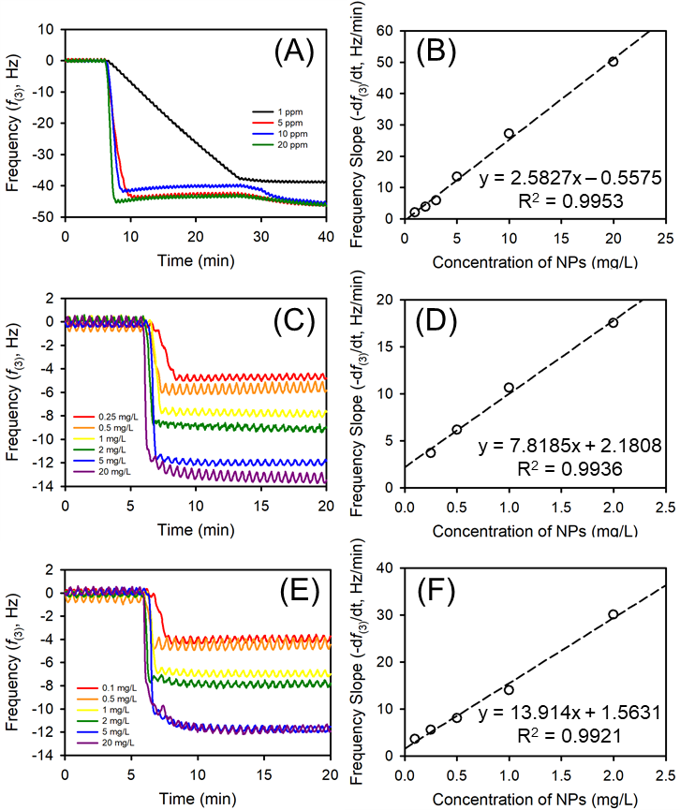
Supplementary Fig. 4. Frequency shift and slope with respect to the different concentration of IONCs with various surface coating; (A, B) CTAB, (C, D) PEI25k, and (E, F) PEI10k, respectively.
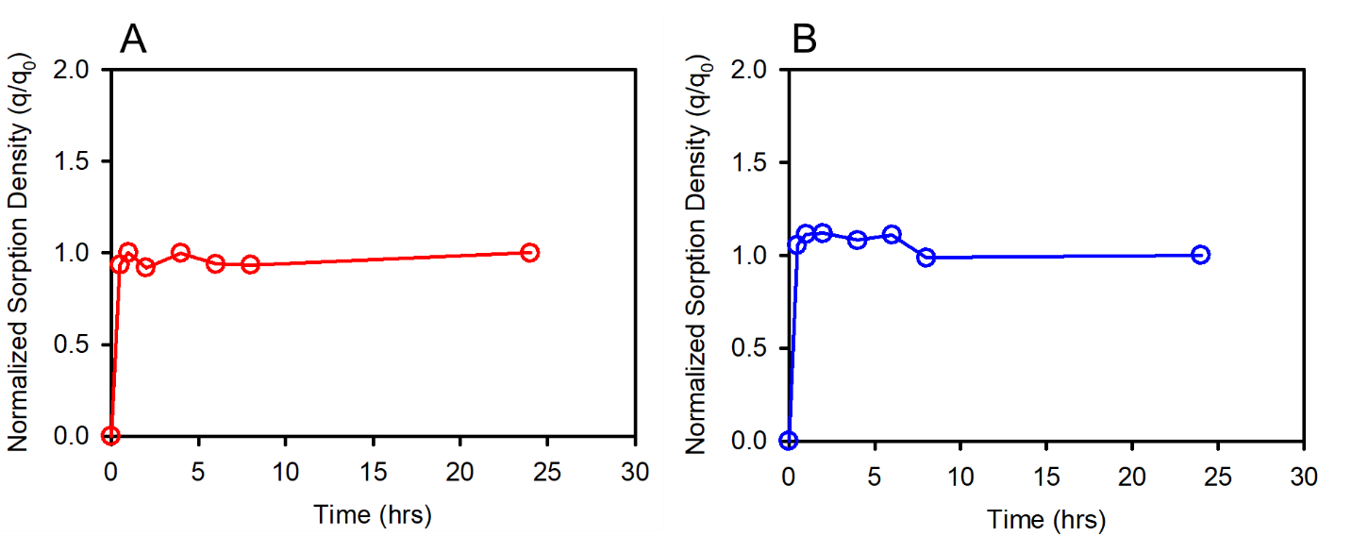
Supplementary Fig. 5. Time dependent normalized sorption density of PEI coated IONCs (Fe₃O₄@PEI25k) for 0.6 mM of (A) PFOA and (B) PFOS.
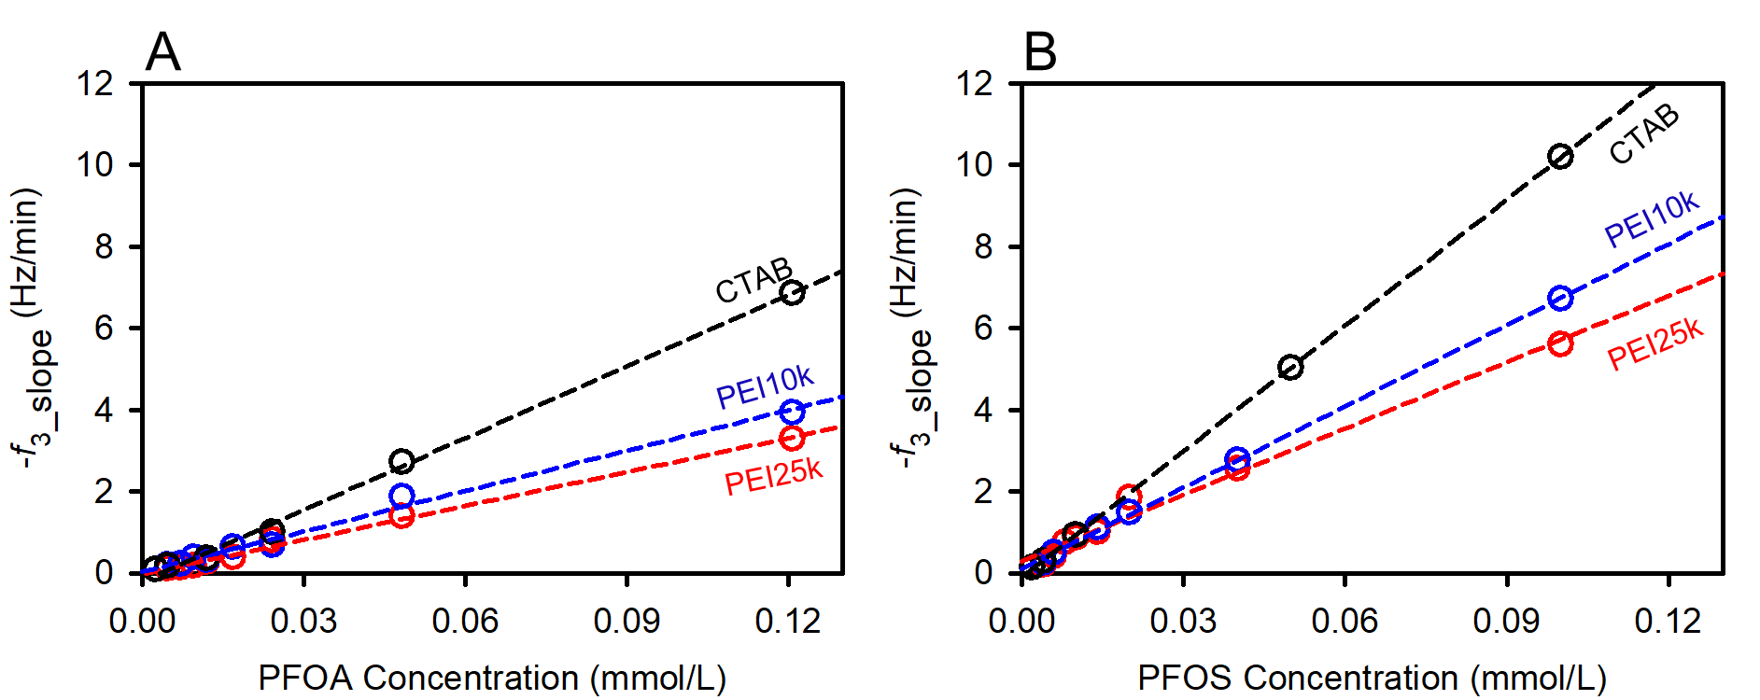
Supplementary Fig. 6. Real time deposition rates (-f_{3_slope}) of (A) PFOA and (B) PFOS on IONCs with respect to the different surface coating (PEI25k, PEI10k, and CTAB).
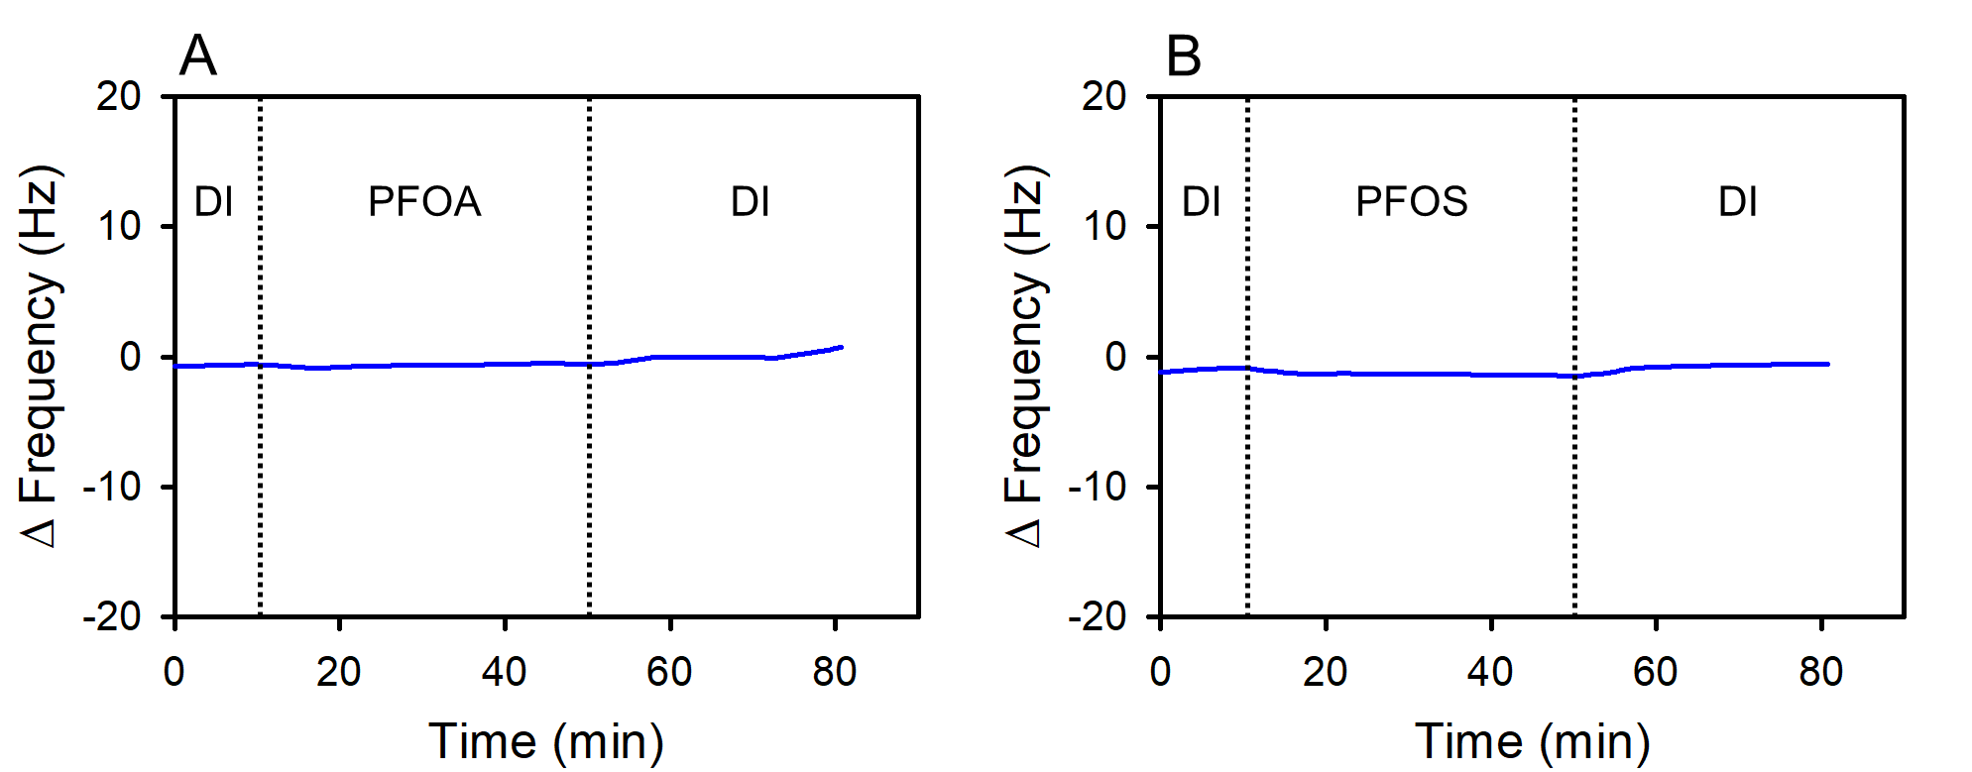
Supplementary Fig. 7. Frequency shift of quartz crystal sensor (overtone = 3) with 0.6 mM of (A) PFOA and (B) PFOS solutions at pH 7.
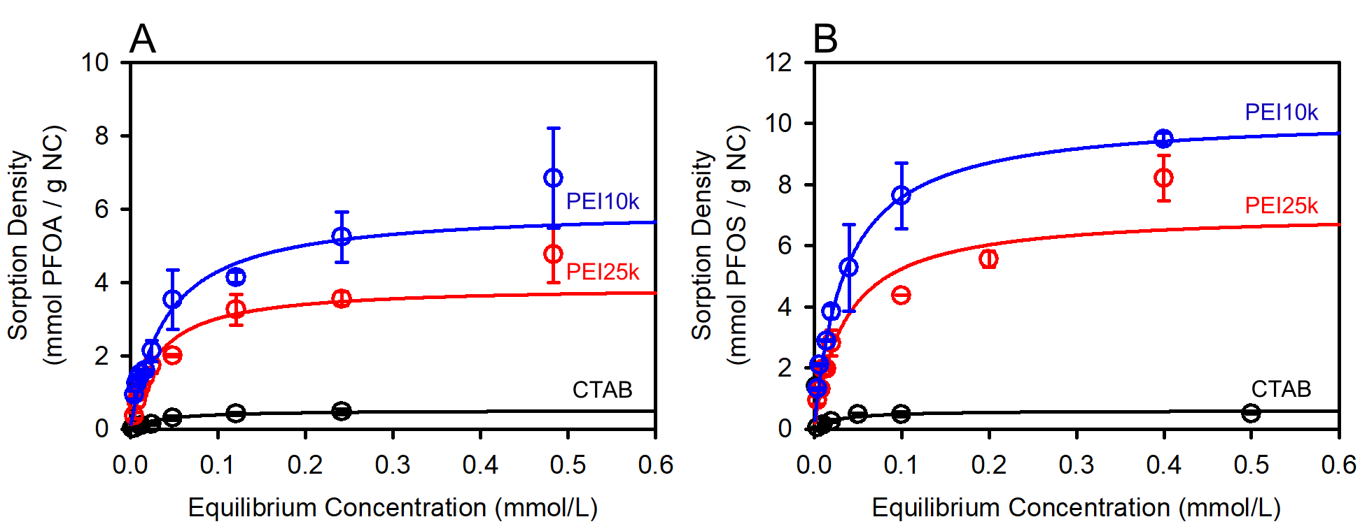
Supplementary Fig. 8. (A) PFOA and (B) PFOS sorption isotherm on iron oxide nanocrystals (IONCs) obtained from mass of IONCs deposited on Q-sensor and mole of PFAS attached to IONCs via QCM-D. Note that no correction factor is applied here to consider water sorption.
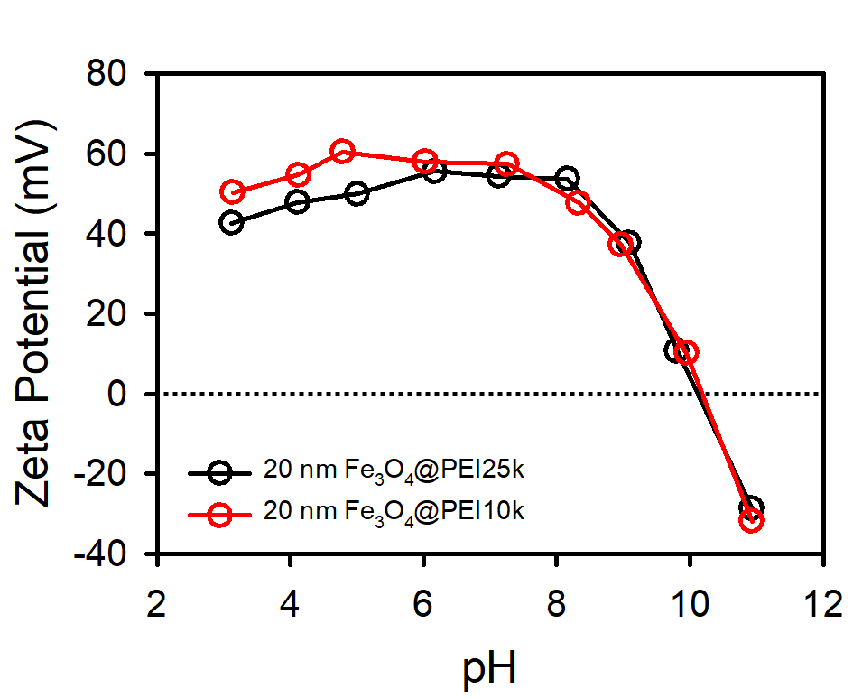
Supplementary Fig. 9. Zeta potential of PEI coated IONCs with different molecular weight (25k and 10k) as a function of solution pH.
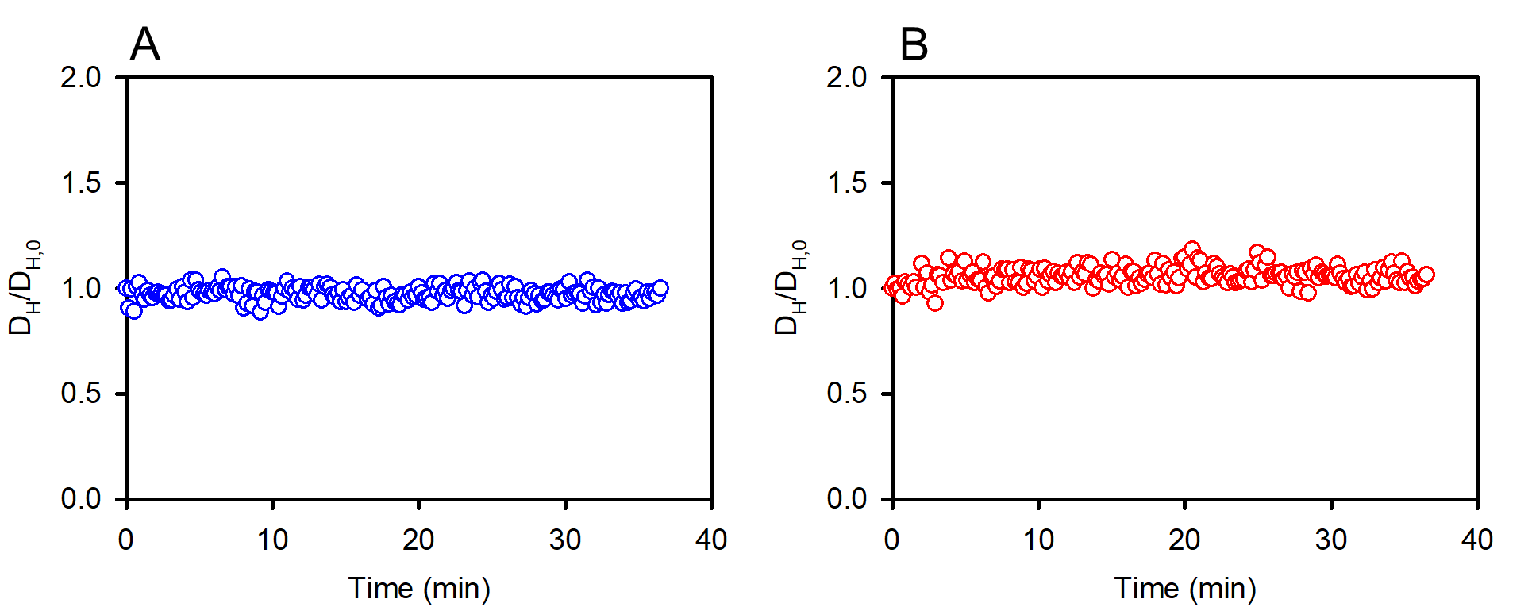
Supplementary Fig. 10. Aggregation profile of Fe₃O₄@PEI25k NCs in the presence of (A) 1000 mM of NaCl and (B) 1000 mM of CaCl₂ concentrations at pH 7.
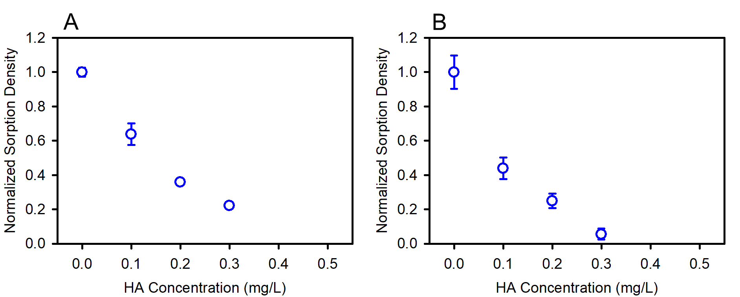
Supplementary Fig. 11. Normalized sorption density for (A) PFOA and (B) PFOS on Fe₃O₄@PEI25k NCs as a function of humic acid (HA) concentrations via QCM-D method.
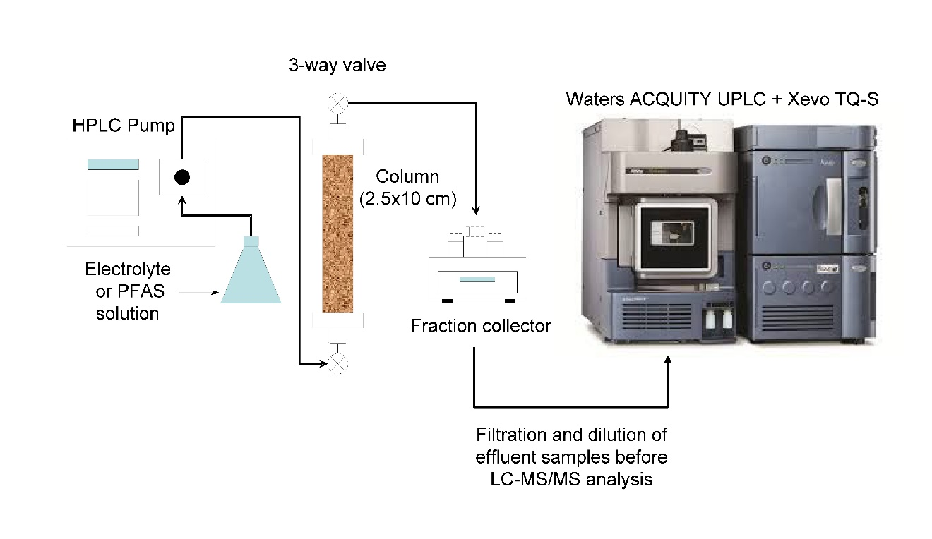
Supplementary Fig. 12. Schematic diagram of the experimental system used for the column studies.
Supplementary Table 1. Organic loading on the nanocrystals.
Nanocrystals | Molecular weight of coating material | Total organic carbon (ppm of carbon)^{α} | Number of carbon per nanocrystal | Number of amine groups per carbon^{β, γ} | Number of amine groups per nanocrystal | Number of molecules per nanocrystal
Fe₃O₄@PEI25k | 25,000 | 63 ± 1.3 | 690,306 | 0.5^{β} | 345,153 | 297
Fe₃O₄@PEI10k | 10,000 | 57 ± 0.7 | 627,729 | 0.5 | 313,864 | 676
Fe₃O₄@CTAB | 364.45 | 6.3 ± 0.1 | 685,526 | 0.037^{γ} | 25,364 | 25,364
^{α}Total organic carbon (TOC) for organic functionalized iron oxide nanocrystals (10 ppm Fe).
^{β}Number of amine groups per carbon of PEI coated IONCs was obtained by considering repeat unit of multi branched PEI structure.
^{γ}Number of amine groups per carbon of CTAB functionalized IONCs was obtained based on an assumption of full surfactant encapsulation.
Supplementary Table 2. Sorption isotherm constants and regression data for Langmuir and Freundlich adsorption isotherm models.
Target | Adsorbents | Langmuir Isotherm |  |  | Freundlich Isotherm
Target | Adsorbents | q_{max} (mmol/g) | k (L/mmol) | R² | K_{f} ^{α} | n | R²
PFOA | Fe₃O₄@PEI25k | 18.3 | 657 | 0.99 | 41.9 | 4.28 | 0.88
PFOA | Fe₃O₄@PEI10k | 11.9 | 148 | 0.95 | 29.9 | 2.92 | 0.98
PFOA | Fe₃O₄@CTAB | 3.14 | 112 | 0.99 | 4.16 | 5.36 | 0.90
PFOA | Fe₃O₄@OA | 1.83 | 16.5 | 0.70 | 3.60 | 1.94 | 0.89
PFOS | Fe₃O₄@PEI25k | 88.8 | 4.22 | 0.99 | 98.6 | 1.73 | 0.99
PFOS | Fe₃O₄@PEI10k | 83.5 | 9.27 | 0.99 | 88.5 | 3.20 | 0.95
PFOS | Fe₃O₄@CTAB | 6.58 | 16.3 | 0.99 | 7.02 | 3.10 | 0.97
PFOS | Fe₃O₄@OA | 5.30 | 6.89 | 0.61 | 16.0 | 1.17 | 0.75
^{α}Unit of K_{f} is (mmol/g) (L/mmol)^{1/n}.
Supplementary Table 3. Ionic composition of synthetic groundwater.
Ion | Na⁺ | Ca²⁺ | Mg²⁺ | HCO³⁻ | Cl⁻ | HPO₄²⁻ | SiO₃²⁻
Conc.  (mM) | 10.4 | 2.5 | 1.6 | 8.2 | 8.2 | 0.1 | 1

