Supplementary information for

Renal microdissection revisited: Lectin-aided sorting of intact tubular nephron segments as a new tool to study sex-related differences in kidney disease

Authors and affiliations:
Jessica Roskosch¹, Anne-Christine Uldry², Uyen Huynh-Do^{1,†}, and Stefan Rudloff^{1,†,*}

¹Division of Nephrology and Hypertension, University of Bern and University Hospital Bern, Freiburgstrasse 15, CH-3010 Bern, Switzerland
²Core Facility Proteomics and Mass Spectrometry, Department for BioMedical Research, University of Bern, Murtenstrasse 28, CH-3008 Bern, Switzerland

†Authors contributed equally to this work
*Corresponding author: Stefan Rudloff: stefan.rudloff@dbmr.unibe.ch
Tel.: +41 31 632 98 17
Fax: +41 31 632 97 34

Supplementary Material

Supplementary Fig. S1. BSA in the staining solution reduced lectin staining specificity.
Supplementary Fig. S2. Lectin staining on renal cryosections.
Supplementary Fig. S3. SBA labeled two different nephron segment populations.
Supplementary Fig. S4. Gating strategy.
Supplementary Fig. S5. Lipid metabolism and gluconeogenesis were enriched in PTs.
Supplementary Fig. S6. Glycogenolysis and glycolysis were enriched in DCTs.
Supplementary Fig. S7. Androgen-regulated proteins were enriched in males.
Supplementary Fig. S8. Proteins involved in drug metabolism enriched in males.

Supplementary Table T1. Top 20 records for female and male PT nephron segments.
Supplementary Table T2. Top 20 records for female and male DCT nephron segments.
Supplementary Table T3. Lectins used in this study.
Supplementary Table T4. Primers for qPCR.

Separate files
Supplementary File F1 Proteins differentially expressed between sorted PT and DCT.
Supplementary File F2 Proteins differentially expressed between females and males.
Supplementary File F3. Other source data.

Supplementary Figures

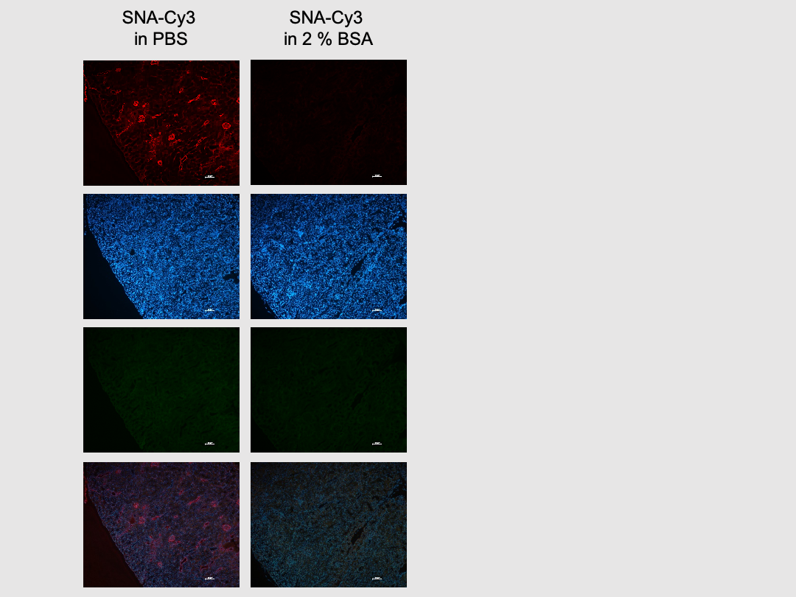
Supplementary Fig. S1 BSA in the staining solution reduced lectin staining specificity. Rehydrated, formalin fixed paraffin embedded (FFPE) kidney sections were stained with SNA-Cy3 in the absence (left column) or presence of BSA in the staining solution (right column). Scale bars 100µm.

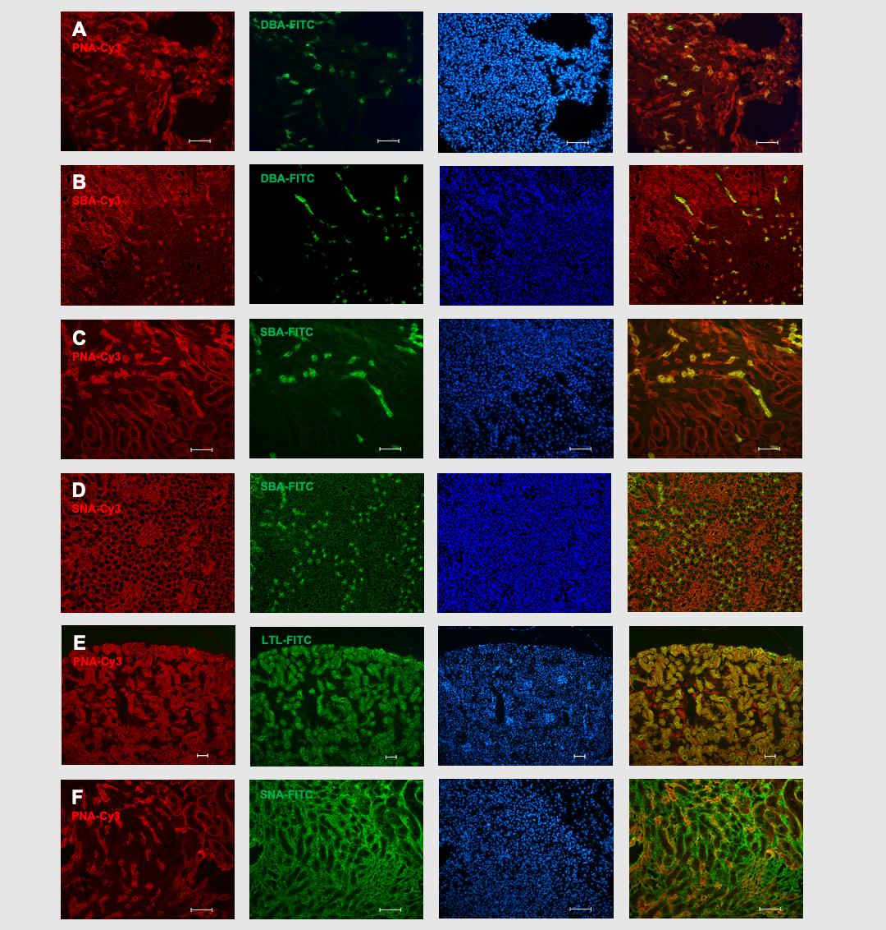
Supplementary Fig. S2 Lectin staining on renal cryosections. Double staining of renal cryosections with PNA-Cy3 and DBA-FITC (A), SBA-Cy3 and DBA-FITC (B), PNA-Cy3 and SBA-FITC (C), SNA-Cy3 and SBA-FITC (D), PNA-Cy3 and LTL-FITC (E), or PNA-Cy3 and SNA-FITC (F). DAPI and merged images are shown in the right hand columns, respectively. Scale bars 200µm.

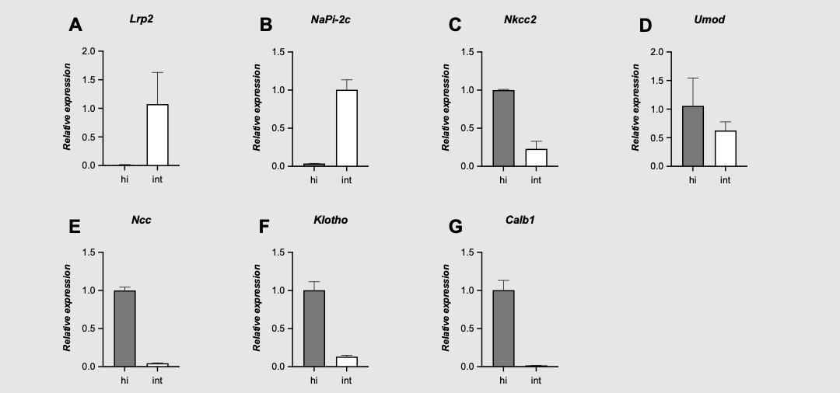
Supplementary Fig. S3 SBA labeled two different nephron segment populations. The identities of nephron segments with high (hi) or intermediate (int) SBA staining intensity were validated by assessment of the mRNA expression levels of the PT markers Lrp2 (A) and NaPi-2c (B), the TAL markers Nkcc2 (C) and Umod (D), or the DCT markers Ncc (E), Klotho (F) and Calb1 (G).

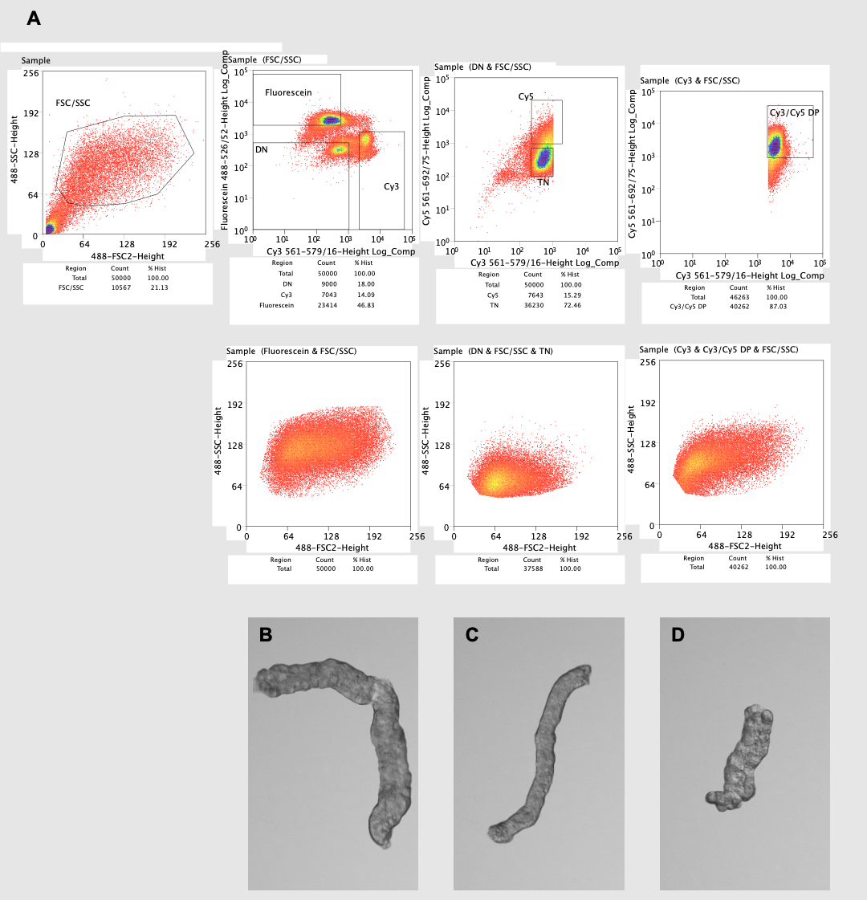
Supplementary Fig. S4 Gating strategy. (A) Nephron segments were first gated based on forward and side scatter (FSC/SSC), then FITC-positive (Fluorescein), Cy3-positive (Cy3) and double negative (DN) populations were separated. The DN were further sorted into triple negative (TN) or Cy5 single positive (Cy5) tubules, whereas from the Cy3 population only the Cy3/Cy5 double positive (DP) segments were collected. Representative images of sorted FITC tubules (B), TN tubules (C), or DP tubules (D).

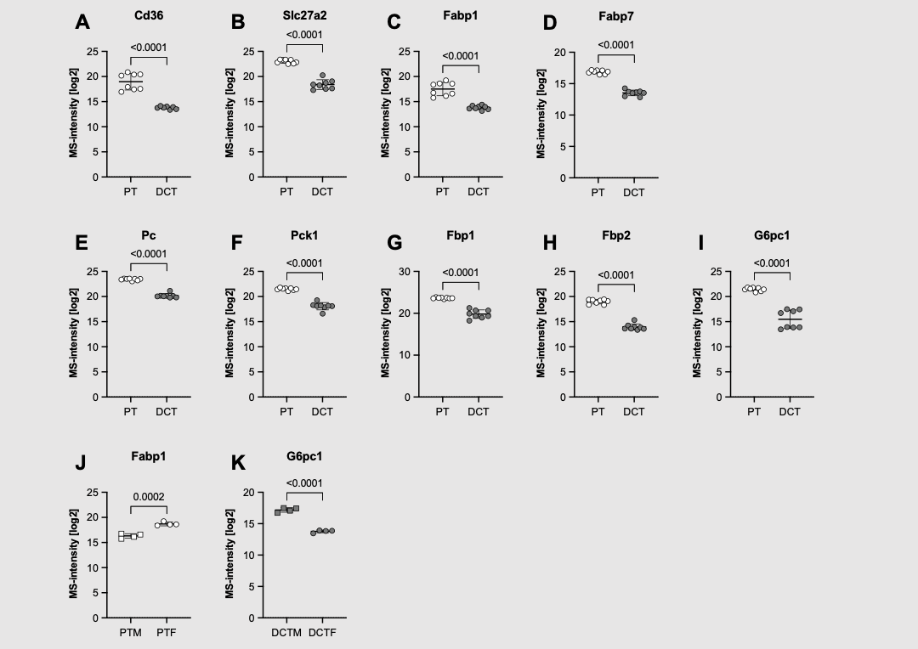
Supplementary Fig. S5 Lipid metabolism and gluconeogenesis were enriched in PTs. Compared to DCTs, PTs had higher abundances for proteins involved in lipid metabolism (A-D), or gluconeogenesis (E-I), including the fatty acid translocase Cd36 (A), the very long-chain acyl-CoA synthetase Slc27a2 (B), and the fatty acid binding proteins (Fabp) 1 and 7 (C, D), or (E) pyruvate carboxylase (Pc), (F) phosphoenolpyruvate carboxykinase 1 (Pck1), (G) fructose-1,6-bisphosphatase 1 (Fbp1), (H) fructose-bisphosphatase 2 (Fbp2), and (I) glucose-6-phosphatase (G6pc1), respectively. Of note, Fabp1 was higher in female PTs (PTF) than in male PTs (PTM) (J), while G6pc1 was higher in male DCTs (DCTM) than in female DCTs (DCTF) (K). Unpaired t test (D, E, H, J, K) or Welch’s t test (A-C, F, G, I).

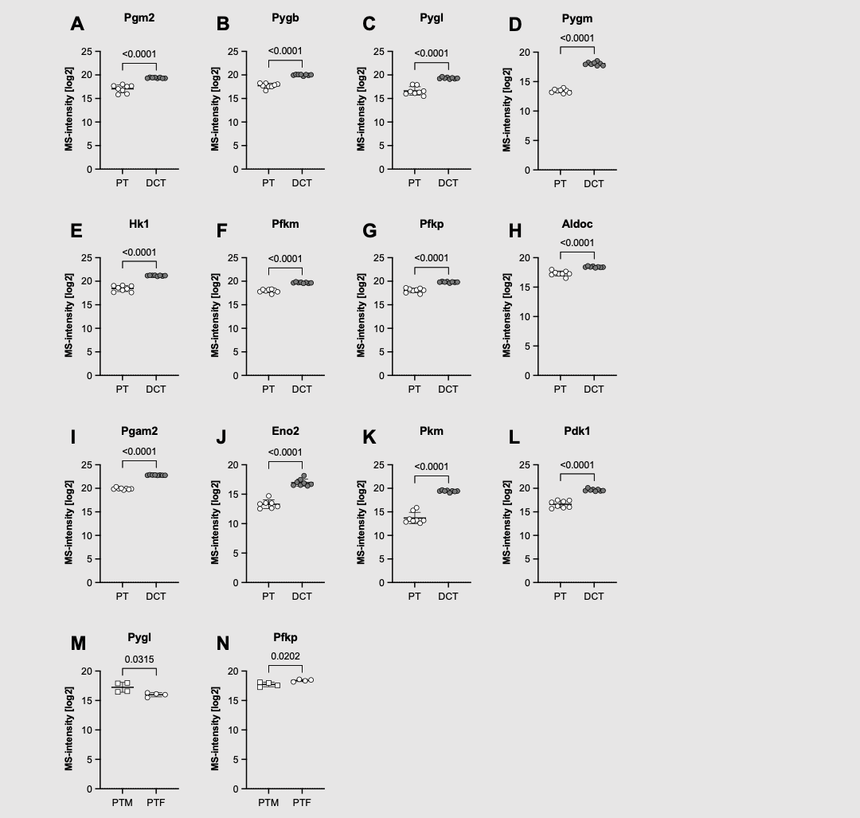
Supplementary Fig. S6 Glycogenolysis and glycolysis were enriched in DCTs. Compared to PTs, DCTs had higher abundances for proteins involved in glycogenolysis (A-D), or glycolysis (E-L), including (A) phosphoglucomutase-2 (Pgm2), (B-D) brain, liver, and muscle isoform of glycogen phosphorylase (Pygb, Pygl, Pygm), or (E) hexokinase-1 (Hk1), (F, G) muscle and platelet isoform of phosphofructokinase (Pfkm, Pfkp), (H) aldolase C (Aldoc), (I) phosphoglycerate mutase 2 (Pgam2), (J) enolase 2 (Eno2), (K) pyruvate kinase muscle isozyme (Pkm), and (L) pyruvate dehydrogenase kinase 1 (Pdk1), respectively. Of note, Pygl was also higher in male PTs (PTM) than in female PTs (PTF) (M), while Pfkp was higher in PTF compared to PTM (N). Unpaired t test (D, J, M, N) or Welch’s t test (A-C, G-I, K, L).

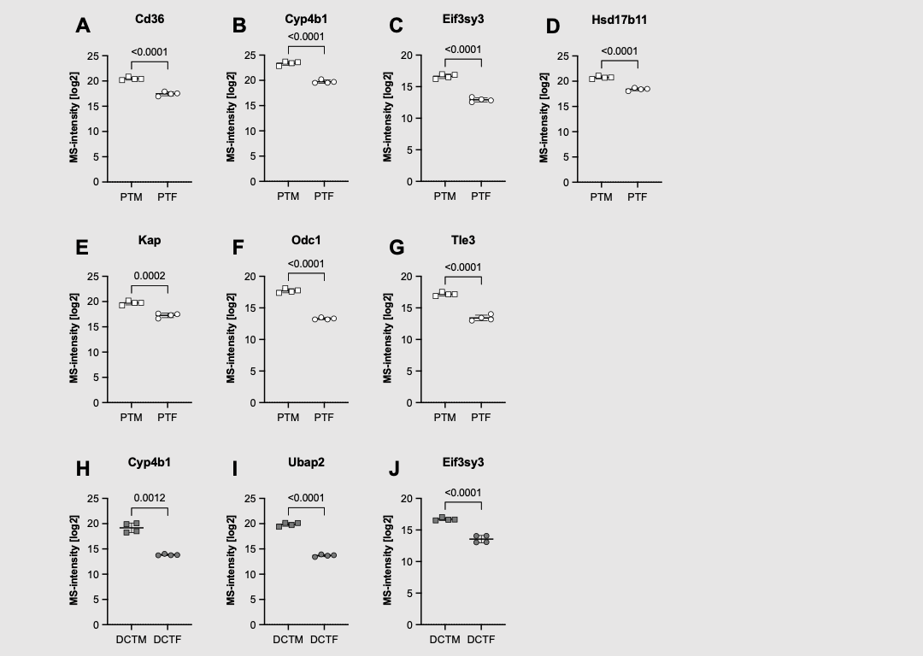
Supplementary Fig. S7 Androgen-regulated proteins were enriched in males. Compared to female PTs (PTF), PTs sorted from males (PTM) had higher abundances for proteins regulated by androgens, including (A) Cd36, (B) Cyp4b1, (C) Eifs3y3, (D) Hsd17b11, (E) kidney androgen-regulated protein (Kap), (F) Odc1, and (G) Tle3. Similarly, Cyp4b4 (H), Ubap2 (I), and Eifs3y3 (J) were also enriched in males DCTs (DCTM) compared to female DCTs (DCTF). Of note, Eifs3y3 (C, J) is encoded on the Y-chromosome. Unpaired t test or Welch’s t test (H).

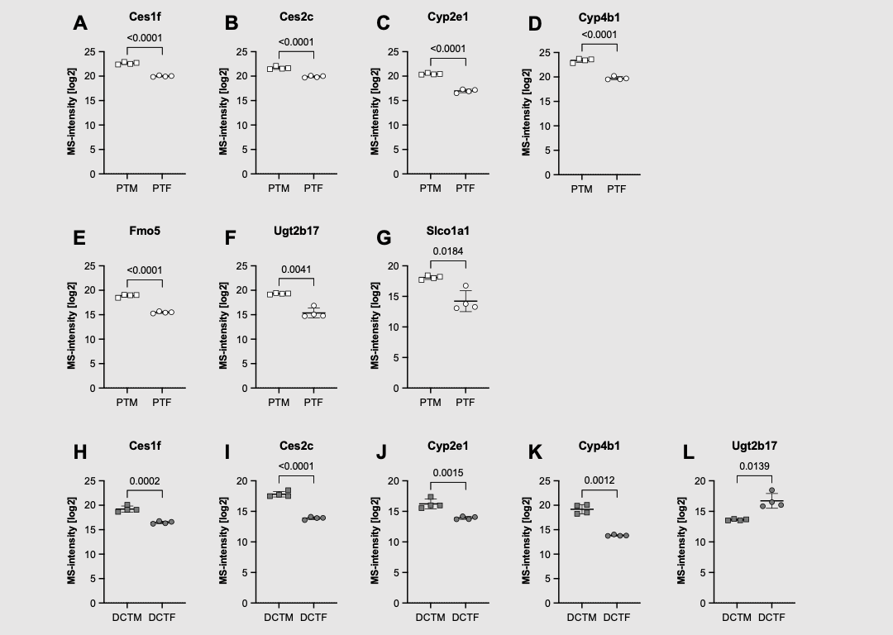
Supplementary Fig. S8 Proteins involved in drug metabolism enriched in males. Compared to female PTs (PTF), male PTs (PTM) had higher protein abundances for the oxidoreductases Ces1f (A), Ces2c (B), Cyp2e1 (C), Cyp4b1 (D), and Fmo5 (E), the conjugating enzymes Ugt2b17 (F), and the organic anion transporter Slco1a1 (G). Ces1f (H), Ces2c (I), Cyp2e1 (J), Cyp4b1 (K), and Ugt2b17 (L) were also enriched in male DCTs (DCTM) compared to female DCTs (DCTF) (C). Unpaired t test (A-E, H-J) or Welch’s t test (F, G, K, L).

Supplementary Tables

Supplementary Table T1 Top 20 records for female and male PT nephron segments. Top 20 records of the DAVID functional annotation chart for female (red) and male (blue) PT nephron segments.
Supplementary Table T2 Top 20 records for female and male DCT nephron segments. Top 20 records of the DAVID functional annotation chart for female (red) and male (blue) DCT nephron segments.

Supplementary Table T3 Lectins used in this study.

Supplementary Table T4 Primers for qPCR.

