Supporting Information

Comparing Virgin and Post-consumer HDPE based Hemp Hurd Bio-composites for Commercial Scale-up Operations

Dylan Jubinville, Tizazu H. Mekonnen*
Department of Chemical Engineering, Institute of Polymer Research, Waterloo Institute of Nanotechnology, University of Waterloo, Waterloo, Ontario, N2L 3G1, Canada.
*Corresponding author: tmekonnen@uwaterloo.ca.

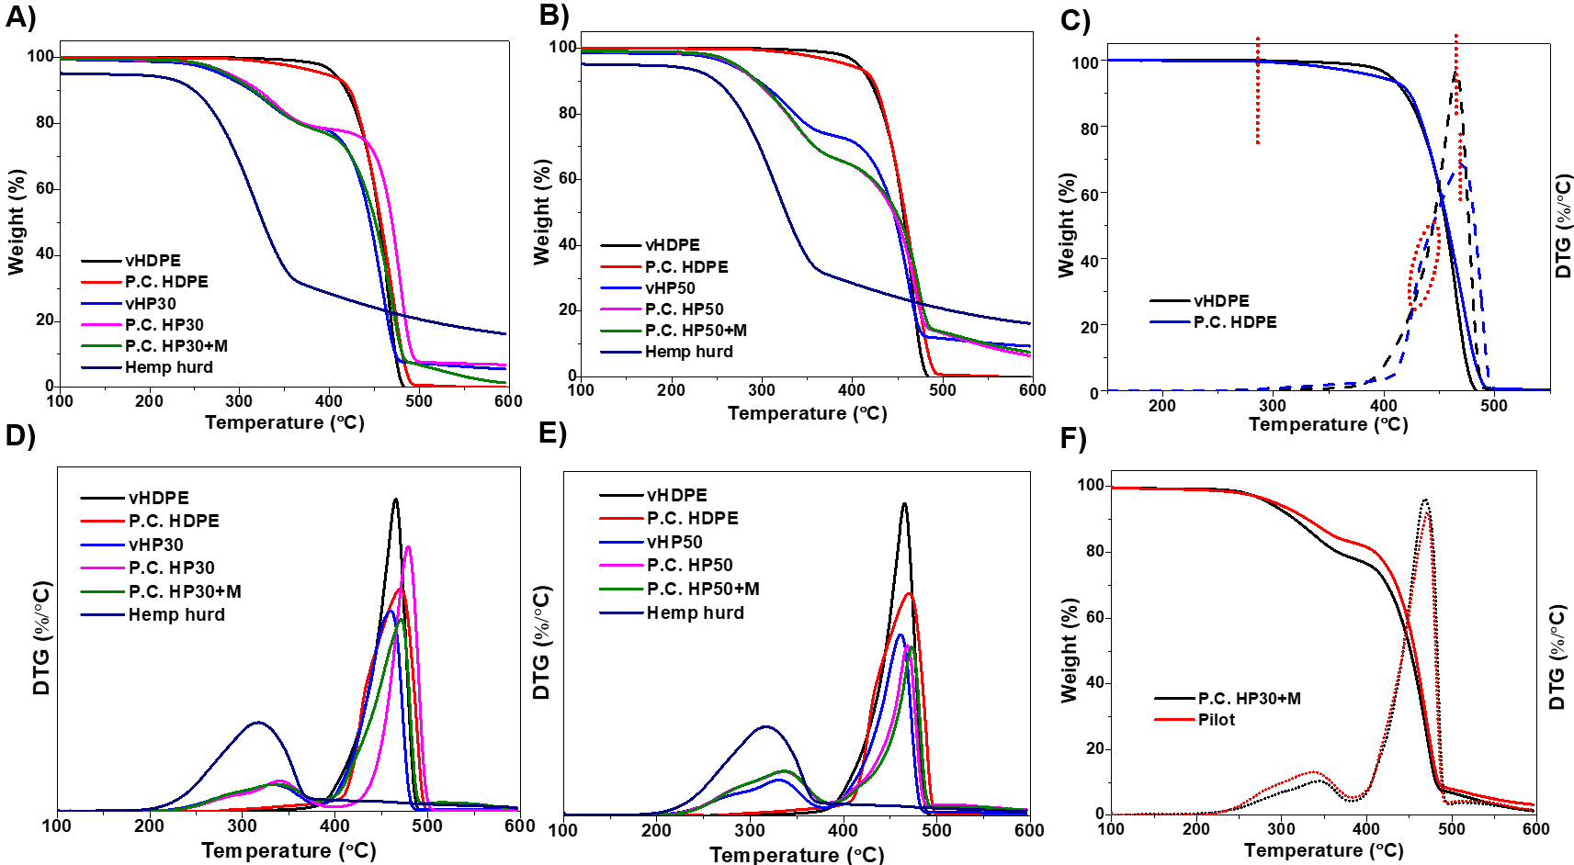
Figure S1. (A) Mass loss curve for HPCs with 30 wt.% hemp; (B) Weight derivative curve for HPCs with 30 wt.% hemp; (C) Mass and derivative weight loss curves for virgin and P.C. HDPEs; (D) Mass loss curve for HPCs with 30 wt.% hemp; (E) Weight derivative curve for HPCs with 30 wt.% hemp; and (F) Mass and derivative weight loss curves for pilot test comparison.

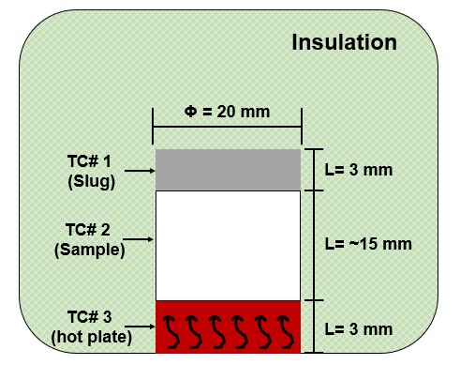
Scheme S1. Schematic of ATC experimental set-up.

Table S1. ATC date across various temperature ranges.
 | Apparent thermal conductivity (W/(m*K))
 | 310 K | 320 K | 330 K | 335 K
vHDPE | 0.194 ± 0.058 | 0.302 ± 0.082 | 0.377 ± 0.003 | 0.382 ± 0.004
P.C. HDPE | 0.050 ± 0.015 | 0.070 ± 0.009 | 0.821 ± 0.039 | 0.388 ± 0.007
P.C. HP30 | 0.053 ± 0.004 | 0.077 ± 0.002 | 0.090 ± 0001 | 0.095 ± 0.028
P.C. HP30+M | 0.0145 ± 0.015 | 0.0194 ± 0.053 | 0.0194 ± 0.054 | 0.0104 ± 0.008
Pilot | 0.0447 ± 0.009 | 0.0723 ± 0.002 | 0.094 ± 0.007 | 0.103 ± 0.017

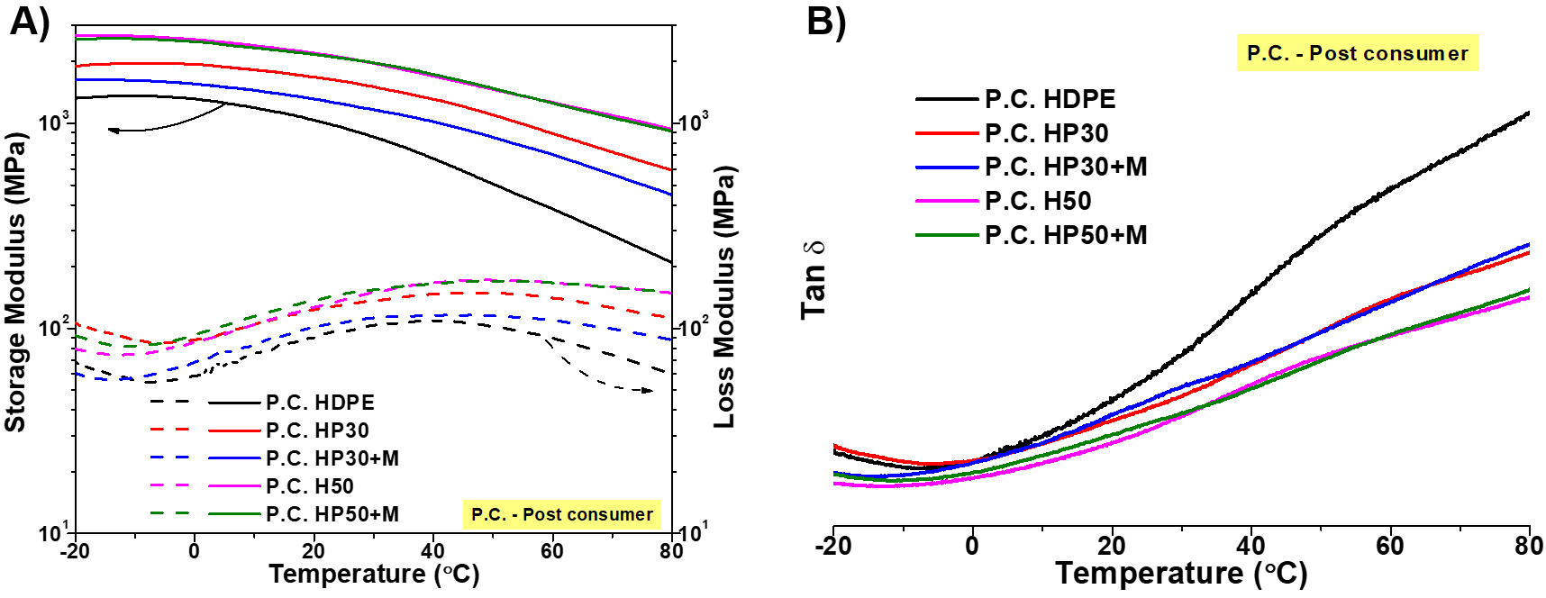
Figure S2. (A) DMA storage and loss modulus and (B) DMA determined tan delta for the P.C. HDPE and its HPCs.

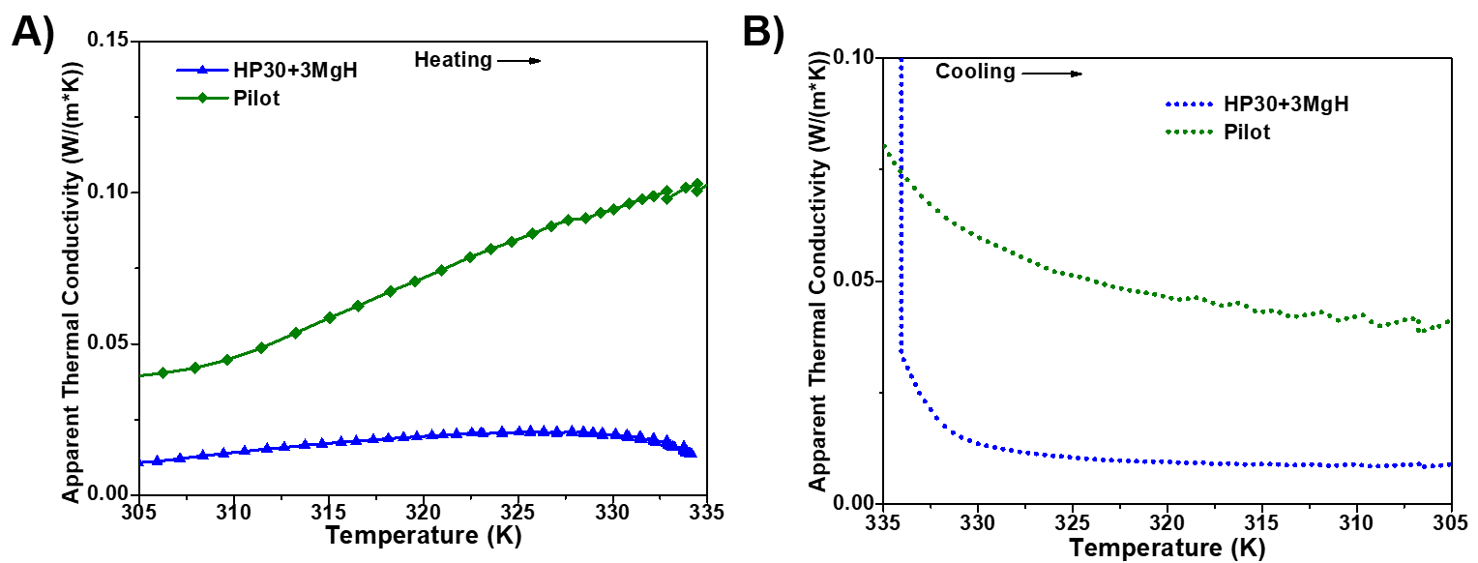
Figure S3. (A) ATC upon heating comparing the pilot scale specimen against the lab scale version and (B) the cooling ATC for the pilot and lab scale samples.

