HDAC3 promotes macrophage pyroptosis via regulating histone deacetylation in acute lung injury
Supplementary material

Supplementary figure1. The barplot for biological process of the DEGs in BMDM from LPS and LPS (HDAC3 KO) group. Transcriptomic profiling of bone-marrow derived macrophages (BMDM) harvested from control or macrophage HDAC3-deficient mice and wild type mice. BMDM were then stimulated with PBS or LPS (5ng/ml for 4hour) before RNA were extracted for RNA-seq library preparation. Library was prepared with Illumina Truseq kit and sequenced on either Illumina Nextseq 500 or Hiseq 2000/4000 sequencer.
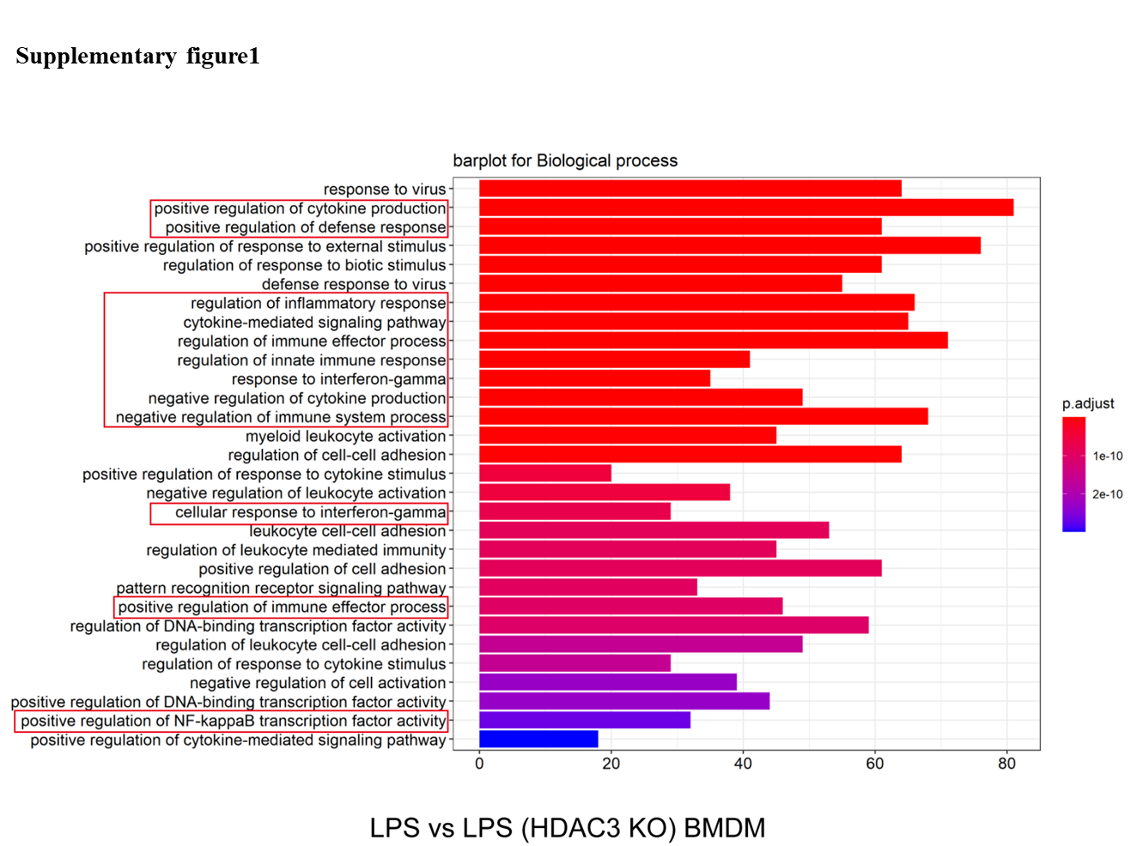

Supplementary figure2. The RNA and protein levels of inflammatory cytokines in mice upon LPS stimulation. (A). Relative mRNA levels of IL-6, IL-1β and Tnf-α in mouse lung tissues after LPS challenge (n=6). (B) The levels of IL-18,IL-1β and TNF-α detected by ELISA in the BALF of mice after LPS challenge(n=6). Values represent the mean ± SEM. *p <0.05, **p<0.01, ***p<0.001 versus the matched groups, n.s. represents no significance.

Supplementary figure3. HDAC3 deficiency in macrophage could block the activation of NLRP3/cGAS/STING pathway in lung tissues from mice with ALI. (A). Western blot analysis of NLRP3, Caspase-1 p20, GSDMD-N, cGAS, P-STING, T-STING, NLRP3, and GSDMD-N in HDAC3-C or HDAC3-CKO mice (n=6). (B). Immumohistochemical staining of cGAS and NLRP3 in lung tissues. Values represent the mean ± SEM. *p <0.05, **p<0.01, ***p<0.001 versus the matched groups, n.s. represents no significance.

Supplementary figure4. HDAC3 overexpression aggravated the activation of cGAS/STING pathway induced by LPS in macrophages. (A) Western blot analysis of cGAS, P-STING, T-STING, NLRP3, Caspase-1 p20 and GSDMD-N in differentiated THP-1 cells transfected with Ad-Hdac3 (n=6). (B-C) IL-1β and IL-18 content in differentiated THP-1 cells (n=6). Values represent the mean ± SEM. *p <0.05, **p<0.01, ***p<0.001 versus the matched groups, n.s. represents no significance.

Supplementary figure5. Identification of HDAC3 myeloid macrophage specific knockout mice. (A) HDAC3 flox genotype analysis by PCR. The HDAC3 flox sequence in mouse tissue DNA was amplified and separated by gel electrophoresis on a 2 % agarose gel. WT, 290 bp; Heterozygous,290 and 356 bp; Homozygous, 356 bp.b. (B) Lyz2 cre genotype analysis by PCR. The Lyz2 cre sequence in mouse tissue DNA was amplified and separated by gel electrophoresis on a 1.8 % agarose gel. WT, 0bp; Targeted, 543bp.
Supplementary Table 1 The information of primers used in the present study
Gene | Species | Forward primer (5→3) | Reverse primer (3→5)
Hdac3 | Mouse | CCCAGACTTCACACTTCATCCA | GGTCCAGATACTGGCGTGAGTT
Hdac3 | Human | TTGAGTTCTGCTCGCGTTACA | CCCAGTTAATGGCAATATCACAGAT
Gapdh | Mouse | ACTCCACTCACGGCAAATTC | TCTCCTATGGTGGTGACGACA
Gapdh | Human | GGGCTGCTTTTAACTCTGGT | TGGCAGGTTTTTCTAGCGG
Il-6 | Mouse | CCCCAATTTCCAATGCTCTCC | CCCCAATTTCCAATGCTCTCC
Il-6 | Human | AGCCCTGAGAAAGGAGACA | CCAAAAGACCAGTGATGAT
Tnf-α | Mouse | ACTGAACTTCGGGGTGATCGGT | TGGTTTGCTACGACGTGGGCTA
Tnf-α | Human | TCCAGGCGGTGCTTGTTC | GCTTGTCACTCGGGGTTC
Il-1β | Mouse | AATGAAGGAACGGAGGAGCC | CTCCAGCCAAGCTTCCTTGT
Il-1β | Human | CGGGACTCACAGCAAAAAA | TTCAACACGCAGGACAGGT
MiR-4767 | Mouse | ATTTCTACGTCGTAGTCGTAA | CCCGTAGTCGTAGTCGTAGTGTCA
MiR-4767 | Human | AATAATACGCGGGCGCTC | ACGCTTCACGAATTTGCGTGTC
U6 | Mouse | CTCGCTTCGGCAGCACA | AACGTTCACGAATTGCGT
U6 | Human | GCTTCGGCAGCACATATACTA AAAT | GCTTCGGCAGCACATATACTAAAAT
MiR-4767 agomir | Human | AGCTGTAGTCGTAGAAATGAA | CTGATGTCGATGATGATGTGTCA
MiR-4767 antagomir | Human | ATGCTAGTGTCGTAGCACCC | CGTAGTGCTGATGTCGTGAAA
MiR-4767 antagomir | Mouse | ATTTGCTGTAGTGCTGATGCCA | TGCTGATGTGCTGATGTCGTAA

